Data Mining and Machine Learning
Fundamentals for Beginners
Written Assessment (SAQ)

A: Trainee Information:

Trainee Name (as Per NRIC): _______________________________

Last 3 digits and alphabet of NRIC/FIN: _________________

Date: __________________

B: Instruction to Candidates

1. This is an individual exercise
2. This is an open book assessment
3. A total of 45 minutes is given to complete the written assessment
4. Submit your answers on the document provided

C: Short Answer Questions

Question 1:
Imagine you're working as a data analyst for a retail company. You're tasked with analyzing customer purchase data to understand buying trends. Unfortunately, the dataset you receive has missing values for some customers' income levels. These missing values are encoded as "NA".

Name three ways that you can deal with the missing values / perform imputation on the missing values. (K1)

Question 2:
You are working on a project to predict housing prices based on various features such as size, location, and amenities. After collecting and preprocessing the dataset, you notice that your linear regression model is showing signs of overfitting, where it performs well on the training data but poorly on new, unseen data.

Name two regularization methods that you can use to mitigate overfitting and reduce bias in your linear regression housing model. (K2)

Question 3:
Imagine you're a data analyst working for a law enforcement agency. You're tasked with understanding patterns in crime rates across different US states. You have a dataset containing arrest rates for various crimes and want to group states with similar crime profiles.

You've created a dendrogram to visualize the hierarchical clustering of US states based on arrest rates as shown below. Now, you need to determine the optimal number of clusters that best represent distinct groups of states with similar crime characteristics. By analyzing the dendrogram, you'll identify potential cut-off points and evaluate the resulting clusters to make an informed decision.

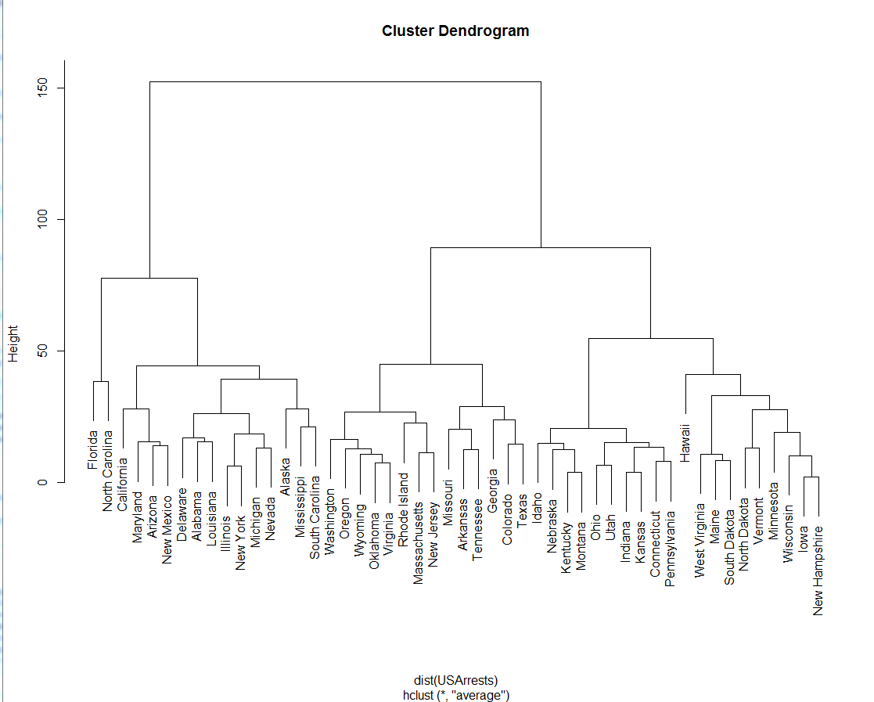

What is the recommended number of clusters for the above dendrogram? (K3)

Question 4:
You are working as a data scientist at a marketing analytics firm. Your team is tasked with analyzing customer data to improve targeted advertising campaigns. As part of your analysis, you need to explain the difference between supervised learning and unsupervised learning to your colleagues who are not familiar with machine learning concepts.

What are the main differences between supervised learning and unsupervised learning? (K4)

Question 5:
You are tasked with developing an AI-driven platform to assess the credibility of news articles automatically. The system needs to analyze various textual features, such as language patterns, sources, and historical accuracy, to determine the likelihood of an article being fake or genuine.

Which of the following machine learning methods would be most suitable for such a project?

- Classification
- Regression
- Clustering
- Dimension reduction
- Association

(K5)

Question 6:
Imagine you're a data scientist tasked with evaluating the performance of a model that predicts whether a customer will churn or not. You have a confusion matrix that summarizes the model's predictions against the actual churn status of customers as shown below (0 means “negative” and 1 means “positive”)
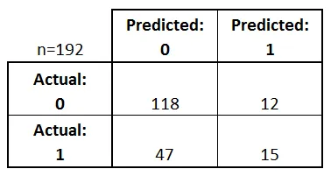

Calculate the Precision, Recall, and F1-score based on the above confusion matrix to assess the model's effectiveness in identifying churned customers. Show your answers below: (K6)

Question 7:
Imagine you're a data scientist evaluating three different machine learning models for a binary classification task. You have generated ROC curves for each model to assess their performance as shown below

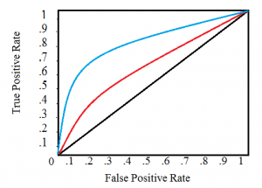

Analyze the ROC curves above to determine which model (i.e., blue, red, or black) exhibits the best overall classification performance. Consider factors such as the shape of the curve, the area under the curve (AUC), and the trade-off between true positive rate and false positive rate. (K7)

Question 8:
Imagine you're a data scientist working on a project to analyze customer behavior. You've applied Principal Component Analysis (PCA) to reduce the dimensionality of your dataset while preserving as much information as possible.

Examine the following scree plot:
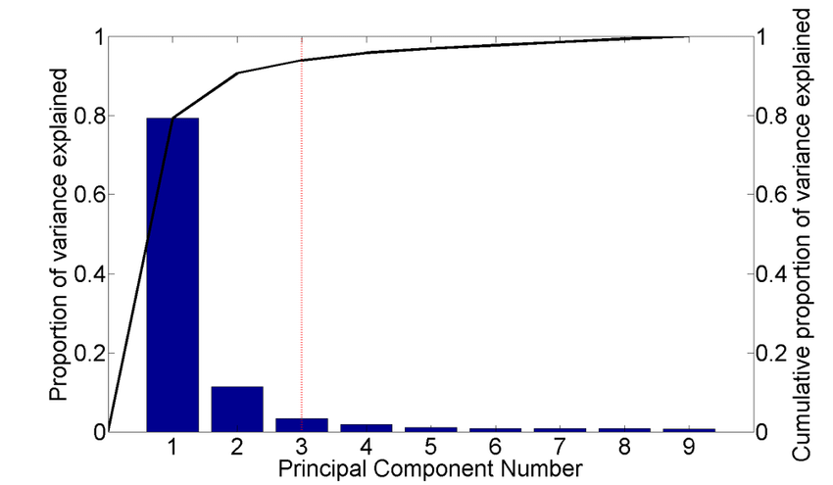

What is the optimal number of principal components to retain? Remember to consider the balance between preserving variance and reducing dimensionality. (K8)

Question 9:
Imagine you are a data analyst for a grocery store chain. You have access to a dataset containing a sample of customer transactions, represented as lists of items purchased in each transaction. You want to understand the popularity of different products and identify potential associations between items.

Examine the list of transactions below:
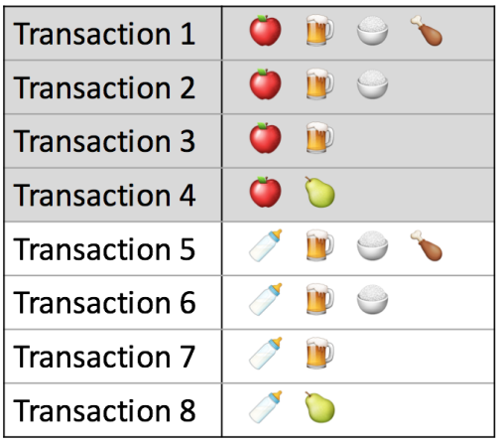

Calculate the support for the item "beer" (🍺) (K9)

Question 10:
Imagine you're a data scientist building a model to predict housing prices. You have a dataset containing features like square footage, number of bedrooms, and property taxes.

Consider the implications of directly fitting a regression model to these features without any preprocessing. Then, explain the rationale behind scaling or normalizing the features before training the model. You should discuss how feature scaling can impact model performance and convergence. (K10)

_____________________________________________________________________________
For Official Use Only

Grade: _____ (C / NYC)

Assessor Name: _______________ Assessor NRIC: _____________

Date: ________________________ Signature: _________________

Please create a subfolder named YYYY-MM-DD/DD_<<Trainer Name>> and upload all the learner's assessments to the respective Google Drive.
Please email support@tertiarycourses.com.sg after you have uploaded the assessment.

