Python Programming for Finance
Written Assessment (SAQ)

A: Trainee Information:

Trainee Name (as Per NRIC): _______________________________

Last 3 digits and alphabet of NRIC/FIN: _________________

Date: __________________

B: Instruction to Candidates

1. This is an individual exercise
2. This is an open book assessment
3. A total of 1 hr is given to complete the written assessment
4. Submit your answers on the document provided

C: Short Answer Questions

Question 1:
Alex, a seasoned developer at TechWave Solutions, is working on a project that involves creating interactive data visualizations. He needs to implement a formatting function to display numerical data with specific decimal precision. Alex finds the following code snippet and wants to understand its behavior before integrating it into his project.
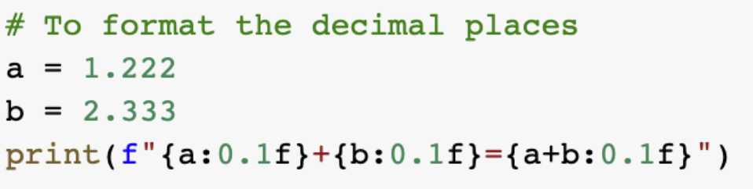
What is the output from executing the above lines of code? (K1)

Question 2:
Capital Growth Inc. is an investment firm renowned for its data-driven approaches. However, in recent years, the company has been facing increasing competition in the financial market. To maintain its competitive edge, the firm needs to enhance its investment decision-making processes.
Emma, a skilled financial analyst, is tasked with developing a robust analytical tool to process vast amounts of financial data, identify market trends, and generate actionable insights. She wants to select a programming language that can handle large datasets, perform complex calculations efficiently, and provide flexibility for model development. She is considering Python as a potential solution but needs to justify its suitability for this critical project.

Explain why Python is well suited for such financial analyses. (K2)

Question 3:
Jordan, a budding programmer at InnovateTech, is tasked with maintaining an existing Python script. While reviewing the code, he encounters a decision-making block that controls the program's behavior based on a specific condition. To ensure the script functions correctly, Jordan needs to understand the output of this code snippet under the given circumstances.The code snippet is shown below:
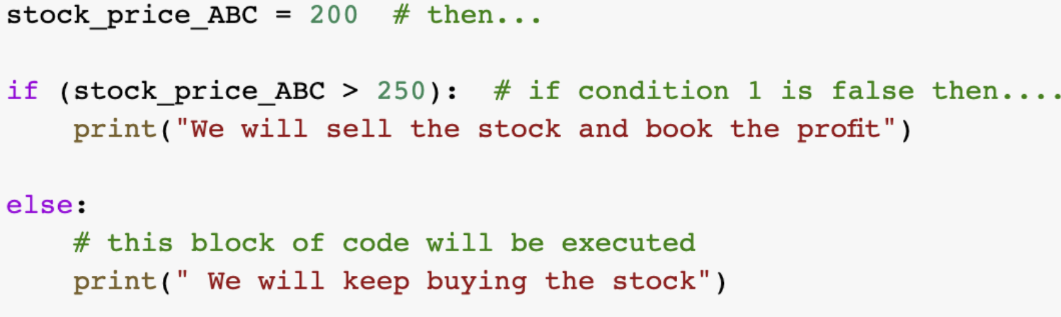
What is the output from executing the above lines of code? (K3)

Question 4:
Alex, a detail-oriented data analyst at DataInsights Corp., is tasked with integrating a new data processing module into the company's robust analytics pipeline. Before incorporating the module, he needs to thoroughly understand the data structure it produces to ensure compatibility and efficient processing. Alex examines a Python code snippet that appears to create a dataset related to stock portfolios. He needs to determine the exact format of the output data structure to assess its suitability for downstream analysis and visualization.
The code snippet is shown below: 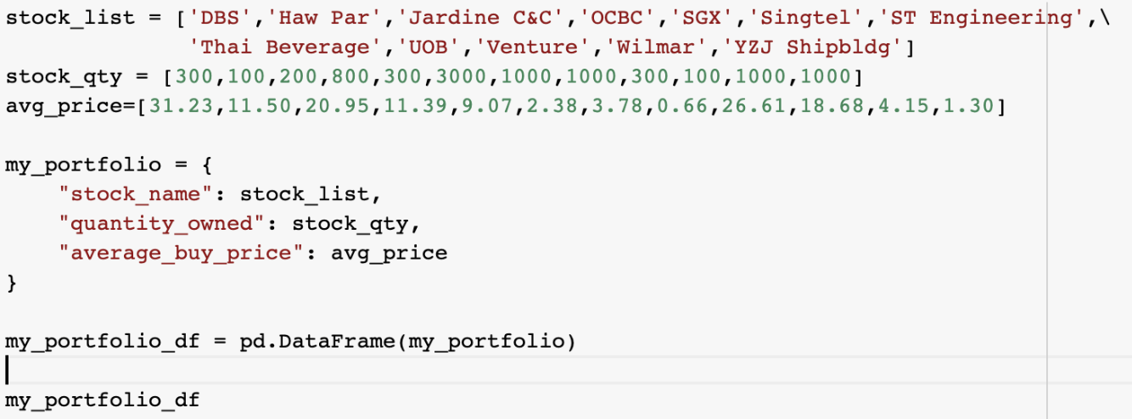
Describe the data structure produced when you execute the above lines of code: (K4)

Question 5:
Jordan, a meticulous software developer at Capital Growth Inc., is tasked with optimizing a Python script designed to analyze stock market trends. While examining the code, he comes across a specific section that filters trading signals. Jordan needs to understand the functionality of this code snippet to ensure it accurately identifies the correct buy/sell signals from the given dataset.
The code snippet is shown below:

What is the output from executing the above lines of code? (K5)

Question 6:
Emily, a data analyst at FinTech Solutions, is working on analyzing historical stock price data for a client. To smooth out short-term fluctuations and highlight longer-term trends, she needs to calculate a 5-day moving average of the stock prices. She decides to write a Python script to perform this calculation.What is the code to calculate a 5-day moving average of the stock price? (K6)

Question 7:
Liam, a newbie to Python, is just starting to learn programming. He encounters the following code snippet from an online tutorial and wants to determine what the output will look like when run:
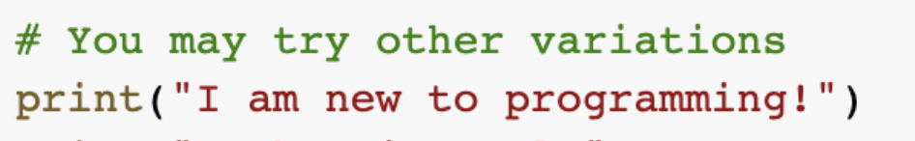

What is the output from executing the above lines of code? (K7)

Question 8:
David, a junior data analyst at FinTech Solutions, has been tasked with reviewing a piece of code to understand how data is processed within the specific pipeline. The code seems to be part of a larger data analysis process:
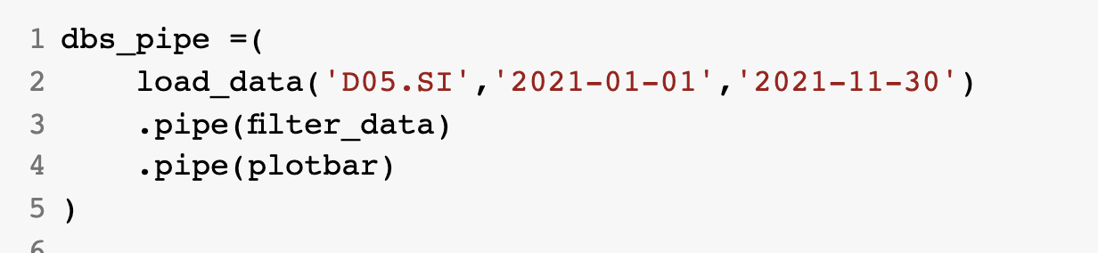
Explain what the above lines of code do. (K8)

__________________________________________________________________________
For Official Use Only

Grade: (C / NYC)

Assessor Name: _______________ Assessor NRIC: _____________

Date: _________________ Signature: _________________

Please create a subfolder named YYYY-MM-DD/DD_<<Trainer Name>> and upload all the learner's assessments to the respective Google Drive.
Please email support@tertiarycourses.com.sg after you have uploaded the assessment.

