

ASSESSMENT PLAN

For

Creating High-Converting Email Campaigns with Mailchimp

TGS Ref No: TGS-2020503109

Conducted by
Tertiary Infotech Pte Ltd

UEN: 201200696W

Version 4.0
Table of Contents
1. Version Control Record 4
2. Overview of Assessment 5
Assessment Methods 5
Assessment Duration (per candidate) 5
Assessment Venue 6
3. Matrix of Assessment Methods and Evidence Gathering Plan 6
3.1. Knowledge Assessment Matrix 6
3.2. Abilities Assessment Matrix 7
3.3. Evidence Gathering Plan 8
4. Assessment Method Specifications 9
4.1. Assessment Specifications 9
4.1.1. Assessment Specification for Written Assessment - Short-Answer Questions 9
4.1.2. Assessment Specification for Practical Performance 11
4.1.3. Assessment Specification for Oral Questioning 13
5. Assessment Code of Practice 15
6. Assessment Management Organisation 16
6.1. Assessment Appeal Panel 16
6.2. Assessment Manager 16
6.3. Assessor 16
6.4. Appeal Procedures 17
7. Instructions to Assessor 18
8. Instructions to Candidate 19
8.1. Pre-Assessment Information for Candidate 19
9. Assessment Records 20
9.1. Assessment Record for Written Assessment (MCQ) 20
9.2. Assessment Record for Oral Questioning 21
9.3. Assessment Record for Practical Performance 22
9.4. Assessment Summary Record 23
10. Annexes 25
10.1. Assessment Questions and Answers 25
10.1.1. Annex A: Assessment Questions for WA-SAQ 25
10.1.2. Annex B: Suggested Answer to Assessment Questions for WA-SAQ 25
10.1.3. Annex C: Assessment Questions for PP 25
10.1.4. Annex D: Suggested Answer to Assessment Questions for PP 25
10.1.5. Annex E: Suggested Answer to Assessment Questions for OQ 25

Version Control Record

Version | Effective Date | Changes | Developer
1.0 | 18 Feb 2023 | For Pilot Launch | Tertiary Infotech
2.0 | 15 Jul 2024 | Update on the format  Added the appeal procedure  Added evidence collection and submission | Tertiary Infotech
2.1 | 2 Jan 2025 | Changed “Developer” column To “Who”  Change everything to Tertiary Infotech instead of name | Tertiary Infotech
3.0 | 08 Jan 2025 | Added Assessment Questions Answers into Annex D | Tertiary Infotech
4.0 | 26 Jan 2025 | Revised Assessment Plan Format | Tertiary Infotech

Overview of Assessment

The purpose of this assessment is to evaluate the candidate’s performance for Creating High-Converting Email Campaigns with Mailchimp against the following technical skills and competencies (TSC)

Skills Framework: Infocomm Technologies
TSC Title: Integrated Marketing
TSC Code: ICT-SNM-3006-1.1

Assessment Methods

Learning Unit | Assessment Method(s)
LU1: Overview of Email Campaign Marketing | OQ, WA(MCQ), PP
LU2: Manage Audience | WA(MCQ), PP
LU3: Setup Email Campaign | OQ, WA(MCQ), PP
LU4: Automate marketing process | OQ, WA(MCQ), PP
LU5: Campaign Reports | WA(MCQ), PP
Legend: WA-SAQ: Written Assessment (Short Answer Questions), PP: Practical Performance,
CS: Case Study, OQ: Oral Questioning, RP: Role Play

Assessment Duration (per candidate)

Assessment Method(s) | Assessor to Candidate Ratio | Duration
WA(MCQ) | 1:10 | 40 mins
PP | 1:10 | 90 mins
OQ | 1:1 | 20 mins
Total time |  | 2.5 hrs

Assessment Venue

Assessment Method(s) | Venue
WA(MCQ) | Tertiary Infotech or  Client’s Premise
PP
OQ

Matrix of Assessment Methods and Evidence Gathering Plan

Knowledge Assessment Matrix

Knowledge | WA(MCQ) | PP | OQ
K1: Organisation's marketing strategy and target customers | - | - | √
K2: Features, pros and cons of various marketing channels and platforms | √ | - | -
K3: Types of content on different marketing channels | - | - | √
K4: Types of marketing communications tactics | √ | - | √
K5: Elements of marketing campaigns | √ | - | -
K6: Methods to optimize effectiveness of marketing on a specific channel | √ | - | -

Abilities Assessment Matrix

Ability | WA(MCQ) | PP | OQ
A1: Assess advantages and disadvantages of different marketing channel options | - | √ | -
A2: Propose suitable platforms and marketing activities to address intended objectives and target customer | - | √ | -
A3: Develop a marketing plan for specific channels | - | √ | -
A4: Implement marketing activities and campaigns in alignment with an overall marketing plan | - | √ | -
A5: Curate relevant content to reinforce the organisation's competitive advantage, key messages and brand | - | √ | -
A6: Manage timely release and maintenance of marketing content and activities on specific channels | - | √ | -
A7: Evaluate the effectiveness of marketing campaigns through a specific channel | - | √ | -
A8: Determine the factors that optimise marketing effectiveness | - | √ | -

Evidence Gathering Plan

Assessment Methods | Evidence Gathering Plan
Written Assessment (MCQ)  Individual, Summative, Open book | Type of Evidence: Written responses to MCQ questions.  Manner of Submission: Candidates will generate answers to the questions and submit the hardcopy to the assessor.  Marking Process: Assessors will evaluate the written responses on the accuracy and comprehensiveness of the answers.  Retention Period: 3 years.
Practical Performance  Individual, Summative, Open book | Type of Evidence:  - LO1: Candidates will develop a proposal outlining email marketing strategies tailored to specific objectives and target demographics.  - LO2: Candidates will demonstrate effective management of newsletter audiences by segmenting a given market for targeted campaigns.  - LO3: Candidates will create and execute an email campaign that achieves defined objectives, showcasing use of key campaign elements.  - LO4: Candidates will setup and use Mailchimp's automation tools to streamline marketing processes for enhanced efficiency.  - LO5: Candidates will submit detailed analytical reports evaluating the performance of deployed email campaigns.  Manner of Submission:  - Candidates will submit their proposals, audience management strategies, executed campaigns, automation setups, and analytical reports electronically via the designated learning management system.  Marking Process:  - Relevance of Strategies.  - Audience Management Effectiveness.  - Campaign Execution Quality.  Retention Period: All submitted evidence including proposals, strategies, campaigns, and reports will be retained for 3 years to ensure compliance with institutional policies and for auditing purposes.
Oral Questioning  Individual, Summative | N/A

Assessment Method Specifications

Assessment Specifications

Assessment Specification for Written Assessment - Short-Answer Questions

Specifications | Written Assessment - Short-Answer Questions
Abilities and Knowledge | K2, K4, K5, K6
Duration | 40 mins
Venue | Training room / designated assessment area
Set up | Physical Assessment (Main)  Candidates are required to sit in a manner whereby there is sufficient separation so that they will not be able to interact during the assessment.  Virtual Assessment  LMS  - Questions to be pre-loaded into LMS and opened only to the candidates and during the assessment time.  - Alternatively, assessor will send the questions electronically to candidates only during the assessment time.  Virtual Environment  - Learners to ensure the camera is on all the time and showing their full face.  - Learners to share their whole screen throughout the assessment period  - Assessors to ensure the recording is started before the candidates and remained recordings for every breakout room throughout all the duration of the Assessment.
Pre-assessment instructions for assessors | - Put the candidate at ease  - Explain clearly the purpose and context of the assessment:  - Purpose of the assessment  - Assessment duration  - Assessment methods and tools  - Explain the methods to be used, the standards and criteria for the assessment and the duration of the assessment.  - Explain the procedures of the assessment:  - Check whether candidate has any special requirements e.g. language, special needs, etc.  - Ensure that the following documents are made available  - Assessment Summary Record  - Candidate’s Appeal Form  - Brief candidate on his/her rights and process of appeal  - Identify any allowable adjustments that candidates may require should they have a special need  In addition to the usual pre-assessment instructions, Include instructions on use of:  - Assessment Code of Practice
Pre-assessment instructions for candidates | - Be punctual  - Observe dress code: smart casual  - Request for assessor to repeat questions if question is not clear or if candidate has difficulty understanding assessor's accent  - To specify special needs, if any
Process of conducting assessment | - Verification of candidate’s identity  - Ensure candidates are seated properly so that they will not interact with each other  - Encourage the candidate to seek clarification if any  - Keep in mind the time limit for the assessment
Managing limitations of evidence | - Use of Oral Clarification
Recording Assessment Results | - Record the results in the Assessment Summary Record  - Check that all record forms, timing, dates, names, NRIC, signatures are completed.  - Check that all Assessment Criteria are ticked competent (C) or not yet competent (NYC) in the specific questions. As long as there is a NYC, the candidate is considered not successful in the entire assessment. The candidate is required to re-take the entire assessment.  - Record observation of Competence where applicable in the ‘Evidence of C and NYC must be recorded column  - Record reasons of Not Yet Competence where applicable in the ‘Evidence of C and NYC must be recorded column  - An ‘NYC’ in any K or A will results in an ‘NYC’ in the unit.A candidate is only deemed competent when they achieved a ‘C’ for all the A and K in the unit.
Feedback | - Give clear and constructive feedback to candidate using appropriate language  - Seek clarification and agreement with the candidate on the outcome  - Provide guidance on overcoming gaps in competency  - Ask the candidates to sign the assessment record  - Record the feedback on the assessment record  - Sign off the assessment record  - Assessor should reiterate the appeal process (if the candidate is assessed as not yet competent)

Assessment Specification for Practical Performance

Specifications | Practical Performance
Abilities and Knowledge | A1, A2, A3, A4, A5, A6, A7, A8
Duration | 90 mins
Venue | Training room / designated assessment area
Set up | Physical Assessment (Main)  Candidates are required to sit in a manner whereby there is sufficient separation so that they will not be able to interact during the assessment.  Virtual Assessment  LMS  - Questions to be pre-loaded into LMS and opened only to the candidates and during the assessment time.  - Alternatively, assessor will send the questions electronically to candidates only during the assessment time.  Virtual Environment  - Learners to ensure the camera is on all the time and showing their full face.  - Learners to share their whole screen throughout the assessment period  - Assessors to ensure the recording is started before the candidates and remained recordings for every breakout room throughout all the duration of the Assessment.
Pre-assessment instructions for assessors | - Put the candidate at ease  - Explain clearly the purpose and context of the assessment:  - Purpose of the assessment  - Assessment duration  - Assessment methods and tools  - Explain the methods to be used, the standards and criteria for the assessment and the duration of the assessment.  - Explain the procedures of the assessment:  - Check whether candidate has any special requirements e.g. language, special needs, etc.  - Ensure that the following documents are made available  - Assessment Summary Record  - Candidate’s Appeal Form  - Brief candidate on his/her rights and process of appeal  - Identify any allowable adjustments that candidates may require should they have a special need  In addition to the usual pre-assessment instructions, Include instructions on use of:  - Assessment Code of Practice
Pre-assessment instructions for candidates | - Be punctual  - Observe dress code: smart casual  - Request for assessor to repeat questions if question is not clear or if candidate has difficulty understanding assessor's accent  - To specify special needs, if any
Process of conducting assessment | - Verification of candidate’s identity  - Ensure candidates are seated properly so that they will not interact with each other  - Encourage the candidate to seek clarification if any  - Keep in mind the time limit for the assessment
Managing limitations of evidence | - Use of Oral Clarification
Recording Assessment Results | - Record the results in the Assessment Summary Record  - Check that all record forms, timing, dates, names, NRIC, signatures are completed.  - Check that all Assessment Criteria are ticked competent (C) or not yet competent (NYC) in the specific questions. As long as there is a NYC, the candidate is considered not successful in the entire assessment. The candidate is required to re-take the entire assessment.  - Record observation of Competence where applicable in the ‘Evidence of C and NYC must be recorded column  - Record reasons of Not Yet Competence where applicable in the ‘Evidence of C and NYC must be recorded column  - An ‘NYC’ in any K or A will results in an ‘NYC’ in the unit.A candidate is only deemed competent when they achieved a ‘C’ for all the A and K in the unit.
Feedback | - Give clear and constructive feedback to candidate using appropriate language  - Seek clarification and agreement with the candidate on the outcome  - Provide guidance on overcoming gaps in competency  - Ask the candidates to sign the assessment record  - Record the feedback on the assessment record  - Sign off the assessment record  - Assessor should reiterate the appeal process (if the candidate is assessed as not yet competent)

Assessment Specification for Oral Questioning

Specifications | Oral Questioning
Abilities and Knowledge | K1, K3, K4
Duration | 20 mins
Venue | Training room / designated assessment area
Set up | Physical Assessment (Main)  Candidates are required to sit in a manner whereby there is sufficient separation so that they will not be able to interact during the assessment.  Virtual Assessment  LMS  - Questions to be pre-loaded into LMS and opened only to the candidates and during the assessment time.  - Alternatively, assessor will send the questions electronically to candidates only during the assessment time.  Virtual Environment  - Learners to ensure the camera is on all the time and showing their full face.  - Learners to share their whole screen throughout the assessment period  - Assessors to ensure the recording is started before the candidates and remained recordings for every breakout room throughout all the duration of the Assessment.
Pre-assessment instructions for assessors | - Put the candidate at ease  - Explain clearly the purpose and context of the assessment:  - Purpose of the assessment  - Assessment duration  - Assessment methods and tools  - Explain the methods to be used, the standards and criteria for the assessment and the duration of the assessment.  - Explain the procedures of the assessment:  - Check whether candidate has any special requirements e.g. language, special needs, etc.  - Ensure that the following documents are made available  - Assessment Summary Record  - Candidate’s Appeal Form  - Brief candidate on his/her rights and process of appeal  - Identify any allowable adjustments that candidates may require should they have a special need  In addition to the usual pre-assessment instructions, Include instructions on use of:  - Assessment Code of Practice
Pre-assessment instructions for candidates | - Be punctual  - Observe dress code: smart casual  - Request for assessor to repeat questions if question is not clear or if candidate has difficulty understanding assessor's accent  - To specify special needs, if any
Process of conducting assessment | - Verification of candidate’s identity  - Ensure candidates are seated properly so that they will not interact with each other  - Encourage the candidate to seek clarification if any  - Keep in mind the time limit for the assessment
Managing limitations of evidence | - Use of Oral Clarification
Recording Assessment Results | - Record the results in the Assessment Summary Record  - Check that all record forms, timing, dates, names, NRIC, signatures are completed.  - Check that all Assessment Criteria are ticked competent (C) or not yet competent (NYC) in the specific questions. As long as there is a NYC, the candidate is considered not successful in the entire assessment. The candidate is required to re-take the entire assessment.  - Record observation of Competence where applicable in the ‘Evidence of C and NYC must be recorded column  - Record reasons of Not Yet Competence where applicable in the ‘Evidence of C and NYC must be recorded column  - An ‘NYC’ in any K or A will results in an ‘NYC’ in the unit.A candidate is only deemed competent when they achieved a ‘C’ for all the A and K in the unit.
Feedback | - Give clear and constructive feedback to candidate using appropriate language  - Seek clarification and agreement with the candidate on the outcome  - Provide guidance on overcoming gaps in competency  - Ask the candidates to sign the assessment record  - Record the feedback on the assessment record  - Sign off the assessment record  - Assessor should reiterate the appeal process (if the candidate is assessed as not yet competent)

Assessment Code of Practice

5.1 This code of practice provides:
- Assessors with direction on the standard of practice.
- Candidates with assurance of the standards of practice expected of assessors.
- Employers with assurance of the standards maintained by Tertiary Infotech Pte Ltd in the conduct of assessment.

5.2 The following code of practice is based on the international code of ethics and practice (The National Council for Measurement in Education [NCME]).
  - The differing needs and requirements of the person(s) being assessed, the local enterprise(s) and/or industry are identified and handled with sensitivity.
  - Potential forms of conflict of interest in the assessment process and/or outcomes are identified and appropriate referrals are made, if necessary.
  - All forms of harassment are avoided throughout the planning, conducting, reviewing and reporting of the assessment outcomes.
  - The rights of the candidate(s) are protected during and after the assessment.
  - Personal or interpersonal factors that are not relevant to the assessment of competency must not influence the assessment outcomes.
  - The candidate is made aware of rights and processes of appeal.
  - Evidence that is gathered during the assessment is verified for validity, reliability, authenticity, sufficiency and currency.
  - Assessment decisions are based on available evidence that can be produced and verified by another assessor.
  - Assessments are conducted within the boundaries of the assessment system policies and procedures.
  - Formal agreement is obtained from both the candidate(s) and the assessor that the assessment was carried out in accordance with agreed procedures.
  - Assessment tools, systems, and procedures are consistent with equal opportunity legislation.
  - The candidate is informed of all assessment reporting processes prior to the Assessment.
  - The candidate is informed of all known potential consequences of decisions arising from an assessment, prior to the assessment.
  - Confidentiality is maintained regarding assessment results.
  - Results are only released with the written permission of the candidate(s).
  - The assessment results are used consistently with the purposes explained to the candidate.
  - Self-assessments are periodically conducted to compare current competencies against the required competencies.
  - Professional development opportunities are identified and sought.
  - Opportunities for networking amongst assessors are created and maintained.
  - Opportunities are created for technical assistance in planning, conducting and reviewing assessment procedures and outcomes.

Assessment Management Organisation

Assessment Appeal Panel

Assessment
Appeal Panel

I
Assessment Manager

I
Assessors

Assessment Appeal Panel

- The Assessment Appeal Panel is responsible for reviewing and giving a decision on appeals against a Not-Yet-Competent award
- The panel is comprised of a Management Representative, the Assessment Manager and one Assessor who is independent of the case in question.

Assessment Manager

The Assessment Manager is responsible:

- For the administration and conduct of assessment
- Monitoring and continuous improvement of the assessment process and tools
- For the continuous professional development of the pool of assessors
- Managing the process and outcome of the appeal cases.

Assessor

The Assessor is responsible for conducting the assessment according to the Assessment Plan.

Appeal Procedures

The candidate has the right to challenge the assessment decision made by the Assessor. When giving feedback to the candidate about the assessment, the Assessor must ask the candidate if they agree with the outcome.

If the candidate agrees with the outcome, the Assessor and the candidate must sign the Assessment Outcome record. If the candidate does not agree with the outcome, the candidate should not sign the Assessment Outcome record.

If the candidate intends to appeal against the decision made, he/she should discuss the matter with the Assessor. If he/she is still not satisfied with the decision, the candidate must notify the Assessor of the intention to appeal. The Assessor will enter the intention in the Feedback section of the Assessment Outcome record.

The Assessor will notify the training provider of the candidate’s intention to lodge an appeal.

The Assessment Manager will collect information from the Assessor. A separate session will be arranged for the candidate and an independent Assessor appointed by the training provider. An outcome agreed by all will conclude the appeal procedure.

A record of the appeal and any subsequent actions and findings will be submitted to SSG for record purposes.

Instructions to Assessor

A. Prior to the Assessment, I... | Tick | Remarks
1. ensured that the candidate is informed regarding the venue and schedule of assessment
2. reviewed the current copies of the performance statement to be assessed, the assessment and evidence gathering plan, the assessment checklist and the organisations standard operating procedures (SOP)
3. reviewed the performance statement and evidence plan to ensure that I clearly understood the instructions and the requirements of the assessment process.
4. identified and accommodated any special needs candidate
5. checked the logistics set up and resources for the assessment.
B. During the Assessment, I:
1. introduced myself and confirmed the identities of the candidates.
2. put the candidates at ease by being friendly and helpful.
3. explained to the candidates the purpose, context and benefits of the assessment.
4. ensured the candidates understood the process of the assessment.
5. gave the candidates an overview of performance statement to be assessed.
6. explained the appeal procedure and the results reporting procedure.
7. encouraged candidates to seek clarifications if in doubt.
8. asked candidates for feedback on the assessment.
9. explained appropriate legal, safety and ethical issues
C. After the Assessment, I:
1. ensured that the candidate was given constructive feedback.
2. completed and signed the Individual Assessment Summary Record and the Assessment Record – Class Summary
3. thanked the candidate for participating in the assessment.

Instructions to Candidate

Pre-Assessment Information for Candidate

Assessors are required to provide candidates with relevant pre-assessment information which includes, but is not limited

- This assessment of a range of assessment methods, including Written Assignment (QA), Written Assignment (Case Study) and Oral Questioning. The conduct of the assessment may be one-on-one, and, in a group, context as outlined in the Assessment Specifications.
- For these competency elements and the required performance criteria (including range and context) will be assessed. Refer to the Assessment Specifications and ‘Instructions for Candidates’ for a detailed coverage of the assessment requirements.
- You have a right of appeal to assessment decisions in accordance with Tertiary Infotech Pte Ltd appeal procedures
- The conditions for granting a deferred assessment are:
- Medical grounds – a medical report or certificate from registered medical practitioners
- Unexpected and exceptional circumstances which may include (but are not limited to):
- accidents (sporting, motor vehicle, etc.) where an injury is sustained bereavement

Unexpected and exceptional circumstances do not include cases where candidates have mistaken the day, time or venue of assessment.

Assessment Records

Assessment Record for Written Assessment (MCQ)

Learning Outcomes | TSC Abilities and Knowledge | Please Tick |  | Remarks
 |  | C | NYC
LO1: Propose email marketing strategies to address intended objectives and target customers | K2: Features, pros and cons of various marketing channels and platforms
LO2: Manage newsletter audience for a particular market segment | K4: Types of marketing communications tactics
LO3: Develop effective email campaigns to meet email campaign objective | K5: Elements of marketing campaigns
LO4: Automate marketing process to improve efficiency | K4: Types of marketing communications tactics
LO5: Evaluate the effectiveness of marketing campaigns with analytics reports | K6: Methods to optimize effectiveness of marketing on a specific channel
C: Competent; NYC: Not Yet Competent

Assessment Record for Oral Questioning

Learning Outcomes | TSC Abilities and Knowledge | Please Tick |  | Remarks
 |  | C | NYC
LO1: Propose email marketing strategies to address intended objectives and target customers | K1: Organisation's marketing strategy and target customers
LO2: Manage newsletter audience for a particular market segment | -
LO3: Develop effective email campaigns to meet email campaign objective | K3: Types of content on different marketing channels
LO4: Automate marketing process to improve efficiency | K4: Types of marketing communications tactics
LO5: Evaluate the effectiveness of marketing campaigns with analytics reports | -
C: Competent; NYC: Not Yet Competent

Assessment Record for Practical Performance

Enabling Learning Outcomes | TSC Abilities and Knowledge | Please Tick |  | Remarks
 |  | C | NYC
LO1: Propose email marketing strategies to address intended objectives and target customers | A1: Assess advantages and disadvantages of different marketing channel options  A2: Propose suitable platforms and marketing activities to address intended objectives and target customer
LO2: Manage newsletter audience for a particular market segment | A3: Develop a marketing plan for specific channels
LO3: Develop effective email campaigns to meet email campaign objective | A4: Implement marketing activities and campaigns in alignment with an overall marketing plan  A5: Curate relevant content to reinforce the organisation's competitive advantage, key messages and brand
LO4: Automate marketing process to improve efficiency | A6: Manage timely release and maintenance of marketing content and activities on specific channels
LO5: Evaluate the effectiveness of marketing campaigns with analytics reports | A7: Evaluate the effectiveness of marketing campaigns through a specific channel  A8: Determine the factors that optimise marketing effectiveness
C: Competent; NYC: Not Yet Competent

Assessment Summary Record

Learning Outcomes | WA-SAQ | PP | OQ | Competence  (Please Tick)  C or NYC
LO1: Propose email marketing strategies to address intended objectives and target customers | √ | √ | √
LO2: Manage newsletter audience for a particular market segment | √ | √ | -
LO3: Develop effective email campaigns to meet email campaign objective | √ | √ | √
LO4: Automate marketing process to improve efficiency | √ | √ | √
LO5: Evaluate the effectiveness of marketing campaigns with analytics reports | √ | √ | -
Legend: WA-SAQ: Written Assessment (Short Answer Questions), PP: Practical Performance, CS: Case Study, OQ: Oral Questioning, RP: Role Play,
NA: Not Applicable, C: Competent, NYC: Not Yet Competent
This candidate has been assessed as

COMPETENT
NOT YET COMPETENT

Candidate Name (As in NRIC) |  | Assessor Name
NRIC (Last 3 digits alphabet) |  | NRIC (Last 3 digits alphabet)
Candidate Signature |  | Assessor Signature
Date: |  | Date:
By signing, the candidate is agreeing to accept the assessment outcome |  | By signing, the assessor is agreeing to have duly assessed the performance criteria and underpinning knowledge as required in the competence units

Feedback on outcome by Assessor/ Feedback by candidate:

{Feedback on the overall performance or in the case of NYC; any area of skills gap and improvement needed}

Annexes

Assessment Questions and Answers

Annex A: Assessment Questions for WA-SAQ

Annex B: Suggested Answer to Assessment Questions for WA-SAQ

Annex C: Assessment Questions for PP

Annex D: Suggested Answer to Assessment Questions for PP

Annex E: Suggested Answer to Assessment Questions for OQ

Annex A:
QUESTION PAPER OF WA (SAQ) ASSESSMENT

Creating High-Converting Email Campaigns with Mailchimp
Written Assessment (SAQ)

A: Trainee Information:

Trainee Name (as Per NRIC): _______________________________

Last 3 digits and alphabet of NRIC/FIN: _________________

Date: __________________

B: Instruction to Candidates

1. This is an individual exercise
2. This is an open book assessment
3. A total of 40 minutes is given to complete the written assessment
4. Submit your answers on the document provided

C: Questions and Answers

Question 1:
Your company has recently launched a new product and aims to attract potential customers through an email marketing campaign using Mailchimp. Explain how the concept of Lead Magnets in Mailchimp contributes to an organization's marketing strategy in targeting customers. (K1)
Question 2:
Your marketing team is evaluating different platforms to enhance customer segmentation and improve campaign targeting. Discuss the advantages and disadvantages of using Mailchimp for Email Segmentation in comparison to other marketing channels and platforms. (K2)
Question 3:
You are tasked with creating a content strategy for a month-long promotional email campaign using Mailchimp. What are the different types of email templates available in Mailchimp, and how do they cater to varied content needs across different marketing channels? (K3)
Question 4:
Your company wants to improve customer engagement and retention through automated email sequences. Describe how Automation Triggers in Mailchimp are used as a marketing communications tactic to enhance customer engagement. (K4)
Question 5:
You are preparing to launch an email marketing campaign for an upcoming seasonal sale using Mailchimp. Identify and explain the key elements that are essential for setting up a successful email marketing campaign in Mailchimp. (K5)
Question 6:
You want to improve the performance of your email campaigns by understanding what resonates best with your audience.How can A/B testing campaigns in Mailchimp be used to optimize the effectiveness of email marketing on this specific channel? (K6)

_____________________________________________________________________________
For Official Use Only

Candidate has successfully completed all the tasks for PP and is able to explain the overall functions and features used to achieve these tasks.

Grade: _____ (C / NYC)

Assessor Name: _______________ Assessor NRIC: _____________

Date: ________________________ Signature: _________________

Please create a subfolder named YYYY-MM-DD/DD_<<Trainer Name>> and upload all the learner's assessments to the respective Google Drive.
Please email erra@tertiaryinfotech.com after you have uploaded the assessment.

Annex B:
SUGGESTED ANSWER TO WA (SAQ) ASSESSMENT QUESTIONS

Creating High-Converting Email Campaigns with Mailchimp
Answers to Written Assessment (SAQ)

C: Questions

Question 1:
Your company has recently launched a new product and aims to attract potential customers through an email marketing campaign using Mailchimp. Explain how the concept of Lead Magnets in Mailchimp contributes to an organization's marketing strategy in targeting customers. (K1)
Suggestive answers (not exhaustive):

- Lead Magnets are an integral part of an email marketing strategy.
- They involve offering a valuable resource to potential customers in exchange for their contact information.
- This method helps businesses target the right audience by attracting individuals interested in their products or services, effectively contributing to the organization's overall marketing strategy.

Question 2:
Your marketing team is evaluating different platforms to enhance customer segmentation and improve campaign targeting. Discuss the advantages and disadvantages of using Mailchimp for Email Segmentation in comparison to other marketing channels and platforms. (K2)
Suggestive answers (not exhaustive):

- Mailchimp's Email Segmentation allows businesses to target specific groups within their audience, ensuring that the right people receive the most relevant messages.
- This targeted approach is more efficient than broad-spectrum advertising on other channels.
- However, it requires a well-maintained and segmented email list to be effective.
- The effectiveness of Email Segmentation using Mailchimp versus other channels depends on the business's specific needs and audience.

Question 3:
You are tasked with creating a content strategy for a month-long promotional email campaign using Mailchimp. What are the different types of email templates available in Mailchimp, and how do they cater to varied content needs across different marketing channels? (K3)
Suggestive answers (not exhaustive):

- Mailchimp offers several types of email templates, including Basic, Themed, and Custom templates.
- Each type caters to different content needs - Basic templates are versatile for general use, Themed templates are designed with specific aesthetics in mind, and Custom templates offer the most flexibility for unique branding requirements.
- These templates allow businesses to tailor their email content according to the nature of their message and audience preferences, ensuring effective communication across various marketing channels.

Question 4:
Your company wants to improve customer engagement and retention through automated email sequences. Describe how Automation Triggers in Mailchimp are used as a marketing communications tactic to enhance customer engagement. (K4)
Suggestive answers (not exhaustive):

- Automation Triggers in Mailchimp are used to send automated emails based on specific actions or timeframes.
- This tactic enhances customer engagement by delivering timely and relevant content.
- For example, a welcome email can be sent immediately after a customer subscribes,
or a promotional email can be triggered by a customer's past purchase behavior.
- This targeted approach ensures that customers receive personalized and relevant communications, thereby enhancing engagement and relationship building.

Question 5:
You are preparing to launch an email marketing campaign for an upcoming seasonal sale using Mailchimp. Identify and explain the key elements that are essential for setting up a successful email marketing campaign in Mailchimp. (K5)
Suggestive answers (not exhaustive):

- The key elements for a successful email marketing campaign in Mailchimp include defining the audience, crafting an engaging subject title, choosing an appropriate template, adding relevant and compelling content, and deciding on the sending schedule.
- These elements ensure that the campaign is targeted, visually appealing, content-rich, and timely, all of which are crucial for engaging the audience and achieving the campaign's objectives.

Question 6:
You want to improve the performance of your email campaigns by understanding what resonates best with your audience.How can A/B testing campaigns in Mailchimp be used to optimize the effectiveness of email marketing on this specific channel? (K6)
Suggestive answers (not exhaustive):

- A/B testing campaigns in Mailchimp allow marketers to test different variables such as subject lines, content, send times, and more, to determine what resonates best with the audience.
- This method helps in optimizing email campaign effectiveness by identifying the most engaging elements that lead to higher open and click rates.

Annex C:
QUESTION PAPER OF PP ASSESSMENT

Creating High-Converting Email Campaigns with Mailchimp
Answers to Practical Performance Assessment

A: Trainee Information:

Trainee Name (as Per NRIC): _______________________________

Last 3 digits and alphabet of NRIC/FIN: _________________

Date: __________________

B: Instruction to Candidates

1. This is an individual exercise
2. This is an open book assessment
3. A total of 90 minutes is given to complete the written assessment
4. Submit your answers on the document provided

Scenario: You are working for a fitness studio called "ZenFit" that offers a variety of yoga classes and products. ZenFit is planning to launch an email marketing campaign using Mailchimp to promote its new yoga class and free yoga mat offer. As part of the marketing team, you are responsible for creating, implementing, and evaluating the campaign. Your objective is to design engaging email templates, propose suitable platforms, and assess the campaign's effectiveness.

Task 1: Evaluate the benefits and drawbacks of using Mailchimp for ZenFit’s email marketing campaign compared to other platforms such as Constant Contact and HubSpot. Recommend specific marketing activities to attract new customers to ZenFit’s new yoga classes. Consider the target audience demographics and the goals of the campaign.

Take a snap shot at the end of each point and paste the snapshot in the box below. (A1, A2)

Task 2: Design a comprehensive email marketing plan for the Free Yoga Mat campaign. Include the email schedule, key messages, target audience, and metrics for success.

Take a snap shot at the end of each point and paste the snapshot in the box below. (A3)
Task 3: Create an email template for ZenFit’s “New Yoga Class” campaign using Mailchimp. Ensure the template aligns with ZenFit’s branding and overall marketing plan. Develop content for the New Yoga Class email that highlights ZenFit’s unique value proposition and reinforces its brand message. Ensure the content appeals to the target audience and emphasizes ZenFit’s competitive advantages.

Take a snap shot at the end of each point and paste the snapshot in the box below. (A4, A5)

Task 4: Set up an automated workflow in Mailchimp for the email campaign. Include steps such as email triggers, follow-up emails, and conditions for sending.

Take a snap shot at the end of each point and paste the snapshot in the box below. (A6)

Task 5: Analyze the open rate reports for both the yoga class and yoga mat campaigns. Determine the effectiveness of each campaign by identifying trends and key factors that contributed to their success or failure. Suggest improvements and strategies to enhance future campaigns based on your findings.
Take a snapshot at the end of each point and paste the snapshot in the box below. (A7, A8)

__________________________________________________________________________
For Official Use Only

Candidate has successfully completed all the tasks for PP and is able to explain the overall functions and features used to achieve these tasks.

Grade: (C / NYC)

Assessor Name: _______________ Assessor NRIC: _____________

Date: _________________ Signature: _________________

Note: Please create a subfolder named YYYY-MM-DD/DD_<<Trainer Name>> and upload all the learner's assessments to the respective Google Drive.
Please email erra@tertiaryinfotech.com after you have uploaded the assessment.

Annex D:
SUGGESTED ANSWER TO PP ASSESSMENT QUESTIONS

Creating High-Converting Email Campaigns with Mailchimp
Answers to Practical Performance Assessment

Scenario: You are working for a fitness studio called "ZenFit" that offers a variety of yoga classes and products. ZenFit is planning to launch an email marketing campaign using Mailchimp to promote its new yoga class and free yoga mat offer. As part of the marketing team, you are responsible for creating, implementing, and evaluating the campaign. Your objective is to design engaging email templates, propose suitable platforms, and assess the campaign's effectiveness.

Task 1: Evaluate the benefits and drawbacks of using Mailchimp for ZenFit’s email marketing campaign compared to other platforms such as Constant Contact and HubSpot. Recommend specific marketing activities to attract new customers to ZenFit’s new yoga classes. Consider the target audience demographics and the goals of the campaign.

Take a snap shot at the end of each point and paste the snapshot in the box below. (A1, A2)
Suggestive answers (not exhaustive):

Mailchimp:
- Advantages:
  - Cost: Offers a free tier suitable for small businesses.
  - User-Friendliness: Intuitive interface with drag-and-drop design capabilities.
  - Analytics: Comprehensive analytics including open rates, click-through rates, and A/B testing.
  - Integration: Integrates with numerous platforms such as Shopify, WordPress, and social media.
- Disadvantages:
  - Scalability: The free plan has limitations on the number of contacts and emails sent.
  - Advanced Features: Some advanced features are only available in higher-tier plans.
Constant Contact:
- Advantages:
  - User-Friendliness: Easy to use with excellent customer support.
  - Templates: A wide variety of customizable templates.
  - Event Management: Features for managing events, including RSVP tracking.
- Disadvantages:
  - Cost: More expensive compared to Mailchimp, especially for smaller businesses.
  - Analytics: Less comprehensive compared to Mailchimp, limited A/B testing.
HubSpot:
- Advantages:
  - All-in-One Solution: Combines email marketing with CRM, sales, and service tools.
  - Automation: Robust marketing automation features.
  - Analytics: Advanced analytics and reporting capabilities.
- Disadvantages:
  - Cost: Higher pricing, particularly for small businesses.
  - Complexity: Steeper learning curve due to its extensive features.
Platform Recommendation:
- Mailchimp is recommended due to its cost-effectiveness, user-friendly interface, and robust analytics. It's suitable for ZenFit's needs, allowing easy management of email campaigns with features like segmentation and automation.
Marketing Activities:
- Segmentation: Segment the email list into different groups based on demographics such as age, location, and yoga experience level.
- Personalized Emails: Create personalized email content for each segment.
- For example, beginners receive introductory class information, while advanced practitioners get details on specialized classes.
- Engaging Content: Include high-quality visuals, videos of class previews, testimonials, and benefits of attending the new yoga class.
- Call to Action: Strong CTAs encouraging sign-ups with incentives like discounts for the first class or free trials.
- Follow-Up Campaigns: Implement follow-up emails to those who open the initial email but do not sign up, offering additional incentives or more information.
- A/B Testing: Test different subject lines, email designs, and CTAs to optimize engagement rates.
- Integration with Social Media: Promote the email campaign on ZenFit’s social media channels to reach a broader audience and encourage sign-ups.

Task 2: Design a comprehensive email marketing plan for the Free Yoga Mat campaign. Include the email schedule, key messages, target audience, and metrics for success.

Take a snap shot at the end of each point and paste the snapshot in the box below. (A3)
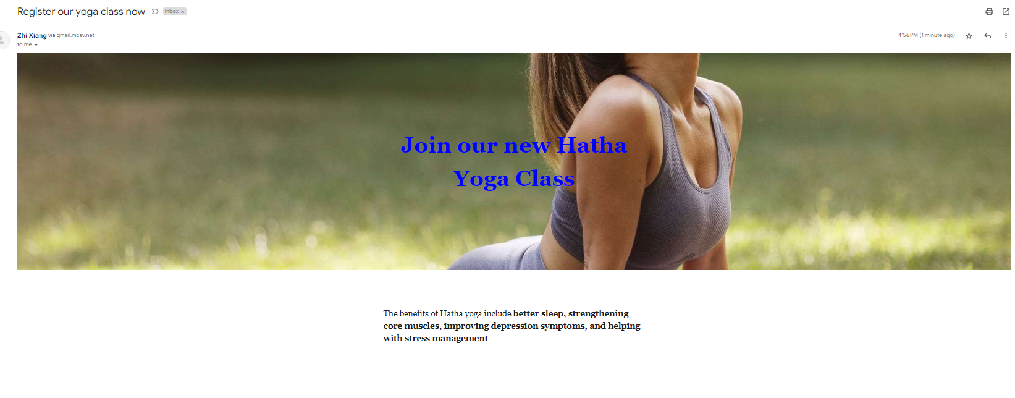



Task 3: Create an email template for ZenFit’s “New Yoga Class” campaign using Mailchimp. Ensure the template aligns with ZenFit’s branding and overall marketing plan. Develop content for the New Yoga Class email that highlights ZenFit’s unique value proposition and reinforces its brand message. Ensure the content appeals to the target audience and emphasizes ZenFit’s competitive advantages.

Take a snap shot at the end of each point and paste the snapshot in the box below. (A4, A5)
Suggestive answers (not exhaustive):





Task 4: Set up an automated workflow in Mailchimp for the email campaign. Include steps such as email triggers, follow-up emails, and conditions for sending.

Take a snap shot at the end of each point and paste the snapshot in the box below. (A6)
Suggestive answers (not exhaustive):
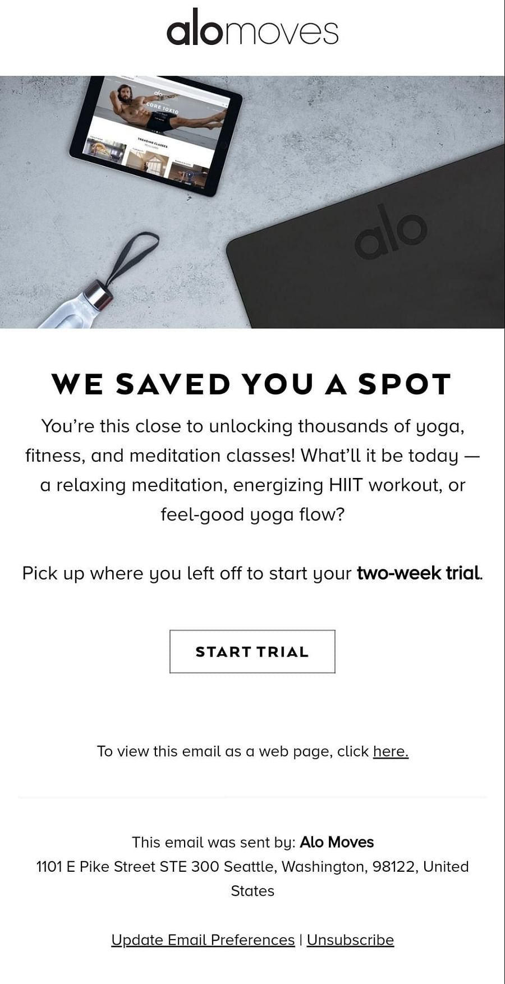
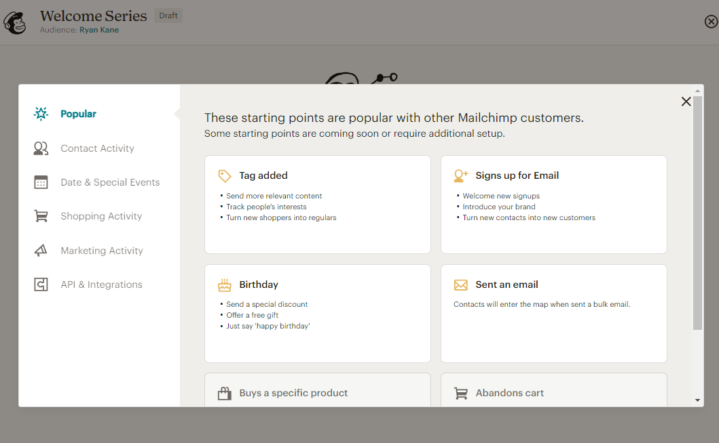

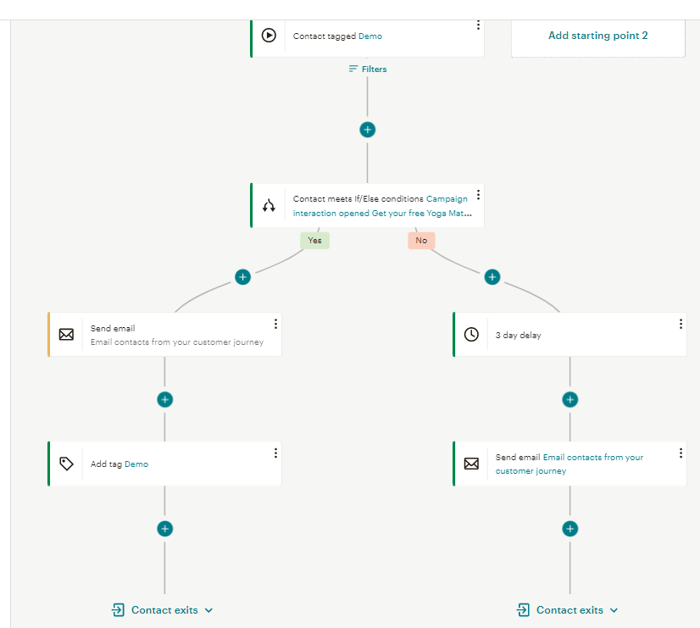

Task 5: Analyze the open rate reports for both the yoga class and yoga mat campaigns. Determine the effectiveness of each campaign by identifying trends and key factors that contributed to their success or failure. Suggest improvements and strategies to enhance future campaigns based on your findings.
Take a snapshot at the end of each point and paste the snapshot in the box below. (A7, A8)
Suggestive answers (not exhaustive):

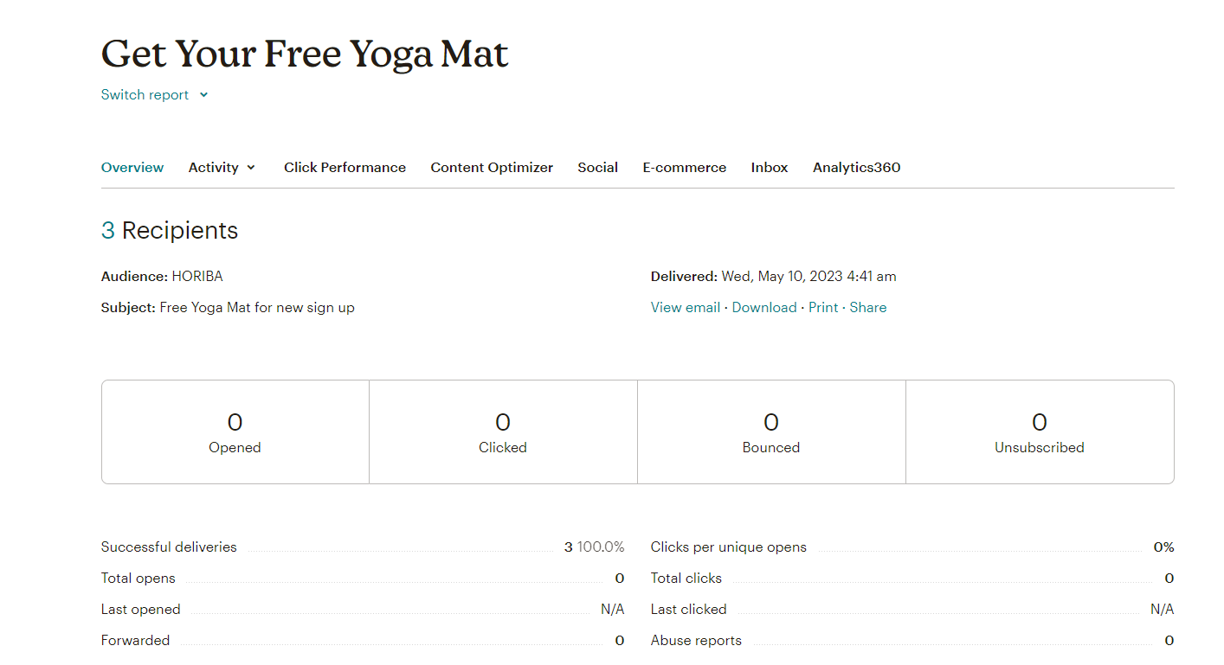

Annex E:
ANSWER PAPER OF Oral Questioning ASSESSMENT

Creating High-Converting Email Campaigns with Mailchimp
Answers to Oral Questioning (OQ)

C: Questions

Question 1: Describe how you would apply drip marketing to your target customers. (K1)

Suggestive answers (not exhaustive):
- generate awareness through SEO, social media, PPC, first email, anything that generate traffics or visitors
- use lead magnet to generate leads in your drip campaign.
- follow through the drip campaign email marketing to convert leads to customers/advocates

Question 2: Describe what is your strategy to segment your email marketing audience. (K2)

Suggestive answers (not exhaustive):
- Segment using demographics or Psychographic criteria
- Use tags, segments or groups to create segments

Question 3: Describe how you plan to automate your email marketing campaign. (K3)

Suggestive answers (not exhaustive):
- Apply drip marketing strategy to generate a series of emails

Question 4: Describe how you plan to improve the open or click rates of your email campaign. (K4)

Suggestive answers (not exhaustive):
- Your click rate essentially tells you how many of your subscribers find your campaign content useful. To improve your click rate, you'll need to create content that's useful to more subscribers. Like open rates, you can sometimes accomplish this by targeting specific content to a smaller, segmented audience.
- To improve open rates, you can considers below
- Make links more effective
- Embed more links
- Testing content with A/B Testing Campaigns

__________________________________________________________________________

