

ASSESSMENT PLAN

For

Data Visualisation with Tableau

TGS Ref No: TGS-2020503177

Conducted by
TERTIARY INFOTECH PTE. LTD.

UEN: 201200696W

Version 4.0
Table of Contents
1. Version Control Record 3
2. Overview of Assessment 4
Assessment Methods 4
Assessment Duration (per candidate) 4
Assessment Venue 5
3. Matrix of Assessment Methods and Evidence Gathering Plan 6
3.1. Knowledge Assessment Matrix 6
3.2. Abilities Assessment Matrix 7
3.3. Evidence Gathering Plan 8
4. Assessment Method Specifications 9
4.1. Assessment Specifications 9
4.1.1. Assessment Specification for Written Assessment - Short-Answer Questions (WA-SAQ) 9
4.1.2. Assessment Specification for Practical Performance (PP) 11
4.1.3. Assessment Specification for Oral Questioning (OQ) 13
5. Assessment Code of Practice 15
6. Assessment Management Organisation 16
6.1. Assessment Appeal Panel 16
6.2. Assessment Manager 16
6.3. Assessor 16
6.4. Appeal Procedures 17
7. Instructions to Assessor 18
8. Instructions to Candidate 19
8.1. Pre-Assessment Information for Candidate 19
9. Assessment Records 20
9.1. Assessment Record for Written Assessment - Short-Answer Questions (WA-SAQ) 20
9.2. Assessment Record for Oral Questioning (OQ) 21
9.3. Assessment Record for Practical Performance (PP) 22
9.4. Assessment Summary Record 23
10. Annexes 25
10.1. Assessment Questions and Answers 25
10.1.1. Annex A: Assessment Questions for WA-SAQ 25
10.1.2. Annex B: Suggested Answer to Assessment Questions for WA-SAQ 25
10.1.3. Annex C: Assessment Questions for PP 25
10.1.4. Annex D: Suggested Answer to Assessment Questions for PP 25
10.1.5. Annex E: Assessment Questions for OQ 25
10.1.6. Annex F: Suggested Answer to Assessment Questions for OQ 25

Version Control Record

Version | Effective Date | Changes | Developer
1.0 | 9 Mar 2020 | For Pilot Launch | Tertiary Infotech
1.1 | 2 Jun 2020 | Modified Oral Questioning | Tertiary Infotech
2.0 | 3 Jul 2024 | Update on the format  Added the appeal procedure  Added evidence collection and submission | Tertiary Infotech
4.0 | 16 Jan 2025 | Revised Assessment Plan Format | Tertiary Infotech

Overview of Assessment

The purpose of this assessment is to evaluate the candidate’s performance for Data Visualisation with Tableau against the following technical skills and competencies (TSC)

Skills Framework: Infocomm Technology
TSC Title: Data Visualization
TSC Code: ICT-DIT-3006-1.1

Assessment Methods

Learning Unit | Assessment Method(s)
LU1: Basic Tableau Features | WA-SAQ, PP, OQ
LU2: Data Visualization | WA-SAQ, PP, OQ
LU3: Data Transformation | WA-SAQ, PP, OQ
LU4: Dashboard and Story | WA-SAQ, PP, OQ
LU5: Calculation & Parameter | WA-SAQ, PP, OQ
LU6: Analytics | WA-SAQ, PP, OQ
Legend: WA-SAQ: Written Assessment (Short Answer Questions), PP: Practical Performance,
CS: Case Study, OQ: Oral Questioning, RP: Role Play

Assessment Duration (per candidate)

Assessment Method(s) | Assessor to Candidate Ratio | Duration
WA-SAQ | 1:3 (Min)  1:20 (Max) | 1 hr
PP | 1:3 (Min)  1:20 (Max) | 1 hr
OQ | 1:1 | 30 mins
Total time |  | 2 hrs 30 mins

Assessment Venue

Assessment Method(s) | Venue
WA-SAQ | Tertiary Infotech or  Client’s Premise
PP
OQ

Matrix of Assessment Methods and Evidence Gathering Plan

Knowledge Assessment Matrix

Knowledge | WA-SAQ | PP | OQ
K1: Interpretation of data analysis and findings | √ | - | √
K2: Types of information displays | √ | - | √
K2: Types of information displays | √ | - | √
K3: Suitability of different data representations and visual displays for different contexts | √ | - | √
K4: Data visualisation tools and techniques | √ | - | √
K5: Elements of data dashboards | √ | - | √

Abilities Assessment Matrix

Ability | WA-SAQ | PP | OQ
A1: Select appropriate visualisation techniques and information displays to convey data and findings | - | √ | -
A2: Organise the presentation of data to reflect trends and correlations in a visually compelling way | - | √ | -
A3: Incorporate appropriate elements to create informative and dynamic data displays | - | √ | -
A4: Develop basic dashboards and scorecards to display internal as well as external benchmark data | - | √ | -
A5: Incorporate interactive graphics, visuals and technical features into the data presentation | - | √ | -
A6: Communicate limitations of data and interpretations of findings | - | √ | -

Evidence Gathering Plan

Assessment Methods | Evidence Gathering Plan
Written Assessment - Short-Answer Questions (WA-SAQ)  Individual, Summative, Open book | Type of Evidence: Written responses to short-answer questions.  Manner of Submission: Candidates will generate answers to the questions and submit the hardcopy to the assessor.  Marking Process: Assessors will evaluate the written responses on the accuracy and comprehensiveness of the answers.  Retention Period: 3 years.
Practical Performance (PP)  Individual, Summative, Open book | Type of Evidence:  - LO1: Candidates will analyze gaming trends and prepare technical briefs that align with state-of-the-art gaming technologies.  - LO2: Candidates will develop a 2D Unity game incorporating localization requirements, third-party services, and live data while maintaining updated technical documentation.  - LO3: Candidates will create a 3D Unity game by collaborating on technology requirements and optimizing workflows for gaming platforms.  Manner of Submission: Candidates will submit Unity project files, technical briefs, and gameplay demos showcasing their developed 2D and 3D games.  Marking Process:  - Alignment with gaming trends and standards.  - Functionality and quality of the Unity games.  - Accuracy and relevance of technical documentation.  Retention Period: All submitted evidence, including Unity project files, technical briefs, and gameplay demos, will be retained for 3 years to ensure compliance with institutional policies and for auditing purposes.
Oral Questioning (OQ)  Individual, Summative, Open book  Individual, Summative | N/A

Assessment Method Specifications

Assessment Specifications

Assessment Specification for Written Assessment - Short-Answer Questions (WA-SAQ)

Specifications | Written Assessment - Short-Answer Questions (WA-SAQ)
Abilities and Knowledge | K2, K3, K4, K5, K1
Duration | 1 hr
Venue | Training room / designated assessment area
Set up | Physical Assessment (Main)  Candidates are required to sit in a manner whereby there is sufficient separation so that they will not be able to interact during the assessment.  Virtual Assessment  LMS  - Questions to be pre-loaded into LMS and opened only to the candidates and during the assessment time.  - Alternatively, assessor will send the questions electronically to candidates only during the assessment time.  Virtual Environment  - Learners to ensure the camera is on all the time and showing their full face.  - Learners to share their whole screen throughout the assessment period  - Assessors to ensure the recording is started before the candidates and remained recordings for every breakout room throughout all the duration of the Assessment.
Pre-assessment instructions for assessors | - Put the candidate at ease  - Explain clearly the purpose and context of the assessment:  - Purpose of the assessment  - Assessment duration  - Assessment methods and tools  - Explain the methods to be used, the standards and criteria for the assessment and the duration of the assessment.  - Explain the procedures of the assessment:  - Check whether candidate has any special requirements e.g. language, special needs, etc.  - Ensure that the following documents are made available  - Assessment Summary Record  - Candidate’s Appeal Form  - Brief candidate on his/her rights and process of appeal  - Identify any allowable adjustments that candidates may require should they have a special need  In addition to the usual pre-assessment instructions, Include instructions on use of:  - Assessment Code of Practice
Pre-assessment instructions for candidates | - Be punctual  - Observe dress code: smart casual  - Request for assessor to repeat questions if question is not clear or if candidate has difficulty understanding assessor's accent  - To specify special needs, if any
Process of conducting assessment | - Verification of candidate’s identity  - Ensure candidates are seated properly so that they will not interact with each other  - Encourage the candidate to seek clarification if any  - Keep in mind the time limit for the assessment
Managing limitations of evidence | - Use of Oral Clarification
Recording Assessment Results | - Record the results in the Assessment Summary Record  - Check that all record forms, timing, dates, names, NRIC, signatures are completed.  - Check that all Assessment Criteria are ticked competent (C) or not yet competent (NYC) in the specific questions. As long as there is a NYC, the candidate is considered not successful in the entire assessment. The candidate is required to re-take the entire assessment.  - Record observation of Competence where applicable in the ‘Evidence of C and NYC must be recorded column  - Record reasons of Not Yet Competence where applicable in the ‘Evidence of C and NYC must be recorded column  - An ‘NYC’ in any K or A will results in an ‘NYC’ in the unit.A candidate is only deemed competent when they achieved a ‘C’ for all the A and K in the unit.
Feedback | - Give clear and constructive feedback to candidate using appropriate language  - Seek clarification and agreement with the candidate on the outcome  - Provide guidance on overcoming gaps in competency  - Ask the candidates to sign the assessment record  - Record the feedback on the assessment record  - Sign off the assessment record  - Assessor should reiterate the appeal process (if the candidate is assessed as not yet competent)

Assessment Specification for Practical Performance (PP)

Specifications | Practical Performance (PP)
Abilities and Knowledge | A1, A2, A3, A4, A5, A6
Duration | 1 hr
Venue | Training room / designated assessment area
Set up | Physical Assessment (Main)  Candidates are required to sit in a manner whereby there is sufficient separation so that they will not be able to interact during the assessment.  Virtual Assessment  LMS  - Questions to be pre-loaded into LMS and opened only to the candidates and during the assessment time.  - Alternatively, assessor will send the questions electronically to candidates only during the assessment time.  Virtual Environment  - Learners to ensure the camera is on all the time and showing their full face.  - Learners to share their whole screen throughout the assessment period  - Assessors to ensure the recording is started before the candidates and remained recordings for every breakout room throughout all the duration of the Assessment.
Pre-assessment instructions for assessors | - Put the candidate at ease  - Explain clearly the purpose and context of the assessment:  - Purpose of the assessment  - Assessment duration  - Assessment methods and tools  - Explain the methods to be used, the standards and criteria for the assessment and the duration of the assessment.  - Explain the procedures of the assessment:  - Check whether candidate has any special requirements e.g. language, special needs, etc.  - Ensure that the following documents are made available  - Assessment Summary Record  - Candidate’s Appeal Form  - Brief candidate on his/her rights and process of appeal  - Identify any allowable adjustments that candidates may require should they have a special need  In addition to the usual pre-assessment instructions, Include instructions on use of:  - Assessment Code of Practice
Pre-assessment instructions for candidates | - Be punctual  - Observe dress code: smart casual  - Request for assessor to repeat questions if question is not clear or if candidate has difficulty understanding assessor's accent  - To specify special needs, if any
Process of conducting assessment | - Verification of candidate’s identity  - Ensure candidates are seated properly so that they will not interact with each other  - Encourage the candidate to seek clarification if any  - Keep in mind the time limit for the assessment
Managing limitations of evidence | - Use of Oral Clarification
Recording Assessment Results | - Record the results in the Assessment Summary Record  - Check that all record forms, timing, dates, names, NRIC, signatures are completed.  - Check that all Assessment Criteria are ticked competent (C) or not yet competent (NYC) in the specific questions. As long as there is a NYC, the candidate is considered not successful in the entire assessment. The candidate is required to re-take the entire assessment.  - Record observation of Competence where applicable in the ‘Evidence of C and NYC must be recorded column  - Record reasons of Not Yet Competence where applicable in the ‘Evidence of C and NYC must be recorded column  - An ‘NYC’ in any K or A will results in an ‘NYC’ in the unit.A candidate is only deemed competent when they achieved a ‘C’ for all the A and K in the unit.
Feedback | - Give clear and constructive feedback to candidate using appropriate language  - Seek clarification and agreement with the candidate on the outcome  - Provide guidance on overcoming gaps in competency  - Ask the candidates to sign the assessment record  - Record the feedback on the assessment record  - Sign off the assessment record  - Assessor should reiterate the appeal process (if the candidate is assessed as not yet competent)

Assessment Specification for Oral Questioning (OQ)

Specifications | Oral Questioning (OQ)
Abilities and Knowledge | K2, K3, K4, K5, K1
Duration | 30 mins
Venue | Training room / designated assessment area
Set up | Physical Assessment (Main)  Candidates are required to sit in a manner whereby there is sufficient separation so that they will not be able to interact during the assessment.  Virtual Assessment  LMS  - Questions to be pre-loaded into LMS and opened only to the candidates and during the assessment time.  - Alternatively, assessor will send the questions electronically to candidates only during the assessment time.  Virtual Environment  - Learners to ensure the camera is on all the time and showing their full face.  - Learners to share their whole screen throughout the assessment period  - Assessors to ensure the recording is started before the candidates and remained recordings for every breakout room throughout all the duration of the Assessment.
Pre-assessment instructions for assessors | - Put the candidate at ease  - Explain clearly the purpose and context of the assessment:  - Purpose of the assessment  - Assessment duration  - Assessment methods and tools  - Explain the methods to be used, the standards and criteria for the assessment and the duration of the assessment.  - Explain the procedures of the assessment:  - Check whether candidate has any special requirements e.g. language, special needs, etc.  - Ensure that the following documents are made available  - Assessment Summary Record  - Candidate’s Appeal Form  - Brief candidate on his/her rights and process of appeal  - Identify any allowable adjustments that candidates may require should they have a special need  In addition to the usual pre-assessment instructions, Include instructions on use of:  - Assessment Code of Practice
Pre-assessment instructions for candidates | - Be punctual  - Observe dress code: smart casual  - Request for assessor to repeat questions if question is not clear or if candidate has difficulty understanding assessor's accent  - To specify special needs, if any
Process of conducting assessment | - Verification of candidate’s identity  - Ensure candidates are seated properly so that they will not interact with each other  - Encourage the candidate to seek clarification if any  - Keep in mind the time limit for the assessment
Managing limitations of evidence | - Use of Oral Clarification
Recording Assessment Results | - Record the results in the Assessment Summary Record  - Check that all record forms, timing, dates, names, NRIC, signatures are completed.  - Check that all Assessment Criteria are ticked competent (C) or not yet competent (NYC) in the specific questions. As long as there is a NYC, the candidate is considered not successful in the entire assessment. The candidate is required to re-take the entire assessment.  - Record observation of Competence where applicable in the ‘Evidence of C and NYC must be recorded column  - Record reasons of Not Yet Competence where applicable in the ‘Evidence of C and NYC must be recorded column  - An ‘NYC’ in any K or A will results in an ‘NYC’ in the unit.A candidate is only deemed competent when they achieved a ‘C’ for all the A and K in the unit.
Feedback | - Give clear and constructive feedback to candidate using appropriate language  - Seek clarification and agreement with the candidate on the outcome  - Provide guidance on overcoming gaps in competency  - Ask the candidates to sign the assessment record  - Record the feedback on the assessment record  - Sign off the assessment record  - Assessor should reiterate the appeal process (if the candidate is assessed as not yet competent)

Assessment Code of Practice

5.1 This code of practice provides:
- Assessors with direction on the standard of practice.
- Candidates with assurance of the standards of practice expected of assessors.
- Employers with assurance of the standards maintained by Tertiary Infotech Pte Ltd in the conduct of assessment.

5.2 The following code of practice is based on the international code of ethics and practice (The National Council for Measurement in Education [NCME]).
  - The differing needs and requirements of the person(s) being assessed, the local enterprise(s) and/or industry are identified and handled with sensitivity.
  - Potential forms of conflict of interest in the assessment process and/or outcomes are identified and appropriate referrals are made, if necessary.
  - All forms of harassment are avoided throughout the planning, conducting, reviewing and reporting of the assessment outcomes.
  - The rights of the candidate(s) are protected during and after the assessment.
  - Personal or interpersonal factors that are not relevant to the assessment of competency must not influence the assessment outcomes.
  - The candidate is made aware of rights and processes of appeal.
  - Evidence that is gathered during the assessment is verified for validity, reliability, authenticity, sufficiency and currency.
  - Assessment decisions are based on available evidence that can be produced and verified by another assessor.
  - Assessments are conducted within the boundaries of the assessment system policies and procedures.
  - Formal agreement is obtained from both the candidate(s) and the assessor that the assessment was carried out in accordance with agreed procedures.
  - Assessment tools, systems, and procedures are consistent with equal opportunity legislation.
  - The candidate is informed of all assessment reporting processes prior to the Assessment.
  - The candidate is informed of all known potential consequences of decisions arising from an assessment, prior to the assessment.
  - Confidentiality is maintained regarding assessment results.
  - Results are only released with the written permission of the candidate(s).
  - The assessment results are used consistently with the purposes explained to the candidate.
  - Self-assessments are periodically conducted to compare current competencies against the required competencies.
  - Professional development opportunities are identified and sought.
  - Opportunities for networking amongst assessors are created and maintained.
  - Opportunities are created for technical assistance in planning, conducting and reviewing assessment procedures and outcomes.

Assessment Management Organisation

Assessment Appeal Panel

Assessment
Appeal Panel

I
Assessment Manager

I
Assessors

Assessment Appeal Panel

- The Assessment Appeal Panel is responsible for reviewing and giving a decision on appeals against a Not-Yet-Competent award
- The panel is comprised of a Management Representative, the Assessment Manager and one Assessor who is independent of the case in question.

Assessment Manager

The Assessment Manger is responsible:

- For the administration and conduct of assessment
- Monitoring and continuous improvement of the assessment process and tools
- For the continuous professional development of the pool of assessors
- Managing the process and outcome of the appeal cases.

Assessor

The Assessor is responsible for conducting the assessment according to the Assessment Plan.

Appeal Procedures

The candidate has the right to challenge the assessment decision made by the Assessor. When giving feedback to the candidate about the assessment, the Assessor must ask the candidate if they agree with the outcome.

If the candidate agrees with the outcome, the Assessor and the candidate must sign the Assessment Outcome record. If the candidate does not agree with the outcome, the candidate should not sign the Assessment Outcome record.

If the candidate intends to appeal against the decision made, he/she should discuss the matter with the Assessor. If he/she is still not satisfied with the decision, the candidate must notify the Assessor of the intention to appeal. The Assessor will enter the intention in the Feedback section of the Assessment Outcome record.

The Assessor will notify training provider of the candidate’s intention to lodge an appeal.

The Assessment Manager will collect information from the Assessor. A separate session will be arranged for the candidate and an independent Assessor appointed by training provider. An outcome agreed by all will conclude the appeal procedure.

A record of the appeal and any subsequent actions and findings will be submitted to SSG for record purposes.

Instructions to Assessor

A. Prior to the Assessment, I... | Tick | Remarks
1. ensured that the candidate is informed regarding the venue and schedule of assessment
2. reviewed the current copies of the performance statement to be assessed, the assessment and evidence gathering plan, the assessment checklist and the organisations standard operating procedures (SOP)
3. reviewed the performance statement and evidence plan to ensure that I clearly understood the instructions and the requirements of the assessment process.
4. identified and accommodated any special needs candidate
5. checked the logistics set up and resources for the assessment.
B. During the Assessment, I:
1. introduced myself and confirmed the identities of the candidates.
2. put the candidates at ease by being friendly and helpful.
3. explained to the candidates the purpose, context and benefits of the assessment.
4. ensured the candidates understood the process of the assessment.
5. gave the candidates an overview of performance statement to be assessed.
6. explained the appeal procedure and the results reporting procedure.
7. encouraged candidates to seek clarifications if in doubt.
8. asked candidates for feedback on the assessment.
9. explained appropriate legal, safety and ethical issues
C. After the Assessment, I:
1. ensured that the candidate was given constructive feedback.
2. completed and signed the Individual Assessment Summary Record and the Assessment Record – Class Summary
3. thanked the candidate for participating in the assessment.

Instructions to Candidate

Pre-Assessment Information for Candidate

Assessors are required to provide candidates with relevant pre-assessment information which includes, but is not limited

- This assessment of a range of assessment methods, including Written Assignment (Q&A), Written Assignment (Case Study) and Oral Questioning. The conduct of assessment may be one-on-one, and, in a group, context as outlined in the Assessment Specifications.
- For these competency elements and the required performance criteria (including range and context) will be assessed. Refer to the Assessment Specifications and ‘Instructions for Candidates’ for a detailed coverage of the assessment requirements.
- You have a right of appeal to assessment decisions in accordance with Tertiary Infotech Pte Ltd appeal procedures
- The conditions for granting a deferred assessment are:
- Medical grounds – a medical report or certificate from registered medical practitioners
- Unexpected and exceptional circumstances which may include (but are not limited to):
- accidents (sporting, motor vehicle, etc.) where an injury is sustained bereavement

Unexpected and exceptional circumstances does not include cases where candidates have mistaken the day, time or venue of assessment.

Assessment Records

Assessment Record for Written Assessment - Short-Answer Questions (WA-SAQ)

Learning Outcomes | TSC Abilities and Knowledge | Please Tick |  | Remarks
 |  | C | NYC
LO1: Learners will be able to apply basic Tableau features for displaying information | K2: Types of information displays
LO2: Learners will be able to synthesize various plots to present data visually | K3: Suitability of different data representations and visual displays for different contexts
LO3: Learners will be able to transform data to create informative and dynamic data display | K4: Data visualisation tools and techniques
LO4: Learners will be able to create dashboards and scorecards to display internal as well as external benchmark data | K5: Elements of data dashboards
LO5: Learners will be able to apply calculation and parameter to create interactive graphics, visuals and technical features into the data presentation. | K2: Types of information displays
LO6: Learners will be able to perform analytics to communicate limitations of data and interpretations of findings. | K1: Interpretation of data analysis and findings
C: Competent; NYC: Not Yet Competent

Assessment Record for Oral Questioning (OQ)

Learning Outcomes | TSC Abilities and Knowledge | Please Tick |  | Remarks
 |  | C | NYC
LO1: Learners will be able to apply basic Tableau features for displaying information | K2: Types of information displays
LO2: Learners will be able to synthesize various plots to present data visually | K3: Suitability of different data representations and visual displays for different contexts
LO3: Learners will be able to transform data to create informative and dynamic data display | K4: Data visualisation tools and techniques
LO4: Learners will be able to create dashboards and scorecards to display internal as well as external benchmark data | K5: Elements of data dashboards
LO5: Learners will be able to apply calculation and parameter to create interactive graphics, visuals and technical features into the data presentation. | K2: Types of information displays
LO6: Learners will be able to perform analytics to communicate limitations of data and interpretations of findings. | K1: Interpretation of data analysis and findings
C: Competent; NYC: Not Yet Competent

Assessment Record for Practical Performance (PP)

Enabling Learning Outcomes | TSC Abilities and Knowledge | Please Tick |  | Remarks
 |  | C | NYC
LO1: Learners will be able to apply basic Tableau features for displaying information | A1: Select appropriate visualisation techniques and information displays to convey data and findings
LO2: Learners will be able to synthesize various plots to present data visually | A2: Organise the presentation of data to reflect trends and correlations in a visually compelling way
LO3: Learners will be able to transform data to create informative and dynamic data display | A3: Incorporate appropriate elements to create informative and dynamic data displays
LO4: Learners will be able to create dashboards and scorecards to display internal as well as external benchmark data | A4: Develop basic dashboards and scorecards to display internal as well as external benchmark data
LO5: Learners will be able to apply calculation and parameter to create interactive graphics, visuals and technical features into the data presentation. | A5: Incorporate interactive graphics, visuals and technical features into the data presentation
LO6: Learners will be able to perform analytics to communicate limitations of data and interpretations of findings. | A6: Communicate limitations of data and interpretations of findings
C: Competent; NYC: Not Yet Competent

Assessment Summary Record

Learning Outcomes | WA-SAQ | PP | OQ | Competence  (Please Tick)  C or NYC
LO1: Learners will be able to apply basic Tableau features for displaying information | √ | √ | √
LO2: Learners will be able to synthesize various plots to present data visually | √ | √ | √
LO3: Learners will be able to transform data to create informative and dynamic data display | √ | √ | √
LO4: Learners will be able to create dashboards and scorecards to display internal as well as external benchmark data | √ | √ | √
LO5: Learners will be able to apply calculation and parameter to create interactive graphics, visuals and technical features into the data presentation. | √ | √ | √
LO6: Learners will be able to perform analytics to communicate limitations of data and interpretations of findings. | √ | √ | √
Legend: WA-SAQ: Written Assessment (Short Answer Questions), PP: Practical Performance, CS: Case Study, OQ: Oral Questioning, RP: Role Play,
NA: Not Applicable, C: Competent, NYC: Not Yet Competent
This candidate has been assessed as

COMPETENT
NOT YET COMPETENT

Candidate Name (As in NRIC) |  | Assessor Name
NRIC (Last 3 digits & alphabet) |  | NRIC (Last 3 digits & alphabet)
Candidate Signature |  | Assessor Signature
Date: |  | Date:
By signing, the candidate is agreeing to accept the assessment outcome |  | By signing, the assessor is agreeing to have duly assessed the performance criteria and underpinning knowledge as required in the competence units

Feedback on outcome by Assessor/ Feedback by candidate:

{Feedback on the overall performance or in the case of NYC; any area of skills gap and improvement needed}

Annexes

Assessment Questions and Answers

Annex A: Assessment Questions for WA-SAQ

Annex B: Suggested Answer to Assessment Questions for WA-SAQ

Annex C: Assessment Questions for PP

Annex D: Suggested Answer to Assessment Questions for PP

Annex E: Assessment Questions for OQ

Annex F: Suggested Answer to Assessment Questions for OQ

Annex A:
QUESTION PAPER OF WA (SAQ) ASSESSMENT

Data Visualisation with Tableau
Written Assessment (SAQ)

A: Trainee Information:

Trainee Name (as Per NRIC): _______________________________

Last 3 digits and alphabet of NRIC/FIN: _________________

Date: __________________

B: Instruction to Candidates

1. This is an individual exercise
2. This is an open book assessment
3. A total of 1 hr is given to complete the written assessment
4. Submit your answers on the document provided

C: Short Answer Questions

Question 1: You are working for a retail company that tracks monthly sales data across multiple stores. The goal is to understand sales trends and seasonal patterns to improve inventory management and marketing strategies. What type of data analysis techniques can be applied to time series data? (K1)

Question 2: You are working on a project to analyze customer purchase data for a retail store. The goal is to generate insights on customer behavior and sales performance. What is the difference between Dimensions and Measures? (K2)

Question 3: You work for a retail chain and are tasked with analyzing the relationship between sales and profit to identify which products or stores are performing well financially. You want to create a visual representation that helps in understanding how sales impact profit and whether there are any trends or patterns. How would you plot [Sales] and [Profit] data fields and visualize them together? (K3)

Question 4: You work for a multinational retail company that sells products in various countries. Your goal is to identify and analyze countries where the total sales exceed $10,000. This will help you focus on regions with significant sales activity and evaluate their performance more closely.
What filter would your use to isolate countries with SUM([Sales]) above $10000 (K4)

Question 5: You are developing a sales performance dashboard for a regional sales team at a company. The goal is to make the dashboard interactive so that team members can explore the data in more depth and gain insights tailored to their specific needs.
Name any three actions to add interactivity to a Dashboard.(K5)

___________________________________________________________________
For Official Use Only

Grade: _____ (C / NYC)

Assessor Name: _______________ Assessor NRIC: _____________

Date: ________________________ Signature: _________________

Please create a subfolder named YYYY-MM-DD/DD_<<Trainer Name>> and upload all the learner's assessments to the respective Google Drive.
Please email erra@tertiaryinfotech.com after you have uploaded the assessment.

Annex B:
SUGGESTED ANSWER TO WA (SAQ) ASSESSMENT QUESTIONS

Answers to Data Visualisation with Tableau
Written Assessment (SAQ)

C: Questions and Answers

Question 1:
You are working for a retail company that tracks monthly sales data across multiple stores. The goal is to understand sales trends and seasonal patterns to improve inventory management and marketing strategies.

What type of data analysis techniques can be applied to time series data? (K1)
Suggestive (non exhaustive):

- Trend Analysis
- Forecasting

Question 2:
You are working on a project to analyze customer purchase data for a retail store. The goal is to generate insights on customer behavior and sales performance.

What is the difference between Dimensions and Measures? (K2)
Suggestive (non exhaustive):

- Dimensions measure categorical data
- Dimesions pill are blue
- Measure measure numerical data
- Measures pill are green

Question 3:
You work for a retail chain and are tasked with analyzing the relationship between sales and profit to identify which products or stores are performing well financially. You want to create a visual representation that helps in understanding how sales impact profit and whether there are any trends or patterns.
How would you plot [Sales] and [Profit] data fields and visualize them together? (K3)
Suggestive (non exhaustive)

- Scatterplot

Question 4:
You work for a multinational retail company that sells products in various countries. Your goal is to identify and analyze countries where the total sales exceed $10,000. This will help you focus on regions with significant sales activity and evaluate their performance more closely.
What filter would your use to isolate countries with SUM([Sales]) above $10000 (K4)
Suggestive (non exhaustive)

- Conditional filter

Question 5:
You are developing a sales performance dashboard for a regional sales team at a company. The goal is to make the dashboard interactive so that team members can explore the data in more depth and gain insights tailored to their specific needs.

Name any three actions to add interactivity to a Dashboard.(K5)
Suggestive (non exhaustive)

- Filter
- Highlight
- Go to URL
- Go to Sheet

Annex C:
QUESTION PAPER OF PP ASSESSMENT

Data Visualization with Tableau
Practical Performance Assessment

A: Trainee Information:

Trainee Name (as Per NRIC): _______________________________

Last 3 digits and alphabet of NRIC/FIN: _________________

Date: __________________

B: Assessment Instruction

This is a Practicum Performance Assessment
Duration: 60 mins

1. This is an open book exam that must be completed individually.
2. You need to use Tableau Desktop or Tableau Public.

Submission Procedure:

1. Name your file as this format TGS-2020503177_JohnTan_XXXX567A
2. Save your work as Tableau packaged workbook format (.twbx)
3. Email your file to the assessor

Practical Performance:

Scenario: TechFusion, a data analytics firm, has been hired by a retail company to analyze their sales data from the year 2016. The company wants to identify trends, understand market performance, and visualize sales data to make informed business decisions. Using Tableau, TechFusion needs to create various visualizations and dashboards that will help the retail company better understand their sales performance and product success across different markets and categories.

Download the two datasets Sales 2016.xls and Products 2016.csv from Google Classroom.
Here are the google links to the 2 files
https://docs.google.com/spreadsheets/d/1n-EEvgsXrAk4OlRKUCpte1ydy7fnIMB7/edit?usp=sharing&ouid=110436939998412125668&rtpof=true&sd=true
https://drive.google.com/file/d/14rZ0oEMEdCLSfHq7MSBd1QKoI4reFtg7/view?usp=sharing

Task 1: The retail company’s marketing team wants to understand the overall sales performance across different markets to allocate their advertising budget effectively. Given the datasets "Sales 2016.xls" and "Products 2016.csv," create an inner join using the two worksheets. Create a worksheet named 'Sales vs Market' and plot a bar chart of SUM([Sales]) vs Market. Add [Category] to the ‘Color’ mark to differentiate the categories visually.

Take a snap shot at the end of each point and paste the snapshot in the box below: (A1)
Task 2: The sales department needs a clear visualization of how sales have changed over time to forecast future sales and plan inventory. Create a second worksheet titled 'Sales vs Time'. Plot a time series graph with the ‘Quarter’ as the breakdown for SUM([Sales]) versus [OrderDate]. Add the [Category] field to the ‘Color’ mark to visualize the different categories.

Take a snap shot at the end of each point and paste the snapshot in the box below: (A2)

Task 3: The product management team wants to compare the sales performance of different sub-categories within the Asia Pacific market to determine which products to focus on. Create a third worksheet 'Sales vs Sub-Category'. Plot a barchart of SUM([Sales]) vs [Subcategory]. Add [Sales] into the ‘Label’ mark. Add [Market] into the ‘Filter’ mark to filter only data from ‘Asia Pacific’ market. Sort the SUM([Sales]) in descending order (A3)

Take a snap shot at the end of each point and paste the snapshot in the box below: (A3)

Task 4: The executive team wants a comprehensive dashboard that provides an interactive view of sales data across different dimensions to make strategic decisions. Create a single dashboard using the previous 3 worksheets created in the tasks above. Add ‘Filter’ action (for dashboard) for each of the 3 graphs, to create an interactive dashboard.

Take a snap shot at the end of each point and paste the snapshot in the box below: (A4)

Task 5: The finance team needs to analyze sales performance by individual product IDs and filter out low-performing products to streamline inventory management. Create a fourth worksheet 'Sales vs Product ID'. Plot SUM([Sales]) vs Product ID and sort by [Sales]. Create a parameter 'Threshold' - integer, range from 0 to 85000, step size 100. Display the parameter on the right. Put [Product ID] into the Filter and use ‘Conditional Filter] to filter products above the Threshold parameter.

Take a snap shot at the end of each point and paste the snapshot in the box below: (A5)

Task 6: The analytics team needs to highlight products with exceptionally high sales and understand their performance relative to the average to make recommendations for future product lines. For the worksheet 'Sales vs Product ID', use the parameter created in Task 5 and filter for only products with SUM[(Sales)] above 30,000 . Add an ‘Average Line’ into the pane.

Take a snap shot at the end of each point and paste the snapshot in the box below: (A6)

_____________________________________________________________________________
For Official Use Only

Candidate has successfully completed all the tasks for PP and is able to explain the overall functions and features used to achieve these tasks.

Grade: _____ (C / NYC)

Assessor Name: _______________ Assessor NRIC: _____________

Date: ________________________ Signature: _________________

Please create a subfolder named YYYY-MM-DD/DD_<<Trainer Name>> and upload all the learner's assessments to the respective Google Drive.
Please email erra@tertiaryinfotech.com after you have uploaded the assessment.

Annex D:
SUGGESTED ANSWER TO PP ASSESSMENT QUESTIONS

Data Visualization with Tableau
Answers to Practical Performance Assessment

Practical Performance:

Task 1:
The retail company’s marketing team wants to understand the overall sales performance across different markets to allocate their advertising budget effectively. Given the datasets "Sales 2016.xls" and "Products 2016.csv," create an inner join using the two worksheets. Create a worksheet named 'Sales vs Market' and plot a bar chart of SUM([Sales]) vs Market. Add [Category] to the ‘Color’ mark to differentiate the categories visually.

Take a snap shot at the end of each point and paste the snapshot in the box below: (A1)
Suggestive answers (not exhaustive):

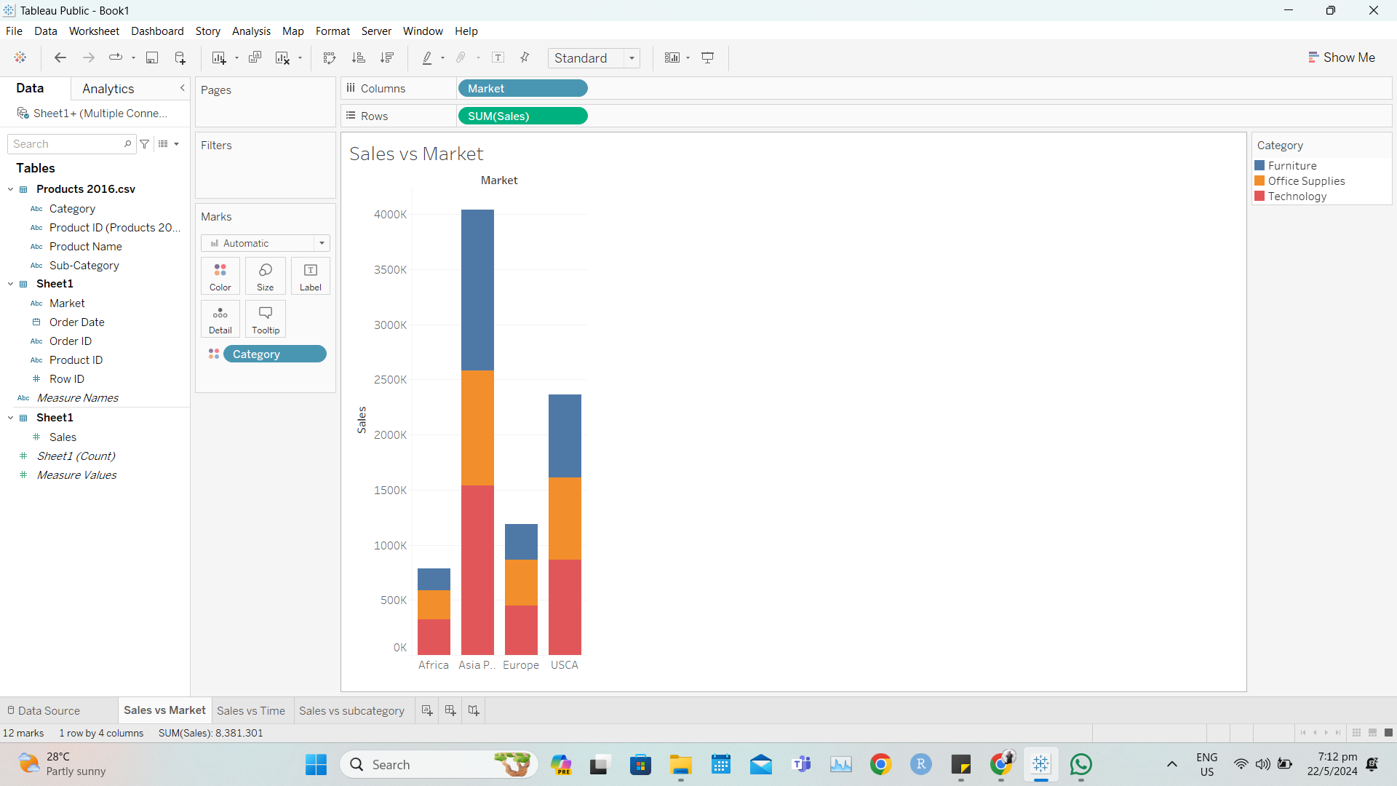
Task 2:
The sales department needs a clear visualization of how sales have changed over time to forecast future sales and plan inventory. Create a second worksheet titled 'Sales vs Time'. Plot a time series graph with the ‘Quarter’ as the breakdown for SUM([Sales]) versus [OrderDate]. Add the [Category] field to the ‘Color’ mark to visualize the different categories.

Take a snap shot at the end of each point and paste the snapshot in the box below: (A2)
Suggestive answers (not exhaustive):

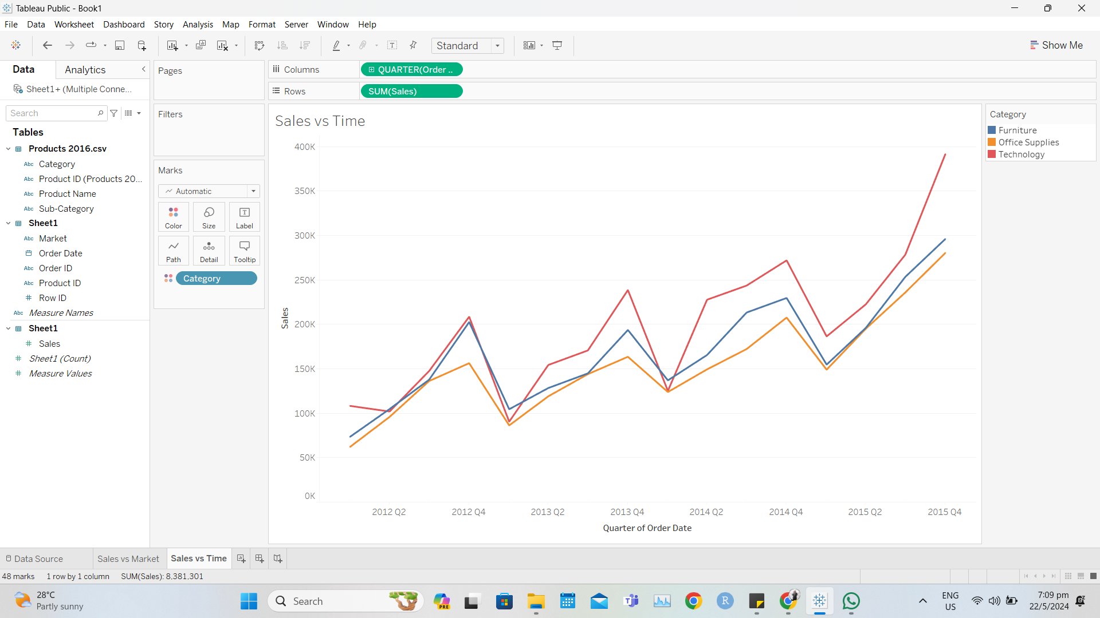

Task 3:
The product management team wants to compare the sales performance of different sub-categories within the Asia Pacific market to determine which products to focus on. Create a third worksheet 'Sales vs Sub-Category'. Plot a barchart of SUM([Sales]) vs [Subcategory]. Add [Sales] into the ‘Label’ mark. Add [Market] into the ‘Filter’ mark to filter only data from ‘Asia Pacific’ market. Sort the SUM([Sales]) in descending order (A3)

Take a snap shot at the end of each point and paste the snapshot in the box below: (A3)
Suggestive answers (not exhaustive):

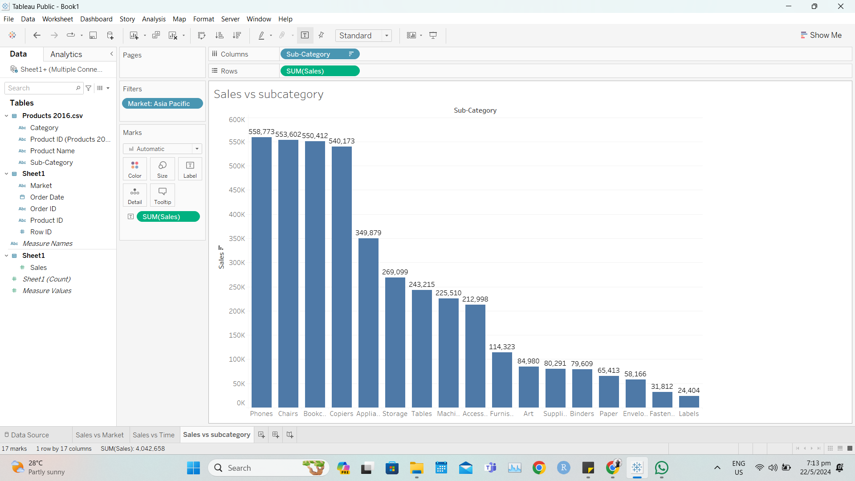

Task 4:
The executive team wants a comprehensive dashboard that provides an interactive view of sales data across different dimensions to make strategic decisions. Create a single dashboard using the previous 3 worksheets created in the tasks above. Add ‘Filter’ action (for dashboard) for each of the 3 graphs, to create an interactive dashboard.

Take a snap shot at the end of each point and paste the snapshot in the box below: (A4)
Suggestive answers (not exhaustive):

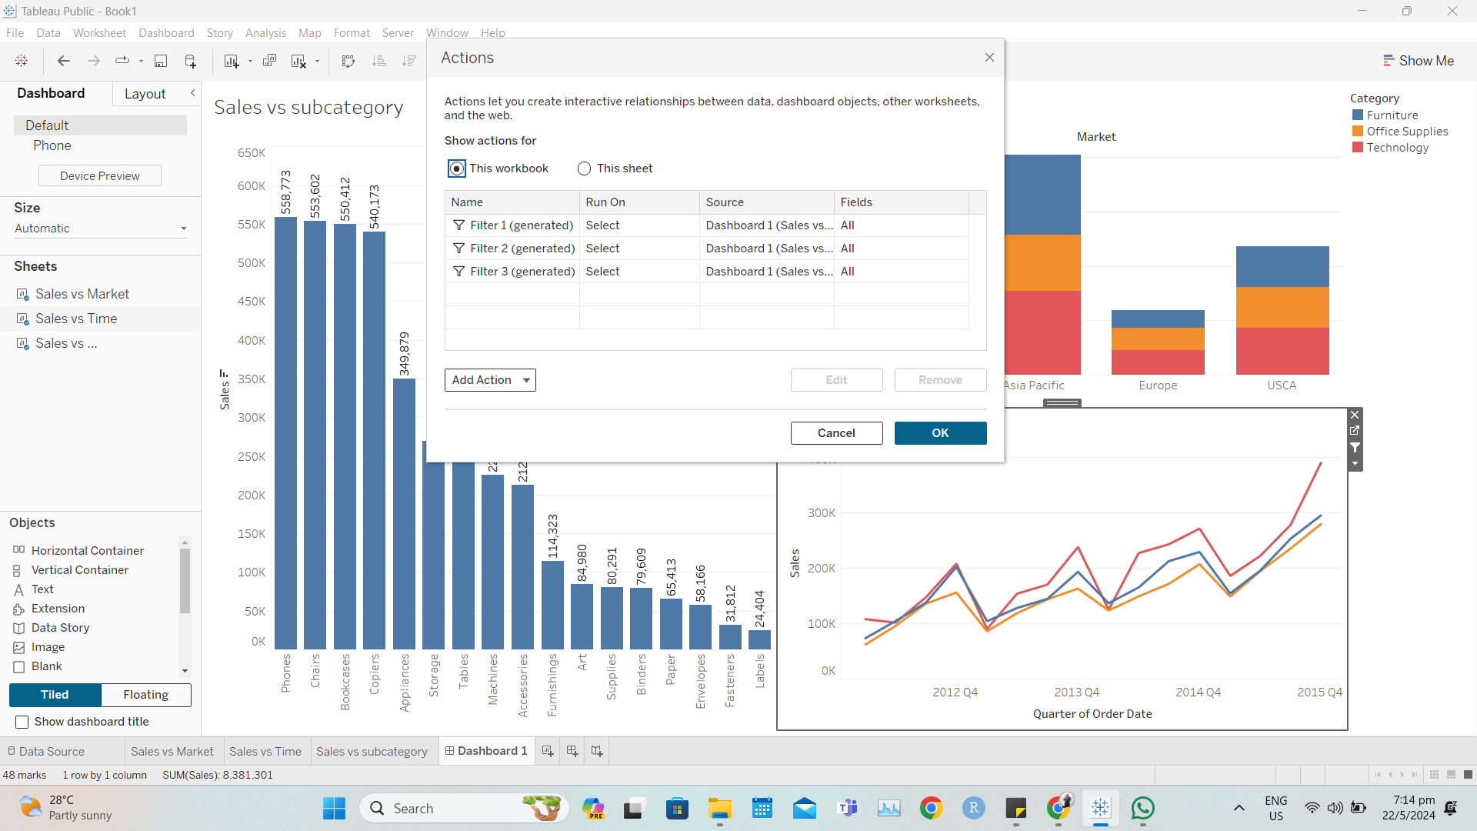

Task 5:
The finance team needs to analyze sales performance by individual product IDs and filter out low-performing products to streamline inventory management. Create a fourth worksheet 'Sales vs Product ID'. Plot SUM([Sales]) vs Product ID and sort by [Sales]. Create a parameter 'Threshold' - integer, range from 0 to 85000, step size 100. Display the parameter on the right. Put [Product ID] into the Filter and use ‘Conditional Filter] to filter products above the Threshold parameter.

Take a snap shot at the end of each point and paste the snapshot in the box below: (A5)
Suggestive answers (not exhaustive):

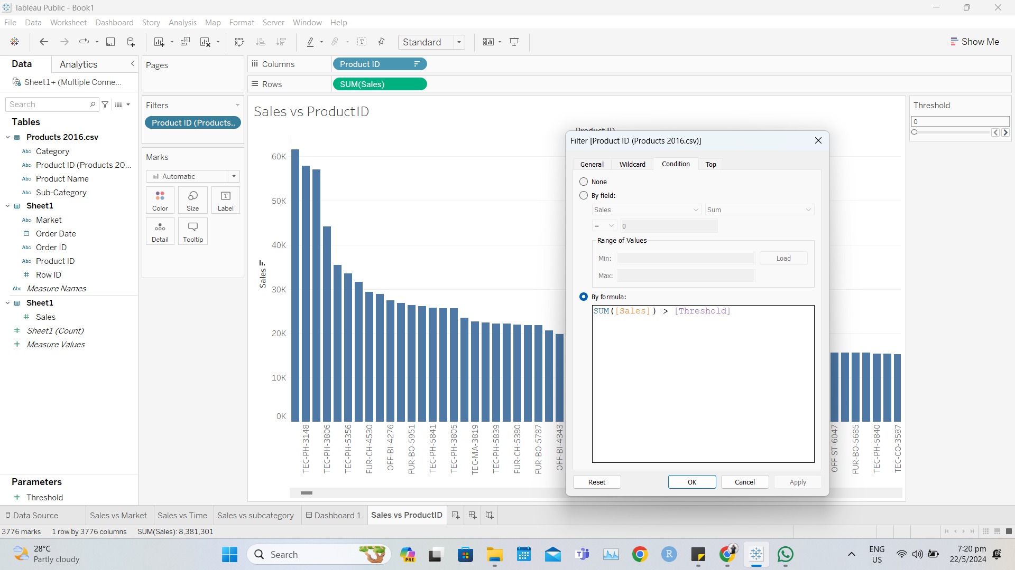

Task 6:
The analytics team needs to highlight products with exceptionally high sales and understand their performance relative to the average to make recommendations for future product lines. For the worksheet 'Sales vs Product ID', use the parameter created in Task 5 and filter for only products with SUM[(Sales)] above 30,000 . Add an ‘Average Line’ into the pane.

Take a snap shot at the end of each point and paste the snapshot in the box below: (A6)
Suggestive answers (not exhaustive):

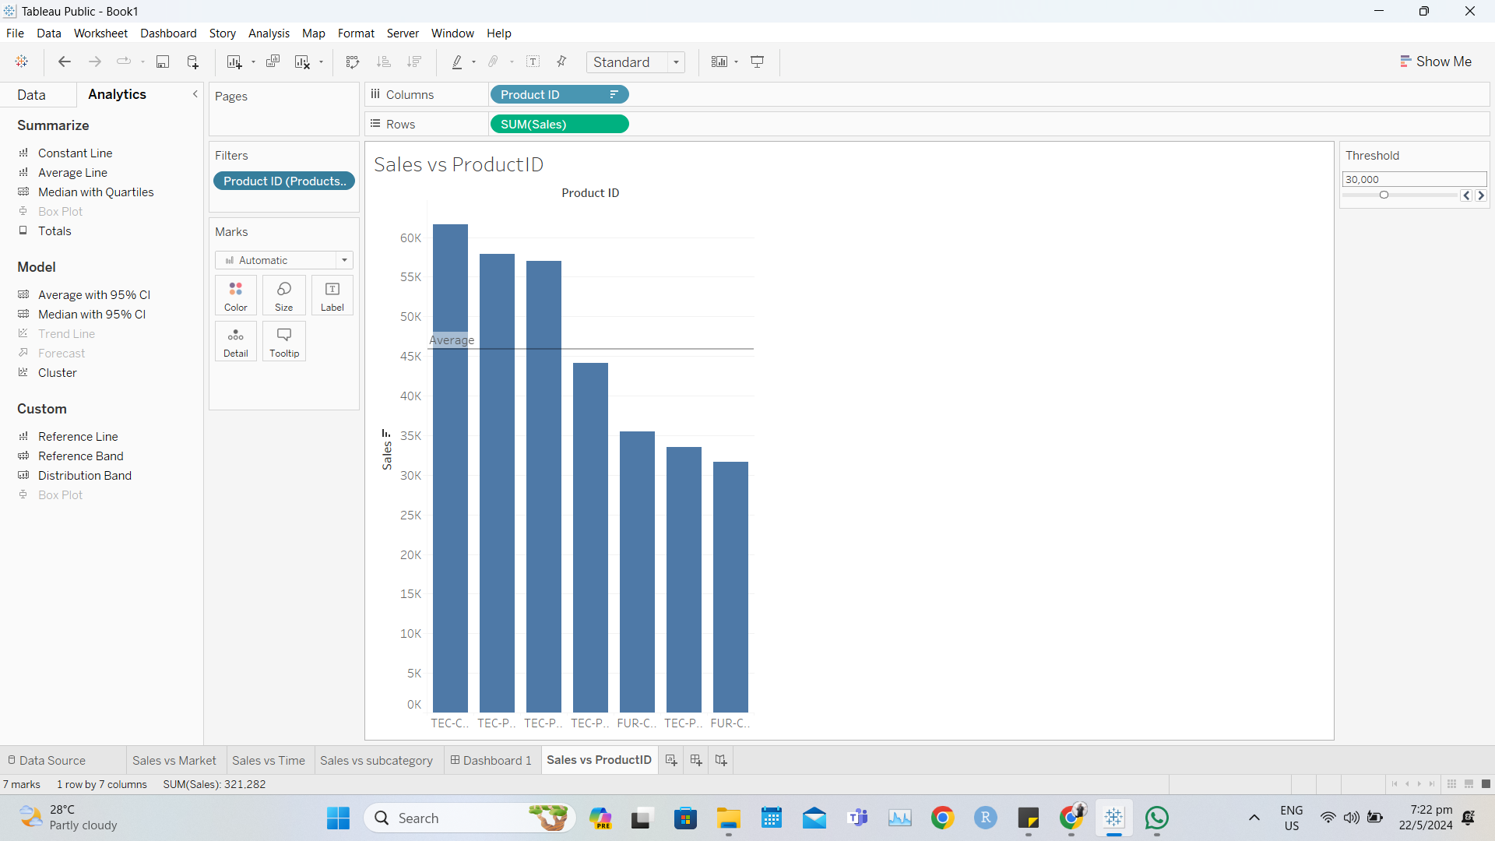

Annex E:
SUGGESTED ANSWER TO Oral Questioning ASSESSMENT QUESTIONS

Data Visualisation with Tableau
Answers to Oral Questioning (OQ)

Question 1: What is the purpose of cluster analysis? (K1)
Suggestive answers (not exhaustive):
To identify data that are similar or close eg customers with different purchasing power, or customers with different buying preferences.

Question 2: What are various types of aggregate functions available in the calculation? (K2)
Suggestive answers (not exhaustive):
- AVG
- COUNT
- MEDIAN
- STDEV

Question 3: If you want to show the relationship between sales and profit for different markets, which plot would you recommend? (K3)
Suggestive answers (not exhaustive):
- Scatter plot, coloured by the markets
- Stacked bar plots for different markets

Question 4: If you want to show the sales of top 5 best-selling products for Singapore, how would you display the data? (K4)
Suggestive answers (not exhaustive):
- Use context filter to select Singapore
- Use Top filter to select the top 5 best-selling products

Question 5: What are the actions that you can use for dashboards to create interactivity? (K5)
Suggestive answers (not exhaustive):
- Filter
- Highlight
- URL
- Goto
- Set
- Parameter

