

ASSESSMENT PLAN

For

Mastering Prompt Engineering for Generative AI Content Creation

TGS Ref No: TGS-2023036153

Conducted by
Tertiary Infotech Pte Ltd

UEN: 201200696W

Version 4.0
Table of Contents
1. Version Control Record 4
2. Overview of Assessment 5
Assessment Methods 5
Assessment Duration (per candidate) 5
Assessment Venue 6
3. Matrix of Assessment Methods and Evidence Gathering Plan 6
3.1. Knowledge Assessment Matrix 6
3.2. Abilities Assessment Matrix 6
3.3. Evidence Gathering Plan 7
4. Assessment Method Specifications 8
4.1. Assessment Specifications 8
4.1.1. Assessment Specification for Written Assessment - Short-Answer Questions 8
4.1.2. Assessment Specification for Practical Performance 10
5. Assessment Code of Practice 12
6. Assessment Management Organisation 13
6.1. Assessment Appeal Panel 13
6.2. Assessment Manager 13
6.3. Assessor 13
6.4. Appeal Procedures 14
7. Instructions to Assessor 15
8. Instructions to Candidate 16
8.1. Pre-Assessment Information for Candidate 16
9. Assessment Records 17
9.1. Assessment Record for Written Assessment - Short-Answer Questions 17
9.2. Assessment Record for Practical Performance 18
9.3. Assessment Summary Record 19
10. Annexes 21
10.1. Assessment Questions and Answers 21
10.1.1. Annex A: Assessment Questions for WA-SAQ 21
10.1.2. Annex B: Suggested Answer to Assessment Questions for WA-SAQ 21
10.1.3. Annex C: Assessment Questions for PP 21
10.1.4. Annex D: Suggested Answer to Assessment Questions for PP 21

Version Control Record

Version | Effective Date | Changes | Developer
1.0 | 18 Feb 2023 | For Pilot Launch | Tertiary Infotech
2.0 | 31 Jul 2024 | Update on the format  Added the appeal procedure  Added evidence collection and submission | Tertiary Infotech
3.0 | 08 Jan 2025 | Added Assessment Questions Answers into Annex D | Tertiary Infotech
4.0 | 26 Jan 2025 | Revised Assessment Plan Format | Tertiary Infotech

Overview of Assessment

The purpose of this assessment is to evaluate the candidate’s performance for Mastering Prompt Engineering for Generative AI Content Creation against the following technical skills and competencies (TSC)

Skills Framework: Infocomm Technology
TSC Title: Content Strategy
TSC Code: ICT-SNM-4004-1.1

Assessment Methods

Learning Unit | Assessment Method(s)
LU1: Conceptualize content ideas with prompt engineering to meet marketing objectives and map out digital storyboards as part of a content strategy. | WA-SAQ, PP
LU2: Identify content requirements with prompt engineering based on evaluation of customers and potential customer preferences and determine frequency of delivering marketing content. | WA-SAQ, PP
LU3: Determine types and styles of content to be delivered to customers with prompt engineering and decide on modes and processes for distributing content. | WA-SAQ, PP
LU4: Develop guidelines for content strategy execution using appropriate modes of content delivery for marketing. | WA-SAQ, PP
Legend: WA-SAQ: Written Assessment (Short Answer Questions), PP: Practical Performance,
CS: Case Study, OQ: Oral Questioning, RP: Role Play

Assessment Duration (per candidate)

Assessment Method(s) | Assessor to Candidate Ratio | Duration
WA-SAQ | 1:3 (Min)  1:20 (Max) | 1 hr
PP | 1:3 (Min)  1:20 (Max) | 1 hr
Total time |  | 2 hrs

Assessment Venue

Assessment Method(s) | Venue
WA-SAQ | Tertiary Infotech or  Client’s Premise
PP

Matrix of Assessment Methods and Evidence Gathering Plan

Knowledge Assessment Matrix

Knowledge | WA-SAQ | PP
K1: Principles of digital storytelling | √ | -
K2: Potential customers' evolving preferences of content types, styles and modes of delivery | √ | -
K3: Process of developing digital storyboard | √ | -
K4: Parameters of delivering content for marketing purposes | √ | -
K5: Features of marketing content | √ | -
K6: Modes of content delivery for marketing | √ | -

Abilities Assessment Matrix

Ability | WA-SAQ | PP
A1: Conceptualise content ideas to meet marketing objectives | - | √
A2: Map out digital storyboards as part of a content strategy | - | √
A3: Identify content requirements based on evaluation of customers and potential customer preferences | - | √
A4: Determine frequency of delivering marketing content to customers | - | √
A5: Determine types and styles of content to be delivered to customers | - | √
A6: Determine modes and processes for distributing content. | - | √
A7: Develop guidelines for content strategy execution | - | √

Evidence Gathering Plan

Assessment Methods | Evidence Gathering Plan
Written Assessment - Short-Answer Questions  Individual, Summative, Open book | Type of Evidence: Written responses to short-answer questions.  Manner of Submission: Candidates will generate answers to the questions and submit the hardcopy to the assessor.  Marking Process: Assessors will evaluate the written responses on the accuracy and comprehensiveness of the answers.  Retention Period: 3 years.
Practical Performance  Individual, Summative, Open book | Type of Evidence:  - LO1: Candidates will create a digital storyboard using prompt engineering to meet specified marketing objectives.  - LO2: Candidates will evaluate potential customer preferences and submit a content strategy plan detailing frequency and requirements using prompt engineering.  - LO3: Candidates will produce and submit a content distribution plan using prompt engineering to determine content types, styles, and delivery modes.  - LO4: Candidates will develop and submit guidelines for content strategy execution focusing on appropriate modes of marketing content delivery.  Manner of Submission:  - Candidates will submit their digital storyboard, content strategy plan, content distribution plan, and guideline documents electronically through the learning management system.  Marking Process:  - Effectiveness of Content Strategy.  - Quality of Content Solutions.  - Alignment with Marketing Objectives.  Retention Period: All submitted evidence, including digital storyboard, strategy plans, and guidelines, will be retained for 3 years for auditing and compliance purposes.

Assessment Method Specifications

Assessment Specifications

Assessment Specification for Written Assessment - Short-Answer Questions

Specifications | Written Assessment - Short-Answer Questions
Abilities and Knowledge | K1, K2, K4, K3, K5, K6
Duration | 1 hr
Venue | Training room / designated assessment area
Set up | Physical Assessment (Main)  Candidates are required to sit in a manner whereby there is sufficient separation so that they will not be able to interact during the assessment.  Virtual Assessment  LMS  - Questions to be pre-loaded into LMS and opened only to the candidates and during the assessment time.  - Alternatively, assessor will send the questions electronically to candidates only during the assessment time.  Virtual Environment  - Learners to ensure the camera is on all the time and showing their full face.  - Learners to share their whole screen throughout the assessment period  - Assessors to ensure the recording is started before the candidates and remained recordings for every breakout room throughout all the duration of the Assessment.
Pre-assessment instructions for assessors | - Put the candidate at ease  - Explain clearly the purpose and context of the assessment:  - Purpose of the assessment  - Assessment duration  - Assessment methods and tools  - Explain the methods to be used, the standards and criteria for the assessment and the duration of the assessment.  - Explain the procedures of the assessment:  - Check whether candidate has any special requirements e.g. language, special needs, etc.  - Ensure that the following documents are made available  - Assessment Summary Record  - Candidate’s Appeal Form  - Brief candidate on his/her rights and process of appeal  - Identify any allowable adjustments that candidates may require should they have a special need  In addition to the usual pre-assessment instructions, Include instructions on use of:  - Assessment Code of Practice
Pre-assessment instructions for candidates | - Be punctual  - Observe dress code: smart casual  - Request for assessor to repeat questions if question is not clear or if candidate has difficulty understanding assessor's accent  - To specify special needs, if any
Process of conducting assessment | - Verification of candidate’s identity  - Ensure candidates are seated properly so that they will not interact with each other  - Encourage the candidate to seek clarification if any  - Keep in mind the time limit for the assessment
Managing limitations of evidence | - Use of Oral Clarification
Recording Assessment Results | - Record the results in the Assessment Summary Record  - Check that all record forms, timing, dates, names, NRIC, signatures are completed.  - Check that all Assessment Criteria are ticked competent (C) or not yet competent (NYC) in the specific questions. As long as there is a NYC, the candidate is considered not successful in the entire assessment. The candidate is required to re-take the entire assessment.  - Record observation of Competence where applicable in the ‘Evidence of C and NYC must be recorded column  - Record reasons of Not Yet Competence where applicable in the ‘Evidence of C and NYC must be recorded column  - An ‘NYC’ in any K or A will results in an ‘NYC’ in the unit.A candidate is only deemed competent when they achieved a ‘C’ for all the A and K in the unit.
Feedback | - Give clear and constructive feedback to candidate using appropriate language  - Seek clarification and agreement with the candidate on the outcome  - Provide guidance on overcoming gaps in competency  - Ask the candidates to sign the assessment record  - Record the feedback on the assessment record  - Sign off the assessment record  - Assessor should reiterate the appeal process (if the candidate is assessed as not yet competent)

Assessment Specification for Practical Performance

Specifications | Practical Performance
Abilities and Knowledge | A1, A2, A3, A4, A5, A6, A7
Duration | 1 hr
Venue | Training room / designated assessment area
Set up | Physical Assessment (Main)  Candidates are required to sit in a manner whereby there is sufficient separation so that they will not be able to interact during the assessment.  Virtual Assessment  LMS  - Questions to be pre-loaded into LMS and opened only to the candidates and during the assessment time.  - Alternatively, assessor will send the questions electronically to candidates only during the assessment time.  Virtual Environment  - Learners to ensure the camera is on all the time and showing their full face.  - Learners to share their whole screen throughout the assessment period  - Assessors to ensure the recording is started before the candidates and remained recordings for every breakout room throughout all the duration of the Assessment.
Pre-assessment instructions for assessors | - Put the candidate at ease  - Explain clearly the purpose and context of the assessment:  - Purpose of the assessment  - Assessment duration  - Assessment methods and tools  - Explain the methods to be used, the standards and criteria for the assessment and the duration of the assessment.  - Explain the procedures of the assessment:  - Check whether candidate has any special requirements e.g. language, special needs, etc.  - Ensure that the following documents are made available  - Assessment Summary Record  - Candidate’s Appeal Form  - Brief candidate on his/her rights and process of appeal  - Identify any allowable adjustments that candidates may require should they have a special need  In addition to the usual pre-assessment instructions, Include instructions on use of:  - Assessment Code of Practice
Pre-assessment instructions for candidates | - Be punctual  - Observe dress code: smart casual  - Request for assessor to repeat questions if question is not clear or if candidate has difficulty understanding assessor's accent  - To specify special needs, if any
Process of conducting assessment | - Verification of candidate’s identity  - Ensure candidates are seated properly so that they will not interact with each other  - Encourage the candidate to seek clarification if any  - Keep in mind the time limit for the assessment
Managing limitations of evidence | - Use of Oral Clarification
Recording Assessment Results | - Record the results in the Assessment Summary Record  - Check that all record forms, timing, dates, names, NRIC, signatures are completed.  - Check that all Assessment Criteria are ticked competent (C) or not yet competent (NYC) in the specific questions. As long as there is a NYC, the candidate is considered not successful in the entire assessment. The candidate is required to re-take the entire assessment.  - Record observation of Competence where applicable in the ‘Evidence of C and NYC must be recorded column  - Record reasons of Not Yet Competence where applicable in the ‘Evidence of C and NYC must be recorded column  - An ‘NYC’ in any K or A will results in an ‘NYC’ in the unit.A candidate is only deemed competent when they achieved a ‘C’ for all the A and K in the unit.
Feedback | - Give clear and constructive feedback to candidate using appropriate language  - Seek clarification and agreement with the candidate on the outcome  - Provide guidance on overcoming gaps in competency  - Ask the candidates to sign the assessment record  - Record the feedback on the assessment record  - Sign off the assessment record  - Assessor should reiterate the appeal process (if the candidate is assessed as not yet competent)

Assessment Code of Practice

5.1 This code of practice provides:
- Assessors with direction on the standard of practice.
- Candidates with assurance of the standards of practice expected of assessors.
- Employers with assurance of the standards maintained by Tertiary Infotech Pte Ltd in the conduct of assessment.

5.2 The following code of practice is based on the international code of ethics and practice (The National Council for Measurement in Education [NCME]).
  - The differing needs and requirements of the person(s) being assessed, the local enterprise(s) and/or industry are identified and handled with sensitivity.
  - Potential forms of conflict of interest in the assessment process and/or outcomes are identified and appropriate referrals are made, if necessary.
  - All forms of harassment are avoided throughout the planning, conducting, reviewing and reporting of the assessment outcomes.
  - The rights of the candidate(s) are protected during and after the assessment.
  - Personal or interpersonal factors that are not relevant to the assessment of competency must not influence the assessment outcomes.
  - The candidate is made aware of rights and processes of appeal.
  - Evidence that is gathered during the assessment is verified for validity, reliability, authenticity, sufficiency and currency.
  - Assessment decisions are based on available evidence that can be produced and verified by another assessor.
  - Assessments are conducted within the boundaries of the assessment system policies and procedures.
  - Formal agreement is obtained from both the candidate(s) and the assessor that the assessment was carried out in accordance with agreed procedures.
  - Assessment tools, systems, and procedures are consistent with equal opportunity legislation.
  - The candidate is informed of all assessment reporting processes prior to the Assessment.
  - The candidate is informed of all known potential consequences of decisions arising from an assessment, prior to the assessment.
  - Confidentiality is maintained regarding assessment results.
  - Results are only released with the written permission of the candidate(s).
  - The assessment results are used consistently with the purposes explained to the candidate.
  - Self-assessments are periodically conducted to compare current competencies against the required competencies.
  - Professional development opportunities are identified and sought.
  - Opportunities for networking amongst assessors are created and maintained.
  - Opportunities are created for technical assistance in planning, conducting and reviewing assessment procedures and outcomes.

Assessment Management Organisation

Assessment Appeal Panel

Assessment
Appeal Panel

I
Assessment Manager

I
Assessors

Assessment Appeal Panel

- The Assessment Appeal Panel is responsible for reviewing and giving a decision on appeals against a Not-Yet-Competent award
- The panel is comprised of a Management Representative, the Assessment Manager and one Assessor who is independent of the case in question.

Assessment Manager

The Assessment Manager is responsible:

- For the administration and conduct of assessment
- Monitoring and continuous improvement of the assessment process and tools
- For the continuous professional development of the pool of assessors
- Managing the process and outcome of the appeal cases.

Assessor

The Assessor is responsible for conducting the assessment according to the Assessment Plan.

Appeal Procedures

The candidate has the right to challenge the assessment decision made by the Assessor. When giving feedback to the candidate about the assessment, the Assessor must ask the candidate if they agree with the outcome.

If the candidate agrees with the outcome, the Assessor and the candidate must sign the Assessment Outcome record. If the candidate does not agree with the outcome, the candidate should not sign the Assessment Outcome record.

If the candidate intends to appeal against the decision made, he/she should discuss the matter with the Assessor. If he/she is still not satisfied with the decision, the candidate must notify the Assessor of the intention to appeal. The Assessor will enter the intention in the Feedback section of the Assessment Outcome record.

The Assessor will notify the training provider of the candidate’s intention to lodge an appeal.

The Assessment Manager will collect information from the Assessor. A separate session will be arranged for the candidate and an independent Assessor appointed by the training provider. An outcome agreed by all will conclude the appeal procedure.

A record of the appeal and any subsequent actions and findings will be submitted to SSG for record purposes.

Instructions to Assessor

A. Prior to the Assessment, I... | Tick | Remarks
1. ensured that the candidate is informed regarding the venue and schedule of assessment
2. reviewed the current copies of the performance statement to be assessed, the assessment and evidence gathering plan, the assessment checklist and the organisations standard operating procedures (SOP)
3. reviewed the performance statement and evidence plan to ensure that I clearly understood the instructions and the requirements of the assessment process.
4. identified and accommodated any special needs candidate
5. checked the logistics set up and resources for the assessment.
B. During the Assessment, I:
1. introduced myself and confirmed the identities of the candidates.
2. put the candidates at ease by being friendly and helpful.
3. explained to the candidates the purpose, context and benefits of the assessment.
4. ensured the candidates understood the process of the assessment.
5. gave the candidates an overview of performance statement to be assessed.
6. explained the appeal procedure and the results reporting procedure.
7. encouraged candidates to seek clarifications if in doubt.
8. asked candidates for feedback on the assessment.
9. explained appropriate legal, safety and ethical issues
C. After the Assessment, I:
1. ensured that the candidate was given constructive feedback.
2. completed and signed the Individual Assessment Summary Record and the Assessment Record – Class Summary
3. thanked the candidate for participating in the assessment.

Instructions to Candidate

Pre-Assessment Information for Candidate

Assessors are required to provide candidates with relevant pre-assessment information which includes, but is not limited

- This assessment of a range of assessment methods, including Written Assignment (QA), Written Assignment (Case Study) and Oral Questioning. The conduct of the assessment may be one-on-one, and, in a group, context as outlined in the Assessment Specifications.
- For these competency elements and the required performance criteria (including range and context) will be assessed. Refer to the Assessment Specifications and ‘Instructions for Candidates’ for a detailed coverage of the assessment requirements.
- You have a right of appeal to assessment decisions in accordance with Tertiary Infotech Pte Ltd appeal procedures
- The conditions for granting a deferred assessment are:
- Medical grounds – a medical report or certificate from registered medical practitioners
- Unexpected and exceptional circumstances which may include (but are not limited to):
- accidents (sporting, motor vehicle, etc.) where an injury is sustained bereavement

Unexpected and exceptional circumstances do not include cases where candidates have mistaken the day, time or venue of assessment.

Assessment Records

Assessment Record for Written Assessment - Short-Answer Questions

Learning Outcomes | TSC Abilities and Knowledge | Please Tick |  | Remarks
 |  | C | NYC
LO1: Conceptualize content ideas with prompt engineering to meet marketing objectives and map out digital storyboards as part of a content strategy. | K1: Principles of digital storytelling
LO2: Identify content requirements with prompt engineering based on evaluation of customers and potential customer preferences and determine frequency of delivering marketing content. | K2: Potential customers' evolving preferences of content types, styles and modes of delivery  K4: Parameters of delivering content for marketing purposes
LO3: Determine types and styles of content to be delivered to customers with prompt engineering and decide on modes and processes for distributing content. | K3: Process of developing digital storyboard  K5: Features of marketing content
LO4: Develop guidelines for content strategy execution using appropriate modes of content delivery for marketing. | K6: Modes of content delivery for marketing
C: Competent; NYC: Not Yet Competent

Assessment Record for Practical Performance

Enabling Learning Outcomes | TSC Abilities and Knowledge | Please Tick |  | Remarks
 |  | C | NYC
LO1: Conceptualize content ideas with prompt engineering to meet marketing objectives and map out digital storyboards as part of a content strategy. | A1: Conceptualise content ideas to meet marketing objectives  A2: Map out digital storyboards as part of a content strategy
LO2: Identify content requirements with prompt engineering based on evaluation of customers and potential customer preferences and determine frequency of delivering marketing content. | A3: Identify content requirements based on evaluation of customers and potential customer preferences  A4: Determine frequency of delivering marketing content to customers
LO3: Determine types and styles of content to be delivered to customers with prompt engineering and decide on modes and processes for distributing content. | A5: Determine types and styles of content to be delivered to customers
LO4: Develop guidelines for content strategy execution using appropriate modes of content delivery for marketing. | A6: Determine modes and processes for distributing content.  A7: Develop guidelines for content strategy execution
C: Competent; NYC: Not Yet Competent

Assessment Summary Record

Learning Outcomes | WA-SAQ | PP | Competence  (Please Tick)  C or NYC
LO1: Conceptualize content ideas with prompt engineering to meet marketing objectives and map out digital storyboards as part of a content strategy. | √ | √
LO2: Identify content requirements with prompt engineering based on evaluation of customers and potential customer preferences and determine frequency of delivering marketing content. | √ | √
LO3: Determine types and styles of content to be delivered to customers with prompt engineering and decide on modes and processes for distributing content. | √ | √
LO4: Develop guidelines for content strategy execution using appropriate modes of content delivery for marketing. | √ | √
Legend: WA-SAQ: Written Assessment (Short Answer Questions), PP: Practical Performance, CS: Case Study, OQ: Oral Questioning, RP: Role Play,
NA: Not Applicable, C: Competent, NYC: Not Yet Competent
This candidate has been assessed as

COMPETENT
NOT YET COMPETENT

Candidate Name (As in NRIC) |  | Assessor Name
NRIC (Last 3 digits alphabet) |  | NRIC (Last 3 digits alphabet)
Candidate Signature |  | Assessor Signature
Date: |  | Date:
By signing, the candidate is agreeing to accept the assessment outcome |  | By signing, the assessor is agreeing to have duly assessed the performance criteria and underpinning knowledge as required in the competence units

Feedback on outcome by Assessor/ Feedback by candidate:

{Feedback on the overall performance or in the case of NYC; any area of skills gap and improvement needed}

Annexes

Assessment Questions and Answers

Annex A: Assessment Questions for WA-SAQ

Annex B: Suggested Answer to Assessment Questions for WA-SAQ

Annex C: Assessment Questions for PP

Annex D: Suggested Answer to Assessment Questions for PP

Annex A:
QUESTION PAPER OF WA (SAQ) ASSESSMENT

Mastering Prompt Engineering for Generative AI Content Creation
Written Assessment (SAQ)

A: Trainee Information:

Trainee Name (as Per NRIC): _______________________________

Last 3 digits and alphabet of NRIC/FIN: _________________

Date: __________________

B: Instruction to Candidates

1. This is an individual exercise
2. This is an open book assessment
3. A total of 1 hr is given to complete the written assessment
4. Submit your answers on the document provided

C: Short Answer Questions

Question 1: You are a content creator at a digital marketing agency tasked with developing a compelling narrative for a new brand of eco-friendly running shoes targeted at young athletes. What does the CREATE framework for prompt engineering consist of to develop an engaging story for the eco-friendly running shoe campaign targeting young athletes. (K1)
Question 2: As a marketing strategist, you need to create content that resonates with teenagers. List down two prompt engineering frameworks when developing content strategies that cater to the evolving preferences of teenage athletes in the context of a long-distance running shoe campaign. (K2)
Question 3: You are part of a creative team developing a digital storyboard for a series of advertisements featuring a teenage athlete endorsing a new long-distance running shoe.
Explain the System, User and Assistant Roles for prompt engineering involved in developing a digital storyboard for an ad campaign focusing on a teenage athlete and the benefits of using the long-distance running shoe. (K3)
Question 4: You are responsible for launching a marketing campaign for a new line of running shoes and must ensure all content adheres to specified marketing parameters. Describe three generative AI tools to consider when delivering marketing content for a new running shoe campaign to ensure maximum reach and engagement. (K4)
Question 5: As a content strategist, you are developing marketing content to highlight the unique features of a new eco-friendly running shoe.Describe three advanced prompt engineering techniques that should be highlighted in marketing content to effectively promote an eco-friendly running shoe to teenage athletes. (K5)
Question 6: You need to design a comprehensive content delivery plan for a new marketing campaign focused on promoting a long-distance running shoe to teenagers. Describe two generative AI technologies that can be used to deliver scam or fraud content delivery for a marketing campaign targeting teenage athletes, considering their media consumption habits. (K6)

__________________________________________________________________________
For Official Use Only

Grade: (C / NYC)

Assessor Name: _______________ Assessor NRIC: _____________

Date: _________________ Signature: _________________

Note: Please create a subfolder named YYYY-MM-DD/DD_<<Trainer Name>> and upload all the learner's assessments to the respective Google Drive.
Please email erra@tertiaryinfotech.com after you have uploaded the assessment.

Annex B:
SUGGESTED ANSWER TO WA (SAQ) ASSESSMENT QUESTIONS

Mastering Prompt Engineering for Generative AI
Content Creation
Answers to Written Assessment (SAQ)

Question 1: You are a content creator at a digital marketing agency tasked with developing a compelling narrative for a new brand of eco-friendly running shoes targeted at young athletes. What does the CREATE framework for prompt engineering consist of to develop an engaging story for the eco-friendly running shoe campaign targeting young athletes. (K1)
Suggestive answer (not exhaustive):

- C - Character.
- R - ReQuestion.
- E - Examples.
- A - Adjustment.
- T - Types of output.
- E - Extra instructions.

Question 2: As a marketing strategist, you need to create content that resonates with teenagers. List down two prompt engineering frameworks when developing content strategies that cater to the evolving preferences of teenage athletes in the context of a long-distance running shoe campaign. (K2)
Suggestive answer (not exhaustive):

- CREATE.
- Pentagon.
- RICCE.

Question 3: You are part of a creative team developing a digital storyboard for a series of advertisements featuring a teenage athlete endorsing a new long-distance running shoe.
Explain the System, User and Assistant Roles for prompt engineering involved in developing a digital storyboard for an ad campaign focusing on a teenage athlete and the benefits of using the long-distance running shoe. (K3)
Suggestive answer (not exhaustive):

- System role: Allows you to specify the way the model answers questions, similar to a manager.
- User role: user Question queries, similar to customer.
- Assistant role: AI response, similar to the waiter.

Question 4: You are responsible for launching a marketing campaign for a new line of running shoes and must ensure all content adheres to specified marketing parameters. Describe three generative AI tools to consider when delivering marketing content for a new running shoe campaign to ensure maximum reach and engagement. (K4)
Suggestive answer (not exhaustive):

- ChatGPT.
- Microsoft 365 Copilot.
- Google Gemini.
- Claude.

Question 5: As a content strategist, you are developing marketing content to highlight the unique features of a new eco-friendly running shoe.Describe three advanced prompt engineering techniques that should be highlighted in marketing content to effectively promote an eco-friendly running shoe to teenage athletes. (K5)
Suggestive answer (not exhaustive):

- Using delimiters.
- Few shot learning.
- Chain of thought (CoT).
- Tree of thought (ToT).
- Self-critiQuestion.

Question 6: You need to design a comprehensive content delivery plan for a new marketing campaign focused on promoting a long-distance running shoe to teenagers. Describe two generative AI technologies that can be used to deliver scam or fraud content delivery for a marketing campaign targeting teenage athletes, considering their media consumption habits. (K6)
Suggestive answer (not exhaustive):

- Voice cloning.
- Deep Fake videos.

Annex C:
QUESTION PAPER OF PP ASSESSMENT

Mastering Prompt Engineering for Generative AI
Content Creation
Practical Performance Assessment

A: Trainee Information:

Trainee Name (as Per NRIC): _______________________________

Last 3 digits and alphabet of NRIC/FIN: _________________

Date: __________________

B: Instruction to Candidates

1. This is an individual exercise
2. This is an open book assessment
3. A total of 2 hrs is given to complete the PP Assessment
4. Submit your answers on the document provided

C. Practical Performance

Scenario: GreenLeaf Café, a sustainable and organic eatery, has recently opened its second branch in a bustling urban area. With a vision to promote healthier eating and environmental consciousness, they want to enhance their digital presence to attract a younger, tech-savvy audience while retaining their existing customer base. The management team is keen on establishing a robust content strategy using generative AI that resonates with their brand values and ethos. As a member of GreenLeaf Café’s marketing team, your role involves conceptualizing and implementing a generative AI-driven content strategy that aligns with GreenLeaf Café’s mission and marketing objectives.

Task 1: You are tasked with conceptualizing a series of content ideas that align with GreenLeaf Café’s goal of promoting sustainable and healthy eating to attract a younger, tech-savvy audience. Using prompt engineering, create a Generative AI prompt to identify a profitable niche and target market for GreenLeaf Café. Additionally, create a digital storyboard for a video campaign that tells the inspiring story of a young woman, Lila, who works at GreenLeaf Café and overcomes personal challenges to achieve her dream. Outline key scenes and messages in a way that reflects the café’s brand values.

Take a snap shot at the end of each point and paste the snapshot in the box below. (A1, A2)

Task 2: Using the preferences of GreenLeaf Café's customers, specifically targeting working professionals in Singapore. Use generative AI to guide the evaluation and content creation process. Develop a content distribution schedule that balances engagement with customer preferences without overwhelming them, utilizing generative AI to determine optimal content delivery frequency across different platforms.

Take a snap shot at the end of each point and paste the snapshot in the box below. (A3, A4)

Task 3: Using prompt engineering, identify the most effective types and styles of content for GreenLeaf Café’s audience. Consider content such as blog posts, short videos, infographics, or social media stories that highlight GreenLeaf’s sustainable practices and healthy menu options. Then, create a comprehensive plan for distributing this content across digital platforms, detailing the modes of distribution across platforms and the processes to ensure consistent and effective content delivery.

Take a snap shot at the end of each point and paste the snapshot in the box below. (A5)

Task 4: Formulate a set of guidelines for executing GreenLeaf Café’s content strategy using generative AI. Ensure these guidelines promote ethical use of AI and align with the café’s brand values of sustainability and health. Include recommendations for modes of content delivery (e.g., social media, email marketing) and establish best practices for consistent execution, such as content review protocols, frequency of updates, and feedback mechanisms. Capture a snapshot of each point and paste it in the designated area. (A6, A7)

__________________________________________________________________________
For Official Use Only

Candidate has successfully completed all the tasks for PP and is able to explain the overall functions and features used to achieve these tasks.

Grade: (C / NYC)

Assessor Name: _______________ Assessor NRIC: _____________

Date: _________________ Signature: _________________

Note: Please create a subfolder named YYYY-MM-DD/DD_<<Trainer Name>> and upload all the learner's assessments to the respective Google Drive.
Please email erra@tertiaryinfotech.com after you have uploaded the assessment.

Annex D:
SUGGESTED ANSWER TO PP ASSESSMENT QUESTIONS

Mastering Prompt Engineering for Generative AI
Content Creation
Answers to Practical Performance Assessment

Scenario: GreenLeaf Café, a sustainable and organic eatery, has recently opened its second branch in a bustling urban area. With a vision to promote healthier eating and environmental consciousness, they want to enhance their digital presence to attract a younger, tech-savvy audience while retaining their existing customer base. The management team is keen on establishing a robust content strategy using generative AI that resonates with their brand values and ethos. As a member of GreenLeaf Café’s marketing team, your role involves conceptualizing and implementing a generative AI-driven content strategy that aligns with GreenLeaf Café’s mission and marketing objectives.

Task 1: You are tasked with conceptualizing a series of content ideas that align with GreenLeaf Café’s goal of promoting sustainable and healthy eating to attract a younger, tech-savvy audience. Using prompt engineering, create a Generative AI prompt to identify a profitable niche and target market for GreenLeaf Café. Additionally, create a digital storyboard for a video campaign that tells the inspiring story of a young woman, Lila, who works at GreenLeaf Café and overcomes personal challenges to achieve her dream. Outline key scenes and messages in a way that reflects the café’s brand values.

Take a snap shot at the end of each point and paste the snapshot in the box below. (A1, A2)
Suggestive answer (not exhaustive):

“GreenLeaf Café, a sustainable and organic eatery, has recently opened its second branch in a bustling urban area. With a vision to promote healthier eating and environmental consciousness, they want to enhance their digital presence to attract a younger, tech-savvy audience while retaining their existing customer base.

Identify a profitable niche and target market for reenLeaf Café, and analyze the existing competition.”
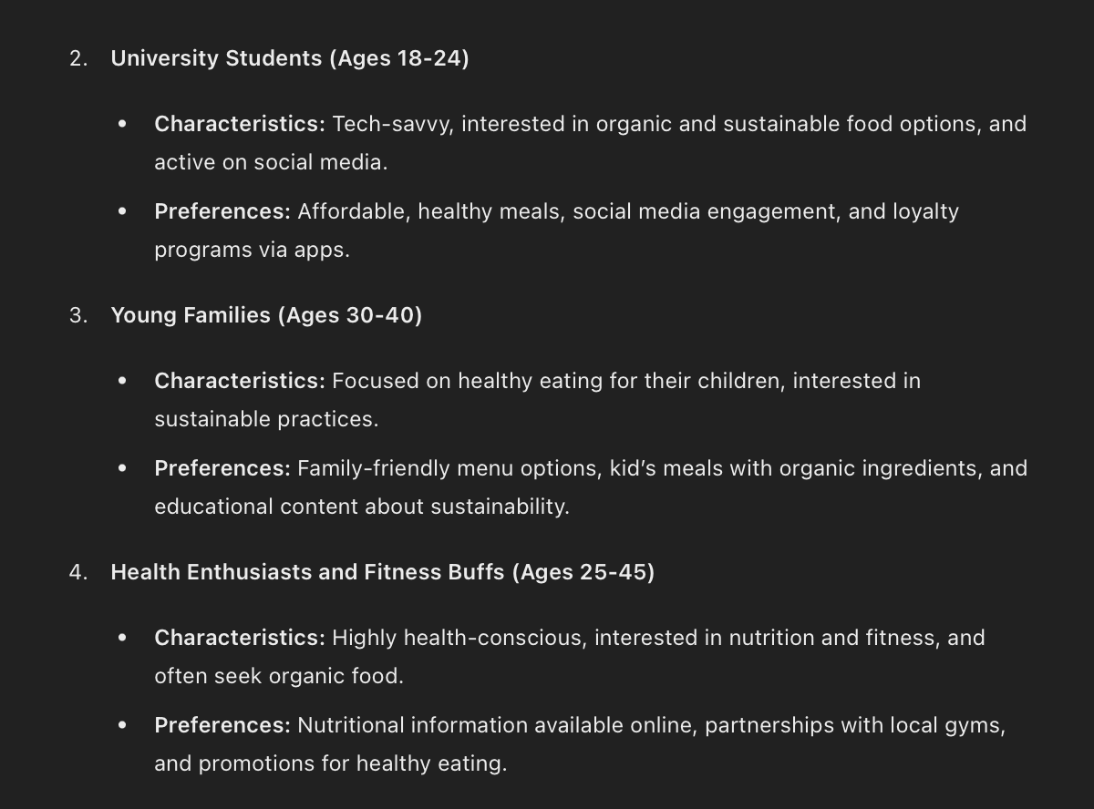
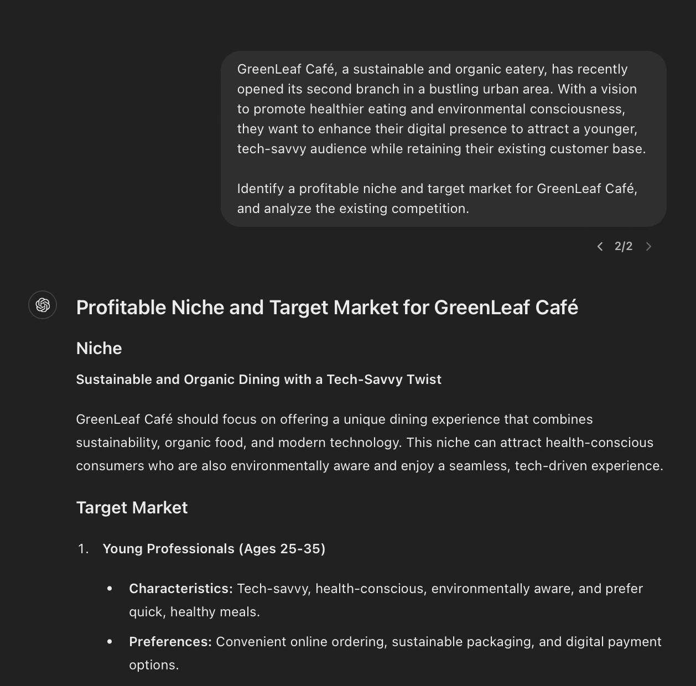
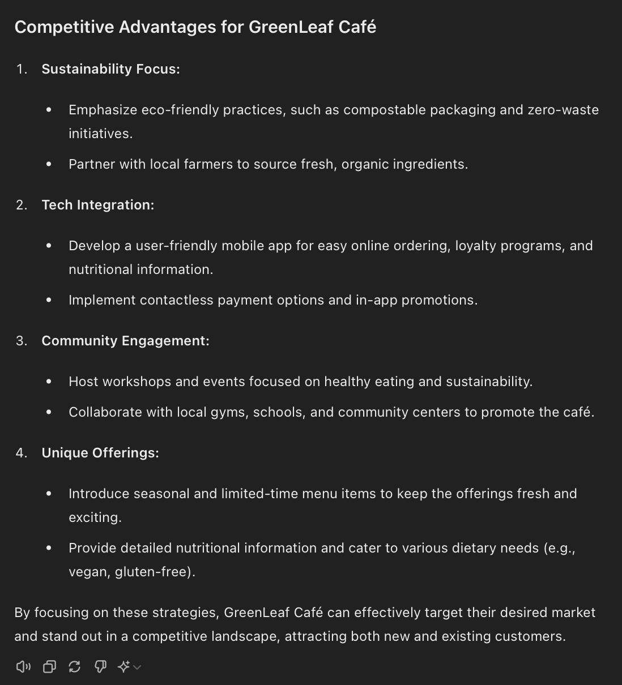

Constraint: The protagonist, a talented young lady named Lila, lives in a small, conservative town where the arts, especially ballad dancing, are not valued as a legitimate career path. Her family expects her to continue the tradition of working in the family business, a local bakery, which leaves little room for her aspirations.

Persona: Lila is a spirited and determined 18-year-old with a natural flair for ballad dancing.

Output: Lila's journey is one of resilience and self-discovery.

Content: The story will explore Lila's struggles and victories as she navigates the challenges of breaking free from societal and familial expectations.

Task: Write a plot that captures Lila's emotional and physical journey to becoming a ballad dancer.

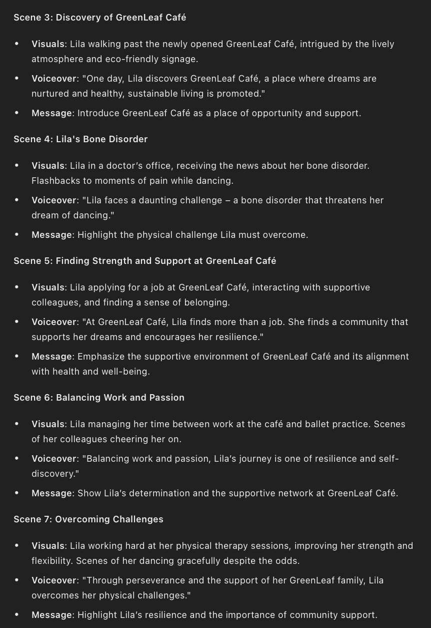
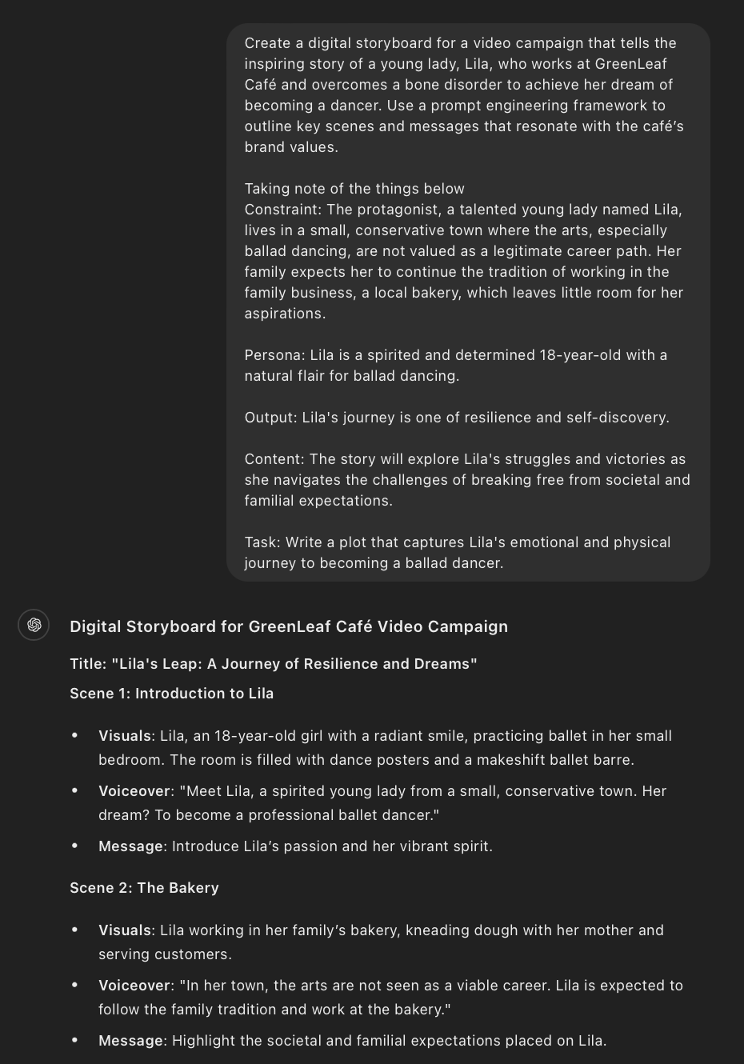
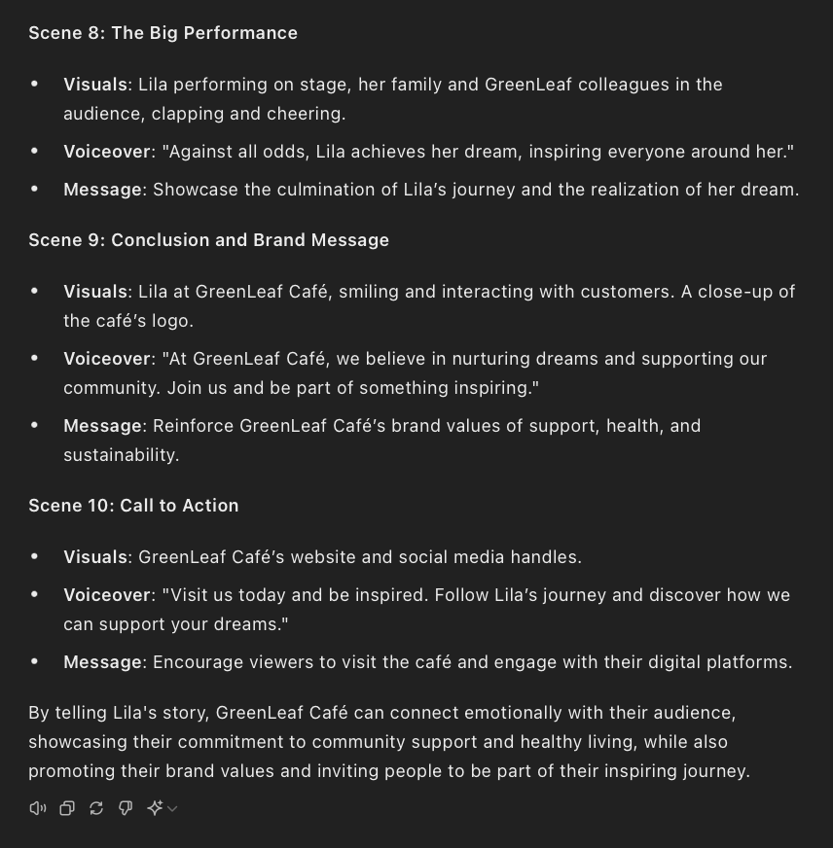


Task 2: Using the preferences of GreenLeaf Café's customers, specifically targeting working professionals in Singapore. Use generative AI to guide the evaluation and content creation process. Develop a content distribution schedule that balances engagement with customer preferences without overwhelming them, utilizing generative AI to determine optimal content delivery frequency across different platforms.

Take a snap shot at the end of each point and paste the snapshot in the box below. (A3, A4)
Suggestive answer (not exhaustive):
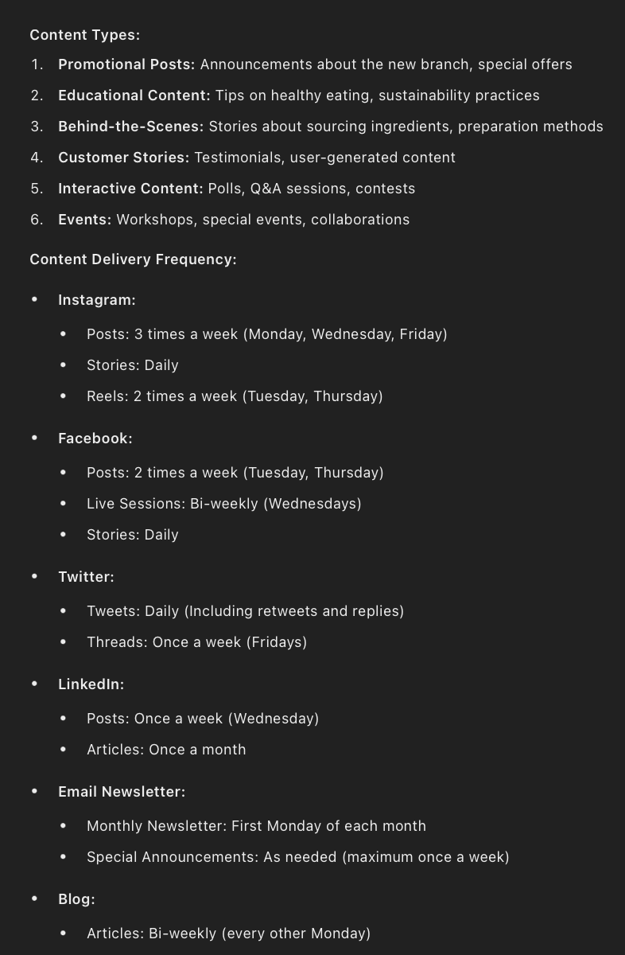
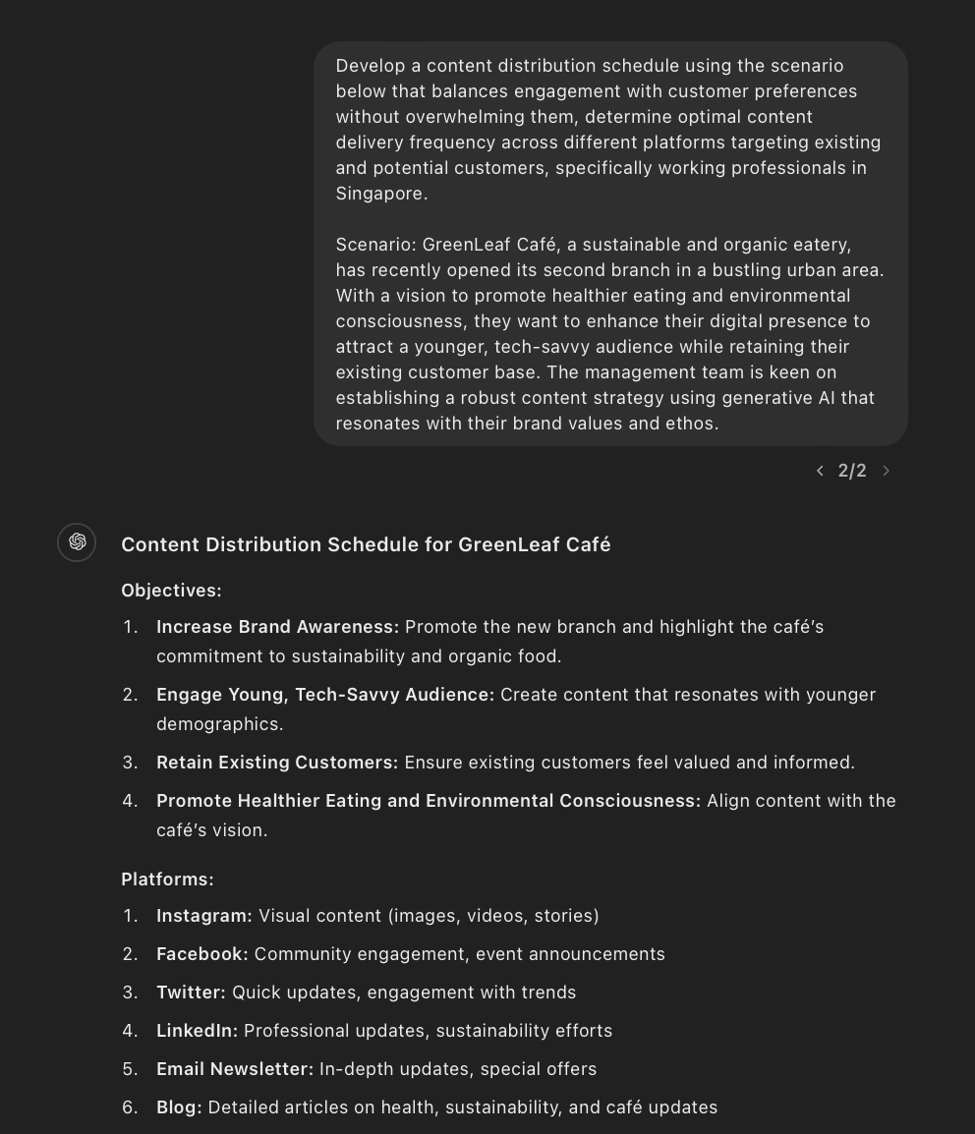

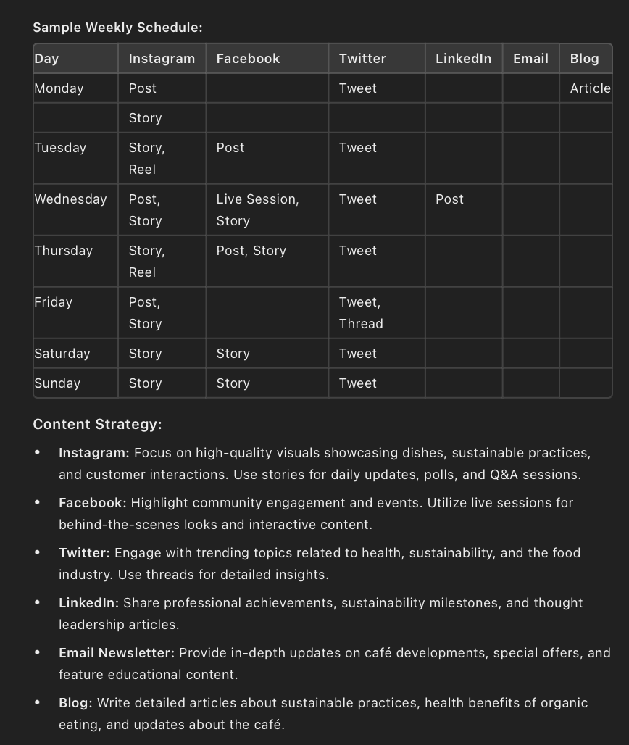

Task 3: Using prompt engineering, identify the most effective types and styles of content for GreenLeaf Café’s audience. Consider content such as blog posts, short videos, infographics, or social media stories that highlight GreenLeaf’s sustainable practices and healthy menu options. Then, create a comprehensive plan for distributing this content across digital platforms, detailing the modes of distribution across platforms and the processes to ensure consistent and effective content delivery.

Take a snap shot at the end of each point and paste the snapshot in the box below. (A5)
Suggestive answer (not exhaustive):

"Create a comprehensive plan for distributing this content cross various digital platforms, detailing the modes of distribution and processes to ensure consistent and effective content delivery using the scenario below.

Scenario: GreenLeaf Cafe, a sustainable and organic eatery, has recently opened its second branch in a bustling urban area. With a vision to promote healthier eating and environmental consciousness, they want to enhance their digital presence to attract a younger, tech-savvy audience while retaining their existing customer base. The management team is keen on establishing a robust content strategy using generative AI that resonates with their brand values and ethos. "
.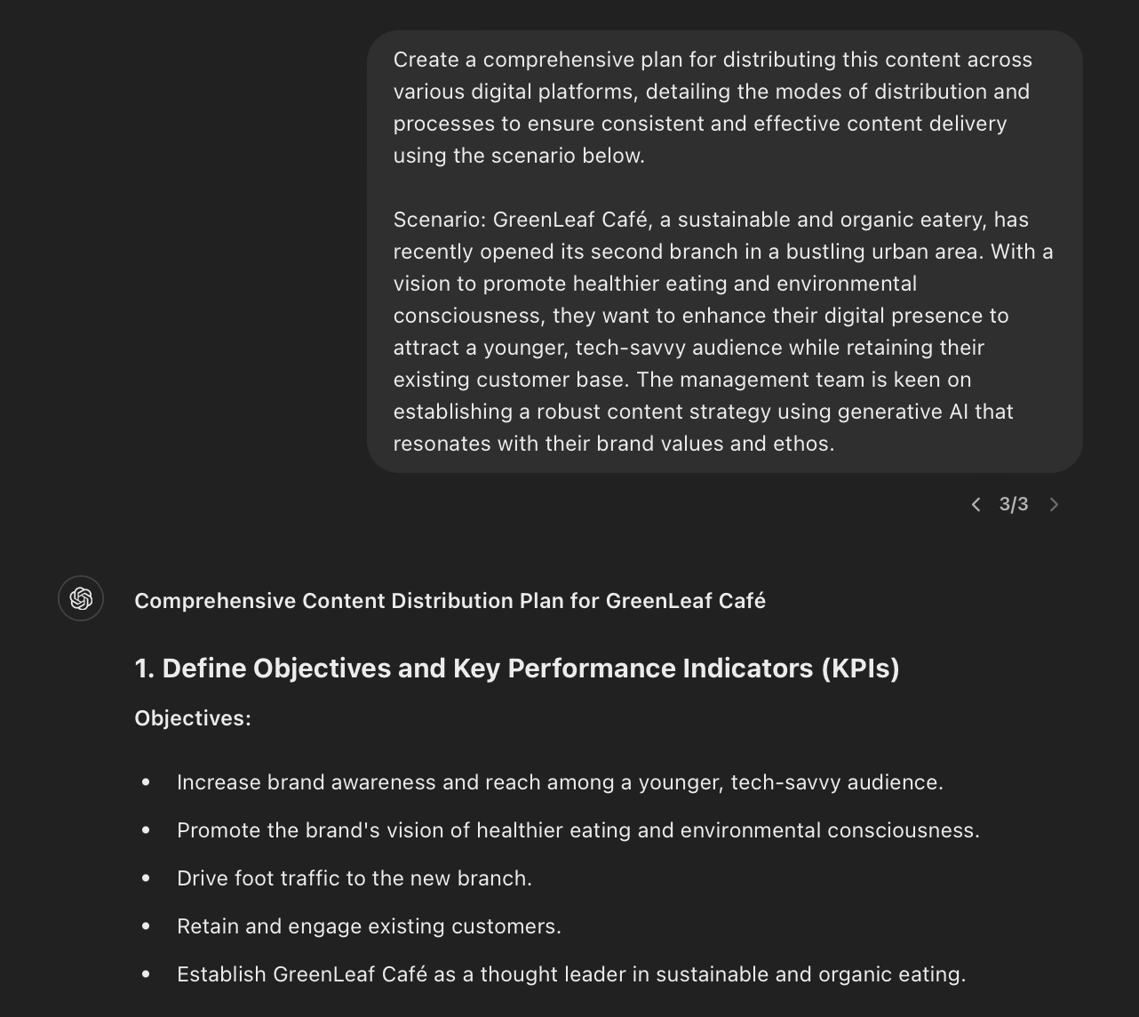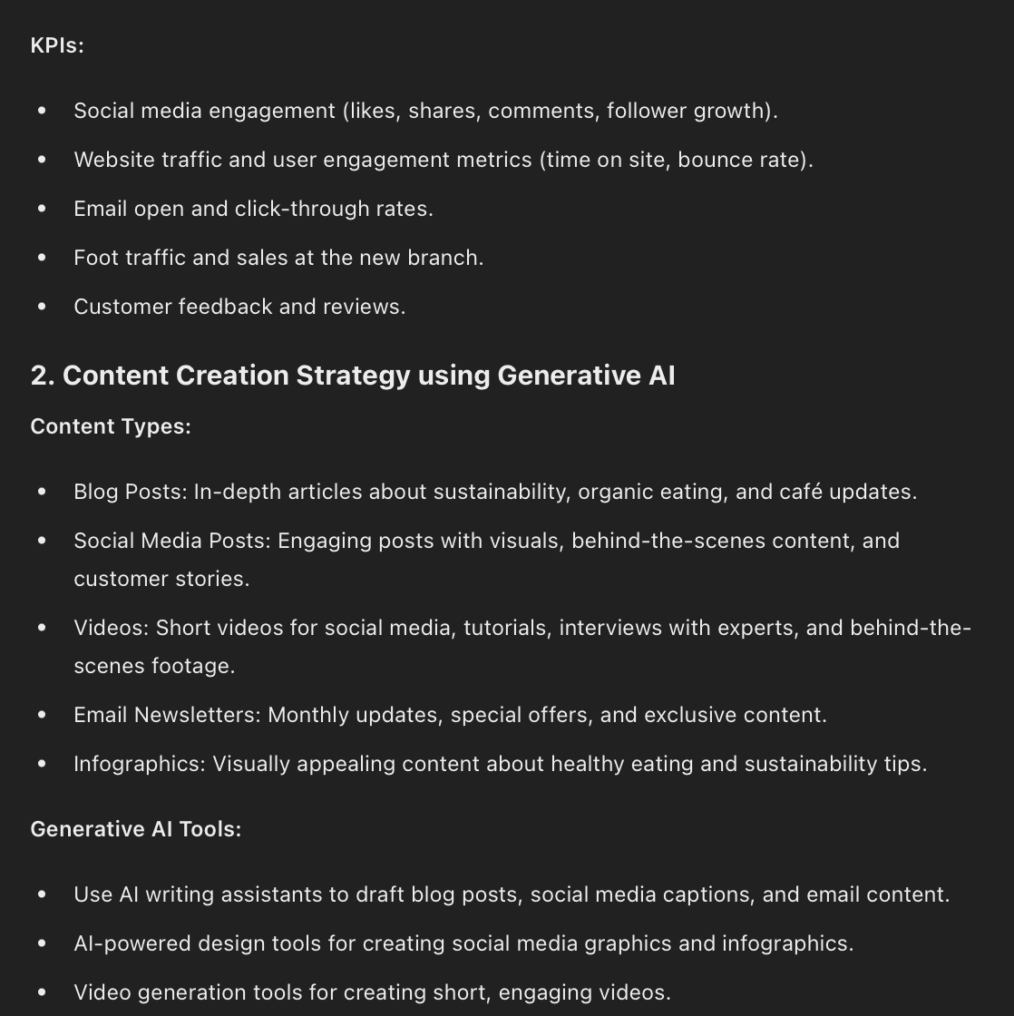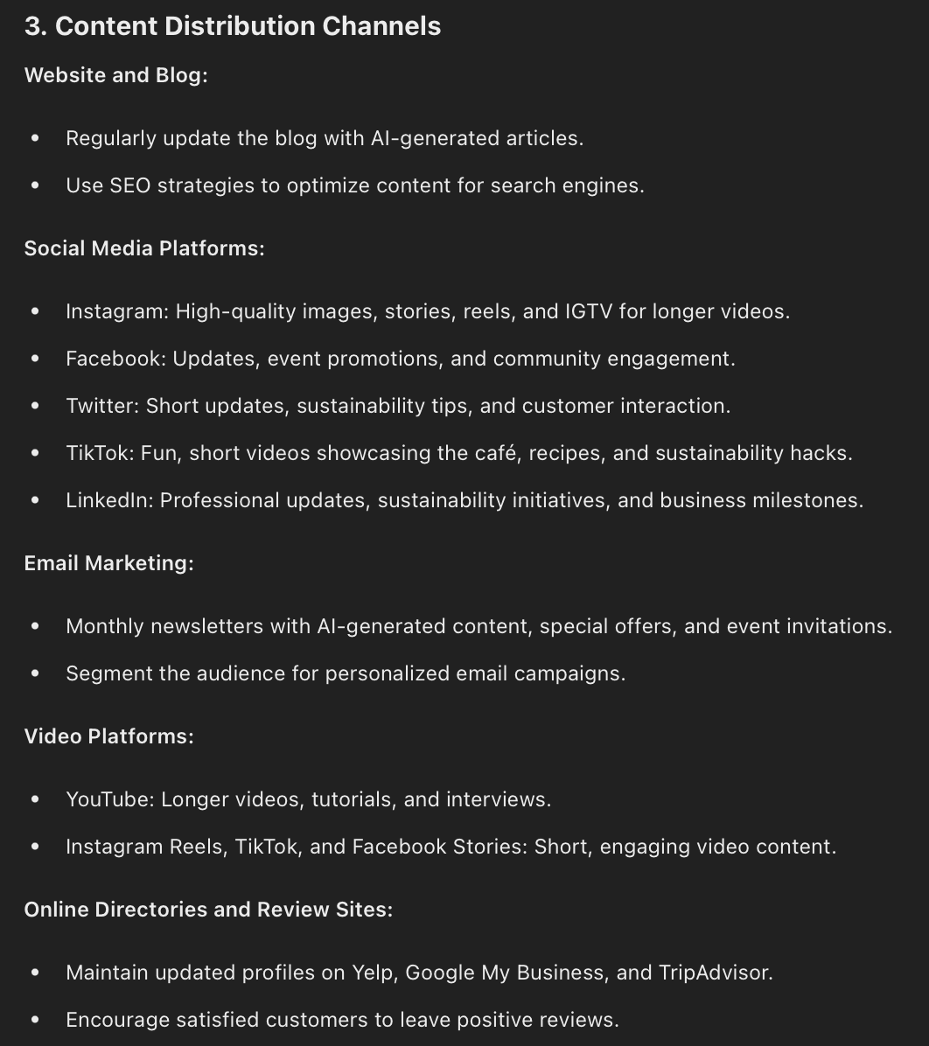
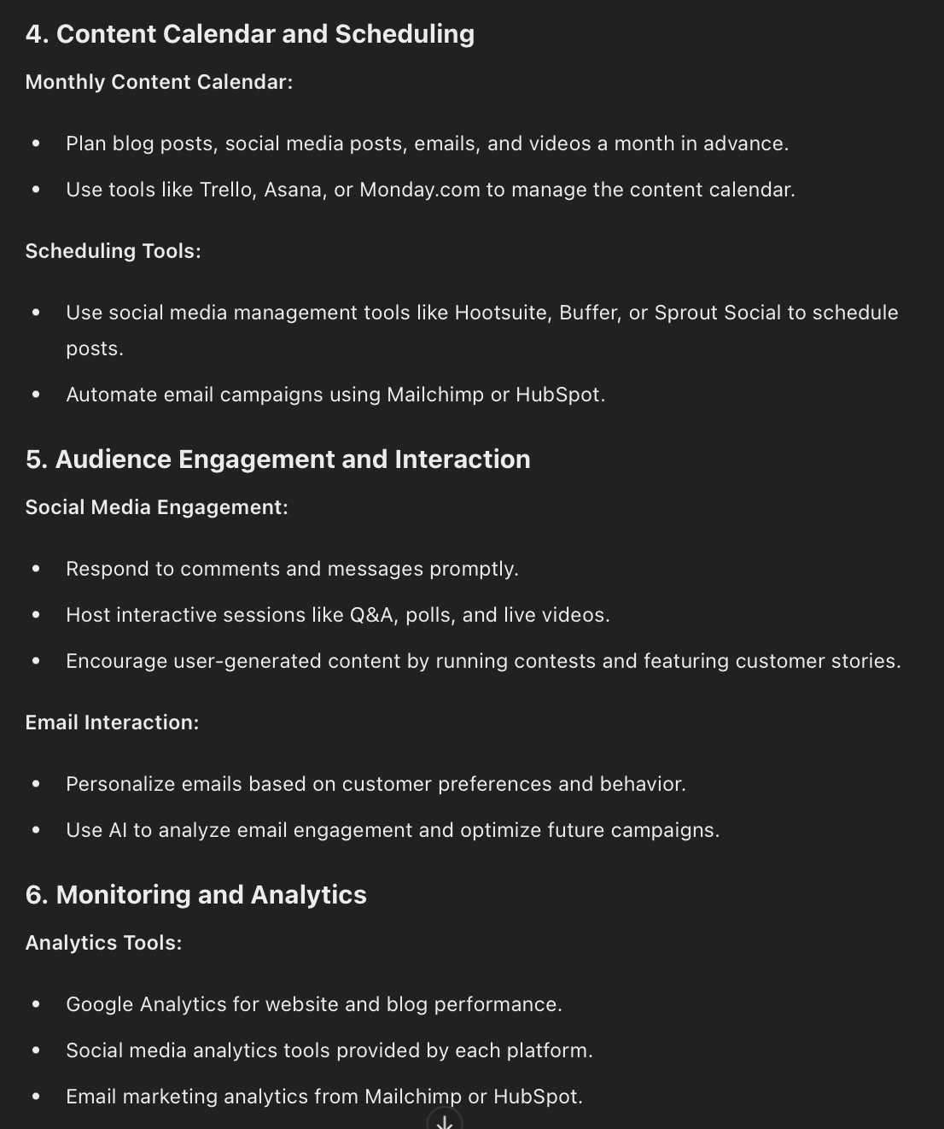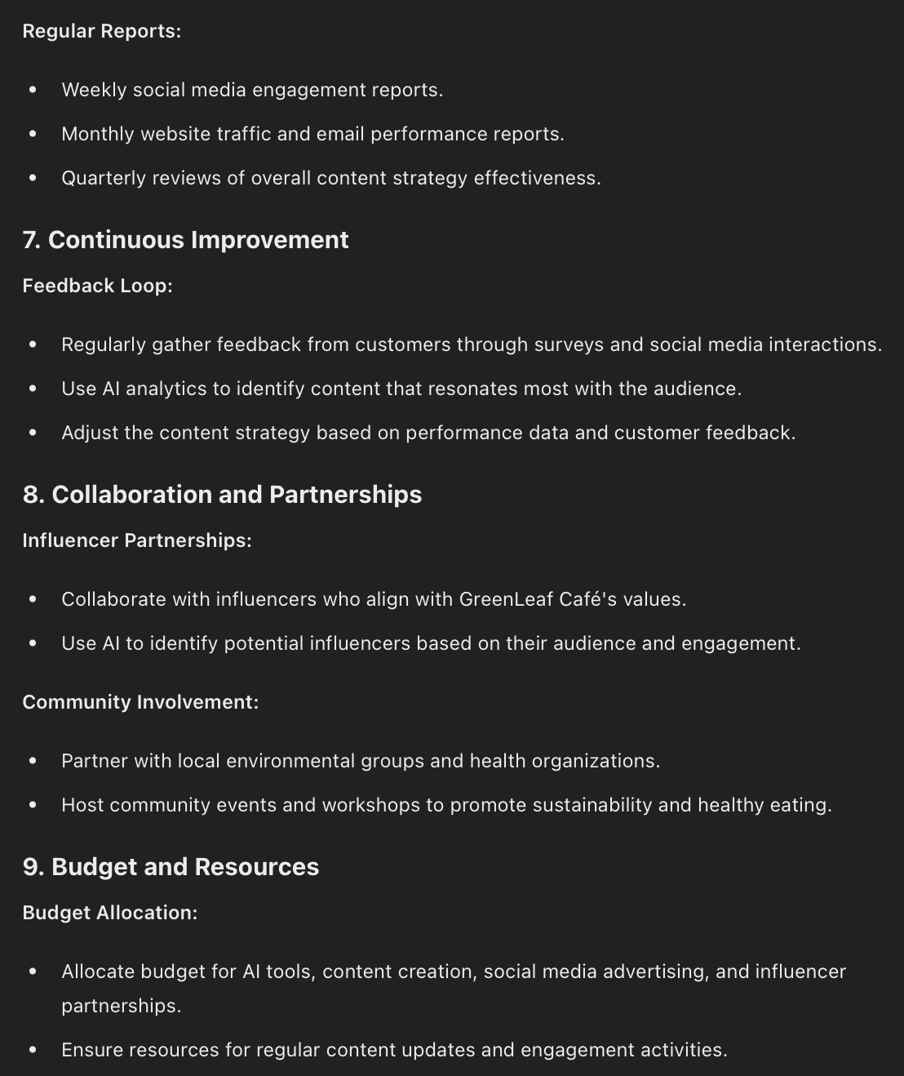
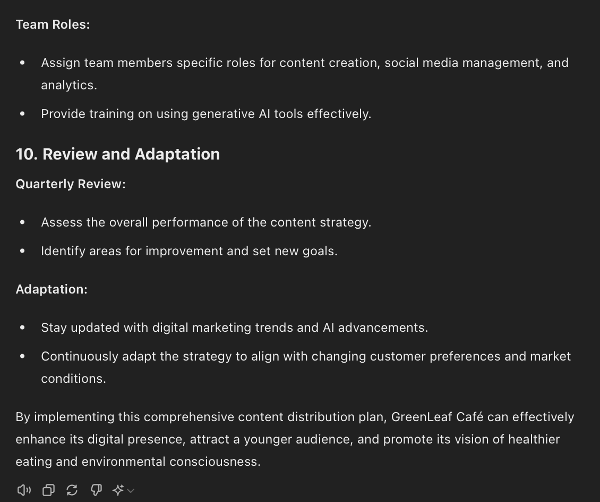

Task 4: Formulate a set of guidelines for executing GreenLeaf Café’s content strategy using generative AI. Ensure these guidelines promote ethical use of AI and align with the café’s brand values of sustainability and health. Include recommendations for modes of content delivery (e.g., social media, email marketing) and establish best practices for consistent execution, such as content review protocols, frequency of updates, and feedback mechanisms. Capture a snapshot of each point and paste it in the designated area. (A6, A7)
Suggestive answer (not exhaustive):

"Formulate a set of guidelines for executing GreenLeaf Café’s content strategy. Ensure these guidelines promote ethical use of AI and align with the café’s brand values using the scenario below.
Scenario: GreenLeaf Café, a sustainable and organic eatery, has recently opened its second branch in a bustling urban area. With a vision to promote healthier eating and environmental consciousness, they want to enhance their digital presence to attract a younger, tech-savvy audience while retaining their existing customer base. The management team is keen on establishing a robust content strategy using generative AI that resonates with their brand values and ethos.”
