

ASSESSMENT PLAN

For

Python Programming for Finance

TGS Ref No: TGS-2022014980

Conducted by
TERTIARY INFOTECH PTE. LTD.

UEN: 201200696W

Version 3.0
Table of Contents
1. Version Control Record 4
2. Overview of Assessment 5
Assessment Methods 5
Assessment Duration (per candidate) 5
Assessment Venue 6
3. Matrix of Assessment Methods and Evidence Gathering Plan 6
3.1. Knowledge Assessment Matrix 6
3.2. Abilities Assessment Matrix 7
3.3. Evidence Gathering Plan 8
4. Assessment Method Specifications 9
4.1. Assessment Specifications 9
4.1.1. Assessment Specification for Written Assessment - Short-Answer Questions (WA-SAQ) 9
4.1.2. Assessment Specification for Practical Performance (PP) 11
5. Assessment Code of Practice 13
6. Assessment Management Organisation 14
6.1. Assessment Appeal Panel 14
6.2. Assessment Manager 14
6.3. Assessor 14
6.4. Appeal Procedures 15
7. Instructions to Assessor 16
8. Instructions to Candidate 17
8.1. Pre-Assessment Information for Candidate 17
9. Assessment Records 18
9.1. Assessment Record for Written Assessment - Short-Answer Questions (WA-SAQ) 18
9.2. Assessment Record for Practical Performance (PP) 19
9.3. Assessment Summary Record 20
10. Annexes 22
10.1. Assessment Questions and Answers 22
10.1.1. Annex A: Assessment Questions for WA-SAQ 22
10.1.2. Annex B: Suggested Answer to Assessment Questions for WA-SAQ 22
10.1.3. Annex C: Assessment Questions for PP 22
10.1.4. Annex D: Suggested Answer to Assessment Questions for PP 22

Version Control Record

Version | Effective Date | Changes | Developer
1.0 | 15 Sep 2022 | For Pilot Launch | Dr. Alfred Ang
2.0 | 08 Jan 2025 | Added Assessment Questions Answers into Annex D | Tertiary Infotech
2.1 | 10 Jan 2025 | Changed “Developer” column To “Who”  Change everything to Tertiary Infotech instead of name | Tertiary Infotech
3.0 | 26 Jan 2025 | Revised Assessment Plan Format | Tertiary Infotech

Overview of Assessment

The purpose of this assessment is to evaluate the candidate’s performance for Python Programming for Finance against the following technical skills and competencies (TSC)

Skills Framework: Programming and Coding ACC-DIT-3018-1.1
TSC Title: Media Skills Framework
TSC Code:

Assessment Methods

Learning Unit | Assessment Method(s)
LU1: Introduction to Python Programming | WA-SAQ, PP
LU2: Data Types and Operators | WA-SAQ, PP
LU3: Problem Solving with Control Structures | WA-SAQ, PP
LU4: Scripting with Function and Lambda | WA-SAQ, PP
LU5: Import and Process Finance Data | WA-SAQ, PP
LU6: Aggregate and Visualize Finance Data | WA-SAQ, PP
LU7: Analyze Finance Data | WA-SAQ, PP
Legend: WA-SAQ: Written Assessment (Short Answer Questions), PP: Practical Performance,
CS: Case Study, OQ: Oral Questioning, RP: Role Play

Assessment Duration (per candidate)

Assessment Method(s) | Assessor to Candidate Ratio | Duration
WA-SAQ | 1:15 | 70 mins
PP | 1:15 | 110 mins
Total time |  | 3 hrs

Assessment Venue

Assessment Method(s) | Venue
WA-SAQ | Tertiary Infotech or  Client’s Premise
PP

Matrix of Assessment Methods and Evidence Gathering Plan

Knowledge Assessment Matrix

Knowledge | WA-SAQ | PP
K1: Programming and coding languages, logics and styles | √ | -
K2: Business requirements and objectives | √ | -
K3: Problem-solving and error handling techniques | √ | -
K4: Algorithm and data structures | √ | -
K5: Scripting approaches | √ | -
K6: Code management approaches | √ | -
K7: Knowledge of codes, systems and platform layouts | √ | -
K8: Organisation’s strategic objectives and processes | √ | -

Abilities Assessment Matrix

Ability | WA-SAQ | PP
A1: Analyse and translate business requirements of software into multiple functions | - | √
A2: Write programmes and codes that are aligned with business requirements | - | √
A3: Draft coding frameworks as a guide for organising codes | - | √
A4: Select appropriate programming languages for business use cases | - | √
A5: Code solutions using required programming languages | - | √
A6: Assess written codes to identify errors and gaps to be addressed | - | √
A7: Test and debug codes to ensure workability | - | √
A8: Incorporate improvements and make corrections to programmes and codes to achieve desired outcomes | - | √
A9: Document programming and coding updates and changes for business and technical professionals | - | √

Evidence Gathering Plan

Assessment Methods | Evidence Gathering Plan
Written Assessment - Short-Answer Questions (WA-SAQ)  Individual, Summative, Open book | Type of Evidence: Written responses to short-answer questions.  Manner of Submission: Candidates will generate answers to the questions and submit the hardcopy to the assessor.  Marking Process: Assessors will evaluate the written responses on the accuracy and comprehensiveness of the answers.  Retention Period: 3 years.
Practical Performance (PP)  Individual, Summative, Open book | Type of Evidence:  - LO1: Candidates will interpret business requirements and apply Python programming to address specified objectives.  - LO2: Candidates will code Python scripts using various data types and operators for business use cases.  - LO3: Candidates will construct Python programs using conditional statements and loops to solve financial problems.  - LO4: Candidates will develop Python functions and scripts, including lambda functions, to address practical business scenarios.  - LO5: Candidates will import, clean, and prepare financial data using the Pandas package, demonstrating proficiency in DataFrame and Series structures.  - LO6: Candidates will test, debug, and visualize financial data using Python, employing aggregation techniques and visualizations for analysis.  - LO7: Candidates will improve Python codes with advanced techniques like pipe and apply, documenting them for analyzing financial data effectively.  Manner of Submission:  - Candidates will upload their video recordings, Python scripts, and problem solutions through the online learning portal.  - Documentation explaining the purpose and detail of each code sample must accompany submissions.  Marking Process:  - Accuracy of Solutions.  - Completeness of Implementations.  - Effective Use of Structures.  Retention Period: All evidence, including video recordings and scripts, will be retained for 3 years for compliance and review.

Assessment Method Specifications

Assessment Specifications

Assessment Specification for Written Assessment - Short-Answer Questions (WA-SAQ)

Specifications | Written Assessment - Short-Answer Questions (WA-SAQ)
Abilities and Knowledge | K1, K2, K3, K4, K5, K6, K7, K8
Duration | 70 mins
Venue | Training room / designated assessment area
Set up | Physical Assessment (Main)  Candidates are required to sit in a manner whereby there is sufficient separation so that they will not be able to interact during the assessment.  Virtual Assessment  LMS  - Questions to be pre-loaded into LMS and opened only to the candidates and during the assessment time.  - Alternatively, assessor will send the questions electronically to candidates only during the assessment time.  Virtual Environment  - Learners to ensure the camera is on all the time and showing their full face.  - Learners to share their whole screen throughout the assessment period  - Assessors to ensure the recording is started before the candidates and remained recordings for every breakout room throughout all the duration of the Assessment.
Pre-assessment instructions for assessors | - Put the candidate at ease  - Explain clearly the purpose and context of the assessment:  - Purpose of the assessment  - Assessment duration  - Assessment methods and tools  - Explain the methods to be used, the standards and criteria for the assessment and the duration of the assessment.  - Explain the procedures of the assessment:  - Check whether candidate has any special requirements e.g. language, special needs, etc.  - Ensure that the following documents are made available  - Assessment Summary Record  - Candidate’s Appeal Form  - Brief candidate on his/her rights and process of appeal  - Identify any allowable adjustments that candidates may require should they have a special need  In addition to the usual pre-assessment instructions, Include instructions on use of:  - Assessment Code of Practice
Pre-assessment instructions for candidates | - Be punctual  - Observe dress code: smart casual  - Request for assessor to repeat questions if question is not clear or if candidate has difficulty understanding assessor's accent  - To specify special needs, if any
Process of conducting assessment | - Verification of candidate’s identity  - Ensure candidates are seated properly so that they will not interact with each other  - Encourage the candidate to seek clarification if any  - Keep in mind the time limit for the assessment
Managing limitations of evidence | - Use of Oral Clarification
Recording Assessment Results | - Record the results in the Assessment Summary Record  - Check that all record forms, timing, dates, names, NRIC, signatures are completed.  - Check that all Assessment Criteria are ticked competent (C) or not yet competent (NYC) in the specific questions. As long as there is a NYC, the candidate is considered not successful in the entire assessment. The candidate is required to re-take the entire assessment.  - Record observation of Competence where applicable in the ‘Evidence of C and NYC must be recorded column  - Record reasons of Not Yet Competence where applicable in the ‘Evidence of C and NYC must be recorded column  - An ‘NYC’ in any K or A will results in an ‘NYC’ in the unit.A candidate is only deemed competent when they achieved a ‘C’ for all the A and K in the unit.
Feedback | - Give clear and constructive feedback to candidate using appropriate language  - Seek clarification and agreement with the candidate on the outcome  - Provide guidance on overcoming gaps in competency  - Ask the candidates to sign the assessment record  - Record the feedback on the assessment record  - Sign off the assessment record  - Assessor should reiterate the appeal process (if the candidate is assessed as not yet competent)

Assessment Specification for Practical Performance (PP)

Specifications | Practical Performance (PP)
Abilities and Knowledge | A1, A2, A3, A4, A5, A6, A7, A8, A9
Duration | 110 mins
Venue | Training room / designated assessment area
Set up | Physical Assessment (Main)  Candidates are required to sit in a manner whereby there is sufficient separation so that they will not be able to interact during the assessment.  Virtual Assessment  LMS  - Questions to be pre-loaded into LMS and opened only to the candidates and during the assessment time.  - Alternatively, assessor will send the questions electronically to candidates only during the assessment time.  Virtual Environment  - Learners to ensure the camera is on all the time and showing their full face.  - Learners to share their whole screen throughout the assessment period  - Assessors to ensure the recording is started before the candidates and remained recordings for every breakout room throughout all the duration of the Assessment.
Pre-assessment instructions for assessors | - Put the candidate at ease  - Explain clearly the purpose and context of the assessment:  - Purpose of the assessment  - Assessment duration  - Assessment methods and tools  - Explain the methods to be used, the standards and criteria for the assessment and the duration of the assessment.  - Explain the procedures of the assessment:  - Check whether candidate has any special requirements e.g. language, special needs, etc.  - Ensure that the following documents are made available  - Assessment Summary Record  - Candidate’s Appeal Form  - Brief candidate on his/her rights and process of appeal  - Identify any allowable adjustments that candidates may require should they have a special need  In addition to the usual pre-assessment instructions, Include instructions on use of:  - Assessment Code of Practice
Pre-assessment instructions for candidates | - Be punctual  - Observe dress code: smart casual  - Request for assessor to repeat questions if question is not clear or if candidate has difficulty understanding assessor's accent  - To specify special needs, if any
Process of conducting assessment | - Verification of candidate’s identity  - Ensure candidates are seated properly so that they will not interact with each other  - Encourage the candidate to seek clarification if any  - Keep in mind the time limit for the assessment
Managing limitations of evidence | - Use of Oral Clarification
Recording Assessment Results | - Record the results in the Assessment Summary Record  - Check that all record forms, timing, dates, names, NRIC, signatures are completed.  - Check that all Assessment Criteria are ticked competent (C) or not yet competent (NYC) in the specific questions. As long as there is a NYC, the candidate is considered not successful in the entire assessment. The candidate is required to re-take the entire assessment.  - Record observation of Competence where applicable in the ‘Evidence of C and NYC must be recorded column  - Record reasons of Not Yet Competence where applicable in the ‘Evidence of C and NYC must be recorded column  - An ‘NYC’ in any K or A will results in an ‘NYC’ in the unit.A candidate is only deemed competent when they achieved a ‘C’ for all the A and K in the unit.
Feedback | - Give clear and constructive feedback to candidate using appropriate language  - Seek clarification and agreement with the candidate on the outcome  - Provide guidance on overcoming gaps in competency  - Ask the candidates to sign the assessment record  - Record the feedback on the assessment record  - Sign off the assessment record  - Assessor should reiterate the appeal process (if the candidate is assessed as not yet competent)

Assessment Code of Practice

5.1 This code of practice provides:
- Assessors with direction on the standard of practice.
- Candidates with assurance of the standards of practice expected of assessors.
- Employers with assurance of the standards maintained by Tertiary Infotech Pte Ltd in the conduct of assessment.

5.2 The following code of practice is based on the international code of ethics and practice (The National Council for Measurement in Education [NCME]).
  - The differing needs and requirements of the person(s) being assessed, the local enterprise(s) and/or industry are identified and handled with sensitivity.
  - Potential forms of conflict of interest in the assessment process and/or outcomes are identified and appropriate referrals are made, if necessary.
  - All forms of harassment are avoided throughout the planning, conducting, reviewing and reporting of the assessment outcomes.
  - The rights of the candidate(s) are protected during and after the assessment.
  - Personal or interpersonal factors that are not relevant to the assessment of competency must not influence the assessment outcomes.
  - The candidate is made aware of rights and processes of appeal.
  - Evidence that is gathered during the assessment is verified for validity, reliability, authenticity, sufficiency and currency.
  - Assessment decisions are based on available evidence that can be produced and verified by another assessor.
  - Assessments are conducted within the boundaries of the assessment system policies and procedures.
  - Formal agreement is obtained from both the candidate(s) and the assessor that the assessment was carried out in accordance with agreed procedures.
  - Assessment tools, systems, and procedures are consistent with equal opportunity legislation.
  - The candidate is informed of all assessment reporting processes prior to the Assessment.
  - The candidate is informed of all known potential consequences of decisions arising from an assessment, prior to the assessment.
  - Confidentiality is maintained regarding assessment results.
  - Results are only released with the written permission of the candidate(s).
  - The assessment results are used consistently with the purposes explained to the candidate.
  - Self-assessments are periodically conducted to compare current competencies against the required competencies.
  - Professional development opportunities are identified and sought.
  - Opportunities for networking amongst assessors are created and maintained.
  - Opportunities are created for technical assistance in planning, conducting and reviewing assessment procedures and outcomes.

Assessment Management Organisation

Assessment Appeal Panel

Assessment
Appeal Panel

I
Assessment Manager

I
Assessors

Assessment Appeal Panel

- The Assessment Appeal Panel is responsible for reviewing and giving a decision on appeals against a Not-Yet-Competent award
- The panel is comprised of a Management Representative, the Assessment Manager and one Assessor who is independent of the case in question.

Assessment Manager

The Assessment Manager is responsible:

- For the administration and conduct of assessment
- Monitoring and continuous improvement of the assessment process and tools
- For the continuous professional development of the pool of assessors
- Managing the process and outcome of the appeal cases.

Assessor

The Assessor is responsible for conducting the assessment according to the Assessment Plan.

Appeal Procedures

The candidate has the right to challenge the assessment decision made by the Assessor. When giving feedback to the candidate about the assessment, the Assessor must ask the candidate if they agree with the outcome.

If the candidate agrees with the outcome, the Assessor and the candidate must sign the Assessment Outcome record. If the candidate does not agree with the outcome, the candidate should not sign the Assessment Outcome record.

If the candidate intends to appeal against the decision made, he/she should discuss the matter with the Assessor. If he/she is still not satisfied with the decision, the candidate must notify the Assessor of the intention to appeal. The Assessor will enter the intention in the Feedback section of the Assessment Outcome record.

The Assessor will notify the training provider of the candidate’s intention to lodge an appeal.

The Assessment Manager will collect information from the Assessor. A separate session will be arranged for the candidate and an independent Assessor appointed by the training provider. An outcome agreed by all will conclude the appeal procedure.

A record of the appeal and any subsequent actions and findings will be submitted to SSG for record purposes.

Instructions to Assessor

A. Prior to the Assessment, I... | Tick | Remarks
1. ensured that the candidate is informed regarding the venue and schedule of assessment
2. reviewed the current copies of the performance statement to be assessed, the assessment and evidence gathering plan, the assessment checklist and the organisations standard operating procedures (SOP)
3. reviewed the performance statement and evidence plan to ensure that I clearly understood the instructions and the requirements of the assessment process.
4. identified and accommodated any special needs candidate
5. checked the logistics set up and resources for the assessment.
B. During the Assessment, I:
1. introduced myself and confirmed the identities of the candidates.
2. put the candidates at ease by being friendly and helpful.
3. explained to the candidates the purpose, context and benefits of the assessment.
4. ensured the candidates understood the process of the assessment.
5. gave the candidates an overview of performance statement to be assessed.
6. explained the appeal procedure and the results reporting procedure.
7. encouraged candidates to seek clarifications if in doubt.
8. asked candidates for feedback on the assessment.
9. explained appropriate legal, safety and ethical issues
C. After the Assessment, I:
1. ensured that the candidate was given constructive feedback.
2. completed and signed the Individual Assessment Summary Record and the Assessment Record – Class Summary
3. thanked the candidate for participating in the assessment.

Instructions to Candidate

Pre-Assessment Information for Candidate

Assessors are required to provide candidates with relevant pre-assessment information which includes, but is not limited

- This assessment of a range of assessment methods, including Written Assignment (QA), Written Assignment (Case Study) and Oral Questioning. The conduct of the assessment may be one-on-one, and, in a group, context as outlined in the Assessment Specifications.
- For these competency elements and the required performance criteria (including range and context) will be assessed. Refer to the Assessment Specifications and ‘Instructions for Candidates’ for a detailed coverage of the assessment requirements.
- You have a right of appeal to assessment decisions in accordance with Tertiary Infotech Pte Ltd appeal procedures
- The conditions for granting a deferred assessment are:
- Medical grounds – a medical report or certificate from registered medical practitioners
- Unexpected and exceptional circumstances which may include (but are not limited to):
- accidents (sporting, motor vehicle, etc.) where an injury is sustained bereavement

Unexpected and exceptional circumstances do not include cases where candidates have mistaken the day, time or venue of assessment.

Assessment Records

Assessment Record for Written Assessment - Short-Answer Questions (WA-SAQ)

Learning Outcomes | TSC Abilities and Knowledge | Please Tick |  | Remarks
 |  | C | NYC
ELO1: Learners will be able to interpret business requirements in combination with the application of Python programming. | K2: Business requirements and objectives  K7: Knowledge of codes, systems and platform layouts
ELO2: Learners will be able to code data types and operators. | K1: Programming and coding languages, logics and styles
ELO3: Learners will be able to construct codes using conditional and loop for problem-solving | K3: Problem-solving and error handling techniques
ELO4: Learners will be able to code Python functions and scripts for business use cases | K4: Algorithm and data structures
ELO5: Learners will be able to code import and prepare finance data using Python Pandas package | K5: Scripting approaches
ELO6: Learners will be able to test and debug Python codes with aggregation and visualization. | K6: Code management approaches
ELO7: Learners will be able to improve and document Python codes to analyse finance data | K8: Organisation’s strategic objectives and processes
C: Competent; NYC: Not Yet Competent

Assessment Record for Practical Performance (PP)

Enabling Learning Outcomes | TSC Abilities and Knowledge | Please Tick |  | Remarks
 |  | C | NYC
ELO1: Learners will be able to interpret business requirements in combination with the application of Python programming. | A1: Analyse and translate business requirements of software into multiple functions
ELO2: Learners will be able to code data types and operators. | A2: Write programmes and codes that are aligned with business requirements
ELO3: Learners will be able to construct codes using conditional and loop for problem-solving | A3: Draft coding frameworks as a guide for organising codes
ELO4: Learners will be able to code Python functions and scripts for business use cases | A4: Select appropriate programming languages for business use cases
ELO5: Learners will be able to code import and prepare finance data using Python Pandas package | A5: Code solutions using required programming languages
ELO6: Learners will be able to test and debug Python codes with aggregation and visualization. | A6: Assess written codes to identify errors and gaps to be addressed  A7: Test and debug codes to ensure workability
ELO7: Learners will be able to improve and document Python codes to analyse finance data | A8: Incorporate improvements and make corrections to programmes and codes to achieve desired outcomes  A9: Document programming and coding updates and changes for business and technical professionals
C: Competent; NYC: Not Yet Competent

Assessment Summary Record

Learning Outcomes | WA-SAQ | PP | Competence  (Please Tick)  C or NYC
ELO1: Learners will be able to interpret business requirements in combination with the application of Python programming. | √ | √
ELO2: Learners will be able to code data types and operators. | √ | √
ELO3: Learners will be able to construct codes using conditional and loop for problem-solving | √ | √
ELO4: Learners will be able to code Python functions and scripts for business use cases | √ | √
ELO5: Learners will be able to code import and prepare finance data using Python Pandas package | √ | √
ELO6: Learners will be able to test and debug Python codes with aggregation and visualization. | √ | √
ELO7: Learners will be able to improve and document Python codes to analyse finance data | √ | √
Legend: WA-SAQ: Written Assessment (Short Answer Questions), PP: Practical Performance, CS: Case Study, OQ: Oral Questioning, RP: Role Play,
NA: Not Applicable, C: Competent, NYC: Not Yet Competent
This candidate has been assessed as

COMPETENT
NOT YET COMPETENT

Candidate Name (As in NRIC) |  | Assessor Name
NRIC (Last 3 digits alphabet) |  | NRIC (Last 3 digits alphabet)
Candidate Signature |  | Assessor Signature
Date: |  | Date:
By signing, the candidate is agreeing to accept the assessment outcome |  | By signing, the assessor is agreeing to have duly assessed the performance criteria and underpinning knowledge as required in the competence units

Feedback on outcome by Assessor/ Feedback by candidate:

{Feedback on the overall performance or in the case of NYC; any area of skills gap and improvement needed}

Annexes

Assessment Questions and Answers

Annex A: Assessment Questions for WA-SAQ

Annex B: Suggested Answer to Assessment Questions for WA-SAQ

Annex C: Assessment Questions for PP

Annex D: Suggested Answer to Assessment Questions for PP

Annex A:
QUESTION PAPER OF WA (SAQ) ASSESSMENT

Python Programming for Finance
Written Assessment (SAQ)

A: Trainee Information:

Trainee Name (as Per NRIC): _______________________________

Last 3 digits and alphabet of NRIC/FIN: _________________

Date: __________________

B: Instruction to Candidates

1. This is an individual exercise
2. This is an open book assessment
3. A total of 1 hr is given to complete the written assessment
4. Submit your answers on the document provided

C: Short Answer Questions

Question 1:
Alex, a seasoned developer at TechWave Solutions, is working on a project that involves creating interactive data visualizations. He needs to implement a formatting function to display numerical data with specific decimal precision. Alex finds the following code snippet and wants to understand its behavior before integrating it into his project.
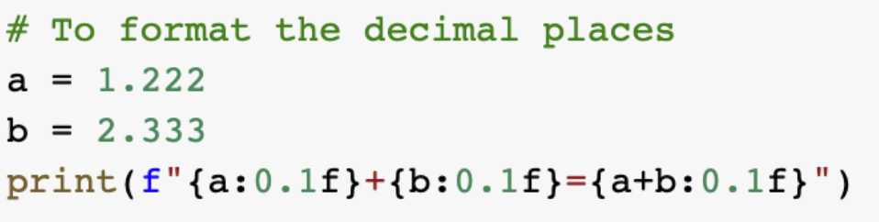
What is the output from executing the above lines of code? (K1)

Question 2:
Capital Growth Inc. is an investment firm renowned for its data-driven approaches. However, in recent years, the company has been facing increasing competition in the financial market. To maintain its competitive edge, the firm needs to enhance its investment decision-making processes.
Emma, a skilled financial analyst, is tasked with developing a robust analytical tool to process vast amounts of financial data, identify market trends, and generate actionable insights. She wants to select a programming language that can handle large datasets, perform complex calculations efficiently, and provide flexibility for model development. She is considering Python as a potential solution but needs to justify its suitability for this critical project.

Explain why Python is well suited for such financial analyses. (K2)

Question 3:
Jordan, a budding programmer at InnovateTech, is tasked with maintaining an existing Python script. While reviewing the code, he encounters a decision-making block that controls the program's behavior based on a specific condition. To ensure the script functions correctly, Jordan needs to understand the output of this code snippet under the given circumstances.The code snippet is shown below:
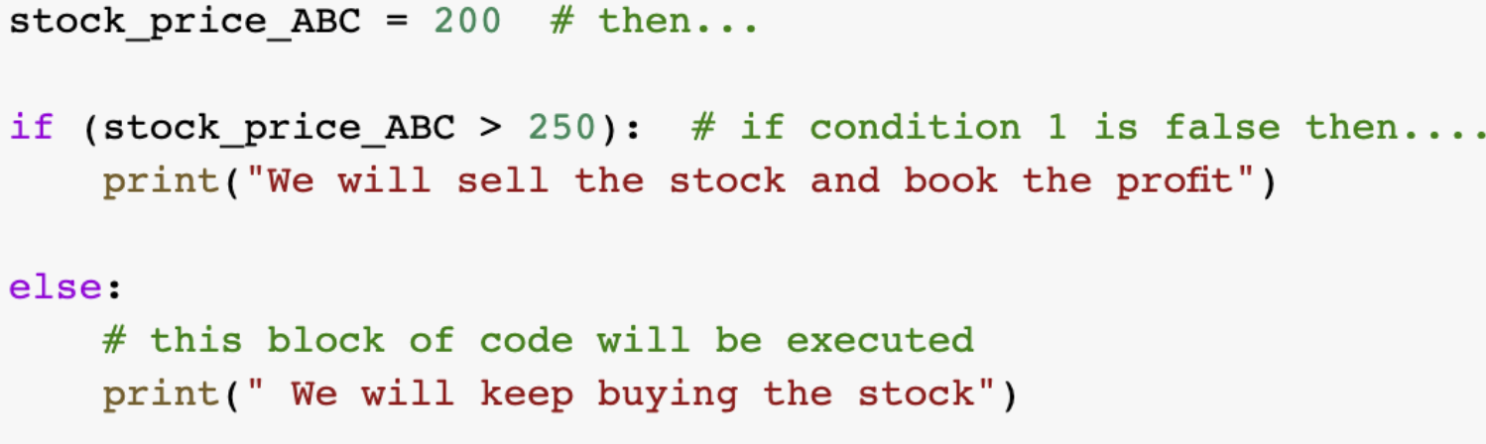
What is the output from executing the above lines of code? (K3)

Question 4:
Alex, a detail-oriented data analyst at DataInsights Corp., is tasked with integrating a new data processing module into the company's robust analytics pipeline. Before incorporating the module, he needs to thoroughly understand the data structure it produces to ensure compatibility and efficient processing. Alex examines a Python code snippet that appears to create a dataset related to stock portfolios. He needs to determine the exact format of the output data structure to assess its suitability for downstream analysis and visualization.
The code snippet is shown below: 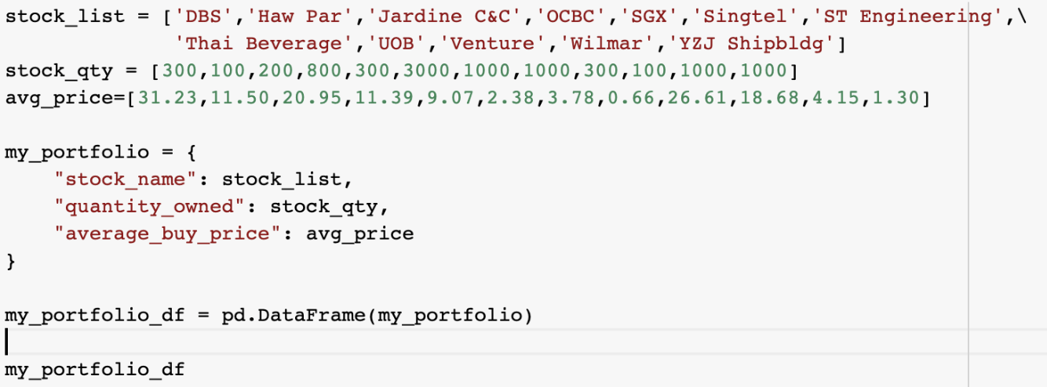
Describe the data structure produced when you execute the above lines of code: (K4)

Question 5:
Jordan, a meticulous software developer at Capital Growth Inc., is tasked with optimizing a Python script designed to analyze stock market trends. While examining the code, he comes across a specific section that filters trading signals. Jordan needs to understand the functionality of this code snippet to ensure it accurately identifies the correct buy/sell signals from the given dataset.
The code snippet is shown below:

What is the output from executing the above lines of code? (K5)

Question 6:
Emily, a data analyst at FinTech Solutions, is working on analyzing historical stock price data for a client. To smooth out short-term fluctuations and highlight longer-term trends, she needs to calculate a 5-day moving average of the stock prices. She decides to write a Python script to perform this calculation.What is the code to calculate a 5-day moving average of the stock price? (K6)

Question 7:
Liam, a newbie to Python, is just starting to learn programming. He encounters the following code snippet from an online tutorial and wants to determine what the output will look like when run:
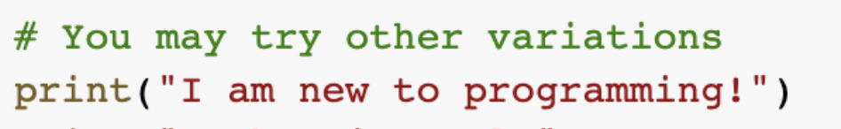

What is the output from executing the above lines of code? (K7)

Question 8:
David, a junior data analyst at FinTech Solutions, has been tasked with reviewing a piece of code to understand how data is processed within the specific pipeline. The code seems to be part of a larger data analysis process:
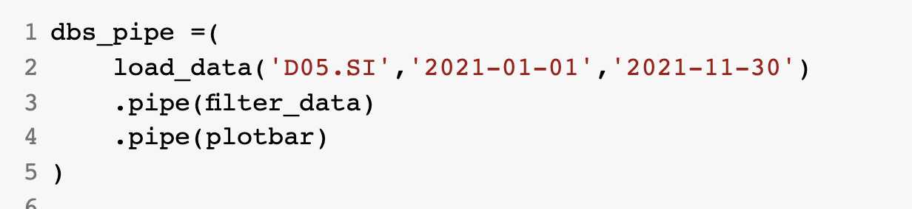
Explain what the above lines of code do. (K8)

__________________________________________________________________________
For Official Use Only

Grade: (C / NYC)

Assessor Name: _______________ Assessor NRIC: _____________

Date: _________________ Signature: _________________

Note: Please create a subfolder named YYYY-MM-DD/DD_<<Trainer Name>> and upload all the learner's assessments to the respective Google Drive.
Please email erra@tertiaryinfotech.com after you have uploaded the assessment.

Annex B:
SUGGESTED ANSWER TO WA (SAQ) ASSESSMENT QUESTIONS

Python Programming for Finance
Answers to Written Assessment (SAQ)

C: Short Answer Questions

Question 1:
Alex, a seasoned developer at TechWave Solutions, is working on a project that involves creating interactive data visualizations. He needs to implement a formatting function to display numerical data with specific decimal precision. Alex finds the following code snippet and wants to understand its behavior before integrating it into his project.



What is the output from executing the above lines of code? (K1)
Suggestive answers (not exhaustive):

- 1.2+2.3 =3.5

Question 2:
Capital Growth Inc. is an investment firm renowned for its data-driven approaches. However, in recent years, the company has been facing increasing competition in the financial market. To maintain its competitive edge, the firm needs to enhance its investment decision-making processes.

Emma, a skilled financial analyst, is tasked with developing a robust analytical tool to process vast amounts of financial data, identify market trends, and generate actionable insights. She wants to select a programming language that can handle large datasets, perform complex calculations efficiently, and provide flexibility for model development. She is considering Python as a potential solution but needs to justify its suitability for this critical project.

Explain why Python is well suited for such financial analyses. (K2)
Suggestive answers (not exhaustive):

- Data-Driven Finance – Python is generally the programming language of choice to interact with APIs and to process and analyze data.
- AI-First Finance – Python is often the programming language of choice for AI practitioners.
- Python seems to have answers to most questions in the financial industry in terms of analytics, data volumes and frequency, compliance and regulation
- Python has the potential to provide a single, powerful, and consistent framework with which to streamline end-to-end development and production efforts even across large financial institutions.

Question 3:
Jordan, a budding programmer at InnovateTech, is tasked with maintaining an existing Python script. While reviewing the code, he encounters a decision-making block that controls the program's behavior based on a specific condition. To ensure the script functions correctly, Jordan needs to understand the output of this code snippet under the given circumstances.

The code snippet is shown below:



What is the output from executing the above lines of code? (K3)
Suggestive answers (not exhaustive):

- We will keep buying the stock

Question 4:
Alex, a detail-oriented data analyst at DataInsights Corp., is tasked with integrating a new data processing module into the company's robust analytics pipeline. Before incorporating the module, he needs to thoroughly understand the data structure it produces to ensure compatibility and efficient processing.

Alex examines a Python code snippet that appears to create a dataset related to stock portfolios. He needs to determine the exact format of the output data structure to assess its suitability for downstream analysis and visualization.

The code snippet is shown below:



Describe the data structure produced when you execute the above lines of code: (K4)
Suggestive answers (not exhaustive):

- The output is a Pandas DataFrame with 10 records, and 3 columns – “stock_name”, “quantity_owned”, and “average_buy_price”

Question 5:
Jordan, a meticulous software developer at Capital Growth Inc., is tasked with optimizing a Python script designed to analyze stock market trends. While examining the code, he comes across a specific section that filters trading signals. Jordan needs to understand the functionality of this code snippet to ensure it accurately identifies the correct buy/sell signals from the given dataset.

The code snippet is shown below:

What is the output from executing the above lines of code? (K5)
Suggestive answers (not exhaustive):

- ['Buy', 'Buy', 'Buy', 'Buy']

Question 6:
Emily, a data analyst at FinTech Solutions, is working on analyzing historical stock price data for a client. To smooth out short-term fluctuations and highlight longer-term trends, she needs to calculate a 5-day moving average of the stock prices. She decides to write a Python script to perform this calculation.

What is the code to calculate a 5-day moving average of the stock price? (K6)
Suggestive answers (not exhaustive):

- moving_avg = stock['Close'].rolling(window=5).mean()

Question 7:
Liam, a newbie to Python, is just starting to learn programming. He encounters the following code snippet from an online tutorial and wants to determine what the output will look like when run:



What is the output from executing the above lines of code? (K7)
Suggestive answers (not exhaustive):

- I am new to programming

Question 8:
David, a junior data analyst at FinTech Solutions, has been tasked with reviewing a piece of code to understand how data is processed within the specific pipeline. The code seems to be part of a larger data analysis process:



Explain what the above lines of code do. (K8)
Suggestive answers (not exhaustive):

- It is piping code to automate loading the data, followed by filtering the data and plotting the data

Annex C:
QUESTION PAPER OF PP ASSESSMENT

Python Programming for Finance
Practical Performance Assessment

A: Trainee Information:

Trainee Name (as Per NRIC): _______________________________

Last 3 digits and alphabet of NRIC/FIN: _________________

Date: __________________

B: Instruction to Candidate
1. This is an individual exercise
2. This is an open book assessment
3. A total of 90 minutes is given to complete the PP Assessment
4. Submit your answers on the document provided

C. Practical Performance

Scenario:
Imagine you work at Quantum Leap Capital, a cutting-edge hedge fund based in Singapore. It is known for its data-driven approach to investment and a strong focus on emerging markets. The firm employs a team of quantitative analysts and financial engineers who use advanced statistical models and machine learning algorithms to identify investment opportunities. Quantum Leap Capital is committed to delivering superior risk-adjusted returns to its investors through rigorous research and disciplined investment processes.

As part of the financial analysis department in Quantum Leap Capital, your project is to analyze the DBS stock market data to predict future stock movements.

Task 1:
In preparation for your data analysis, you need to install the required Python packages, namely:
- pandas-datareader
- yfinance
- pyfolio
- pandas-ta
- talib-binary

Install and import the above Python packages into your Python program. Show your code below: (A1)
Task 2:
We want to perform analysis on DBS’s stock data in the last one year.

- Download the stock data for DBS (stock code: D05.SI) for the past 365 days and store it in a Pandas DataFrame.
- Display the DataFrame data
- Visualize the price movements of the DBS stock by plotting the Open-High-Low-Close (OHLC) chart for this time period.

Show your code below: (A2, A3)

Task 3:
To gain deeper insights into the DBS stock’s behavior, you decide to analyze its daily returns.

Calculate the daily percentage change in DBS’s closing price and create a histogram to visualize the distribution of returns. This analysis will help assess the stock’s risk profile and identify potential outliers or errors in the data.

Show your code below: (A4, A5)

Task 4:
As part of your project, you want to identify potential trends and patterns in DBS’s stock price movements. To this, you decide to compare short-term and long-term trends to get a clearer picture of the stock’s momentum.

Calculate both a 10-day and a 50-day moving average for DBS’s closing price. Show your code below: (A6, A7)
Task 5:
After calculating the 10-day and the 50-day moving average for DBS’s closing price, we can visualize these moving averages together on a line chart. This will allow us to identify potential crossover points which are crucial in technical analysis as they often indicate potential trend reversals or continuations.

Plot both the 10-day moving average and the 50-day moving average of DBS’s closing price on a line chart. Show your code below.

From your graph, determine the crossover point (i.e., the point where the 50 day-moving average line first crosses over the 10-day moving average line) and indicate your answer below: (A8, A9)

______________________________________________________________________________
For Official Use Only

Candidate has successfully completed all the tasks for PP and is able to explain the overall functions and features used to achieve these tasks.

Grade: (C / NYC)

Assessor Name: _______________ Assessor NRIC: _____________

Date: _________________ Signature: _________________

Note: Please create a subfolder named YYYY-MM-DD/DD_<<Trainer Name>> and upload all the learner's assessments to the respective Google Drive.
Please email erra@tertiaryinfotech.com after you have uploaded the assessment.

Annex D:
SUGGESTED ANSWER TO PP ASSESSMENT QUESTIONS

Python Programming for Finance
Answers to Practical Performance Assessment

C. Practical Performance

Task 1:
In preparation for your data analysis, you need to install the required Python packages, namely:
- pandas-datareader
- finance
- pyfolio
- pandas-ta
- talib-binary

Install and import the above Python packages into your Python program. Show your code below: (A1)
Suggested answers (non-exhaustive):

Refer to Answers_to_Assessment_Guide_for_Python_Programming_for_Finance_23_Oct_2022.ipynb file.

Task 2:
We want to perform analysis on DBS’s stock data in the last one year.

- Download the stock data for DBS (stock code: D05.SI) for the past 365 days and store it in a Pandas DataFrame.
- Display the DataFrame data
- Visualize the price movements of the DBS stock by plotting the Open-High-Low-Close (OHLC) chart for this time period.

Show your code below: (A2, A3)
Suggested answers (non-exhaustive):

Refer to Answers_to_Assessment_Guide_for_Python_Programming_for_Finance_23_Oct_2022.ipynb file.

Task 3:
To gain deeper insights into the DBS stock’s behavior, you decide to analyze its daily returns.

Calculate the daily percentage change in DBS’s closing price and create a histogram to visualize the distribution of returns. This analysis will help assess the stock’s risk profile and identify potential outliers or errors in the data.

Show your code below: (A4, A5)
Suggested answers (non-exhaustive):

Refer to Answers_to_Assessment_Guide_for_Python_Programming_for_Finance_23_Oct_2022.ipynb file.

Task 4:
As part of your project, you want to identify potential trends and patterns in DBS’s stock price movements. To this, you decide to compare short-term and long-term trends to get a clearer picture of the stock’s momentum.

Calculate both a 10-day and a 50-day moving average for DBS’s closing price. Show your code below: (A6, A7)
Suggested answers (non-exhaustive):

Refer to Answers_to_Assessment_Guide_for_Python_Programming_for_Finance_23_Oct_2022.ipynb file.

Task 5:
After calculating the 10-day and the 50-day moving average for DBS’s closing price, we can visualize these moving averages together on a line chart. This will allow us to identify potential crossover points which are crucial in technical analysis as they often indicate potential trend reversals or continuations.

Plot both the 10-day moving average and the 50-day moving average of DBS’s closing price on a line chart. Show your code below.

From your graph, determine the crossover point (i.e., the point where the 50 day-moving average line first crosses over the 10-day moving average line) and indicate your answer below: (A8, A9)
Suggested answers (non-exhaustive):

Refer to Answers_to_Assessment_Guide_for_Python_Programming_for_Finance_23_Oct_2022.ipynb file.

______________________________________________________________________________
For Official Use Only

Grade: (C / NYC)

Assessor Name: _______________ Assessor NRIC: _____________

Date: _________________ Signature: _________________

Note: Please create a subfolder named YYYY-MM-DD/DD_<<Trainer Name>> and upload all the learner's assessments to the respective Google Drive.
Please email erra@tertiaryinfotech.com after you have uploaded the assessment.

