[02.177] On Wind & Water: Metaphysics, Design, and Technology
Term Paper
Liu Zhen (1008455)

On the Marina Bay waterfront, a lotus-shaped structure rests gracefully upon the water — the ArtScience Museum. Its distinctive lotus form has become one of Singapore’s most iconic landmarks. In Eastern culture, the lotus symbolises purity and wisdom. The museum’s ten “petals” extend upward, evoking a sense of flow and openness. I chose it as my subject of study not only because its form embodies the profound meanings of Eastern aesthetics and philosophy, but also because it exemplifies — through its functions — the symbiosis and interaction between humans, art, and science. It is both a venue for showcasing artistic creation and a public space that inspires reflection and emotional resonance.
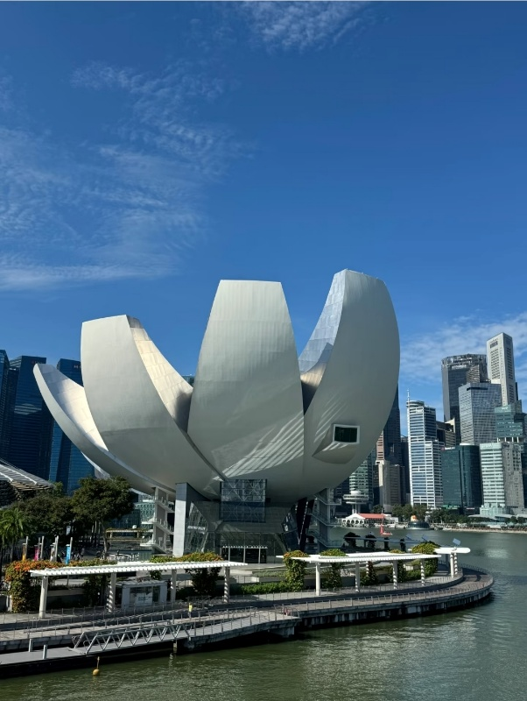

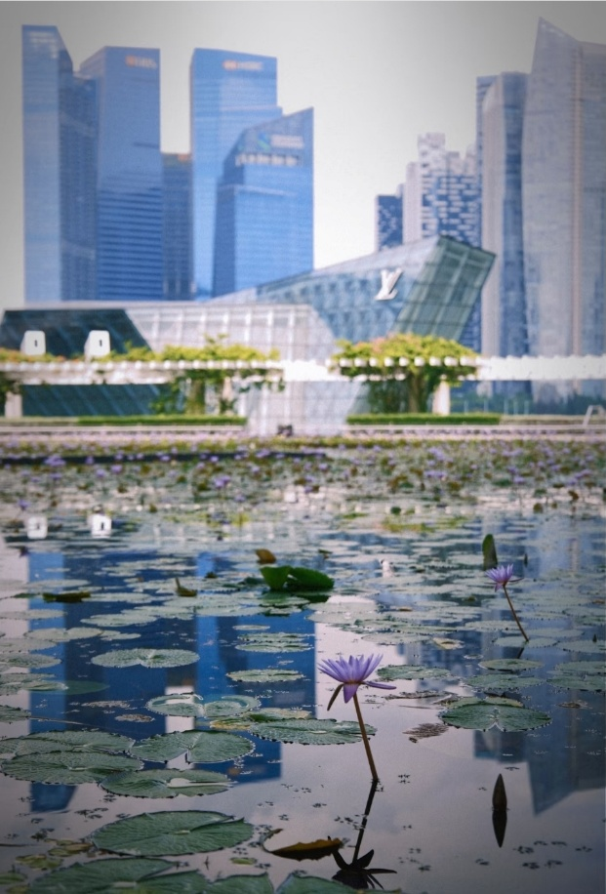
Approaching the ArtScience Museum, the most striking feature is its elegantly unfurling lotus silhouette. Ten petals of varying lengths rise from the water and curve skyward, as though a giant lotus were floating on Marina Bay, radiating harmony between architecture and nature. The surrounding lotus pond brims with life; even without stepping inside, visitors can stroll along the pathways encircling the pond to admire the building’s reflection in the water. Some wander leisurely, others rest on stone benches, some take photographs, while others record dance videos, adding youthful vitality to the serene environment. The open central void acts as a wind corridor, where passersby pause to gaze quietly at the distant skyline. On the first floor, behind a full-height glass façade, people sip coffee while enjoying views of the pond and the CBD skyline. I prefer to remain outdoors — seated in the shadow of the lotus-shaped structure, surrounded by blooming lotuses, feeling the calm that comes with the breeze and the rippling water.

From a spatial and technical perspective, the ArtScience Museum integrates several notable features. First, the lotus-shaped form — nicknamed Singapore’s “Welcoming Hand” — consists of ten petal-shaped galleries symbolising openness and wisdom. The inclined skylights at each petal’s tip break the enclosure, producing a bright and transparent effect. Second, the surrounding pond and pedestrian paths create an open transitional zone, fostering an atmosphere of “stillness within movement.” Third, the expansive glass façade and central wind corridor blur the boundary between interior and exterior, allowing light and air to flow freely. Technically, the roof’s circular oculus not only introduces natural light but also collects rainwater, which is filtered and recycled into the water system. Inside, the permanent exhibition Future World uses motion sensors, light tracking, and sound feedback to make visitors active participants who trigger transformations within the space.
The museum’s design vividly embodies the flow and transparency of qi. At its heart, a large circular oculus allows rainwater to cascade down a 35-meter-tall indoor waterfall into the pool below (Marina Bay Sands, 2011) — a manifestation of the principle “water from heaven, qi received by earth. (天降之水、地纳其气)” This vertical axis of water and qi creates a cyclical exchange between the “heavenly qi” above and the “earthly qi” below. The ten petals encircle the center like open fingers, symbolising a welcoming gesture that draws in water and fortune from Marina Bay. The skylights at each tip bring bright natural light (yang qi) into darker areas (yin qi), achieving yin–yang balance. In feng shui, the lotus represents purity and enlightenment; its form metaphorically transforms turbid qi into clarity. The petals’ upward curves catch both sunlight and rain, while the base pool gathers and concentrates the earth’s water energy — harmoniously uniting “heaven and earth qi.”
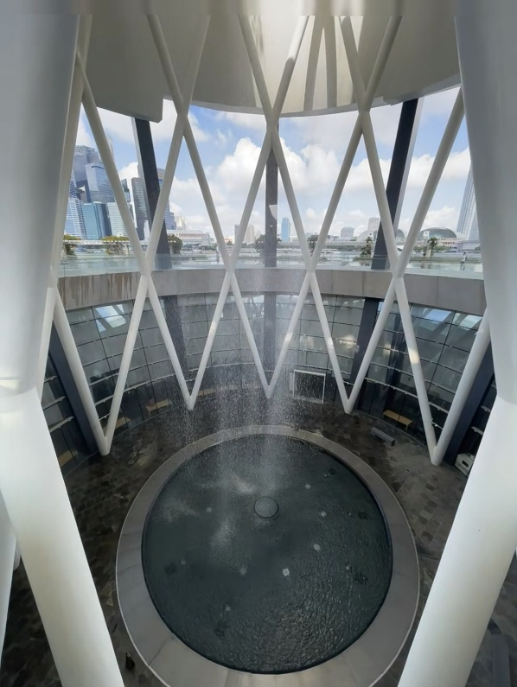

Taoist philosophy is deeply embedded in the museum’s architectural language. The most evident expression lies in the interplay of light and shadow: skylights flood the curved interior walls with daylight, yet during exhibitions, shading systems transform the galleries into fully dark “black box” spaces. This fluidity between light and dark reflects the yin–yang cycle. Structurally, the circular concrete base anchored underground embodies heaviness, stability, and yin, while the white petals rising skyward convey lightness, openness, and yang — together forming a stable yet dynamic whole.
The design of the ArtScience Museum cleverly integrates the five elements. The Water element is embodied in the roof’s central feature, which collects rainwater and channels it through a circular skylight into a reflecting pool. The transparent glass walls on the first floor further enhance the sense of flow and openness, while the lotus pond also contains abundant water.
The Wood element comes from the building’s lotus-shaped form and the numerous lotus leaves and flowers in the surrounding pond; nourished by water, this creates a “mutual generation of Water and Wood (水木相生)” configuration.
The Fire element is reflected in the skylight, which brings sunlight into the interior, allowing the interplay of light and shadow to infuse the space with dynamic energy. At the same time, the predominantly white tone (associated with Metal) of the building establishes a “Metal generates Water, restraining Fire” layout, preventing the tropical sun from becoming overly harsh.
The Earth element is derived from the three towers of Marina Bay Sands—symbolising “fortune, prosperity, and longevity (福禄寿)” (Jason Chan, 2023)—which stand behind the museum as a stable “mountain” backdrop. This is complemented by the deep underground foundation, providing both solid physical support and a symbolic sense of weight and stability.
The Metal element is expressed through the museum’s white façade and the circular lotus-inspired layout, symbolising purity, resilience, and cohesion. It also reflects the cool rationality of modern technological materials.
Rather than relying on rigid lines or monumental mass, the museum opens gently, like a lotus blooming on water — modest, calm, and attuned to natural rhythms. This aligns with the Dao De Jing’s idea that “The greatest form is formless (大象无形)” — the most enduring designs emerge from harmony with nature’s order. The oculus and water system channel sunlight and collect rainwater without force, embodying the maxim “The highest goodness is like water (上善若水)” — water benefits all things without contention. Sitting by the lotus pond, listening to the breeze, watching water flow and light shift, I begin to understand non-action (无为) — refraining from imposing meaning, allowing myself to breathe with the space. I am no longer the center, but simply part of the spatial ecology.
The museum does not compete with the skyline, nor overwhelm through its presence. Instead, it speaks softly through curves, openness, and silence, drawing people inward to reconnect with the qi of heaven and earth. Its spatial language — gentle forms, permeable boundaries, and slow rhythms — creates a “human restoration field.” It does not propel visitors forward in haste but invites them to reclaim the patience to observe, the attentiveness to listen, and the sensitivity to resonate with all things.

The quiet blooming of the lotus, the shifting reflections on water, the muted sound of falling rain — all gradually reshape how people behave. Visitors no longer rush to tick boxes on an itinerary; they pause. They no longer feel compelled to fill silence with words but rediscover its value. This is a deep awakening — to sensibilities dulled by urban life: responsiveness to subtle changes, attunement to natural rhythms, and awareness of time’s gentle passage.
Yet, stillness can also temper human impulses for expression, dominance, or control. The museum offers no “main stage” for dramatic action, nor does it encourage loud assertion; for those accustomed to speed and constant output, it may feel “centerless.” This is a space for being rather than doing; for feeling rather than speaking. Here, silence is not the absence of communication but a deeper mode of engagement; emptiness is not a void, but an invitation to imagination.
Ultimately, the ArtScience Museum is more than an exhibition hall. It is a silent mirror — minimal yet potent — reflecting the most unadorned state of humanity. It reminds us that we are not always builders or performers; we are also perceivers, experiencers, and quiet witnesses to the moment. In a world obsessed with efficiency and constant action, the museum’s silence disrupts our inertia, urging us back to the purity of simply being. It does not dictate meaning or path, but instead holds a generous openness, allowing each visitor to rediscover their connection to the world.
Still, the design can evolve. Its heavy reliance on visual impact means that visitors with visual impairments, or very young children, may miss aspects of its spatial qi. Introducing tactile surfaces, sound-based installations, or wind-responsive elements would broaden accessibility without compromising atmosphere. Similarly, subtle interactive features — such as misted pathways or responsive light — could invite gentle participation while preserving the contemplative mood.
In doing so, the museum would not only preserve its role as a sanctuary for perception and presence but also expand it into a truly inclusive space — one that balances tranquility with engagement, ensuring that each person, regardless of pace or preference, can find their way of being present here.

(1492 words)

References
- (2011) World’s first ArtScience Museum at Marina Bay Sands officially unveiled at Grand Opening Ceremony. Available at: https://www.marinabaysands.com/content/dam/singapore/marinabaysands/master/main/home/company-information/media-centre/marina-bay-sands-amenities/Future-World-at-ArtScience-Museum-Jan-2019.pdf (Accessed: 08 August 2025).
- Chan, J. (2023) Unlocking the feng shui secrets of Marina Bay Sands: Not just a spectacular sight but a money..., Medium. Available at: https://medium.com/@jasonchan_87218811/unlocking-the-feng-shui-secrets-of-marina-bay-sands-not-just-a-spectacular-sight-but-a-money-4ccb8749d015 (Accessed: 08 August 2025).

