TrackCOOP Playwright Testing and Screenshot Evidence
Evidence report for academic review | 8 November 2026 | Asia Manila
All 54 proposed scenarios have a documented disposition. A verified disposable local MySQL instance and synthetic role accounts supported database-backed tests. 54 scenarios passed within the stated scope, 0 failed, 0 remain incomplete, 0 are blocked, and 0 workflow was not found in the implementation. Partial checks are not counted as full passes.

1 Testing Overview
The proposed coverage concerns functional suitability, selected observable interaction capability, and short-run repeatability. Playwright cannot establish subjective satisfaction, perceived usability, learnability, or long-term operational reliability. Specific Objective numbers were not supplied in the request and the thesis was not inspected; mappings need academic confirmation. Requirements below refer to the numbered proposed scenarios.

2 Test Environment
Item | Observed or limitation
Date and time | 8 November 2026, Asia/Manila
Branch | feature/section3-financial-evidence-1e
Baseline and retest | Baseline commit d9a7240d6f720636602df9418d722d9bff460d2b; corrective retest used the uncommitted working tree on that commit.
Application | TrackCOOP package 0.1.0; Next.js 16.2.10 frontend; Express and MySQL backend
Playwright | 1.61.1; Chromium headless shell revision 1228; exact browser version not captured
Host | Windows; frontend 127.0.0.1:3217; isolated API 127.0.0.1:3218
Isolation | MySQL 8.4.3 on loopback port 33327; verified workspace data directory and synthetic database. API uses disabled email, disabled PayMongo and local storage.
Fixtures | Project schema and synthetic seed, with test-only configuration updates and additive activity management migration. Three roles and synthetic records.
Command | npx.cmd playwright test --config playwright.database-evidence.config.ts; external PayMongo opt-ins unset.
Evidence | database-resolution-final contains consolidated HTML and JSON results; earlier failures, original reports and individual retests are preserved. coverage-ledger.json is the case-level source of truth.

3 Test Coverage Matrix
P01–P50 and P54 are provisionally critical; P51–P53 are selected interaction checks. A partial check can establish a mismatch, but a passing partial check is not a full scenario pass. Review actual test code and individual evidence for exact roles, routes, fixture conditions and assertions.
ID / characteristic | Requirement and module | Status / evidence
P01  Functional suitability | Chairman successfully logs in and accesses authorized functions.  Authentication and access | Passed — Full scenario passed within the test implementation scope. Evidence: database-resolution-final/results.json
P02  Functional suitability | Bookkeeper successfully logs in and accesses authorized functions.  Authentication and access | Passed — Full scenario passed within the test implementation scope. Evidence: database-resolution-final/results.json
P03  Functional suitability | Member successfully logs in and accesses permitted personal information.  Authentication and access | Passed — Full scenario passed within the test implementation scope. Evidence: database-resolution-final/results.json
P04  Functional suitability | Invalid credentials are rejected with appropriate feedback.  Authentication and access | Passed — Full scenario passed within the test implementation scope. Evidence: database-resolution-final/results.json
P05  Functional suitability | Logout terminates authenticated access and prevents unauthorized session reuse.  Authentication and access | Passed — Full scenario passed within the test implementation scope. Evidence: database-resolution-final/results.json
P06  Functional suitability | Unauthorized roles cannot access restricted pages or execute prohibited backend operations.  Authentication and access | Passed — database-consolidated/results.json; member and bookkeeper backend denials plus restricted-page redirects. Evidence: database-consolidated/results.json; member and bookkeeper backend denials plus restricted-page redirects.
P07  Functional suitability | Members cannot retrieve, modify, or view another member's private records.  Authentication and access | Passed — database-member-privacy/results.json; protected document ownership and member/share-capital backend denials. Evidence: database-member-privacy/results.json; protected document ownership and member/share-capital backend denials.
P08  Functional suitability | Public visitors can access permitted public pages and inquiries without gaining private access.  Authentication and access | Passed — Full scenario passed within the test implementation scope. Evidence: database-resolution-final/results.json
P09  Functional suitability | Valid membership application is submitted and recorded correctly.  Membership and share capital | Passed — Full scenario passed within the test implementation scope. Evidence: database-resolution-final/results.json
P10  Functional suitability | Invalid or incomplete membership application is rejected.  Membership and share capital | Passed — Full scenario passed within the test implementation scope. Evidence: database-resolution-final/results.json
P11  Functional suitability | Authorized approval correctly updates the application and associated membership records.  Membership and share capital | Passed — database-resolution-payment-final/results.json; chairman reviewed a synthetic signed application, verified fee and initial capital, and approved without waivers. Evidence: database-resolution-payment-final/results.json; chairman reviewed a synthetic signed application, verified fee and initial capital, and approved without waivers.
P12  Functional suitability | Unauthorized approval attempts are rejected.  Membership and share capital | Passed — Full scenario passed within the test implementation scope. Evidence: database-resolution-final/results.json
P13  Functional suitability | Associate and true member classification follows the implemented NFFAC rules.  Membership and share capital | Passed — database-classification-approval/results.json; prepared True applications at 1499.99, 1500, 2999.99 and 3000; fee and signature waived. Evidence: database-classification-approval/results.json; prepared True applications at 1499.99, 1500, 2999.99 and 3000; fee and signature waived.
P14  Functional suitability | The ₱200 associate fee, ₱1,500 initial share capital payment, and ₱3,000 true-member share capital requirement are handled correctly.  Membership and share capital | Passed — database-resolution-payment-final/results.json; original 409 preserved in database-membership-amounts; signed application reviewed, fee and capital validated, duplicate and invalid reference rejected, and approval completed. Evidence: database-resolution-payment-final/results.json; original 409 preserved in database-membership-amounts; signed application reviewed, fee and capital validated, duplicate and invalid reference rejected, and approval completed.
P15  Functional suitability | The ₱15,000 maximum share capital contribution is enforced without overposting.  Membership and share capital | Passed — database-consolidated/results.json; validated 14999.99 + 0.01, rejected further 0.01. Evidence: database-consolidated/results.json; validated 14999.99 + 0.01, rejected further 0.01.
P16  Functional suitability | Contribution history, payment progress, status, and applicable six-month completion rule are correctly represented and enforced where specified.  Membership and share capital | Passed — database-capital-overdue/results.json and database-investigation/results.json; pending/validated installments, six-month new case, overdue status and completion; second reference and adjusted dates were synthetic fixtures. Evidence: database-capital-overdue/results.json and database-investigation/results.json; pending/validated installments, six-month new case, overdue status and completion; second reference and adjusted dates were synthetic fixtures.
P17  Functional suitability | Members belonging to multiple agricultural sectors are not double-counted in unique membership totals.  Membership and share capital | Passed — Full scenario passed within the test implementation scope. Evidence: database-resolution-final/results.json
P18  Functional suitability | Referrals are associated with the correct applicants and remain distinct from approved member counts.  Membership and share capital | Passed — Full scenario passed within the test implementation scope. Evidence: database-resolution-final/results.json
P19  Functional suitability | Successful PayMongo Test Mode membership-related payments link to the correct payment and contribution records.  Payments and finance | Passed — database-gateway-success-both/results.json; prior baseline Test Mode authorization with local signed callback. External gateway checks intentionally not repeated during corrections; local checkout unit test covers the fee snapshot. Evidence: database-gateway-success-both/results.json; prior baseline Test Mode authorization with local signed callback. External gateway checks intentionally not repeated during corrections; local checkout unit test covers the fee snapshot.
P20  Functional suitability | Pending, failed, canceled, or unsuccessful payments do not produce successful financial outcomes.  Payments and finance | Passed — database-paymongo-retest/results.json and database-gateway-unsuccessful-resume/results.json; prior baseline pending, failed, expired and canceled Test Mode paths. External checks intentionally not repeated during corrections. Evidence: database-paymongo-retest/results.json and database-gateway-unsuccessful-resume/results.json; prior baseline pending, failed, expired and canceled Test Mode paths. External checks intentionally not repeated during corrections.
P21  Functional suitability | Duplicate payment notifications or processing attempts do not create duplicate contribution or financial postings.  Payments and finance | Passed — database-gateway-success-both/results.json; prior baseline duplicate locally signed callback; current manual validation replay passed in database-resolution-final/results.json. Evidence: database-gateway-success-both/results.json; prior baseline duplicate locally signed callback; current manual validation replay passed in database-resolution-final/results.json.
P22  Functional suitability | Bookkeeper can validate eligible manually reviewed payment references and supporting proofs.  Payments and finance | Passed — Full scenario passed within the test implementation scope. Evidence: database-resolution-final/results.json
P23  Functional suitability | Unvalidated or rejected payment records do not become validated financial receipts.  Payments and finance | Passed — Full scenario passed within the test implementation scope. Evidence: database-resolution-final/results.json
P24  Functional suitability | Operating income and operating expense records are saved and classified accurately.  Payments and finance | Passed — Full scenario passed within the test implementation scope. Evidence: database-resolution-final/results.json
P25  Functional suitability | Share capital and capital/fund movements are not incorrectly classified as operating income.  Payments and finance | Passed — database-funds-retest/results.json; share capital, internal transfers and capital expenditure excluded from operating totals. Evidence: database-funds-retest/results.json; share capital, internal transfers and capital expenditure excluded from operating totals.
P26  Functional suitability | Net Surplus equals approved operating income minus approved operating expenses, excluding share capital and separately designated funds.  Payments and finance | Passed — Full scenario passed within the test implementation scope. Evidence: database-resolution-final/results.json
P27  Functional suitability | Financial categories, category changes, and editing permissions operate according to configured authorization rules.  Payments and finance | Passed — Full scenario passed within the test implementation scope. Evidence: database-resolution-final/results.json
P28  Functional suitability | Financial Analytics Dashboard totals agree with their underlying records and applied filters.  Payments and finance | Passed — database-consolidated/results.json; 5000 income, 1700 expense, 3300 net. Evidence: database-consolidated/results.json; 5000 income, 1700 expense, 3300 net.
P29  Functional suitability | Exported Excel financial transaction records correctly reflect applicable filters, dates, classifications, amounts, and source rows.  Payments and finance | Passed — database-financial-export-full/results.json; filtered Excel financial activity includes income and expense rows and excludes out-of-range records. Evidence: database-financial-export-full/results.json; filtered Excel financial activity includes income and expense rows and excludes out-of-range records.
P30  Functional suitability | Approved benefit-allocation records, withdrawal requests, and CBU-related workflows respect implemented permissions and rules without initiating unauthorized payouts.  Payments and finance | Passed — database-benefits-retest/results.json; synthetic approved dividend, cash withdrawal record and patronage-capital transfer; no real payout. Evidence: database-benefits-retest/results.json; synthetic approved dividend, cash withdrawal record and patronage-capital transfer; no real payout.
P31  Functional suitability | Rental inquiries and schedules are recorded correctly.  Rental and sales | Passed — database-rental-unique/results.json; duplicate request and confirmed schedule. Evidence: database-rental-unique/results.json; duplicate request and confirmed schedule.
P32  Functional suitability | Rental status changes and applicable recorded rental terms behave correctly.  Rental and sales | Passed — database-rental-unique/results.json; synthetic fixed-rate terms. Evidence: database-rental-unique/results.json; synthetic fixed-rate terms.
P33  Functional suitability | POS or product-sales records contain correct items, quantities, prices, totals, and relevant statuses.  Rental and sales | Passed — database-consolidated/results.json; 3 x 75.50 = 226.50. Evidence: database-consolidated/results.json; 3 x 75.50 = 226.50.
P34  Functional suitability | Advance pickup orders follow the implemented order, payment-status, and pickup workflow.  Rental and sales | Passed — database-consolidated/results.json; member cash order through payment confirmation and pickup release; no pickup-date feature was found. Evidence: database-consolidated/results.json; member cash order through payment confirmation and pickup release; no pickup-date feature was found.
P35  Functional suitability | Eligible rental and product-sales transactions are reflected correctly in financial records without unintended duplicate posting.  Rental and sales | Passed — database-consolidated/results.json and database-rental-replay/results.json; one posting per sale and rental after duplicate validation. Evidence: database-consolidated/results.json and database-rental-replay/results.json; one posting per sale and rental after duplicate validation.
P36  Functional suitability | Authorized document upload, metadata storage, and retrieval function correctly.  Documents and communication | Passed — Full scenario passed within the test implementation scope. Evidence: database-resolution-final/results.json
P37  Functional suitability | Invalid, unsupported, or incomplete file uploads are rejected safely.  Documents and communication | Passed — Full scenario passed within the test implementation scope. Evidence: database-resolution-final/results.json
P38  Functional suitability | Public, member-only, Chairman-only, and Bookkeeper-only document access rules are enforced, including protected download routes.  Documents and communication | Passed — Full scenario passed within the test implementation scope. Evidence: database-resolution-final/results.json
P39  Functional suitability | Public, member-only, and targeted announcements are visible only to their intended audiences.  Documents and communication | Passed — Full scenario passed within the test implementation scope. Evidence: database-resolution-final/results.json
P40  Functional suitability | Event creation, scheduling, and attendance workflows operate correctly.  Documents and communication | Passed — database-resolution-activity-final/results.json and database-resolution-final/results.json; actual event creation and edit, attendance, permissions, duplicate rejection, correction, audit and cancellation; original missing workflow noted in database-final-audit-retest. Evidence: database-resolution-activity-final/results.json and database-resolution-final/results.json; actual event creation and edit, attendance, permissions, duplicate rejection, correction, audit and cancellation; original missing workflow noted in database-final-audit-retest.
P41  Functional suitability | Qualifying attendance connects to the correct member and participation history.  Documents and communication | Passed — database-resolution-activity-final/results.json; attendance recorded through the actual workflow and persisted recency/frequency verified; prior fixture-only check retained. Evidence: database-resolution-activity-final/results.json; attendance recorded through the actual workflow and persisted recency/frequency verified; prior fixture-only check retained.
P42  Functional suitability | Implemented in-app or email notification workflows produce the expected observable result, using safe test notification facilities.  Documents and communication | Passed — Full scenario passed within the test implementation scope. Evidence: database-resolution-final/results.json
P43  Functional suitability | Recency scores follow the defined thresholds:  Member analytics | Passed — database-rfm-persisted/results.json; controlled attendance at recency thresholds, fixed basis date. Evidence: database-rfm-persisted/results.json; controlled attendance at recency thresholds, fixed basis date.
P44  Functional suitability | Frequency scores follow qualifying attendance counts in the rolling 12-month period:  Member analytics | Passed — database-rfm-persisted/results.json; controlled attendance counts at frequency thresholds, fixed basis date. Evidence: database-rfm-persisted/results.json; controlled attendance counts at frequency thresholds, fixed basis date.
P45  Functional suitability | Contribution scores follow validated share capital:  Member analytics | Passed — database-resolution-rfm-boundaries/results.json and database-resolution-final/results.json; all eight approved boundaries persisted, pending capital ignored. Original seed mismatch preserved in database-final-audit-retest. Evidence: database-resolution-rfm-boundaries/results.json and database-resolution-final/results.json; all eight approved boundaries persisted, pending capital ignored. Original seed mismatch preserved in database-final-audit-retest.
P46  Functional suitability | Combined RFM-inspired scores produce:  Member analytics | Passed — database-resolution-final/results.json; persisted score bands at totals 3, 6, 7, 11, 12 and 15 with corrected capital thresholds. Evidence: database-resolution-final/results.json; persisted score bands at totals 3, 6, 7, 11, 12 and 15 with corrected capital thresholds.
P47  Functional suitability | The defined inactivity safeguard correctly overrides otherwise higher combined scores when applicable.  Member analytics | Passed — database-resolution-final/results.json; persisted no-participation and older-than-365-day safeguard overrides. Evidence: database-resolution-final/results.json; persisted no-participation and older-than-365-day safeguard overrides.
P48  Functional suitability | Descriptive engagement classifications do not automatically modify a member's official administrative membership status.  Member analytics | Passed — Full scenario passed within the test implementation scope. Evidence: database-resolution-final/results.json
P49  Functional suitability | Member Analytics Dashboard totals, sector/barangay distribution, growth, and historical recruitment patterns correspond to the underlying records.  Member analytics | Passed — database-consolidated/results.json; synthetic barangay and monthly cohorts. Evidence: database-consolidated/results.json; synthetic barangay and monthly cohorts.
P50  Functional suitability | Financial Analytics and Member Analytics remain logically separate, use appropriate source records, and respect access permissions.  Member analytics | Passed — database-analytics-separation/results.json; isolated source changes and role permissions verified. Evidence: database-analytics-separation/results.json; isolated source changes and role permissions verified.
P51  Interaction capability | Required-field validation and invalid input handling produce appropriate behavior.  Interaction and repeatability | Passed — database-interactions-final/results.json; required/invalid fields in contact and application forms, no persisted submission. Evidence: database-interactions-final/results.json; required/invalid fields in contact and application forms, no persisted submission.
P52  Interaction capability | Navigation paths, interface controls, and selected responsive layouts operate correctly in the configured browser environment.  Interaction and repeatability | Passed — database-resolution-member-verified/results.json and database-resolution-member-controls/results.json; navigation, route, refresh, anonymous denial, mobile width, filters, portal label and synthetic balance passed; provider used a synthetic response. Original 404 retained. Evidence: database-resolution-member-verified/results.json and database-resolution-member-controls/results.json; navigation, route, refresh, anonymous denial, mobile width, filters, portal label and synthetic balance passed; provider used a synthetic response. Original 404 retained.
P53  Interaction capability | Important operations produce the expected visible success, error, or processing feedback.  Interaction and repeatability | Passed — database-interactions-final/results.json; inquiry processing and success against isolated API, plus simulated error feedback. Evidence: database-interactions-final/results.json; inquiry processing and success against isolated API, plus simulated error feedback.
P54  Reliability | Critical workflows remain consistent across repeated executions using isolated, controlled records.  Interaction and repeatability | Passed — database-repeat-approval/results.json, database-repeat-capital/results.json and database-repeat-pos/results.json; each repeated twice on isolated records. Evidence: database-repeat-approval/results.json, database-repeat-capital/results.json and database-repeat-pos/results.json; each repeated twice on isolated records.

4 Playwright Execution Summary
Measure | Count or result
Proposed scenarios | 54
Passed / failed / incomplete / blocked / not implemented | 54 / 0 / 0 / 0 / 0
Initial disposition | 50 passed, 3 failed (P14, P45, P52), 1 not implemented (P40). Historical evidence retained.
Current consolidated Playwright run | 61 passed, 0 failed, 3 skipped. Test counts are not scenario counts.
PayMongo limitation | Three external Test Mode tests deliberately skipped during corrective work because the webhook was disabled. Previous Test Mode and local signed-callback evidence is retained; no external webhook delivery was established.
Critical functional outcome | 51 of 51 provisionally critical cases passed (100.0%); the denominator is all planned critical cases.
Interaction workflows | P51 validation, P52 corrected member navigation and responsive route, and P53 processing and feedback passed within the recorded test scope.
The prior P14 fee rejection, P45 seed thresholds, P52 route 404, and missing P40 workflow were investigated and corrected. The legacy deadline test setting was corrected to six months in the synthetic seed and isolated database. Historical failures remain available in their original results. The current results combine local corrective tests with preserved earlier Test Mode evidence. After the consolidated run, the member page layout and shared dropdowns were refined and retested separately, including a provider control with a synthetic response.

5 Functional Suitability Findings
Synthetic authentication, applications and approval were checked. A chairman reviewed a synthetic signed application and approved after the bookkeeper validated separate membership fee and initial capital payments without waivers. Event creation, attendance, correction, cancellation, access checks and participation-driven analytics were exercised. Payment duplicate prevention, capital limits, financial reports, rental, POS, protected documents and filtered analytics were also checked. Previous Test Mode authorizations and locally simulated callback replay remain historical evidence; external webhook delivery was not tested.

6 Interaction Capability Findings
P51 checked required and invalid inputs in contact and application forms without persisting invalid submissions. P52 now passes direct entry, navigation, refresh, anonymous denial and a mobile-width check for the canonical share-capital route. P53 checked inquiry processing and success against the isolated API plus simulated error feedback. These checks do not establish subjective usability.

7 Reliability and Repeatability Observations
Member login/logout, prepared membership approval, capital-cap validation and POS checkout were repeated on separate synthetic records with consistent results. This short test cannot establish long-term operational reliability.

8 Defects Limitations and Retests
ID | Initial finding and cause | Correction and retest
P14 | Manual reference rejected a True Member fee with 409 because the creation path enforced an older type restriction despite the stored fee snapshot. | Creation now honors stored fee and initial-capital obligations, locks the application during duplicate checking, and retains separate postings. Signed application, payments and approval passed without waivers.
P45 | Editable synthetic seed overrode code defaults with different contribution thresholds. | Seed and isolated setting match approved boundaries; existing administrative overrides and historical classifications are not rewritten. All eight validated boundaries and pending exclusion passed.
P52 | Canonical member share-capital and patronage routes rewrote to themselves, producing a 404. | Proxy now rewrites each canonical route to its actual internal page and the sidebar displays the member role. Direct entry, navigation, refresh, anonymous access, mobile and synthetic balance checks passed. The test-only seed account was backfilled using the existing ledger migration rules.
P40 | Only activity and attendance source tables existed; management workflow was absent. | Added chairman event management and staff attendance endpoints, audit records, corrections and cancellation, plus a chairman interface. Managed attendance uniqueness preserves legacy records. Workflow and analytics retested.
P16 | Legacy synthetic seed had one month while new cases used six months. | Synthetic seed and isolated setting updated to six; existing obligations remain unchanged.
P27 | Duplicate fixture name produced HTTP 500 during the earlier test. | A unique-name retest passed; expected duplicate-name behavior remains an owner-review item.
Gateway | Earlier Test Mode and locally signed simulated callback checks passed. | Webhook remains disabled during this assignment. External webhook delivery and current gateway operations were not retested.

9 Chapter IV Test Case Summary
Test ID | Test scenario | Expected result | Actual result / status
P01 | Chairman successfully logs in and accesses authorized functions. | Behavior stated in scenario, including persisted state where applicable. | Passed — Full scenario passed within the test implementation scope. Evidence: database-resolution-final/results.json
P02 | Bookkeeper successfully logs in and accesses authorized functions. | Behavior stated in scenario, including persisted state where applicable. | Passed — Full scenario passed within the test implementation scope. Evidence: database-resolution-final/results.json
P03 | Member successfully logs in and accesses permitted personal information. | Behavior stated in scenario, including persisted state where applicable. | Passed — Full scenario passed within the test implementation scope. Evidence: database-resolution-final/results.json
P04 | Invalid credentials are rejected with appropriate feedback. | Behavior stated in scenario, including persisted state where applicable. | Passed — Full scenario passed within the test implementation scope. Evidence: database-resolution-final/results.json
P05 | Logout terminates authenticated access and prevents unauthorized session reuse. | Behavior stated in scenario, including persisted state where applicable. | Passed — Full scenario passed within the test implementation scope. Evidence: database-resolution-final/results.json
P06 | Unauthorized roles cannot access restricted pages or execute prohibited backend operations. | Behavior stated in scenario, including persisted state where applicable. | Passed — database-consolidated/results.json; member and bookkeeper backend denials plus restricted-page redirects. Evidence: database-consolidated/results.json; member and bookkeeper backend denials plus restricted-page redirects.
P07 | Members cannot retrieve, modify, or view another member's private records. | Behavior stated in scenario, including persisted state where applicable. | Passed — database-member-privacy/results.json; protected document ownership and member/share-capital backend denials. Evidence: database-member-privacy/results.json; protected document ownership and member/share-capital backend denials.
P08 | Public visitors can access permitted public pages and inquiries without gaining private access. | Behavior stated in scenario, including persisted state where applicable. | Passed — Full scenario passed within the test implementation scope. Evidence: database-resolution-final/results.json
P09 | Valid membership application is submitted and recorded correctly. | Behavior stated in scenario, including persisted state where applicable. | Passed — Full scenario passed within the test implementation scope. Evidence: database-resolution-final/results.json
P10 | Invalid or incomplete membership application is rejected. | Behavior stated in scenario, including persisted state where applicable. | Passed — Full scenario passed within the test implementation scope. Evidence: database-resolution-final/results.json
P11 | Authorized approval correctly updates the application and associated membership records. | Behavior stated in scenario, including persisted state where applicable. | Passed — database-resolution-payment-final/results.json; chairman reviewed a synthetic signed application, verified fee and initial capital, and approved without waivers. Evidence: database-resolution-payment-final/results.json; chairman reviewed a synthetic signed application, verified fee and initial capital, and approved without waivers.
P12 | Unauthorized approval attempts are rejected. | Behavior stated in scenario, including persisted state where applicable. | Passed — Full scenario passed within the test implementation scope. Evidence: database-resolution-final/results.json
P13 | Associate and true member classification follows the implemented NFFAC rules. | Behavior stated in scenario, including persisted state where applicable. | Passed — database-classification-approval/results.json; prepared True applications at 1499.99, 1500, 2999.99 and 3000; fee and signature waived. Evidence: database-classification-approval/results.json; prepared True applications at 1499.99, 1500, 2999.99 and 3000; fee and signature waived.
P14 | The ₱200 associate fee, ₱1,500 initial share capital payment, and ₱3,000 true-member share capital requirement are handled correctly. | Behavior stated in scenario, including persisted state where applicable. | Passed — database-resolution-payment-final/results.json; original 409 preserved in database-membership-amounts; signed application reviewed, fee and capital validated, duplicate and invalid reference rejected, and approval completed. Evidence: database-resolution-payment-final/results.json; original 409 preserved in database-membership-amounts; signed application reviewed, fee and capital validated, duplicate and invalid reference rejected, and approval completed.
P15 | The ₱15,000 maximum share capital contribution is enforced without overposting. | Behavior stated in scenario, including persisted state where applicable. | Passed — database-consolidated/results.json; validated 14999.99 + 0.01, rejected further 0.01. Evidence: database-consolidated/results.json; validated 14999.99 + 0.01, rejected further 0.01.
P16 | Contribution history, payment progress, status, and applicable six-month completion rule are correctly represented and enforced where specified. | Behavior stated in scenario, including persisted state where applicable. | Passed — database-capital-overdue/results.json and database-investigation/results.json; pending/validated installments, six-month new case, overdue status and completion; second reference and adjusted dates were synthetic fixtures. Evidence: database-capital-overdue/results.json and database-investigation/results.json; pending/validated installments, six-month new case, overdue status and completion; second reference and adjusted dates were synthetic fixtures.
P17 | Members belonging to multiple agricultural sectors are not double-counted in unique membership totals. | Behavior stated in scenario, including persisted state where applicable. | Passed — Full scenario passed within the test implementation scope. Evidence: database-resolution-final/results.json
P18 | Referrals are associated with the correct applicants and remain distinct from approved member counts. | Behavior stated in scenario, including persisted state where applicable. | Passed — Full scenario passed within the test implementation scope. Evidence: database-resolution-final/results.json
P19 | Successful PayMongo Test Mode membership-related payments link to the correct payment and contribution records. | Behavior stated in scenario, including persisted state where applicable. | Passed — database-gateway-success-both/results.json; prior baseline Test Mode authorization with local signed callback. External gateway checks intentionally not repeated during corrections; local checkout unit test covers the fee snapshot. Evidence: database-gateway-success-both/results.json; prior baseline Test Mode authorization with local signed callback. External gateway checks intentionally not repeated during corrections; local checkout unit test covers the fee snapshot.
P20 | Pending, failed, canceled, or unsuccessful payments do not produce successful financial outcomes. | Behavior stated in scenario, including persisted state where applicable. | Passed — database-paymongo-retest/results.json and database-gateway-unsuccessful-resume/results.json; prior baseline pending, failed, expired and canceled Test Mode paths. External checks intentionally not repeated during corrections. Evidence: database-paymongo-retest/results.json and database-gateway-unsuccessful-resume/results.json; prior baseline pending, failed, expired and canceled Test Mode paths. External checks intentionally not repeated during corrections.
P21 | Duplicate payment notifications or processing attempts do not create duplicate contribution or financial postings. | Behavior stated in scenario, including persisted state where applicable. | Passed — database-gateway-success-both/results.json; prior baseline duplicate locally signed callback; current manual validation replay passed in database-resolution-final/results.json. Evidence: database-gateway-success-both/results.json; prior baseline duplicate locally signed callback; current manual validation replay passed in database-resolution-final/results.json.
P22 | Bookkeeper can validate eligible manually reviewed payment references and supporting proofs. | Behavior stated in scenario, including persisted state where applicable. | Passed — Full scenario passed within the test implementation scope. Evidence: database-resolution-final/results.json
P23 | Unvalidated or rejected payment records do not become validated financial receipts. | Behavior stated in scenario, including persisted state where applicable. | Passed — Full scenario passed within the test implementation scope. Evidence: database-resolution-final/results.json
P24 | Operating income and operating expense records are saved and classified accurately. | Behavior stated in scenario, including persisted state where applicable. | Passed — Full scenario passed within the test implementation scope. Evidence: database-resolution-final/results.json
P25 | Share capital and capital/fund movements are not incorrectly classified as operating income. | Behavior stated in scenario, including persisted state where applicable. | Passed — database-funds-retest/results.json; share capital, internal transfers and capital expenditure excluded from operating totals. Evidence: database-funds-retest/results.json; share capital, internal transfers and capital expenditure excluded from operating totals.
P26 | Net Surplus equals approved operating income minus approved operating expenses, excluding share capital and separately designated funds. | Behavior stated in scenario, including persisted state where applicable. | Passed — Full scenario passed within the test implementation scope. Evidence: database-resolution-final/results.json
P27 | Financial categories, category changes, and editing permissions operate according to configured authorization rules. | Behavior stated in scenario, including persisted state where applicable. | Passed — Full scenario passed within the test implementation scope. Evidence: database-resolution-final/results.json
P28 | Financial Analytics Dashboard totals agree with their underlying records and applied filters. | Behavior stated in scenario, including persisted state where applicable. | Passed — database-consolidated/results.json; 5000 income, 1700 expense, 3300 net. Evidence: database-consolidated/results.json; 5000 income, 1700 expense, 3300 net.
P29 | Exported Excel financial transaction records correctly reflect applicable filters, dates, classifications, amounts, and source rows. | Behavior stated in scenario, including persisted state where applicable. | Passed — database-financial-export-full/results.json; filtered Excel financial activity includes income and expense rows and excludes out-of-range records. Evidence: database-financial-export-full/results.json; filtered Excel financial activity includes income and expense rows and excludes out-of-range records.
P30 | Approved benefit-allocation records, withdrawal requests, and CBU-related workflows respect implemented permissions and rules without initiating unauthorized payouts. | Behavior stated in scenario, including persisted state where applicable. | Passed — database-benefits-retest/results.json; synthetic approved dividend, cash withdrawal record and patronage-capital transfer; no real payout. Evidence: database-benefits-retest/results.json; synthetic approved dividend, cash withdrawal record and patronage-capital transfer; no real payout.
P31 | Rental inquiries and schedules are recorded correctly. | Behavior stated in scenario, including persisted state where applicable. | Passed — database-rental-unique/results.json; duplicate request and confirmed schedule. Evidence: database-rental-unique/results.json; duplicate request and confirmed schedule.
P32 | Rental status changes and applicable recorded rental terms behave correctly. | Behavior stated in scenario, including persisted state where applicable. | Passed — database-rental-unique/results.json; synthetic fixed-rate terms. Evidence: database-rental-unique/results.json; synthetic fixed-rate terms.
P33 | POS or product-sales records contain correct items, quantities, prices, totals, and relevant statuses. | Behavior stated in scenario, including persisted state where applicable. | Passed — database-consolidated/results.json; 3 x 75.50 = 226.50. Evidence: database-consolidated/results.json; 3 x 75.50 = 226.50.
P34 | Advance pickup orders follow the implemented order, payment-status, and pickup workflow. | Behavior stated in scenario, including persisted state where applicable. | Passed — database-consolidated/results.json; member cash order through payment confirmation and pickup release; no pickup-date feature was found. Evidence: database-consolidated/results.json; member cash order through payment confirmation and pickup release; no pickup-date feature was found.
P35 | Eligible rental and product-sales transactions are reflected correctly in financial records without unintended duplicate posting. | Behavior stated in scenario, including persisted state where applicable. | Passed — database-consolidated/results.json and database-rental-replay/results.json; one posting per sale and rental after duplicate validation. Evidence: database-consolidated/results.json and database-rental-replay/results.json; one posting per sale and rental after duplicate validation.
P36 | Authorized document upload, metadata storage, and retrieval function correctly. | Behavior stated in scenario, including persisted state where applicable. | Passed — Full scenario passed within the test implementation scope. Evidence: database-resolution-final/results.json
P37 | Invalid, unsupported, or incomplete file uploads are rejected safely. | Behavior stated in scenario, including persisted state where applicable. | Passed — Full scenario passed within the test implementation scope. Evidence: database-resolution-final/results.json
P38 | Public, member-only, Chairman-only, and Bookkeeper-only document access rules are enforced, including protected download routes. | Behavior stated in scenario, including persisted state where applicable. | Passed — Full scenario passed within the test implementation scope. Evidence: database-resolution-final/results.json
P39 | Public, member-only, and targeted announcements are visible only to their intended audiences. | Behavior stated in scenario, including persisted state where applicable. | Passed — Full scenario passed within the test implementation scope. Evidence: database-resolution-final/results.json
P40 | Event creation, scheduling, and attendance workflows operate correctly. | Behavior stated in scenario, including persisted state where applicable. | Passed — database-resolution-activity-final/results.json and database-resolution-final/results.json; actual event creation and edit, attendance, permissions, duplicate rejection, correction, audit and cancellation; original missing workflow noted in database-final-audit-retest. Evidence: database-resolution-activity-final/results.json and database-resolution-final/results.json; actual event creation and edit, attendance, permissions, duplicate rejection, correction, audit and cancellation; original missing workflow noted in database-final-audit-retest.
P41 | Qualifying attendance connects to the correct member and participation history. | Behavior stated in scenario, including persisted state where applicable. | Passed — database-resolution-activity-final/results.json; attendance recorded through the actual workflow and persisted recency/frequency verified; prior fixture-only check retained. Evidence: database-resolution-activity-final/results.json; attendance recorded through the actual workflow and persisted recency/frequency verified; prior fixture-only check retained.
P42 | Implemented in-app or email notification workflows produce the expected observable result, using safe test notification facilities. | Behavior stated in scenario, including persisted state where applicable. | Passed — Full scenario passed within the test implementation scope. Evidence: database-resolution-final/results.json
P43 | Recency scores follow the defined thresholds: | Behavior stated in scenario, including persisted state where applicable. | Passed — database-rfm-persisted/results.json; controlled attendance at recency thresholds, fixed basis date. Evidence: database-rfm-persisted/results.json; controlled attendance at recency thresholds, fixed basis date.
P44 | Frequency scores follow qualifying attendance counts in the rolling 12-month period: | Behavior stated in scenario, including persisted state where applicable. | Passed — database-rfm-persisted/results.json; controlled attendance counts at frequency thresholds, fixed basis date. Evidence: database-rfm-persisted/results.json; controlled attendance counts at frequency thresholds, fixed basis date.
P45 | Contribution scores follow validated share capital: | Behavior stated in scenario, including persisted state where applicable. | Passed — database-resolution-rfm-boundaries/results.json and database-resolution-final/results.json; all eight approved boundaries persisted, pending capital ignored. Original seed mismatch preserved in database-final-audit-retest. Evidence: database-resolution-rfm-boundaries/results.json and database-resolution-final/results.json; all eight approved boundaries persisted, pending capital ignored. Original seed mismatch preserved in database-final-audit-retest.
P46 | Combined RFM-inspired scores produce: | Behavior stated in scenario, including persisted state where applicable. | Passed — database-resolution-final/results.json; persisted score bands at totals 3, 6, 7, 11, 12 and 15 with corrected capital thresholds. Evidence: database-resolution-final/results.json; persisted score bands at totals 3, 6, 7, 11, 12 and 15 with corrected capital thresholds.
P47 | The defined inactivity safeguard correctly overrides otherwise higher combined scores when applicable. | Behavior stated in scenario, including persisted state where applicable. | Passed — database-resolution-final/results.json; persisted no-participation and older-than-365-day safeguard overrides. Evidence: database-resolution-final/results.json; persisted no-participation and older-than-365-day safeguard overrides.
P48 | Descriptive engagement classifications do not automatically modify a member's official administrative membership status. | Behavior stated in scenario, including persisted state where applicable. | Passed — Full scenario passed within the test implementation scope. Evidence: database-resolution-final/results.json
P49 | Member Analytics Dashboard totals, sector/barangay distribution, growth, and historical recruitment patterns correspond to the underlying records. | Behavior stated in scenario, including persisted state where applicable. | Passed — database-consolidated/results.json; synthetic barangay and monthly cohorts. Evidence: database-consolidated/results.json; synthetic barangay and monthly cohorts.
P50 | Financial Analytics and Member Analytics remain logically separate, use appropriate source records, and respect access permissions. | Behavior stated in scenario, including persisted state where applicable. | Passed — database-analytics-separation/results.json; isolated source changes and role permissions verified. Evidence: database-analytics-separation/results.json; isolated source changes and role permissions verified.
P51 | Required-field validation and invalid input handling produce appropriate behavior. | Behavior stated in scenario, including persisted state where applicable. | Passed — database-interactions-final/results.json; required/invalid fields in contact and application forms, no persisted submission. Evidence: database-interactions-final/results.json; required/invalid fields in contact and application forms, no persisted submission.
P52 | Navigation paths, interface controls, and selected responsive layouts operate correctly in the configured browser environment. | Behavior stated in scenario, including persisted state where applicable. | Passed — database-resolution-member-verified/results.json and database-resolution-member-controls/results.json; navigation, route, refresh, anonymous denial, mobile width, filters, portal label and synthetic balance passed; provider used a synthetic response. Original 404 retained. Evidence: database-resolution-member-verified/results.json and database-resolution-member-controls/results.json; navigation, route, refresh, anonymous denial, mobile width, filters, portal label and synthetic balance passed; provider used a synthetic response. Original 404 retained.
P53 | Important operations produce the expected visible success, error, or processing feedback. | Behavior stated in scenario, including persisted state where applicable. | Passed — database-interactions-final/results.json; inquiry processing and success against isolated API, plus simulated error feedback. Evidence: database-interactions-final/results.json; inquiry processing and success against isolated API, plus simulated error feedback.
P54 | Critical workflows remain consistent across repeated executions using isolated, controlled records. | Behavior stated in scenario, including persisted state where applicable. | Passed — database-repeat-approval/results.json, database-repeat-capital/results.json and database-repeat-pos/results.json; each repeated twice on isolated records. Evidence: database-repeat-approval/results.json, database-repeat-capital/results.json and database-repeat-pos/results.json; each repeated twice on isolated records.

10 Demonstration Screenshot Inventory
The following 50 subjects are mapped to the verified synthetic screenshots. Ready means the named subject is visible; partial identifies a narrower view, and unavailable identifies a missing capture. Full paths, roles, routes, capture dates and supplementary images are recorded in final-screenshots/manifest.json and README.md. The original test evidence remains in its historical run folders.
ID | Screenshot subject | Image file | Coverage and limitation
S01 | Public homepage or landing page | public-authentication/homepage-viewport.png | Ready: Public landing page and navigation.
S02 | Public cooperative information | public-authentication/cooperative-information.png | Ready: Cooperative information and membership overview.
S03 | Public inquiry or prospective-member application interface | public-authentication/application-viewport.png | Ready: Prospective member application fields.
S04 | Login page | public-authentication/login.png | Ready: Clean sign-in screen.
S05 | Role-specific navigation, where necessary | chairman-membership/member-directory-view.png | Ready: Chairman navigation and member directory.
S06 | Financial Analytics Dashboard overview | financial-management/financial-overview-viewport.png | Ready: Financial analytics, filters, and export button.
S07 | Financial income, expense, and Net Surplus summary | financial-management/financial-overview-viewport.png | Ready: Income, expense, and indicative net surplus.
S08 | Financial category breakdown or historical trends | financial-management/financial-analytics.png | Ready: Full financial analytics including trends.
S09 | Financial transaction ledger | financial-management/financial-ledger.png | Ready: Bookkeeper financial ledger.
S10 | Add or edit financial transaction interface | Unavailable | Unavailable: A usable add or edit transaction form was not captured.
S11 | Managed financial categories interface | financial-management/financial-categories.png | Ready: Managed financial categories.
S12 | Payment record or validation interface | financial-management/payment-review.png | Ready: Synthetic payment reference review dialog.
S13 | Financial transaction filtering | financial-management/financial-overview-viewport.png | Ready: Reporting filters on the financial dashboard.
S14 | Excel export interface or generated output preview | financial-management/financial-overview-viewport.png | Partial: Export Excel action is visible; workbook contents are not shown.
S15 | Membership management interface | chairman-membership/applications-viewport.png | Ready: Membership application list and statuses.
S16 | Membership application details and approval | chairman-membership/application-review.png | Ready: Synthetic application detail and review progress.
S17 | Member profile interface | member-bookkeeper-portals/member-profile.png | Ready: Synthetic member profile settings.
S18 | Associate and true member classification | chairman-membership/member-directory-view.png | Ready: Associate and True Member counts.
S19 | Share capital contribution history | share-capital/member-share-capital.png | Ready: Member capital balance and transaction history.
S20 | Share capital progress or status | chairman-membership/application-review.png | Ready: Synthetic application capital progress.
S21 | Membership-related payment interface in Test Mode | Unavailable | Unavailable: PayMongo is disabled; no external checkout or webhook was triggered.
S22 | Member Analytics Dashboard overview | member-analytics/analytics-overview.png | Partial: Loaded dashboard filters and top of capital-completion chart; detailed metrics shown in related images.
S23 | RFM-inspired engagement classification | member-analytics/rfm-summary.png | Ready: RFM-inspired member indicator workspace.
S24 | Member distribution by barangay | member-analytics/analytics-geography.png | Partial: Barangay map is shown with boundaries; external map tiles were blocked and part of the map extends below the viewport.
S25 | Member distribution by agricultural sector | member-analytics/membership-growth.png | Ready: Agricultural sector chart and member engagement.
S26 | Historical membership growth | member-analytics/membership-growth.png | Ready: Membership growth chart.
S27 | Historical recruitment-period analysis | member-analytics/referral-summary.png | Ready: Recruitment performance chart.
S28 | Member referral summaries | member-analytics/referral-summary.png | Ready: Referral counts and qualification summary.
S29 | Rental service listings or management | rental-management/rental-services-viewport.png | Partial: Rental equipment listings are loaded, but synthetic equipment photos are unavailable.
S30 | Rental inquiry or scheduling interface | rental-management/rental-bookings-viewport.png | Ready: Rental request and scheduling list.
S31 | Rental booking details and status | rental-management/booking-details.png | Ready: Synthetic booking details and status.
S32 | POS or product management interface | pos-sales/inventory-viewport.png | Ready: Product and inventory management.
S33 | POS transaction or checkout interface | pos-sales/sale-details-viewport.png | Partial: Completed synthetic order details shown; checkout itself was not captured.
S34 | Advance pickup order interface | pos-sales/member-orders.png | Partial: Completed member orders and synthetic pickup release notes; no dated pickup scheduling view identified.
S35 | Product-sales summaries, where implemented | pos-sales/pos-sales.png | Ready: Sales list and status summary.
S36 | Document repository | document-management/document-repository.png | Ready: Document repository and access levels.
S37 | Document upload and access-level interface | document-management/document-upload.png | Ready: Upload form and audience/access-level control.
S38 | Authorized document viewing or retrieval | document-management/document-details.png | Partial: Authorized document metadata shown; content preview was not captured.
S39 | Event management and schedules | events-attendance/event-edit.png | Ready: Event editing form and scheduled-event list.
S40 | Member attendance recording | events-attendance/attendance-list-viewport.png | Ready: Recorded synthetic attendance and correction control.
S41 | Announcement management | announcements-notifications/announcements.png | Ready: Chairman announcement management.
S42 | Published announcement or member-facing notice | member-bookkeeper-portals/member-notifications.png | Ready: Member-facing announcements.
S43 | Supported notification interface | member-bookkeeper-portals/member-notifications.png | Ready: Member-facing live alerts.
S44 | Chairman dashboard or main workspace | member-analytics/analytics-overview.png | Ready: Chairman dashboard and navigation.
S45 | Bookkeeper dashboard or main workspace | member-bookkeeper-portals/bookkeeper-dashboard-viewport.png | Ready: Bookkeeper dashboard and navigation.
S46 | Member dashboard or main workspace | member-bookkeeper-portals/member-dashboard-viewport.png | Ready: Member dashboard.
S47 | Member personal contribution information | share-capital/member-capital-viewport.png | Ready: Corrected member capital page and synthetic balance.
S48 | A representative form-validation example | public-authentication/login-validation.png | Ready: Previously captured required-field validation.
S49 | A representative permitted document-access example | document-management/document-details.png | Partial: Bookkeeper-only access label and metadata; actual content not shown.
S50 | A representative authorized export or printable transaction receipt | financial-management/financial-overview-viewport.png | Partial: Authorized Excel export control visible; no exported workbook preview.

11 Representative System Screenshots
The following 25 figures are genuine application captures from the isolated test environment. All member and transaction records shown are synthetic. Related screenshots are grouped by module; additional images are retained in the screenshot collection.

Public Authentication

Figure 1. Public homepage
Public landing page and navigation. Role: public. Source: public-authentication/homepage-viewport.png.
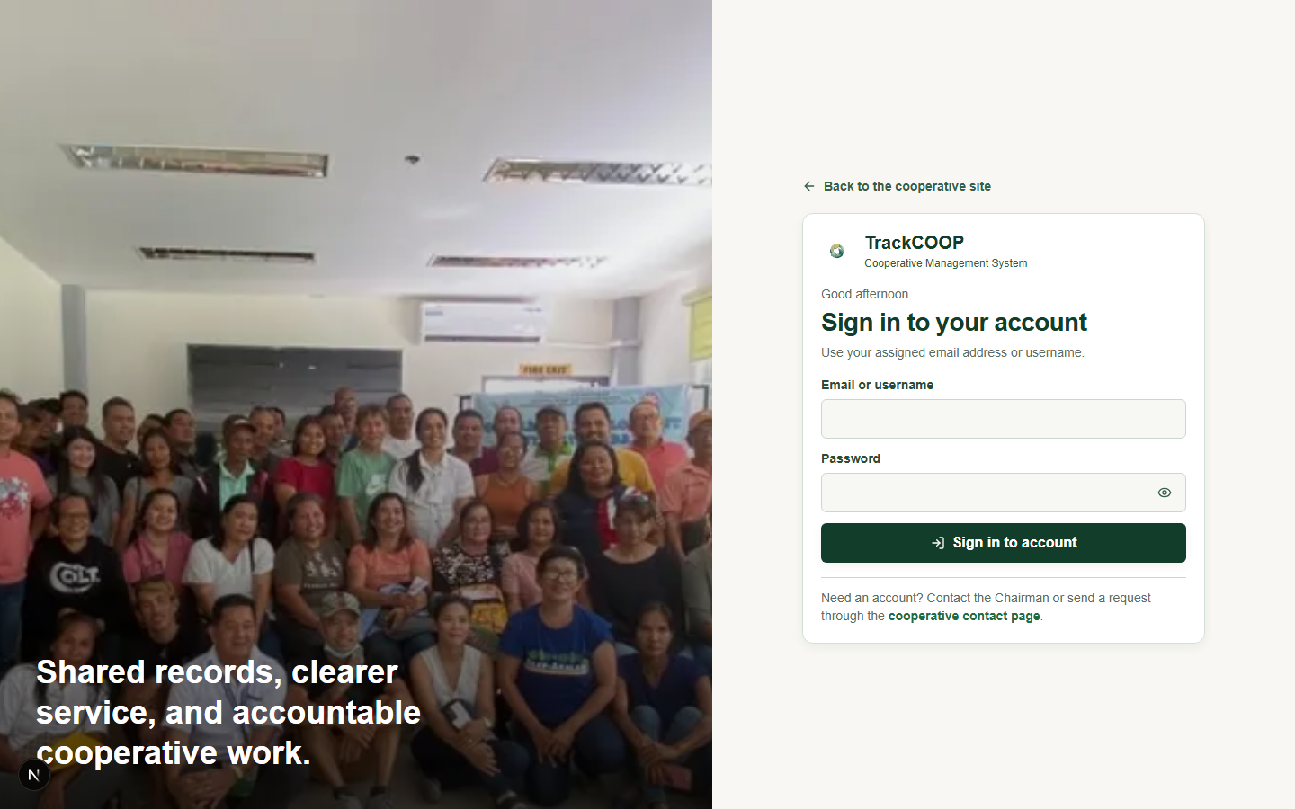
Figure 2. Sign-in interface
Clean sign-in screen. Role: public. Source: public-authentication/login.png.
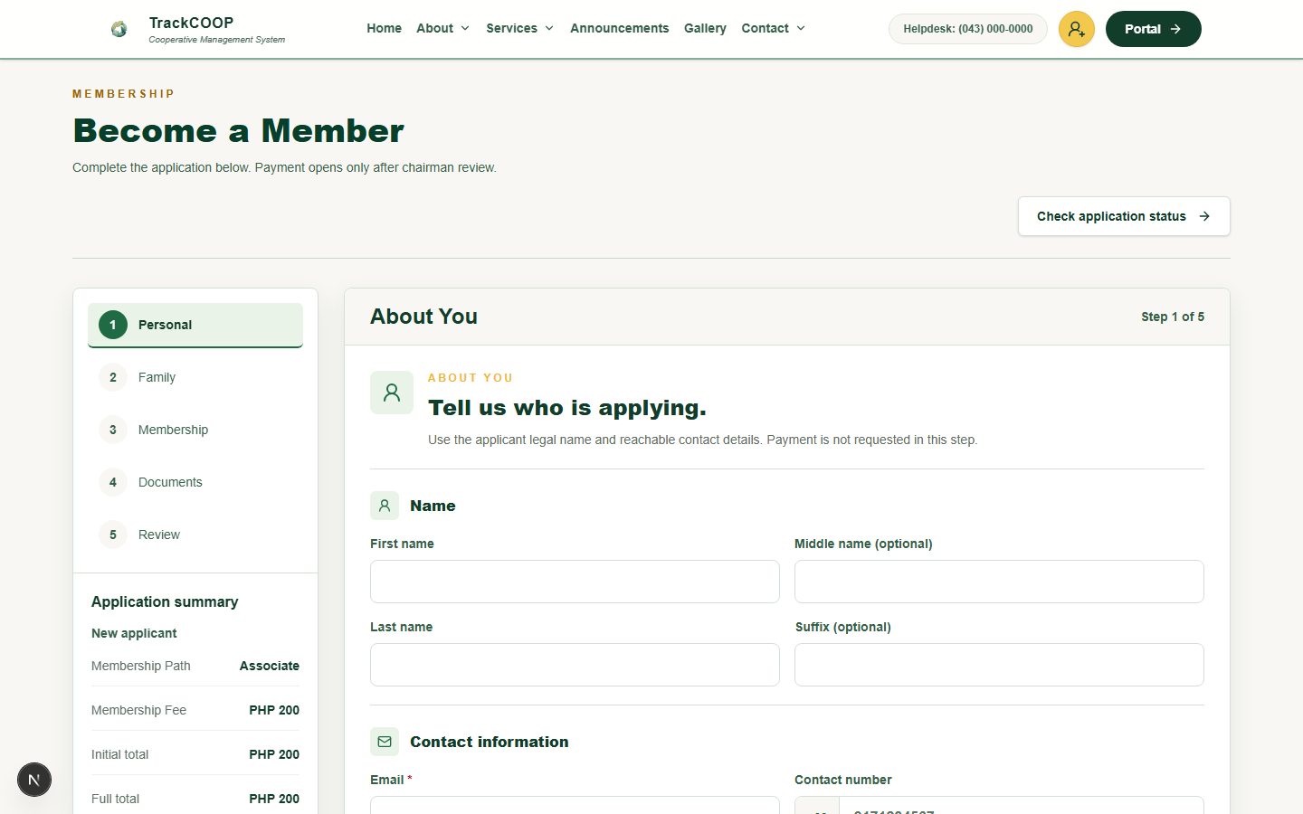
Figure 3. Membership application
Prospective member application fields. Role: public. Source: public-authentication/application-viewport.png.
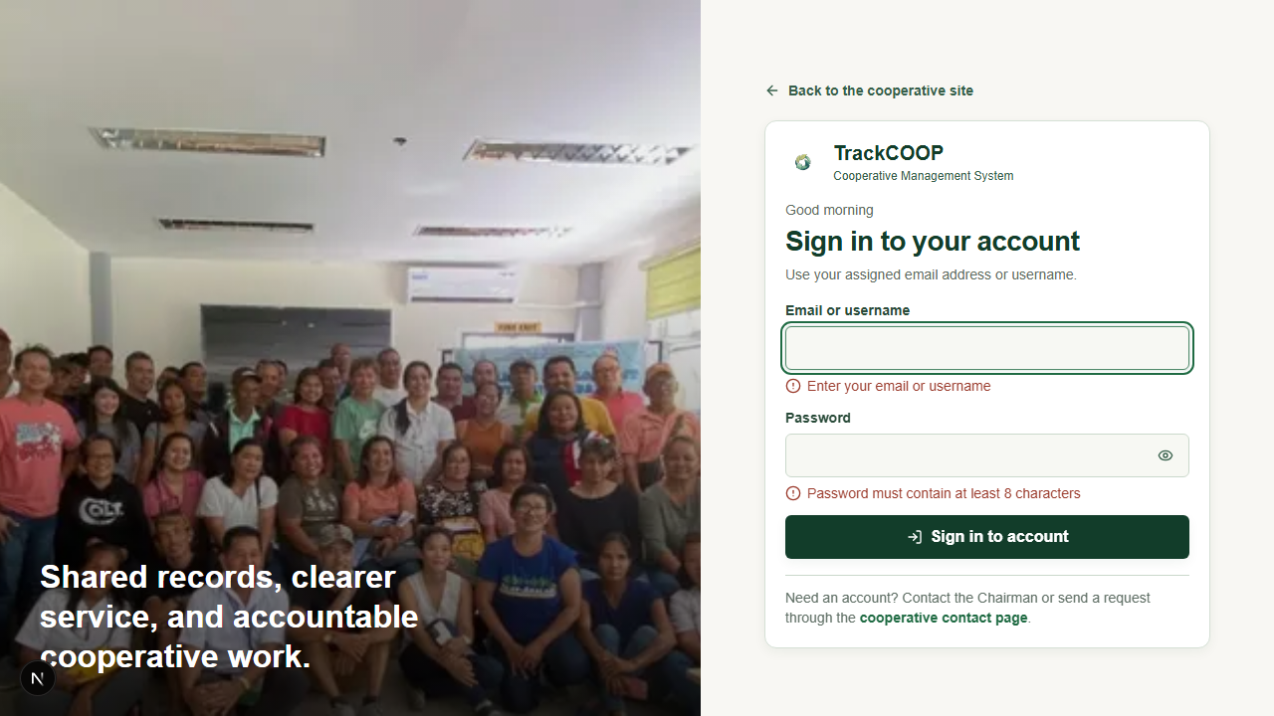
Figure 4. Sign-in validation
Previously captured required-field validation. Role: public. Source: public-authentication/login-validation.png.

Chairman Membership
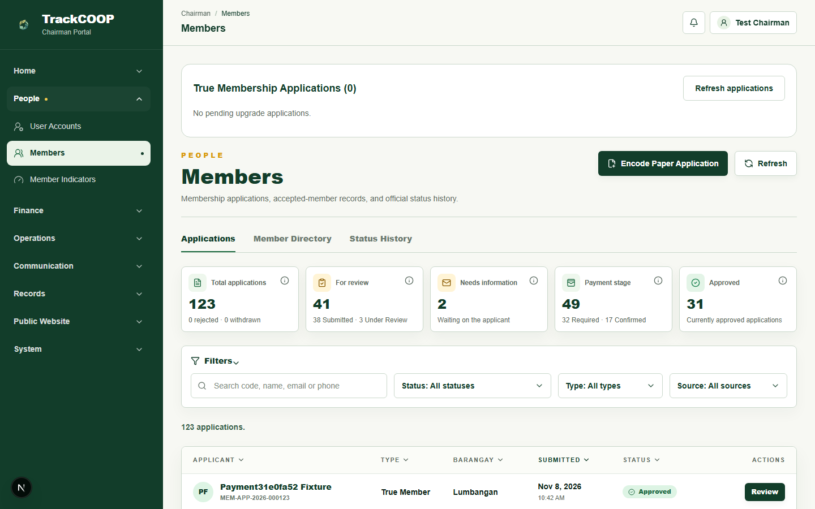
Figure 5. Membership applications
Membership application list and statuses. Role: chairman. Source: chairman-membership/applications-viewport.png.
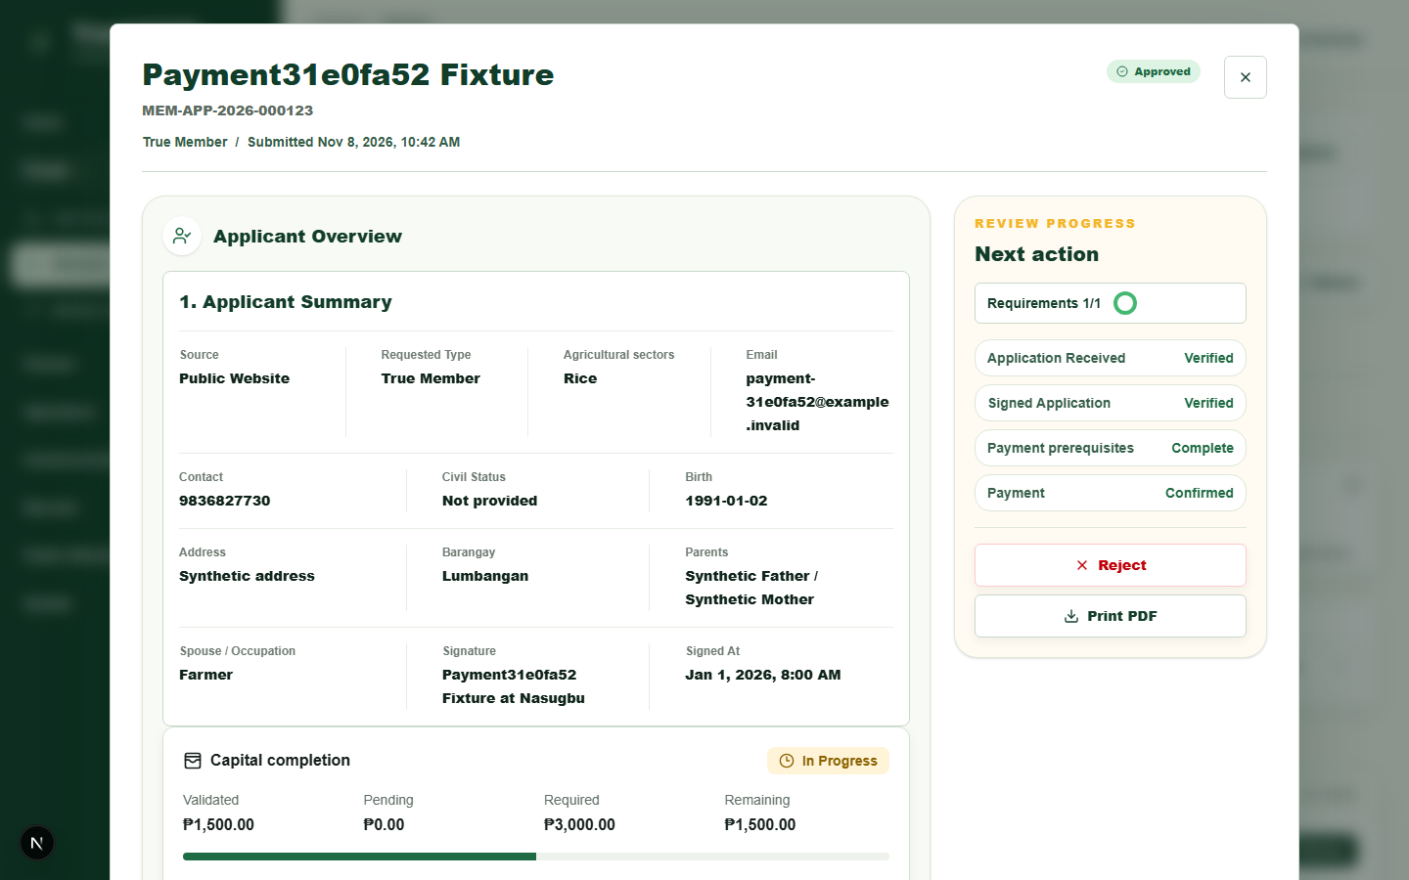
Figure 6. Application review and capital progress
Synthetic application detail and review progress. Role: chairman. Source: chairman-membership/application-review.png.
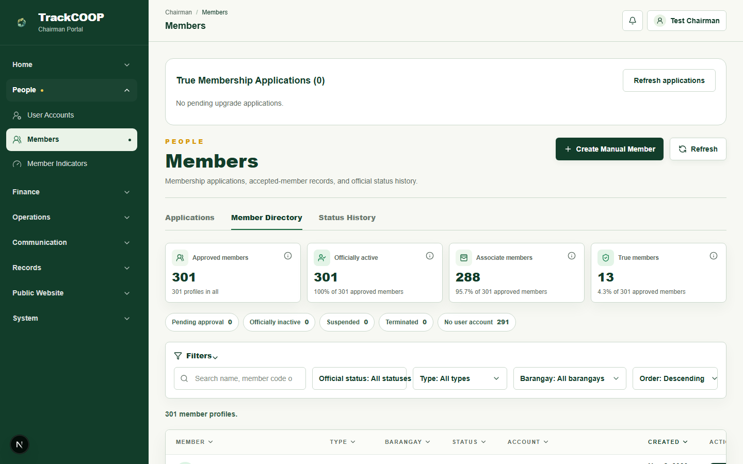
Figure 7. Member directory and classification
Chairman navigation and member directory. Role: chairman. Source: chairman-membership/member-directory-view.png.

Share Capital
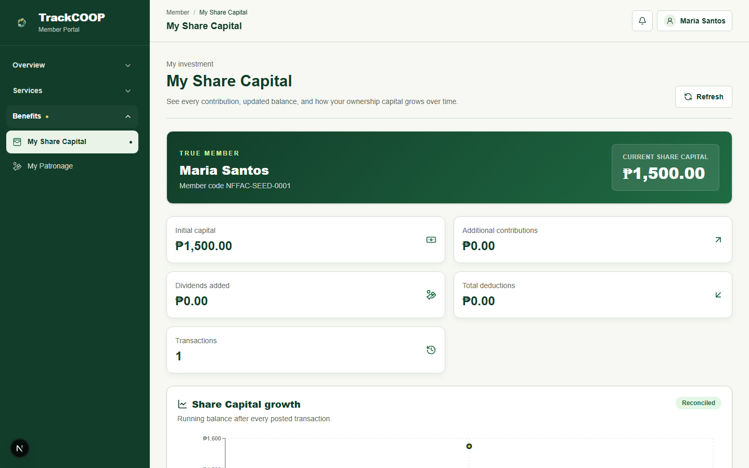
Figure 8. Member share-capital overview
Corrected member capital page and synthetic balance. Role: member. Source: share-capital/member-capital-viewport.png.

Financial Management
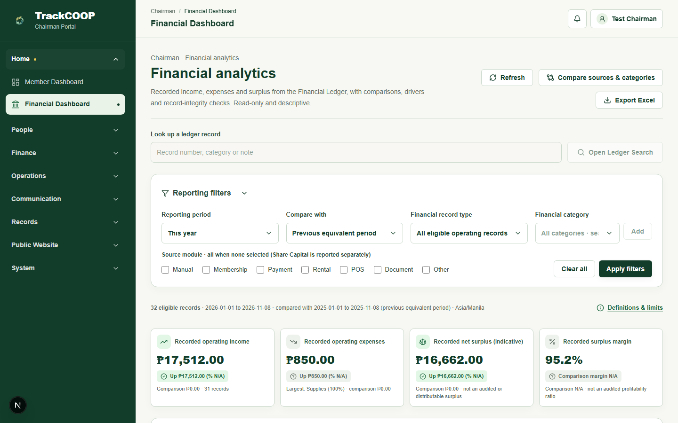
Figure 9. Financial analytics and filters
Financial analytics, filters, and export button. Role: chairman. Source: financial-management/financial-overview-viewport.png.
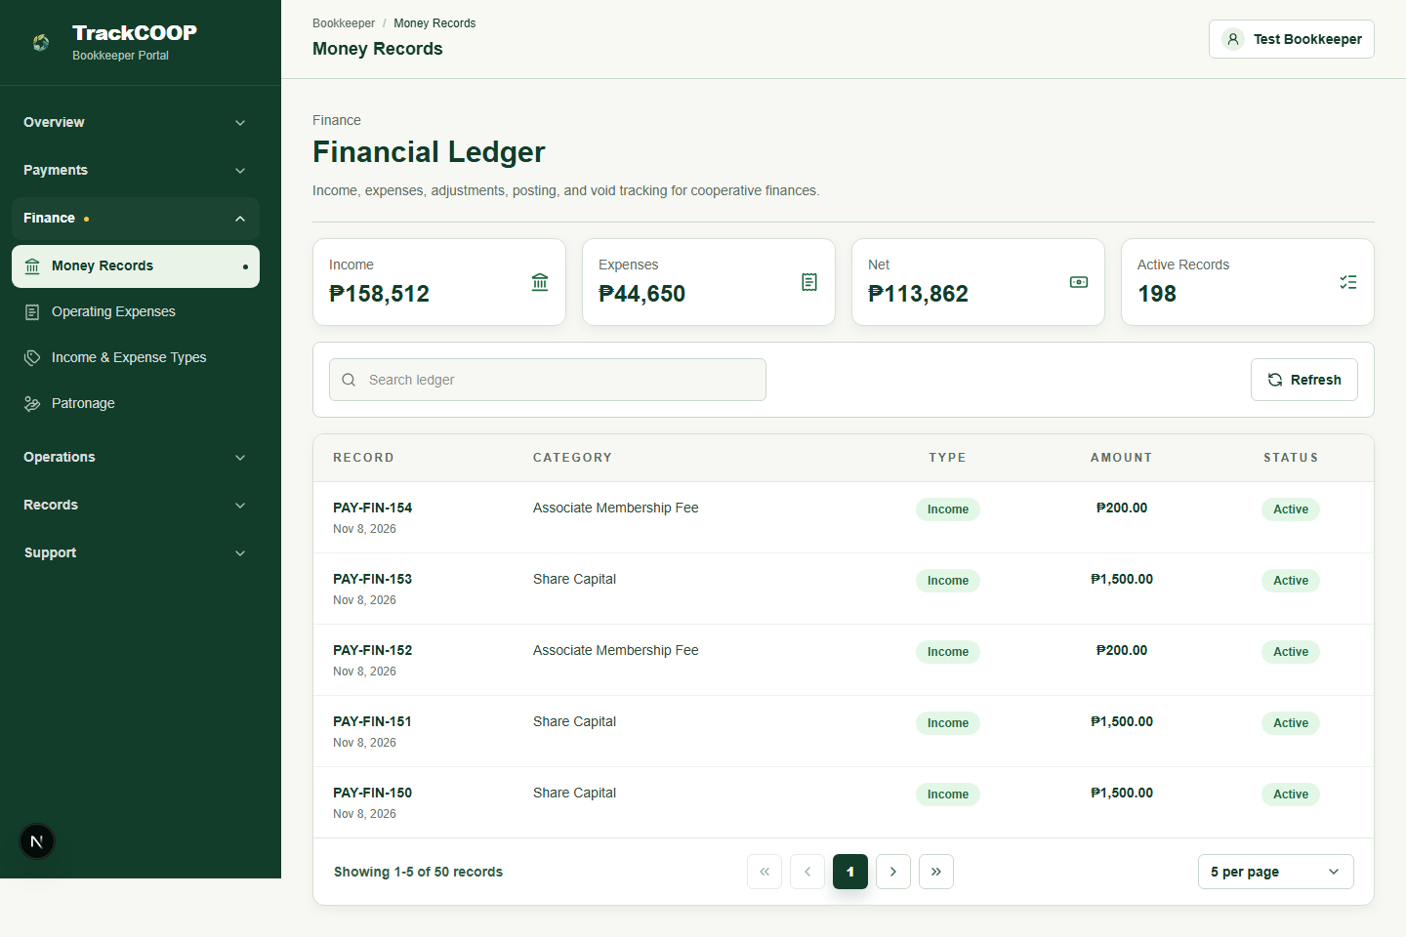
Figure 10. Financial ledger
Bookkeeper financial ledger. Role: bookkeeper. Source: financial-management/financial-ledger.png.
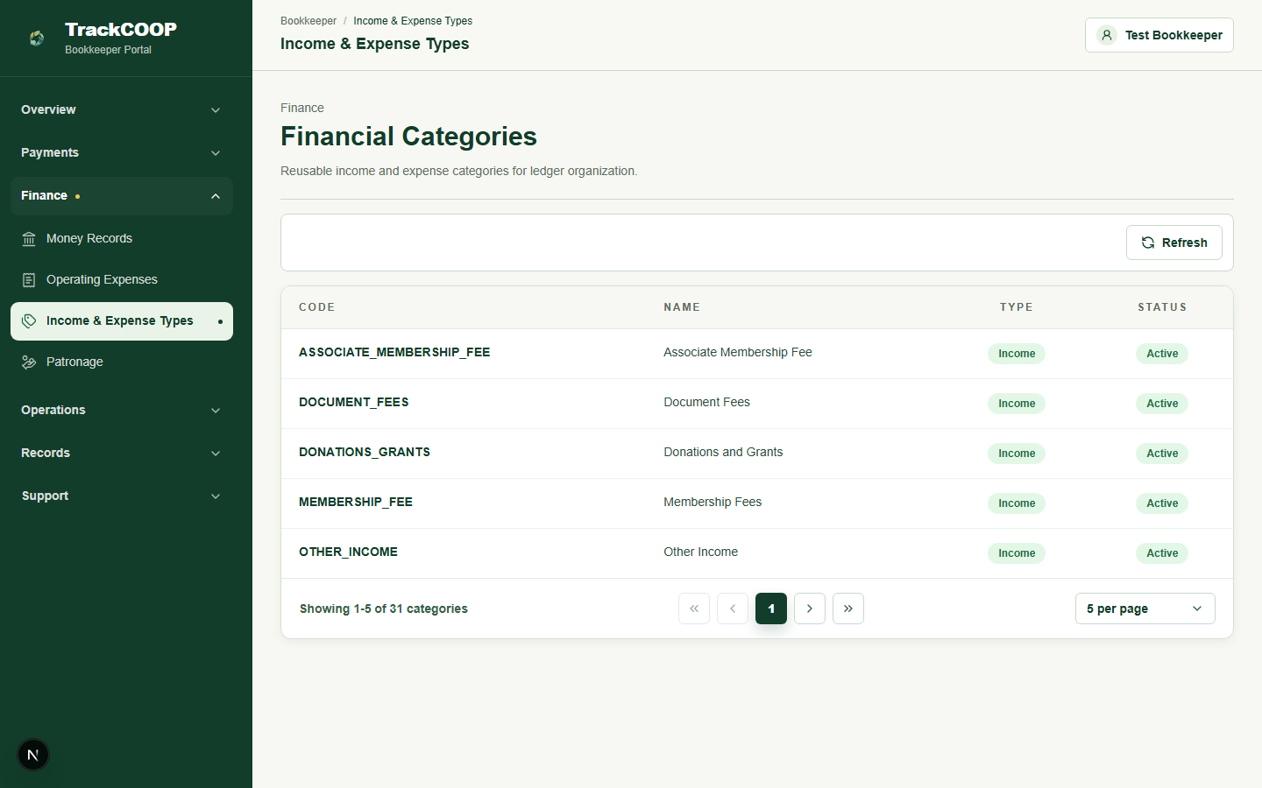
Figure 11. Financial categories
Managed financial categories. Role: bookkeeper. Source: financial-management/financial-categories.png.
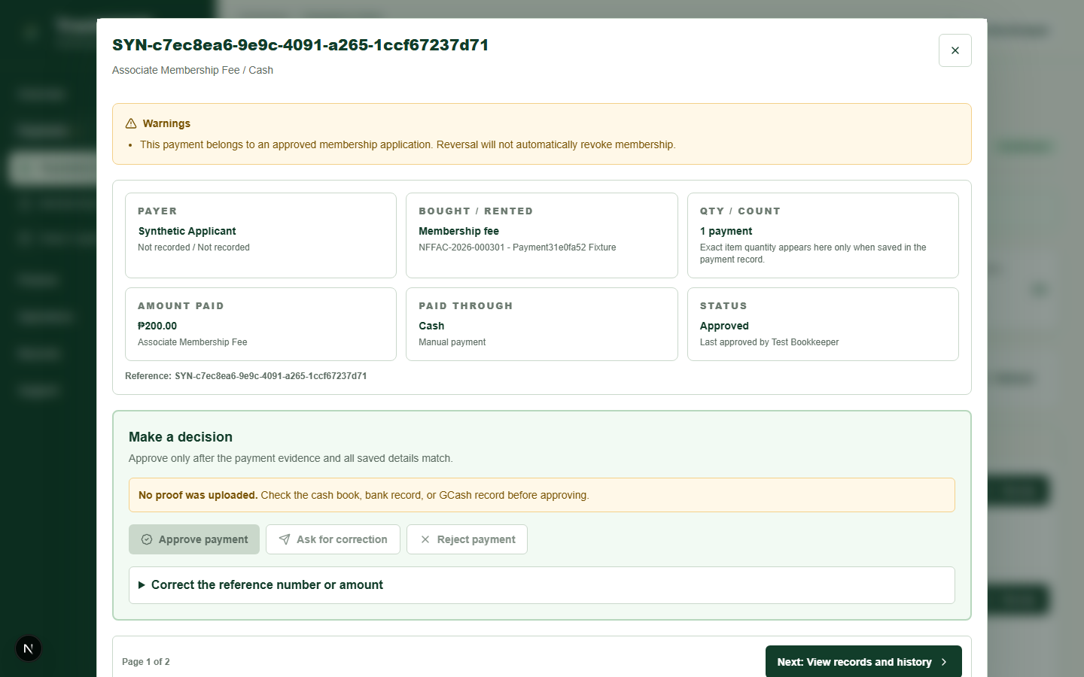
Figure 12. Payment reference review
Synthetic payment reference review dialog. Role: bookkeeper. Source: financial-management/payment-review.png.

Member Analytics
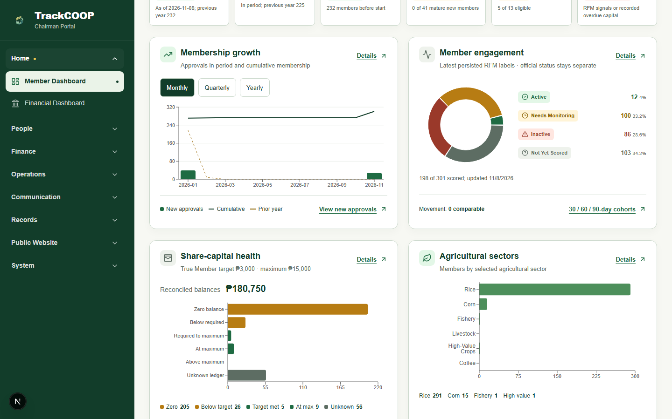
Figure 13. Membership growth, engagement and capital health
Agricultural sector chart and member engagement. Role: chairman. Source: member-analytics/membership-growth.png.
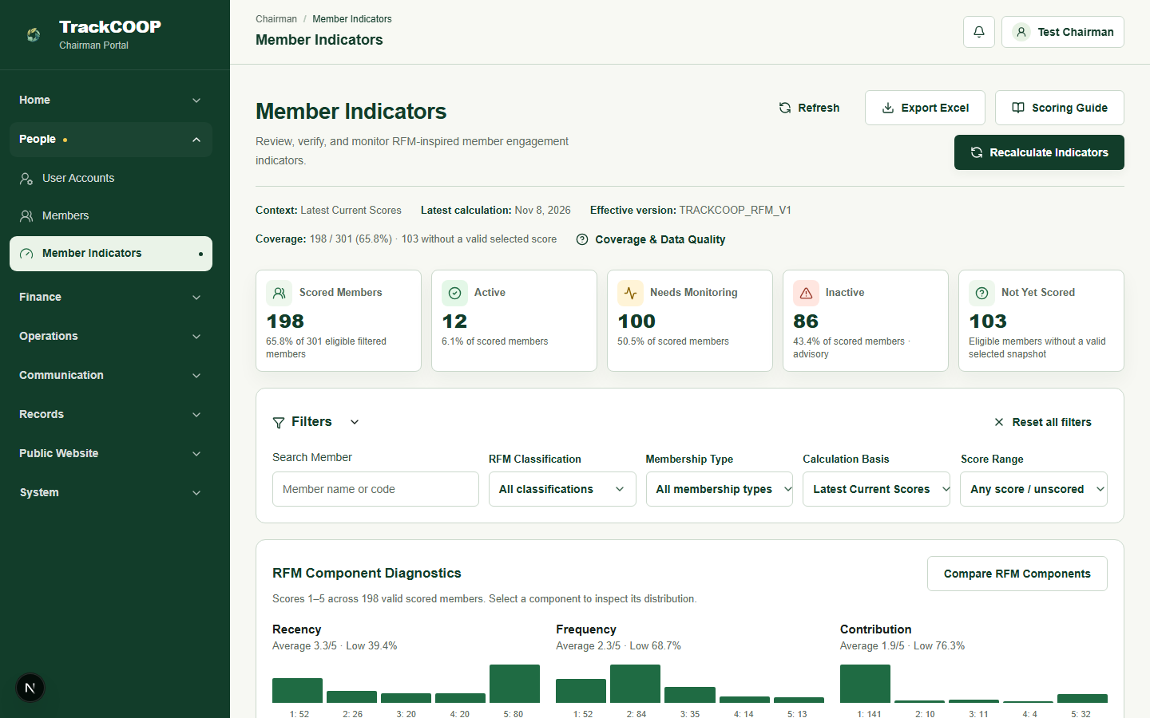
Figure 14. Member indicators
RFM-inspired member indicator workspace. Role: chairman. Source: member-analytics/rfm-summary.png.
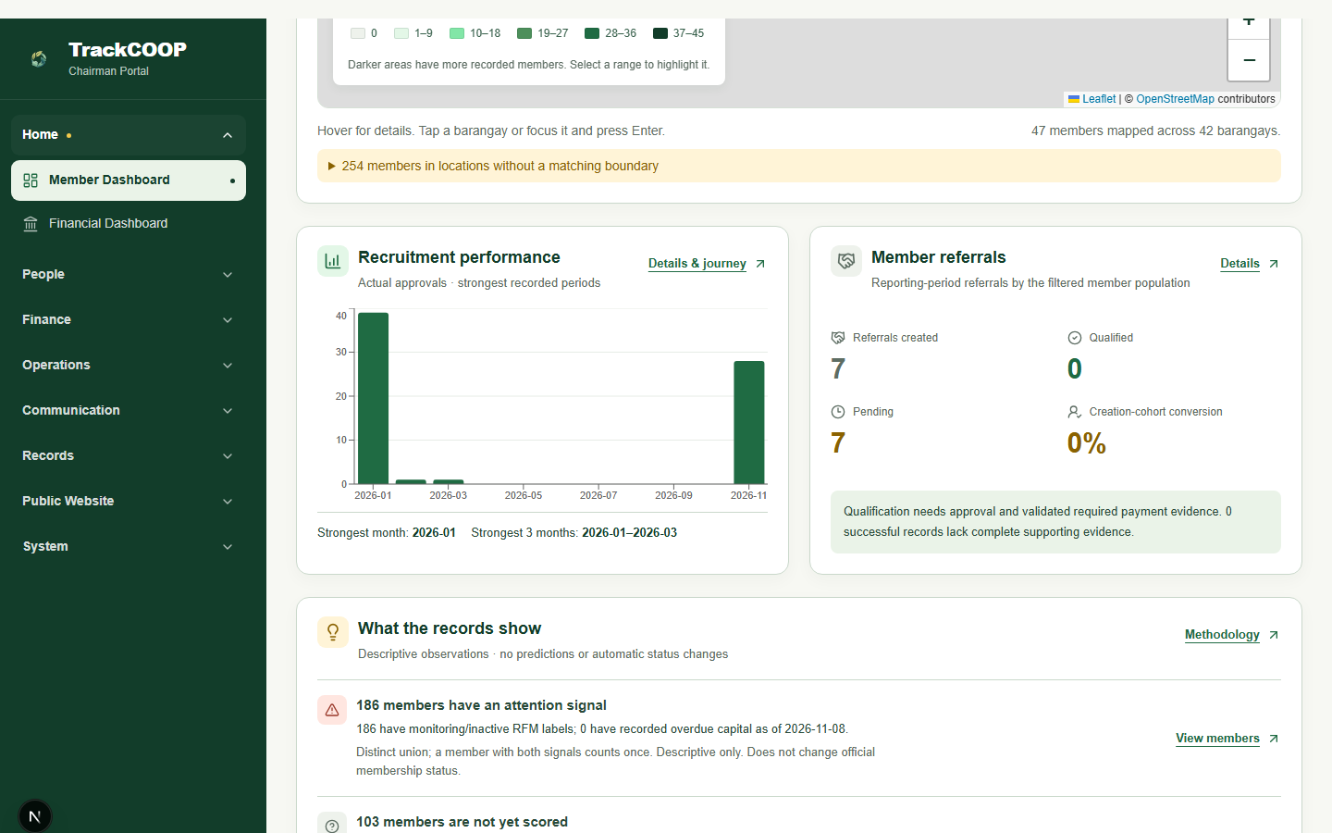
Figure 15. Recruitment and referrals
Recruitment performance chart. Role: chairman. Source: member-analytics/referral-summary.png.

Rental Management
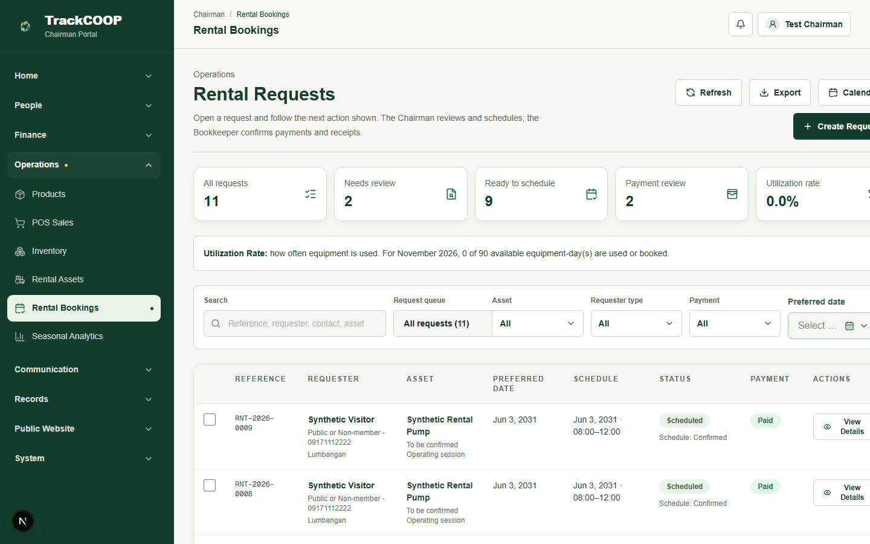
Figure 16. Rental requests and schedules
Rental request and scheduling list. Role: chairman. Source: rental-management/rental-bookings-viewport.png.
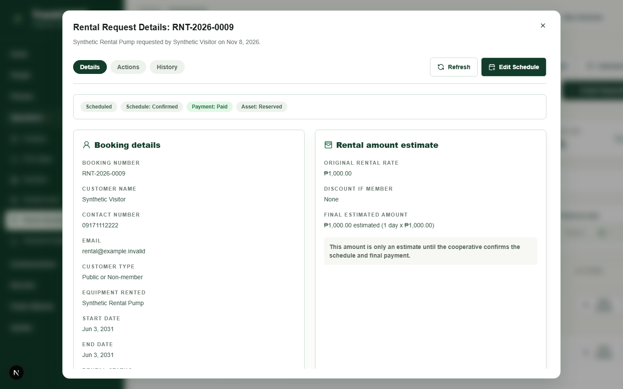
Figure 17. Rental booking details
Synthetic booking details and status. Role: chairman. Source: rental-management/booking-details.png.

Pos Sales
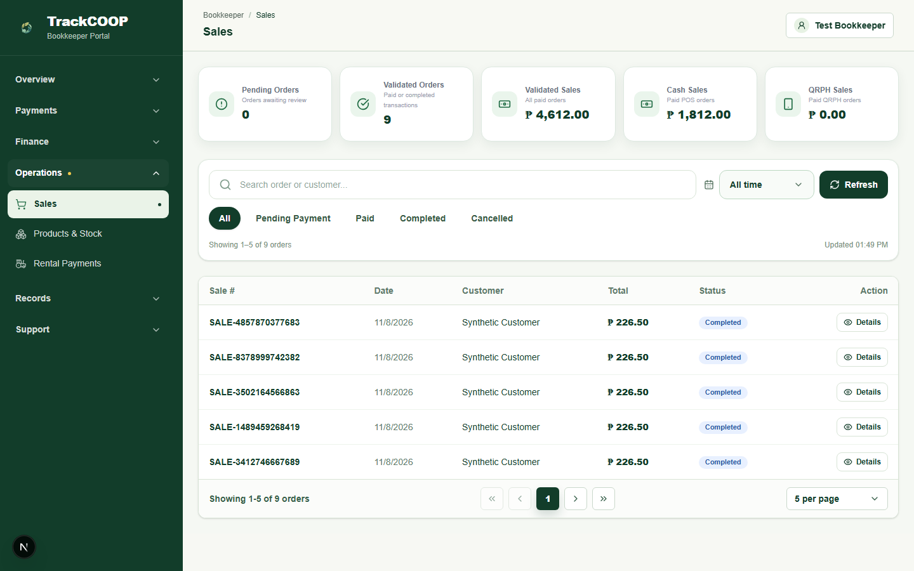
Figure 18. Product sales
Sales list and status summary. Role: bookkeeper. Source: pos-sales/pos-sales.png.
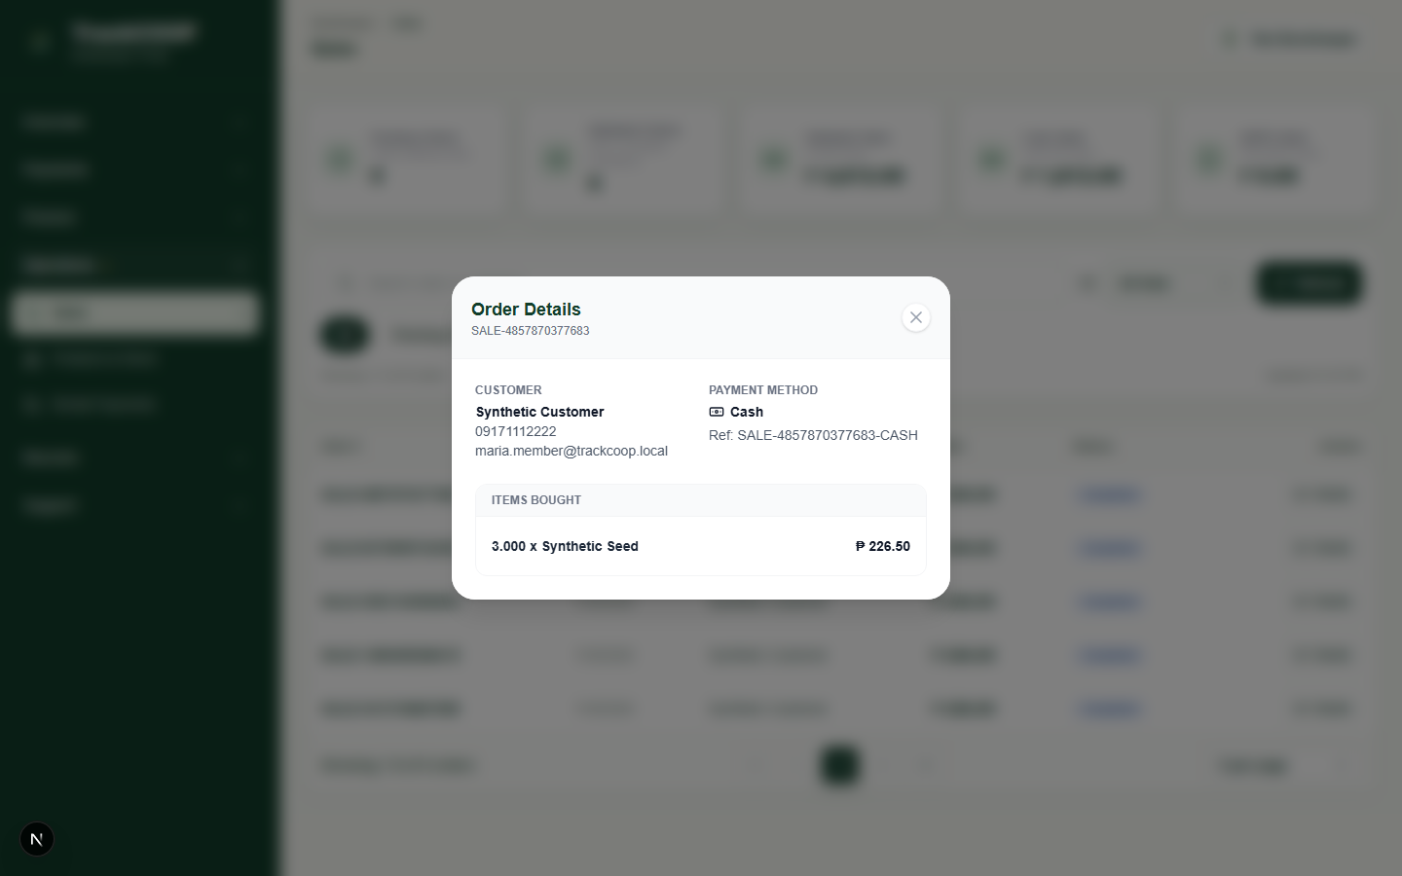
Figure 19. Sale details
Completed synthetic order details shown; checkout itself was not captured. Role: bookkeeper. Source: pos-sales/sale-details-viewport.png.

Document Management
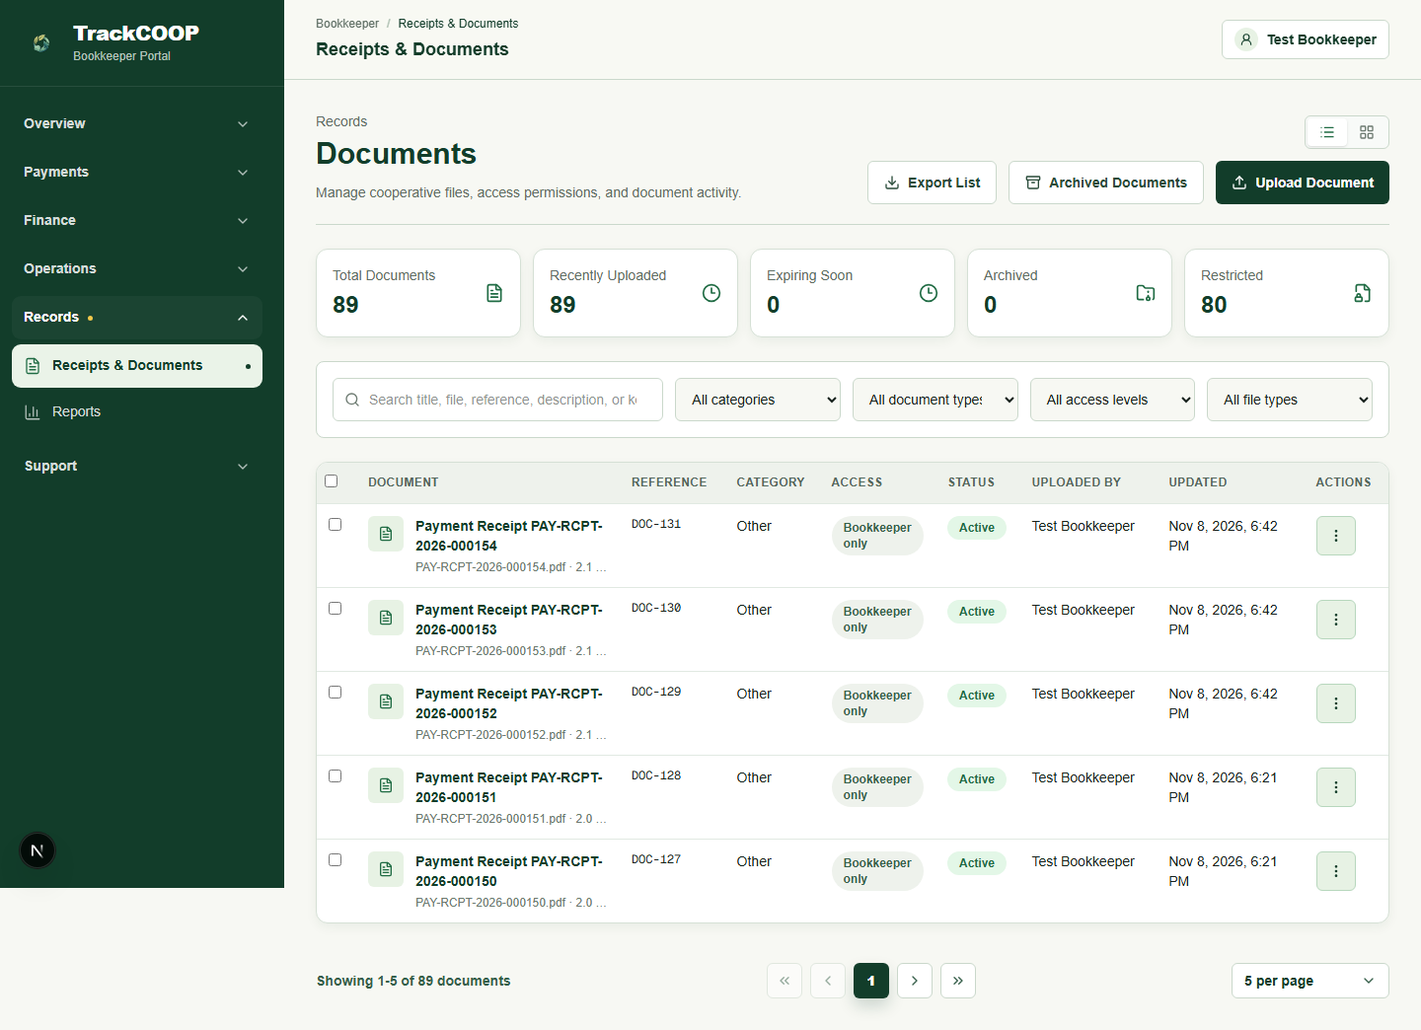
Figure 20. Document repository
Document repository and access levels. Role: bookkeeper. Source: document-management/document-repository.png.
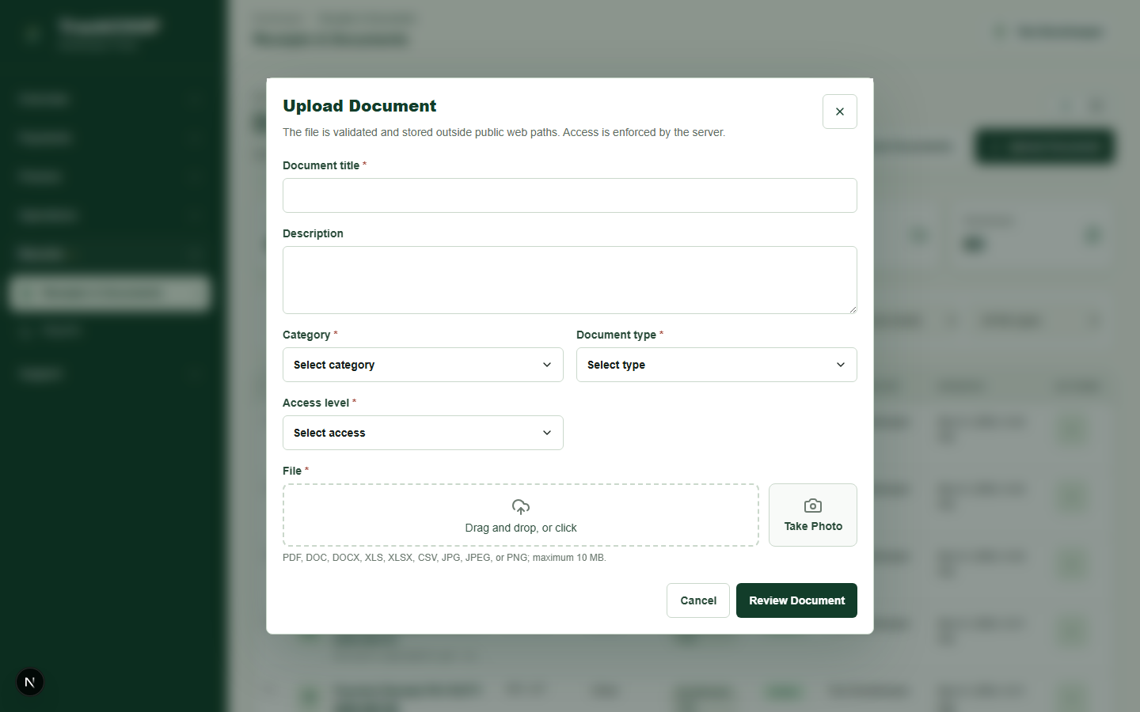
Figure 21. Document upload and access
Upload form and audience/access-level control. Role: bookkeeper. Source: document-management/document-upload.png.

Events Attendance
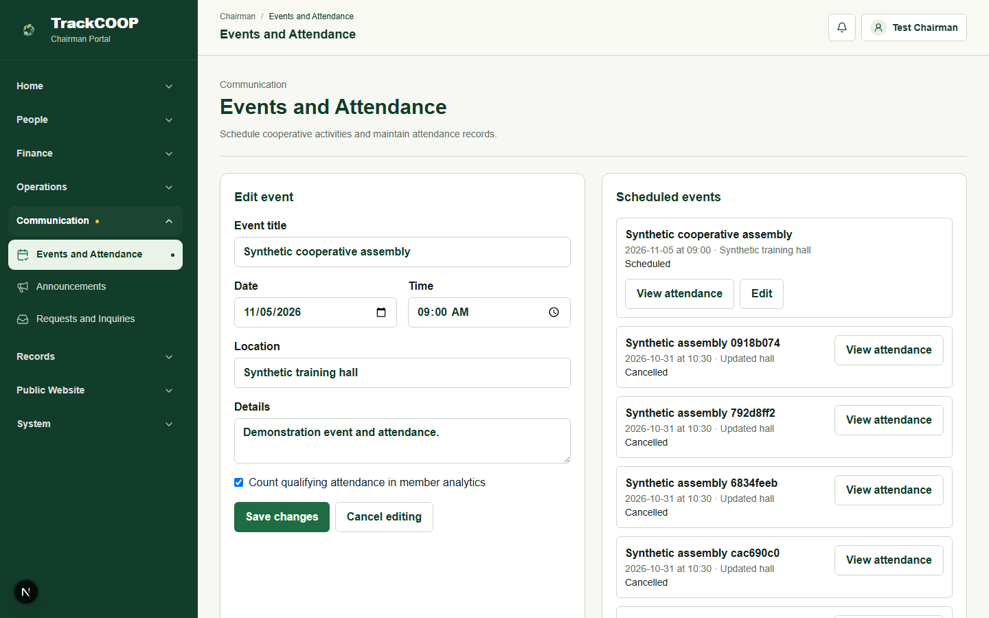
Figure 22. Event scheduling and editing
Event editing form and scheduled-event list. Role: chairman. Source: events-attendance/event-edit.png.
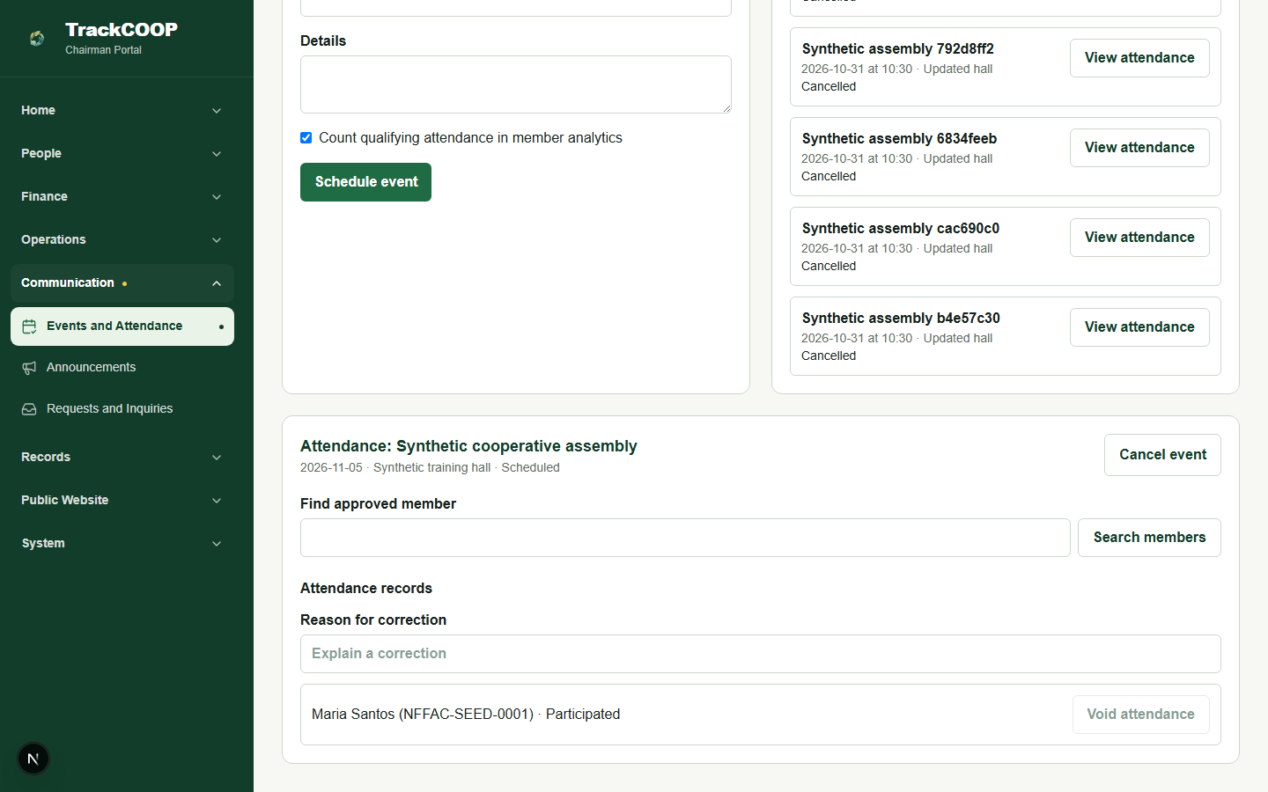
Figure 23. Event attendance and corrections
Recorded synthetic attendance and correction control. Role: chairman. Source: events-attendance/attendance-list-viewport.png.

Member Bookkeeper Portals
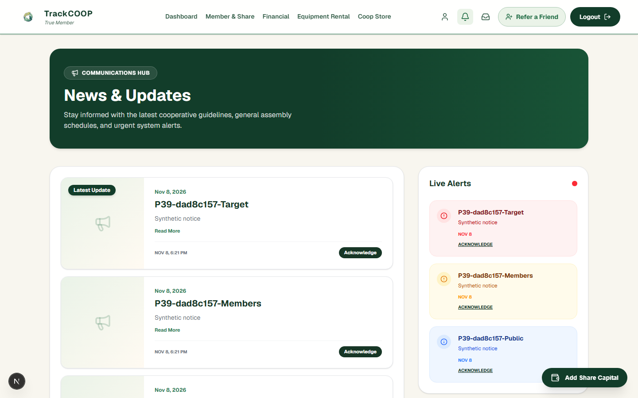
Figure 24. Member announcements and alerts
Member-facing announcements. Role: member. Source: member-bookkeeper-portals/member-notifications.png.
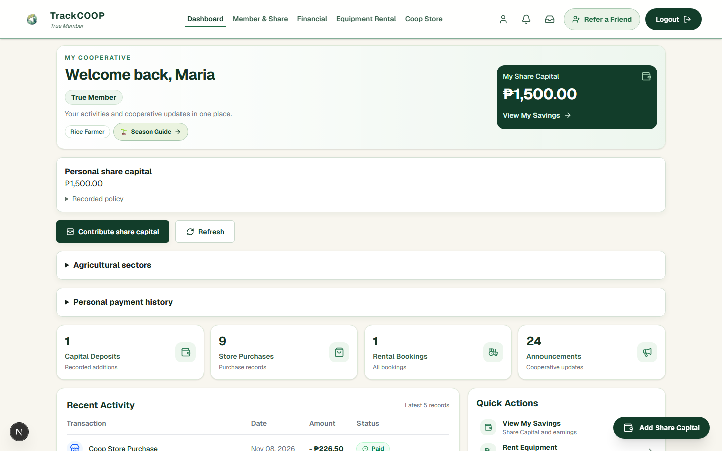
Figure 25. Member dashboard
Member dashboard. Role: member. Source: member-bookkeeper-portals/member-dashboard-viewport.png.

12 Appendix Ready Detailed Test Cases
Each record identifies its disposition and links to execution evidence. The executable tests contain the controlled data, route, role, steps and assertions for the observed checks.

P01 Authentication and access
Scenario and expected outcome: Chairman successfully logs in and accesses authorized functions.
Preconditions and data: isolated environment and synthetic data appropriate to the scenario. Procedure: exercise the relevant interface or backend boundary and verify persisted state where applicable. Actual and status: Passed — Full scenario passed within the test implementation scope. Evidence: database-resolution-final/results.json Exact fixtures, routes and assertions are in the tests/e2e/evidence-*.spec.ts files.

P02 Authentication and access
Scenario and expected outcome: Bookkeeper successfully logs in and accesses authorized functions.
Preconditions and data: isolated environment and synthetic data appropriate to the scenario. Procedure: exercise the relevant interface or backend boundary and verify persisted state where applicable. Actual and status: Passed — Full scenario passed within the test implementation scope. Evidence: database-resolution-final/results.json Exact fixtures, routes and assertions are in the tests/e2e/evidence-*.spec.ts files.

P03 Authentication and access
Scenario and expected outcome: Member successfully logs in and accesses permitted personal information.
Preconditions and data: isolated environment and synthetic data appropriate to the scenario. Procedure: exercise the relevant interface or backend boundary and verify persisted state where applicable. Actual and status: Passed — Full scenario passed within the test implementation scope. Evidence: database-resolution-final/results.json Exact fixtures, routes and assertions are in the tests/e2e/evidence-*.spec.ts files.

P04 Authentication and access
Scenario and expected outcome: Invalid credentials are rejected with appropriate feedback.
Preconditions and data: isolated environment and synthetic data appropriate to the scenario. Procedure: exercise the relevant interface or backend boundary and verify persisted state where applicable. Actual and status: Passed — Full scenario passed within the test implementation scope. Evidence: database-resolution-final/results.json Exact fixtures, routes and assertions are in the tests/e2e/evidence-*.spec.ts files.

P05 Authentication and access
Scenario and expected outcome: Logout terminates authenticated access and prevents unauthorized session reuse.
Preconditions and data: isolated environment and synthetic data appropriate to the scenario. Procedure: exercise the relevant interface or backend boundary and verify persisted state where applicable. Actual and status: Passed — Full scenario passed within the test implementation scope. Evidence: database-resolution-final/results.json Exact fixtures, routes and assertions are in the tests/e2e/evidence-*.spec.ts files.

P06 Authentication and access
Scenario and expected outcome: Unauthorized roles cannot access restricted pages or execute prohibited backend operations.
Preconditions and data: isolated environment and synthetic data appropriate to the scenario. Procedure: exercise the relevant interface or backend boundary and verify persisted state where applicable. Actual and status: Passed — database-consolidated/results.json; member and bookkeeper backend denials plus restricted-page redirects. Evidence: database-consolidated/results.json; member and bookkeeper backend denials plus restricted-page redirects. Exact fixtures, routes and assertions are in the tests/e2e/evidence-*.spec.ts files.

P07 Authentication and access
Scenario and expected outcome: Members cannot retrieve, modify, or view another member's private records.
Preconditions and data: isolated environment and synthetic data appropriate to the scenario. Procedure: exercise the relevant interface or backend boundary and verify persisted state where applicable. Actual and status: Passed — database-member-privacy/results.json; protected document ownership and member/share-capital backend denials. Evidence: database-member-privacy/results.json; protected document ownership and member/share-capital backend denials. Exact fixtures, routes and assertions are in the tests/e2e/evidence-*.spec.ts files.

P08 Authentication and access
Scenario and expected outcome: Public visitors can access permitted public pages and inquiries without gaining private access.
Preconditions and data: isolated environment and synthetic data appropriate to the scenario. Procedure: exercise the relevant interface or backend boundary and verify persisted state where applicable. Actual and status: Passed — Full scenario passed within the test implementation scope. Evidence: database-resolution-final/results.json Exact fixtures, routes and assertions are in the tests/e2e/evidence-*.spec.ts files.

P09 Membership and share capital
Scenario and expected outcome: Valid membership application is submitted and recorded correctly.
Preconditions and data: isolated environment and synthetic data appropriate to the scenario. Procedure: exercise the relevant interface or backend boundary and verify persisted state where applicable. Actual and status: Passed — Full scenario passed within the test implementation scope. Evidence: database-resolution-final/results.json Exact fixtures, routes and assertions are in the tests/e2e/evidence-*.spec.ts files.

P10 Membership and share capital
Scenario and expected outcome: Invalid or incomplete membership application is rejected.
Preconditions and data: isolated environment and synthetic data appropriate to the scenario. Procedure: exercise the relevant interface or backend boundary and verify persisted state where applicable. Actual and status: Passed — Full scenario passed within the test implementation scope. Evidence: database-resolution-final/results.json Exact fixtures, routes and assertions are in the tests/e2e/evidence-*.spec.ts files.

P11 Membership and share capital
Scenario and expected outcome: Authorized approval correctly updates the application and associated membership records.
Preconditions and data: isolated environment and synthetic data appropriate to the scenario. Procedure: exercise the relevant interface or backend boundary and verify persisted state where applicable. Actual and status: Passed — database-resolution-payment-final/results.json; chairman reviewed a synthetic signed application, verified fee and initial capital, and approved without waivers. Evidence: database-resolution-payment-final/results.json; chairman reviewed a synthetic signed application, verified fee and initial capital, and approved without waivers. Exact fixtures, routes and assertions are in the tests/e2e/evidence-*.spec.ts files.

P12 Membership and share capital
Scenario and expected outcome: Unauthorized approval attempts are rejected.
Preconditions and data: isolated environment and synthetic data appropriate to the scenario. Procedure: exercise the relevant interface or backend boundary and verify persisted state where applicable. Actual and status: Passed — Full scenario passed within the test implementation scope. Evidence: database-resolution-final/results.json Exact fixtures, routes and assertions are in the tests/e2e/evidence-*.spec.ts files.

P13 Membership and share capital
Scenario and expected outcome: Associate and true member classification follows the implemented NFFAC rules.
Preconditions and data: isolated environment and synthetic data appropriate to the scenario. Procedure: exercise the relevant interface or backend boundary and verify persisted state where applicable. Actual and status: Passed — database-classification-approval/results.json; prepared True applications at 1499.99, 1500, 2999.99 and 3000; fee and signature waived. Evidence: database-classification-approval/results.json; prepared True applications at 1499.99, 1500, 2999.99 and 3000; fee and signature waived. Exact fixtures, routes and assertions are in the tests/e2e/evidence-*.spec.ts files.

P14 Membership and share capital
Scenario and expected outcome: The ₱200 associate fee, ₱1,500 initial share capital payment, and ₱3,000 true-member share capital requirement are handled correctly.
Preconditions and data: isolated environment and synthetic data appropriate to the scenario. Procedure: exercise the relevant interface or backend boundary and verify persisted state where applicable. Actual and status: Passed — database-resolution-payment-final/results.json; original 409 preserved in database-membership-amounts; signed application reviewed, fee and capital validated, duplicate and invalid reference rejected, and approval completed. Evidence: database-resolution-payment-final/results.json; original 409 preserved in database-membership-amounts; signed application reviewed, fee and capital validated, duplicate and invalid reference rejected, and approval completed. Exact fixtures, routes and assertions are in the tests/e2e/evidence-*.spec.ts files.

P15 Membership and share capital
Scenario and expected outcome: The ₱15,000 maximum share capital contribution is enforced without overposting.
Preconditions and data: isolated environment and synthetic data appropriate to the scenario. Procedure: exercise the relevant interface or backend boundary and verify persisted state where applicable. Actual and status: Passed — database-consolidated/results.json; validated 14999.99 + 0.01, rejected further 0.01. Evidence: database-consolidated/results.json; validated 14999.99 + 0.01, rejected further 0.01. Exact fixtures, routes and assertions are in the tests/e2e/evidence-*.spec.ts files.

P16 Membership and share capital
Scenario and expected outcome: Contribution history, payment progress, status, and applicable six-month completion rule are correctly represented and enforced where specified.
Preconditions and data: isolated environment and synthetic data appropriate to the scenario. Procedure: exercise the relevant interface or backend boundary and verify persisted state where applicable. Actual and status: Passed — database-capital-overdue/results.json and database-investigation/results.json; pending/validated installments, six-month new case, overdue status and completion; second reference and adjusted dates were synthetic fixtures. Evidence: database-capital-overdue/results.json and database-investigation/results.json; pending/validated installments, six-month new case, overdue status and completion; second reference and adjusted dates were synthetic fixtures. Exact fixtures, routes and assertions are in the tests/e2e/evidence-*.spec.ts files.

P17 Membership and share capital
Scenario and expected outcome: Members belonging to multiple agricultural sectors are not double-counted in unique membership totals.
Preconditions and data: isolated environment and synthetic data appropriate to the scenario. Procedure: exercise the relevant interface or backend boundary and verify persisted state where applicable. Actual and status: Passed — Full scenario passed within the test implementation scope. Evidence: database-resolution-final/results.json Exact fixtures, routes and assertions are in the tests/e2e/evidence-*.spec.ts files.

P18 Membership and share capital
Scenario and expected outcome: Referrals are associated with the correct applicants and remain distinct from approved member counts.
Preconditions and data: isolated environment and synthetic data appropriate to the scenario. Procedure: exercise the relevant interface or backend boundary and verify persisted state where applicable. Actual and status: Passed — Full scenario passed within the test implementation scope. Evidence: database-resolution-final/results.json Exact fixtures, routes and assertions are in the tests/e2e/evidence-*.spec.ts files.

P19 Payments and finance
Scenario and expected outcome: Successful PayMongo Test Mode membership-related payments link to the correct payment and contribution records.
Preconditions and data: isolated environment and synthetic data appropriate to the scenario. Procedure: exercise the relevant interface or backend boundary and verify persisted state where applicable. Actual and status: Passed — database-gateway-success-both/results.json; prior baseline Test Mode authorization with local signed callback. External gateway checks intentionally not repeated during corrections; local checkout unit test covers the fee snapshot. Evidence: database-gateway-success-both/results.json; prior baseline Test Mode authorization with local signed callback. External gateway checks intentionally not repeated during corrections; local checkout unit test covers the fee snapshot. Exact fixtures, routes and assertions are in the tests/e2e/evidence-*.spec.ts files.

P20 Payments and finance
Scenario and expected outcome: Pending, failed, canceled, or unsuccessful payments do not produce successful financial outcomes.
Preconditions and data: isolated environment and synthetic data appropriate to the scenario. Procedure: exercise the relevant interface or backend boundary and verify persisted state where applicable. Actual and status: Passed — database-paymongo-retest/results.json and database-gateway-unsuccessful-resume/results.json; prior baseline pending, failed, expired and canceled Test Mode paths. External checks intentionally not repeated during corrections. Evidence: database-paymongo-retest/results.json and database-gateway-unsuccessful-resume/results.json; prior baseline pending, failed, expired and canceled Test Mode paths. External checks intentionally not repeated during corrections. Exact fixtures, routes and assertions are in the tests/e2e/evidence-*.spec.ts files.

P21 Payments and finance
Scenario and expected outcome: Duplicate payment notifications or processing attempts do not create duplicate contribution or financial postings.
Preconditions and data: isolated environment and synthetic data appropriate to the scenario. Procedure: exercise the relevant interface or backend boundary and verify persisted state where applicable. Actual and status: Passed — database-gateway-success-both/results.json; prior baseline duplicate locally signed callback; current manual validation replay passed in database-resolution-final/results.json. Evidence: database-gateway-success-both/results.json; prior baseline duplicate locally signed callback; current manual validation replay passed in database-resolution-final/results.json. Exact fixtures, routes and assertions are in the tests/e2e/evidence-*.spec.ts files.

P22 Payments and finance
Scenario and expected outcome: Bookkeeper can validate eligible manually reviewed payment references and supporting proofs.
Preconditions and data: isolated environment and synthetic data appropriate to the scenario. Procedure: exercise the relevant interface or backend boundary and verify persisted state where applicable. Actual and status: Passed — Full scenario passed within the test implementation scope. Evidence: database-resolution-final/results.json Exact fixtures, routes and assertions are in the tests/e2e/evidence-*.spec.ts files.

P23 Payments and finance
Scenario and expected outcome: Unvalidated or rejected payment records do not become validated financial receipts.
Preconditions and data: isolated environment and synthetic data appropriate to the scenario. Procedure: exercise the relevant interface or backend boundary and verify persisted state where applicable. Actual and status: Passed — Full scenario passed within the test implementation scope. Evidence: database-resolution-final/results.json Exact fixtures, routes and assertions are in the tests/e2e/evidence-*.spec.ts files.

P24 Payments and finance
Scenario and expected outcome: Operating income and operating expense records are saved and classified accurately.
Preconditions and data: isolated environment and synthetic data appropriate to the scenario. Procedure: exercise the relevant interface or backend boundary and verify persisted state where applicable. Actual and status: Passed — Full scenario passed within the test implementation scope. Evidence: database-resolution-final/results.json Exact fixtures, routes and assertions are in the tests/e2e/evidence-*.spec.ts files.

P25 Payments and finance
Scenario and expected outcome: Share capital and capital/fund movements are not incorrectly classified as operating income.
Preconditions and data: isolated environment and synthetic data appropriate to the scenario. Procedure: exercise the relevant interface or backend boundary and verify persisted state where applicable. Actual and status: Passed — database-funds-retest/results.json; share capital, internal transfers and capital expenditure excluded from operating totals. Evidence: database-funds-retest/results.json; share capital, internal transfers and capital expenditure excluded from operating totals. Exact fixtures, routes and assertions are in the tests/e2e/evidence-*.spec.ts files.

P26 Payments and finance
Scenario and expected outcome: Net Surplus equals approved operating income minus approved operating expenses, excluding share capital and separately designated funds.
Preconditions and data: isolated environment and synthetic data appropriate to the scenario. Procedure: exercise the relevant interface or backend boundary and verify persisted state where applicable. Actual and status: Passed — Full scenario passed within the test implementation scope. Evidence: database-resolution-final/results.json Exact fixtures, routes and assertions are in the tests/e2e/evidence-*.spec.ts files.

P27 Payments and finance
Scenario and expected outcome: Financial categories, category changes, and editing permissions operate according to configured authorization rules.
Preconditions and data: isolated environment and synthetic data appropriate to the scenario. Procedure: exercise the relevant interface or backend boundary and verify persisted state where applicable. Actual and status: Passed — Full scenario passed within the test implementation scope. Evidence: database-resolution-final/results.json Exact fixtures, routes and assertions are in the tests/e2e/evidence-*.spec.ts files.

P28 Payments and finance
Scenario and expected outcome: Financial Analytics Dashboard totals agree with their underlying records and applied filters.
Preconditions and data: isolated environment and synthetic data appropriate to the scenario. Procedure: exercise the relevant interface or backend boundary and verify persisted state where applicable. Actual and status: Passed — database-consolidated/results.json; 5000 income, 1700 expense, 3300 net. Evidence: database-consolidated/results.json; 5000 income, 1700 expense, 3300 net. Exact fixtures, routes and assertions are in the tests/e2e/evidence-*.spec.ts files.

P29 Payments and finance
Scenario and expected outcome: Exported Excel financial transaction records correctly reflect applicable filters, dates, classifications, amounts, and source rows.
Preconditions and data: isolated environment and synthetic data appropriate to the scenario. Procedure: exercise the relevant interface or backend boundary and verify persisted state where applicable. Actual and status: Passed — database-financial-export-full/results.json; filtered Excel financial activity includes income and expense rows and excludes out-of-range records. Evidence: database-financial-export-full/results.json; filtered Excel financial activity includes income and expense rows and excludes out-of-range records. Exact fixtures, routes and assertions are in the tests/e2e/evidence-*.spec.ts files.

P30 Payments and finance
Scenario and expected outcome: Approved benefit-allocation records, withdrawal requests, and CBU-related workflows respect implemented permissions and rules without initiating unauthorized payouts.
Preconditions and data: isolated environment and synthetic data appropriate to the scenario. Procedure: exercise the relevant interface or backend boundary and verify persisted state where applicable. Actual and status: Passed — database-benefits-retest/results.json; synthetic approved dividend, cash withdrawal record and patronage-capital transfer; no real payout. Evidence: database-benefits-retest/results.json; synthetic approved dividend, cash withdrawal record and patronage-capital transfer; no real payout. Exact fixtures, routes and assertions are in the tests/e2e/evidence-*.spec.ts files.

P31 Rental and sales
Scenario and expected outcome: Rental inquiries and schedules are recorded correctly.
Preconditions and data: isolated environment and synthetic data appropriate to the scenario. Procedure: exercise the relevant interface or backend boundary and verify persisted state where applicable. Actual and status: Passed — database-rental-unique/results.json; duplicate request and confirmed schedule. Evidence: database-rental-unique/results.json; duplicate request and confirmed schedule. Exact fixtures, routes and assertions are in the tests/e2e/evidence-*.spec.ts files.

P32 Rental and sales
Scenario and expected outcome: Rental status changes and applicable recorded rental terms behave correctly.
Preconditions and data: isolated environment and synthetic data appropriate to the scenario. Procedure: exercise the relevant interface or backend boundary and verify persisted state where applicable. Actual and status: Passed — database-rental-unique/results.json; synthetic fixed-rate terms. Evidence: database-rental-unique/results.json; synthetic fixed-rate terms. Exact fixtures, routes and assertions are in the tests/e2e/evidence-*.spec.ts files.

P33 Rental and sales
Scenario and expected outcome: POS or product-sales records contain correct items, quantities, prices, totals, and relevant statuses.
Preconditions and data: isolated environment and synthetic data appropriate to the scenario. Procedure: exercise the relevant interface or backend boundary and verify persisted state where applicable. Actual and status: Passed — database-consolidated/results.json; 3 x 75.50 = 226.50. Evidence: database-consolidated/results.json; 3 x 75.50 = 226.50. Exact fixtures, routes and assertions are in the tests/e2e/evidence-*.spec.ts files.

P34 Rental and sales
Scenario and expected outcome: Advance pickup orders follow the implemented order, payment-status, and pickup workflow.
Preconditions and data: isolated environment and synthetic data appropriate to the scenario. Procedure: exercise the relevant interface or backend boundary and verify persisted state where applicable. Actual and status: Passed — database-consolidated/results.json; member cash order through payment confirmation and pickup release; no pickup-date feature was found. Evidence: database-consolidated/results.json; member cash order through payment confirmation and pickup release; no pickup-date feature was found. Exact fixtures, routes and assertions are in the tests/e2e/evidence-*.spec.ts files.

P35 Rental and sales
Scenario and expected outcome: Eligible rental and product-sales transactions are reflected correctly in financial records without unintended duplicate posting.
Preconditions and data: isolated environment and synthetic data appropriate to the scenario. Procedure: exercise the relevant interface or backend boundary and verify persisted state where applicable. Actual and status: Passed — database-consolidated/results.json and database-rental-replay/results.json; one posting per sale and rental after duplicate validation. Evidence: database-consolidated/results.json and database-rental-replay/results.json; one posting per sale and rental after duplicate validation. Exact fixtures, routes and assertions are in the tests/e2e/evidence-*.spec.ts files.

P36 Documents and communication
Scenario and expected outcome: Authorized document upload, metadata storage, and retrieval function correctly.
Preconditions and data: isolated environment and synthetic data appropriate to the scenario. Procedure: exercise the relevant interface or backend boundary and verify persisted state where applicable. Actual and status: Passed — Full scenario passed within the test implementation scope. Evidence: database-resolution-final/results.json Exact fixtures, routes and assertions are in the tests/e2e/evidence-*.spec.ts files.

P37 Documents and communication
Scenario and expected outcome: Invalid, unsupported, or incomplete file uploads are rejected safely.
Preconditions and data: isolated environment and synthetic data appropriate to the scenario. Procedure: exercise the relevant interface or backend boundary and verify persisted state where applicable. Actual and status: Passed — Full scenario passed within the test implementation scope. Evidence: database-resolution-final/results.json Exact fixtures, routes and assertions are in the tests/e2e/evidence-*.spec.ts files.

P38 Documents and communication
Scenario and expected outcome: Public, member-only, Chairman-only, and Bookkeeper-only document access rules are enforced, including protected download routes.
Preconditions and data: isolated environment and synthetic data appropriate to the scenario. Procedure: exercise the relevant interface or backend boundary and verify persisted state where applicable. Actual and status: Passed — Full scenario passed within the test implementation scope. Evidence: database-resolution-final/results.json Exact fixtures, routes and assertions are in the tests/e2e/evidence-*.spec.ts files.

P39 Documents and communication
Scenario and expected outcome: Public, member-only, and targeted announcements are visible only to their intended audiences.
Preconditions and data: isolated environment and synthetic data appropriate to the scenario. Procedure: exercise the relevant interface or backend boundary and verify persisted state where applicable. Actual and status: Passed — Full scenario passed within the test implementation scope. Evidence: database-resolution-final/results.json Exact fixtures, routes and assertions are in the tests/e2e/evidence-*.spec.ts files.

P40 Documents and communication
Scenario and expected outcome: Event creation, scheduling, and attendance workflows operate correctly.
Preconditions and data: isolated environment and synthetic data appropriate to the scenario. Procedure: exercise the relevant interface or backend boundary and verify persisted state where applicable. Actual and status: Passed — database-resolution-activity-final/results.json and database-resolution-final/results.json; actual event creation and edit, attendance, permissions, duplicate rejection, correction, audit and cancellation; original missing workflow noted in database-final-audit-retest. Evidence: database-resolution-activity-final/results.json and database-resolution-final/results.json; actual event creation and edit, attendance, permissions, duplicate rejection, correction, audit and cancellation; original missing workflow noted in database-final-audit-retest. Exact fixtures, routes and assertions are in the tests/e2e/evidence-*.spec.ts files.

P41 Documents and communication
Scenario and expected outcome: Qualifying attendance connects to the correct member and participation history.
Preconditions and data: isolated environment and synthetic data appropriate to the scenario. Procedure: exercise the relevant interface or backend boundary and verify persisted state where applicable. Actual and status: Passed — database-resolution-activity-final/results.json; attendance recorded through the actual workflow and persisted recency/frequency verified; prior fixture-only check retained. Evidence: database-resolution-activity-final/results.json; attendance recorded through the actual workflow and persisted recency/frequency verified; prior fixture-only check retained. Exact fixtures, routes and assertions are in the tests/e2e/evidence-*.spec.ts files.

P42 Documents and communication
Scenario and expected outcome: Implemented in-app or email notification workflows produce the expected observable result, using safe test notification facilities.
Preconditions and data: isolated environment and synthetic data appropriate to the scenario. Procedure: exercise the relevant interface or backend boundary and verify persisted state where applicable. Actual and status: Passed — Full scenario passed within the test implementation scope. Evidence: database-resolution-final/results.json Exact fixtures, routes and assertions are in the tests/e2e/evidence-*.spec.ts files.

P43 Member analytics
Scenario and expected outcome: Recency scores follow the defined thresholds:
Preconditions and data: isolated environment and synthetic data appropriate to the scenario. Procedure: exercise the relevant interface or backend boundary and verify persisted state where applicable. Actual and status: Passed — database-rfm-persisted/results.json; controlled attendance at recency thresholds, fixed basis date. Evidence: database-rfm-persisted/results.json; controlled attendance at recency thresholds, fixed basis date. Exact fixtures, routes and assertions are in the tests/e2e/evidence-*.spec.ts files.

P44 Member analytics
Scenario and expected outcome: Frequency scores follow qualifying attendance counts in the rolling 12-month period:
Preconditions and data: isolated environment and synthetic data appropriate to the scenario. Procedure: exercise the relevant interface or backend boundary and verify persisted state where applicable. Actual and status: Passed — database-rfm-persisted/results.json; controlled attendance counts at frequency thresholds, fixed basis date. Evidence: database-rfm-persisted/results.json; controlled attendance counts at frequency thresholds, fixed basis date. Exact fixtures, routes and assertions are in the tests/e2e/evidence-*.spec.ts files.

P45 Member analytics
Scenario and expected outcome: Contribution scores follow validated share capital:
Preconditions and data: isolated environment and synthetic data appropriate to the scenario. Procedure: exercise the relevant interface or backend boundary and verify persisted state where applicable. Actual and status: Passed — database-resolution-rfm-boundaries/results.json and database-resolution-final/results.json; all eight approved boundaries persisted, pending capital ignored. Original seed mismatch preserved in database-final-audit-retest. Evidence: database-resolution-rfm-boundaries/results.json and database-resolution-final/results.json; all eight approved boundaries persisted, pending capital ignored. Original seed mismatch preserved in database-final-audit-retest. Exact fixtures, routes and assertions are in the tests/e2e/evidence-*.spec.ts files.

P46 Member analytics
Scenario and expected outcome: Combined RFM-inspired scores produce:
Preconditions and data: isolated environment and synthetic data appropriate to the scenario. Procedure: exercise the relevant interface or backend boundary and verify persisted state where applicable. Actual and status: Passed — database-resolution-final/results.json; persisted score bands at totals 3, 6, 7, 11, 12 and 15 with corrected capital thresholds. Evidence: database-resolution-final/results.json; persisted score bands at totals 3, 6, 7, 11, 12 and 15 with corrected capital thresholds. Exact fixtures, routes and assertions are in the tests/e2e/evidence-*.spec.ts files.

P47 Member analytics
Scenario and expected outcome: The defined inactivity safeguard correctly overrides otherwise higher combined scores when applicable.
Preconditions and data: isolated environment and synthetic data appropriate to the scenario. Procedure: exercise the relevant interface or backend boundary and verify persisted state where applicable. Actual and status: Passed — database-resolution-final/results.json; persisted no-participation and older-than-365-day safeguard overrides. Evidence: database-resolution-final/results.json; persisted no-participation and older-than-365-day safeguard overrides. Exact fixtures, routes and assertions are in the tests/e2e/evidence-*.spec.ts files.

P48 Member analytics
Scenario and expected outcome: Descriptive engagement classifications do not automatically modify a member's official administrative membership status.
Preconditions and data: isolated environment and synthetic data appropriate to the scenario. Procedure: exercise the relevant interface or backend boundary and verify persisted state where applicable. Actual and status: Passed — Full scenario passed within the test implementation scope. Evidence: database-resolution-final/results.json Exact fixtures, routes and assertions are in the tests/e2e/evidence-*.spec.ts files.

P49 Member analytics
Scenario and expected outcome: Member Analytics Dashboard totals, sector/barangay distribution, growth, and historical recruitment patterns correspond to the underlying records.
Preconditions and data: isolated environment and synthetic data appropriate to the scenario. Procedure: exercise the relevant interface or backend boundary and verify persisted state where applicable. Actual and status: Passed — database-consolidated/results.json; synthetic barangay and monthly cohorts. Evidence: database-consolidated/results.json; synthetic barangay and monthly cohorts. Exact fixtures, routes and assertions are in the tests/e2e/evidence-*.spec.ts files.

P50 Member analytics
Scenario and expected outcome: Financial Analytics and Member Analytics remain logically separate, use appropriate source records, and respect access permissions.
Preconditions and data: isolated environment and synthetic data appropriate to the scenario. Procedure: exercise the relevant interface or backend boundary and verify persisted state where applicable. Actual and status: Passed — database-analytics-separation/results.json; isolated source changes and role permissions verified. Evidence: database-analytics-separation/results.json; isolated source changes and role permissions verified. Exact fixtures, routes and assertions are in the tests/e2e/evidence-*.spec.ts files.

P51 Interaction and repeatability
Scenario and expected outcome: Required-field validation and invalid input handling produce appropriate behavior.
Preconditions and data: isolated environment and synthetic data appropriate to the scenario. Procedure: exercise the relevant interface or backend boundary and verify persisted state where applicable. Actual and status: Passed — database-interactions-final/results.json; required/invalid fields in contact and application forms, no persisted submission. Evidence: database-interactions-final/results.json; required/invalid fields in contact and application forms, no persisted submission. Exact fixtures, routes and assertions are in the tests/e2e/evidence-*.spec.ts files.

P52 Interaction and repeatability
Scenario and expected outcome: Navigation paths, interface controls, and selected responsive layouts operate correctly in the configured browser environment.
Preconditions and data: isolated environment and synthetic data appropriate to the scenario. Procedure: exercise the relevant interface or backend boundary and verify persisted state where applicable. Actual and status: Passed — database-resolution-member-verified/results.json and database-resolution-member-controls/results.json; navigation, route, refresh, anonymous denial, mobile width, filters, portal label and synthetic balance passed; provider used a synthetic response. Original 404 retained. Evidence: database-resolution-member-verified/results.json and database-resolution-member-controls/results.json; navigation, route, refresh, anonymous denial, mobile width, filters, portal label and synthetic balance passed; provider used a synthetic response. Original 404 retained. Exact fixtures, routes and assertions are in the tests/e2e/evidence-*.spec.ts files.

P53 Interaction and repeatability
Scenario and expected outcome: Important operations produce the expected visible success, error, or processing feedback.
Preconditions and data: isolated environment and synthetic data appropriate to the scenario. Procedure: exercise the relevant interface or backend boundary and verify persisted state where applicable. Actual and status: Passed — database-interactions-final/results.json; inquiry processing and success against isolated API, plus simulated error feedback. Evidence: database-interactions-final/results.json; inquiry processing and success against isolated API, plus simulated error feedback. Exact fixtures, routes and assertions are in the tests/e2e/evidence-*.spec.ts files.

P54 Interaction and repeatability
Scenario and expected outcome: Critical workflows remain consistent across repeated executions using isolated, controlled records.
Preconditions and data: isolated environment and synthetic data appropriate to the scenario. Procedure: exercise the relevant interface or backend boundary and verify persisted state where applicable. Actual and status: Passed — database-repeat-approval/results.json, database-repeat-capital/results.json and database-repeat-pos/results.json; each repeated twice on isolated records. Evidence: database-repeat-approval/results.json, database-repeat-capital/results.json and database-repeat-pos/results.json; each repeated twice on isolated records. Exact fixtures, routes and assertions are in the tests/e2e/evidence-*.spec.ts files.

13 Outstanding Work
Review the remaining duplicate-category response and confirm research objective mappings before academic use. P34 covered order payment and pickup release; no pickup-date feature was identified. External PayMongo webhook delivery and current Test Mode transactions were intentionally not tested during corrective work. Performance testing is a separate activity and was not performed here.

