SWOT ANALYSIS

Approved Topic:
Development of Student Performance and Attendance Monitoring System for the College of Information and Computing Sciences of Marinduque State University

Major Problem:
How the College of Information and Computing Sciences (CICS) of Marinduque State University can improve the way it records, computes, and monitors student grades, attendance, and behavior through a web-based system that will help faculty, students, and school officials see student progress on time.

Specific Problems:
1. Faculty spend a lot of time computing grades and keeping class records by hand or in separate spreadsheets, which can lead to errors.
2. Students cannot easily see their posted grades, absences, and missing requirements while the term is still going on.
3. The program head does not have one updated view of student grades and attendance, so students who are failing or often absent are noticed too late.

INTERNAL  FACTORS  EXTERNAL  FACTORS | A. STRENGTHS (S) | B. WEAKNESSES (W)
INTERNAL  FACTORS  EXTERNAL  FACTORS | 1. Faster encoding and computing of grades for faculty. | 1. Needs stable internet connection to work well.
INTERNAL  FACTORS  EXTERNAL  FACTORS | 2. One central database for enrollment, class records, attendance, and conduct reports. | 2. Faculty and staff must learn how to use the system.
INTERNAL  FACTORS  EXTERNAL  FACTORS | 3. Grades are computed by the system using one fixed formula, which lessens errors. | 3. Some faculty may still prefer their own spreadsheets.
INTERNAL  FACTORS  EXTERNAL  FACTORS | 4. Students can see their own posted grades and attendance online. | 4. Technical issues may happen (bugs, downtime).
INTERNAL  FACTORS  EXTERNAL  FACTORS | 5. Program heads can check classes in read-only mode anytime. | 5. Wrong data can still be encoded if done carelessly.
INTERNAL  FACTORS  EXTERNAL  FACTORS | 6. Every important change is saved in a change log. | 6. Needs regular backups to avoid losing records.
INTERNAL  FACTORS  EXTERNAL  FACTORS | 7. Each user only sees the data allowed for his or her role. | 7. Classes can only be filled after the Registrar enrolls the students.
C. OPPORTUNITIES (O) | E.1. SO Strategies | E.2. WO Strategies
1. Better monitoring of student performance in the whole college. | 1. Use the central database to monitor student performance in the whole college. | 1. Give short trainings to faculty and staff on how to use the system.
2. Future add-on for SMS or e-mail alerts to students and parents. | 2. Use the online student view to prepare for future SMS and e-mail alerts. | 2. Show faculty that the system can replace their own spreadsheets.
3. Can be linked to the early warning and intervention modules of partner groups. | 3. Use the stored grades and attendance as data for the early warning module. | 3. Work with the MIS office for a more stable server and internet.
4. Can be expanded to other colleges and campuses of MarSU. | 4. Use the role-based design to easily add other colleges and campuses. | 4. Use feedback from other colleges to fix bugs before expanding.
5. Records can support CHED and AACCUP reports. | 5. Use the change log and records to support CHED and AACCUP reports. | 5. Use SMS alerts in the future to remind faculty to check their encoded data.
6. Can be used as data for planning and decision-making. | 6. Use the read-only monitoring pages to help the program head in planning. | 6. Schedule regular backups using the planning data of the college.
7. Future mobile version of the system. | 7. Use the simple and clear pages as the base for a future mobile version. | 7. Coordinate with the Registrar so enrollment is finished early in the term.
D. THREATS (T) | E.3. ST Strategies | E.4. WT Strategies
1. Cybersecurity risks like hacking or data leaks. | 1. Use role-based access and the change log to protect student data from hacking and leaks. | 1. Train users well to avoid mistakes that may cause system problems.
2. Slow internet and power interruptions on campus. | 2. Use the central database so records are safe even when the internet is slow. | 2. Let faculty save their work often so nothing is lost when the internet drops.
3. Some users may not want to change from the old way. | 3. Use the faster grade computing to encourage users who do not want to change. | 3. Give a simple user guide to users who are not used to online systems.
4. Limited budget for server and system maintenance. | 4. Use the reports of the system to support requests for maintenance budget. | 4. Do regular security checks to prevent hacking and data leaks.
5. Technical failures during grade submission week. | 5. Use the saved records to restore data quickly after a failure. | 5. Set up local backup storage to keep records safe during failures.
 | 6. Use read-only monitoring so fewer people can change records by mistake. | 6. Fix system issues quickly, most of all before grade submission week.
 |  | 7. Ask the school for a small yearly budget for maintenance and backups.

INTERVIEW RESULTS
A. Strengths
1. Grade computing becomes faster.
2. One database keeps all class records in order.
3. Fewer errors in computing grades.
4. Easier to search and update records.
5. Students can check their records online anytime.
6. Helpful in tracking absences and conduct.
7. All changes are recorded.

B. Weaknesses
1. Needs stable internet.
2. Faculty and staff need training.
3. Some faculty may still use their own spreadsheets.
4. Possible technical issues.
5. Errors are still possible if careless.
6. Requires regular backups.
7. Depends on early enrollment by the Registrar.

C. Opportunities
1. Better monitoring of students in the whole college.
2. Possible SMS and e-mail alerts.
3. Can connect to early warning and intervention modules.
4. Can expand to other colleges and campuses.
5. Helps in CHED and AACCUP reports.
6. Useful for planning and decisions.
7. Can have a mobile version.

D. Threats
1. Risk of hacking or data leaks.
2. Slow internet and power interruptions.
3. Some users may not want to change.
4. Limited budget for maintenance.
5. Downtime during grade submission week.

E. Strategies
E.1. – SO Strategies
1. Use the central database to monitor student performance in the whole college.
2. Use the online student view to prepare for future SMS and e-mail alerts.
3. Use the stored grades and attendance as data for the early warning module.
4. Use the role-based design to easily add other colleges and campuses.
5. Use the change log and records to support CHED and AACCUP reports.

E.2. – WO Strategies
1. Give short trainings to faculty and staff on how to use the system.
2. Show faculty that the system can replace their own spreadsheets.
3. Work with the MIS office for a more stable server and internet.
4. Use feedback from other colleges to fix bugs before expanding.
5. Use SMS alerts in the future to remind faculty to check their encoded data.

E.3. – ST Strategies
1. Use role-based access and the change log to protect student data from hacking and leaks.
2. Use the central database so records are safe even when the internet is slow.
3. Use the faster grade computing to encourage users who do not want to change.
4. Use the reports of the system to support requests for maintenance budget.
5. Use the saved records to restore data quickly after a failure.

E.4. – WT Strategies
1. Train users well to avoid mistakes that may cause system problems.
2. Let faculty save their work often so nothing is lost when the internet drops.
3. Give a simple user guide to users who are not used to online systems.
4. Do regular security checks to prevent hacking and data leaks.
5. Set up local backup storage to keep records safe during failures.

F. Remarks
The strategies above match the strengths, weaknesses, opportunities, and threats found through the interview and the SWOT analysis. These strategies aim to make the system fast, safe, easy to use, and useful for a long time, while also dealing with problems like slow internet, users who are new to online systems, technical risks, and the proper handling of student data. In general, the combined strategies support the successful use and future improvement of the Student Performance and Attendance Monitoring System in the college.

Prepared by:

JOHN MARK R. DALUMPIENES
IVAN KRISTIAN B. QUINTANA
JOHN PAULO PIMENTEL
IRISH CATHERINE RAMOS

Date: [date]
PROJECT DESCRIPTION
(Option No. 1)

Characteristics:
1. Provides one central database for enrollment, class records, attendance, and conduct reports.
2. Uses a web platform that can be opened on computers or mobile phones.
3. Computes grades automatically using the MarSU 1.00 to 5.00 grading scale.
4. Gives each user a separate workspace based on his or her role (Registrar, Faculty, Student, Admin, Program Head).
5. Keeps a record of every important change, like posting or correcting grades.
6. Designed with a simple and easy-to-use layout.

Advantages:
1. Makes grade computing faster and more accurate.
2. Lets students see their posted grades, absences, and deficiencies on time.
3. Reduces paperwork and repeated encoding of the same data.
4. Allows quick searching of student and class records.
5. Helps the program head see which students need help early.
6. Protects student data because each user only sees what he or she is allowed to see.

Disadvantages:
1. Requires stable internet access to work properly.
2. Faculty and staff need training to use the system.
3. The system needs regular updates and backups.
4. Technical issues may stop the system for a while.
5. Slow network speed can make the pages load slowly.
6. Some users may still prefer the manual way of keeping records.

Major Parts | Functions
Enrollment Section | Used by the Registrar to enroll students for the term and to set their subject load.
Faculty Workspace | Lets the faculty create classes, accept students, post announcements and materials, and encode scores.
Class Record and Grading | Computes the grade of each student from the scores and weights, and locks the record once the grades are posted.
Attendance Section | Records the daily roll-call of each class and counts the absences of each student.
Conduct Section | Lets the faculty write reports about student behavior that only allowed users can see.
Student Portal | Shows the student his or her classes, posted grades, attendance, conduct notices, and deficiencies.
Monitoring Section | Gives the admin and program head a read-only view of classes, grades, and attendance.
Security and User Access | Protects the data, checks the role of each user, and blocks pages that the user is not allowed to open.

Prepared by:

[NAME OF PROPONENT 1]

[NAME OF PROPONENT 2]

Date: [date]
CHAPTER I
INTRODUCTION

BACKGROUND OF THE STUDY
Grades and attendance are two of the clearest signs of how a student is doing in school. When a student keeps getting low scores or keeps missing classes, it usually means that he or she needs help. If teachers and school officials see these signs early, they can talk to the student, give extra work, or send the student to the guidance office before it is too late. Because of this, schools need records that are correct, updated, and easy to open.
In the College of Information and Computing Sciences (CICS) of Marinduque State University, faculty members keep their own class records. Based on the interview with [name and position of the person interviewed], most faculty still use printed class records or their own spreadsheets to list scores, compute grades, and check attendance. Each faculty has a different way of computing, so it takes time to check if the grades are correct. Students usually know their final grade only at the end of the term, and they cannot easily see how many absences they already have. The program head also has to ask each faculty for copies of the records when they want to know how a class is doing. As a result, students who are failing or often absent are noticed late, and there is little time left to help them.
The main problem of this study is how the CICS of Marinduque State University can improve the way it records, computes, and monitors student grades, attendance, and behavior through a system that helps faculty, students, and school officials see student progress on time. The problem is caused by several things, such as the lack of one shared place for class records, the different ways of computing grades, and the slow passing of records from faculty to the program head. These issues lead to errors in grades, late feedback to students, and late action for students who need help. To address these concerns, the study proposes the Student Performance and Attendance Monitoring System (SPAMS). This system will act as one web-based platform where the Registrar, faculty, students, and school officials can record, update, and view grades, attendance, and conduct reports. Through this system, the college can make its records more accurate, make its work faster, and help its students earlier.

OBJECTIVES OF THE STUDY
General Objective:
The general objective of this study is to develop a Student Performance and Attendance Monitoring System that will make the recording, computing, and monitoring of student grades and attendance faster, more accurate, and easier to access in the College of Information and Computing Sciences of Marinduque State University.

Specific Objectives:
This study has the following specific objectives:
1. To develop a system that lets faculty encode scores, compute grades using one fixed formula, and post the grades of their classes.
2. To create a student portal where students can see their own posted grades, attendance, conduct notices, and deficiencies.
3. To design a read-only monitoring feature that lets the program head and admin see the grades and attendance of classes so they can find students who need help early.

SCOPE AND LIMITATIONS OF THE STUDY
The scope of this study is to design and develop a web-based Student Performance and Attendance Monitoring System for the College of Information and Computing Sciences of Marinduque State University. The system is a module of the MarSU Centralized ERP platform. It has five types of users: the Registrar, Faculty, Students, the Admin, and the Program Head. The Registrar enrolls students for the term and sets their subject load. The faculty create classes with a class code, accept students into their classes, post announcements and learning materials, encode scores, take attendance, write conduct reports, mark students as Incomplete (INC) or Dropped (DRP), and post grades. Posted grades are locked, and any change must go through a correction request that the admin approves. Students can join a class using its code and can see their classes, posted grades, term General Weighted Average (GWA), attendance, and conduct notices. The admin can view all records and the program head can view the records of the assigned programs in read-only mode, and the admin can manage grading templates, settings, and the change log. The study covers system analysis, database design, system development, and testing to make sure that the system works based on the identified requirements.
On the other hand, the study also has some limitations. The system is made only for the College of Information and Computing Sciences of Marinduque State University and does not cover other colleges or other schools. It does not include the early warning system, intervention and guidance referral, and reports and analytics modules, because these are handled by partner groups. It does not send SMS or e-mail alerts, does not accept online payments, and is not connected to CHED or other outside systems. The system also does not decide whether a student will fail; it only shows the records so that people can decide. Lastly, the system needs a stable internet connection, so users with slow or no internet may have a hard time using it.

SIGNIFICANCE OF THE STUDY
This study is important because it aims to improve the recording and monitoring of student grades and attendance in the University through a web-based system that gives correct records, faster grade computing, and on-time monitoring of students. By developing this system, the college can lessen errors, save time, and help students who are having a hard time before the term ends. The proposed system could be helpful to the following:

To the Marinduque State University:
The system gives the University one organized place for all class records, which helps in planning, monitoring, and preparing reports for CHED and AACCUP.

To the Faculty:
The system lessens the time spent on computing grades and checking attendance, so the faculty can spend more time on teaching.

To the Students:
The system lets students see their own scores, grades, absences, and deficiencies on time, so they can act on them before the term ends.

To the Registrar:
The system gives the Registrar an organized list of enrolled students and their subject loads for each term.

To the Program Head:
The system gives the Program Head an updated, read-only view of the classes in the assigned program so they can quickly find students who need help.

To the Parents:
Parents can be more sure that the progress of their children is being properly recorded and watched by the school.

To the Developers:
The development of this system gives the developers a chance to improve their skills in database design, system analysis, and web-based application development.

To Future Researchers:
This study can serve as a guide for future studies that aim to build or improve systems for monitoring student performance and attendance.
CHAPTER II
CONCEPTUAL FRAMEWORK

This chapter presents the review of related literature and studies underlying the framework of the study. It includes the conceptual model of the study and the operational definition of terms.

REVIEW OF RELATED LITERATURE AND STUDIES
Introduction

Going to class is one of the simplest things a student can do to pass, yet it has a big effect on grades. A large review of many studies found that class attendance is a better predictor of college grades than other known predictors such as study habits and study skills. The same review found that students who attend class regularly tend to get higher grades in their subjects [1]. A newer study that followed a large group of university students in Denmark also showed that students who attend class more often tend to perform better in school [2]. These findings show that attendance is not just a rule to follow, but an important sign of how well a student will do.
Students also learn better when they know where they stand. A well-known review of many classroom studies showed that giving students regular feedback on their work while they are still learning can raise their achievement [3]. This means that students should be able to see their scores and progress during the term, and not only at the end. On the other hand, when students keep failing and do not get help, they are more likely to leave school. One of the most cited theories on student dropout explains that a student's success in his or her studies and connection with the school affect the decision to stay or leave [4]. Because of this, schools need a way to see early which students are having a hard time.
The use of student data to improve learning is now a growing field. Learning analytics is described as the gathering and study of data about learners so that schools can understand and improve learning [5]. A review of educational data mining also showed that data from school systems, such as grades and attendance, can help teachers and school officials make better decisions [6]. These studies show that the records a school already keeps can become useful information when they are organized in one system.
Several studies have used school data to find students at risk. In one study, data from a learning management system was used to build an early warning model, and the results showed that the data could point out students who were likely to fail while the course was still going on [7]. At Purdue University, a system called Course Signals used grades, effort, and past records to show each student a red, yellow, or green signal. Students in courses that used the signals got better grades and were more likely to stay in school [8]. Another study showed that grades given during the term, even early in the course, can be used to predict which students are at risk [9]. These studies show that recording scores and attendance regularly during the term is the first step in helping students on time.
Local studies in the Philippines also show the value of computerized grade systems. At Eastern Samar State University, a grade evaluation and student retention system was developed to check student grades and track their retention status, and its users found it easy to use [10]. Another study built a web-based grade entry and inquiry system that replaced the manual encoding of grades by instructors, and the users rated it as usable in terms of efficiency, helpfulness, and learnability [11]. For attendance, a study on the use of QR codes for checking attendance found that teachers and students rated it very highly acceptable in terms of reliability, efficiency, accuracy, and usability [12]. These studies show that Filipino teachers and students are ready to use computer systems for grades and attendance.
For a system to be useful, people must also be willing to use it. The Technology Acceptance Model explains that people are more likely to use a system when they believe it is useful and easy to use [13]. This is why the proposed system should have a simple layout and should save time for its users. Since the system will keep personal and academic records of students, it must also follow the Data Privacy Act of 2012, which requires schools to protect the personal information they collect [14]. Lastly, to check if a system is of good quality, the ISO/IEC 25010 standard gives a list of qualities such as functional suitability, performance efficiency, usability, reliability, security, and maintainability [15].

Synthesis
The reviewed literature shows that attendance and grades are strong signs of how well a student is doing, and that students learn better when they get regular feedback. It also shows that when school records are organized and checked during the term, teachers and school officials can find students at risk early and help them before they fail or leave school. Local studies prove that web-based grade and attendance systems are accepted by Filipino users, while other studies remind that a system must be easy to use, must protect personal data, and must meet quality standards. These findings support the development of the Student Performance and Attendance Monitoring System as one place where grades, attendance, and conduct reports are recorded, computed, and monitored on time.
REFERENCES

[1] Credé, M. Roch, S. G. and Kieszczynka, U. M. 2010. [Online]. Class Attendance in College: A Meta-Analytic Review of the Relationship of Class Attendance With Grades and Student Characteristics. Available: https://doi.org/10.3102/0034654310362998

[2] Kassarnig, V. Bjerre-Nielsen, A. Mones, E. Lehmann, S. and Lassen, D. D. 2017. [Online]. Class attendance, peer similarity, and academic performance in a large field study. PLoS ONE. Available: https://doi.org/10.1371/journal.pone.0187078

[3] Black, P. and Wiliam, D. 1998. [Online]. Assessment and Classroom Learning. Assessment in Education: Principles, Policy & Practice. Available: https://doi.org/10.1080/0969595980050102

[4] Tinto, V. 1975. [Online]. Dropout from Higher Education: A Theoretical Synthesis of Recent Research. Review of Educational Research. Available: https://doi.org/10.3102/00346543045001089

[5] Siemens, G. and Long, P. 2011. [Online]. Penetrating the Fog: Analytics in Learning and Education. EDUCAUSE Review. Available: https://er.educause.edu/articles/2011/9/penetrating-the-fog-analytics-in-learning-and-education

[6] Romero, C. and Ventura, S. 2010. [Online]. Educational Data Mining: A Review of the State of the Art. IEEE Transactions on Systems, Man, and Cybernetics, Part C. Available: https://doi.org/10.1109/TSMCC.2010.2053532

[7] Macfadyen, L. P. and Dawson, S. 2010. [Online]. Mining LMS data to develop an “early warning system” for educators: A proof of concept. Computers & Education. Available: https://doi.org/10.1016/j.compedu.2009.09.008

[8] Arnold, K. E. and Pistilli, M. D. 2012. [Online]. Course Signals at Purdue: Using Learning Analytics to Increase Student Success. Proceedings of the 2nd International Conference on Learning Analytics and Knowledge. Available: https://doi.org/10.1145/2330601.2330666

[9] Marbouti, F. Diefes-Dux, H. A. and Madhavan, K. 2016. [Online]. Models for early prediction of at-risk students in a course using standards-based grading. Computers & Education. Available: https://doi.org/10.1016/j.compedu.2016.09.005

[10] Cantilang, K. W. 2019. [Online]. Grade Evaluation and Student Retention System of Eastern Samar State University. Indian Journal of Science and Technology. Available: https://doi.org/10.17485/ijst/2019/v12i17/143581

[11] Llanda, C. J. R. Ambre, J. A. and Guidang, E. P. B. 2016. [Online]. ASIST Web-Based Grade Entry and Inquiry System. Scholars Journal of Engineering and Technology. Available: https://saspublishers.com/article/2742

[12] Maleriado, M. A. C. 2019. [Online]. The Features of Quick Response (QR) Code as an Attendance Monitoring System: Its Acceptability and Implication to Classroom. The Asian Conference on Education & International Development (ACEID) 2019. Available: https://papers.iafor.org/submission44683/

[13] Davis, F. D. 1989. [Online]. Perceived Usefulness, Perceived Ease of Use, and User Acceptance of Information Technology. MIS Quarterly. Available: https://doi.org/10.2307/249008

[14] Republic of the Philippines. 2012. [Online]. Republic Act No. 10173: Data Privacy Act of 2012. Available: https://privacy.gov.ph/data-privacy-act/

[15] International Organization for Standardization. 2011. [Online]. ISO/IEC 25010:2011 Systems and software engineering – Systems and software Quality Requirements and Evaluation (SQuaRE) – System and software quality models. Available: https://www.iso.org/standard/35733.html

CONCEPTUAL MODEL OF THE STUDY
On the basis of the foregoing concepts, theories, and findings of related literature, studies presented, and insights taken from them, a conceptual model is developed as shown below:
Inputs |  | Process |  | Output
Knowledge Requirements  a. Understanding how class records and grading work in MarSU  b. Basic knowledge of database management  c. Knowledge of web system development  d. Familiarity with the needs of faculty, students, and school officials  e. Knowledge of the Data Privacy Act and record-keeping rules  Software Requirements  a. Web browser  b. Database software (MariaDB / MySQL)  c. Programming tools (PHP, HTML, CSS, JavaScript)  d. Operating System  e. Web server software (Apache / XAMPP)  Hardware Requirements  a. Desktop or laptop computer  b. Stable internet connection  c. Server or computer for hosting the system  d. Storage device for saving backups  e. Printer for printing grade sheets and reports | → | Design  a. Identify the features needed by the Registrar, faculty, students, and school officials  b. Create the layout of the user interface  c. Plan the database for enrollment, classes, scores, grades, and attendance  d. Organize the workflow for encoding, posting, and monitoring  e. Prepare system diagrams to guide development  Development  a. Set up the development environment and needed software  b. Build the database tables of the system  c. Develop the main modules of the system  d. Connect the interface with the database  e. Combine all functions into one working system  Testing and Improvements  a. Check each feature to make sure it works correctly  b. Find bugs or errors in the system  c. Ask users and evaluators for feedback  d. Fix problems and adjust features based on feedback  e. Improve the speed, accuracy, and ease of use of the system | → | A working Student Performance and Attendance Monitoring System that records enrollment, scores, grades, attendance, and conduct reports in one place. The system helps faculty compute and post grades faster, lets students see their own records, and helps school officials monitor students who need help.
↑
Evaluation
a. Check if the system works properly and performs all needed functions
b. Gather feedback from users to see if the system is easy to use
c. Review the accuracy, speed, and reliability of the system for improvements
Figure 1. The conceptual model of the study.

The conceptual model explains how the Student Performance and Attendance Monitoring System is made and improved. It starts with the inputs, which include the needed knowledge, software, and hardware to build the system. Then it goes through the process, where the system is designed, developed, tested, and improved to make sure everything works well. After these steps, the output is a working system that records grades, attendance, and conduct reports, and helps the college monitor its students more easily. The evaluation step checks if the system is useful, easy to use, and meets the needs of the faculty, students, and school officials.
OPERATIONAL DEFINITION OF TERMS
To ensure clarity and avoid misunderstanding, the following terms are defined based on how they are used in this study:

Attendance. The record of whether a student is present, late, absent, or excused in a class meeting.
Class Code. A unique code given to each class that students can use to ask to join the class.
Class Record. The list of all scores of the students in one class, used to compute their grades.
Conduct Report. A report written by the faculty about the behavior of a student in class.
Correction Request. A request made by the faculty to change grades that were already posted. The admin must approve it first.
DRP (Dropped). A mark given to a student who stopped attending or officially dropped the subject.
Faculty. A teacher of the college who handles classes and uses the system to encode scores and attendance.
General Weighted Average (GWA). The average of all the grades of a student in a term, where each grade is multiplied by the units of the subject.
Grading Template. A set of grade parts (like quizzes, exams, and projects) and their weights used to compute the final grade.
INC (Incomplete). A mark given to a student who has missing requirements and must finish them within a set time.
Posting. The act of the faculty releasing the final grades of a class. Posted grades are locked.
Program Head. The person in charge of a degree program who monitors the classes and students under it.
Registrar. The office that enrolls students for the term and keeps their official subject load.
Student Portal. The part of the system where students see their own classes, grades, and attendance.
System. Refers to the Student Performance and Attendance Monitoring System (SPAMS) developed in this study.
WORKING DRAWINGS

Use Case Diagram
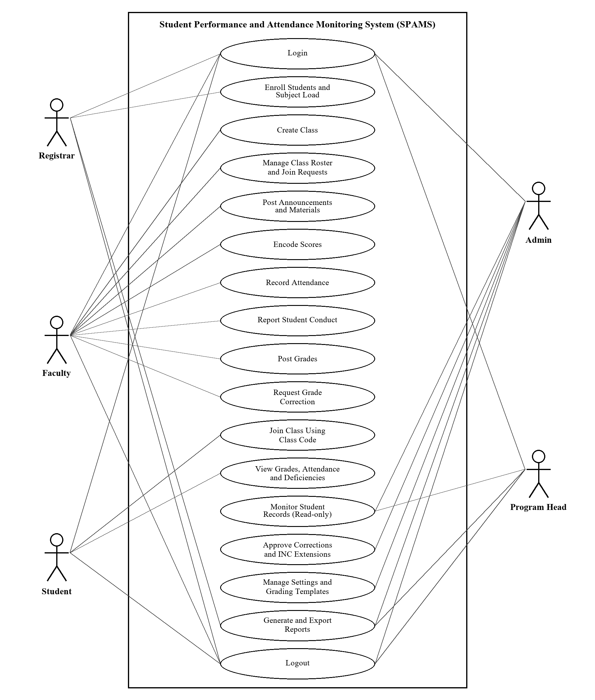
Figure 2. Use case diagram of the system.

Use Case Title | Login
Primary Actor: | Registrar, Faculty, Student, Admin, Program Head
Description: | User enters login details.
Goal: | To give access to the workspace of the user.
Normal Scenarios: | 1. The user enters correct login details and the system opens his or her workspace.  2. The user enters wrong details and the system shows an error.

Use Case Title | Enroll Students and Subject Load
Primary Actor: | Registrar
Description: | Enrolling a student for the term and adding the subjects.
Goal: | To keep an official list of enrolled students and their subjects.
Normal Scenarios: | 1. The Registrar selects the student, term, and subjects, and the system saves the enrollment.  2. The system shows a warning if the student is already enrolled in that term.

Use Case Title | Create Class
Primary Actor: | Faculty
Description: | Making a new class for a subject and section.
Goal: | To prepare a class where the faculty can add students and records.
Normal Scenarios: | 1. The faculty fills in the subject, section, schedule, and grading template, and the system saves the class with a class code.  2. The system shows an error if a needed field is empty.

Use Case Title | Manage Class Roster and Join Requests
Primary Actor: | Faculty
Description: | Adding students to a class and checking join requests.
Goal: | To make sure only enrolled students are in the class.
Normal Scenarios: | 1. The faculty adds students who are enrolled in the subject.  2. The faculty approves or declines the requests of students who used the class code.

Use Case Title | Post Announcements and Materials
Primary Actor: | Faculty
Description: | Sharing news and learning files with the class.
Goal: | To keep students informed about class activities.
Normal Scenarios: | 1. The faculty writes an announcement or attaches a file and the system posts it in the class stream.  2. The system blocks files that are not allowed or too large.

Use Case Title | Encode Scores
Primary Actor: | Faculty
Description: | Entering the scores of students in each task.
Goal: | To keep a complete class record.
Normal Scenarios: | 1. The faculty enters the scores and the system saves them and updates the computed grades.  2. The system shows an error if a score is higher than the highest possible score.

Use Case Title | Record Attendance
Primary Actor: | Faculty
Description: | Taking the roll-call of a class meeting.
Goal: | To keep track of the absences of each student.
Normal Scenarios: | 1. The faculty marks each student as present, late, absent, or excused and the system saves it.  2. The system shows the total absences of each student compared to the allowed limit.

Use Case Title | Report Student Conduct
Primary Actor: | Faculty
Description: | Writing a report about the behavior of a student.
Goal: | To record behavior issues that school officials need to know.
Normal Scenarios: | 1. The faculty fills in the conduct report and the system saves it.  2. Only allowed users can see the report.

Use Case Title | Post Grades
Primary Actor: | Faculty
Description: | Releasing the final grades of the class.
Goal: | To let students see their official grades.
Normal Scenarios: | 1. The faculty checks the computed grades and posts them, and the system locks the class record.  2. The system asks the faculty to confirm before posting.

Use Case Title | Request Grade Correction
Primary Actor: | Faculty
Description: | Asking to change grades that are already posted.
Goal: | To fix mistakes in posted grades in a proper way.
Normal Scenarios: | 1. The faculty gives the reason and sends the request.  2. The admin approves it and the class record is opened again for editing.

Use Case Title | Join Class Using Class Code
Primary Actor: | Student
Description: | Entering the class code to join a class.
Goal: | To let the student request to be added to a class.
Normal Scenarios: | 1. The student enters a correct code and the system sends a join request to the faculty.  2. The system shows an error if the code is wrong.

Use Case Title | View Grades, Attendance and Deficiencies
Primary Actor: | Student
Description: | Viewing his or her own records.
Goal: | To let the student see his or her progress on time.
Normal Scenarios: | 1. The student opens the portal and the system shows the posted grades, GWA, and attendance.  2. The system shows the scores of tasks only if the faculty allowed it.

Use Case Title | Monitor Student Records
Primary Actor: | Admin, Program Head
Description: | Viewing the records of classes and students in read-only mode.
Goal: | To find students who need help early.
Normal Scenarios: | 1. The user opens the monitoring pages and the system shows the grades and attendance.  2. The program head only sees the programs assigned to him or her.

Use Case Title | Approve Corrections and INC Extensions
Primary Actor: | Admin
Description: | Checking requests from the faculty.
Goal: | To control changes to official records.
Normal Scenarios: | 1. The admin approves a request and the system records it in the change log.  2. The admin declines a request and gives the reason.

Use Case Title | Manage Settings and Grading Templates
Primary Actor: | Admin
Description: | Updating the rules used by the system.
Goal: | To make sure the system follows the policies of the college.
Normal Scenarios: | 1. The admin updates the passing grade, INC period, or grading templates and the system saves them.  2. The system shows an error if the weights of a template do not add up to 100%.

Use Case Title | Generate and Export Reports
Primary Actor: | Registrar, Admin, Program Head
Description: | Creating and downloading lists and reports.
Goal: | To give information for monitoring and decision-making.
Normal Scenarios: | 1. The user selects a report and the system shows it.  2. The user applies filters and exports the report as a CSV file.

Use Case Title | Logout
Primary Actor: | All Users
Description: | Leaving the system.
Goal: | To safely end the user session.
Normal Scenarios: | 1. The user clicks “Logout” and the system goes back to the login page.  2. The system logs out the user after a long time of no activity.
WORK BREAKDOWN STRUCTURE

1. Initiating Process
1.1 Formulation of Team
1.2 Selection of Organization
1.3 Selection of Potential Project
1.4 Submission of a Letter to the Adviser
1.5 Submission of a Letter to the Organization
1.6 Preparation of the Project Schedule

2. Planning Process
2.1 Identifying the Scope and Limitation
2.2 Determining the Significance of the Study
2.3 Reading and Gathering Related Literature and Studies
2.4 Determining the Tools and Techniques to be Used
2.5 Identifying the Hardware and Software Requirements
2.6 Feasibility Study
2.6.1 Technical Feasibility
2.6.2 Operational Feasibility
2.6.3 Economic Feasibility
2.7 Use Case Model of the Developed System
2.8 Entity Relationship Diagram of the Developed System
2.9 Work Breakdown Structure and Gantt Chart

3. Executing Process
3.1 Waterfall Model as the Methodology
3.2 Coding
3.3 System Testing
3.4 Implementation and Unit Testing

4. Monitoring and Controlling Process
4.1 Finalizing the Documentation
4.2 Monitoring of Errors in the System
4.3 Determining Syntax and Logical Errors

5. Closing Process
5.1 Maintenance
5.2 Installation
GANTT CHART
Task Name | August |  |  |  | September |  |  |  | October |  |  |  | November |  |  |  | December
Task Name | 1 | 2 | 3 | 4 | 1 | 2 | 3 | 4 | 1 | 2 | 3 | 4 | 1 | 2 | 3 | 4 | 1 | 2 | 3 | 4
1. Initiating Process
1.1 Formulation of Team
1.2 Selection of Organization
1.3 Selection of Potential Project
1.4 Submission of a Letter to the Adviser
1.5 Submission of a Letter to the Organization
1.6 Preparation of the Project Schedule
2. Planning Process
2.1 Identifying the Scope and Limitation
2.2 Determining the Significance of the Study
2.3 Reading and Gathering Related Literature and Studies
2.4 Determining the Tools and Techniques to be Used
2.5 Identifying the Hardware and Software Requirements
2.6 Feasibility Study
2.6.1 Technical Feasibility
2.6.2 Operational Feasibility
2.6.3 Economic Feasibility
2.7 Use Case Model of the Developed System
2.8 Entity Relationship Diagram of the Developed System
2.9 Work Breakdown Structure and Gantt Chart
3. Executing Process
3.1 Waterfall Model as the Methodology
3.2 Coding
3.3 System Testing
3.4 Implementation and Unit Testing
4. Monitoring and Controlling Process
4.1 Finalizing the Documentation
4.2 Monitoring of Errors in the System
4.3 Determining Syntax and Logical Errors
5. Closing Process
5.1 Maintenance
5.2 Installation
Figure 3. Gantt chart of the project (August to December 2026).
PROJECT MANAGEMENT
A. Organizational Chart
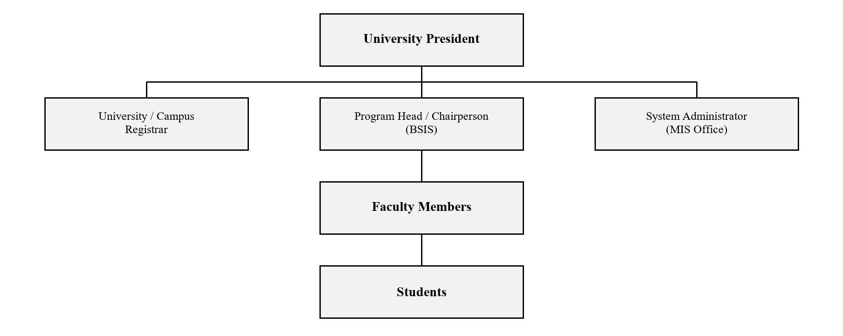
Figure 4. Organizational chart.

B. Duties and Responsibilities
Designation | Duties and Responsibilities | Remarks
University President | Leads the whole university, approves major plans, and supports projects that improve school services. | Head of the university
Program Head / Chairperson | Handles a degree program, checks class records, and follows up students who are failing or often absent. | Monitors assigned programs
Faculty Members | Teach classes, encode scores and attendance, write conduct reports, and post the grades of their students. | Main data encoders
University / Campus Registrar | Enrolls students, keeps their official subject load, and releases official grade documents. | Manages enrollment
System Administrator (MIS Office) | Manages user accounts, settings, grading templates, backups, and approves grade corrections. | Admin of the system
Students | Attend classes, join classes using the class code, and check their own grades and attendance. | Read-only view of own records
CHAPTER III
METHODOLOGY

Requirements Gathering and Analysis
This section explains the steps used to gather the information needed for the Development of Student Performance and Attendance Monitoring System for the College of Information and Computing Sciences of Marinduque State University.
Before the interview, a formal request letter and guide questions were prepared by the proponents to ask permission to conduct an interview. The interview was conducted with [name and position of the person interviewed], who explained the current way of keeping class records, computing grades, checking attendance, and reporting student performance in the college. During the interview, sample class records and grade sheets used in the manual process were also shown. This helped the proponents understand the problems of the current process and identify what features were needed for improvement.
A Use Case Diagram was created to clearly show how the users work with the proposed system and what major functions are needed. A Gantt Chart was also prepared to plan the schedule of activities, monitor progress, and make sure that each task is finished on time. These tools helped the proponents organize the gathered information and guide the development of the proposed system.

Feasibility Analysis Procedure

Economic Feasibility
Equipment Used in Operation | Estimated Price | Description
Laptop | ₱35,000 | Used to develop the system and to encode grades and attendance.
Desktop Computer (Server) | ₱30,000 | Used to host the system and the database inside the campus.
Printer | ₱7,000 | Used to print grade sheets, class lists, and reports.
Bond Paper | ₱250 per ream | Used for printed documents.
Internet Connection | ₱1,500 per month | Used to access the system and for system updates.
Software (XAMPP, PHP, MariaDB, Bootstrap, VS Code) | Free | Open-source tools used to build and run the system.

Technical Feasibility
SWOT ANALYSIS FOR TECHNICAL FEASIBILITY
STRENGTH | WEAKNESS
- The developers know basic computer and coding skills.  - The developers work well together as a team.  - The developers can learn fast when guided.  - The developers know how the MarSU ERP platform works. | - Limited experience in building full systems.  - Sometimes have difficulty managing time.  - Need better computers or tools for development.  - Not fully familiar with some advanced software.
OPPORTUNITIES | THREATS
- Strengthen and widen the knowledge in different programming languages.  - A chance to keep working with the college to improve, maintain, and update the system. | - Possible power interruptions while working.  - Unstable internet connection.  - Unexpected technical problems like laptop issues.

Operational Feasibility
SWOT ANALYSIS FOR OPERATIONAL FEASIBILITY
STRENGTH | WEAKNESS
- Faculty are already familiar with class records and grading.  - The college has clear rules on grading, attendance, and INC.  - Faculty and students are used to using computers and the internet. | - Records are slow to gather because each faculty keeps his or her own files.  - Some processes are still done by hand, which slows down work.  - Passing of records to the program head is sometimes slow.
OPPORTUNITIES | THREATS
- Support from the university can help improve the services of the college.  - Trainings can improve the skills of faculty and staff in using the system.  - Better coordination with the Registrar can make enrollment faster. | - Unstable power or internet may affect daily use.  - Heavy workload during grade submission week may slow down work.  - Typhoons and other disturbances may stop classes and office work.

Development Procedure
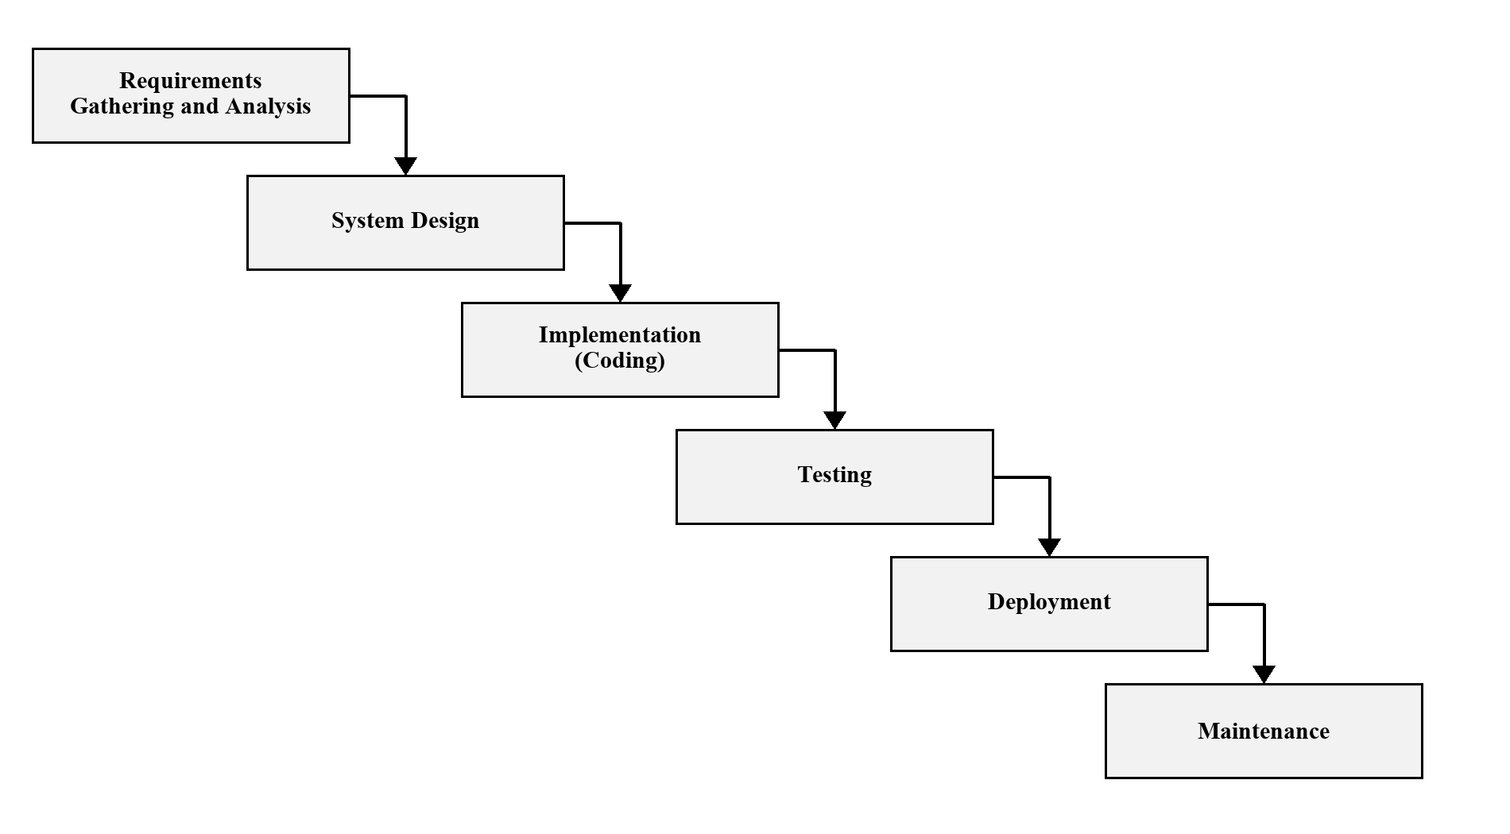
Figure 5. Waterfall Development Model
The proponents used the Waterfall Model in developing the system. In this model, each phase is finished before moving to the next. First, the needs of the users were gathered and studied. Second, the system design, such as the database and the layout of the pages, was prepared. Third, the system was coded. Fourth, the system was tested to find and fix errors. Fifth, the system was deployed for the users. Lastly, the system will be maintained and updated based on the feedback of the users.

Operation and Testing Procedures

Operation Procedure
1. Open the system and log in using your username and password.
2. Go to the dashboard of your workspace to see an overview of your classes or records.
3. For the Registrar, open the Enrollment page to enroll students and add their subject load.
4. For the faculty, create a class, add the enrolled students, and share the class code.
5. Encode the scores of the students in the Class Record page and check the computed grades.
6. Use the Attendance page to take the roll-call of each class meeting.
7. Write a conduct report when a student has a behavior issue.
8. Post the final grades when the class record is complete.
9. For students, open the Student Portal to see your grades, attendance, and deficiencies.
10. Log out after using the system to keep information safe.

Testing Procedure
1. Test if all main features work properly, including login, enrollment, class creation, score encoding, attendance, and grade posting.
2. Check if the layout is clear, such as buttons, labels, and pages that should be easy to use.
3. Try entering wrong or incomplete information to see if the system gives warnings.
4. Make sure the database saves, updates, and deletes records correctly.
5. Check if the computed grades are correct by comparing them with manual computation.
6. Check the security features, such as passwords and the pages each role is allowed to open.
7. Test how fast the system loads and responds when used.
8. Try opening the system on different devices and web browsers.
9. Check if the system still works when the internet connection is slow.
10. Write down all results, find the problems, and suggest improvements before the final release.

Evaluation Procedure
The evaluation of the Student Performance and Attendance Monitoring System will be done to know its usability, accuracy, performance, and overall acceptability. The system will first go through a preliminary evaluation to check if its major features are working correctly. This will be followed by a performance evaluation based on the ISO/IEC 25010 software quality standard, which looks at functional suitability, performance efficiency, usability, reliability, and security. To measure user satisfaction, a survey questionnaire using a 5-point Likert scale will be given to selected evaluators. The evaluators will include [number] faculty members, [number] students, the Registrar, the program head, and 1 to 3 IT experts. They will be chosen based on their use of class records or their knowledge in system development. The evaluators will use the system by doing tasks such as logging in, enrolling students, encoding scores, taking attendance, posting grades, and viewing records. After using the system, they will answer the questionnaire, and the gathered data will be summarized and analyzed using the mean and weighted mean to know the level of acceptability of the system. The results will help find areas for improvement before the full use of the system.

Implementation Plan
The implementation of the Student Performance and Attendance Monitoring System will be done step by step so that the faculty, students, and school officials of the CICS can easily adopt and use the system. The project will begin with proposing the working title of the project to formally identify its purpose and scope. After this, a questionnaire will be made and checked to make sure that it properly measures the needs and expectations of the users. The survey will then be given to the selected respondents to gather important data that will guide the development of the system. Once the data is gathered and studied, the design and development of the system will follow, including the making of the pages and the main features. After the system is built, it will go through deployment, user orientation, and initial testing to make sure it works correctly. Feedback from testing will be used to make improvements until the system is ready for full use. All throughout the process, the proponents, the MIS office, and the CICS faculty and staff will work together to make sure that the system is smoothly put in place and truly helps the work of the college.

Development of Student Performance and Attendance Monitoring System for the College of Information and Computing Sciences of Marinduque State University

Proponents
[NAME OF PROPONENT 1]
[NAME OF PROPONENT 2]

December 2026

