Folder contents
- Conda environment yml file : environment\testing_env.yml
- Source files
  - Test script src/tests/test_api.py
  - Application src/app.py
  - Configuration src/config.json

Setting up the conda environment
- conda env create -n testing_env -f <path to environment yml file>

Activate the environment
- conda activate testing_env

Run the python application
- Navigate to the src folder (environment should be active)
- Run from the terminal “python app.py”

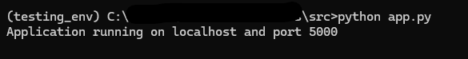

Note: Ensure that the feddit APIs are working

Testing the API
- Navigate to tests folder
- Run “pytest”
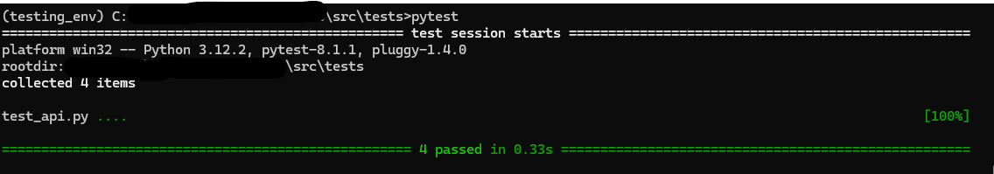

API requests:
- Fetching comments with a specific category and limit
http://localhost:5000/get_classified_comments/?subfeddit_id=<id>&limit=<limit>
http://localhost:5000/get_classified_comments/?subfeddit_id=2&limit=5

- Sorting the comments based on polarity score
http://localhost:5000/get_classified_comments/?subfeddit_id=<id>&limit=<limit>& sort
http://localhost:5000/get_classified_comments/?subfeddit_id=2&limit=5&sort

Note:
- The default subfeddit_id is 1 and limit is 25
- Sorting based on polarity score is disabled by default
- The host and port for the application and feddit can be changed in config

