AiCOD Solutions Limited Company Structure

Company Overview
Company Name: AiCOD SOLUTIONS.LTD
Date of Incorporation: 01ST Jan, 2025
Location: BST Plaza, Kabale Municipality
Industry: Technology / Software Development

Mission, Vision & Values

Mission Statement
Empowering businesses and individuals through innovative digital solutions, exceptional service, and continuous learning, while fostering growth, productivity, and success in the digital age.

Vision Statement
To be a leading technology company in Uganda, recognized for our expertise in digital solutions, commitment to customer satisfaction, and contribution to the growth of the digital economy.

Core Values
- Innovation
- Customer-Centricity
- Excellency
- Collaboration
- Integrity

Strategic Objectives
- Help 36 businesses adopt digital solutions every year.
- Achieve a customer satisfaction rate of 95%+.
- Launch 2 new digital products or services annually.
- Grow the team by 20% in 12 months.
- Provide digital skills training to 1000 individuals in 2 years.

Organizational Structure

Management Team
- CEO / Managing Director
- CTO / Head of Development

Draft Role Descriptions

CEO / Managing Director
Provides overall leadership, defines strategic goals, oversees all operations and ensures alignment with company mission and vision.

CTO / Head of Development
Leads the technical team in software and mobile development, ensures technological innovation and security best practices.

Head of Sales & Marketing
Manages marketing strategies, drives product promotions, customer engagement, and lead generation.

Head of Finance & Admin
Oversees financial planning, budgeting, HR management, and legal compliance.

Head of Training & Research
Coordinates ICT training programs, research support, and curriculum development.

Head of IT Services & Support
Supervises technical support team, manages computer repair, installations, and customer IT assistance.

Head of Security Solutions
Leads the team in CCTV installations and security solution delivery for clients.
A diagragm illustrating major Organisational structure for AiCOD SOLUTIONS LIMITED
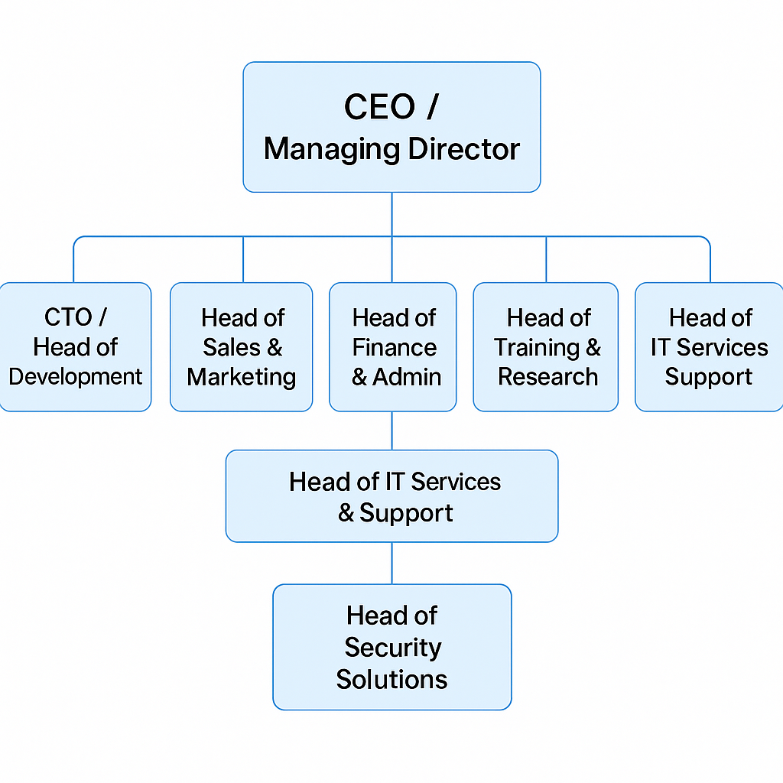

Aicod Solutions Limited is a technology company specializing in digital solutions. Here's an overview:
About Aicod Solutions Limited
Aicod Solutions Limited provides top-notch computing services, focusing on digital transformations for businesses. Their goal is to help clients make profits using modern digital techniques.
Services Offered
- Website Design: Creating visually appealing and secure websites for businesses
- Mobile App Development: Developing fast and cross-platform mobile apps
- Advanced ICT Training: Providing training in MS Office, computer programming, and more
- Computer Repair and Maintenance: Offering repair and maintenance services for computers
- Academic Research Assistance: Guiding students with research projects
- Security Camera Installation: Installing security cameras for businesses and homes
Company Information
- Location: Plot 22, Bushekwiire Road, Kabale (Mukikolegyi), Uganda
- Contact: +256-771097982, +256-782937175, aicodsolutions@gmail.com
- Business Hours: Monday to Saturday (9 am - 5:59 pm), Sunday (2 pm - 5 pm)
Team
- N. Wyclife: CEO/Web Developer
- I. Alfred: Full Stack Developer/Mobile App Development expert
Aicod Solutions Limited aims to improve business efficiency, reduce costs, and increase profits for its clients. With expertise in digital solutions, they're well-positioned to help businesses thrive in the digital age.

