SV-Functions
Version 0.2
2018-07-18
Installation
Method 1:
Load the SV-Functions folder as an unpacked extension in Google Chrome.
- Open Google Chrome
- Browse to chrome://extensions/
(or Menu -> More tools -> Extensions)
- Enable "Developer mode" (top right)
- Select "Load Unpacked" and browse to the SV-Functions extension folder

Method 2:
Add the individual Javascript files from the SV-Functions folder to a user script manager such as TamperMonkey (Chrome, Safari, Edge) or GreaseMonkey (Firefox). Some of the information from manifest.json needs to be migrated to the header of each script, including the matching URL, jQuery and Bootstrap libraries and the isolated Bootstrap CSS.

Production:
Publish a private Google Chrome extension through G Suite or Education that will be available to users within the organization. Google Chrome extensions can be installed through Group Policy, if needed (http://dennisspan.com/deploying-google-chrome-extensions-using-group-policy/). Cross browser/device approach possible through user script managers.

Configuration:
- Target a specific instance by replacing “https://*/” in manifest.json with the host name of the instance (e.g. “https://myinstance.com/”)
- Debugging messages are logged to the console by default; set “debugging = false” to disable
- Placement by level requires configuration in terms of a JSON concordance table in placement.level.js
- Exam proficiency update requires questionnaire fields that contain caption text "Exam Proficiency: Date" (date selector) and "Exam Proficiency: EXAM_CODE" (numeric or text)

Preference Table CSV Import/Export
Import and export preference table data with comma-delimited (CSV) files.
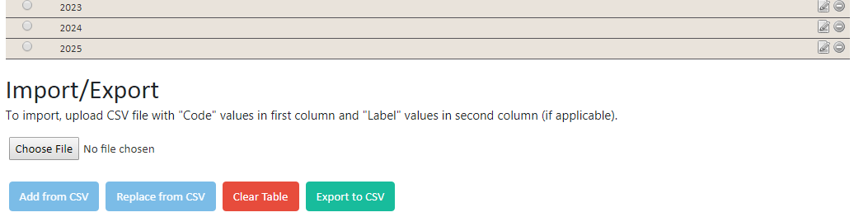

Features:
- Bulk creation of preference table items from file
- Synchronize preference table items with external source convertible to CSV
- Clear preference table (delete all existing items)
- Download/export preference table in CSV format
Notes:
- Label is not required for most preference tables and can be omitted wherever it is not used
- The following format, with or without column headers, is expected for the CSV import feature:

Code | Label
1 | A
2 | B
3 | C

Floating 1-Click Navigation and Student Lookup
The default navigation menu is well suited to users within individual roles, but power users such as analysts and developers can benefit from 1-click navigation and the ability to jump directly to a student profile by unique identifier.
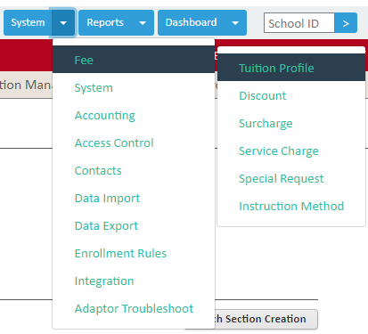
Features:
- Single click navigation across modules and sub-menus
- Jump directly to a student profile by unique School ID
- Remains at the top of the page when scrolling
- Hover or click to expand sub-menus
- Current module highlighted
Notes:
- The menu is a static element in its current form, and does not adjust to different users, roles or contexts
- Bootstrap 4 CSS isolated from the rest of the DOM to prevent conflicts (in ConfMgr and elsewhere)
- Update theme for Bootstrap 4 by replacing boostrapiso.min.css with one of the themed styles at https://github.com/cryptoapi/Isolate-Bootstrap-4.1-CSS-Themes
- Navigation can be made fully responsive, toggleable, or vertical, by tweaking Bootstrap 4 classes

Bulk Assign Program Offering Levels
For programs with levels (e.g. ESL), set each participant's level based on their exam proficiency score(s). Assign the levels for all students in a program offering dashboard with a single click.
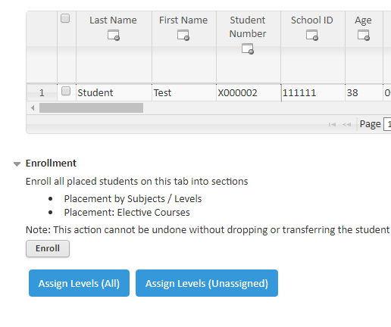
Features:
- Bulk assign program offering levels to all students in a program offering dashboard
- Configure concordance tables in JSON format
- Cycle all participants in dashboard or filter on unassigned participants only
- Optionally merge data from other internal/external sources
Setup:
- Configure one or more concordance tables in JSON format in placement.level.js
Notes:
- Cannot assign levels to students already enrolled in sections
Bulk Assign Program Offering Sections
For programs with multiple course sections, set each participant's section randomly while equally distributing language and gender. Assign the sections for all students in a program offering dashboard with a single click. This simple example can be extended to incorporate a variety of constraints and/or conditional logic for automating a placement exercise.
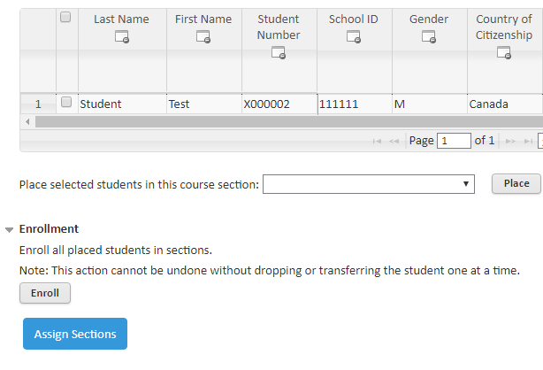
Features:
- Bulk assign program offering sections to all students in a program offering dashboard
- Distribute placements according to gender, language, and a pseudo-random token
Notes:
- Placement logic can be extended to incorporate additional constraints

Update Exam Proficiency from Application
Create exam proficiency record(s) and review existing records from an application questionnaire.
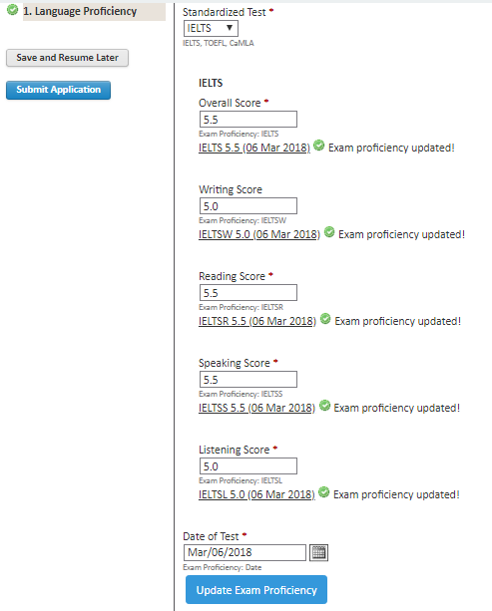
Features:
- View and jump to existing exam proficiency record(s)
- Create one or more exam proficiency record(s) with a single click
Setup:
- The existing functionality matches on certain field properties:
  - Date selector input with caption containing "Exam Proficiency: Date"
  - One or more text input(s) with caption containing "Exam Proficiency: EXAM_CODE"
Help Page Additions
Help pages are updated to add information on custom features.
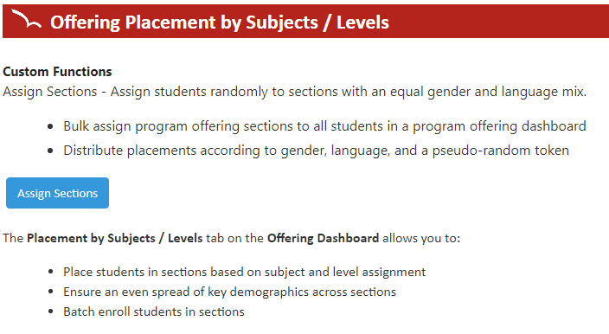

Notes:
- Use “all_frames” option in manifest.json to successfully target help content frame
- Match help files on content path without CSHID value (not always present when referred from within the help contents/search)

