Blood Donation Management System
Project Study & Presentation Guide
A Django + MySQL web application | Prepared for project defence

How to use this guide: Read it together before the defence. It explains the whole system in plain language, then breaks down the code so either of you can answer questions. The last sections give likely panel questions with ready answers, plus a glossary so you can speak about the project with confidence.

1. What the Project Is (in plain English)
The Blood Donation Management System is a web application that connects everyone involved in the blood supply chain onto one platform: blood donors, hospitals, ambulance/response teams, and a system administrator. Instead of paper records and phone calls, each type of user logs in and gets their own dashboard built for their job.
The core idea: take a unit of blood on its full journey — from a donor signing up, to a hospital storing and tracking it, to an urgent request being raised, to an ambulance delivering it to a patient — and manage every step in one connected system.

The problem it solves
- Blood banks and hospitals often track donors and stock manually, which is slow and error-prone.
- It is hard to know quickly who is eligible to donate, what stock is available, and which units are about to expire.
- In emergencies, coordinating an urgent blood request and getting it delivered wastes precious time.
Our system digitises all of this: eligibility is checked automatically, stock and expiry are tracked in real time, and critical requests can trigger an ambulance dispatch instantly.

2. How It Is Used in a Real-World Scenario
Imagine a county blood service. Here is the full story the system supports, end to end:
- A university student registers as a donor on the public website, choosing the "Donor" role and entering their blood type.
- They complete their profile — date of birth, weight, county, and last donation date. The system automatically works out whether they are eligible to donate.
- If eligible, they book a donation appointment at a nearby hospital. They receive an email confirmation.
- At the hospital, a hospital administrator logs in and records the collected blood as a "blood unit" in the inventory. The system automatically sets its expiry date (42 days later).
- Later, a patient in theatre needs blood urgently. The hospital administrator raises a blood request, marking it "Critical".
- Because it is critical, the system automatically dispatches an available ambulance in that county to deliver the blood.
- The ambulance operator logs in, sees the dispatch on their dashboard, delivers the blood, and marks it "Delivered". The ambulance becomes available again.
- Throughout, the system administrator oversees everything — a priority-ordered queue of all pending requests, live counts of donors/hospitals/units, and full control to create, edit or delete any record.
This mirrors how a real blood service operates, but with the coordination, eligibility checking, and record-keeping automated.
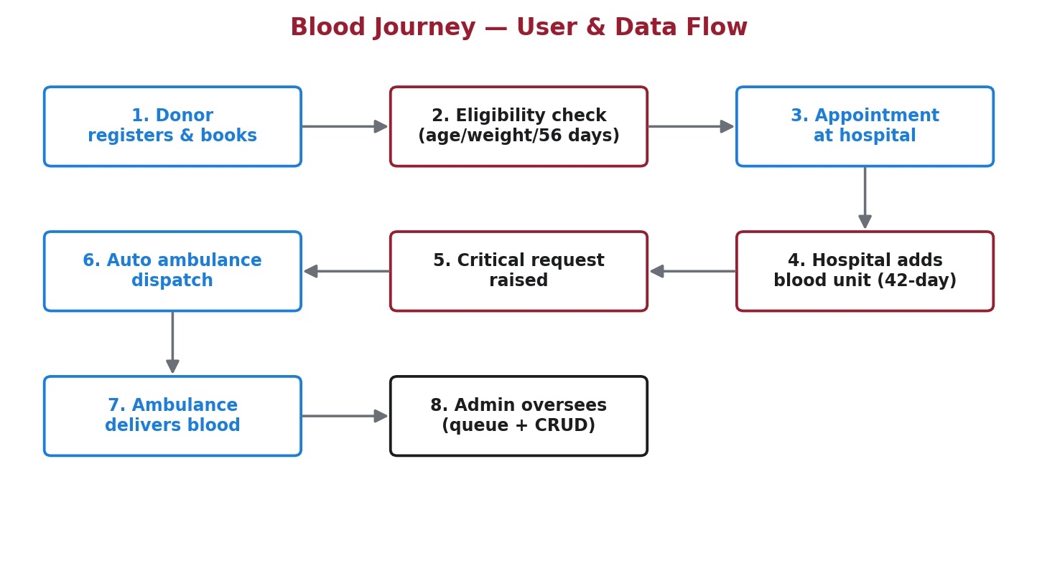
Figure 1: The eight-step blood journey the system manages, end to end.

3. The Users (Roles) and What Each Can Do
Every account has a role. After login, the system sends each user to the dashboard built for their role. This is called role-based access control.
Role | What they do
Donor | Register, complete profile, see eligibility status and reasons, book donation appointments, view appointment history.
Hospital Administrator | Manage the hospital blood inventory (add units, see expiry), raise blood requests by priority, mark requests fulfilled.
Ambulance Operator | See dispatches assigned to their ambulance for critical requests and mark deliveries as completed.
System Administrator | Oversee the whole platform: a priority request queue, system-wide statistics, and full create/read/update/delete (CRUD) on every record via a custom control panel.

4. The Key Business Rules (know these cold)
The panel will likely ask about the "logic" of the system. These are the rules the code enforces automatically.

4.1 Donor eligibility
A donor must satisfy ALL three of the following to be allowed to book a donation. If any fail, the system marks them ineligible and shows the specific reason.
Requirement | Rule | Why
Age | Between 18 and 65 years | Standard safe age range for blood donation.
Weight | At least 50 kg | Lower weight makes donation unsafe for the donor.
Time since last donation | At least 56 days | The body needs about 8 weeks to replenish red blood cells.

If the donor has never donated, the 56-day rule does not apply. If required data (date of birth or weight) is missing, they are treated as not-yet-eligible and asked to complete their profile.

4.2 Blood unit expiry
When a hospital adds a blood unit, the system automatically sets its expiry date to 42 days after collection (the typical shelf life of stored whole blood). The hospital dashboard flags units expiring within 7 days so they can be used first.

4.3 Request priority and the queue
Blood requests have a priority: Critical, Urgent, or Normal. The administrator queue is sorted so Critical appears first, then Urgent, then Normal (and within each, oldest first). This means the most life-threatening needs are always at the top.

4.4 Automatic ambulance dispatch
When a hospital raises a CRITICAL request, the system immediately looks for an available ambulance in the same county (or any available one), marks it busy, and creates a dispatch record. This removes the delay of manually finding transport in an emergency.

5. Technology Used (and why)
Technology | What it is / why we used it
Python | The programming language the whole backend is written in — readable and widely used.
Django 5.2 | A high-level Python web framework. It gives us the database layer, authentication, forms, admin, and security features out of the box, so we build faster and safer.
MySQL | A robust relational database that stores all data (users, donors, units, requests, etc.). Chosen for reliability and because it is standard in industry and coursework.
PyMySQL | A pure-Python connector that lets Django talk to MySQL.
HTML & CSS | The templates (pages) the user sees, styled to look clean and professional. We use the Poppins font and a red blood-themed palette.
Django Templates | Django's templating system builds the HTML pages dynamically from data.

Architecture pattern: Django follows MVT — Model, View, Template. Models define the data, Views hold the logic that responds to requests, and Templates render the HTML shown to the user. It is Django's version of the well-known MVC pattern.
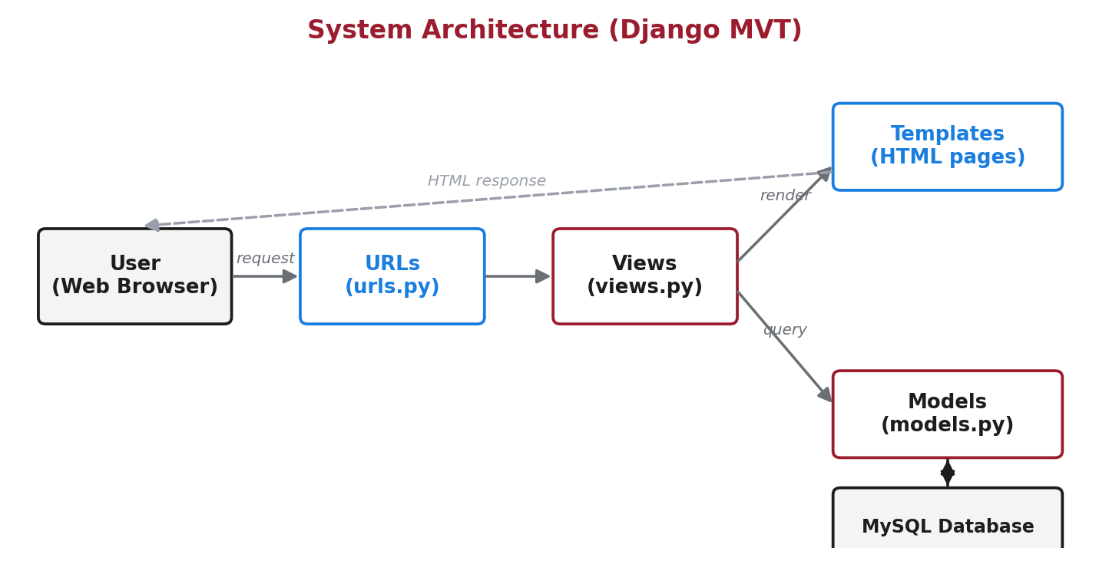
Figure 2: How a request flows through the app. The browser hits a URL, which calls a View; the View reads/writes Models (MySQL) and renders a Template back to the user.

6. Code Structure (so you can answer code questions)
The project is organised into a Django "project" (bloodbank) and one Django "app" (core) that holds all our logic. Here is the folder layout and what each part does.
ISProject-I/
manage.py -> command-line tool to run/manage the project
requirements.txt -> list of Python packages needed
bloodbank/ -> project configuration
settings.py -> all settings (database, apps, security)
urls.py -> top-level URL routing
wsgi.py / asgi.py -> entry points that web servers use to run the app
core/ -> our main application
models.py -> database tables defined as Python classes
views.py -> the logic for each page/action
urls.py -> maps web addresses to views
forms.py -> form definitions and validation
admin.py -> registers models in Django's built-in admin
migrations/ -> auto-generated files that build the DB schema
management/commands/ -> seed_demo & seed_bulk (create demo data)
templates/ -> all the HTML pages
static/img/ -> the logo image

6.1 models.py — the data
Each class here becomes a table in MySQL. Our models:
- User: the four roles (donor, hospital admin, ambulance operator, system admin) via a "role" field.
- Hospital: a hospital, linked to the user who manages it.
- Donor: a donor's profile — blood type, date of birth, county, weight, last donation date. It also contains the eligibility logic (age, weight, 56-day checks).
- Appointment: a donation booking linking a donor to a hospital on a date.
- BloodUnit: one unit of blood in stock; auto-calculates its 42-day expiry.
- BloodRequest: a hospital's request for blood, with priority and status.
- Ambulance: a vehicle with an operator, county, and availability.
- Dispatch: a record that an ambulance is delivering blood for a request.
The eligibility rules live on the Donor model as "properties" — small pieces of logic that calculate a value. For example, is_eligible returns True only if the list of eligibility_issues is empty.

6.2 views.py — the logic
A view is a Python function that runs when a user visits a URL. Key views:
- index: renders the public homepage.
- register_view / login_view / logout_view: handle sign-up, login and logout.
- dashboard: checks the logged-in user's role and sends them to the correct dashboard.
- donor_dashboard / hospital_dashboard / ambulance_dashboard / admin_dashboard: the four role dashboards showing role-specific data.
- book_appointment: lets a donor book (blocked with reasons if not eligible) and sends an email confirmation.
- add_unit / create_request: hospital adds stock and raises requests; a critical request calls dispatch_ambulance automatically.
- fulfill_request / complete_dispatch: marks a request done / marks a delivery complete.
- manage_list / manage_form / manage_delete: the custom admin control panel — generic Create/Read/Update/Delete for all eight models, restricted to system administrators.
A nice detail to mention: instead of writing CRUD code eight times, we built one set of generic views driven by a "registry" dictionary (ADMIN_REGISTRY) that describes each model. This is DRY (Don't Repeat Yourself) — less code, fewer bugs.

6.3 urls.py — the routing
URLs map a web address to a view. For example "/login/" -> login_view, "/dashboard/" -> dashboard, and "/manage/<model>/" -> the admin CRUD views. There is a top-level urls.py in bloodbank and an app-level one in core.

6.4 forms.py — input and validation
Forms define what fields a user fills in and validate the input. We use Django ModelForms, which build a form directly from a model. Examples: the registration form, the donor profile form (now including weight), and the admin forms for editing every model.

6.5 templates/ — the pages
These are the HTML files. base.html is the shared shell (top bar with logo, and the footer) that every page extends. index.html is the homepage. There are login/register pages, the four dashboards, action pages (book appointment, add unit, create request, edit profile), and the admin panel pages (admin_base.html plus manage_list/form/delete).

6.6 Authentication & security
- Passwords are never stored as plain text — Django hashes them (PBKDF2). Even we cannot read them in the database.
- Pages that require login use the @login_required decorator; anonymous users are redirected to the login page.
- The admin control panel checks the user's role and blocks anyone who is not a system administrator.
- Django protects every form against CSRF (cross-site request forgery) using a token.
- The database password and secret key are read from environment variables, not written in the code.

6.7 Management commands (demo data)
seed_demo creates the four standard demo accounts and a little sample data. seed_bulk adds realistic bulk data — real Kenyan names, hospitals, ambulances, blood units, requests, appointments and dispatches — so the dashboards look full during the demo. Both are safe to re-run.

7. Database Design (tables & relationships)
All data lives in MySQL. The main tables and how they relate:
Table | Key relationships
core_user | The account and its role. A user may manage one hospital or operate one ambulance.
core_hospital | Belongs to one manager (User). Has many units and many requests.
core_donor | One-to-one with a User. Has many appointments.
core_appointment | Links one Donor to one Hospital on a date.
core_bloodunit | Belongs to one Hospital. Has blood type, collection & expiry dates.
core_bloodrequest | Belongs to one Hospital. Has priority and status. May have dispatches.
core_ambulance | Operated by one User. Has a county and availability flag.
core_dispatch | Links one BloodRequest to one Ambulance.

Relationship types to remember: One-to-One (a User and their Donor profile), One-to-Many / ForeignKey (a Hospital has many BloodUnits). These are enforced by Django and MySQL.

8. How to Run It (demo-day checklist)
- Make sure the MySQL server is running.
- Open a terminal in the project folder.
- Set the database password for this terminal, then start the server:
Command Prompt:
set MYSQL_PASSWORD=alfredgithui
python manage.py runserver
PowerShell:
$env:MYSQL_PASSWORD = "alfredgithui"
python manage.py runserver
- Open the browser at http://127.0.0.1:8000/
- Log in with any demo account — the password for all of them is Password123!
Important: the MYSQL_PASSWORD line must be run every time you open a new terminal, before starting the server. If logins fail, that is almost always the cause.
Demo logins:
Username | Role
ethan (or donor1) | Donor
hospital1 | Hospital Administrator
ambulance1 | Ambulance Operator
admin1 | System Administrator (also opens Django admin at /admin/)

9. Likely Panel Questions and Answers
Practise saying these out loud. Split them between you so each of you owns some.

General & conceptual
Q: What problem does your system solve?
A: It replaces slow, manual, paper-based blood-bank processes with one connected platform. It automatically checks donor eligibility, tracks blood stock and expiry, and speeds up emergency delivery through automatic ambulance dispatch.
Q: Who are the users of the system?
A: Four roles: donors, hospital administrators, ambulance operators, and a system administrator. Each logs in and gets a dashboard built for their tasks.
Q: Walk us through what happens when a hospital urgently needs blood.
A: The hospital admin raises a request marked Critical. The system instantly finds an available ambulance in that county, marks it busy, and creates a dispatch. The ambulance operator sees it on their dashboard, delivers the blood, and marks it delivered.

Django & technical
Q: Why did you choose Django?
A: It is a mature Python framework that provides the database layer, authentication, forms, an admin site, and strong security by default. That let us focus on the blood-bank logic instead of rebuilding common web features.
Q: Explain the MVT architecture in your project.
A: Model = the data (models.py, e.g. Donor, BloodUnit). View = the logic that handles a request (views.py). Template = the HTML shown to the user (templates/).
A request comes in, a URL sends it to a view, the view fetches data from models and passes it to a template, which is rendered and returned.
Q: Why a custom User model, and how do roles work?
A: We extended Django's built-in user with a "role" field (donor, hospital_admin, ambulance_operator, system_admin). After login, the dashboard view reads the role and routes the user to the correct dashboard.
Q: How are passwords stored securely?
A: Django hashes them with PBKDF2 before saving. The database only holds the hash, never the real password, so even we cannot see it. Login works by hashing the entered password and comparing hashes.
Q: How do you stop a normal user from opening the admin control panel?
A: Every admin view checks the logged-in user's role. If they are not a system administrator, they are blocked and redirected with an "Admin access only" message. Pages also require login via the @login_required decorator.
Q: You have CRUD for eight models — did you write it eight times?
A: No. We wrote one generic set of views driven by a registry dictionary that describes each model (its form and the columns to show). This follows the DRY principle — much less code and fewer bugs.
Q: What are migrations?
A: Migrations are files Django generates from our models that build and update the database tables. Running "python manage.py migrate" applies them to MySQL, keeping the code and database in sync.
Q: What is the difference between your custom admin panel and Django's built-in /admin?
A: Django's /admin is a generic tool we get for free. Our custom panel is one we built into the app with our own design and role checks, so the system administrator manages everything without leaving our interface. Both give full CRUD.

Database
Q: Why MySQL and not SQLite?
A: MySQL is a production-grade relational database — more robust and closer to what is used in industry. It also demonstrates configuring Django with a real external database.
Q: Describe a one-to-one versus a one-to-many relationship in your schema.
A: One-to-one: each User has exactly one Donor profile. One-to-many (ForeignKey): one Hospital has many BloodUnits and many BloodRequests.
Q: How is a blood unit's expiry date determined?
A: When a unit is saved, if no expiry is set the model automatically adds 42 days to the collection date — the typical shelf life of stored whole blood.

Business logic
Q: How exactly is donor eligibility decided?
A: Three checks, all must pass: age 18-65, weight at least 50 kg, and at least 56 days since the last donation. The Donor model builds a list of any failed checks; if the list is empty the donor is eligible.
If they have never donated, the 56-day rule is skipped. Missing data means not-yet-eligible.
Q: Why 56 days, 50 kg, and 18-65?
A: These are the standard whole-blood donation guidelines: about 8 weeks for the body to recover, a minimum safe body weight, and the usual eligible age range.
Q: How does the priority queue work?
A: Pending requests are sorted so Critical comes first, then Urgent, then Normal, and within each group the oldest request first — so the most urgent needs are always at the top.

Security, testing & deployment
Q: How do you protect against unauthorised access?
A: Login is required for all internal pages, passwords are hashed, forms are CSRF-protected, and the admin panel enforces a role check. Secrets like the DB password are kept in environment variables.
Q: How did you test the system?
A: We drove the full flow end to end — registering a donor, booking, adding stock, raising a critical request, auto-dispatch, delivery, and admin CRUD — and confirmed each step behaves correctly for each role.
Q: How would you deploy this for real use?
A: Host it on a server or cloud platform, use a production web server (e.g. Gunicorn) behind Nginx, a managed MySQL database, turn off debug mode, set a strong secret key, and serve static files properly. HTTPS would secure traffic.
Q: What would you improve or add next?
A: SMS/email alerts for low stock, search and filters on lists, richer reporting/analytics, an audit log, and clinical checks beyond weight and age (e.g. haemoglobin).

10. Quick Glossary (speak with confidence)
Term | Simple meaning
Framework | A ready-made structure of tools (Django) that speeds up building the app.
Model | A Python class that represents a database table.
View | A function that runs when a page is requested and returns a response.
Template | An HTML file that displays data to the user.
Migration | A file that creates or updates database tables from the models.
CRUD | Create, Read, Update, Delete — the four basic data operations.
Role-based access | Showing/allowing features based on the user's role.
Hashing | A one-way scrambling of passwords so they cannot be read back.
CSRF | A web attack Django blocks with a hidden token on every form.
ORM | Object-Relational Mapper — lets us use Python objects instead of raw SQL.
Environment variable | A setting stored outside the code, e.g. the DB password.
DRY | Don't Repeat Yourself — avoid duplicated code (our generic admin panel).

11. Contribution Split (for the "who did what" question)
The project is on GitHub with a two-person commit history. A convenient way to describe the split:
Partner | Area | Files / commits
Alfred (alfredmuriu) | Backend & logic | Project config, data models & migrations, views & URL routing, forms & admin, the admin CRUD control panel, and documentation.
Partner (sebaisfly) | Front end & data | All page templates and dashboards, the action pages (booking, inventory, requests, profile), the demo-data seed commands, and the system overview document.

Evidence: the GitHub contributors graph and commit history show both authors.

— End of Guide — Good luck with the defence! —

