Ex1:  
 Create login page and when user press login button create object login that hold

the data and if username = admin and password = 123 show him message

“welcome” , else show him message “not registered”

don’t use alert or prompt , use dom to get the data from user and display it

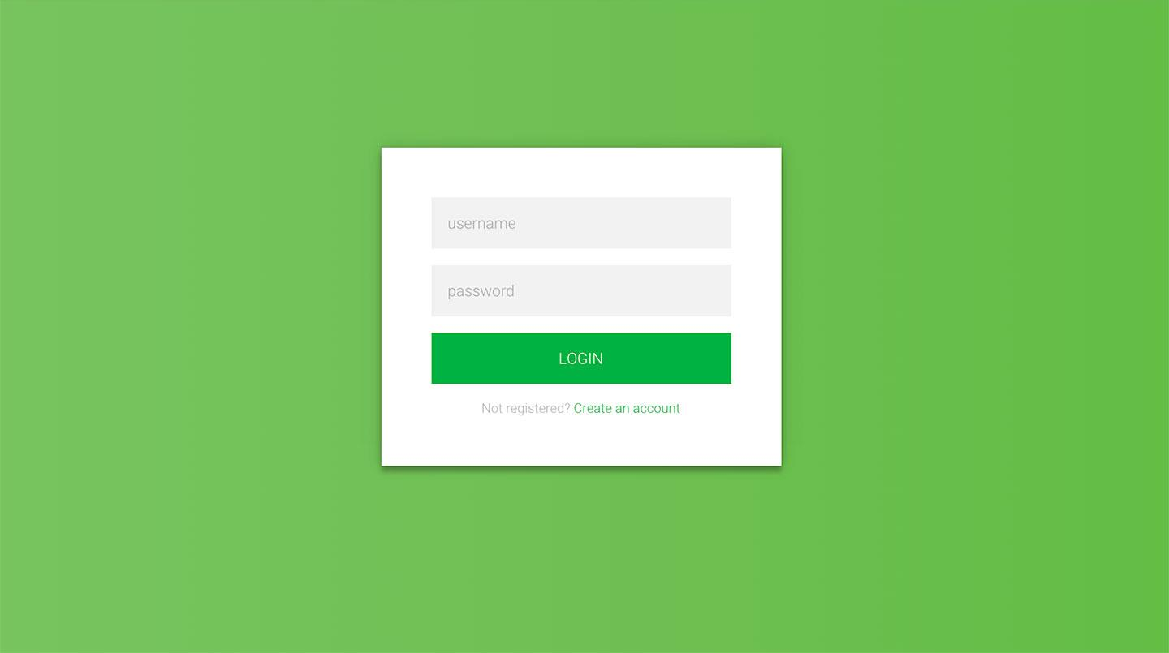

EX:2

write a JavaScript program that will merge two arrays and remove duplicate items from an array.

Ask the user through input type string to enter number like 1,6,5,9,1,2

Then Ask the user through input type string to enter number like 5,6,3,1,9

merge two arrays and remove duplicate items and display new array don’t use set

Ex3;

Create Todo list app similar to this object

[{name:’task1’,status,’done’},{…},…..]

when user write task name and press add new task will be added to tasks list and array of tasks

When user click the done mark in green the task status will be updated to done and change color

When user click the delete button , the task should be deleted from list and array of tasks

