**Lab Assignments**

1. Create Class
   1. Employee has the properties name (whose value defaults to the empty string) and dept (whose value defaults to "general").
   2. Manager is based on Employee. It adds the reports property (whose value defaults to an empty array, intended to have an array of Employee objects as its value).
   3. WorkerBee is also based on Employee. It adds the projects property (whose value defaults to an empty array, intended to have an array of strings as its value).
   4. SalesPerson is based on WorkerBee. It adds the quota property (whose value defaults to 100). It also overrides the dept property with the value "sales", indicating that all salespersons are in the same department.
   5. Engineer is based on WorkerBee. It adds the machine property (whose value defaults to the empty string) and also overrides the dept property with the value "engineering".

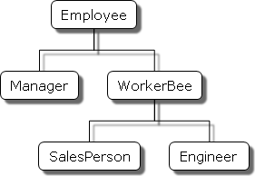

1. Create login page and when user press login button create object login that hold

the data and if username = admin and password = 123 show him message

“welcome” , else show him message “not registered”

don’t use alert or prompt , use dom to get the data from user and display it

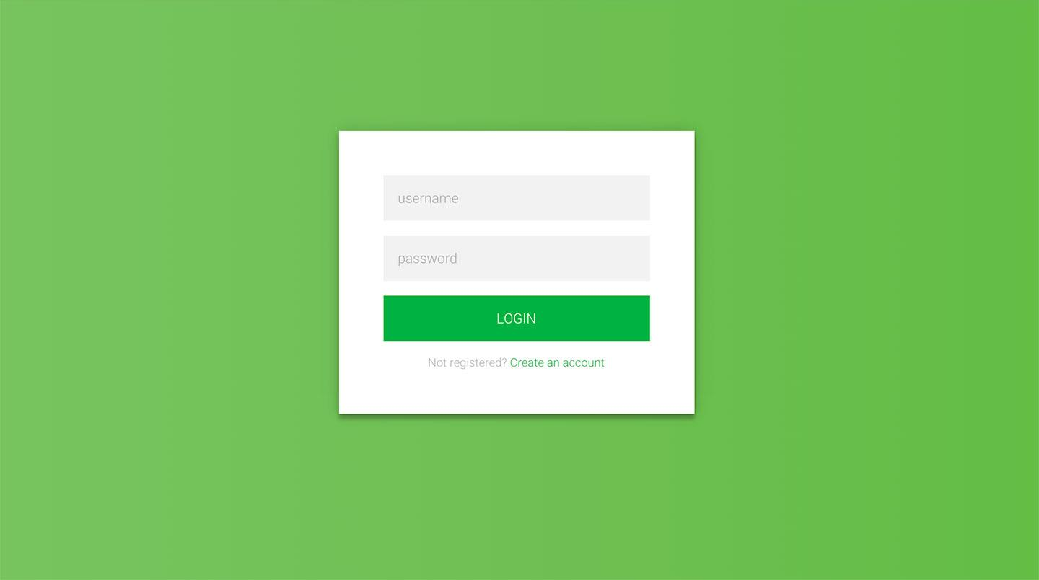

1. write a JavaScript program that will create image slider
2. Get slider image Using XMLHttpRequest from <https://jsonplaceholder.typicode.com/albums/1/photos>
3. User url property to view image
4. Use title property to view text over the image
5. Create play button (start auto play slider)
6. Create stop button (stop auto play slider)
7. Create next button (view next image)
8. Create pervious button (view pervious image)
9. Create 1x 6s button (change speed to 6 second)
10. Create 2x 4s button (change speed to 4 second)
11. Create 3x 2s button (change speed to 2 second)

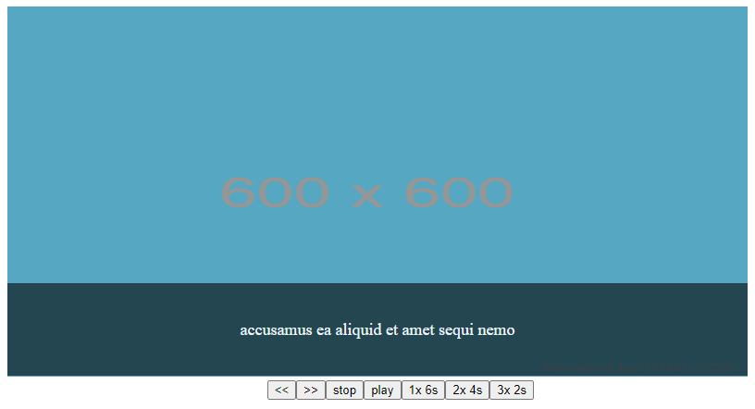

1. Use this object and destructuring **title** and **localization_tags**

const metadata = {

title: 'Scratchpad',

translations: [

{

locale: 'de',

localization_tags: ['de-gen', 'de-or'],

last_edit: '2014-04-14T08:43:37',

url: '/de/docs/Tools/Scratchpad',

titles: 'JavaScript-Umgebung'

}

],

};

1. Use fetch to get all User From <https://jsonplaceholder.typicode.com/users>
   1. Then get all posts for each user from [https://jsonplaceholder.typicode.com/users/${userid}/posts](https://jsonplaceholder.typicode.com/users/$%7buserid%7d/posts)
   2. Then Display to page as order list (user name |
      * + 1. Post1
          2. Post2
          3. …….
2. Create Todo list app similar to this object

[{name:’task1’,status,’done’},{…},…..]

when user write task name and press add new task will be added to tasks list and array of tasks

When user click the done mark in green the task status will be updated to done and change color

When user click the delete button , the task should be deleted from list and array of tasks

