# How-to

## Basic-excel-data-visualization

# Balance

Indicates the status of the incomes and outcomes in general or filter by month, year from the table I-O

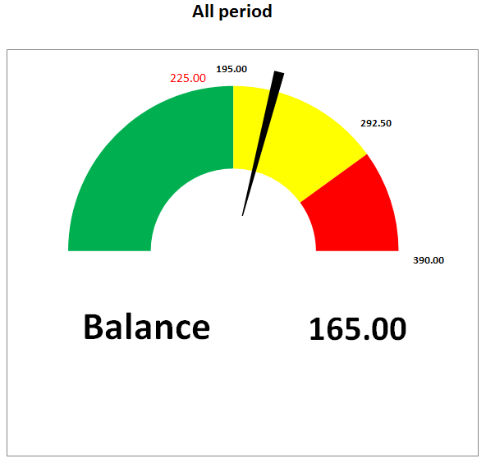

# Dashboard

Take a look at the behavior of your incomes and incomes playing with the results from the table I-O, the sliders Year, Month and Categories allow to identify where-when the money comes in or goes out.

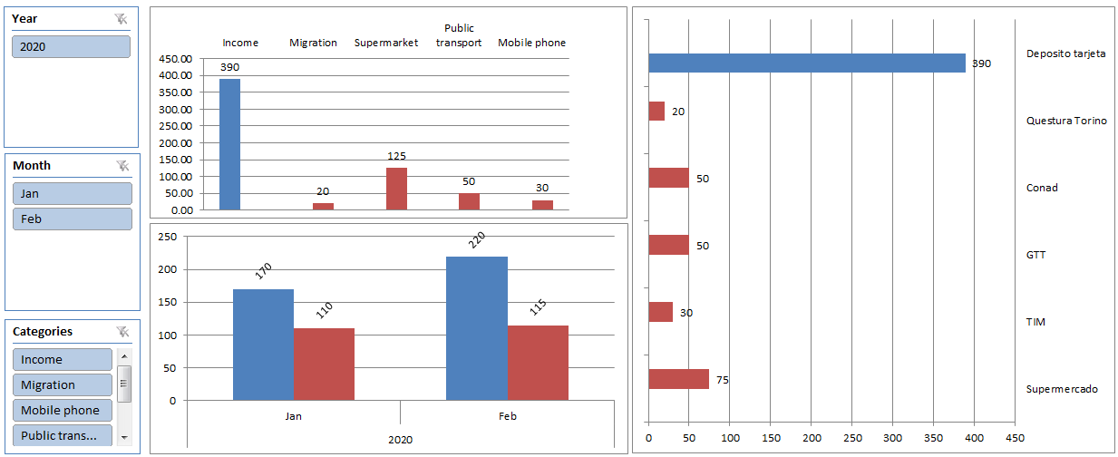

# Input – Output

Just type the following info to start discovering the behaviour of your finance.

## How-to:

|  |  |
| --- | --- |
| Column | Description |
| Id | Automatic index number. |
| Id_Cat | Select the category from the list. |
| Concept | The concept of income or outcome. |
| Abs_Amount | The value of the amount. |
| Date | Date of fact. |

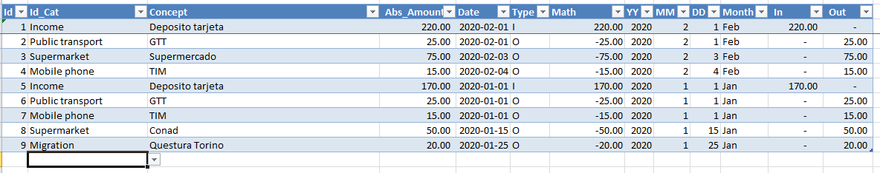

# Cat

Add or updated your proper categories to the list according to the image below:

