Mysql -u root -p

**Creating the user accounts**

**CREATE USER** <username>@localhost IDENTIFIED BY ‘password’

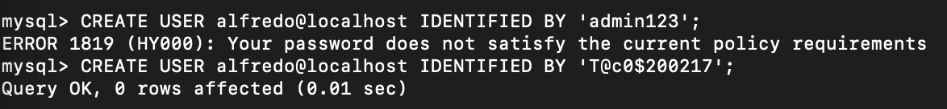

**View the user account on a given host/server**

**View the current user information**

**See available DATABASES**

**Creating a Database: CREATE DATABASE <database name>**

**Use Database**

**Creating table**

**INSERT**

**SELECT *FROM**