Monday Session – Documentation Map
Scope. This folder is a focused documentation set produced for the upcoming consultancy / training session that uses HexaStock as a teaching asset for DDD + Hexagonal Architecture + Spring Modulith + Domain Events. It complements, but does not replace, the broader doc/consultancy/ briefing pack and the doc/architecture/ reference material.
Branch. All material lives on feature/modulith-watchlists-extraction. Nothing here ships to main.

File index
# | File | Type | Purpose
0 | README.md | Index | This map and reading order.
1 | 00-ARCHITECTURE-OVERVIEW.md | Main doc | What HexaStock is, business capabilities, the four architectural styles in play, why the combination makes sense here.
2 | 01-FILESYSTEM-AND-MAVEN-STRUCTURE.md | Main doc | Filesystem layout, Maven multi-module, package structure, how Maven modules / packages / Modulith modules relate.
3 | 02-WATCHLISTS-EVENT-FLOW-DEEP-DIVE.md | Main doc | End-to-end walk-through of WatchlistAlertTriggeredEvent, why it is the canonical teaching example.
4 | 03-LAYOUT-ALTERNATIVES.md | Main doc | Rigorous comparison of the current layout against four common alternatives.
5 | 04-PRODUCTION-EVOLUTION.md | Main doc | Realistic evolution paths beyond the current in-process domain events: outbox, externalisation, eventual extraction.
6 | 05-INSTRUCTOR-GUIDE.md | Teaching | Practical guide for running the Monday session: agenda, talking points, demo sequence, discussion prompts, exercise flow.
7 | 06-SLIDE-DECK-SPEC.md | Teaching | Structured, AI-feedable slide-by-slide specification.
8 | diagrams/ | Sources | 11 PlantUML sources for this folder, each rendered to PNG and SVG under diagrams/Rendered/.
The Sell Stocks event-driven exercise also gets three new diagrams – they live with the existing tutorial under doc/tutorial/sellStocks/diagrams/, following the convention already established in that folder:
File | Purpose
diagrams/sell-events-current.puml | Sequence – current synchronous sell flow.
diagrams/sell-events-target.puml | Sequence – target event-driven sell flow.
diagrams/sell-events-conceptual.puml | Conceptual – one business fact, many reactions.
The exercise document itself, SELL-STOCK-DOMAIN-EVENTS-EXERCISE.md, is updated in-place to embed the three rendered diagrams.

Diagram index
All diagram sources are PlantUML. Each .puml has a sibling Rendered/<name>.svg and Rendered/<name>.png produced by scripts/render-diagrams.sh (Docker image plantuml/plantuml:latest).
# | Source | Rendered
1 | 01-architecture-overview.puml | PNG · SVG
2 | 02-maven-multimodule.puml | PNG · SVG
3 | 03-filesystem-layout.puml | PNG · SVG
4 | 04-modulith-modules.puml | PNG · SVG
5 | 05-bounded-context-map.puml | PNG · SVG
6 | 06-hexagonal-view.puml | PNG · SVG
7 | 07-watchlist-sentinel-sequence.puml | PNG · SVG
8 | 08-watchlist-event-flow.puml | PNG · SVG
9 | 09-notification-flow.puml | PNG · SVG
10 | 10-layout-alternatives.puml | PNG · SVG
11 | 11-current-vs-future-events.puml | PNG · SVG
S1 | sell-events-current.puml | PNG · SVG
S2 | sell-events-target.puml | PNG · SVG
S3 | sell-events-conceptual.puml | PNG · SVG
To regenerate everything from the repository root:
./scripts/render-diagrams.sh

Recommended reading order (for the instructor)
Read in this order to prepare for Monday – total approx. 90 minutes:
- 00-ARCHITECTURE-OVERVIEW.md – anchor the mental model.
- 01-FILESYSTEM-AND-MAVEN-STRUCTURE.md – be ready to explain where things live and why.
- 02-WATCHLISTS-EVENT-FLOW-DEEP-DIVE.md – the demo case.
- 03-LAYOUT-ALTERNATIVES.md – the part where senior engineers will push back; have the trade-offs internalised.
- 04-PRODUCTION-EVOLUTION.md – the “what would we do at real scale?” conversation.
- ../../tutorial/sellStocks/SELL-STOCK-DOMAIN-EVENTS-EXERCISE.md – the participant exercise.
- 05-INSTRUCTOR-GUIDE.md – agenda and timing.
- 06-SLIDE-DECK-SPEC.md – feed into your slide tool of choice.

Cross-references to existing material
- Higher-level briefing chapters: doc/consultancy/ (DDD, Hexagonal, Modulith, Domain Events deep dive, Domain Events roadmap, cheatsheet).
- Bounded-context inventory and migration history: doc/architecture/MODULITH-BOUNDED-CONTEXT-INVENTORY.md.
- Architectural decision records: doc/architecture/adr/.
- Hexagonal layering reference diagrams: doc/tutorial/sellStocks/HEXAGONAL-ARCHITECTURE-REFERENCE-DIAGRAMS.md.
- Ubiquitous language: doc/tutorial/sellStocks/UBIQUITOUS-LANGUAGE.md.

00 – Architecture Overview
Audience. Senior Java engineers and architects attending the Monday session. Reading time. ~15 minutes. Prerequisite. Working knowledge of Spring Boot and basic DDD vocabulary.

1. What HexaStock is
HexaStock is a small but realistic financial-portfolio backend used inside the Generalitat de Catalunya / AGAUR teaching context. Functionally it lets a user:
- open a Portfolio, deposit and withdraw cash,
- buy stocks at the current market price (creating lots with FIFO ordering),
- sell stocks consuming those lots in FIFO order and computing realised profit / loss,
- inspect Transactions (an append-only ledger of all monetary movements),
- maintain Watchlists with price-threshold alerts, and receive a notification when an alert triggers.
Stock prices come from external market-data providers (Finnhub, Alpha Vantage, plus a deterministic mock for tests). Notifications are delivered today through either a Telegram bot or a logging sink, depending on the active Spring profile.
The whole system runs as a single Spring Boot deployable with an embedded relational option (JPA / MySQL or H2) and a MongoDB option for the persistence side. There are no microservices. There is no message broker.

2. Business capabilities (~ candidate bounded contexts)
Four business capabilities have been identified, each promoted to a Spring Modulith application module:
Capability | Modulith module | Core types
Portfolio management & FIFO trading | portfolios | Portfolio, Lot, Transaction
Market data acquisition | marketdata | Ticker, StockPrice, MarketDataPort
Watchlists & alert detection | watchlists | Watchlist, AlertEntry, MarketSentinelService
Outbound notifications | notifications | NotificationChannel, NotificationDestination, NotificationSender
The provenance of those modules is the inventory in doc/architecture/MODULITH-BOUNDED-CONTEXT-INVENTORY.md; their boundaries are enforced at build time by ModulithVerificationTest.

3. The four architectural styles in play, and how they coexist
DDD --> decides where the boundaries between capabilities lie
Hexagonal --> decides where the boundaries between layers lie
Spring Modulith --> enforces both at build time
Domain Events --> let one capability react to another without coupling
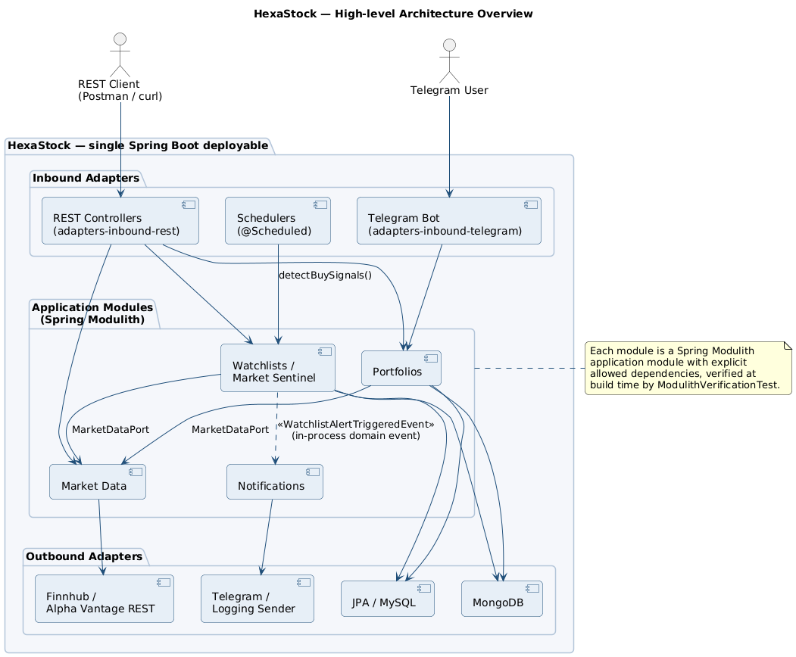
High-level architecture overview

3.1 DDD – strategic and tactical
- The four bounded contexts above are strategic DDD applied to this codebase.
- Inside each context the tactical DDD vocabulary is used: aggregate roots (Portfolio, Watchlist), value objects (Money, Ticker, Price, ShareQuantity), domain services where they earn their keep, repositories hidden behind ports.
- The ubiquitous language is documented in doc/tutorial/sellStocks/UBIQUITOUS-LANGUAGE.md and referenced by SELL-STOCK-DOMAIN-TUTORIAL.md.

3.2 Hexagonal Architecture – ports and adapters
- The hexagon is per bounded context, not global. Each capability has its own primary ports (...UseCase) and secondary ports (...Port).
- Layering is enforced by Maven module dependencies: application depends on domain; every adapter module depends on application; only bootstrap depends on adapters. The dependency graph is in diagrams/02-maven-multimodule.puml.
- The application Maven module is intentionally Spring-free (ADR-007). The only Spring annotation tolerated there is jakarta.transaction.@Transactional, which is a JTA spec annotation rather than a Spring one. Everything Spring-aware lives in bootstrap or in outbound adapter modules.
- A second build-time guard, HexagonalArchitectureTest (ArchUnit), fails the build if a domain class imports org.springframework.*, jakarta.persistence.*, or com.fasterxml.jackson.*.

3.3 Spring Modulith – runtime enforcement of bounded contexts
- Each business capability is a top-level Java package directly under cat.gencat.agaur.hexastock.* – portfolios, marketdata, watchlists, notifications. That makes them detectable as Modulith application modules.
- The @org.springframework.modulith.ApplicationModule annotations live on package-info.java files inside the bootstrap Maven module so the application module stays Spring-free; runtime detection works because Spring Modulith scans by package, not by JAR.
- Allowed cross-module dependencies are declared explicitly:
- portfolios -> marketdata::model, marketdata::port-out
watchlists -> marketdata::model
notifications -> watchlists, marketdata::model
- ModulithVerificationTest.verifyModuleStructure() calls MODULES.verify() to fail the build on any cycle or undeclared cross-module dependency.

3.4 Domain Events – the only intentional decoupling mechanism today
- Exactly one domain event flows in production: WatchlistAlertTriggeredEvent, emitted by MarketSentinelService and consumed by WatchlistAlertNotificationListener (in the notifications module) using @ApplicationModuleListener.
- The event is a plain Java record. The publisher is an outbound port (DomainEventPublisher) implemented by SpringDomainEventPublisher, which delegates to Spring’s ApplicationEventPublisher. Application code never imports anything from Spring.
- See the deep dive: 02-WATCHLISTS-EVENT-FLOW-DEEP-DIVE.md.

4. Why this combination makes sense here
HexaStock is small enough that microservices would be massive over-engineering, but it is structured enough that a “fat Spring Boot project” would erode quickly. The combination of the four styles addresses that trade-off:
- DDD gives the boundaries. Without them every other tool degenerates into ceremony.
- Hexagonal gives the layering. It keeps the domain free of frameworks and makes adapters interchangeable (JPA and MongoDB persistence both compile against the same ports).
- Spring Modulith gives the enforcement. It is the difference between a bounded context being a team agreement and being a failing build.
- Domain events give the in-process decoupling. They let two modules collaborate without one importing the other’s internals – a property that becomes very valuable on day one of every cross-team change.
The thesis the consultancy will defend is that this combination is deliberately conservative: the project is one deployable, no broker, no outbox, no event store. The architectural shape, however, is the one that lets the project grow into any of those choices later without rewriting the domain.

5. What this overview is not
- It is not a defence of the current layout against the alternatives – that is in 03-LAYOUT-ALTERNATIVES.md.
- It is not a deep dive on any single mechanism – see the dedicated documents.
- It does not claim that the current implementation is production-ready under arbitrary load or reliability targets – see 04-PRODUCTION-EVOLUTION.md.

01 – Filesystem, Maven and Modulith Structure
Audience. Engineers who will navigate the codebase live during the session. Reading time. ~15 minutes.

1. The three orthogonal axes
A frequent point of confusion when senior engineers first read this codebase is that it is organised along three orthogonal axes simultaneously:
Axis | Encoded by | Enforced by
Hexagonal layer (domain / application / adapter / bootstrap) | Maven modules | Maven dependency graph + HexagonalArchitectureTest (ArchUnit)
Bounded context (portfolios / marketdata / watchlists / notifications) | Top-level Java packages under cat.gencat.agaur.hexastock.* | ModulithVerificationTest (MODULES.verify())
Adapter technology (JPA, Mongo, REST, Telegram, market provider) | Distinct Maven adapter modules | Maven module isolation
Once you internalise that those three axes are independent, the layout reads trivially.

2. Maven multi-module layout
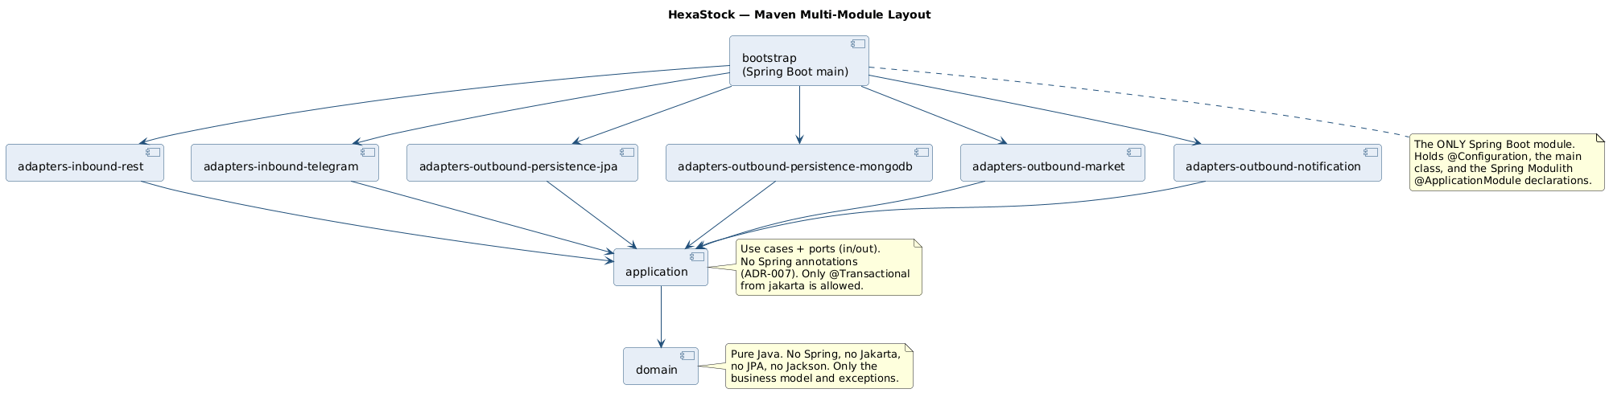
Maven multi-module layout
The aggregator pom.xml declares nine modules:
domain
application
adapters-inbound-rest
adapters-inbound-telegram
adapters-outbound-notification
adapters-outbound-persistence-jpa
adapters-outbound-persistence-mongodb
adapters-outbound-market
bootstrap
Their dependency rules are simple and strictly enforced by Maven:
- application depends on domain (and on nothing Spring).
- Every adapters-* module depends on application (and may depend on its technology stack: JPA, Spring Data MongoDB, OkHttp, Telegram Bots, etc.).
- bootstrap is the only Spring Boot module. It depends on every adapter and contains HexaStockApplication (@SpringBootApplication), @Configuration classes, and the Spring Modulith @ApplicationModule declarations on package-info.java.
This forces a constraint that is easy to verify by reading any POM: the domain module’s POM is minimal – JUnit and AssertJ for tests, nothing else. The application module’s POM adds only what is strictly needed for use cases.

Why split adapters into separate Maven modules at all?
Three reasons that survived several rounds of internal review:
- Compile-time isolation of optional adapters. A deployment that does not want MongoDB simply does not include adapters-outbound-persistence-mongodb on the classpath. The application code does not change.
- Forced ports first. A new adapter cannot be written until a port exists, because the adapter module depends on application, not the other way round.
- Clear cost of leaks. An accidental import of, say, JPA in the domain would not even compile (the domain module has no jakarta.persistence dependency on its classpath).

3. Filesystem layout
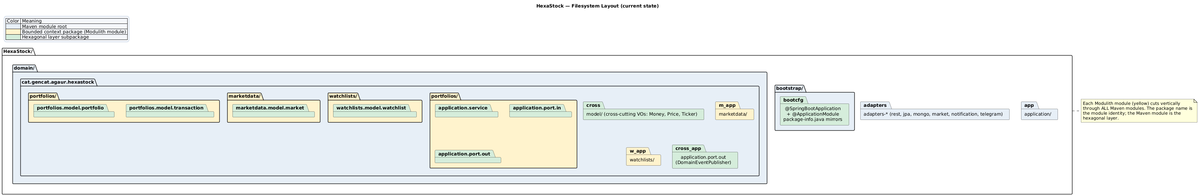
Filesystem layout
Inside each Maven module, the source tree follows a single rule:
<maven-module>/src/main/java/
cat/gencat/agaur/hexastock/
<bounded-context>/
<hexagonal-sublayer>/
... Java types ...
Concrete examples for the Watchlists context:
domain/src/main/java/cat/gencat/agaur/hexastock/
watchlists/model/watchlist/Watchlist.java
watchlists/model/watchlist/WatchlistId.java
watchlists/model/watchlist/AlertEntry.java
watchlists/model/watchlist/AlertNotFoundException.java
watchlists/model/watchlist/DuplicateAlertException.java
application/src/main/java/cat/gencat/agaur/hexastock/
watchlists/package-info.java <- javadoc + Modulith intent
watchlists/WatchlistAlertTriggeredEvent.java <- published API (record)
watchlists/application/port/in/WatchlistUseCase.java
watchlists/application/port/in/MarketSentinelUseCase.java
watchlists/application/port/out/WatchlistPort.java
watchlists/application/port/out/WatchlistQueryPort.java
watchlists/application/port/out/TriggeredAlertView.java
watchlists/application/service/WatchlistService.java
watchlists/application/service/MarketSentinelService.java
adapters-inbound-rest/src/main/java/cat/gencat/agaur/hexastock/
watchlists/adapter/in/... <- REST controller, DTOs
adapters-outbound-persistence-jpa/src/main/java/cat/gencat/agaur/hexastock/
watchlists/adapter/out/persistence/jpa/... <- JPA entities + repository
adapters-outbound-persistence-mongodb/src/main/java/cat/gencat/agaur/hexastock/
watchlists/adapter/out/persistence/mongodb/... <- Mongo documents + repository
bootstrap/src/main/java/cat/gencat/agaur/hexastock/
watchlists/package-info.java <- @ApplicationModule lives here
Read that vertical slice once and you have read every bounded context – they all follow the same template.

4. The relationship between Maven modules, Java packages, and Modulith modules
Concept | Identity carrier | Example
Maven module | pom.xml artifact id | application
Hexagonal sublayer | Suffix in package name | application.port.in, application.service
Bounded context | Top-level package under cat.gencat.agaur.hexastock | watchlists
Modulith module | Same top-level package | watchlists (detected by Spring Modulith)
Modulith named interface | Inner package marked with @NamedInterface | marketdata::port-out
Three observations matter for the consultancy:
- A Modulith module is a package, not a JAR. It cuts vertically through Maven modules. The Watchlists Modulith module spans domain, application, adapters-inbound-rest, adapters-outbound-persistence-jpa, adapters-outbound-persistence-mongodb, and bootstrap.
- package-info.java files appear twice for the same package – once in application (Spring-free, javadoc only) and once in bootstrap (carrying @ApplicationModule). This is the price ADR-007 pays to keep application pure. The duplication is intentional and has a long comment in the bootstrap-side package-info.java explaining why.
- Cross-module dependencies are opt-in, not opt-out. notifications declares allowedDependencies = {"watchlists", "marketdata::model"}; a fifth module appearing in its imports would fail MODULES.verify().

5. The Spring Modulith view
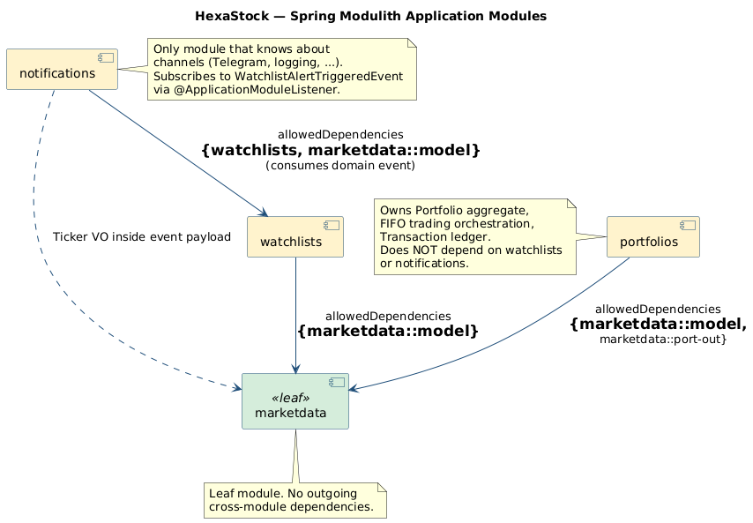
Spring Modulith application modules
Live inspection commands for the demo:
# Renders Modulith's own PlantUML / AsciiDoc into target/spring-modulith-docs
./mvnw -pl bootstrap test -Dtest=ModulithVerificationTest#writeDocumentation
# Verifies the dependency graph is acyclic and respects allowed dependencies
./mvnw -pl bootstrap test -Dtest=ModulithVerificationTest
What MODULES.verify() would catch the moment someone broke the rules:
- An accidental import cat.gencat.agaur.hexastock.notifications.* from inside portfolios – refused as an undeclared module dependency.
- A circular dependency between two modules – refused as a cycle.
- Any class outside marketdata that imports a non-@NamedInterface package of marketdata – refused as a leak past the published interface.

6. How the layout supports – and constrains – DDD and Hexagonal

Supports
- Vertical slices stay coherent. Everything that belongs to the Watchlists business capability lives under packages whose first segment is watchlists, regardless of which Maven module hosts the file.
- Layer purity is mechanical, not aspirational. A reviewer does not need to spot a Spring import in the domain – Maven would have failed the build long before review.
- Adapters are interchangeable. WatchlistJpaRepositoryAdapter and WatchlistMongoRepositoryAdapter both implement the same WatchlistPort. Swapping persistence is a Spring bean wiring choice, not a refactoring exercise.

Constrains
- Newcomers see nine Maven modules and one tree per module – that is a lot. The first half-day is spent learning the map. The investment pays back quickly, but it is real.
- A single bounded context spans many directories. Renaming the Watchlists module touches eight src/main/java/cat/gencat/agaur/hexastock/watchlists trees. Modern IDEs (IntelliJ “Refactor -> Move package”) handle this, but command-line git mv does not.
- Two package-info.java files for the same package. Discussed above – ADR-007 is the trade-off.
The competing layouts and how they compare are analysed in 03-LAYOUT-ALTERNATIVES.md.

02 – Watchlists / Market Sentinel: Domain Event Deep Dive
Audience. Engineers who will live-trace the canonical event flow during the demo. Reading time. ~20 minutes. Source artefacts. MarketSentinelService · WatchlistAlertTriggeredEvent · DomainEventPublisher · SpringDomainEventPublisher · WatchlistAlertNotificationListener · NotificationsEventFlowIntegrationTest.

1. Business intent
A user maintains one or more Watchlists. Each Watchlist is an aggregate that holds a list of AlertEntry value objects, each pinning a Ticker to a Money threshold (for example: “tell me when AAPL falls below 170 USD”). The Market Sentinel periodically scans the universe of distinct tickers across all active watchlists, fetches their current price from the market data provider, and – for each alert whose threshold has been reached – publishes a domain event. The user is then notified through whichever channels the Notifications module knows about (Telegram or logging today; email, WebSocket, mobile push tomorrow).
The point of using a domain event here is not convenience: it is that the Watchlists module must remain completely ignorant of how those alerts become user-visible signals. That is the entire teaching value of the example.

2. End-to-end sequence
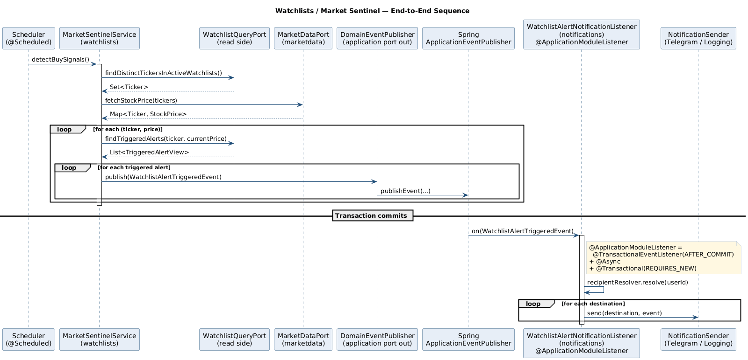
Watchlists / Market Sentinel sequence
The flow is short enough to walk verbally during the demo:
- A scheduler (or the integration test) calls MarketSentinelService.detectBuySignals().
- The service reads, on a CQRS-style read port (WatchlistQueryPort.findDistinctTickersInActiveWatchlists()), the set of tickers currently being watched.
- It calls MarketDataPort.fetchStockPrice(tickers), returning a Map<Ticker, StockPrice>. This is the only outgoing call that crosses process boundaries.
- For each price, it asks the read port findTriggeredAlerts(ticker, price) for the materialised list of TriggeredAlertView projections.
- For each triggered alert it builds a WatchlistAlertTriggeredEvent and calls DomainEventPublisher.publish(event).
The publication call returns immediately; the listener does not run inside the calling transaction (see §5).

3. The event itself – anatomy of a good domain event
public record WatchlistAlertTriggeredEvent(
String watchlistId,
String userId,
Ticker ticker,
AlertType alertType,
Money threshold,
Money currentPrice,
Instant occurredOn,
String message
) {
public WatchlistAlertTriggeredEvent { /* explicit non-null validation */ }
public Optional<String> messageOptional() { ... }
public enum AlertType { PRICE_THRESHOLD_REACHED }
}
Five properties are worth highlighting because they recur in every healthy domain-event design:
Property | Embodied here by
It is a Java record. Immutable, value-equal, no setters. | The whole class.
It carries business identity, not infrastructure identity. | userId is the watchlist owner, not a Telegram chat id, not an email address. The notifications module resolves channels later.
It validates its invariants at construction. | The compact constructor calls Objects.requireNonNull on every required field.
It is timestamped at the source. | occurredOn is set by the publisher’s injected Clock, never inferred downstream.
It is enum-typed, not string-typed. | AlertType.PRICE_THRESHOLD_REACHED keeps the contract evolvable without breaking existing consumers.
What it deliberately does not carry: any mention of channels, transport, retries, or downstream system identities. Those would couple the publisher to the consumer.

4. Where the event lives – and why that matters
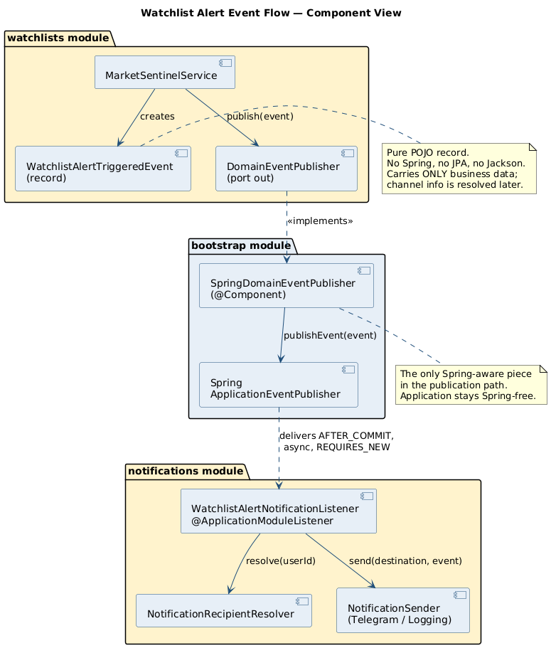
Component view
Concern | Where | Why
Event type | application Maven module, package cat.gencat.agaur.hexastock.watchlists | The published API of the Watchlists module. Living in the application module makes it visible to consumers without dragging the domain along, and keeps it Spring-free.
Publisher port | application/.../application/port/out/DomainEventPublisher.java | Plain Java interface, the only contract the application service knows.
Publisher adapter | bootstrap/.../config/events/SpringDomainEventPublisher.java | Bridges the port to Spring’s ApplicationEventPublisher. The only Spring-aware piece.
Consumer | adapters-outbound-notification/.../WatchlistAlertNotificationListener.java | Lives in the notifications Modulith module. Spring’s @ApplicationModuleListener does the wiring.
The bidirectional rule is: publishers know the event, consumers know the event, neither knows the other. That property is what lets you add a second consumer (an AuditTrailListener, say) without touching the publisher.

5. Transactional semantics – the real reason @ApplicationModuleListener exists
@ApplicationModuleListener
public void on(WatchlistAlertTriggeredEvent event) { ... }
@ApplicationModuleListener is a Spring Modulith convenience that expands to:
@TransactionalEventListener(phase = AFTER_COMMIT)
@Async
@Transactional(propagation = REQUIRES_NEW)
Each piece earns its place:
- AFTER_COMMIT – guarantees the publisher’s transaction has successfully committed before the listener runs. If the publisher rolls back, the event is silently discarded. This is the entire reason this annotation exists in Modulith: it makes “I detected a triggered alert and I want to notify the user” a transactionally honest assertion.
- @Async – runs the listener on a separate thread. The publishing transaction is not slowed down by Telegram latency or by a slow recipient resolver.
- @Transactional(REQUIRES_NEW) – gives the listener its own transactional context. If a future consumer needs to write to the database (an audit log, for example), it writes in its own transaction; a failure does not roll back the publishing transaction (which is already committed) and does not cascade to other listeners.
These three properties together are what make in-process domain events safe enough to be used in a real codebase rather than being a leaky abstraction.

6. The notification side – why it can be ignored from the publisher’s point of view
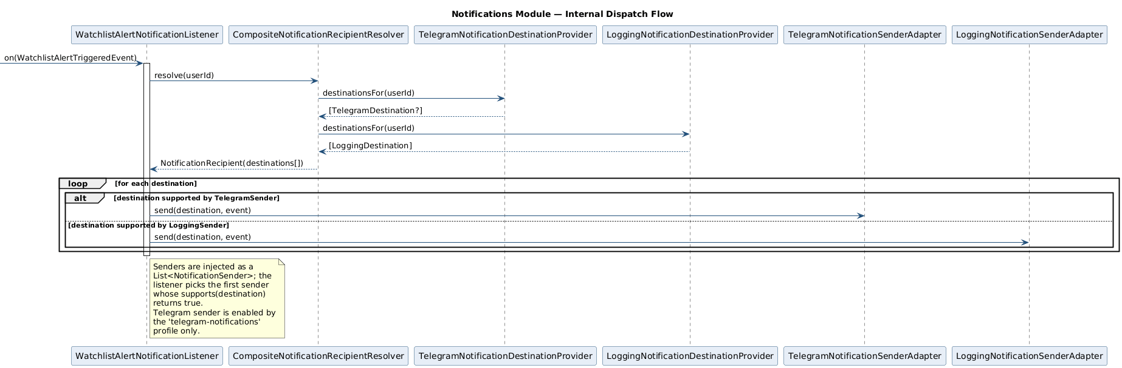
Notification dispatch flow
Inside the listener:
- NotificationRecipientResolver.resolve(userId) produces a NotificationRecipient carrying every known destination for that user. The default implementation (CompositeNotificationRecipientResolver) aggregates results from each NotificationDestinationProvider bean – today: a Telegram one (active under the telegram-notifications profile) and a logging one (always active).
- For each NotificationDestination, the listener picks the first NotificationSender whose supports(destination) returns true, and calls send(destination, event).
That entire mechanism is private to the notifications module. The watchlists module has no idea any of those types exist. Adding SMS would be:
- a new SmsNotificationDestination,
- a new SmsNotificationDestinationProvider (resolves a phone number for a userId),
- a new SmsNotificationSenderAdapter.
No change to Watchlists. No change to the event. No change to the listener. That is what the consultancy is selling.

7. Why this is a perfect teaching example
A short, defensible list:
- It is real code that runs, not an abstract example. The flow is exercised by NotificationsEventFlowIntegrationTest and (in deployment) by a @Scheduled job.
- It exercises all four architectural styles at once – DDD (the Watchlist aggregate), Hexagonal (the DomainEventPublisher port + Spring adapter), Modulith (the @ApplicationModule boundary and @ApplicationModuleListener consumer), and Domain Events (the WatchlistAlertTriggeredEvent record).
- It demonstrates asymmetric coupling: notifications declares allowedDependencies = {"watchlists", "marketdata::model"}, but the inverse is not declared and would fail the build. That asymmetry is the entire point.
- It demonstrates the CQRS read side without going full CQRS: WatchlistQueryPort returns flat TriggeredAlertView projections, distinct from the Watchlist aggregate read path.
- The behaviour is safely reversible – disabling the listener (commenting out @ApplicationModuleListener) produces zero alerts, but breaks no invariants. That property would not hold if MarketSentinelService were calling notificationSender.send(...) directly.

8. Caveats and honest limitations
- The event is in-memory only. If the JVM crashes between AFTER_COMMIT and the listener body running, the event is lost. There is no outbox today. See 04-PRODUCTION-EVOLUTION.md §2 for what to do about this.
- The listener’s @Async execution uses Spring’s default executor. A production deployment should configure a bounded executor with explicit rejection policy.
- There is no retry. A Sender.send(...) failure is logged and dropped. In production, retries would belong in the sender adapter (or in the broker layer once the event is externalised), not in the listener.
- The notifications module currently depends on the Ticker value object from marketdata, which it includes in the rendered message. That keeps the example honest but means a hypothetical extraction would still need a shared kernel for Ticker. A future refactor could carry the ticker as a String in the event instead, eliminating that dependency.

03 – Layout Alternatives: a Rigorous Comparison
Audience. Senior engineers who will, correctly, ask “why did you split it like this rather than like that?”. Reading time. ~20 minutes.
This document compares the current HexaStock layout against four common alternatives for projects that combine Spring Modulith + DDD + Hexagonal Architecture + bounded-context thinking, and explains the position the project takes.
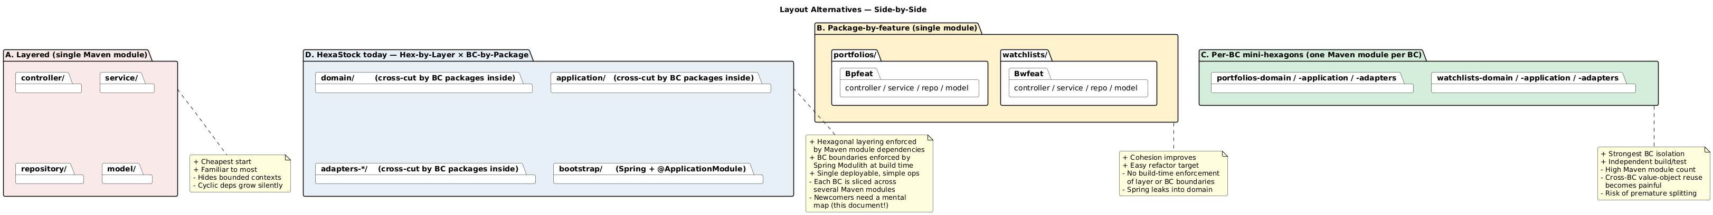
Layout alternatives at a glance

A. Layered, single Maven module
Shape. One Maven artefact. Top-level packages by technical layer – controller, service, repository, model. The bounded contexts are not visible at the package level; they are diluted across the four layer packages.
Strengths. - The shape every Spring tutorial uses; new joiners need zero ramp-up. - Cheapest possible build; everything compiles in one go. - Refactoring across layers is trivial because nothing is enforced.
Weaknesses. - Bounded contexts are invisible. A WatchlistService and a PortfolioService end up next to each other in the same service package, and a junior developer will gladly inject one into the other. - There is no build-time guarantee that the domain is framework-free. - Spring Modulith has nothing to enforce – everything lives in the same module. - Cycles grow silently. By the time controller -> service -> repository -> service cycles appear, unwinding them is a multi-week project.
Good fit for. A throwaway prototype, a take-home interview project, or a codebase whose lifetime is measured in months.
Comparison with HexaStock. This is the layout HexaStock would degenerate into if every guard rail (HexagonalArchitectureTest, ModulithVerificationTest, the multi-module Maven graph) were removed. The project’s thesis is that the incremental cost of avoiding this layout is small and pays back almost immediately.

B. Package-by-feature, single Maven module
Shape. One Maven artefact. Top-level packages by bounded context – portfolios/, watchlists/. Inside each, sub-packages mirror the layered shape – portfolios/controller, portfolios/service, portfolios/repository, portfolios/model.
Strengths. - Bounded contexts become visible the moment you open the project tree. - A reviewer can see a feature-shaped commit; cross-context noise drops. - It is the natural starting point for an incremental migration toward Modulith – it is exactly what was done in the early stages of the HexaStock refactoring program (see SPRING-MODULITH-GLOBAL-REFACTORING-PLAN.md).
Weaknesses. - Layer boundaries are not enforced; nothing prevents a controller importing a repository directly. Spring Modulith does not catch this – it polices modules, not layers. - Bounded-context boundaries are not enforced either, unless Spring Modulith is added on top with explicit allowedDependencies. Without that, a WatchlistsService can still import a PortfoliosService freely. - The domain is on the same classpath as Spring; the “no Spring in the domain” rule is aspirational only.
Good fit for. Single-team projects of moderate size where the team can be trusted with conventions but not with build-time enforcement.
Comparison with HexaStock. Adding spring-modulith-core to a layout B project gets you most of the bounded-context enforcement that HexaStock has, but none of the layer enforcement. The HexaStock thesis is that paying the multi-Maven-module tax buys you the latter.

C. Per-bounded-context mini-hexagons (Maven module per BC)
Shape. One Maven artefact per bounded context, each containing its own -domain, -application, -adapters sub-modules. So: portfolios-domain, portfolios-application, portfolios-adapters-jpa, portfolios-adapters-rest, etc. – multiplied by the number of contexts.
Strengths. - The strongest possible isolation. Each BC is a fully independent hexagonal application; it could in principle be extracted to its own repository tomorrow. - Build-time impossible to import across BCs unless the dependency is declared in the consumer’s POM. - Independent test execution per BC.
Weaknesses. - The Maven module count explodes. With four bounded contexts and three hexagonal layers each, you get ~12 modules before any persistence variant is added, and ~20 once you split JPA/Mongo/REST adapters per BC. - Cross-BC value-object reuse becomes painful. Money, Ticker, Price need to live in a shared kernel module that every BC depends on, which becomes a magnet for “I’ll just add this here for now”. - High risk of premature splitting. Bounded contexts are not always obvious early; this layout makes them very expensive to merge later. - Setup, IDE indexing, and CI friction are non-trivial.
Good fit for. Multi-team projects where each BC has a separate codeowner and the BC boundaries have already been validated by months of operational experience. Often a stop on the way to physically separated services.
Comparison with HexaStock. This is what HexaStock might evolve into if the project grows to multiple teams, if one BC starts shipping at a materially different cadence than the others, and if the cost of the extra Maven modules is justified by the team structure. None of those is true today.

D. Modulith-first (top-level package per module, single Maven module)
Shape. One Maven artefact. Top-level packages directly map to Spring Modulith application modules. Internal sub-packages can use any internal convention. Everything is enforced by Spring Modulith only.
Strengths. - This is the canonical Spring Modulith reference shape (the kitchensink sample). - Lowest ceremony for a Modulith-first design. - Build-time BC isolation through MODULES.verify().
Weaknesses. - Hexagonal layering inside a module is convention, not enforcement. - Domain code can import Spring; no compile-time wall protects it. - A purely package-based hexagon needs ArchUnit rules to be more than a visual organisation choice.
Good fit for. Greenfield projects that want Modulith’s BC enforcement now and are happy to layer hexagonal discipline on top via ArchUnit rather than via Maven modules.
Comparison with HexaStock. HexaStock is essentially “Layout D plus hexagonal layering enforced by Maven modules”. The extra Maven modules pay for the layering enforcement; the top-level package convention pays for the BC enforcement.

E. HexaStock today – Hexagonal × Bounded Context, by Maven and by package
Shape. Already described in 01-FILESYSTEM-AND-MAVEN-STRUCTURE.md:
- Hexagonal layer -> Maven module (domain, application, adapters-*, bootstrap).
- Bounded context -> top-level Java package (portfolios, marketdata, watchlists, notifications).
- Hexagonal sublayer inside a BC -> Java sub-package (watchlists.application.port.in, watchlists.application.service, watchlists.adapter.out.persistence.jpa).
Strengths. - Hexagonal layering is mechanically enforced by the Maven dependency graph: the application module’s POM does not contain Spring; the domain module’s POM does not even contain Jakarta. A leak does not compile. - Bounded contexts are mechanically enforced by Spring Modulith via MODULES.verify(); cross-module imports must be declared in allowedDependencies. - Domain events stay framework-free: they live in application (a Spring-free Maven module) and only the adapter (SpringDomainEventPublisher) knows about Spring. - Persistence variants (JPA and MongoDB) coexist as alternative Maven adapter modules selecting at deployment time.
Weaknesses. - Each BC is split across many Maven modules; an IDE-driven mental map is needed. - package-info.java files appear twice for the same package (Spring-free copy in application, Spring-aware copy with @ApplicationModule in bootstrap). The duplication is intentional but is the kind of thing senior engineers will rightly question. - Newcomers spend the first half-day learning the layout. The investment pays back quickly, but it is real.
When this is right. When you want the enforcement of layered hexagonal and the enforcement of bounded contexts, and the project is small enough that one Spring Boot deployable still makes operational sense. That is precisely HexaStock today.

How to explain this coherently to senior engineers
A four-line summary that survives any whiteboard:
“We picked the layout that lets the build itself enforce two orthogonal things – layer purity via Maven modules, and bounded-context isolation via Spring Modulith. The cost is one extra package-info.java per module and a slightly larger Maven graph. The benefit is that we will never accidentally leak Spring into the domain or WatchlistsService into Portfolios, and we paid that cost on day one rather than during the first cross-team incident.”
Then, if pushed:
- Layout A would let the project ship faster today, and erode faster next quarter.
- Layout B is what HexaStock looked like during early Modulith phases; it was the right transitional shape, not the right destination.
- Layout C is what HexaStock might eventually become, if and only if the team structure and the cadence pressure justify the multiplication of Maven modules.
- Layout D is what HexaStock would look like without the Maven module split – it would be cleaner to navigate, but domain/ would not be guaranteed framework-free.
The current shape is a deliberate, conservative bet on enforcement over ergonomics – a bet that pays off as soon as the codebase is touched by more than one engineer.

04 – From Current Solution to Realistic Production Evolution
Audience. Engineers and architects who will ask “and what would you do at 10× the load?”. Reading time. ~15 minutes.
The current Watchlists / Notifications event flow is intentionally simple: in-memory, in-process, no broker, no outbox. This document explains what that buys you, where it stops being safe, and the realistic evolution paths – none of which require throwing away the current architecture.
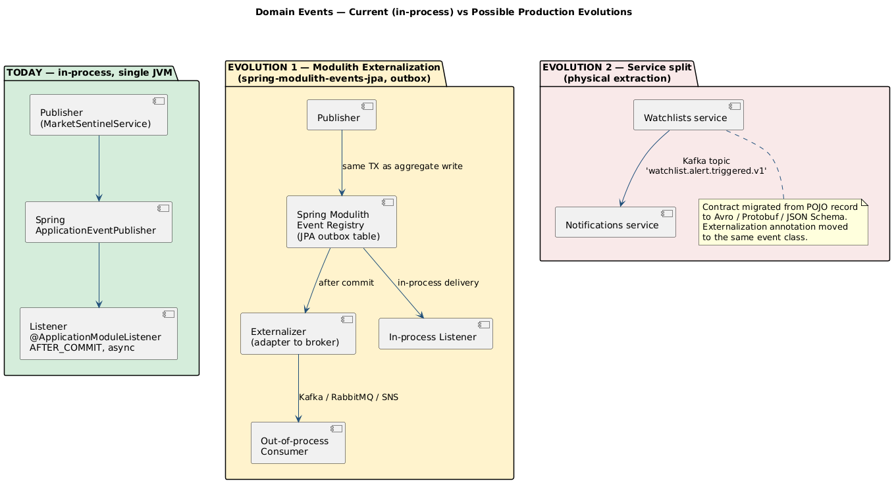
Current vs future event topologies

1. What the current implementation actually guarantees
Property | Today | How
Event is delivered iff the publishing transaction commits | [OK] | @ApplicationModuleListener => @TransactionalEventListener(AFTER_COMMIT)
Listener does not slow down the publisher | [OK] | @ApplicationModuleListener => @Async
Listener failure does not roll back the publisher | [OK] | @ApplicationModuleListener => @Transactional(REQUIRES_NEW)
Event survives a JVM crash between commit and listener invocation | [X] | No persistence; in-memory event bus
Event survives a listener exception | [X] | No retry; logged and dropped
Event has a global ordering guarantee | [X] | None requested or provided
Event is consumable from another process | [X] | In-process only
Event has a published, versioned schema | [!] | Java record contract; no machine-checkable schema
The honest summary: it is good enough for a single-deployable, single-team financial-portfolio backend with non-mission-critical notifications, and is architecturally shaped so that any of the missing properties can be added without rewriting the publisher.

2. Evolution path 1 – add durability inside the same monolith
The Spring Modulith project ships spring-modulith-events-jpa (and equivalents for MongoDB, JDBC, Kafka, etc.). Adding it gives the transactional outbox pattern with effectively no code changes:
<dependency>
<groupId>org.springframework.modulith</groupId>
<artifactId>spring-modulith-starter-jpa</artifactId>
</dependency>
What you get the moment you flip that switch:
- Every ApplicationEventPublisher.publishEvent(event) whose event class is marked @org.springframework.modulith.events.Externalized (or annotated with the framework-level externalisation marker) is persisted to an outbox table inside the same JDBC transaction as the publisher’s writes.
- Listener invocations become completion records in that same table.
- A scheduled poller / republisher retries failed listener invocations until they succeed (or are explicitly dead-lettered).
The publisher does not change. The listener does not change. What changes:
- The application has a new database table (event_publication), so a schema migration is needed.
- The listener should be made idempotent, because retries become possible. In practice this means designing the side effect to tolerate a duplicate invocation – which is good practice anyway.
The architectural diagram is EVOLUTION 1 in the figure above.

3. Evolution path 2 – externalise selected events to a broker
Once the outbox is in place, externalising a specific event becomes a configuration change rather than a redesign. Spring Modulith supports externalising to Kafka, RabbitMQ, AWS SNS/SQS, JMS, etc., via additional starters and a single annotation on the event class:
@org.springframework.modulith.events.Externalized("watchlist.alert.triggered.v1")
public record WatchlistAlertTriggeredEvent(...) { ... }
The framework will then publish each persisted event to the configured broker after commit, with at-least-once semantics backed by the outbox.
What this enables:
- A second consumer in another process (a notifications worker, a reporting job, a fraud-detection pipeline) can subscribe to the broker topic without modifying HexaStock.
- A truly async processing pipeline that survives consumer outages.
- A natural seam for a future physical extraction of the consumer (see §4).
What it costs:
- The event becomes a published contract in the strong sense. Consumers outside the codebase will rely on it. Versioning discipline becomes mandatory: name the topic *.v1, plan for *.v2, never silently change field semantics.
- The Java record POJO is no longer the contract – the wire format schema is. Avro, Protobuf, or JSON Schema (with a registry) becomes a serious choice, not a stylistic one.
- Operational concerns enter: broker availability, consumer lag, dead-letter topics, retry budgets.

4. Evolution path 3 – physically extract a module
If notifications becomes either (a) a substantially heavier workload than the rest of the application, (b) a separately-owned product, or (c) a compliance-isolated component, it can be extracted into a separate deployable. The architecture is already shaped for this:
- The publishing side already speaks an external contract (after step 3).
- The notifications module already imports nothing from portfolios and only consumes the published WatchlistAlertTriggeredEvent plus the Ticker VO.
- The module’s adapters (TelegramNotificationSenderAdapter, LoggingNotificationSenderAdapter) are independently deployable units.
Extraction is not free, of course:
- The shared Ticker value object now needs a strategy: vendored copy, shared library, or replaced by a String ticker inside the event.
- The persistence story for the notifications side (if any) becomes a separate database, not a separate schema.
- Operational concerns (CI, deployment pipelines, observability, identity/auth between services) are now in scope.
The point: this is a capability you preserve, not a target you commit to. The current layout makes the option cheap to keep open without paying the cost upfront.

5. What the current architecture deliberately does not claim
These are the honest “no” answers to the questions a senior engineer will ask:
- “Is this microservices-ready?” – No, and it does not claim to be. It is deployable-monolith-correct and extraction-friendly. Those are different goals.
- “Does this guarantee exactly-once delivery?” – No. Exactly-once does not exist outside of constrained transactional boundaries. The current flow is at-most-once in memory; with the outbox it becomes at-least-once with idempotent consumers.
- “Is the event a stable API?” – Today it is an internal Java record. The moment a second team consumes it, treat it as a stable API and apply versioning rules. Not before.
- “Should every aggregate operation publish a domain event?” – No. Publish events for business facts other modules legitimately want to react to. Publishing for the sake of “decoupling” leads to event spam and makes the aggregate harder to reason about.

6. Where this leaves the consultancy thesis
“We picked an architecture that is honest about today’s needs and shaped for tomorrow’s options. The Watchlists event flow is the smallest correct example of that thesis: in-process today, outbox-and-broker-ready tomorrow, extractable the day after – and none of those moves require us to revisit the Watchlists domain code.”
That sentence is the take-away. Everything else in this folder is the evidence that backs it.

Exercise – Refactor Sell Stocks with Domain Events
Audience. Senior Java engineers, software architecture students and professional training participants who are already comfortable with HexaStock’s hexagonal layout and the requirement-traceability model.
Format. Reference demo (instructor) + hands-on refactor (participants) + facilitated review.
Scope. Documentation only. This exercise asks participants to refactor live code; it does not alter the codebase as committed.

At a glance
Idea | Diagram
Conceptual – one business fact, many reactions | 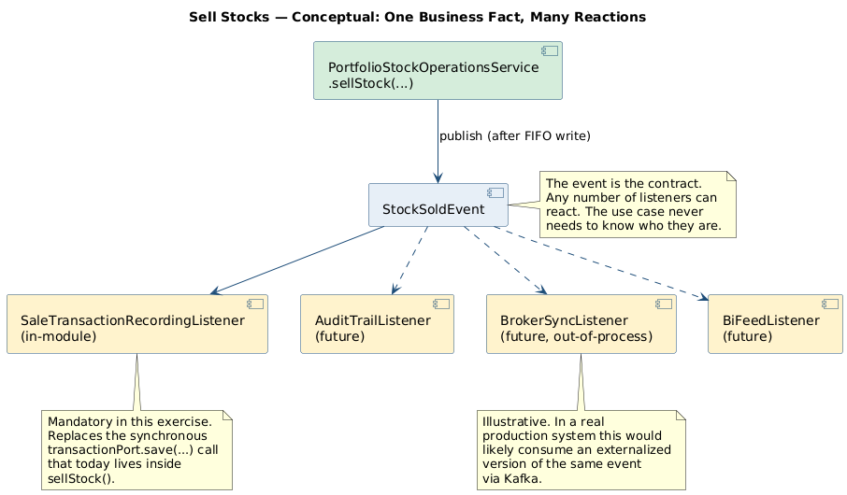
Today – synchronous, two persistence side effects in one method | 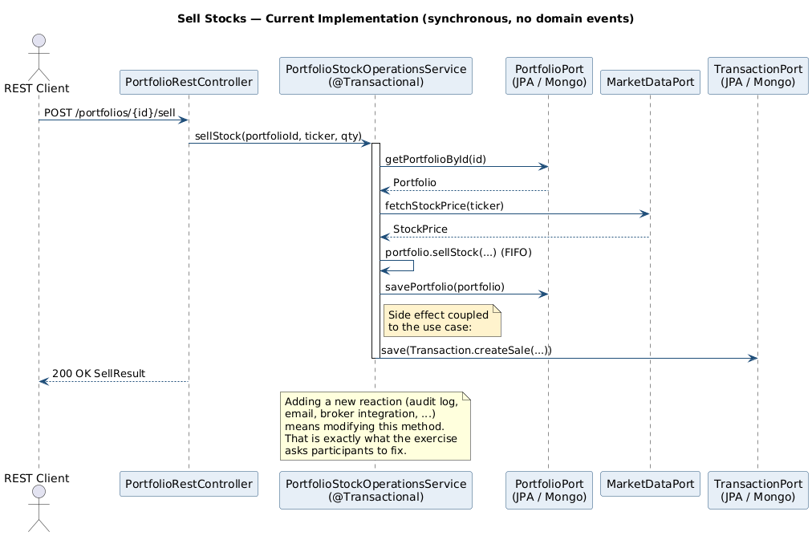
Target – event-driven, listener writes the transaction | 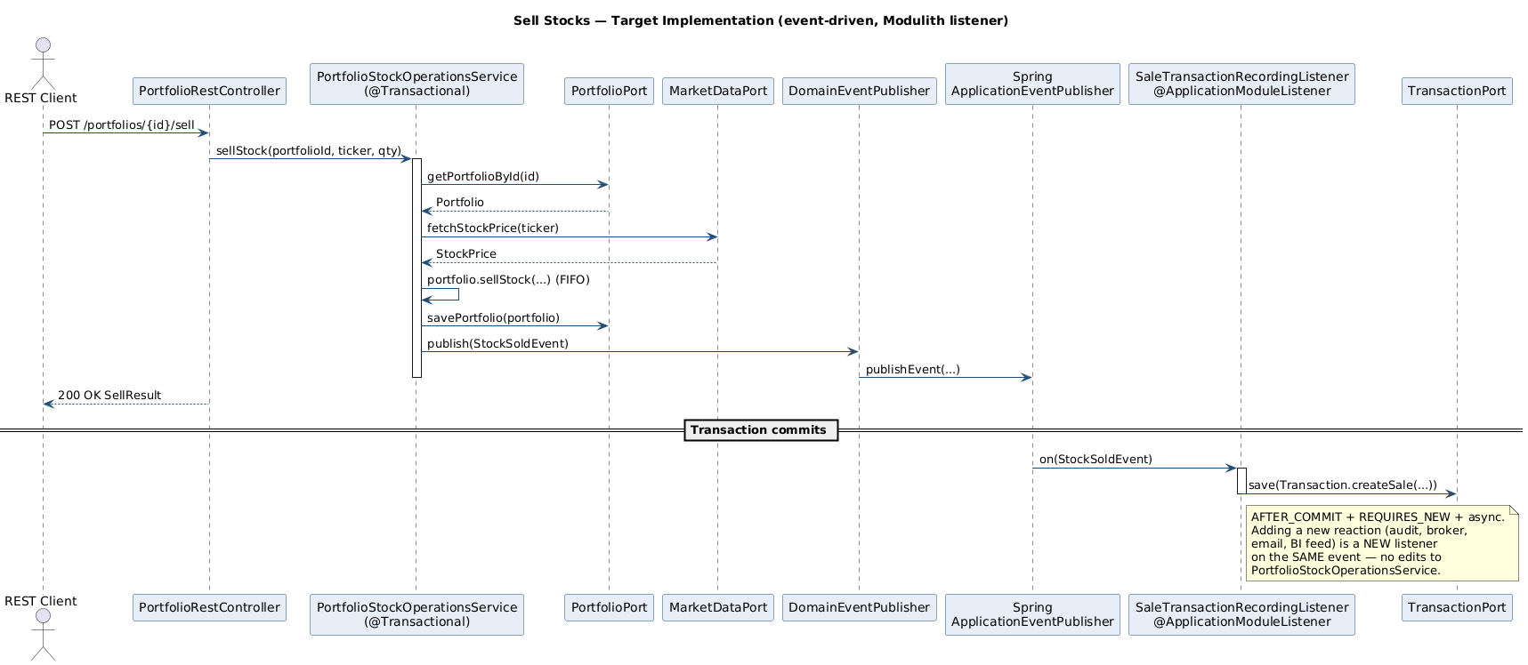
The companion documentation set for the upcoming consultancy session lives under doc/consultancy/monday-session/.

1. Why this exercise exists
HexaStock already contains one fully working domain-event flow: the Watchlist / Market Sentinel -> Notifications pipeline. That pipeline is documented in doc/tutorial/watchlists/WATCHLISTS-MARKET-SENTINEL.md and dissected end-to-end in the consultancy briefing chapter 04-DOMAIN-EVENTS-DEEP-DIVE.md.
That flow is the instructor demo. It exhibits the canonical separation between a fact (an alert condition was reached for a ticker) and reactions to that fact (a notification is dispatched). The publishing module – Watchlists – knows nothing about how, when or through which channel the reaction is performed.
This exercise asks participants to apply the same separation to a different, equally important business operation: selling stocks. The current implementation in PortfolioStockOperationsService.sellStock(…) couples the sell decision with one of its consequences (recording a Transaction) inside a single synchronous method. The exercise is to disentangle them using the same pattern that the Watchlists module already exemplifies.
The pedagogical intent is to give participants the experience of recognising the pattern in working code, justifying its application in a new context and implementing the refactor end-to-end.

2. The instructor demo: the existing Market Sentinel flow
Spend approximately fifteen minutes walking through the in-flight implementation. The salient artefacts are:
Layer | Artefact
Event (POJO record) | WatchlistAlertTriggeredEvent.java
Outbound port (publisher abstraction) | DomainEventPublisher.java
Spring adapter for the publisher | bootstrap/.../config/events/SpringDomainEventPublisher.java
Publication site (application service) | MarketSentinelService.detectBuySignals()
Consumer (@ApplicationModuleListener) | WatchlistAlertNotificationListener.java
End-to-end integration test | NotificationsEventFlowIntegrationTest.java
Architectural verification | ModulithVerificationTest.java (assertions watchlistsHasNoOutgoingModuleDependencies and notificationsOnlyDependsOnWatchlists)
Five properties of this implementation should be made explicit during the demo, because the participants will be asked to reproduce them:
- The event is a Java record with no framework imports. It compiles in the framework-free application Maven module (see ADR-007).
- The event carries business identity, not transport identity. It contains userId, never chatId or email.
- Publication goes through a port (DomainEventPublisher), not Spring’s ApplicationEventPublisher directly. This preserves the application layer’s framework independence.
- The consumer uses @ApplicationModuleListener, which is @TransactionalEventListener(AFTER_COMMIT) + @Async + @Transactional(REQUIRES_NEW). The reaction therefore runs only after the publishing transaction commits, on a different thread, in its own transaction.
- The publisher knows nothing about the consumer. No import statement in MarketSentinelService references anything in the notifications package; the ModulithVerificationTest asserts this property in CI.
Make the participants see property 5 by opening both files side by side. Decoupling is concrete.

3. The current Sell Stocks implementation
The participants’ starting point is the production code in PortfolioStockOperationsService.sellStock(…):
@Override
@RetryOnWriteConflict
public SellResult sellStock(PortfolioId portfolioId, Ticker ticker, ShareQuantity quantity) {
Portfolio portfolio = portfolioPort.getPortfolioById(portfolioId)
.orElseThrow(() -> new PortfolioNotFoundException(portfolioId.value()));
StockPrice stockPrice = stockPriceProviderPort.fetchStockPrice(ticker);
Price price = stockPrice.price();
SellResult sellResult = portfolio.sell(ticker, quantity, price);
portfolioPort.savePortfolio(portfolio);
Transaction transaction = Transaction.createSale(
portfolioId, ticker, quantity, price, sellResult.proceeds(), sellResult.profit());
transactionPort.save(transaction);
return sellResult;
}
Three responsibilities are interleaved inside this single method:
- The core business operation. Loading the portfolio, fetching the current price and invoking portfolio.sell(...). This is what Sell Stocks fundamentally is.
- State persistence. portfolioPort.savePortfolio(portfolio) makes the new aggregate state durable.
- A side effect: recording a financial transaction. Transaction.createSale(...) followed by transactionPort.save(transaction) writes an audit-style record into a separate Transaction collection / table. The Transaction aggregate is not part of the Portfolio aggregate; it lives under domain/…/transaction with its own port TransactionPort.java and its own persistence adapters.
Responsibility 3 is precisely what should be separated from responsibility 1. It is a reaction to a business fact (a sale happened), not a constituent of the fact itself.

4. The architectural problem
Three concrete problems flow from the current arrangement.

4.1 Open-closed violation under future reactions
Today the only consequence of a sale is that one Transaction row is recorded. Future plausible consequences include – non-exhaustively – an entry in an immutable audit ledger (Section 5.2 of the domain-events roadmap), a real-time analytics projection of trading volume, a per-tax-year realised-gain aggregator, an outbound message to a brokerage reconciliation queue, an opt-in confirmation notification to the user, and a re-evaluation of any position-size watchlist alert configured by the same user on the same ticker. Each new reaction means a new line in sellStock(...), a new injected port and a new responsibility attributed to a service whose name still claims to be about stock operations.

4.2 Transactional coupling between the decision and the reaction
The transaction record is written inside the same JPA / Mongo transaction as the portfolio mutation. If a future reaction is slow, fragile or involves an external system, that fragility leaks back into the user-facing sellStock path. A failed audit append should not roll back a successful sale; today’s design has no mechanism to express that.

4.3 Bounded-context leakage as the platform grows
A future audit, reporting or integrations.brokerage module will need to know that a sale has occurred. Each such module would otherwise have to call TransactionService.getTransactions(...) on a polling basis and reconstruct the fact from the row, or – worse – depend directly on PortfolioStockOperationsService. Both options re-introduce the cross-module coupling that Spring Modulith exists to prevent.
A domain event addresses all three problems with a single mechanism.

5. The exercise
The exercise is performed on a new feature branch, branched from the current experimental branch (or from main, depending on the participants’ working agreement). It is performed without modifying tests – except to add new tests that verify the new behaviour – and without weakening any existing architectural assertion.

5.1 Required outcome
Participants must deliver a refactor in which:
- The application service PortfolioStockOperationsService.sellStock(...) continues to return the same SellResult and continues to enforce the same invariants.
- The synchronous call to transactionPort.save(...) is removed from sellStock(...). (The buy path is out of scope unless participants choose to extend the refactor; see Section 8.)
- A new domain event – name and shape to be decided by the participants, based on the project’s ubiquitous language – is published from sellStock(...) through the existing DomainEventPublisher port.
- A new @ApplicationModuleListener consumes the event and writes the Transaction record. This listener replaces the synchronous side effect with an after-commit reaction.
- All existing tests remain green. New tests cover the new event flow at the same level of rigour as NotificationsEventFlowIntegrationTest.
- The Modulith verifications in ModulithVerificationTest and the architecture rules in HexagonalArchitectureTest remain green.

5.2 Open design questions for the participants
The exercise is deliberately not prescriptive about the following points. Each participant – or each pair – is expected to take a position, justify it and defend it during the review.
- What is the event called? Candidates include StockSoldEvent, SaleExecutedEvent, PortfolioStockSoldEvent and others. The name must respect the project’s ubiquitous language and match the past-tense convention used by WatchlistAlertTriggeredEvent.
- What does the event carry? At minimum: portfolio identity, owner identity, ticker, quantity sold, sale price per share, proceeds, realised profit, instant of occurrence. Whether to include a list of consumed lots – the canonical “one aggregate operation, multiple emitted events” extension – is the more interesting design question. See Section 7.
- In which package does the event live? A defensible answer is cat.gencat.agaur.hexastock.portfolios.events (a new published-API sub-package), declared with @NamedInterface("events") in the bootstrap-side mirror package-info.java. Compare with how cat.gencat.agaur.hexastock.marketdata.model.market is exposed (see marketdata/model/market/package-info.java).
- Where does the listener live? The Transaction recording is a Portfolio Management concern – the Transaction aggregate is owned by Portfolio Management – so the listener lives inside cat.gencat.agaur.hexastock.portfolios. This is intra-module event consumption, which is a perfectly valid use of @ApplicationModuleListener and an excellent first step before introducing cross-module consumers.
- Does the aggregate stay value-returning, or does it accumulate events internally? Both styles are acceptable in DDD literature. HexaStock’s Portfolio is currently value-returning (it returns a SellResult), which makes Vernon’s “register events as a side effect of behaviour” idiom (IDDD, Ch. 8) the less idiomatic choice for this codebase. Discuss with the participants which style they prefer and why.
- What allowedDependencies change in the portfolios @ApplicationModule? If the listener is intra-module, none. If a future cross-module consumer (e.g. audit) is introduced as part of the same refactor, that consumer’s module must declare allowedDependencies = {..., "portfolios::events"}.
- What architectural assertion is added? A bespoke test (portfoliosEventsAreImmutableRecords) that scans portfolios.events and asserts every type is a record is a strong candidate. Discuss whether to also assert no infrastructure imports.

5.3 Suggested package layout for the proposed solution
The exact layout is the participants’ decision, but a defensible target – consistent with how Watchlists exposes its event – is:
application/src/main/java/cat/gencat/agaur/hexastock/portfolios/events/
StockSoldEvent.java (or whichever name participants choose)
bootstrap/src/main/java/cat/gencat/agaur/hexastock/portfolios/events/
package-info.java @NamedInterface("events")
application/src/main/java/cat/gencat/agaur/hexastock/portfolios/application/service/
SaleTransactionRecordingListener.java (the @ApplicationModuleListener)
PortfolioStockOperationsService.java (modified: publishes the event,
no longer calls transactionPort)
A natural alternative is to place the listener in a separate portfolios.adapter.out.events sub-package to underline that it is an adapter-style infrastructure concern. The choice is itself a discussion point.

5.4 Suggested event shape
A serviceable starting point – which participants are encouraged to question and improve – is the following record:
package cat.gencat.agaur.hexastock.portfolios.events;
import cat.gencat.agaur.hexastock.marketdata.model.market.Ticker;
import cat.gencat.agaur.hexastock.model.money.Money;
import cat.gencat.agaur.hexastock.model.money.Price;
import cat.gencat.agaur.hexastock.model.money.ShareQuantity;
import cat.gencat.agaur.hexastock.portfolios.model.portfolio.PortfolioId;
import java.time.Instant;
import java.util.Objects;
public record StockSoldEvent(
PortfolioId portfolioId,
String ownerName,
Ticker ticker,
ShareQuantity quantity,
Price salePrice,
Money proceeds,
Money realisedProfit,
Instant occurredOn
) {
public StockSoldEvent {
Objects.requireNonNull(portfolioId, "portfolioId is required");
Objects.requireNonNull(ownerName, "ownerName is required");
Objects.requireNonNull(ticker, "ticker is required");
Objects.requireNonNull(quantity, "quantity is required");
Objects.requireNonNull(salePrice, "salePrice is required");
Objects.requireNonNull(proceeds, "proceeds is required");
Objects.requireNonNull(realisedProfit, "realisedProfit is required");
Objects.requireNonNull(occurredOn, "occurredOn is required");
}
}
Whether realisedProfit should be modelled as a single signed Money or split into realisedGain / realisedLoss is a deliberate open question. Defer the answer to the participants.

5.5 Suggested publication site
Inside PortfolioStockOperationsService.sellStock(...), after portfolioPort.savePortfolio(portfolio) and before the method returns:
SellResult sellResult = portfolio.sell(ticker, quantity, price);
portfolioPort.savePortfolio(portfolio);
eventPublisher.publish(new StockSoldEvent(
portfolioId,
portfolio.getOwnerName(),
ticker,
quantity,
price,
sellResult.proceeds(),
sellResult.profit(),
clock.instant()));
return sellResult;
Two design notes worth discussing live:
- The publication is after savePortfolio and inside the @Transactional boundary. Spring Modulith’s event publication registry binds the publication to the transaction; the registered listener fires only on commit.
- A Clock should be injected into the service rather than calling Instant.now() directly. The Watchlists module sets the precedent (MarketSentinelService accepts a Clock constructor argument).

5.6 Suggested consumer
package cat.gencat.agaur.hexastock.portfolios.application.service;
import cat.gencat.agaur.hexastock.portfolios.application.port.out.TransactionPort;
import cat.gencat.agaur.hexastock.portfolios.events.StockSoldEvent;
import cat.gencat.agaur.hexastock.portfolios.model.transaction.Transaction;
import org.springframework.modulith.events.ApplicationModuleListener;
import org.springframework.stereotype.Component;
@Component
public class SaleTransactionRecordingListener {
private final TransactionPort transactionPort;
public SaleTransactionRecordingListener(TransactionPort transactionPort) {
this.transactionPort = transactionPort;
}
@ApplicationModuleListener
public void on(StockSoldEvent event) {
Transaction tx = Transaction.createSale(
event.portfolioId(),
event.ticker(),
event.quantity(),
event.salePrice(),
event.proceeds(),
event.realisedProfit());
transactionPort.save(tx);
}
}
Two notes for the review session:
- @Component is acceptable here because the listener lives in the application Maven module’s test-and-runtime classpath via Spring’s component scanning. If ADR-007 should apply with the same strictness as elsewhere, place the listener in bootstrap/.../config/events/ and wire it manually in SpringAppConfig. This is a legitimate trade-off worth discussing.
- The Transaction creation logic is now in two places at once during the migration window: it must be removed from PortfolioStockOperationsService.sellStock(...) atomically with the introduction of the listener, otherwise the integration tests will see two Transaction records per sale.

5.7 Suggested testing
Participants are expected to add at least:
- A unit test for SaleTransactionRecordingListener that supplies a stub TransactionPort, invokes on(...) directly with a hand-built StockSoldEvent and asserts that one Transaction was saved with the expected fields. No Spring context required.
- A modification to the existing service test (PortfolioStockOperationsServiceTest – locate the file) so that the test now verifies that the TransactionPort is not called by the service (the responsibility has moved) and that the DomainEventPublisher is called with an event whose fields match the SellResult. Use a fake publisher that records published events.
- A new integration test modelled exactly on NotificationsEventFlowIntegrationTest that boots the full Spring context, performs a sell through the application service and uses Awaitility to wait until exactly one Transaction is persisted by the listener. The test must assert:
  - The Transaction is recorded after the publishing transaction commits.
  - A failure inside the listener does not roll back the portfolio mutation.
- A new architecture assertion that scans cat.gencat.agaur.hexastock.portfolios.events and asserts every type is a record.

6. Hexagonal-architecture boundaries to preserve
The refactor must respect the following invariants. Each of them is currently enforced by an existing test suite; the exercise will fail if any of them regresses.
Invariant | Enforced by
Domain types do not import Spring or JPA. | Maven module boundary + HexagonalArchitectureTest
Application services do not import Spring (other than annotations whitelisted in application/pom.xml). | Maven module boundary + ADR-007
portfolios does not import from notifications, watchlists or any other promoted module except marketdata::model, marketdata::port-in, marketdata::port-out. | ModulithVerificationTest.portfoliosOnlyDependsOnMarketData
Inbound REST controllers do not call domain entities directly. | HexagonalArchitectureTest$AdapterIsolation
Two points deserve emphasis with the participants:
- The new StockSoldEvent lives in the application Maven module but inside the portfolios package. It is therefore part of Portfolio Management’s published API; the @NamedInterface("events") declaration on the bootstrap-side package-info.java is what makes that fact explicit to Spring Modulith.
- The new listener consumes a portfolios event and writes a portfolios aggregate (Transaction). This is intra-module and crosses no architectural boundary. Future consumers in other modules – audit, reporting, integrations.brokerage – would have to declare allowedDependencies = {..., "portfolios::events"} and would each be reviewed independently.

7. Stretch goal: the canonical “one operation, many events” pattern
The Sell Stocks use case under FIFO accounting consumes one or more Lot entities – possibly partially. Each consumption is a business fact in its own right:
- It has its own cost basis (the price at which the lot was originally purchased).
- It has its own purchase date, which matters for jurisdictions where holding-period rules affect tax treatment.
- It has its own realised gain, which is the per-lot contribution to the aggregate SellResult.profit().
A natural extension of the exercise – for participants who finish the core refactor early or for a follow-up session – is to introduce a second event, LotSoldEvent, and to publish one LotSoldEvent per lot consumed alongside the single aggregate-level StockSoldEvent. The full design sketch lives in section 5.2 of the domain-events roadmap.
The mechanical change is in two places:
- The aggregate’s Portfolio.sell(...) (or its delegate inside Holding) returns a richer SellResult that includes a List<LotConsumption> describing each per-lot consumption.
- The application service iterates that list and publishes one LotSoldEvent per element, immediately after the single StockSoldEvent.
This stretch goal is the most direct illustration of why event-driven design matters in a financial context: the aggregate operation is one (the user sold 100 shares); the business facts emitted are many (one per lot consumed); each fact is independently consumable by reporting, audit and integration concerns. No alternative design known to the architecture community matches this expressiveness.

8. Out of scope (deliberate)
The following are explicitly not part of the exercise. Mention them so participants do not over-extend.
- Refactoring the buy path. The same pattern applies and the same exercise can be repeated, but doing both at once dilutes the focus.
- Externalising events to Kafka / RabbitMQ / JMS. Spring Modulith provides an in-process bus that is sufficient for HexaStock today; externalisation is a configuration change rather than a refactor and is out of scope here.
- Persisting the event publication registry with spring-modulith-events-jpa or -mongodb. The current configuration uses the in-memory registry, which is sufficient for the exercise and for development; production hardening is a separate task.
- Removing the Transaction aggregate. The Transaction aggregate remains. What changes is who writes it and when: not the application service synchronously, but a listener after commit.

9. Trade-offs the review must address
The facilitator should make sure the post-exercise review surfaces, at minimum, the following questions:
- Has the apparent simplicity of sellStock(...) been bought at the cost of behavioural complexity elsewhere? The new asynchronous step adds operational concerns (event publication failures, listener exceptions, ordering, replays) that did not exist before. When is this trade favourable?
- Is the new event part of the public API of the portfolios module? If yes, its shape becomes a contract; consumers will depend on its fields. Treat it as a published interface from day one.
- What happens if the listener throws? With @ApplicationModuleListener, the listener’s REQUIRES_NEW transaction rolls back; the publishing transaction is unaffected. The event publication registry can be configured to retain the failed publication for re-delivery. Discuss whether the current in-memory registry is sufficient for production.
- Is the synchronous call to transactionPort.save(...) really a side effect, or is it part of the business invariant? A defensible counter-argument is that “every sale must be auditable” is a business rule, and that breaking the synchronous link weakens it. The architectural answer is that the rule is preserved by the event publication registry: the publication is committed atomically with the portfolio mutation, and the audit record will be produced eventually. Whether eventual is acceptable for a given regulatory regime is a domain decision.
- When is not introducing a domain event the right answer? If the only consumer is intra-aggregate, if the consumer must complete synchronously to satisfy a business invariant or if the cardinality of events would dwarf the benefit, the synchronous call is preferable. Domain events are not free; they pay back when reactions are plural, optional or eventually consistent.
A good review session ends with the participants able to articulate, in their own words, why HexaStock benefits from this refactor and what would have made it overengineering.

10. Instructor notes

10.1 Preparation
- Confirm that the participants have a working build: ./mvnw clean verify -DskipITs should complete green. If anything fails on their machines, fix it before the session – the exercise depends on a green baseline.
- Open the eight files listed in Section 2 in IDE tabs and have them ready.
- Have a checked-out copy of NotificationsEventFlowIntegrationTest in front of you – participants will copy its structure for their own integration test.

10.2 Suggested timing (half-day session)
Slot | Activity
0:00-0:30 | Instructor demo of the Market Sentinel flow (Section 2). Walk every artefact; insist on the five properties at the end of Section 2.
0:30-0:45 | Joint reading of the current sellStock(...) (Section 3) and statement of the architectural problem (Section 4).
0:45-1:00 | Participants split into pairs. Each pair drafts – on paper – the event name, the event payload and the package layout (Section 5.2 and 5.3). Compare answers across pairs before any code is written.
1:00-2:30 | Implementation. The instructor circulates, answering questions but not coding. Participants follow Sections 5.4 to 5.7.
2:30-3:00 | Each pair presents its solution. The instructor asks the trade-off questions of Section 9.
3:00-3:30 | Optional stretch: introduce LotSoldEvent (Section 7) collectively at the screen.
3:30-4:00 | Recap: when domain events help, when they hurt. Cross-reference to the domain-events roadmap for the rest of the platform.

10.3 What to look for during the review
- A record event with Objects.requireNonNull in the canonical constructor.
- No Spring import in the event class.
- The publisher injected as DomainEventPublisher, never ApplicationEventPublisher.
- The listener annotated with @ApplicationModuleListener, not with @EventListener or @TransactionalEventListener directly.
- A Clock injected into the service rather than Instant.now().
- Existing tests still green.
- New integration test that uses Awaitility, mirrors NotificationsEventFlowIntegrationTest and asserts both the positive property (the listener fires) and the negative property (a listener failure does not corrupt the publishing transaction).

10.4 Common pitfalls
- Removing the synchronous call before the listener works. Insist on the listener being functionally complete before the synchronous call is removed; otherwise the integration tests turn red and the participants debug two problems at once.
- Putting the event in the wrong package. A common error is to place StockSoldEvent directly in cat.gencat.agaur.hexastock.portfolios (the module root). Doing so would expose it as the default published API. The exercise prefers a events sub-package with an explicit @NamedInterface("events") declaration, mirroring how marketdata exposes its three slices.
- Confusing intra-module and cross-module listening. This exercise is intra-module: the listener and the publisher both belong to portfolios. Clarify that this is legitimate and is a sound first step before introducing cross-module consumers in other modules.
- Forgetting the time-source abstraction. A test that asserts an exact Instant will be flaky if the service calls Instant.now(). Inject a Clock.

11. Where this fits in the wider documentation set
Document | Relationship to this exercise
doc/tutorial/sellStocks/SELL-STOCK-TUTORIAL.md | Walkthrough of the current Sell Stocks implementation. Read first.
doc/tutorial/sellStocks/SELL-STOCK-DOMAIN-TUTORIAL.md | Focused tutorial on the FIFO domain model. Background for Section 7.
doc/tutorial/sellStocks/SELL-STOCK-EXERCISES.md | Pre-existing self-directed exercises. This exercise is a natural addition to that catalogue.
doc/tutorial/watchlists/WATCHLISTS-MARKET-SENTINEL.md | Reference for the instructor demo (Section 2).
doc/consultancy/04-DOMAIN-EVENTS-DEEP-DIVE.md | Complete dissection of the Market Sentinel event flow, beyond what the demo covers.
doc/consultancy/05-DOMAIN-EVENTS-ROADMAP.md | Forward-looking catalogue of further events; its section 5.2 (LotSoldEvent) is the source for the stretch goal of Section 7.
doc/architecture/MODULITH-BOUNDED-CONTEXT-INVENTORY.md | The promoted-module inventory. Useful when discussing future cross-module consumers.

12. Acceptance checklist for the participants’ deliverable
A participant submission is complete when all of the following are true:
- A new event type (Java record, no framework imports) lives under cat.gencat.agaur.hexastock.portfolios and is published from PortfolioStockOperationsService.sellStock(...).
- The synchronous transactionPort.save(transaction) call has been removed from sellStock(...).
- A new @ApplicationModuleListener consumes the event and writes the Transaction record.
- A Clock is injected into PortfolioStockOperationsService.
- At least one new unit test covers the listener in isolation.
- The existing PortfolioStockOperationsServiceTest is updated to verify that the publisher is called and the transaction port is not.
- A new integration test mirrors NotificationsEventFlowIntegrationTest and verifies the after-commit, asynchronous Transaction recording with Awaitility.
- An ArchUnit assertion verifies that every type in the new events package is a record.
- ./mvnw clean verify -DskipITs is green.
- MODULES.verify() and the bespoke Modulith assertions are green.
- A short Markdown note (one page) inside the participant’s branch documents the design choices made in Section 5.2 and the trade-offs from Section 9.
A submission that meets all twelve items demonstrates that the participant has internalised the canonical domain-event pattern and is ready to apply it elsewhere in HexaStock without supervision.

05 – Instructor Guide for the Monday Session
Audience. Yourself, on Monday morning, ten minutes before the room fills up. Reading time. ~10 minutes; refer back during the session.

1. Session objective
By the end of the session, every participant should be able to:
- Explain how DDD, Hexagonal Architecture, and Spring Modulith coexist in HexaStock and what each style enforces.
- Walk the Watchlists / Market Sentinel domain event flow end-to-end and defend the design choices in it.
- Apply the same pattern themselves to the Sell Stocks use case during the hands-on exercise.
- Articulate at least three realistic evolution paths beyond the current in-process design, and the trade-offs of each.

2. Suggested agenda (half-day, ~3.5 h with breaks)
Time | Block | Material
0:00 - 0:05 | Welcome, framing, what we will not cover | Slide 1
0:05 - 0:30 | HexaStock and the four architectural styles | 00-ARCHITECTURE-OVERVIEW.md
0:30 - 1:00 | Filesystem, Maven and Modulith structure (live tour) | 01-FILESYSTEM-AND-MAVEN-STRUCTURE.md
1:00 - 1:15 | Break | –
1:15 - 1:55 | Watchlists / Market Sentinel deep dive (live demo) | 02-WATCHLISTS-EVENT-FLOW-DEEP-DIVE.md
1:55 - 2:20 | Layout alternatives & trade-offs (whiteboard discussion) | 03-LAYOUT-ALTERNATIVES.md
2:20 - 2:40 | Production evolution path | 04-PRODUCTION-EVOLUTION.md
2:40 - 2:50 | Break | –
2:50 - 3:25 | Hands-on exercise: Sell Stocks with Domain Events | SELL-STOCK-DOMAIN-EVENTS-EXERCISE.md
3:25 - 3:35 | Group debrief on exercise | –
3:35 - 3:50 | Wrap-up, Q&A, next steps | CHEATSHEET.md
If pressed for time, drop the production-evolution block to 10 minutes and keep everything else.

3. Recommended flow

3.1 Open with the thesis, not with the project
Spend the first five minutes stating what the project is not: not microservices, not event-sourced, not CQRS-everywhere, not asynchronous everything. The thesis: a deliberately conservative architectural shape that gives compile-time enforcement of two orthogonal things – layer purity and bounded-context isolation – without paying the operational cost of distribution.

3.2 Tour the filesystem live, with the IDE projector
Open the IDE on the projector and walk through:
domain/src/main/java/cat/gencat/agaur/hexastock/watchlists/model/watchlist/Watchlist.java
application/src/main/java/cat/gencat/agaur/hexastock/watchlists/WatchlistAlertTriggeredEvent.java
application/src/main/java/cat/gencat/agaur/hexastock/watchlists/application/service/MarketSentinelService.java
bootstrap/src/main/java/cat/gencat/agaur/hexastock/watchlists/package-info.java
adapters-outbound-notification/src/main/java/cat/gencat/agaur/hexastock/notifications/WatchlistAlertNotificationListener.java
Each file is a different point on the same vertical slice. Make the audience see that the BC name is the second package segment in every Maven module.

3.3 Run the verification tests live
./mvnw -pl bootstrap test -Dtest=ModulithVerificationTest
./mvnw -pl bootstrap test -Dtest=HexagonalArchitectureTest
Then, for theatre value, deliberately break the rule: in MarketSentinelService add import org.springframework.stereotype.Service; and re-run HexagonalArchitectureTest so it fails publicly. Revert. The visceral demonstration of the build refusing the architectural error is the single most memorable moment of the session.

3.4 Run the integration test as the demo
NotificationsEventFlowIntegrationTest exercises the whole chain in a single JVM. Run it on the projector and walk through the log output as the event flows:
./mvnw -pl bootstrap test -Dtest=NotificationsEventFlowIntegrationTest
Then read the test method top to bottom to convince the audience that what they just saw is indeed a real end-to-end exercise.

3.5 Do the layout-alternatives discussion as a discussion, not a lecture
Show the side-by-side diagram, then ask the room: “which of A, B, C, D would you pick for a project of this size, and why?”. Let the answers come. Steer toward the two main pivots: (i) what each layout enforces vs. what it asks you to trust, and (ii) at what team size each layout starts to pay off.

3.6 Set up the exercise before the break
Push participants to clone the repository (or pull the branch) during the break so the hands-on time is spent on the architecture, not on git.

4. Key talking points (memorise three of these, improvise the rest)
- “The build is the architecture’s bouncer.” Maven module dependencies enforce hexagonal layering; MODULES.verify() enforces bounded-context isolation. Neither relies on review discipline.
- “@ApplicationModuleListener is just three annotations in a trench coat.” @TransactionalEventListener(AFTER_COMMIT) + @Async + @Transactional(REQUIRES_NEW). Once you understand each piece, the transactional safety of the in-process event bus stops feeling magical.
- “The event carries business identity, not infrastructure identity.” The single most common rookie mistake is putting Telegram chat ids in the event. Don’t. Resolve channels in the consumer.
- “The publisher does not know the consumer exists.” That is the property you are paying for, and the property the exercise tests.
- “In-process domain events are the first step of an evolution, not the last one.” Outbox, externalisation, extraction are all preserved options.
- “Bounded contexts are not microservices.” They are modelling decisions. Microservices are deployment decisions. Conflating them is the textbook error this project avoids.

5. Demo sequence (cut-and-keep card)
- Show the Maven dependency graph in the IDE.
- Show two package-info.java files for the same watchlists package.
- Show MarketSentinelService and walk the detectBuySignals() method.
- Show WatchlistAlertTriggeredEvent (the record).
- Show WatchlistAlertNotificationListener (the consumer).
- Run ModulithVerificationTest.
- Run HexagonalArchitectureTest.
- Run NotificationsEventFlowIntegrationTest.
- (Optional theatre) Break a rule, watch the build fail, revert.

6. Discussion prompts
Use these to draw the audience out:
- Where in this codebase would you put a “user signed up” event, and why?
- Suppose Marketing wants every stock sale to trigger an email. Where do you change code? How does your answer differ between the current sell flow and the target sell flow?
- Should notifications know about marketdata? Today it does, because Ticker is in the event payload. Is that a leak?
- If you had to remove Spring Modulith tomorrow, what would you lose? What would you keep?
- What would you measure on Monday morning to know whether the in-process event bus is starting to cost you?
- At what team size does Layout C (per-BC mini-hexagons) start to be worth it?

7. Common misconceptions to address proactively
Misconception | Correction
“Spring Modulith is a microservices framework.” | It is a build-time module verifier and an in-process event bus with transactional semantics.
“Hexagonal means three concentric circles in a slide.” | Hexagonal means the application defines ports, the adapters implement them. The visual is incidental.
“DDD requires aggregates everywhere.” | DDD requires thinking about aggregates. Most code is not in an aggregate. The Watchlists aggregate is small for a reason.
“Domain events should be published from the aggregate.” | They can be. Here they are published from the application service because the trigger condition (price-threshold) is not an aggregate invariant – it is a cross-aggregate read-side observation.
“If we add @Async, we have made it scalable.” | We have made it off-thread. Scalability requires bounded executors, back-pressure, and idempotent consumers.
“The outbox is what gives us exactly-once.” | The outbox gives at-least-once with idempotent consumers. Exactly-once is a marketing term outside of constrained transactional contexts.

8. Architecture trade-offs to highlight (when asked)
- Two package-info.java per Modulith package. Yes, it is friction. It is the price of application staying Spring-free (ADR-007). The trade could be reversed if the team accepted a Spring import in the application layer.
- Per-BC vertical slicing across many Maven modules. Yes, the IDE experience is denser. The pay-off is a build that refuses to compile layer violations.
- In-process event bus. Yes, it loses events on JVM crash. The evolution path to durable / brokered delivery is a configuration change, not a redesign – that is the point.

9. Suggested exercise flow (35 minutes)
Time | What
0:00 - 0:05 | Read §3-§4 of the exercise document.
0:05 - 0:10 | Discuss in pairs: what is the business fact?
0:10 - 0:25 | Implement: define the event, publish it, write the listener.
0:25 - 0:30 | Add the integration test. Make it green.
0:30 - 0:35 | One pair presents their event payload to the room; group critiques.
Pre-warn participants that the exercise is not a code-completeness test – it is a discussion vehicle. The interesting outputs are what they put in the payload, what they leave out, and where they put the listener.

10. Wrap-up points (last five minutes)
- The architecture is conservative by design – it favours enforcement over ergonomics.
- The Watchlists flow is the smallest correct example of every concept covered.
- The Sell Stocks exercise is the same pattern, applied with one twist (the consumer writes to the database).
- Every “production-grade” property the audience asked about is a preserved option, not an architectural debt.
- Send the participants the doc map: doc/consultancy/monday-session/README.md.
Optional homework: read doc/consultancy/05-DOMAIN-EVENTS-ROADMAP.md for a forward-looking catalogue of additional domain events the project will benefit from.

06 – Slide Deck Specification (AI-feedable)
Purpose. A structured, slide-by-slide specification suitable for direct ingestion by an AI slide-generation tool (Beautiful.ai, Gamma, Tome, Microsoft Designer, Google’s NotebookLM slide export, etc.).
Audience of the resulting deck. Senior Java engineers and architects. Tone: precise, technical, free of marketing language.
Visual style. Clean, low-chrome, technical. White backgrounds. One diagram per architecture slide. Diagram references point to the rendered SVGs in diagrams/Rendered/ and (for the exercise) in ../../tutorial/sellStocks/diagrams/Rendered/. Use SVG when supported.
Suggested total length. 28 slides, ~45 minutes of speaking time.

How to feed this to a slide generator
Each slide block below contains the same fields:
- # – slide number.
- Title – slide title.
- Objective – the one thing the audience must take away.
- Bullets – concise content (3 - 5 bullets).
- Visual – what to put on the slide; a path to a rendered diagram or a prose description of a chart.
- Speaker notes – what to actually say.
- Timing – suggested speaking time.
You may pass the document verbatim, or extract the fields you need.

Slide 1
- Title: HexaStock – DDD, Hexagonal, Spring Modulith and Domain Events
- Objective: Frame the session and set expectations.
- Bullets:
  - A small, real, financial-portfolio backend used as a teaching asset
  - Combines four architectural styles deliberately
  - Half-day session; theory + live demo + hands-on exercise
- Visual: Title card. No diagram.
- Speaker notes: Welcome. State explicitly what we will not cover: microservices, event sourcing, CQRS-as-religion, message brokers in production. Emphasise: the architecture is deliberately conservative.
- Timing: 2 min.

Slide 2
- Title: What HexaStock is
- Objective: Anchor the business model in two sentences.
- Bullets:
  - Open a portfolio, deposit cash, buy and sell stocks (FIFO)
  - Maintain watchlists with price-threshold alerts -> notifications
  - Single Spring Boot deployable; JPA or MongoDB; Telegram or logging
- Visual: None (text card) or a thumbnail of the architecture overview.
- Speaker notes: Keep it brief. The point is to establish the domain vocabulary before introducing any architectural term.
- Timing: 2 min.

Slide 3
- Title: Four architectural styles, one codebase
- Objective: Introduce the thesis.
- Bullets:
  - DDD – where the boundaries lie
  - Hexagonal – between which layers the boundaries lie
  - Spring Modulith – enforces both at build time
  - Domain Events – let modules react without coupling
- Visual: Rendered/01-architecture-overview.svg
- Speaker notes: Four styles, four jobs. The combination is what matters; any one of them on its own would not do.
- Timing: 3 min.

Slide 4
- Title: The four bounded contexts
- Objective: Make the BCs concrete.
- Bullets:
  - portfolios – Portfolio aggregate, FIFO trading, Transaction ledger
  - marketdata – Ticker, StockPrice, MarketDataPort
  - watchlists – Watchlist aggregate, Market Sentinel scheduler
  - notifications – channels, destinations, senders
- Visual: Rendered/05-bounded-context-map.svg
- Speaker notes: Note the asymmetry: notifications depends on watchlists (because it consumes the event); the inverse never holds.
- Timing: 2 min.

Slide 5
- Title: Maven multi-module layout
- Objective: Show the physical shape of the codebase.
- Bullets:
  - 9 Maven modules: domain, application, adapters-*, bootstrap
  - application does not depend on Spring (ADR-007)
  - bootstrap is the only Spring Boot module
- Visual: Rendered/02-maven-multimodule.svg
- Speaker notes: The Maven graph is the layer-purity enforcement mechanism. A leak does not compile.
- Timing: 3 min.

Slide 6
- Title: Filesystem layout – three orthogonal axes
- Objective: Resolve the “why is the same package in many trees?” confusion.
- Bullets:
  - Hex layer -> Maven module
  - Bounded context -> top-level Java package
  - Adapter tech -> distinct adapter Maven module
- Visual: Rendered/03-filesystem-layout.svg
- Speaker notes: Internalise this slide and the rest of the session is a walk in the park.
- Timing: 3 min.

Slide 7
- Title: Spring Modulith application modules
- Objective: Show what Modulith adds on top.
- Bullets:
  - 4 modules detected automatically by package
  - @ApplicationModule declares allowed dependencies
  - MODULES.verify() fails the build on cycles or undeclared imports
- Visual: Rendered/04-modulith-modules.svg
- Speaker notes: This is the BC-isolation enforcement mechanism. Hexagonal enforces layers; Modulith enforces contexts.
- Timing: 3 min.

Slide 8
- Title: Hexagonal – per bounded context, not global
- Objective: Correct the most common architectural misreading.
- Bullets:
  - One hexagon per BC (today: 4 hexagons)
  - Primary ports: ...UseCase interfaces
  - Secondary ports: ...Port interfaces (repository, market data, event publisher)
  - Adapters live in their own Maven modules
- Visual: Rendered/06-hexagonal-view.svg
- Speaker notes: “Hexagonal” is a layering rule, not a single hexagon drawn for the whole app.
- Timing: 3 min.

Slide 9
- Title: Watchlists / Market Sentinel – what it does
- Objective: Set up the demo.
- Bullets:
  - Scheduler scans active watchlists
  - Reads current prices for distinct tickers
  - Emits WatchlistAlertTriggeredEvent per triggered alert
  - Notifications module dispatches per channel
- Visual: Rendered/07-watchlist-sentinel-sequence.svg
- Speaker notes: The flow is short; walk it verbally before showing the code.
- Timing: 3 min.

Slide 10
- Title: The event itself – a Java record
- Objective: Show what a good domain event looks like.
- Bullets:
  - record WatchlistAlertTriggeredEvent(...) – immutable, value-equal
  - Carries business identity (userId), not infrastructure identity
  - Validates non-null at construction
  - Timestamped at the source via injected Clock
  - Enum-typed AlertType, evolvable
- Visual: Code snippet of the record (~10 lines, monospace).
- Speaker notes: The five properties on the slide are the recurring pattern; if the audience remembers only one slide, this is it.
- Timing: 3 min.

Slide 11
- Title: Where the event lives
- Objective: Trace the publication path through the codebase.
- Bullets:
  - Event in application/.../watchlists/
  - Port: DomainEventPublisher (Spring-free)
  - Adapter: SpringDomainEventPublisher in bootstrap/
  - Consumer: WatchlistAlertNotificationListener in notifications
- Visual: Rendered/08-watchlist-event-flow.svg
- Speaker notes: The application layer never imports Spring. Only the adapter does.
- Timing: 2 min.

Slide 12
- Title: @ApplicationModuleListener = three annotations in a trench coat
- Objective: Demystify the listener annotation.
- Bullets:
  - @TransactionalEventListener(AFTER_COMMIT) – only fires on commit
  - @Async – off the publisher’s thread
  - @Transactional(REQUIRES_NEW) – own transaction, own failure budget
  - This is what makes in-process events safe, not just convenient
- Visual: Three concentric annotation pills with the listener method inside; or just a code block.
- Speaker notes: This is the slide where senior engineers stop being sceptical. Take your time.
- Timing: 3 min.

Slide 13
- Title: Notification dispatch – pluggable senders
- Objective: Show how the consumer side handles channels.
- Bullets:
  - NotificationRecipientResolver aggregates destinations per user
  - NotificationSender.supports(destination) selects the sender
  - Telegram sender is profile-gated
  - Adding SMS = three new classes, zero changes upstream
- Visual: Rendered/09-notification-flow.svg
- Speaker notes: This is where the value of the asymmetric coupling becomes obvious.
- Timing: 3 min.

Slide 14
- Title: Live demo – the build refusing the rule
- Objective: Make the architectural enforcement visceral.
- Bullets:
  - Run ModulithVerificationTest
  - Run HexagonalArchitectureTest
  - Add an illegal Spring import -> watch the build fail
  - Revert
- Visual: A still of an IDE test runner showing red bars; or a terminal screenshot of the failing test.
- Speaker notes: Do not skip this. It is the most memorable five minutes of the session.
- Timing: 5 min.

Slide 15
- Title: Layout alternatives at a glance
- Objective: Set up the discussion.
- Bullets:
  - A. Layered, single Maven module
  - B. Package-by-feature, single Maven module
  - C. Per-BC mini-hexagons
  - D. Modulith-first (top-level package per module)
  - E. HexaStock today (Hex × BC, by Maven and by package)
- Visual: Rendered/10-layout-alternatives.svg
- Speaker notes: Show the slide, then ask the room which they would pick. Let the discussion happen.
- Timing: 4 min.

Slide 16
- Title: Why the current shape, in four lines
- Objective: Give the audience a quotable summary.
- Bullets:
  - Layer purity -> enforced by Maven modules
  - BC isolation -> enforced by Spring Modulith
  - Cost: one extra package-info.java per module + a denser Maven graph
  - Benefit: leaks fail to compile
- Visual: None or a quote card.
- Speaker notes: This is the quotable version of the thesis.
- Timing: 2 min.

Slide 17
- Title: What the in-process event bus actually guarantees
- Objective: Be honest about the limits.
- Bullets:
  - [OK] Delivered iff publisher’s transaction commits
  - [OK] Listener does not slow down the publisher
  - [OK] Listener failure does not roll back the publisher
  - ☒ Survives a JVM crash
  - ☒ Has retries
- Visual: A two-column table ([OK] / [X] ).
- Speaker notes: This is the slide that buys credibility with the ops/SRE-leaning members of the audience.
- Timing: 3 min.

Slide 18
- Title: Evolution path 1 – durability inside the monolith
- Objective: Show that the monolith can become durable without being rewritten.
- Bullets:
  - Add spring-modulith-starter-jpa
  - Events persisted to outbox in same transaction
  - Listener completion tracked, retried until success
  - Idempotency becomes a real concern
- Visual: Left half of Rendered/11-current-vs-future-events.svg
- Speaker notes: Single dependency change.
- Timing: 3 min.

Slide 19
- Title: Evolution path 2 – externalise to a broker
- Objective: Show the seam to async cross-process.
- Bullets:
  - @Externalized("watchlist.alert.triggered.v1")
  - Event becomes a published contract – schema discipline begins
  - Out-of-process consumers become possible
- Visual: Middle of Rendered/11-current-vs-future-events.svg
- Speaker notes: The architecture preserves this option. It does not commit to it.
- Timing: 3 min.

Slide 20
- Title: Evolution path 3 – physical extraction
- Objective: Demystify the path to “microservices, when justified”.
- Bullets:
  - Notifications can be its own deployable
  - Shared Ticker becomes a question (vendor / library / replace with String)
  - Operational concerns enter; modelling stays the same
  - This is a capability you preserve, not a target you commit to
- Visual: Right of Rendered/11-current-vs-future-events.svg
- Speaker notes: This is the slide where someone will say “so why not just start with microservices?” – be ready with: “because we’d be paying the cost without having validated that we need it”.
- Timing: 3 min.

Slide 21
- Title: Hands-on exercise – Sell Stocks with Domain Events
- Objective: Set up the exercise.
- Bullets:
  - Today: sellStock(...) synchronously writes the Transaction
  - Goal: emit a StockSoldEvent and let a listener write the transaction
  - Reuse DomainEventPublisher and @ApplicationModuleListener
  - Same pattern as Watchlists, applied to a write-side consumer
- Visual: sell-events-conceptual.svg
- Speaker notes: Set the framing: this is the same pattern, with a twist (the consumer writes).
- Timing: 3 min.

Slide 22
- Title: Sell Stocks – current synchronous flow
- Objective: Show what we are refactoring.
- Bullets:
  - Controller -> service -> portfolio repo -> market data -> portfolio repo -> transaction repo
  - Two persistence side effects in one method
  - Adding any new reaction means modifying sellStock(...)
- Visual: sell-events-current.svg
- Speaker notes: Read the current method top to bottom.
- Timing: 3 min.

Slide 23
- Title: Sell Stocks – target event-driven flow
- Objective: Show the destination.
- Bullets:
  - sellStock(...) writes the portfolio and publishes the event
  - SaleTransactionRecordingListener writes the transaction (AFTER_COMMIT)
  - New reactions = new listeners, not edits to sellStock(...)
- Visual: sell-events-target.svg
- Speaker notes: Emphasise that the change is additive. Future reactions will not touch the method again.
- Timing: 3 min.

Slide 24
- Title: Exercise tasks (35 minutes)
- Objective: Hand the work to the room.
- Bullets:
  - Define StockSoldEvent (decide payload – defend it)
  - Replace the synchronous transaction write with a publication
  - Add SaleTransactionRecordingListener
  - Add an integration test mirroring NotificationsEventFlowIntegrationTest
- Visual: None or a checklist card.
- Speaker notes: Pair them up. Pre-warn: the exercise grade is the decisions they defend, not the line count.
- Timing: 1 min.

Slide 25
- Title: Common mistakes during the exercise
- Objective: Pre-empt the predictable.
- Bullets:
  - Putting persistence ids of the Transaction in the event payload
  - Calling the listener from inside the publishing transaction
  - Letting the listener throw (forgetting REQUIRES_NEW semantics)
  - Adding @Component on the application service
- Visual: None.
- Speaker notes: Walk the room. Catch these before they spread.
- Timing: 2 min.

Slide 26
- Title: Stretch – LotSoldEvent per FIFO consumption
- Objective: Tease the deeper pattern.
- Bullets:
  - One aggregate operation, multiple emitted events
  - Per-lot event enables tax-lot reporting downstream
  - Discussed in doc/consultancy/05-DOMAIN-EVENTS-ROADMAP.md
- Visual: None or a small fan-out diagram.
- Speaker notes: Optional content; mention only if time allows.
- Timing: 2 min.

Slide 27
- Title: What to take away
- Objective: Close the loop.
- Bullets:
  - The build enforces the architecture; reviews don’t
  - Domain events are an internal coordination mechanism before they are an integration mechanism
  - In-process today, durable + brokered tomorrow, extractable the day after – same domain code
  - Bounded contexts are modelling decisions, not deployment decisions
- Visual: A short bullet card.
- Speaker notes: This is the slide they will photograph.
- Timing: 3 min.

Slide 28
- Title: Q&A and references
- Objective: Hand off to the room.
- Bullets:
  - doc/consultancy/monday-session/ – this folder
  - doc/consultancy/ – full briefing pack
  - doc/architecture/MODULITH-BOUNDED-CONTEXT-INVENTORY.md
  - doc/architecture/adr/ – ADRs (especially ADR-007)
  - Spring Modulith reference
- Visual: A reference card with QR codes if printed.
- Speaker notes: Keep this slide up during Q&A.
- Timing: 5+ min Q&A.

Notes for the slide generator
- Prefer SVG over PNG when the target tool supports it (better scaling).
- Keep slide titles short. Bullet count: 3 - 5 lines, monospace for code.
- For diagram slides, the diagram is the slide; bullets go in speaker notes.
- For text slides, prefer a single quote-card layout.
- Footer on every slide: HexaStock – DDD · Hexagonal · Spring Modulith · Domain Events.

