Mnist
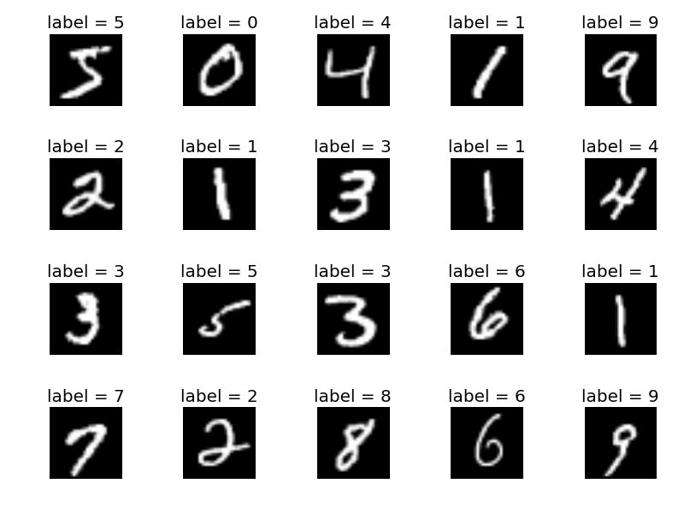
Initial Data Analysis:
- 70,000 examples of hand written digits. 60,000 in the training set, and 10,000 in the test set.
- The shape of the images is 28x28 gray scale
- 10 classes. Digits from 0 to 10
- The examples are almost equally distributed between the 10 classes
- Testing set is similar to the training set

Implementing the network from table 1:
1. Set up the data for training and testing:
(x_train, y_train), (x_test, y_test) = mnist.load_data()

2. Normalize the pixel intensity from -0.5 to 0.5:
pixel_mean = x_train.mean(axis=0)
pixel_std = x_train.std(axis=0) + 1e-10
x_train = (x_train - pixel_mean) / pixel_std
x_test = (x_test - pixel_mean) / pixel_std

3. One hot encode the labels:
y_train = keras.utils.to_categorical(y_train, 10)
y_test = keras.utils.to_categorical(y_test, 10)

4. Adding an axis to fit tensorflow input:
x_train = x_train[:,:,:, np.newaxis].astype(np.float32)
x_test = x_test[:,:,:, np.newaxis].astype(np.float32)

5. Splitting up the data for training and validation:
indexes = np.arange(training_examples)
np.random.shuffle(indexes)

idx_train = indexes[:int(training_fraction*training_examples)]
idx_val = indexes[int(training_fraction*training_examples):]

x_val = x_train[idx_val]
y_val = y_train[idx_val]

x_train = x_train[idx_train]
y_train = y_train[idx_train]

6. Setting the hyperparameters:
learning_rate = 0.001
lossfunction = keras.losses.categorical_crossentropy
opimize = keras.optimizers.Adam(lr=learning_rate, beta_1=0.9, beta_2=0.999, epsilon=None, decay=0.0, amsgrad=False)
number_of_epochs = 100
batch_size = 128

7. Constructing the model:
model = Sequential()
model.add(Flatten(input_shape=x_train.shape[1:]))
model.add(Dense(128, activation = "relu"))
model.add(Dense(10, activation = "softmax"))

model.compile(loss = lossfunction, optimizer = opimize, metrics = ['accuracy'])

8. Training the model:
model.fit(x_train, y_train,
batch_size = batch_size,
epochs = number_of_epochs,
verbose = 1,
validation_data = (x_val, y_val))

This gave test accuracy of 97.28%
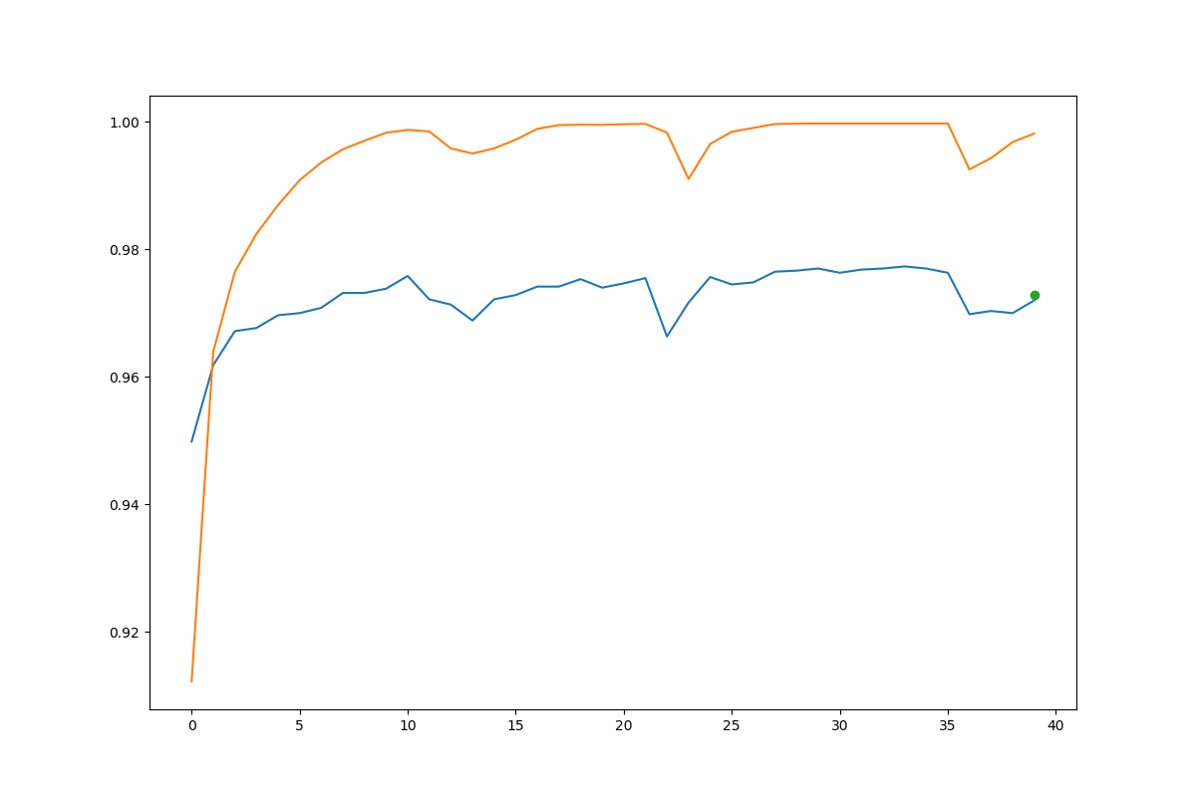
Finding the simplest fully-connected network that achieves more than 95% on the mnist test-set:
learning_rate = 0.001
lossfunction = keras.losses.categorical_crossentropy
opimize = keras.optimizers.Adam(lr=learning_rate, beta_1=0.9, beta_2=0.999, epsilon=None, decay=1e-6, amsgrad=False)
number_of_epochs = 120
batch_size = 32

#Construct model
model = Sequential()
model.add(Flatten(input_shape=x_train.shape[1:]))
model.add(Dropout(0.18))
model.add(Dense(12, activation = "relu"))
model.add(Dense(10, activation = "softmax"))

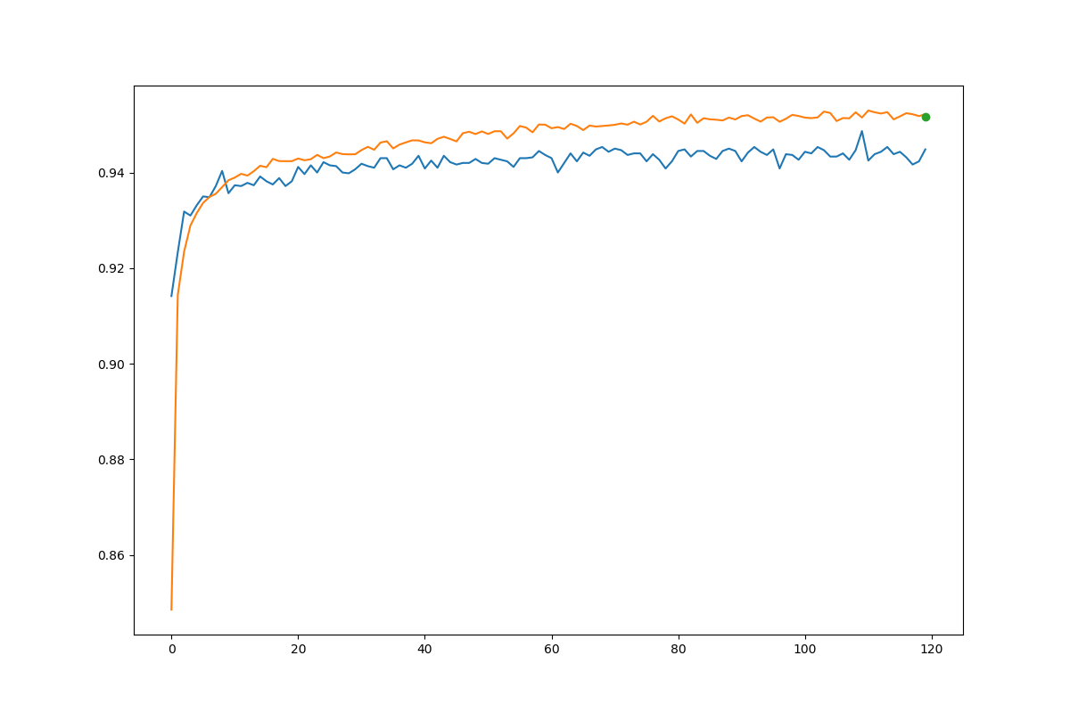
With 9,550 params, this gave test accuracy of 95.15 %
Finding the model that reaches the highest test accuracy on MNIST test-set:
learning_rate = 0.001
lossfunction = keras.losses.categorical_crossentropy
opimize=keras.optimizers.Adam(lr=learning_rate,beta_1=0.9,beta_2=0.999,epsilon=None, decay=1e-6, amsgrad=False)
number_of_epochs = 18
batch_size = 256

model = Sequential()
model.add(Flatten(input_shape=x_train.shape[1:]))
model.add(Dropout(0.3))
model.add(Dense(784, activation = "relu"))
model.add(Dense(784*2, activation = "relu"))
model.add(Dense(784, activation = "relu"))
model.add(Dropout(0.15))
model.add(Dense(256, activation = "relu"))
model.add(Dense(128, activation = "relu"))
model.add(Dense(28, activation = "relu"))
model.add(Dense(10, activation = "softmax")

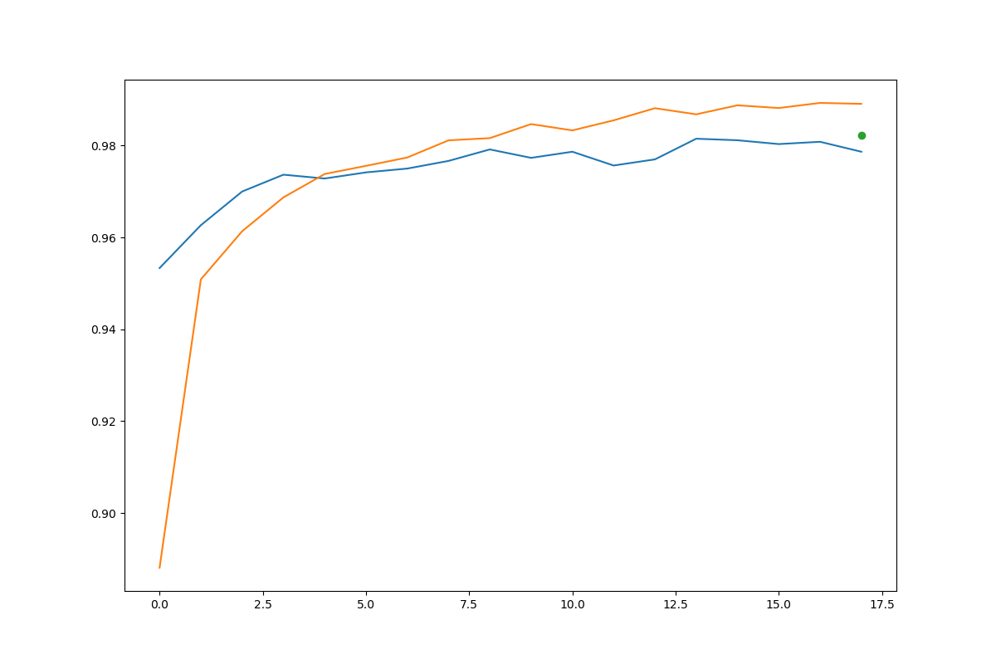
This network achieved 98.2 % after 18 epochs
From previous experience with MNIST data set, adam optimizer, and relu activation seemed to work good on this set. I tried some other optimizers and activation functions, but those seemed to be the best.
My plan was making a pretty deep net that was able to make the model learn detailed and abstract relationships within the data. The problem with this approach was overfitting. The training accuracy became almost 100% while the test accuracy decreased in the last epochs.
I added dropouts after the input layer to make the inputs vary from each time the model saw the same example. With dropout of 0.3, 30% of the pixels in the input becomes black. This way instead of learning the inputs and targets for specific images, the model generalized more. Added another dropout in middle just for extra variance.
Cifar10
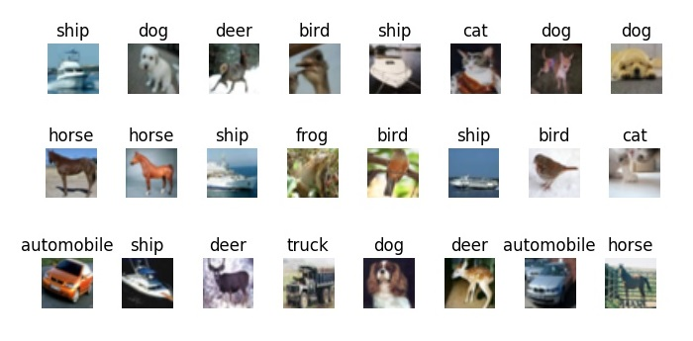
Initial Data Analysis:
- 60,000 examples of color images. 50,000 in the training set, and 10,000 in the test set
- The shape of the image is 32x32 3 channels rgb
- 10 classes: airplane, automobile, bird, cat, deer, dog, frog, horse, ship, truck
- Examples as evenly distributed. 6000 examples from each class.
- Testing set is similar to the training set

Using the same Network as my best model for mnist:
This gave a final test accuracy of 51.1%

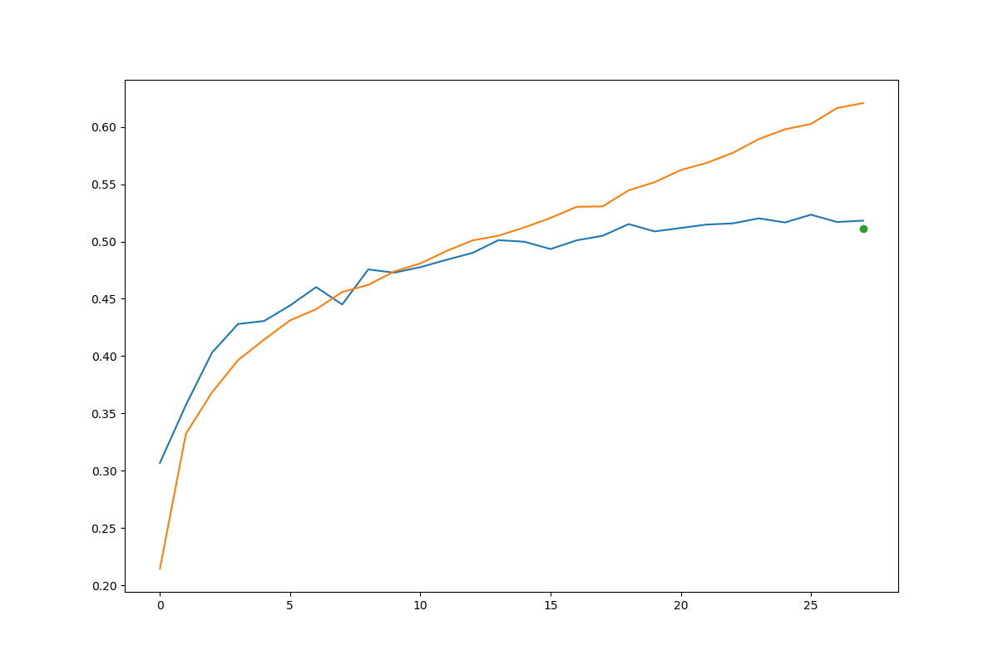
Network from table 2:

learning_rate = 0.001
lossfunction = keras.losses.categorical_crossentropy
optimize = keras.optimizers.Adam(lr=learning_rate, beta_1=0.9, beta_2=0.999, epsilon=None, decay=0.0, amsgrad=False)
number_of_epochs = 12
batch_size = 64

model = Sequential()
model.add(Conv2D(32, (3, 3), input_shape=x_train.shape[1:]))
model.add(Activation('relu'))
model.add(MaxPooling2D(pool_size=(2, 2)))
model.add(Conv2D(64, (3, 3)))
model.add(Activation('relu'))
model.add(MaxPooling2D(pool_size=(2, 2)))
model.add(Conv2D(128, (3, 3)))
model.add(Activation('relu'))
model.add(MaxPooling2D(pool_size=(2, 2)))
model.add(Flatten())

model.add(Dense(128))
model.add(Activation('relu'))
model.add(Dense(64))
model.add(Activation('relu'))
model.add(Dense(10))
model.add(Activation('softmax'))

This gave 70.8 % test accuracy

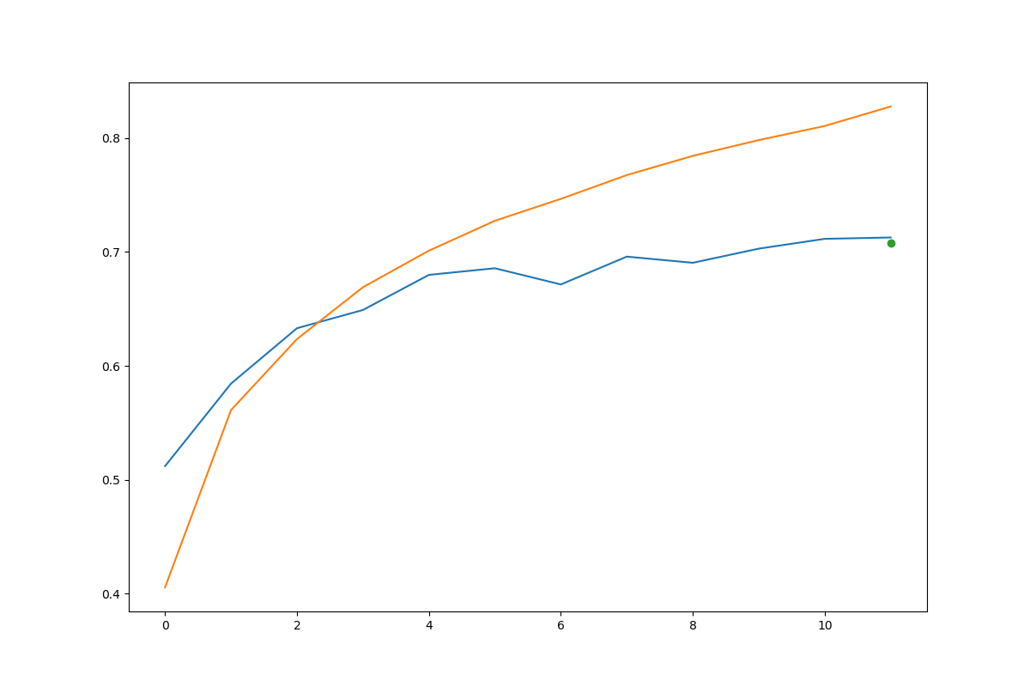

Simplest model above 70%:
learning_rate = 0.001
lossfunction = keras.losses.categorical_crossentropy
optimize = keras.optimizers.Adam(lr=learning_rate, beta_1=0.9, beta_2=0.999, epsilon=None, decay=0.0, amsgrad=False)
number_of_epochs = 80
batch_size = 32

model = Sequential()
model.add(Conv2D(32, (3, 3), input_shape=x_train.shape[1:]))
model.add(Activation('relu'))
model.add(MaxPooling2D(pool_size=(2, 2)))
model.add(BatchNormalization())
model.add(Conv2D(32, (3, 3)))
model.add(Activation('relu'))
model.add(MaxPooling2D(pool_size=(2, 2)))
model.add(BatchNormalization())
model.add(Conv2D(16, (3, 3)))
model.add(Activation('relu'))
model.add(BatchNormalization())
model.add(MaxPooling2D(pool_size=(2, 2)))
model.add(Flatten())
model.add(Dropout(0.2))
model.add(Dense(32))
model.add(Activation('relu'))
model.add(Dropout(0.3))
model.add(Dense(10))
model.add(Activation('softmax'))

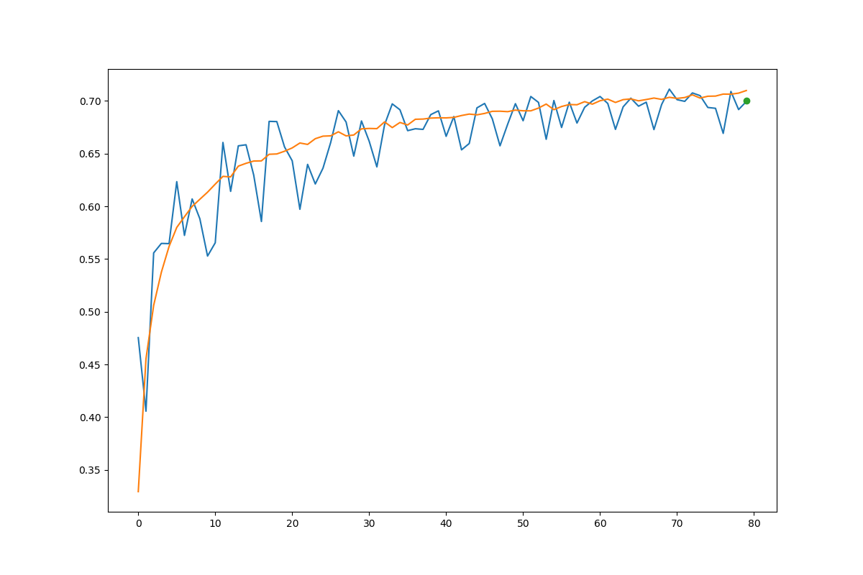
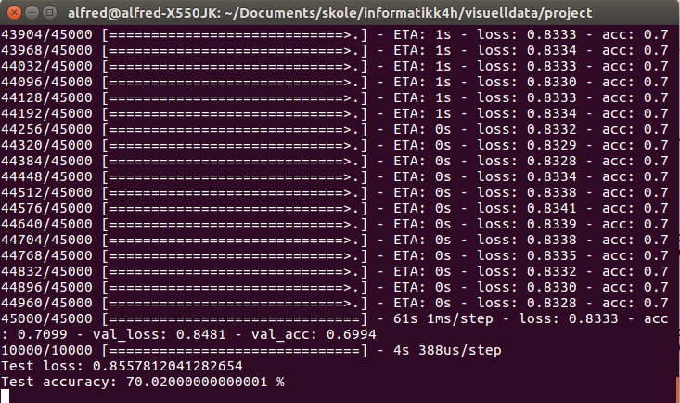
17,498 params
Best cifar10 model:

