TALLINN UNIVERSITY OF TECHNOLOGY
Department of Informatics
Institute of Informatics
Chair of Information Systems

Loan Infosystem project

Andmebaasid I IDU0220
Andmebaaside projekteerimine IDU3381

Student: | Andrei Korsunski 061836  Andrei Andrievski 110040  Anton Vesselov 061902
E-mail: | a_korsunskyy@hotmail.com

Supervisor: | Erki Eessaar

Tallinn
2012
Table of Contents

1 Strategic analysis phase 4
1.1 Overview of the entire system 4
1.1.1 Goals of the organization 4
1.1.2 Goals of the information system 4
1.1.3 Statements that describe the system 4
1.1.4 Main objects 5
1.1.5 Main processes 5
1.1.6 Main events 5
1.1.7 Actors 5
1.1.8 Locations 6
1.1.9 Decomposition of the system 6
1.1.9.1 Areas of competence 6
1.1.9.2 Functional subsystems 6
1.1.9.3 Registers 6
1.2 Preliminary models of the Loan functional subsystem 7
1.2.1 Goals 7
1.2.2 Areas of competence that use the functional subsystem 7
1.2.3 Registers that are used by the functional subsystem 7
1.2.4 Activity diagram of a main process of the functional subsystem 8
1.2.5 Preliminary use case model of the functional subsystem 9
1.2.6 Non-functional requirements 10
1.3 Preliminary models of the Loan register, which is served by the Loan functional subsystem 11
1.3.1 Goals 11
1.3.2 Areas of competence that use the register 11
1.3.3 Functional subsystems that use the register 11
1.3.4 Requirements of information 11
1.3.5 Relationships with other registers 11
1.3.6 Business rules 11
1.3.7 Preliminary conceptual model of the register 12
2 Detailed analysis phase 13
2.1 Detailed analysis of the Loan functional subsystem 13
2.1.1 Use case model 13
2.2 Detailed analysis of the registers that are used by the Loan functional subsystem 16
2.2.1 Conceptual data model 16
2.2.1.1 Entity-relationship diagram 16
2.2.1.2 Definition of entity types 16
2.2.1.3 Definition of attributes 17
2.2.2 Contracts of database operations 20
2.2.3 State diagram of the main object of the register 23
2.3 CRUD matrix 23
2.4 Description of the roles of the information system 23
3 Logical design 24
3.1 Logical design of the registers that are used by the functional subsystem X 24
3.1.1 Logical database schema 24
3.1.1.1 Database diagram 24
4 Statements 24

Autorideklaratsioon

Kinnitan, et olen koostanud antud töö iseseisvalt ning seda ei ole kellegi teise poolt varem hindamiseks/arvestuse saamiseks esitatud. Kõik töö koostamisel kasutatud teiste autorite tööd, olulised seisukohad, kirjandusallikatest ja mujalt pärinevad andmed on töös viidatud.

Andrei Andrievski

Andrei Korsunski

Anton Veselov

Strategic analysis phase

Overview of the entire system
In this part we will preset overview of loan giving system.

Goals of the organization
Main goal of our organization is to give clients a possibility to get loans in fast, convenient and reliable way. Loans are defined as small sum of money given for a short period of time.

Goals of the information system
- Loan registration and issuing process automation
- Statistics gathering for future planning of company policy.
- Removal of human mistakes from loan registration.
- Collection and analysis of clients’ information.
- Give possibility to add new loan offers with the means of technological advantages.

Statements that describe the system
- Client is a user
- Blacklisted client cannot access system
- Client should register himself for future activities.
- Loan can be taken by client.
- Client chooses a loan offer according to availability.
- Client requests a loan.
- Client requests to postpone a loan payback.
- Client pays back a loan.
- Client can have zero or one active loan.
- Client can access his loan history when he is authenticated.
- Postpone loan is active loan.
- Unpaid loan is active loan.
- Pending loan is active loan.
- Pending loan is loan request that is not approved or canceled.
- Loan can have zero or one postpone request.
- CAM is a user
- CAM (Client account manager) checks client data.
- CAM approves client data.
- CAM approves or cancels loan request application
- CAM supervises client’s activity.
- CAM can access client loan history only during making decision on new loan request.
- Team leader analyzes client’s information.
- Team leader make decision whether to give loan to questionable client as an oral advice.
- Team leader organizes CAM work process.
- Team leader make decisions about postponed loan due date.
- Team leader can access client loan history only during making decision on loan postpone request

Main objects
- Loan
- Client
- Employee
- Loan offer
- Clients group

Main processes
- New client registration
- Loan issuance
- Loan payback
- Postpone of a loan
- Client group change

Main events
- Client registers himself in the system
- Client sends loan request application.
- Client sends loan postpone application.
- Client sends loan payback request.
- Client status changes to client_blacklisted.
- Client is assigned to the client group.
- Loan is issued.
- Loan is paid back.
- Loan due date is changed with postpone application approval.
- Loan is sent to debt collection.
- CAM makes decision on client registration application.
- Loan due date has come.
- Client group changed.
- Team decides to create a new loan offer.
- Team leader changes loan offer status to active.
- Decision on loan payback postpone request is made.
- Decision on loan request is made.
- Client choose connection method (SMS, internet)

Actors
- Client
- Client account manager (CAM)
- Team leader

Locations
- Client can make all his actions from any place that has internet connection.
- CAM can make his actions from the office, but if it necessary everything can be done during vacation or being out of the office, using internet.
- Team leader can make his action from his office in the company or also from any place with internet connection.

Decomposition of the system
Lending agency info system.

Areas of competence

Organization internal competences
- CAM competence
- Team leader competence

Organization external competences
- Client competence

Functional subsystems
Main subsystems
- Client registration functional subsystem
- Loan functional subsystem
- Loan offer functional subsystem
- Bank data functional subsystem
- Debt collection functional subsystem
- Statistics gathering functional subsystem

Administrative subsystems
- Employees functional subsystem
- Documents management subsystem
- Equipment subsystem
- Accounting subsystem
- Contracts subsystem

Registers
Main registers
- Clients register
- Loan register
- Loan Offer Register
- Classifier register
- History register

Administrative registers
- Employees register
- User register
- Documents register
- Contracts register
- Equipment register
- Financial register

Preliminary models of the Loan functional subsystem

Goals
- Allow client to see current loans
- Allow client to see available loan offers
- Allow client to send request for a loan
- Allow Team Leader to overview loan offers
- Allow CAM to overview pending loan requests
- Allow CAM to make decision on client loan requests
- Allow Team leader add, edit and remove loan offers
- Allow Team leader to make a decision on pending loan payback postopone requests

Areas of competence that use the functional subsystem
- Client competence
- CAM competence
- Team leader competence

Registers that are used by the functional subsystem
- Clients register
- Loans register
- Employees register
- Classifiers register
- History register
- Loan Offer register

Activity diagram of a main process of the Loan functional subsystem
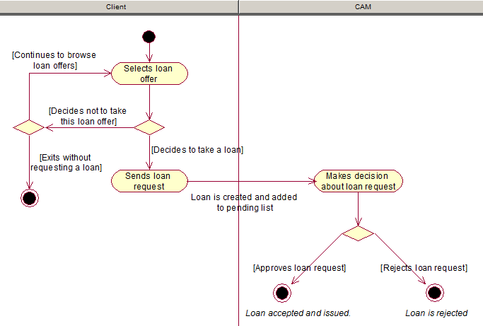
Figure 1 Loan request activity diagram

Preliminary use case model of the functional subsystem
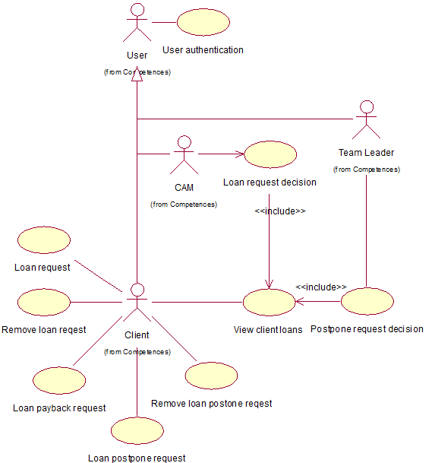
Figure 2 Loan functional subsystem use case model
Use Case: User Autentication
Actors: Client, CAM, Team Leader
Description: Own credentials input and check in database. In case of existence of such user, user is given access to use the system. If user is not found the system access is not given.

Use Case: Loan Request
Actors: Client
Description: Chooses loan from the possible list of loan offers and sends a loan request.

Use Case: Remove Loan request
Actors: Client
Description: If loan request is not yet approved Client can cancel loan request.

Use Case: Loan Payback Request
Actors: Client
Description: When client is ready to pay back the loan he sends application about readiness to pay it back.

Use Case: Loan Postpone Request
Actors: Client
Description: If client wants to postpone loan pay back then he sends a request to postpone the loan.

Use Case: Remove Loan Postpone Request
Actors: Client
Description: If client wants to cancel the request to postpone loan pay back then he cancels it.

Use Case: View Client Loans
Actors: Client, CAM, Team Leader
Description: Allows to view client loans. Possible to view active, paid back, requested loans.
Note: CAM accesses the use case through use case Loan Request Decision, team leader through use case Postpone Request Decision

Use Case: Loan Request Decision
Actors: CAM
Description: Makes a decision for the pending loan request.

Use Case: Postpone Request Decision
Actors: Team Leader
Description: Analyzes Client pay back history, and makes a decision weather to approve loan postpone request application or decline it.

Non-functional requirements
Type | Description of the requirement
server software
development tools
Language
user interface
performance of database operations
Reliability
Backup
Security

Preliminary models of the Loan register, which is served by the Loan functional subsystem

Goals
To hold data about loan that allows completing loans subsystem objectives.

Areas of competence that use the register
- Client competence
- CAM competence
- Team leader competence

Functional subsystems that use the register
- Loan functional subsystem – creates, uses and updates data stored in register
- Statistics gathering functional subsystem – uses data in register

Requirements of information
- List of loans by client.
- List of loans by Loan Status.
- List of loans by loan offer
- Postpone request for specific loan.
- List of loans/postpones approved by employee.

Relationships with other registers
Client register - Client register is connected to loan register through entity Client. The purpose is getting full information about client. Loan is given to specific client.

Employee register - Employee register is connected to loan register through entity Employee. Loan and Postpone Request are approved by specific employee.

History register – History register is connected to loan register through entity Loan History. Changes in loan ere reflected in loan history.

Loan Offer register – Loan Offer register is connected to loan register through entity Loan Offer. Loan is created base on loan offer.

Business rules
Each loan is connected to one or zero postpone requests.
Each loan is connected to one client.
Each loan has one active status.
Each loan is connected to one loan offer.
Each client has to be authenticated in the system to send loan request.
Each client can request to postpone a loan once for each loan.
Each client can have null or one loan in active status loan_requested or loan_approved.
Each postpone request can be deleted by client till the time decision for it is made by Team Leader.
Each loan request can be deleted by client till the time approval decision is made.
Each loan can be connected to zero or one employee.
Client can request to postpone loan pay back date by maximum half of loan offer payback period.
Loan is handed to debt collection after it is not paid back after due date is exceeded in amount of 2 pay back periods but not longer than half a year.
Client rating is increased in case of successful payback by due date according to loan offer.
Client rating is decreased in case of loan successful payback after due date according to loan offer.
Client rating is put to ‘-1’ in case of unsuccessful payback by the time loan is handled to debt collection.
Client rating is decreased in amount corresponding to rating_drop value for specific loan offer in case of payback after due date but before the time loan is handled to debt collection.

Preliminary conceptual model of the register
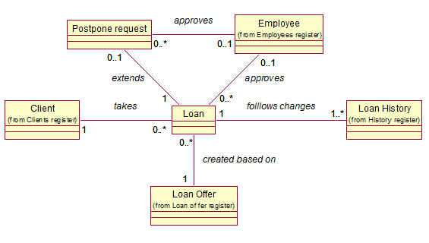
Figure 3 Loan register conceptual model

Detailed analysis phase

Detailed analysis of the Loan functional subsystem

Use case model
Use case: User authentication
Actors: Client, CAM, Team Leader
Sides and their interests: User wants to perform actions in the responsibility scope borders inside system
Triggering event: User wants to log in to system
Preconditions: User is registered in the system
Post conditions: Defined if the user has permission to access the system. User is authenticated and is given opportunity to use the system in his responsibility scope.
Scenario:
- User enters into system.
- System is waiting for credentials input from User.
- User identifies himself (inputting his username and password).
- System checks if user with specified credentials exists in the database and gives the opportunity for User to use the system according responsibility scope.
Extensions:
4a. In case system doesn’t find user with specified credentials, corresponding notification is displayed by the system. Authentication process is aborted.
4b. In case user is Client and status is ‘Client blacklisted’, corresponding notification is displayed by the system. Authentication process is aborted.

Use case: Loan request
Actors: Client
Sides and their interests: Client wants to get a loan to cover his financial needs.
Triggering event: Client wants to get information about possible loans
Preconditions: Client is authenticated by the system and has opportunity to send loan request.
Post conditions: Sent request is waiting for CAM’s decision, whether to approve or cancel loan application.
Scenario:
- Client sends request for available loan offers.
- System gives a list of available loan offers (OP 3.1).
- Client selects a loan offer from available list and forms a request for a loan.
- System asks Client to check correctness of his request.
- Client approves correctness of request and sends loan request application with chosen loan offer.
- System registers new loan request in the database for the client (OP 1.1).
Extensions:
3a. If client doesn’t find loan offer he is interested in, then he exits the process.
5a. Client doesn’t approve request.
- System goes to step 2.

Use case: Remove Loan Request
Actors: Client
Sides and their interests: Client wants to cancel requested loan application.
Triggering event: Client wants to view his requested loan application.
Preconditions:
- Client is authenticated by the system.
- Client has loan request application that is not yet approved.
Post conditions: Loan request application is canceled
Scenario:
- Client sends request for his pending loan requests.
- System gives a loan requests available for cancellation (OP 1.7).
- Client chooses to cancel loan request.
- System asks Client’s confirmation to cancel loan request.
- Client approves loan request cancellation.
- System cancels the loan request for the client (OP 1.3).
Extensions:
3a. Client doesn’t find any loan request that he wants to cancel and exits the process.
5a. Client doesn’t approve loan request cancellation.
- System goes to step 2.

Use case: Loan Payback Request
Actors: Client
Sides and their interests: Client wants to pay back the loan as soon as possible.
Triggering event: Client wants to pay back the loan.
Preconditions:
- Client is authenticated in the system.
- Client has an active loan.
Post conditions:
- A positive answer is received from money transfer subsystem.
- Loan data is updated.
Scenario:
- Client sends request for unpaid loan.
- System displays active loan. (OP 1.7)
- Client sends a request to pay back the loan.
- System asks Client to check correctness of request.
- Client approves loan request payback.
- System sends request to Bank data subsystem and on response updates loan data (OP 1.4).
Extensions:
3a. Client doesn’t send request to pay back the loan and exists process.
5a. Client doesn’t approve loan payback.
- System goes to step 2.
6a. System receives negative answer from money transfer subsystem. Notification displayed. Process aborted.

Use case: Loan Postpone Request
Actors: Client
Sides and their interests: Client wants to postpone loan pay back due to financial difficulties.
Triggering event: Client wants to postpone loan pay back.
Preconditions:
- Client is authenticated in the system.
- Client has loan that is not paid back.
- Loan due date is not passed.
- No accepted postpone request for this loan.
Post conditions: Loan postpone request created.
Scenario:
- Client asks for loans that can be postponed.
- System displays list of loans that can be postponed. (OP 1.7)
- Client chooses amount of days to postpone payback and sends postpone request.
- System asks for approval of postpone request.
- Client approves his intention to postpone loan request.
- System creates loan postpone request (OP 2.1).
Extensions:
3a. Client exits process
5a. Client cancels his intentions to request loan payback postpone.
- System goes to step 2.

Use case: Remove Loan Postpone Request
Actors: Client
Sides and their interests: Client wants to cancel loan postpone request due to financial circumstances or due to made mistake.
Triggering event: Client wants to remove loan postpone request.
Preconditions:
- Client is authenticated in the system.
- Client has loan with postpone request registered and not yet approved
Post conditions: Loan postpone request removed.
Scenario:
- Client asks for a loan with pending postpone request.
- System displays active loan. (OP 1.7)
- Client chooses to remove postpone request.
- System asks client to check correctness.
- Client approves his intention to remove postpone loan request.
- System removes loan postpone request (OP 2.2).
Extensions:
3a. Client exits process
5a. Client cancels his intention to remove postpone request.
- System goes to step 2.

Use case: View client loans
Actors: User (Client, CAM or Team Leader)
Sides and their interests: Client wants to view his loans history. CAM wants to view client loans to make decision on loan request. Team Leader wants to view client loans to make decision on loan postpone request
Triggering event: Client chooses to view his loans. CAM chooses to view client loan information. Team Leader chooses to view client loan information.
Preconditions:
- User is authenticated in the system.

  - Client has loans that are connected with him.
  - CAM: Client has Loan request that has not been approved.
  - Team Leader: Client has Loan postpone request that has not been approved.
Post conditions: Client loans history is shown to user
Scenario:
- User chooses to view loans history.
- System shows a filter form where user can specify search criteria (from, to, sum, status).
- User fills the search form and chooses to show results.
- System shows loans according to search criteria. (OP 1.2).
Extensions:
3a. No results for specified search criteria. Corresponding notification is shown to user.

Use case: Loans requests decision
Actors: CAM
Sides and their interests: CAM wants to make decision to approve or cancel client’s loan request.
Triggering event: CAM chooses to approve or cancel client loan request.
Preconditions:
- CAM is authenticated in the system.
- Decision for loan request is not made.
- There are not approved loan requests from clients.
Post conditions: Decision for loan request is made.
Scenario:
- CAM chooses to view pending loan requests.
- System shows a list of pending loan requests and search form which allows filtering loan requests (time request made, loan payback period, loan request sum, client group).
- CAM fills search form and chooses to show results.
- System shows a list of pending loan requests according to search filter. (OP 1.6)
- CAM chooses to approve loan request decision.
- System asks to approve made decision.
- CAM approves loan request decision.
- System notifies CAM about made decision for loan request application (OP 1.5).
Extensions:
4a. No results for specified search criteria. Corresponding notification is shown to user
5a. CAM chooses to reject loan request application.
- System asks to approve made decision.
- CAM approves loan request cancellation.
- System notifies CAM about made decision for loan request application. (OP 1.5)
5b. CAM executes ‘view client loans’ use case.
- After exiting ‘view client loans’ use case system goes to
7a. CAM doesn’t accept decision approval.
- System goes to step 2.

Use case: Postpone request decision
Actors: Team Leader
Sides and their interests: Team leader wants to make a decision for postpone request application to take into account client’s interests and company’s interests.
Triggering event: Team leader wants to make a decision for postpone request application.
Preconditions:
- Team Leader is authenticated in the system.
- There exists not canceled loan postpone request in the database.
Post conditions: Decision about loan postpone request applications is made.
Scenario:
- Team Leader chooses to view postpone request applications.
- System asks to specify search criteria.
- Team Leader specifies search criteria for the system to filter results.
- System displays loan postpone applications according to applied filter. (OP 2.4)
- Team Leader chooses to approve loan postpone request application.
- System asks to approve made decision.
- Team Leader approves made decision.
- System notifies Team Leader about made decision for loan postpone request application and executes operations accordingly (OP 2.3).
Extensions:
4a. No results for specified search criteria. Corresponding notification is shown to user.
5a. Team Leader chooses to reject loan postpone request application
- System asks to approve made decision.
- Team Leader approves loan postpone rejection.
- System notifies Team Leader about loan postpone request rejection and executes operations accordingly (OP 2.3).
7a. Team Leader doesn’t approve decision
- System goes to step 4.

Detailed analysis of the registers that are used by the Loan functional subsystem

Conceptual data model

Entity-relationship diagram
This entity type marked in red is the main object of register (in this case main object of loan register).
This entity type marked in yellow is not main objects of register (in this case postpone request and loan offer register).
This entity type marked in green is objects of other registers (that are needed in loan functional subsystem).
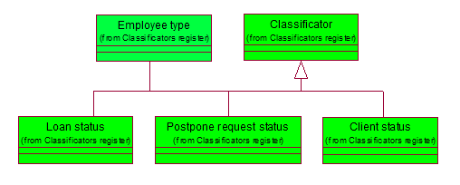
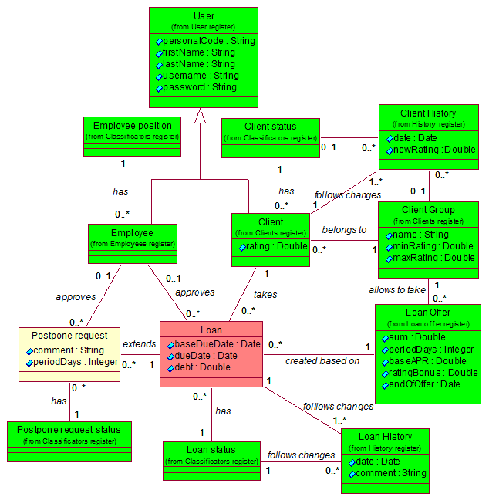
Figure 4 Extended loan register entity-relationship diagram

Definition of entity types
Name of the  entity type (aliases) | Register, where the entity type belongs to | Definition
User | User register | Person who is registered in the system, taking part in the loan info system processes workflow.
Employee | Employee register | Person who is working in the company. In this subsystem relevant employees are CAM and Team Leader.
Employee position | Classifiers | Classifier which describes employee functions in the system
Client | Clients register | A person who takes and pays back the loan.
Clients status | Classifiers | Classifier which describes client opportunities in the system(e.g. whether client can take a loan or cannot)
Client History | History register | Entity type which contains data about changes to client (e.g. rating, status, group in which client belongs)
Client Group | Clients register | Entity that specifies boundaries of the client grouping.
Loan Offer | Loan register | Entity type which determine loan characteristics (e.g. loan sum, payback date)
Loan | Loan register | Entity type which contains data about the taken loan.
Loan Status | Classifiers | Loan Status name. Loan Status contains all possible statuses for the loan.
Loan History | History register | Entity type which contains data on the Loan Statuses changes (e.g. When loan was issued and paid back)
Postpone request | Loan register | Entity type which contains data about the possibility to postpone loan payback date
Postpone request status | Classifiers | Classifier which contains all possible postpone request statuses

Definition of attributes
Name of the  entity type | Name of the attribute | Definition of the attribute | Sample value
User | personalCode | Personal of the registered person  {String. Personal code consists of 11 digits. First digit is between 3 and 6. Forth digit is 0 or 1. Sixth digit is between 0 and 3.} | 38706260385
User | firstName | User’s first name  {String. First name cannot be empty string or consist only of whitespaces. Can contain only letters, whitespaces and hyphens. First name begins with capital letter, others are lowercase letters. If person has more than one first name they are separated with hyphens. Every first name starts with capital letter.} | Andrei
User | lastName | User’s last name  {String. Last name cannot be empty string or consist only of whitespaces. Can contain only letters, whitespaces and hyphens. Last name begins with capital letter, others are lowercase letters. If person has more than one last name they are separated with hyphens. Every last name starts with capital letter.} | Korsunski
User | username | User’s name in the system  {String. Cannot be empty. Can contain letters, digits, dashes} | Ondriy
User | password | User’s password in the system  {String. Cannot be empty. Can contain letters, digits, dashes, whitespaces} | OND123
Client | rating | Clients rating is the numeric value that represents the dependence between taken loans and paid back loans of the client  {Can be between -200 and 1000} | 11.15
Client History | date | Represents the event time  {Can be between 01/01/2011 and 31/12/2050} | 16/06/2011 15:30:02
Client History | newRating | Client rating after change.  {Numeric value. Can be between -200 and 1000} | 16.20
Loan | dueDate | Last date when the loan is supposed to be paid back  {Can be between 01/01/2011 and 31/12/2050} | 16/07/2011 15:30:02
Loan | baseDueDate | Date when the loan was supposed to be paid back initially  {Can be between 01/01/2011 and 31/12/2050} | 16/06/2011 15:30:02
Loan | debt | Amount of money in Euros for a client to payback including additional fees based on APR  {Positive number no less than 10} | 115
Loan | comment | Optional comment describing decision  {String. Can be empty} | Not paid previous loan in time
Loan History | date | Date of Loan Status change  {Can be between 01/01/2011 and 31/12/2050} | 16/06/2011 15:30:02
Postpone request | periodDays | Changed payback date after postpone request approval  {Integer value. Between 1 and half of the corresponding Loan Offer periodDays} | 5
Postpone request | comment | Optional comment by Team Leader which describes reason for a decision  {String. Can be empty} | Not paid previous loan in time
Loan Offer | sum | Initial sum in Euros that is to be paid back without additional fees  {Positive number no less than 10} | 100
Loan Offer | periodDays | Number of days after which loan is to be paid back initially after it has been issued  {Positive number no less than 7} | 7
Loan Offer | baseAPR | Initial APR rate in percents  {Number between 0 (excluding) and 100} | 5
Loan Offer | ratingBonus | Number which is added to the client rating in case of successful payback in nominal period  {Positive number no less than 1} | 2
Loan Offer | endOfOffer | Date when loan offer expires  {Can be between 01/01/2011 and 31/12/2050} | 17/06/2011
Client Group | name | Name of the client group  {String. Cannot be empty. Can contain letters and spaces} | Gold Client
Client Group | minRating | Borderline rating, in case client rating goes below, client leaves this client group and is transferred to another client group.  {Decimal value. Can be between -200 and 1000} | 22.00
Client Group | maxRating | Borderline rating, in case client rating goes above, client leaves this client group and is transferred to another client group.  {Decimal value. Can be between -200 and 1000} | 45.00
Classifier | ID | Reporting the value of the classification code. This code can be used to represent the value in other table. | 1
Classifier | name | Name of the classificatory value. This cannot be blank string or contain only whitespaces.  {String. Cannot be empty. Cannot consist of only whitespaces} | Pending
Classifier | description | Description of the classificatory value. This cannot be blank string or contain only whitespaces.  {String. Cannot be empty. Cannot consist of only whitespaces} | Postpone request awaiting decision

Contracts of database operations
System registers new loan request in the database for the client.

OP 1.1 Registration of new loan request (client_id, loan_offer_id)
- Preconditions:
  - Client sends new loan request application
  - System assures that there are no active loans connected with the client.
- Post conditions
  - New Loan is created
  - Loan.debt = Loan Offer.Sum * (1 + Loan Offer.APR* Loan Offer.periodDays/(100 * 365))
  - Loan.baseDueDate = current date + Loan Offer.periodDays
  - Loan.DueDate = Loan.baseDueDate
  - Loan is connected to Loan Offer which was accepted.
  - Loan is connected to Loan Status ’Pending’.
  - Loan is connected to Client who requested loan.
  - New Loan History is created
  - Loan History is connected to Loan
  - Loan History is connected to Loan Status ’Pending’.
  - Loan History.date = timestamp when loan request sent

Op 1.3 Loan request cancellation (loan_id)
- Preconditions:
  - Loan is connected to Loan Status ’Pending’
- Post conditions:
  - Loan History connected to Loan is deleted.
  - Loan is deleted

Op 1.4 Loan payback (loan_id)
- Preconditions:
  - Loan is connected to Loan Status ‘Issued’, ’Postponed’, or ’Overdue’
  - Positive answer about money transfer is received from bank data validation subsystem
- Post conditions:
  - Loan is connected to Loan Status with name ’Payed Back’
  - New Loan History is created
  - New connection is created between Loan History and Loan that is selected to payback
  - Loan History is connected to Loan Status ’Payed Back’
  - Loan History.date = timestamp when loan is paid back.
  - Client.userRating is changed according to Loan Offer.rating_bonus (Loan Offer which is connected with specific Loan) according to bussines rules
  - New Client History is created
  - Client History is connected to Client
  - Client History.date = current timestamp
  - Client History.newRating = Client.userRating
  - If Client.userRating < Client Group.minRating or Client.userRating > Client Group.maxRating:
    - Client is connected to Client Group that correspondes to new userRating
    - Client History is connected to the same Client Group as Client

OP 1.5 Loan request decision making (loan_id, employee_id, loan_decision, comment)
- Preconditions
  - Loan is connected to Loan Status ’Pending’
- Post conditions
  - Loan is connected to Employee
  - Loan.comment = comment
  - New Loan History is created
  - Loan History is connected to Loan
  - Loan History.date = current timestamp
  - If loan_decision is positive:
    - Loan is connected to Loan Status’Issued’
    - Loan Hystory is connected to Loan Status ’Issued’
  - If loan_decision is negative:
    - Loan is connected to Loan Status ‘Rejected’
    - Loan Hystory is connected to Loan Status’Rejected’

OP 2.1 Loan postpone request application creation (loan_id, period).
- Preconditions:
  - Loan is connected to Loan Status “pending”
  - Loan.baseDueDate - 12 hours >= current timestamp
- Post conditions:
  - New Postpone request is created.
  - Postpone request is connected to Postpone request status ’Requested’
  - Postpone request.periodDays = period
  - Postpone request is connected to Loan
  - Loan is connected to Loan Status ’Postpone requested’
  - New loan_history is created.
  - Loan History.date = current timestamp
  - Loan History is connected to Loan
  - Loan History is connected to Loan Status ’Postpone requested’

OP 2.2 Loan postpone request removal (loan_id)
- Preconditions
  - Loan is connected to Loan Status ’Postpone requested’
  - Postpone request connected to Loan and connected to Postpone request status ’Requested’ exists
- Post conditions
  - Postpone request is connected to Postpone request status ’Client cancelled’
  - New Loan History is created.
  - Loan History.date = current timestamp
  - Loan History is connected to Loan Status ’Issued’

OP 2.3 Loan postpone decision making (loan_id, employee_id, postpone_decision, comment)
- Preconditions
  - Loan is connected to Loan Status ’Postpone requested’
  - Postpone request connected to Loan and connected to Postpone request status ’Requested’ exists
- Post conditions
  - New Loan History is created
  - Loan History is connected to Loan
  - Loan History.date = current timestamp
  - Postpone request.comment = comment
  - Postpone request is connected to Employee
  - If postpone_decision is positive:
    - Postpone request is connected to Postpone request status ’Accepted’
    - Loan is connected to Loan Status ’Postponed’
    - Loan History is connected to Loan Status ’Postponed’
    - Loan.dueDate = Loan.baseDueDate + Postpone request.periodDays
    - Loan.debt = Loan.debt + Loan Offer.sum * Loan Offer.baseAPR * Postpone request.periodDays/(100*365) [Loan Offer to which Loan is connected]
  - If postpone_decision is negative:
    - Postpone request is connected to Postpone request status ’Rejected’
    - Loan is connected to Loan Status ’Issued’
    - Loan History is connected to Loan Status ’Issued’

State diagram of the main object of the register
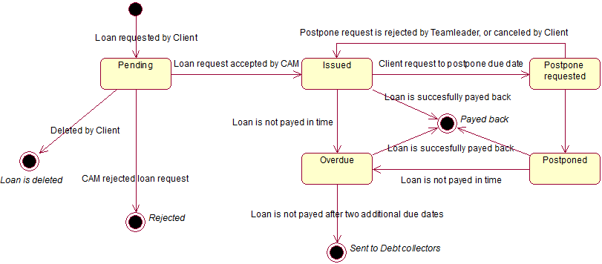
Figure 5 Loan object state diargram

CRUD matrix
Use case | 1 | 2 | 3 | 4 | 5 | 6 | 7 | 8 | 9 | Total
Entity type
User | R |  |  |  |  |  |  |  |  | R
Client | R |  |  | RU |  |  | R | R | R | RU
Client status | R |  |  | R |  |  | R | R | R | R
Client History |  |  |  | C |  |  |  | R | R | CR
Loan |  | C | RD | RU | RU | RU | R | RU | RU | CRUD
Loan Status |  | R | R | R | R | R | R | R |  | R
Loan History |  | C | RD | C | C | C | R | C | C | CRD
Postpone request |  |  |  |  | C | RU | R |  | RU | CRU
Postpone request status |  |  |  |  | R | R | R |  | R | R
Loan Offer |  | R |  | R |  |  | R |  | R | R
Client Group |  | R |  | R |  |  |  |  |  | R
Employee | R |  |  |  |  |  |  |  |  | R
Employee type | R |  |  |  |  |  |  |  |  | R

List of use case

- User authentication
- Loan request
- Remove Loan Request
- Loan Payback Request
- Loan Postpone Request
- Remove Loan Postpone Request
- View Client Loans
- Loan Request Decision
- Postpone Request Decision

Description of the roles of the information system
Role name | Description
Client | Person who takes loans
CAM | Employee who, in the subsystem scope, is responsible for make decision on the loan requests
Team Leader | Employee who, in the subsystem scope, is responsible for make decision on the postpone requests

Logical design

Logical design of the registers that are used by the functional subsystem X

Logical database schema

Database diagram
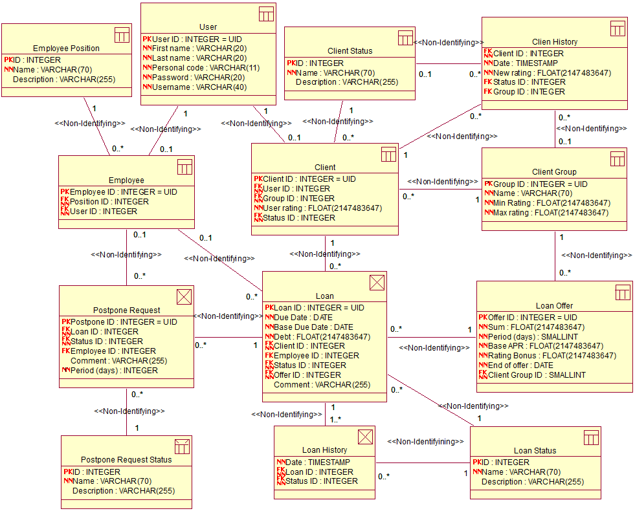
Figure 6 Database schema

Statements
CREATE TABLE client (
client_id INTEGER NOT NULL,
user_id INTEGER NOT NULL,
group_id INTEGER NOT NULL,
rating FLOAT ( 2147483647 ) NOT NULL,
status_id INTEGER NOT NULL,
CONSTRAINT PK_Client_ID PRIMARY KEY (client_id),
CONSTRAINT TC_Client_ID UNIQUE (client_id),
CONSTRAINT TC_Client_User_ID UNIQUE (user_id),
CONSTRAINT FK_Client_Status_ID FOREIGN KEY (status_id) REFERENCES client_status (id) ON DELETE NO ACTION ON UPDATE NO ACTION,
CONSTRAINT FK_Client_Group_ID FOREIGN KEY (group_id) REFERENCES cient_group (group_id) ON DELETE NO ACTION ON UPDATE NO ACTION,
CONSTRAINT FK_Client_User_ID FOREIGN KEY (user_id) REFERENCES user (user_id) ON DELETE NO ACTION ON UPDATE NO ACTION
);

CREATE TABLE postpone_request (
postpone_id INTEGER NOT NULL,
loan_id INTEGER NOT NULL,
status_id INTEGER NOT NULL,
Employee_ID INTEGER,
comment VARCHAR ( 255 ),
period_days INTEGER NOT NULL,
CONSTRAINT TC_Postpone_Request_ID UNIQUE (postpone_id),
CONSTRAINT PK_Postpone_Request_ID PRIMARY KEY (postpone_id),
CONSTRAINT FK_Postpone_Request_Loan_ID FOREIGN KEY (loan_id) REFERENCES loan (loan_id) ON DELETE NO ACTION ON UPDATE NO ACTION,
CONSTRAINT FK_Postpone_Request_Employee_ID FOREIGN KEY (Employee_ID) REFERENCES employee (emloyee_id) ON DELETE NO ACTION ON UPDATE NO ACTION,
CONSTRAINT FK_Postpone_Request_Status_ID FOREIGN KEY (status_id) REFERENCES postpone_request_status (id) ON DELETE NO ACTION ON UPDATE NO ACTION
);

CREATE TABLE loan (
loan_id INTEGER NOT NULL,
due_date DATE NOT NULL,
base_due_date DATE NOT NULL,
debt FLOAT ( 2147483647 ) NOT NULL,
client_id INTEGER NOT NULL,
employee_id INTEGER,
status_id INTEGER NOT NULL,
offer_id INTEGER NOT NULL,
comment VARCHAR ( 255 ) NOT NULL,
CONSTRAINT TC_Loan_ID UNIQUE (loan_id),
CONSTRAINT PK_Loan_ID PRIMARY KEY (loan_id),
CONSTRAINT FK_Loan_Status_ID FOREIGN KEY (status_id) REFERENCES loan_status (id) ON DELETE NO ACTION ON UPDATE NO ACTION,
CONSTRAINT FK_Loan_Employee_ID FOREIGN KEY (employee_id) REFERENCES employee (emloyee_id) ON DELETE NO ACTION ON UPDATE NO ACTION,
CONSTRAINT FK_Loan_Client_ID FOREIGN KEY (client_id) REFERENCES client (client_id) ON DELETE NO ACTION ON UPDATE NO ACTION,
CONSTRAINT FK_Loan_Loan_Offer_ID FOREIGN KEY (offer_id) REFERENCES loan_offer (offer_id) ON DELETE NO ACTION ON UPDATE NO ACTION
);

CREATE TABLE employee_position (
id INTEGER NOT NULL,
name VARCHAR ( 70 ) NOT NULL,
description VARCHAR ( 255 ),
CONSTRAINT TC_Position_Name UNIQUE (name),
CONSTRAINT TC_Position_ID UNIQUE (id),
CONSTRAINT PK_Position_ID PRIMARY KEY (id)
);

CREATE TABLE loan_status (
id INTEGER NOT NULL,
name VARCHAR ( 70 ) NOT NULL,
description VARCHAR ( 255 ),
CONSTRAINT TC_Loan_Status_Name UNIQUE (name),
CONSTRAINT PK_Loan_Status_ID PRIMARY KEY (id),
CONSTRAINT TC_Loan_Status_ID UNIQUE (id)
);

CREATE TABLE loan_history (
date TIMESTAMP NOT NULL,
loan_id INTEGER NOT NULL,
status_id INTEGER NOT NULL,
CONSTRAINT FK_Loan_History_Status_ID FOREIGN KEY (status_id) REFERENCES loan_status (id) ON DELETE NO ACTION ON UPDATE NO ACTION,
CONSTRAINT FK_Loan_History_Loan_ID FOREIGN KEY (loan_id) REFERENCES loan (loan_id) ON DELETE NO ACTION ON UPDATE NO ACTION
);

CREATE TABLE user (
user_id INTEGER NOT NULL,
first_name VARCHAR ( 20 ) NOT NULL,
last_name VARCHAR ( 20 ) NOT NULL,
pers_code VARCHAR ( 11 ) NOT NULL,
password VARCHAR ( 20 ) NOT NULL,
username VARCHAR ( 40 ) NOT NULL,
CONSTRAINT TC_User_ID UNIQUE (user_id),
CONSTRAINT PK_User_ID PRIMARY KEY (user_id),
CONSTRAINT TC_User_Code UNIQUE (pers_code)
);

CREATE TABLE client_status (
id INTEGER NOT NULL,
name VARCHAR ( 70 ) NOT NULL,
description VARCHAR ( 255 ),
CONSTRAINT TC_Client_Status_ID UNIQUE (id),
CONSTRAINT TC_Client_Status_Name UNIQUE (name),
CONSTRAINT PK_Client_Status_ID PRIMARY KEY (id)
);

CREATE TABLE cient_group (
group_id INTEGER NOT NULL,
name VARCHAR ( 70 ) NOT NULL,
min_rating FLOAT ( 2147483647 ) NOT NULL,
max_rating FLOAT ( 2147483647 ) NOT NULL,
CONSTRAINT TC_Client_Group_Name UNIQUE (name),
CONSTRAINT TC_Client_Group_ID UNIQUE (group_id),
CONSTRAINT PK_Client_Group_ID PRIMARY KEY (group_id)
);

CREATE TABLE loan_offer (
offer_id INTEGER NOT NULL,
sum FLOAT ( 2147483647 ) NOT NULL,
period SMALLINT NOT NULL,
apr FLOAT ( 2147483647 ) NOT NULL,
rating_bonus FLOAT ( 2147483647 ) NOT NULL,
offer_end DATE NOT NULL,
group_id INTEGER NOT NULL,
CONSTRAINT TC_Loan_Offer_ID UNIQUE (offer_id),
CONSTRAINT PK_Loan_Offer_ID PRIMARY KEY (offer_id),
CONSTRAINT FK_Loan_Offer_Client_Group_ID FOREIGN KEY (group_id) REFERENCES cient_group (group_id) ON DELETE NO ACTION ON UPDATE NO ACTION
);

CREATE TABLE postpone_request_status (
id INTEGER NOT NULL,
name VARCHAR ( 70 ) NOT NULL,
description VARCHAR ( 255 ),
CONSTRAINT PK_Postpone_Request_Status_ID PRIMARY KEY (id),
CONSTRAINT TC_Postpone_Request_Status_ID UNIQUE (id),
CONSTRAINT TC_Postpone_Request_Status_Name UNIQUE (name)
);

CREATE TABLE client_history (
client_id INTEGER NOT NULL,
date TIMESTAMP NOT NULL,
new_rating FLOAT ( 2147483647 ) NOT NULL,
status_id INTEGER,
group_id INTEGER,
CONSTRAINT FK_Client_History_Client_ID FOREIGN KEY (client_id) REFERENCES client (client_id) ON DELETE NO ACTION ON UPDATE NO ACTION,
CONSTRAINT FK_Client_History_Status_ID FOREIGN KEY (status_id) REFERENCES client_status (id) ON DELETE NO ACTION ON UPDATE NO ACTION,
CONSTRAINT FK_Client_History_Group_ID FOREIGN KEY (group_id) REFERENCES cient_group (group_id) ON DELETE NO ACTION ON UPDATE NO ACTION
);

CREATE TABLE employee (
emloyee_id INTEGER NOT NULL,
position_id INTEGER NOT NULL,
user_id INTEGER NOT NULL,
CONSTRAINT TC_Employee_User_ID UNIQUE (user_id),
CONSTRAINT PK_Employee_ID PRIMARY KEY (emloyee_id),
CONSTRAINT TC_Employee_ID UNIQUE (emloyee_id),
CONSTRAINT FK_Employee_Position_ID FOREIGN KEY (position_id) REFERENCES employee_position (id) ON DELETE NO ACTION ON UPDATE NO ACTION,
CONSTRAINT FK_Employee_User_ID FOREIGN KEY (user_id) REFERENCES user (user_id) ON DELETE NO ACTION ON UPDATE NO ACTION
);

