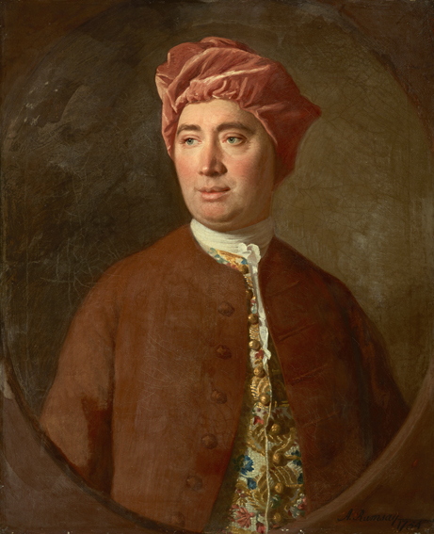
David Hume - expressions
David Hume: "The rules of morality are not the conclusion of our reason."
David Hume: "Beauty in things exists in the mind which contemplates them."
David Hume: "Generally speaking, the errors in religion are dangerous; those in philosophy only ridiculous."
David Hume: "A wise man proportions his belief to the evidence."
David Hume: "To hate, to love, to think, to feel, to see; all this is nothing but to perceive."

