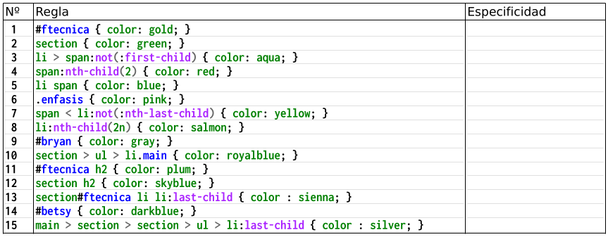
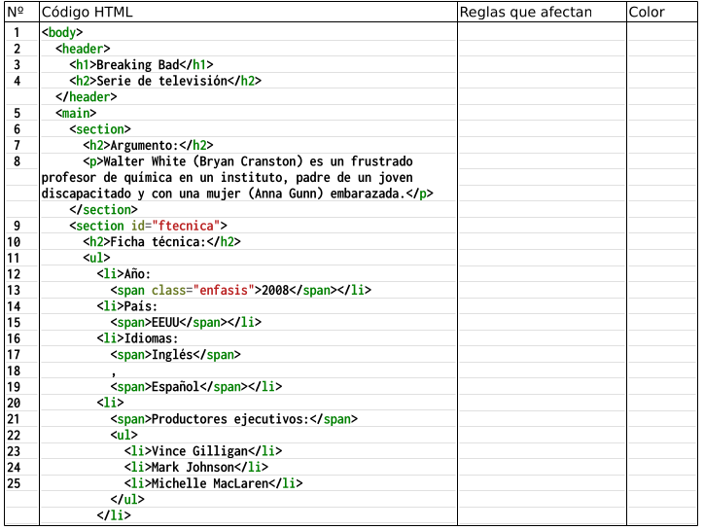
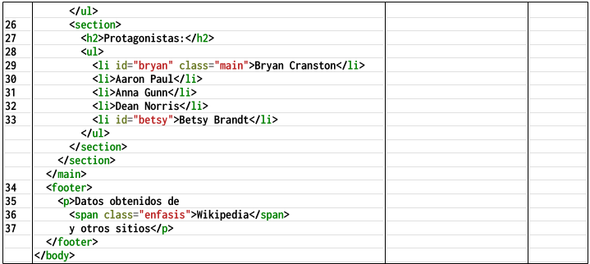
0100
0001
0012
0011
0002
0010
0011
0100
0013
0101
0002
0113
0100
0015
2(section)
green
12(section h2)
skyblue
1.2(#ftecnica&&section)
gold+espec.
11.12(#ftecnica h2 && section h2)
plum
5,6(li span && .enfasis)
pink
5(li span)
blue
3,5(li>span:not(:first-child)&& li span))
aqua
aqua
aqua
aqua
3,5(li>span:not(:first-child)&& li span))
3,5(li>span:not(:first-child)¬¬ li span))
sienna
13(li:last-child)
green
skyblue
gray
salmon
saalmon
darkblue
pink
6(.enfasis)
2(section)
12(section h2)
9,10(#bryan&&li.main)
8(2º,4º,6º...)
8
14(#betsy)

