Welcome to game application program (Tic-Tac-Toe tutorial - Angular 8)

You must have an internet connection.

Installation Requirements

1. Node.js version 12.18.3 or higher

2. npm version 6.14.4

3. Visual Studio Code Editor

============================

run command in as an administrator

Check version in command prompt:

***node -v*** Should be v12.18.3

***npm -v*** Should be 6.14.6

Make a sub directory where you can put your source application. In my case located in C:\users\al\source\tictactoe (This could not be the same as your)

Change directory C:\users\al\source\tictactoe

Check you Angular version:

***ng version***

Should be:

Angular CLI: 10.0.4

Node: 12.18.3

OS: Win32 x64

Angular:

...

Ivy Workspace:

Pakage Version

----------------------- ---------------

@angular-devlit/architect 0.1000.4

@angular-devkit/core 10.0.4

@angular-devkit/schematics 10.0.4

@schematics/angular 10.0.4

@schematics/update 0.1000.4

rxjs 6.5.5

----------------------------------------------------

In C:\users\al\source\tictactoe directory command prompt type:

***ng new Angular-8-tic-tac-toe***

? Would you like to add Angular routing? Yes

? Which stylesheet format would you like to use?

> CSS < - Select this

SCSS [ https://sass-lang.com/documentation/syntax#scss ]

Sass [ https://sass-lang.com/documentation/syntax#the-indented-syntax ]

Less [ http://lesscss.org ]

Stylus [ http://stylus-lang.com ]

Enter

***cd Angular-8-tic-tac-toe***

Just to be sure that the angular cli was installed and other dependencies needed:

***npm install -g @angular/cli***

***npm install popper --save***

***npm install bootstrap --save***

***npm install jquery --save***

***npm install --save-dev @angular-devkit/build-angular***

***code .*** < Run visual studio code editor

See the project explorer below

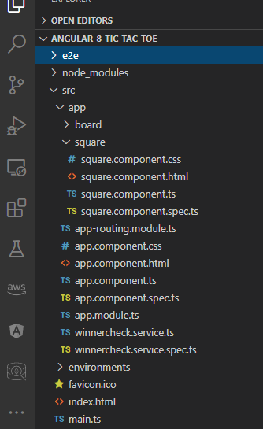

Try to run your application made in http://localhost:4200/ in browser for checking an error:

***ng serve***

If no error exist press Ctrl-C to stop running, then time for customized your application.

Let's list out what are needed. Component, Services, Classes, and Interface for our application customization. We will use Angular CLI and follows best practices and saves much of time.

Application Requirements:

Tic-tac-toe is a paper-and-pencil game for two players, X and O, who take turns marking the spaces of a 3 _ 3 grid. The player who succeeds in placing three of their marks in a horizontal, vertical, or diagonal sequence wins the game.

Functional Requirements

• Player 1 plays symbol “X”, player 2 plays symbol “O”.

• Use the numpad for input (accept numbers 1 through 9): ( Not yet implemented instead) (mouse driven)

|  |  |  |
| --- | --- | --- |
| 7 | 8 | 9 |
| 4 | 5 | 6 |
| 1 | 2 | 3 |

• Use the numpad for input (accept numbers 1 through 9):

– If player 1 wins, prompt using an overlay “Player X Won!”

– If player 2 wins, prompt using an overlay “Player O Won!”

– Otherwise prompt using an overlay “Cat’s Game!”

=======================================================================

We are going to follow the principle of KISS ("keep it simple, stupid"). The KISS principle states that most systems work best if they are kept simple rather than making complicated; therefore, simplicity should be a key goal in design, and unnecessary complexity should be avoided.

1.) Create components in components

***ng g c square***

***ng g c board***

2.) Create services

***ng g s winnercheck***

3.) We should not create Modules since we have opted to automatically include it on above step process.

4.) Creating an Interface (Not applicable - KISS)

5.) Create Class (Not applicable - KISS)

Proceed to customization of codes. After finished run.

***ng serve***

|  |  |  |  |  |  |  |  |  |  |  |
| --- | --- | --- | --- | --- | --- | --- | --- | --- | --- | --- |
| Sample output of application   |  |  |  |  |  | | --- | --- | --- | --- | --- | |  |  |  |  |  | |  |  |  |  |  | |
|  |