**Module 03: Exercise Screenshots**

Algenis A. Romero

Cybersecurity Workforce Certification Training (CWCT)

Ivy Tech Community College

CWCT 140 - Introduction to Python for Cyber Security

Instructor David Lieberman

August 2023

**Filename:** triangle.py

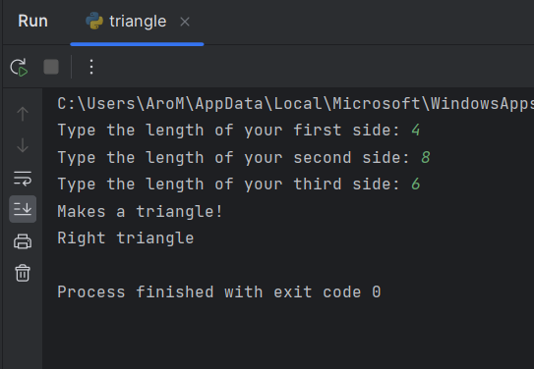

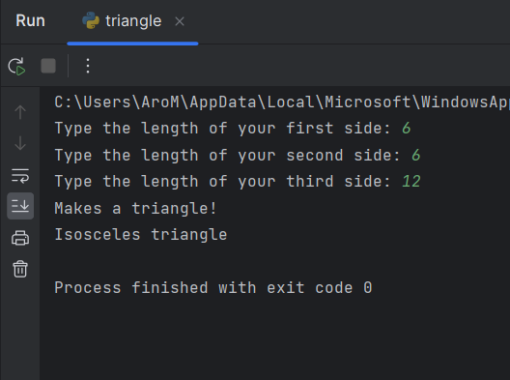

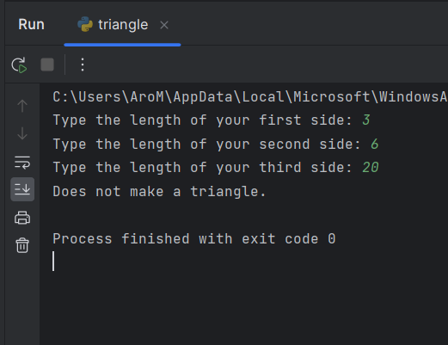

**Filename:** distance_travel.py

