**Module 06: Lab Project**

Algenis A. Romero

Cybersecurity Workforce Certification Training (CWCT)

Ivy Tech Community College

CWCT 140 - Introduction to Python for Cyber Security

Instructor David Lieberman

September 2023

**Module 6 Lab Project   
CWCT140  
Python Essentials**

The lab exercise for this week is to learn basic SQL commands and practice using them on a cloud SQL database server. We will be using W3Schools for this exercise.

Use the links above each exercise to execute the queries. If there is more than one query, execute them one-at-a-time. For each exercise, cut and paste a snapshot of your result.

<https://www.w3schools.com/sql/trysql.asp?filename=trysql_select_top&ss=-1>  
SELECT TOP 5 * FROM Customers

**Paste Snapshot of Query Result Here**

SELECT TOP 5 CustomerName FROM Customers

**Paste Snapshot of Query Result Here**

**SELECT TOP 5** **CustomerName FROM Customers ORDER BY CustomerName DESC**

**Paste Snapshot of Query Result Here**

SELECT TOP 5 CustomerName, City, Country FROM Customers

**Paste Snapshot of Query Result Here**

SELECT TOP 5 * FROM Customers WHERE Country LIKE 'Germany'

**Paste Snapshot of Query Result Here**

SELECT * FROM Customers WHERE Country LIKE 'A%'

**Paste Snapshot of Query Result Here**

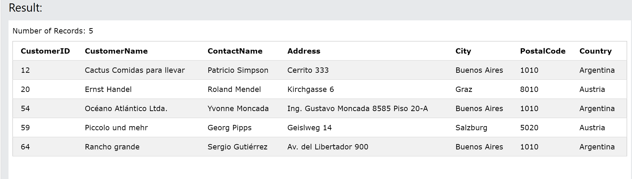

<https://www.w3schools.com/sql/trysql.asp?filename=trysql_update_2>  
SELECT * FROM Customers WHERE CustomerID=1  
UPDATE Customers SET ContactName='Your Name' WHERE CustomerID=1  
SELECT * FROM Customers WHERE CustomerID=1

**Paste Snapshot of Query Result Here**

<https://www.w3schools.com/sql/trysql.asp?filename=trysql_delete>  
SELECT * FROM Customers WHERE CustomerID IN (1, 2)  
DELETE FROM Customers WHERE CustomerID = 1  
SELECT * FROM Customers WHERE CustomerID IN (1, 2)

**Paste Snapshot of Query Result Here**

List all Employees whose first name begins with 'A'

**Paste Snapshot of Query Result Here**

List all products for the supplier with an ID of 2

**Paste Snapshot of Query Result Here**

Count the number of products for the supplier with an ID of 7

**Paste Snapshot of Query Result Here**

List the phone number for the supplier 'New England Seafood Cannery'

**Paste Snapshot of Query Result Here**

What is the total value of all products sold in jars?

**Paste Snapshot of Query Result Here**

