EZFac

User Manual
V1.0

Michael Manalo, Nathan Jack, Ali Al-Ghanim, Fenil Patel, Nick Killion, Hassia Gado Alzouma

3/16/2015

Table of Contents

Table of Contents 2
System Overview 3
Document Overview 4
Installation 5
Menu 6
1.1 File 6
1.2 Settings 6
1.3 Help 6
Configuration 7
Search 10
3.1 Search for a floor: 10
Setting 11
4.1 Change Department Color: 11
4.2 Revert to Default Color: 11
Security 12
Info/Error/Warning Messages 13
Contact Us 14

System Overview
EZFac is built to assist the College of Public Health of Temple University with visually managing information about their facilities. EZFac provides a user-friendly interface to modify .pdf maps to store user-generated data. The program will receive maps from ARCHIBUS in .pdf format, provide a visual representation of the map, and generate a database that stores room data extracted from the PDF. The user will be able to select campus, building, and floor to a view a particular map. The product will display the map with the ability to click on rooms to view and modify data. All data is stored and maintained in the database. The authorized database administrator can manually update the database and add new attributes.

Platform: Windows

Requirements: Windows operating system, Internet connection (for download and updating maps and room data), 15MB of memory space (depending on the amount of data you download)

Document Overview
This document describes how to use EZFac. It includes an overview of the application with all of its features and system requirements. The latter part of the document goes into detail about the application features and steps on how to use those features. These features include menus, selecting multiple rooms, upload/download map and room data, basic admin authentication, and editing room data. Adding to the features is querying for floor map by selecting building and floor. The last part of this document has the developers contact information and glossary.

Installation
You can download EZFac from the OwlBox.
1. Open the temple owlbox
2. Search for “EZFac” application
3. Click on the download
4. Extract the folder
5. Run the application from the extracted folder

Menu
EZFac has three dropdown items in the menu, file, settings, and help. These menus are accessible after log in and on the main screen.

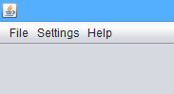

1.1 File
You can access following dropdown items by clicking on “File” button in the menu.
Add new map
  - You can upload/download map and room data by selecting this option
Quit
  - Allows you to exit out of the application

1.2 Settings
You can access this dropdown menu by clicking on “Settings”.
Change department color
  - Allows you to change color for department
Revert to default color
  - Allows you to change color back to the default colors

1.3 Help
You can access this dropdown menu by clicking on “Help.”
User Manual
  - Allows you to see instructions for how to use application
About
  - Allows you to view information about the application

Configuration
2.1 Login
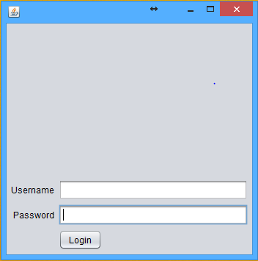
- Step1 : Click on EZFac.Jar file to open
- Step2 : enter username/password provided by the admin
- Step3 : click on Login button

2.2 Add new map
- Step1 : Click on File → choose a map *.pdf
- Step2: Click on Import after selecting file

2.3 Add a spreadsheet
- Step1 : Click on File → Choose a spreadsheet *.csv
- Step2 : Click on Import after selecting file

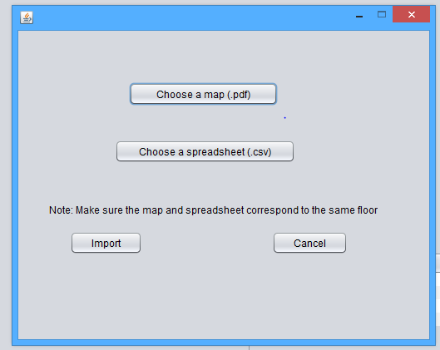

2.4 Change a department color
- Step1: Click on Setting → Change department color
- Step2 : Choose the color degree that you want

2.5 Revert default settings
- Step1 : Click Setting → Revert to Default colors

2.6 Choose specific floor
- Step1 : Use the drop down menus for Campus → Building → floor to choose a specific floor map

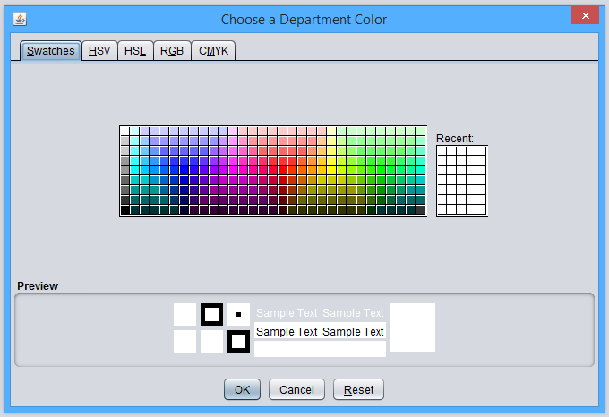

2.7 Get room information
- Step1 : After choosing a specific floor, click on the room that you need to get its information, then a pop-out window is generated with all the data you need will show up

2.8 Select multiple rooms
- Step1 : press Ctrl + Left mouse click on the rooms that you want
- Step2 : a pop out window will show up to scroll between these rooms data

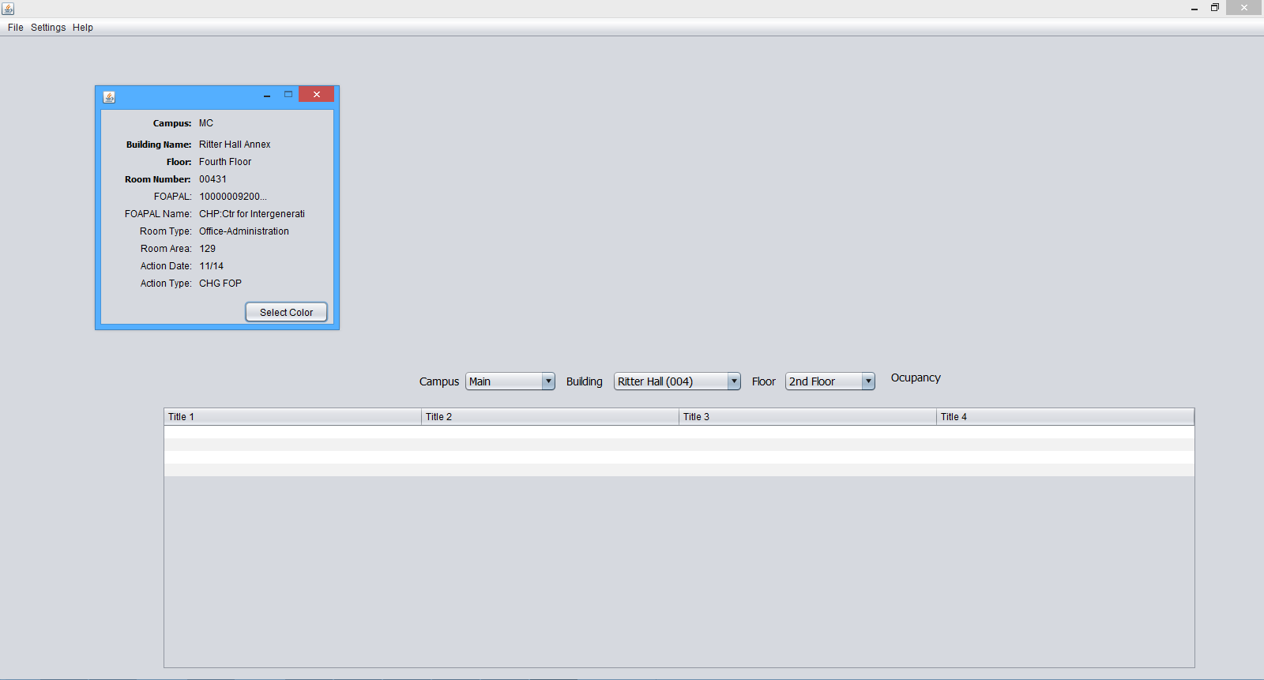

Search
The section allows you to search for a floor map and all its rooms data for a specific building and campus.

3.1 Search for a floor:
- Select “Campus”
- Select “Building”
- Select “Floor”

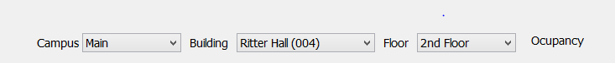

Setting
You can set when your application updates from the setting dropdown menu.

4.1 Change Department Color:
- Click “Settings” from the menu
- Select “Change Department Color” from the dropdown menu
- Select color you like to keep for the department
- Click “Save” to save your changes

4.2 Revert to Default Color:
- Click “Setting” from the menu
- Select “Revert to Default Color” from the dropdown menu

Security
Each user will have a username and password that are provided by the server provider. The admin will create users that are granted with privileges and randomly generated passwords

Info/Error/Warning Messages
Issue | Course of Action
Program doesn't start | Make sure that Java 1.8 or later edition is installed
Cannot access the database | Make sure that you are entering the user-name/password provided by the admin with letter cases
Map cannot be added | Make sure that only pdf extensions are used
Cannot import spreadsheet | Make sure that csv file is the one are used and created by devices with Windows OS
Cannot change an floor/room/campus/building | Make sure that the entry doesn't have a duplicate
Cannot add a floor/room/campus/building/Dept. | Make sure that they aren't already exist and they are unique

Contact Us
Send us your comments or find out how to contribute to the application by emailing us at Tud13865@temple.edu
Tud50428@temple.edu
Tue70000@temple.edu
Tud47465@temple.edu
Tuc69409@temple.edu
Tud16508@temple.edu

For more information on ARCHIBUS, contact Dan Astran at dan.astran@temple.edu. He is with the Office of Space Management, and is involved with the University’s implementation of ARCHIBUS.

