SAVOR the data.

Seth Lingafeldt

Dr. Stephen Clark

UNC Charlotte

Advanced Financial Derivatives

Table of Contents

Motivation: 2

Instrument: 2

Rolling: 3

Example: 3

Split Adjustment: 4

Note - VXX valuation date of 29 Jan 2019 and subsequent recreation: 4

Options Data Analysis: 5

3D Modeling: 6

1: A calm day. 6

Conclusion: 7

2: A day where we see a flip in the VIX and VIX3M. 8

Conclusion: 9

3: A day where we see a reverse split. 10

Conclusion: 11

4: A day with a lot of data. 12

Conclusion: 13

Final Thoughts 14

Bibliography 15

# Motivation:

In early 2022 I added and started trading a complementary strategy to my day trading that involved always being long or short the VXX based on the closing prices of the VIX and the VIX3M future. Said strategy is not particularly good on its own; it is highly volatile, does not beat the market average, and draws down about twice what it returns in a given year. However, the historical returns are uncorrelated with my current strategies’ historical returns, so adding it provides additional expected future value to the portfolio.

Shortly, pun intended, after my first trade (short), I received this notice from my broker:

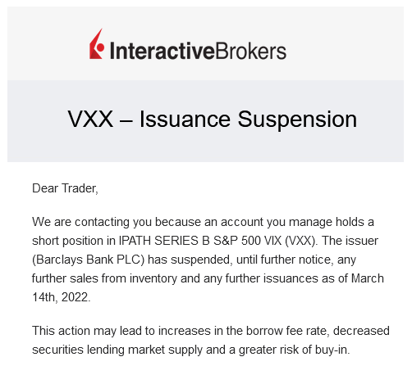

So… **options**!

# Instrument:

According to Barclays’ SEC Filing, the VXX: “is calculated based on the strategy of continuously owning a rolling portfolio of one-month and two-month VIX futures to target a constant weighted average futures maturity of 1 month.” [1]

The VXX is an instrument for individuals that “seek an investment with a return linked to the forward implied volatility of the S&P 500® Index.” [1]

# Rolling:

As time passes, contracts that used to be two-month VIX futures will become less than two-month VIX futures. In order to achieve the desired maturity, these contracts must be “rolled” forward.

If the market for these contracts is in **contango**, such that the prices in the distant delivery months are higher than nearer delivery months, the roll (sale) of the held contract would occur at a price **lower** than the price of buying the more distant contract. This would be referred to as a negative **“roll yield”**.

Note that **contango** is typically the observed historical state of VIX futures, and Barclays sates “The contracts included in the Indices [VXX and VXZ] have not historically exhibited consistent periods of **backwardation**, and **backwardation** will most likely not exist at many, if not most times.” Emphasis mine. [1]

### Example:

* A futures contract is purchased and held in January for $10. It has a March expiration.
* In February, this contact needs to be replaced for a contract that expires in April.
  + This is done in order to retain the desired futures maturity of 1 month.
* The January contract still costs $10.
* The February contract costs $9.
  + This scenario is **backwardation**.
* Selling the January contract results in + $10
* Buying the February contract results in - $9.
  + This scenario has positive **roll yield**.

Because VIX futures have fixed expiration dates, volatility indexes such as the VXX *must* undergo a rolling process to rotate their inventory of futures in order to keep their stated exposure to volatility.

Regardless of rolling, the daily price action of VXX is dominated by market volatility. In periods of high volatility, the negative roll yield puts far less downward pressure on the price than upward pressure due to the VIX increasing. We do occasionally observe periods of long term VXX increases.

# Split Adjustment:

Due to the nature of the roll yield and how the VIX Index has typically mean reverted over the longer term to a historical mean, a tracking ETN such as the VXX should in theory perpetually decay in price. Barclays has addressed this by perpetually splitting with a 0.25 adjustment, or a 1-to-4 “reverse split”.

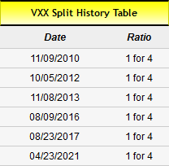

[https://www.splithistory.com/vxx](https://www.splithistory.com/vxx%20%20)  [6]

I suspect that Barclays does this for multiple reasons, but one is likely that fund managers have a mandate to only trade or own products in their portfolios that have a minimum price, much like how insurance companies are not allowed to buy BBB bonds.

# Note - VXX valuation date of 29 Jan 2019 and subsequent recreation:

Someone clever will wonder how I have handled this; as is typical, someone smarter [Marsten Parker, see reference in code snippet] has already found the solution and I simply learned from it.



# Options Data Analysis:

Taking a look at the recent VIX and VIX3M data, we see what has been assumed by Barclays. The VIX has mostly been in contango with its three month future.

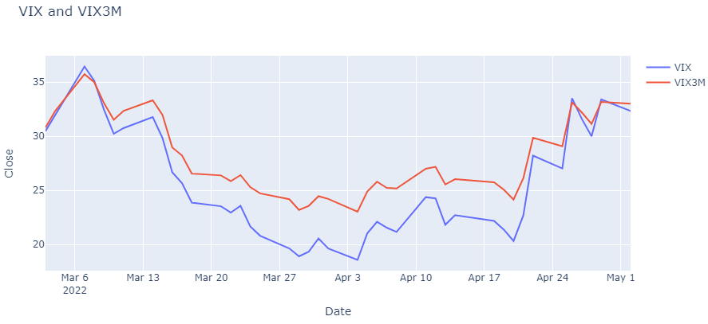

I wanted to compare a few days of data on VXX options and have used data from WRDS thanks to my department.

Using three weeks of expirations and calls and puts, we can verify our assumption that options with a smaller TTM will “smile” more so than those with further expirations.

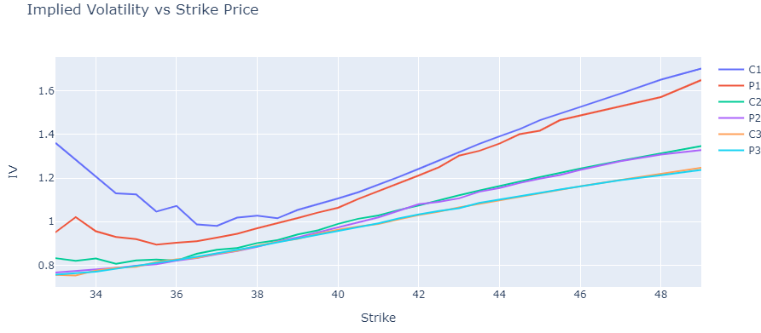

# 3D Modeling:

Let's model the IV of all of the calls and puts on:

1. A calm day, such as the last day of the year.
2. A day where we see a flip in the VIX and VIX3M.
3. A day where we see a reverse split.
4. A day with a lot of data

Some initial housekeeping is needed: namely, merging the datasets used for graphing the VXX closing price to the options data in order to have a spot price, and filtering puts and calls to those within 20% of the spot price.

## 1: A calm day.

There are 84 calls and 91 puts on 2021-12-31 with the original filter.

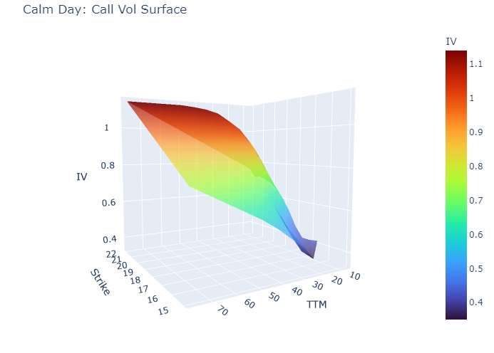

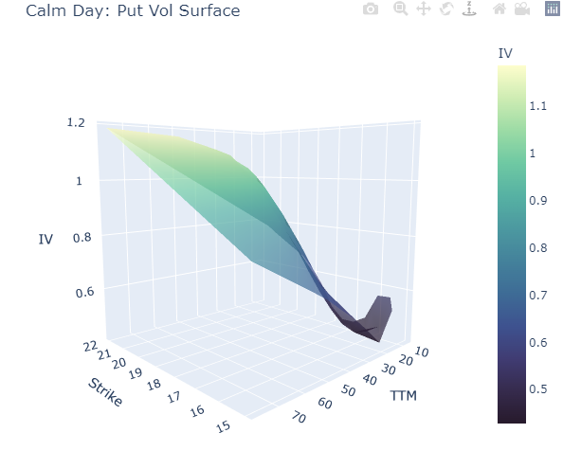

### Conclusion:

The puts have a much "cleaner" looking volatility smile.

The calls seem to have the "smirk".

This could be because of the extra 7 puts that we have, but I don't think that's necessarily the reason.

## 2: A day where we see a flip in the VIX and VIX3M.

There are 78 calls and 26 puts on 2020-02-24 *with a modified filter*.

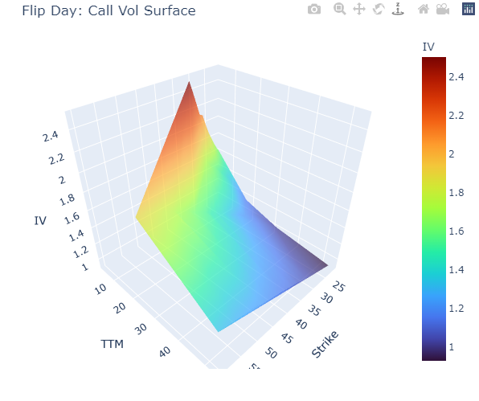

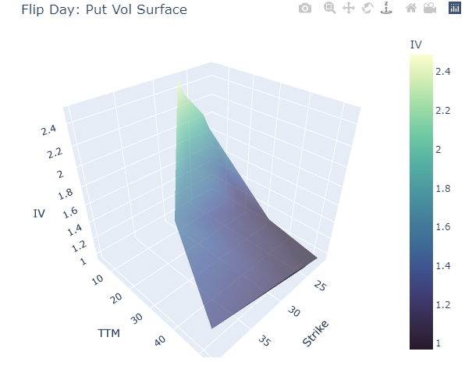

### Conclusion:

Because the VXX price is low, and the instrument that it tracks is a **volatility based product**, a simple 20% above and below underlying price filter for strike was simply not enough.

I had to modify my data for this date to + and – 70% of spot price.

## 3: A day where we see a reverse split.

There are 28 calls and 30 puts on 2021-04-26 with the original filter.

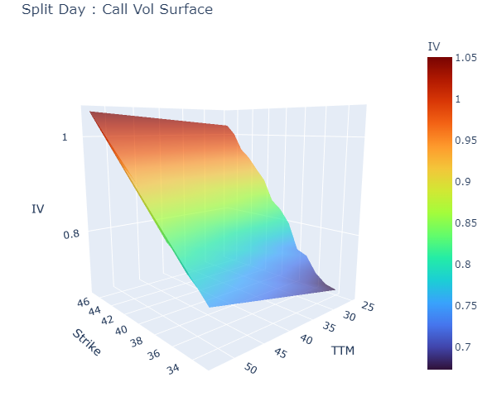

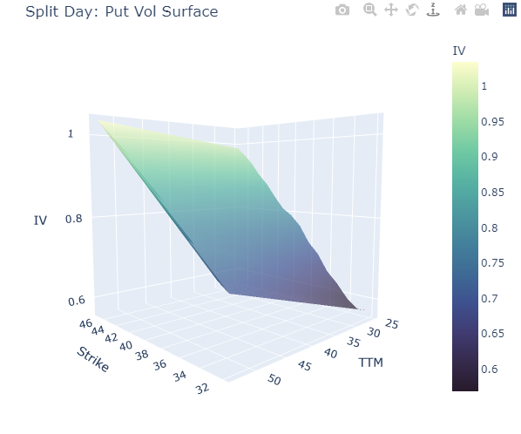

### Conclusion:

It looks like a bona-fide forward slash. There is absolutely no hint of a smile to this day!

## 4: A day with a lot of data.

There are 191 calls and 195 puts on 2021-05-11 with the original filter.

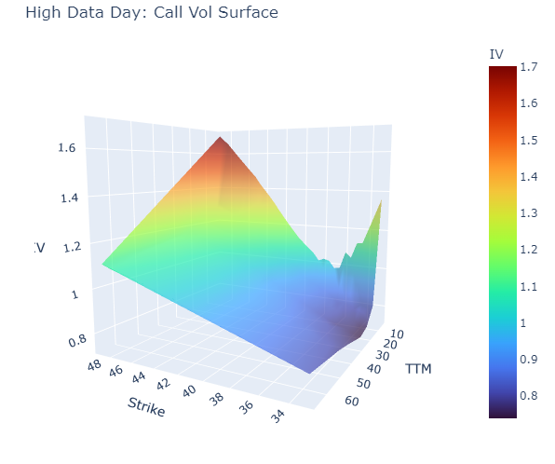

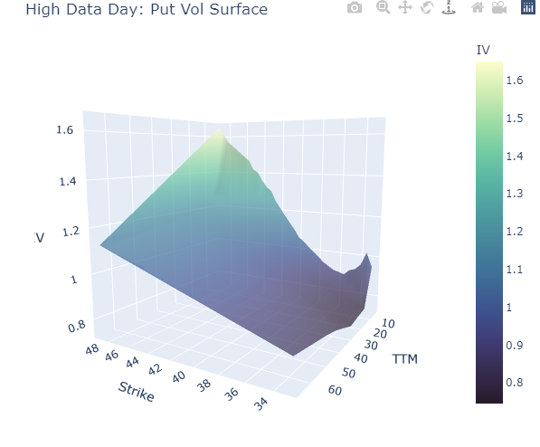

### Conclusion:

Now THAT is a pretty clean looking volatility surface!

# Final Thoughts

It seems to me that further investigation is warranted with a product like the VXX or the VIX.

A simple "Filter strikes within 20% of daily close" is not sufficient.

There should be a far superior way that is not complicated, i.e. robust: keeping all strikes within a certain *rolling range* of the daily close.

There are multiple avenues for this. Some ideas:

* Standard Deviation
* Average True Range
* HH and LL channel

I also imagine that the further you went back in time, due to the nature of the constant reverse splits, this issue will NOT be a problem!

Plenty of people do research on large swaths of historical data, and I can see this error being made accidentally on other similar products.

I think this bias needs a name. I propose the SAVOR.

**S**plit

**A**djusted

**V**olatile

**O**ption

**R**ule

SAVOR your data! I’m glad I did not give up on modeling the flip day, even if it did take a month to figure out. Further information can be found in the discovery.ipynb file at

<https://github.com/algo-dude/AdvancedFinancialDerivatives/tree/master/Final>

# Bibliography

1. BARCLAYS BANK PLC. “Pricing Supplement - SEC Filing.” Pricing supplement--iPath Vix (VXX Upsize). SEC, April 10, 2010. https://www.sec.gov/Archives/edgar/data/312070/000119312510184905/d424b2.htm.
2. Easter, David. “How Volatility and the Roll Yield Contribute to the Price Action of VXX in Different Market Environments (Bats:VXX).” SeekingAlpha. Seeking Alpha, June 5, 2015. https://seekingalpha.com/article/3239206-how-volatility-and-the-roll-yield-contribute-to-the-price-action-of-vxx-in-different-market-environments.
3. Harwood, Vance. “How Does VXX's Daily Roll Work?: Six Figure Investing.” Six Figure Investing | Alternatives to buy and hold, February 25, 2020. https://sixfigureinvesting.com/2015/01/how-does-vxx-daily-roll-work/.
4. Nickolas, Steven. “ETF Analysis: Ipath S&P 500 VIX Futures.” Investopedia. Investopedia, February 22, 2022. https://www.investopedia.com/articles/investing/080715/etf-analysis-ipath-sp-500-vix-futures-vxx.asp.
5. Stein, David. “What Is Roll Yield and How Does It Impacts Returns: Money for the Rest of Us.” Money For The Rest of Us | Investment help and financial guidance for the rest of us., February 25, 2022. https://moneyfortherestofus.com/roll-yield/.
6. “VXX Split History.” Split History, n.d. https://www.splithistory.com/vxx/.