Using black dotted lines as one standard deviation and red dotted lines as the mean, with 50 bins for X axis values:

**RUA DAILY**

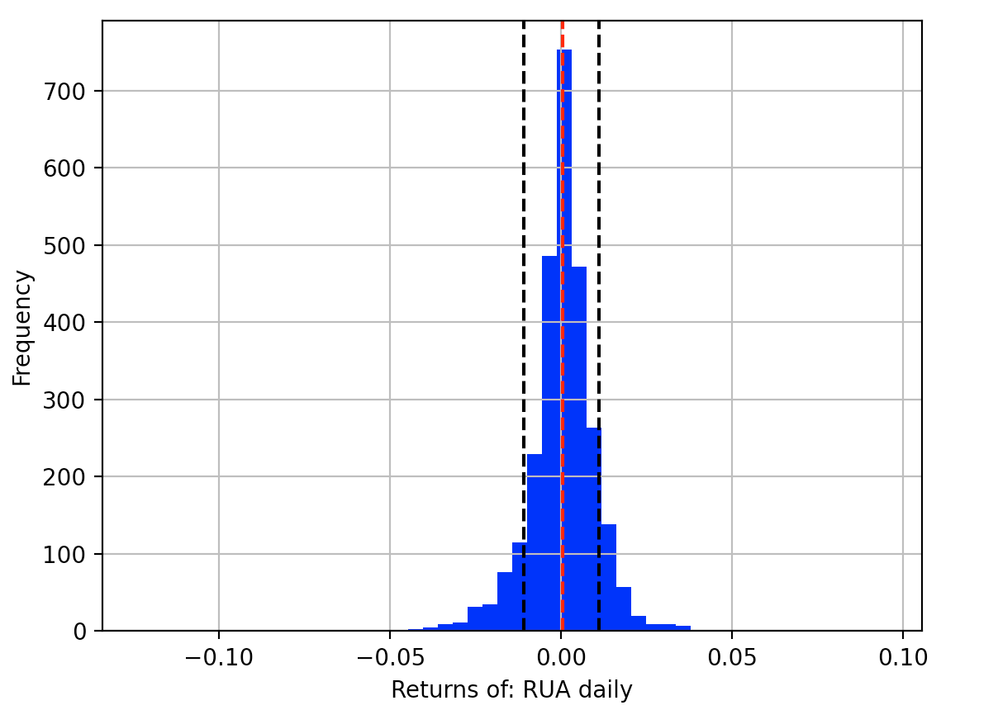

RUA daily returns since 2011 are far more normally distributed than I would imagine. Suspect this is because it is almost the entire market.

Seems to have more extreme values on the left tail, and more quantity of values greater than the mean.

**RUA MONTHLY**

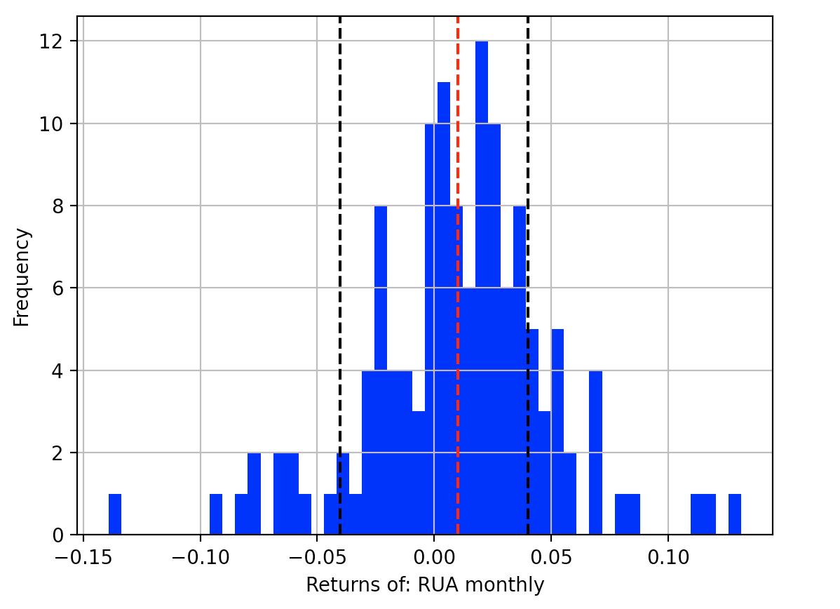

Monthly returns are far less normal, particularly on the negative side. Suspect however that this is because of the ~ 1/20th as many data points as the daily returns.

**BTC DAILY**

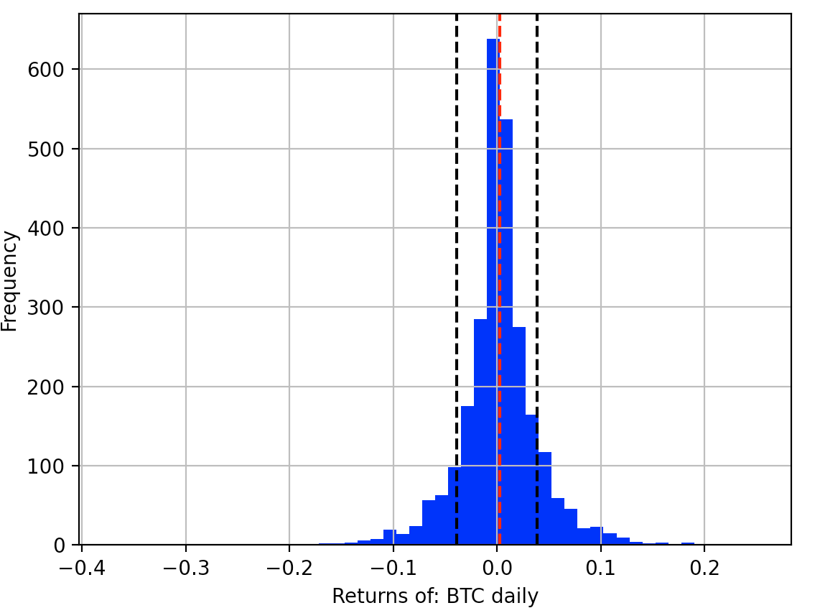

BTC daily is quite normal. Like the RUA, it seems to have more extreme values on the left tail, and more quantity of values greater than the mean.

**BTC MONTHLY**

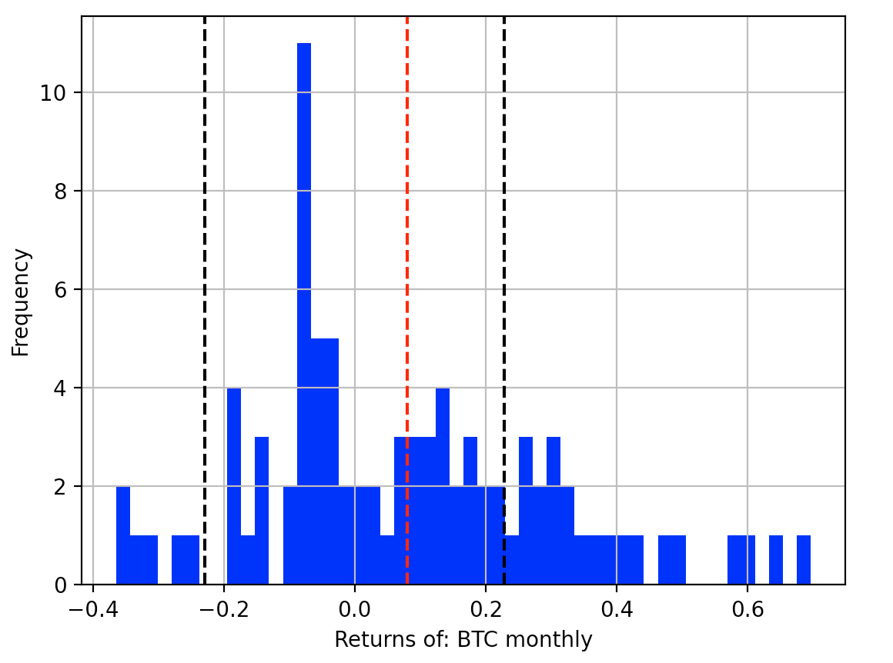

Nobody could think this looks normal. Quite ugly, actually. HODL is a tough strategy to stomach.