Create .pfx file from the given files from GoDaddy:
openssl pkcs12 -export -out api.algosystems.com.au.pfx -inkey api.algosystems.com.au-PrivateKey.pem -in api.algosystems.com.au-certificate.cer -certfile api.algosystems.com.au-intermediate.pem

Setting up local windows user:
Created new windows account:
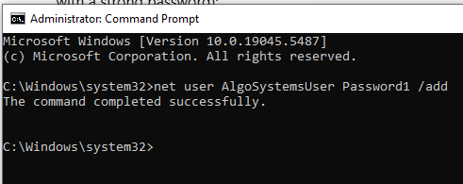

1. Create new windows user:
net user AlgoSystemsUser Password1 /add
2. Add user to local administrators’ group
net localgroup Administrators AlgoSystemsUser /add
3. API URL Swagger UI:
http://localhost:5001/swagger/index.html

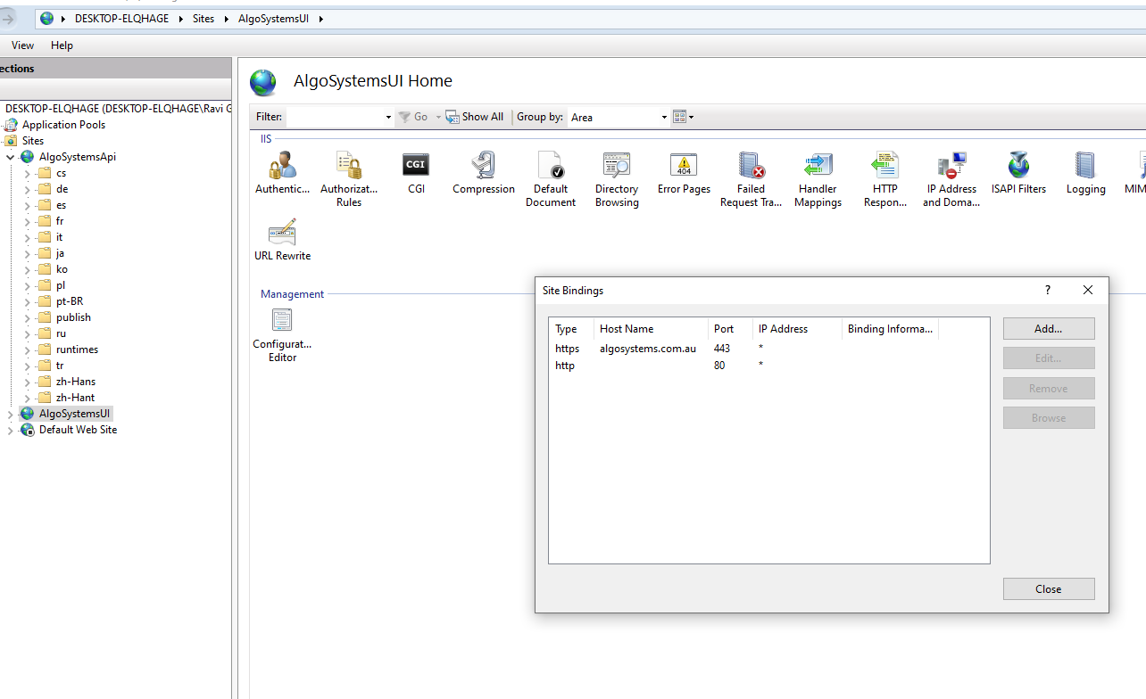
C:>iisreset
C:>Ping algosystems.com.au
C:>ipconfig /all

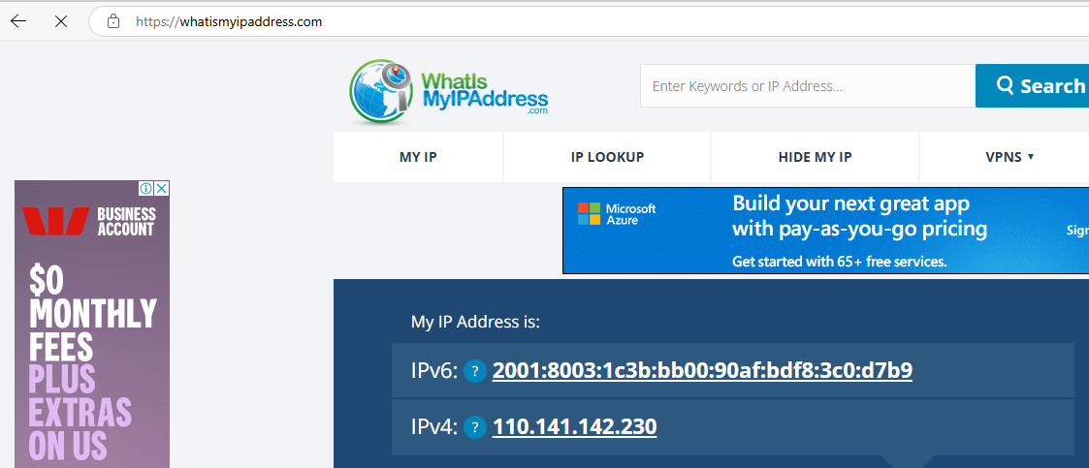
- Gives the what is your Broadband provider IP.
- GoDaddy Changes:
1. @A Type
From :
20.211.64.9
TO:110.141.142.230
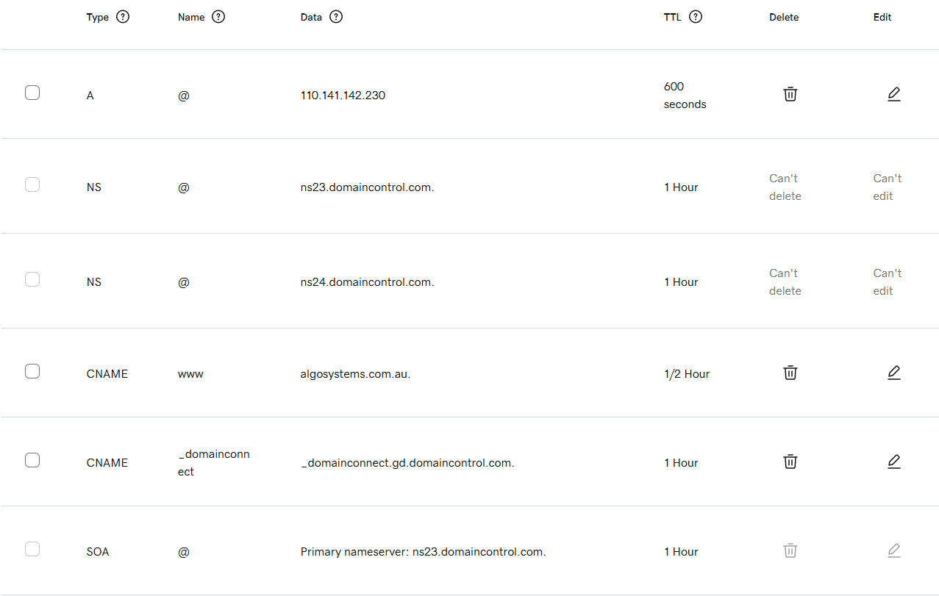
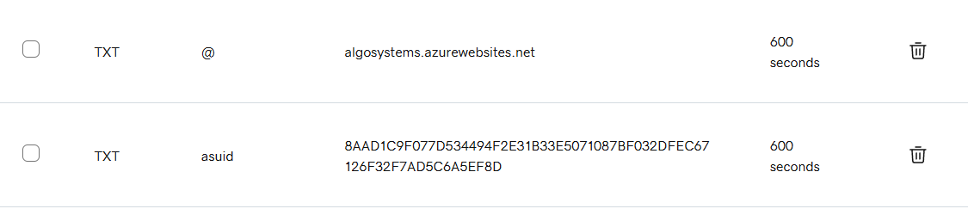

- TELSTA Router Settings:

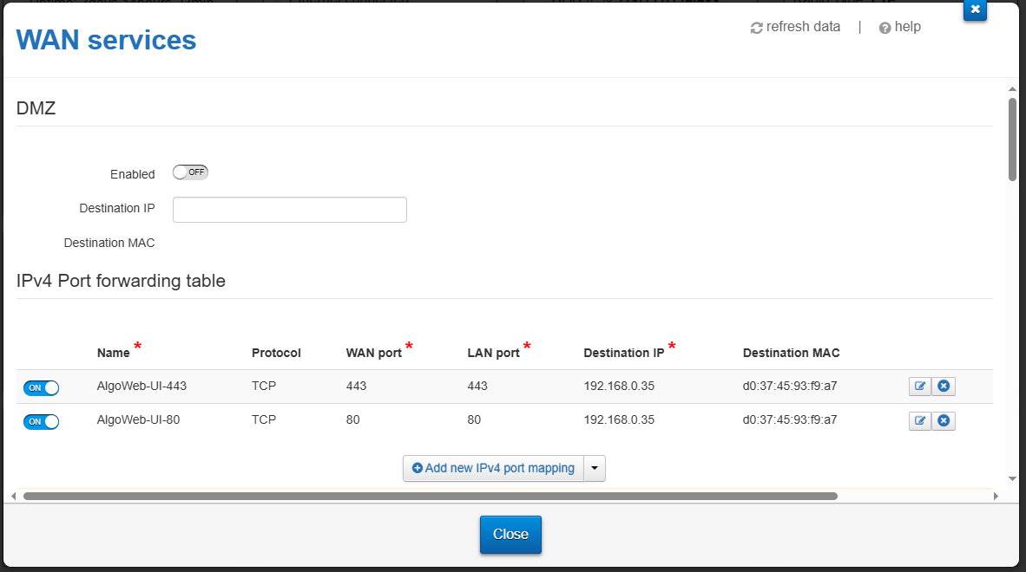

- Your PC configuration
C:>ipconfig /all

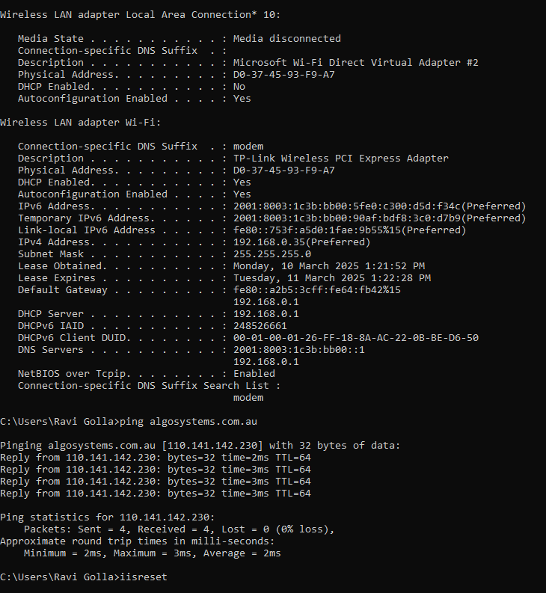

UI project on port: 5001
Create API site on port: 5050
----
1. Enable IIS in Windows
Enable Internet Information Services (IIS) and IIS Management Console.
2. Install the URL Rewrite Module

Download & install IIS URL Rewrite from Microsoft:
https://www.iis.net/downloads/microsoft/url-rewrite

Download and install the .net bundlers:
https://dotnet.microsoft.com/en-us/download/dotnet

Give the deployment folder all access
IIS_IUSRS

Laptop URL for API:
https://localhost:7033/api/eodhd/products/asx20

http://localhost:8000/api/eodhd/products/asx20

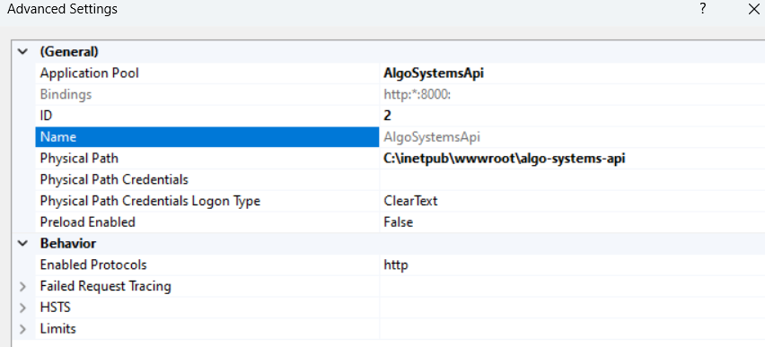

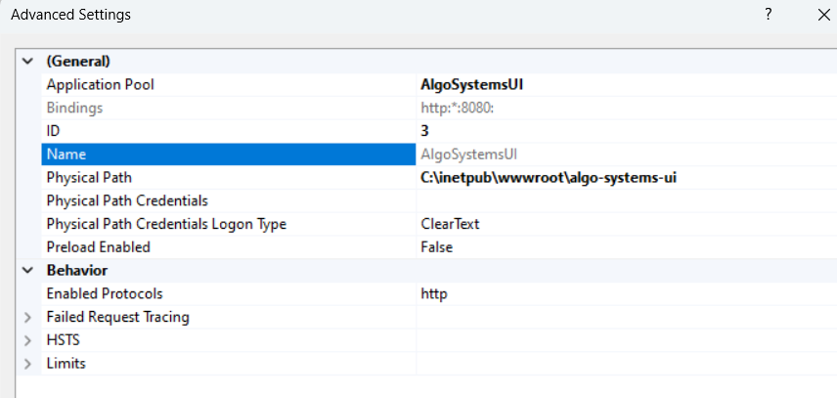

1. Using a Dynamic DNS (DDNS) Service
Since your home IP is dynamic (keeps changing), you'll need a DDNS service that maps your changing IP to a fixed domain/subdomain.
Steps:
- Set up DDNS: Use a service like:
  - No-IP (https://www.noip.com/)
  - DuckDNS (https://www.duckdns.org/)
  - DynDNS (https://dyn.com/dns/)
These services assign you a subdomain (e.g., yourname.ddns.net) that automatically updates when your home IP changes.
- Configure Router for DDNS:
  - Many routers support DDNS integration. Check your router settings for a DDNS option and configure it with your chosen provider.
- Port Forwarding on Router:
  - Forward port 80 (HTTP) and port 443 (HTTPS) to your home server's internal IP.
  - If your React app runs on port 3000, forward that as well.
- Point Your GoDaddy Domain to DDNS:
  - In GoDaddy DNS settings, create a CNAME record:
vbnet
CopyEdit
Host: www
Points to: yourname.ddns.net
  - This will make www.yourdomain.com resolve to your home server.

2. Running the React Website on Your Home Server
Once DDNS is set up, you need to serve your React app.
Option A: Using a Web Server (Recommended)
If your home server runs Linux (Ubuntu, Debian, etc.) or Windows, you can use:
- NGINX (Linux/macOS/Windows)
- Apache (Linux/macOS/Windows)
- Caddy (Easy HTTPS support)
Setup with NGINX (Recommended)
- Build your React app:
sh
CopyEdit
npm run build
- Move the build/ folder to /var/www/react-app
- Configure NGINX:
nginx
CopyEdit
server {
listen 80;
server_name yourdomain.com www.yourdomain.com;

root /var/www/react-app;
index index.html;
location / {
try_files $uri /index.html;
}
}
- Restart NGINX:
sh
CopyEdit
sudo systemctl restart nginx
Option B: Run with Node.js
Instead of a web server, you can use Node.js + Express to serve your React app:
- Install Express:
sh
CopyEdit
npm install -g serve
- Serve your app:
sh
CopyEdit
serve -s build -l 80

3. Securing with SSL (HTTPS)
Since you are hosting from home, Let's Encrypt is the best free SSL option:
- If using NGINX, install Certbot:
sh
CopyEdit
sudo apt install certbot python3-certbot-nginx
sudo certbot --nginx -d yourdomain.com -d www.yourdomain.com
- This will enable HTTPS for your site.

Best Option for Reliability
- Use DDNS with a provider like No-IP or DuckDNS.
- Run NGINX on your home server to serve the React app.
- Enable SSL with Let's Encrypt for HTTPS.
- Set up port forwarding to ensure external access.
This setup allows you to host your website at home while ensuring it's accessible through GoDaddy DNS.
Would you like help setting up a specific part? 🚀

To set up DDNS (Dynamic DNS) with No-IP so that your IIS website is accessible externally, follow these steps:
Step 1: Ensure Your IIS Website is Accessible Locally
- Your IIS website is working at http://localhost:8085/AlgoHome.html, which means it's only accessible on your machine.
- Try accessing it from another device on the same network using your local IP:
  - Open Command Prompt and run:
sh
CopyEdit
ipconfig
  - Find the IPv4 Address (e.g., 192.168.1.100).
  - Test it from another device:
cpp
CopyEdit
http://192.168.1.100:8085/AlgoHome.html
  - If this doesn't work, check IIS binding settings and Windows Firewall (explained below).
Step 2: Allow External Access to IIS Website
- Configure IIS Binding:
  - Open IIS Manager (inetmgr).
  - Select your site → Click Bindings on the right.
  - Click Add, set:
    - Type: HTTP
    - IP Address: All Unassigned or your local IP (e.g., 192.168.1.100).
    - Port: 8085
  - Click OK and restart IIS.
- Allow Port 8085 in Windows Firewall:
  - Open Windows Defender Firewall → Click Advanced settings.
  - Under Inbound Rules, click New Rule.
  - Select Port → Choose TCP → Enter 8085 → Click Allow → Finish.
Step 3: Port Forwarding on Your Router
Your IIS website is on your local network, but to access it externally, you need port forwarding:
- Log in to Your Router (usually 192.168.1.1 or 192.168.0.1 in a browser).
- Look for Port Forwarding / Virtual Server Settings.
- Add a new rule:
  - External Port: 8085 (or any other open port)
  - Internal IP: Your local machine’s IPv4 (e.g., 192.168.1.100).
  - Internal Port: 8085
  - Protocol: TCP
  - Enable the rule.
- Check if Port 8085 is Open:
  - Use an online port checker tool like canyouseeme.org.
  - Enter 8085 and click Check.
  - If closed, double-check firewall and router settings.
Step 4: Configure No-IP DDNS
Now that your local website is accessible via your public IP:
- Find Your Public IP:
  - Visit whatismyipaddress.com.
  - Note down the IPv4 Address (e.g., 123.45.67.89).
- Log in to No-IP & Update Hostname:
  - Go to No-IP.com.
  - Log in → Navigate to DNS Hosts.
  - Click your hostname (algosystems.ddns.net).
  - Ensure it points to your Public IP.
- Install No-IP Dynamic Update Client (DUC) (Optional)
  - If your ISP changes your public IP frequently, install No-IP DUC from here.
  - Run it and log in with your No-IP credentials.
  - It will automatically update your No-IP hostname with your latest public IP.
Step 5: Access Your Website Externally
Now, try accessing it from outside your network using:
arduino
CopyEdit
http://algosystems.ddns.net:8085/AlgoHome.html
If it works, your setup is successful!

Troubleshooting
- Website not accessible externally?
  - Try accessing via your public IP (http://123.45.67.89:8085/AlgoHome.html).
  - If it works but No-IP doesn’t, update the public IP in No-IP.
  - If your ISP blocks port 8085, try another (e.g., 5000, 8080).
- No-IP hostname not updating?
  - Install and run the No-IP DUC client.
- Still not working?
  - Restart IIS, router, and PC.
  - Check router logs for blocked ports.

