The design purpose of the target date fund is to provide investors with a one-stop pension investment tool. It needs to rationally plan the investment portfolio of each period according to the investor’s life cycle attributes on the premise of maximizing the net value of the fund on the maturity date. Generally speaking, as the target date approaches, the investment portfolio tends to be conservative, and the allocation ratio of risky assets gradually decreases. The path of this reduction is the glide path.

The design of a glide path usually requires a logically rigorous model to support. This report will introduce a method of constructing a glide path with the goal of maximizing expected utility after maturity. We establish stochastic dynamic models for various assets, combined with term risk theory, and optimize the expected utility at maturity, and finally build a glide path that fits the needs of customers.

Investment form setting: Generally speaking, investors with the purpose of accumulating pension funds will invest a certain amount of initial capital when purchasing a target date fund (TDF), and will continue to invest a certain amount of money regularly in the subsequent life cycle Amount.

Target fund net value: The target date fund allocates between equity assets and fixed income assets. The proportion of stocks and bonds allocated in different periods is different. The total net value of the fund held by investors on the target date will also vary with stocks and bonds. The income of each period is constantly changing. In addition, the subsequent regular investment of funds will also have an impact on the total net value of the fund on the target date.

Based on the above description, we could establish a dynamic model for the rate of change of the fund's net value on the target date. First we make:

$X_{t}$ indicates the net value of the fund in the 𝒕 period on the target date

$S_{t}$ indicates the net value of equity assets in the 𝑡 period

$B_{t,T}$ indicates the net value of the bond assets maturing in the 𝑡 period

$π_{t}$ represents the actual amount invested in the 𝑡 period

$π_{t}$ = $Q_{t}$ $P_{t}$\*, $Q_{t}$ is a factor that measures the uncertainty of the investment in each period, and $P_{t}$ is the average investment amount in each period, that is, the actual investment may be disturbed by uncertain factors and deviate from the average investment amount.

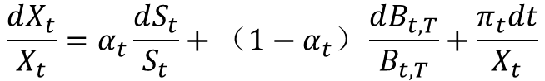

From the perspective of each period of discreteness, that is, the rate of change in the net value of the fund at the target date of the period is determined by the rate of change in the net value of equity assets when the option weight is $α_{t}$, and the bond assets when the option weight is $1-α_{t}$. The net value change rate and the change rate of the current investment amount $π_{t}$ constitute.

Changes in equity assets, bond assets, and uncertain factors of investment in each period cannot be accurately predicted in most cases, and there are random factors. Therefore, we use the following geometric Brownian motion equation to simulate it:

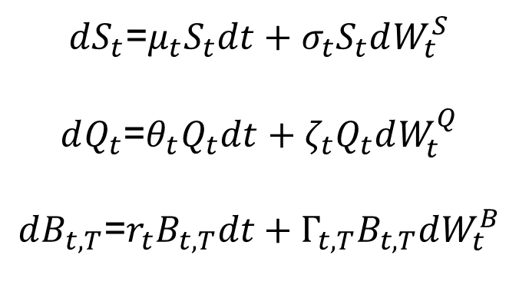

Among them:

$μ_{t}$ and $σ_{t}$ indicate the annualized rate of return and volatility of equity assets in the 𝑡 period

$r_{t}$ and $Γ_{t,T}$ indicate the annualized yield and volatility of bond assets in the period

$θ_{t}$ and $ζ_{t}$ indicate the amount of drift (increase) and diffusion of uncertain factors of investment in the period, indicating that the actual investment in each period may gradually increase as the investor's salary increases, and will fluctuate due to random factors.

After establishing a dynamic model of the net value of the target fund, we use the condition of maximizing expected utility at maturity to find the optimal $α_{t}^{*}$ equity asset allocation ratio

The conditions for maximizing expected utility at maturity are defined as follows: (U(x) is the utility function)

That is, in the case of the 𝑡 period, we can solve the equity asset allocation ratio that can make the net value of the target fund at maturity bring the maximum expected utility in the current period. This allows us to maximize the expected utility at the expiration of each period under the conditions of known information in the current period.

We set the utility function as the CRRA utility function, namely $U\left(x\right)=\frac{x^{1-γ}}{1-γ}\left(γ＞0\right)$; set $Q_{t}$ =1, 𝑟=0, $Γ_{t,T}$ =0, that is, the bond asset yield rate is set to zero, regardless of the impact of bond volatility, and it is assumed that investors will invest a fixed amount in each period $π_{t}$ = $P_{t}$.

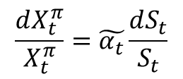The derivation process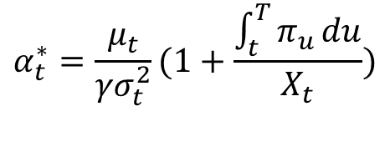:

$X_{t}^{π}=X_{t}+\int_{t}^{T}{π_{u}}du，\tilde{α_{t}}=α_{t}X_{t}/X_{t}^{π}$

Using Ito’s lemma:

$$X_{t}^{π}=X_{0}^{π}\exp\left(\int_{0}^{t}{(\tilde{α_{u}}μ_{u}}-\frac{1}{2}{{\tilde{α}}_{u}^{2}σ}_{u}^{2}\right)du +\int_{0}^{t}{\tilde{α_{u}}σ_{u}dB_{u}^{})}$$

$U\left(x\right)=\frac{x^{1-γ}}{1-γ}$ Take this forum into the last forum:

$$\max_{\tilde{α_{t}}}{(1-γ)(}\tilde{α_{t}}μ_{t}-\frac{1}{2}{{\tilde{α}}_{t}^{2}σ}_{t}^{2}) +\frac{1}{2}{{{(1-γ)}^{2}\tilde{α}}_{t}^{2}σ}_{t}^{2}$$

$$\max_{\tilde{α_{t}}}{E_{t}[U(}X_{t}^{π})]$$

$$\tilde{α_{t}^{*}}=\frac{μ_{t}}{{γσ}_{t}^{2}}$$

We could get

$$α_{t}^{*}=\frac{μ_{t}}{{γσ}_{t}^{2}}(1+\frac{\int_{t}^{T}{π_{u}}du}{X_{t}})$$

Calculating E(X):

Construct the expression of ${E(X}_{t})$ to get the corresponding downward orbit curve.

The increment of ${E(X}_{t})$ at ∆t time consists of three parts: the increase in risk assets with a ratio of $g_{t}$, the increase in bond assets with a ratio of (1− $g_{t}$) and Periodic investment ${ π}_{t}$

Time t+∆𝑡 is relative to time t, since the random term of the net value of risky assets is Brownian motion, its expected increment should be 0, and the volatility of bond assets is 0 according to the assumption.

Therefore, the expected increase in risk assets can be expressed by $μ_{t}∆t$, assuming that each function satisfies the left continuous.

Let ${E(X}_{t})=m_{t}$， $m_{t}$ should satisfy the following differential equation:

$${dm}_{t}=g_{t}μ_{t}m_{t}dt+\left(1-g_{t}\right)r_{t}m_{t}dt+{π }_{t}dt$$

Then the constructed glide path equation is as follows:



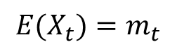

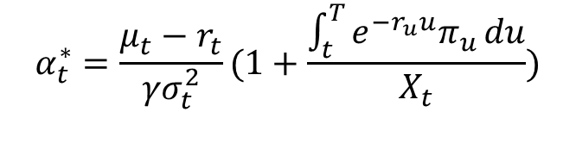

Take the equity asset yield rate of 7.5% as the reference value, considering that the general fund rate is around 1.5%, the actual value is 6%.

The model assumes that the volatility of the bond yield is 0, where the bond yield reference value is 3%

It is assumed that the investment in each period is 10,000 yuan. According to the model, the investment in each period is a fixed value

It is assumed that the initial capital is 40,000 yuan

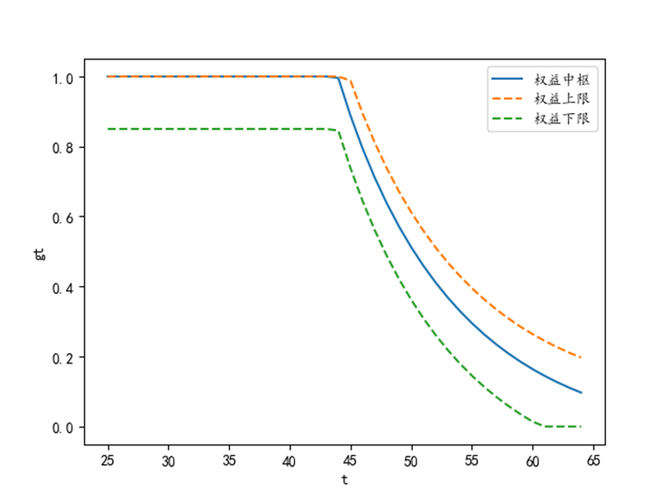We can get the glide path (the percentage on risky asset) is as follows:

So now we know how much we should invest on risky assets.

Perform 1000 simulations on the fund's return in the next 20 years, and the total yield curve for each year is shown in the figure below.

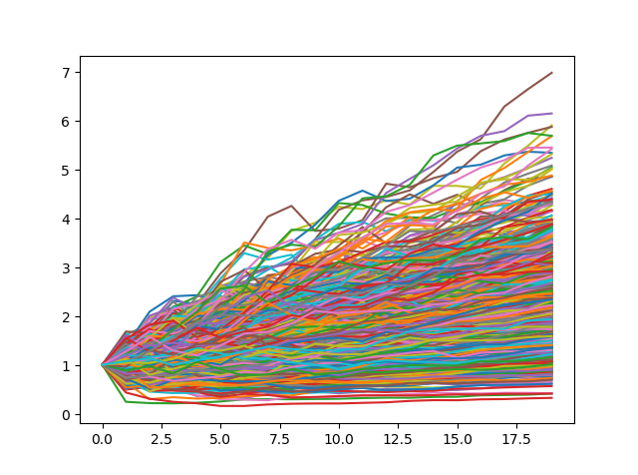

The annualized rate of return distribution for 1000 simulations is shown in the figure below.

