CNN (MNIST):

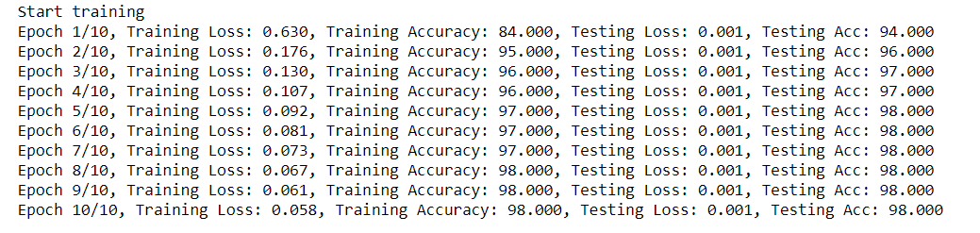

CNN (PermutatedMNIST):

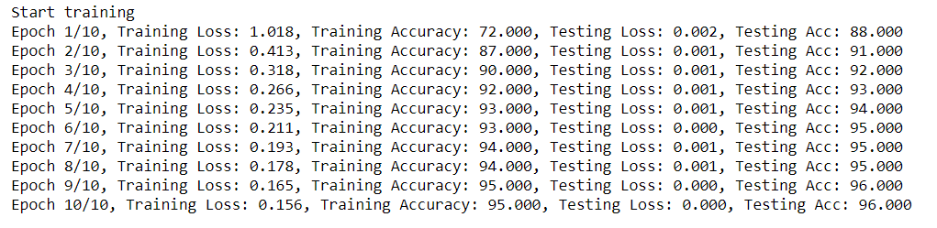

The accuracy of CNN(MNIST) seems better than accuracy of CNN (PermutatedMNIST).