**Multilayer Perceptron (PermutatedMNIST)**

**(Task 2d)**

**Overview**

The model is trained and tested with a lot of different values (125) for the following parameters:

* number of neurons (values = 20,40,60,80,100)
* learning rate (values = 0.02, 0.04, 0.06, 0.08, 0.1)
* training epochs (values = 200, 400, 600, 800, 1000).

**Best results**

Best accuracy obtained with the following parameters:

* number of neurons = 100
* learning rate = 0.02
* training epochs = 1000.

**The following diagrams show the accuracy rate of the model with the best found parameters on the training and validation set with respect to the training epochs**

**Green plot is the accuracy on the training set and the orange one is on the validation set.**

First iteration:

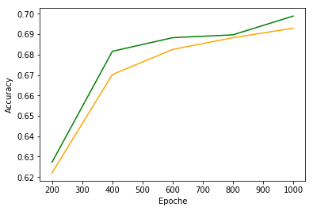

Second iteration:

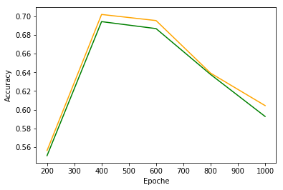

Third iteration:

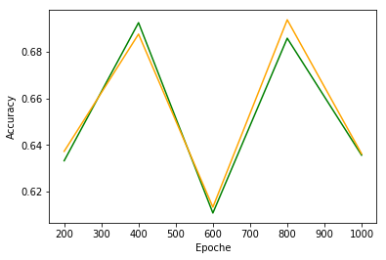

Fourth iteration:

