**ALGO INVESTOR’S PRODUCTS**

 **Consulting** **60 Minutes**

<https://buy.stripe.com/dR6eXMgLO286aOc28i>

 **Consulting 30 Minutes**

<https://buy.stripe.com/28o5ncbru14209yaEP>

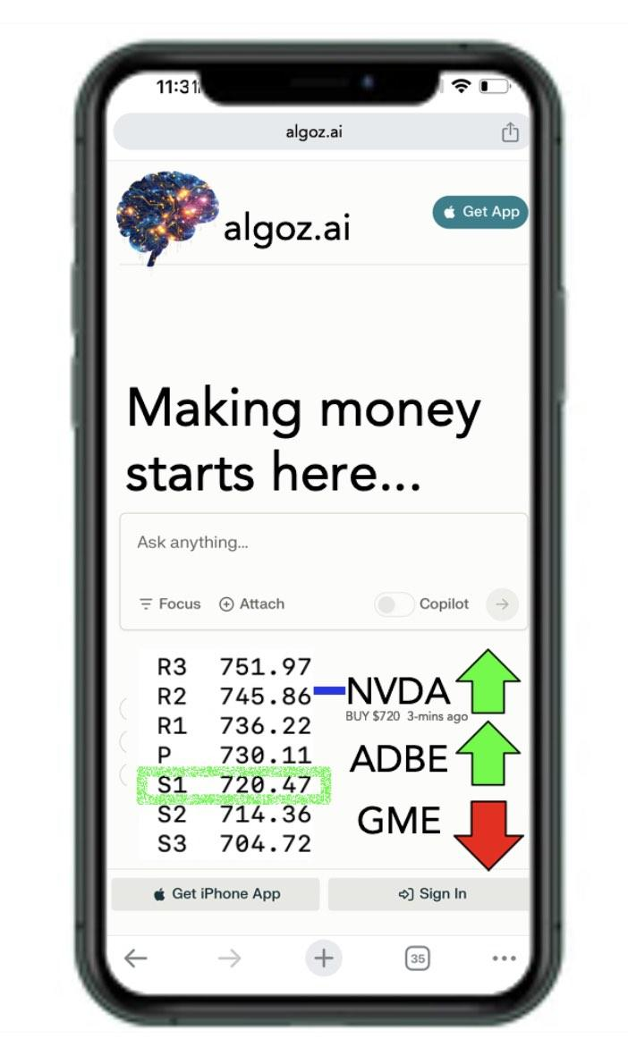**Monthly Gold Access Alert Signals**

<https://buy.stripe.com/3cseXM0MQ9Ay6xWeV3>

**Annual Gold Access Alert Signals**

<https://buy.stripe.com/00g8zogLO286bSgaEM>

**Newsletter** **Annual** **Subscription**

<https://buy.stripe.com/bIYdTI1QUeUS5tSfZ5>

 ** FasterClass 1, 2**

<https://buy.stripe.com/7sI9Ds0MQh303lK7sE>

<https://buy.stripe.com/fZe9Ds2UY286bSg7sF>

** FasterClass 3, 4**

<https://buy.stripe.com/00g4j8bru7sq9K84gu>

<https://buy.stripe.com/dR616WbrubIG5tS4gv>