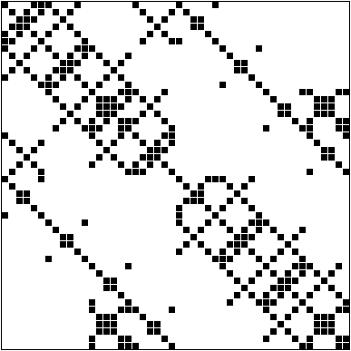

3. 48 48 224

1. 468 468 2820
2. 5357 5357 106526

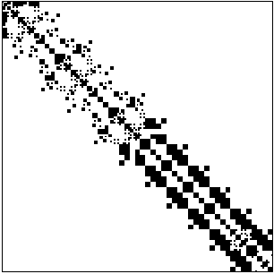

1. 153 153 1288

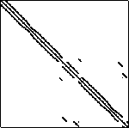 1473 x 1473, 17857 entries

5.

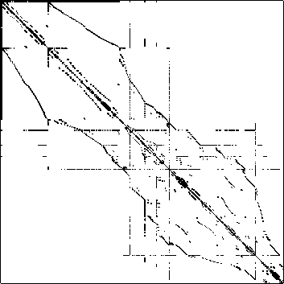

6. 1074 x 1074, 7017 entries



7. 1083 x 1083, 1083 entries

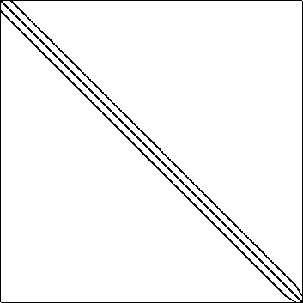

8. 9661 x 9661, 306356 entries

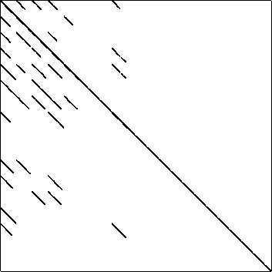

9. 680 x 680, 2646 entries

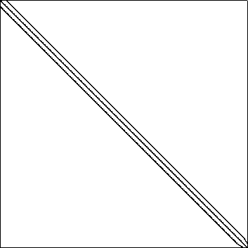

10.

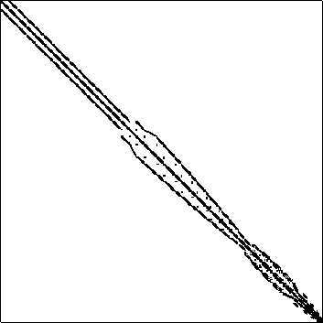

11. 2568 x 2568, 75628 entrie

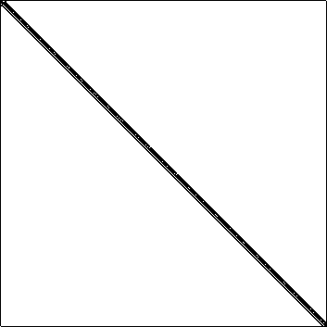

12. 9287 x 9287, 98519 entries

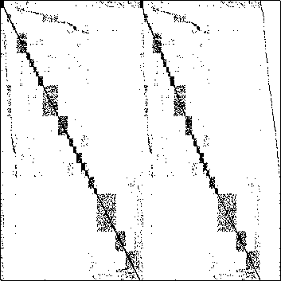

13. 4929 x 4929, 33185 entries

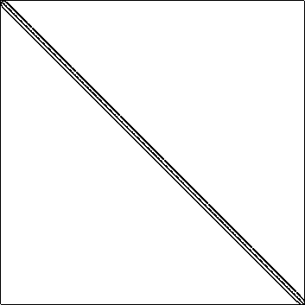

14. 13668 x 13668, 186294 entries

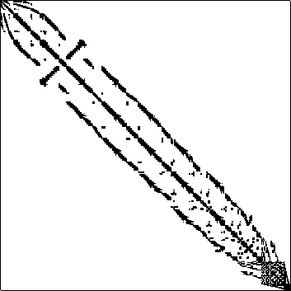

9152 x 9152, 765944 entries



16. 1074 x 1074, 1074 entries

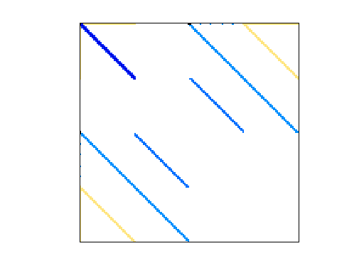

18.

|  |
| --- |
| 40,216 |
| **Num Cols** | 40,216 |
| **Nonzeros** | 1,042,160 |