Theme Editor

Emanuele Ricci, Ivan Litsvinenka, Simone Della Longa

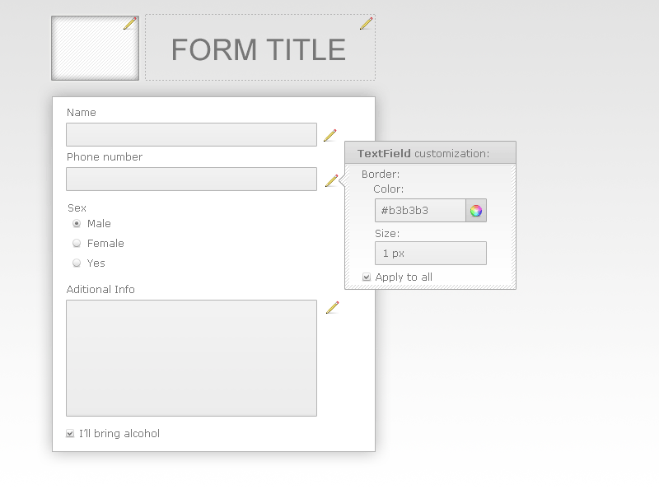
ThemeEditor Logic

The ThemeEditor allow the user to customize each fields in his personal form layout. Each field is identifyed by a CSS's class and id.
On the right side of the input field there's an icon that allow the user to customize some properties of the field ( the set of properties is defined by Fields Group ). The user can choose if apply that change at the selected input field ( using the ID ) or to each fields that belong to that CSS class.

Also than fields customization the user can upload an image to associate to the form and can personalize it with a title.

With ThemeEditor the user can save his theme and re-use it with others forms that he will create.

Property List Structure

var textPropertyList = [
{
"group":"border",
"properties": [
{
"name":"border-width",
"type":"text",
"validator":"size",
"info": "Width of Field Border. Example: 2px"
},
{
"name":"border-color",
"type":"text",
"validator":"color",
"info": "Color of Field Border. Example: #ff00ff"
},
{
"name":"border-style",
"type":"text",
"validator":"none",
"info": "Type of Field Border. Example: solid"
}
]
},{
"group":"background",
"properties": [
{
"name":"background-color",
"type":"text",
"validator":"color",
"info": "Color of Field background. Example: #ff00ff"
}
]

}]

This is an example of the properties binded on a field following the JSON structure. Every properties are groupped by a group name ( like 'border' ). and are composed by 4 fields:
- name: the name to be displayed on the page
- type: the input type for that properties
- validator: the type of validation
- info: the information to show to the user for help purpose

