Theme Editor

Emanuele Ricci, Ivan Litsvinenka, Simone Della Longa
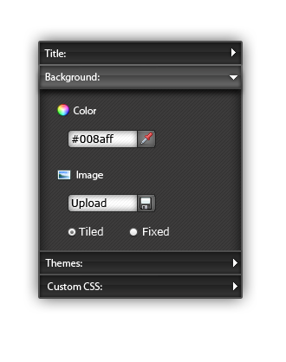

Features

Base:
- Title and font customization
- Upload logo
- Custom background

Advanced:
- Custom CSS
- Custom decoration for each field
- Predefined themes
- Insert HTML snippets

Usage

Form creation:

- WF editor edits the structure and skeleton of the form
- Informations on the form are passed to the Theme Editor
- The theme is changed by the user with the features offered by the Theme Editor. Changes are displayed during the editing process. Custom CSS and HTML are validated using Security APIs
- At the end of the process the changes (CSS, Images, ...) are saved on the Filesystem/Database
Form visualization:
- Gui asks Theme Editor to apply a custom theme to the current form.
- Theme Editor accesses Storage to load the current form's theme informations.
- Theme Editor applies the theme to the form.

APIs

Needed API:
- Storage: storing on database themes informations (css, images, ...)
- Security: CSS and HTML validation

Needed/Offered API:
- GUI: retreive data about the page currently being edited. Offer informations on the themes defined by the user

Offered API:
- GUI: informations on the themes: css, logos and images

RunTime Editor

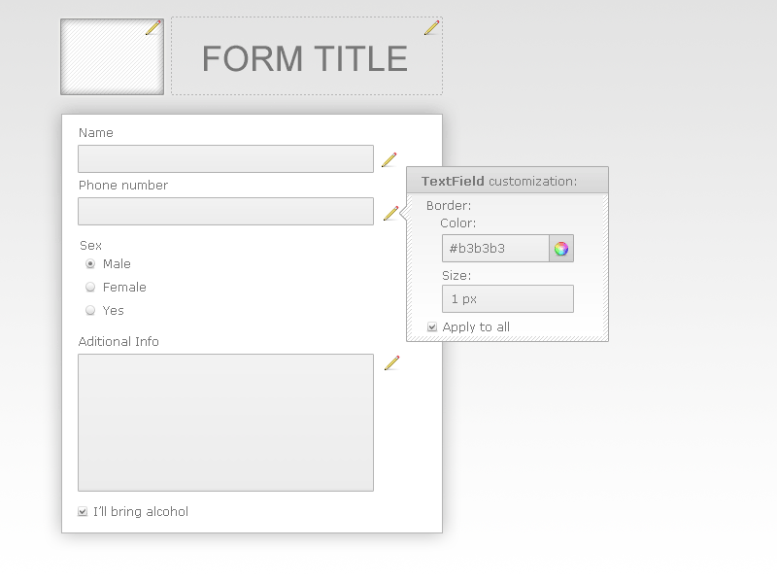

Decorator

