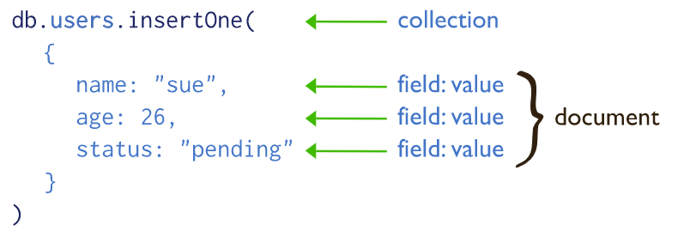

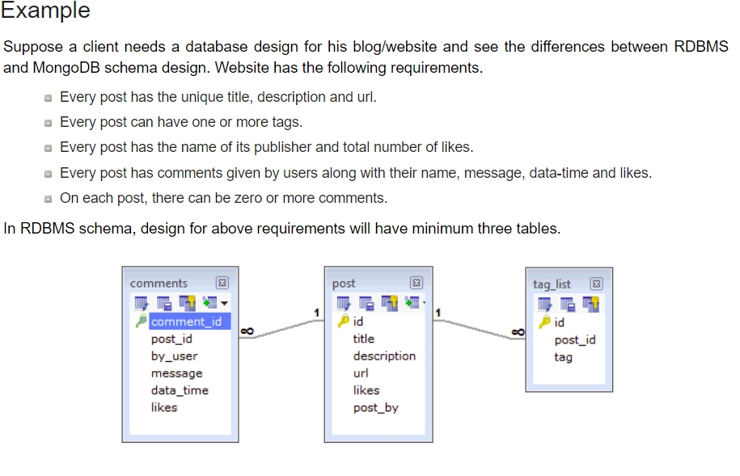

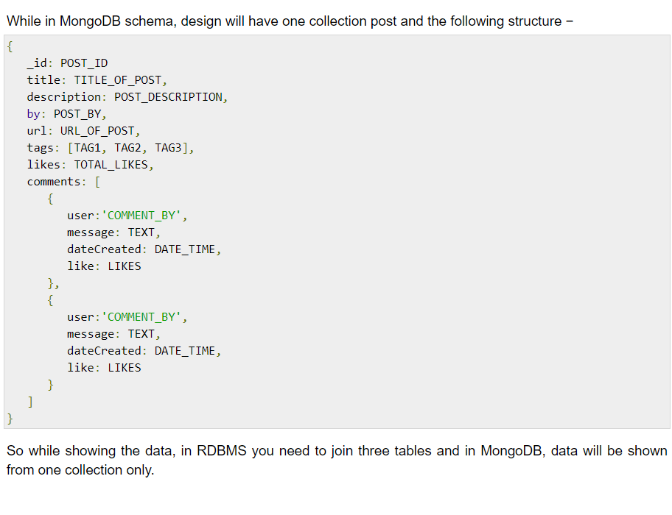

|  |  |  |
| --- | --- | --- |
| **Data Base Type Based on Feature** | **Example of Database** | **Use case (When to Use)** |
| Key/ Value | Redis, MemcacheDB | Caching, Queue-ing, Distributing information |
| Column-Oriented | Cassandra, HBase | Scaling, Keeping Unstructured, non-volatile |
| Document-Oriented | MongoDB, Couchbase | Nested Information, JavaScript friendly |
| Graph-Based | OrientDB, Neo4J | Handling Complex relational information. Modeling and Handling classification. |