Minted 100 MYRSK tokens to account 0. Used MS Windows 10, sublime text editor, truffle framework RSK test network.

Account 0 created on rsk network

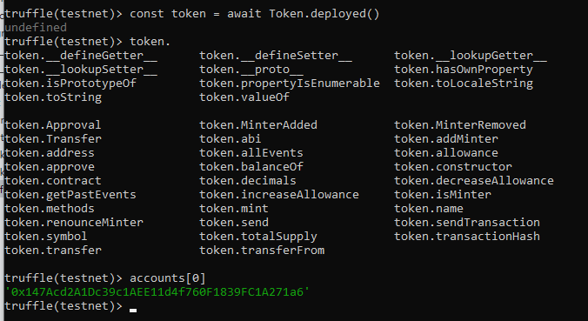

Screenshot of account 0 within RSK test environment showing 100 MRT balance

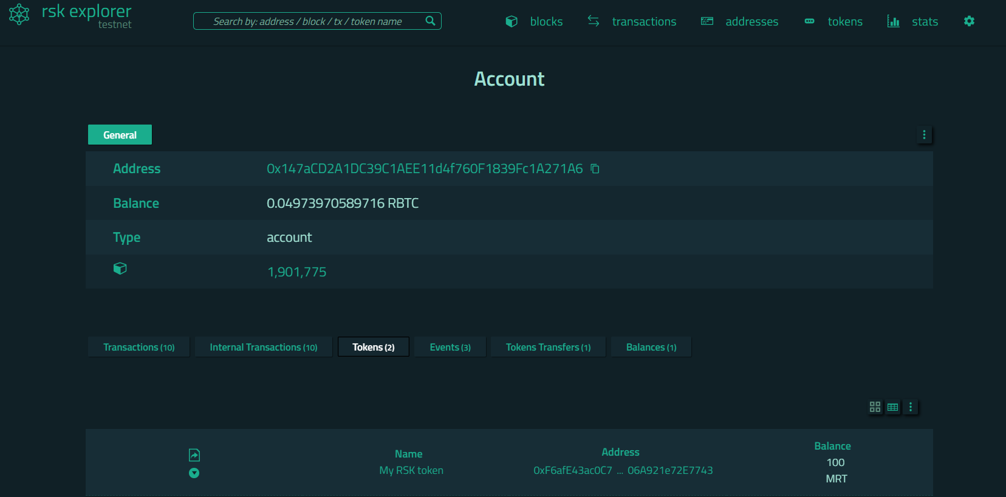

Checking balance of account 0 showing 10000 and results of account 3 key.

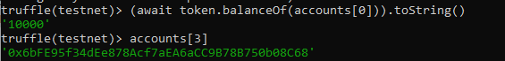

Deploying 'Token'

-----------------

> transaction hash: 0x8f65caee0de254acd573dc2da3b38125741eb49f0f9e29557f56d3b94f53dbdd

> Blocks: 1 Seconds: 60

> contract address: 0xf6afE43AC0c7D28D9306b26C8906A921E72e7743

> block number: 1901667

> block timestamp: 1622922356

> account: 0x147Acd2A1Dc39c1AEE11d4f760F1839FC1A271a6

> balance: 0.04974525478948

> gas used: 1868933 (0x1c8485)

> gas price: 0.05924 gwei

> value sent: 0 ETH

> total cost: 0.00011071559092 ETH