So today we’ll have a spooky Halloween story. What do geomagnetic activity, aliens and Halloween have in common?

The answer is even worse than the notorious tik-tok video that makes one’s eyes leak out. Just because this is a true story. It has been repeated since ancient times every year, and if you understand the hidden meaning of what was said, then your brain will start leaking! For - the mind is like wax, like an old yogin said, who still saw vimanas in the sky - the flying machines of the ancient gods. Humanity is just starting to assemble a mosaic from fragments of ancient knowledge and mathematics to comprehend what is REALLY happening on this planet.

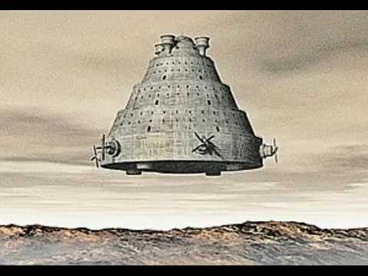
An ancient veman - the “flying chariot” of gods.

The ones who read obscure extracts from Howard Phillips Lovecraft, Zacharia Sitchin, Erich von Däniken and David Icke (among the other lot) remember that since prehistoric times the so-called “intelligent reptilians'' had a cult of the “super-dense gods” from Tartarus (aka “The Old Ones”). In these cult(s) reptilians offered The Old Ones strong emotions of living beings. Yes, it was not the blood itself, but the emotions in particular seem to be a kind of delicacy for these "idiot gods" (the way they’re called in some sources). Subsequent religions of the ancient world were in many ways technically a cargo cult of the forgotten technologies of invocation of “the old ones”. It is for this reason that there have always been some "places of power" characterized by high geomagnetic activity. The explanation may be that the iron compounds in the blood inside capillaries are being affected somehow by that magnetism, therefore amplifying emotionality during rituals, sacraments, orgies and mysteries. But also by solar activity affecting the magnetic kernel of Earth. We don’t know, some geomagnetic activity of Earth’s core might be affected by solar flare, but some of it might have intrinsic planetary reasons like Adolf Hitler fucking Eve Braun inside the hollow Earth using their artificial bodies grown in embryo machines built using pre-reptilian embodiment-tech… Yeah, the embodiment-tech spirits used to experience the low dimensional ‘high of time’ before Solid Earth was a thing, if you get my drift.

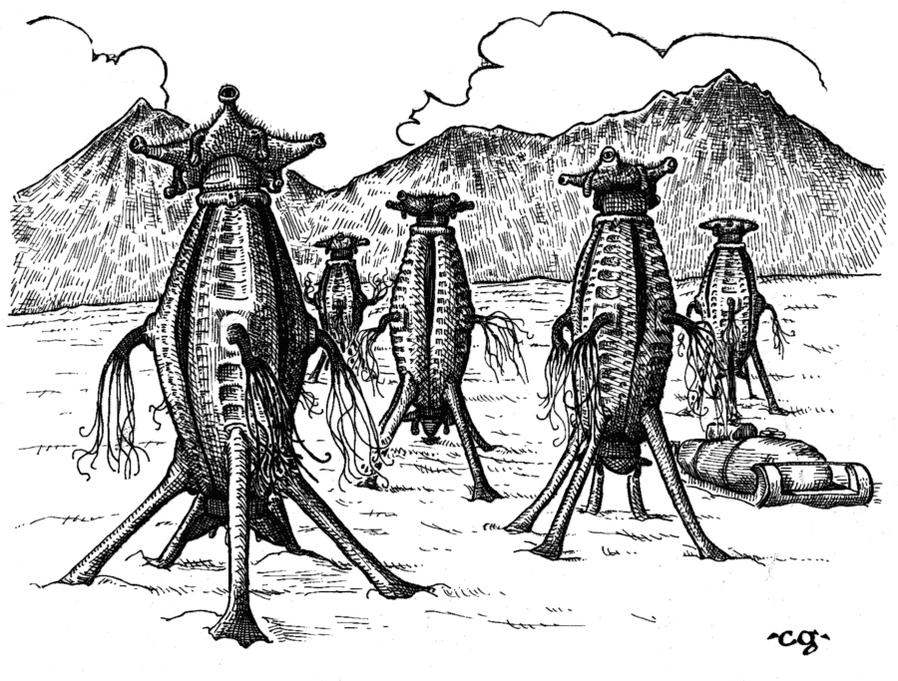
A Lovecraft inspired illustration of some of the old ones.

At the same time, since 1932, an international program has been operating to measure geomagnetic activity through 13 (it’s more now) distributed stations around the globe, compiling data 8 times a day into the so-called Kp Index. The end-of-day average of those 8 measurements is called the Ap Index. We will work with that. The International Service of Geomagnetic Indices (ISGI) is headquartered in Strasbourg, and anyone can view real-time metrics over this link http://isgi.unistra.fr/data_plot.php

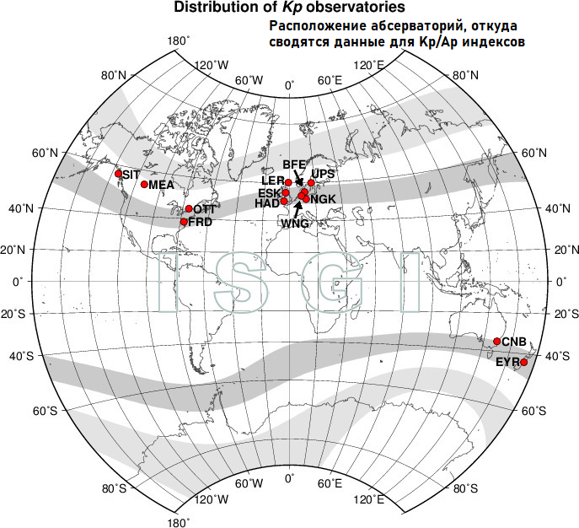

If we decompose the historical data by analyzing the seasonality, we see that there are particularly noticeable ups and downs throughout the year. Moreover, these are well distributed around some well-known dates, often associated with traditional folk and pagan celebrations as well as the significant calendar periods for contemporary religions.

We may propose an idea that the concept of UFO (unidentified flying object) is in the modern world a kind of equivalent or a reference (in human subconscious) to exactly the same phenomena that were associated with the mystical manifestations of this world among ancient people. Among the common associations there goes fear (of unexplainable), and a notion of something incredibly greater than humanity itself, the hope that some knowledge could be acquired from the phenomenon (alien technologies), and even “eros and thanatos” (sexual acts with aliens and participating into their medical experiments executed upon the respondents), something of saint (higher civilizations sharing knowledge on how to improve our world) and chthonic (bad aliens representing fallen angels living in the “hollow earth”). It’s worth mentioning the legendary UFOs seen and reported in the 19th and 20th century that often were described as being built with some kind of technology related to geomagnetism that allowed them to move in a unidirectional mode with ease. Do the devices still fly now and utilize that energy being able to concentrate it and emit some strong interference affecting the observatories? That’s another interesting question.

Now that we explained the significance of the reference to UFOs in the collective unconscious, why don’t we check the seasonality of Google searches for that keyword and compare it with the seasonality of geomagnetic activity across the planet? We took data from 2004 (since earlier data on Google Trends is not available) and displayed it on charts, matching the peaks with green lines. These seasonalities were calculated at the end of September 2021, that is figures for Halloween of this year are not part of it. However, we see a clear peak in geomagnetic activity occurring on this holiday, and also coinciding with the peak for the UFO request. Yes, slightly shifted, but yet vivid.

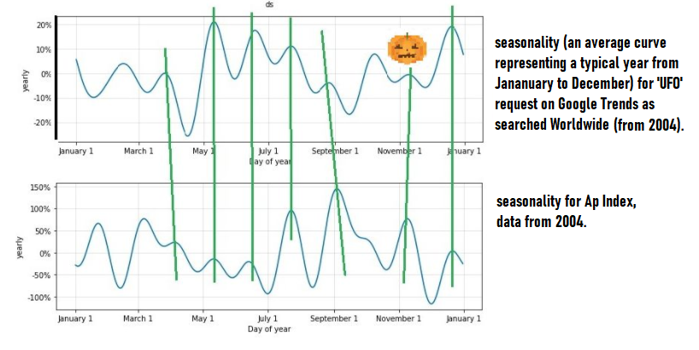
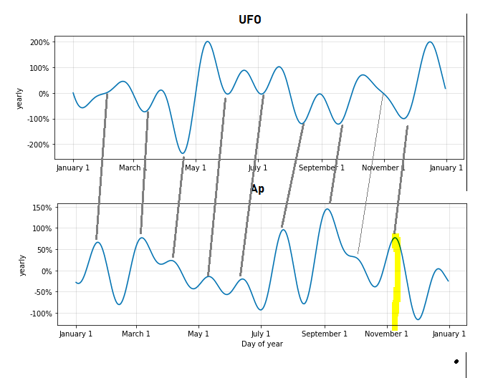

Let's look at the data of queries for the keyword 'UFO' by country. Syria and Albania are far ahead. The latter was rumored back in the 90s about the international hub for massive supply of human organs and narcotic potions. In Syria, about the same is happening now. We also know that conventional "aliens” have always had interest towards the possibility of capturing people for experiments (at least some of them). Now let's see if everything was so this year. That's right, Google Trends and the Geomagnetic Index are showing peaks on exactly October 31, 2021 - see the extra two charts below. The ancient ritual has been completed. Bo-o0О!

UFO data for the last week can be viewed here
https://docs.google.com/spreadsheets/d/1mZXsON8G8e5frev0sSoGPS_hdJBtb1ZGglrbJ1_xHSE/edit?usp=sharing
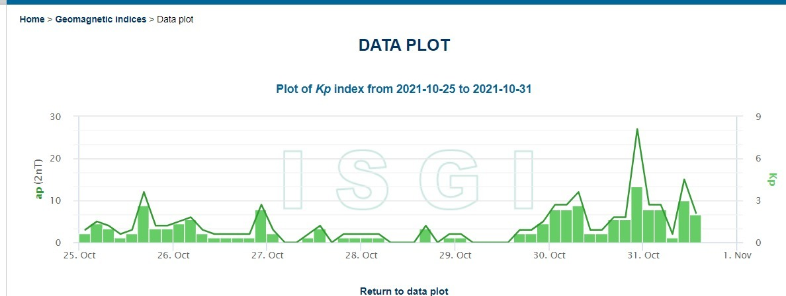
Kp Index, that is intraday data from which the Ap is compiled.

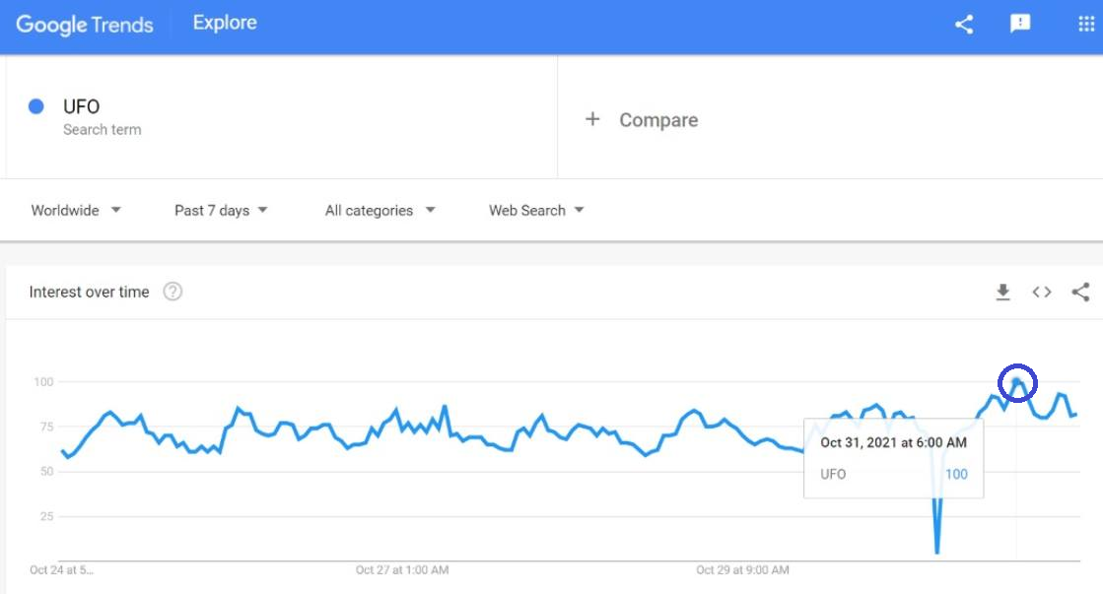
Google Trends data, we see a higher peak for the searches right at 6:00 AM on the day of Helloween.

