**Smiling Tailor**

Welcome to our tailor-centric Custom Business Management System, where the dynamic fusion of **ERP (Enterprise Resource Planning)** and **CRM (Customer Relationship Management)** empowers your tailoring business like never before. Our feature-rich and user-friendly application has been meticulously crafted to streamline your operations effortlessly. With our cutting-edge system, you can easily manage and monitor essential elements of your business, including managers, vendors, inventory, and employees. Effortlessly process orders and witness the seamless flow of transaction history in real-time, ensuring airtight organization, enhanced efficiency, and complete control over your business processes. We take pride in presenting this exceptional software solution, developed in-house by our skilled team at **Algoramming**. Our commitment to quality and reliability ensures that every aspect of our system is fine-tuned to meet the specific needs of your tailoring business, setting you on a path to success with unparalleled ease.

**System Requirements:**

To ensure optimal performance and compatibility, the tailor-focused Custom Business Management System can be run on various devices and platforms. The software supports the following system requirements:

1. **Operating Systems:**

* **Android:** Version 5.0 (Lollipop) or higher.
* **iOS:** Version 11 or higher.
* **Windows:** Windows 7 or higher.
* **Mac:** macOS 10.12 (Sierra) or higher.
* **Linux:** Any modern distribution with a compatible web browser.

1. **Web Browsers:**

* **Google Chrome:** Latest version recommended.
* **Mozilla Firefox:** Latest version recommended.
* **Apple Safari:** Latest version recommended.
* **Microsoft Edge**: Latest version recommended.

1. **Device Requirements:**

* The software is compatible with devices such as desktop computers, laptops, tablets, and smartphones.
* **The minimum screen resolution required is 1170x550 pixels. It is recommended to have a larger screen size for an optimal user experience.**

**Please note that a stable internet connection is required to access and utilize the software effectively.**

The tailor-focused Custom Business Management System has been designed to offer cross-platform functionality, allowing users to access and use the software seamlessly on various devices and operating systems. This flexibility ensures that you can leverage the software's capabilities regardless of your preferred device or platform.

If you have any further questions regarding system requirements or need assistance with the installation process, please refer to the corresponding sections in this documentation or reach out to our support team for further guidance.

**Installation Guide:**

This section provides step-by-step instructions on how to install the tailor-focused Custom Business Management System on your preferred platform. Follow the guidelines below to ensure a smooth installation process:

1. **Downloading the Installation Package:**

* Visit our official website or download the installation package from the designated source. **Currently only for windows (msix file), android (apk file) and web link are available.**
* Choose the appropriate version of the software based on your operating system.

1. **Windows Installation:**

* Locate the downloaded installation package (.msix file) on your computer.
* Right-click on the file and select "Properties."
* In the Properties window, go to the "Digital Signatures" tab.
* Select the "Msix Testing" signature and click on the "Details" button.
* In the Digital Signature Details window, click on the "View Certificate" button.
* Click on the "Install Certificate" button.
* Select "Local Machine" and click on the "Next" button.
* Choose "Place all certificates in the following store" and click on the "Browse" button.
* Select "Trusted Root Certification Authorities" and click on the "OK" button.
* Click on the "Next" button.
* Click on the "Finish" button.
* By following these additional steps, you ensure that the software's digital signature is recognized, enhancing the security and trustworthiness of the installation.
* Now you can proceed with the installation by double-clicking the .msix file and following the on-screen prompts.
* Locate the downloaded installation package (.msix file) on your computer again.
* Double-click the file to start the installation process.
* Follow the on-screen prompts to proceed with the installation.
* Select the destination folder (if appears) where you want to install the software.
* Configure any additional installation settings if prompted.
* Once the installation is complete, you can launch the software from the designated shortcut or Start menu.

1. **Mobile Installation (Android):**
   * On your Android device, go to "Settings" and scroll down to find "Security" or "Biometrics and security".
   * In the security settings, enable the option to "Allow installation from unknown sources" or "Unknown sources". This allows you to install apps from sources other than the Play Store.
   * Open a web browser on your Android device and navigate to the website where you downloaded the tailor-focused Custom Business Management System APK file.
   * Locate the APK file and tap on it to begin the installation.
   * A prompt will appear, informing you about the security risks of installation from unknown sources. Press "Settings" to proceed.
   * In the settings menu, enable the option to "Allow from this source" for the specific APK file.
   * Go back to the installation prompt and press "Install".
   * Once the installation is complete, you can find the software icon on your home screen or app drawer.
2. **Web Installation:**

* Ensure that you have a compatible web browser installed on your device (such as Google Chrome, Mozilla Firefox, or Microsoft Edge).
* Open your preferred web browser.
* Type the URL of our tailor-focused Custom Business Management System in the address bar ([smilingtailor.algoramming.com](https://www.smilingtailor.algoramming.com/)) and press Enter.
* The website will load, and you will be directed to the landing page or login page of your tailor-focused Custom Business Management System.
* If you already have an account, enter your login credentials (username and password) and click on the "Log In" or "Sign In" button.
* After successfully logging in, you will have access to the tailor-focused Custom Business Management System, where you can manage your tailoring business, track transactions, inventory, employees, and customer orders.

If you encounter any issues during the installation process or need further assistance, please refer to the Troubleshooting and FAQs section or contact our support team for prompt help.

**User Guide:**

Welcome to our tailor-focused Custom Business Management System, a powerful software solution designed to streamline your tailoring business operations. The system caters to three types of users: **Admin, Manager, and Operator.** The Operator role grants access to the order management section, allowing users to efficiently handle orders. Managers have access to all sections except for the Manager Configuration part. Finally, the Admin user possesses super admin powers, enabling full access to all system features, including the ability to manage users and access the Manager Configuration section. Our software offers a range of sections, including Dashboard for order and manager summaries, Profile for user details and customization, Vendor for managing vendors and their transactions, Inventory for inventory management and profitability analysis, Employee for managing employee details and transactions, Order for order creation, allocation, and tracking, Invoice for invoice management and printing, Manager Configuration for user account management and role assignments, and Settings for theme, language, and currency customization. With our tailor-centric Custom Business Management System, you can optimize your operations, enhance productivity, and achieve business success.

* **Dashboard:** The Dashboard provides a comprehensive overview of your business's key information. It allows you to monitor the progress of your tailoring orders and manage your team effectively. On the Dashboard, you can find a summary of pending orders, giving you insights into the number of orders awaiting processing or completion. Additionally, all orders summary provides an overview of all your orders, tracking the total number of orders received, completed, and delivered. Furthermore, you can view a list of your managers and their transaction summaries, enabling you to assess their performance and allocate resources effectively. The Dashboard also includes a section where you can conveniently copy all customer phone numbers or emails. This feature allows you to send greetings to your customers via mobile phone messages or emails. You have the option to add a suffix or prefix to the list if desired, allowing for personalized and customized greetings. The Dashboard serves as a centralized hub, providing a convenient and efficient way to stay updated on pending orders, track overall performance, manage your team successfully, and maintain strong customer relationships through personalized greetings.

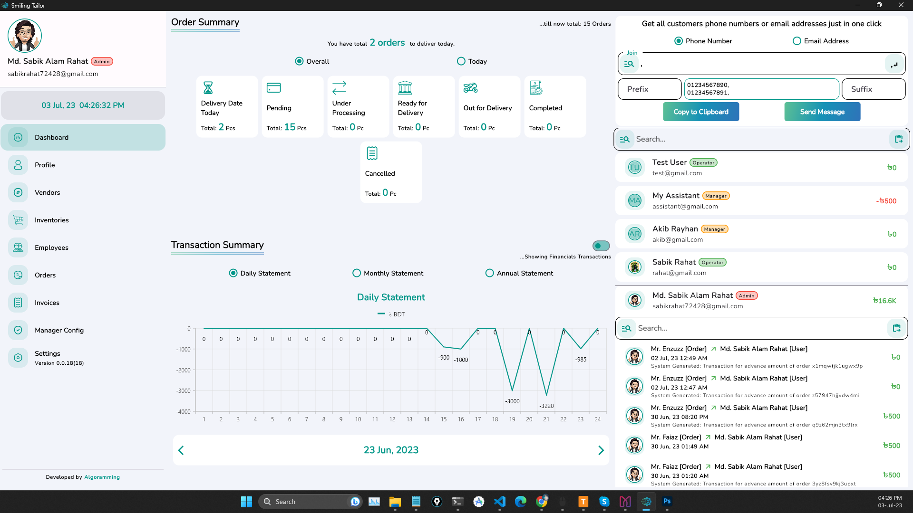

**Figure: Glimpse of Dashboard**

* **Profile:** The Profile section allows users to view and manage their personal information easily. Within this section, users can access their profile details, such as their name and profile picture. They can view and update their name to keep it accurate and up to date. Additionally, users can upload or change their profile picture, allowing them to personalize their account. The Profile section provides a simple and user-friendly interface for users to review and modify their basic information, ensuring that their account reflects their identity and preferences accurately.

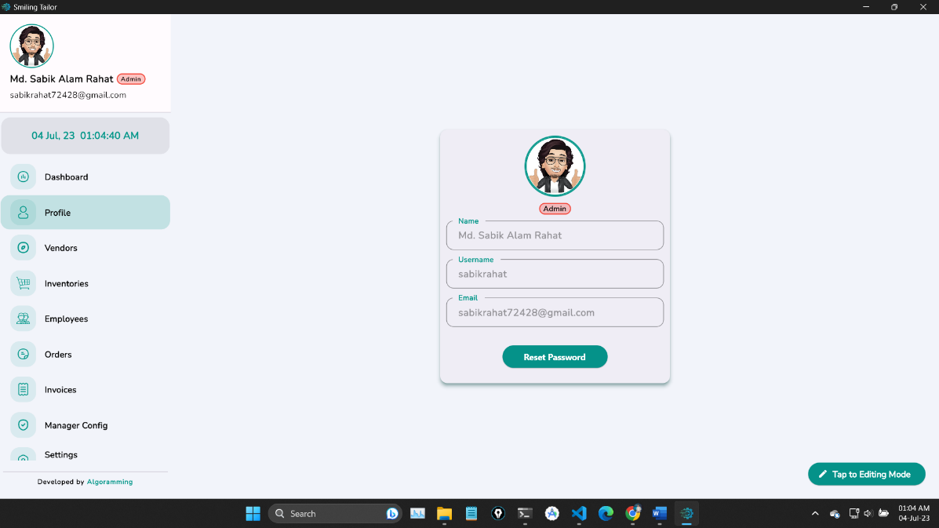

**Figure: Profile Management**

* **Vendor:** The Vendor Management feature enables real-time management of vendors and their transactions. Easily add new vendors with their initial opening balance and track their transaction history. Monitor inventory availability specific to each vendor and seamlessly add new transactions to reflect changes in the vendor relationship. All transactions are updated in real-time, ensuring immediate visibility and synchronization across users. This feature enhances efficiency, transparency, and collaboration, empowering you to make informed decisions and maintain strong vendor relationships.

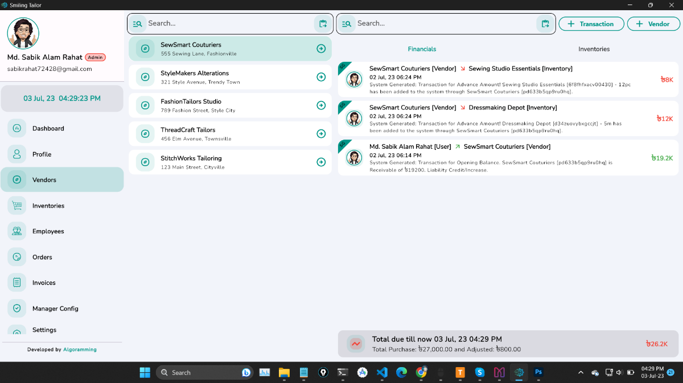

**Figure: Vendor Management**

* **Inventory:** The Inventory Management feature offers comprehensive control over your inventory operations. With this feature, users can effortlessly purchase inventory from any registered vendor, while gaining insights into which inventory items are associated with specific orders and their corresponding purchase amounts. The system provides a concise summary of each inventory item, indicating whether it is generating profit or not. Users can quickly assess the profitability of their inventory investments at a glance. Additionally, a detailed statement is available, offering a comprehensive overview of each inventory item's financial performance. The Inventory Management feature ensures efficient inventory tracking, profitability analysis, and informed decision-making, allowing you to optimize your inventory management processes and drive business success.

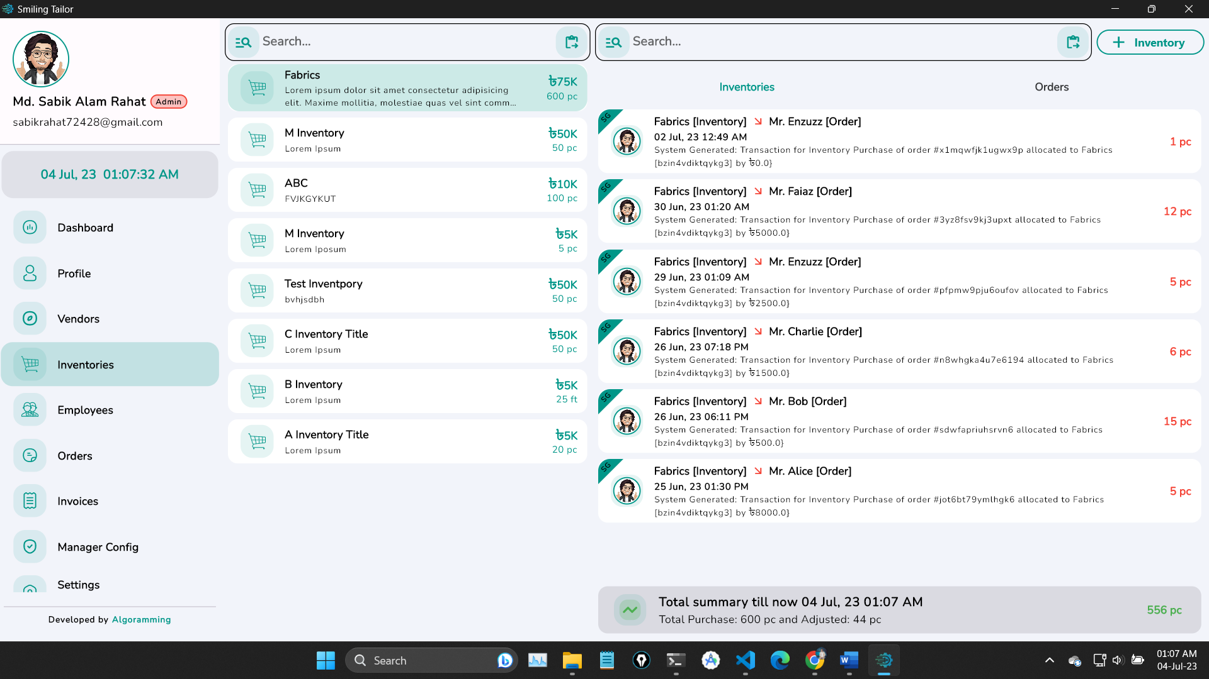

**Figure: Inventory Management**

* **Employee:** The Employee Management feature offers comprehensive control over your workforce. Users can easily add and manage multiple employees, providing detailed information for each one. This includes tracking the full transaction history for employees, allowing users to monitor any amounts taken by them at any given time. At the end of each month, users can view the payable amount for each employee after adjusting their finances. Furthermore, the system provides a complete order completion list for each employee, enabling users to track their productivity. By accessing the monthly statement summary, users can assess the profitability of each employee in relation to their salary. This empowers users to make informed decisions and evaluate the performance of their workforce. The Employee Management feature streamlines the management of employees, providing valuable insights into their transaction history, order completion, and financial impact on the business. By effectively tracking and analyzing employee performance, users can optimize their workforce management and ensure profitability.

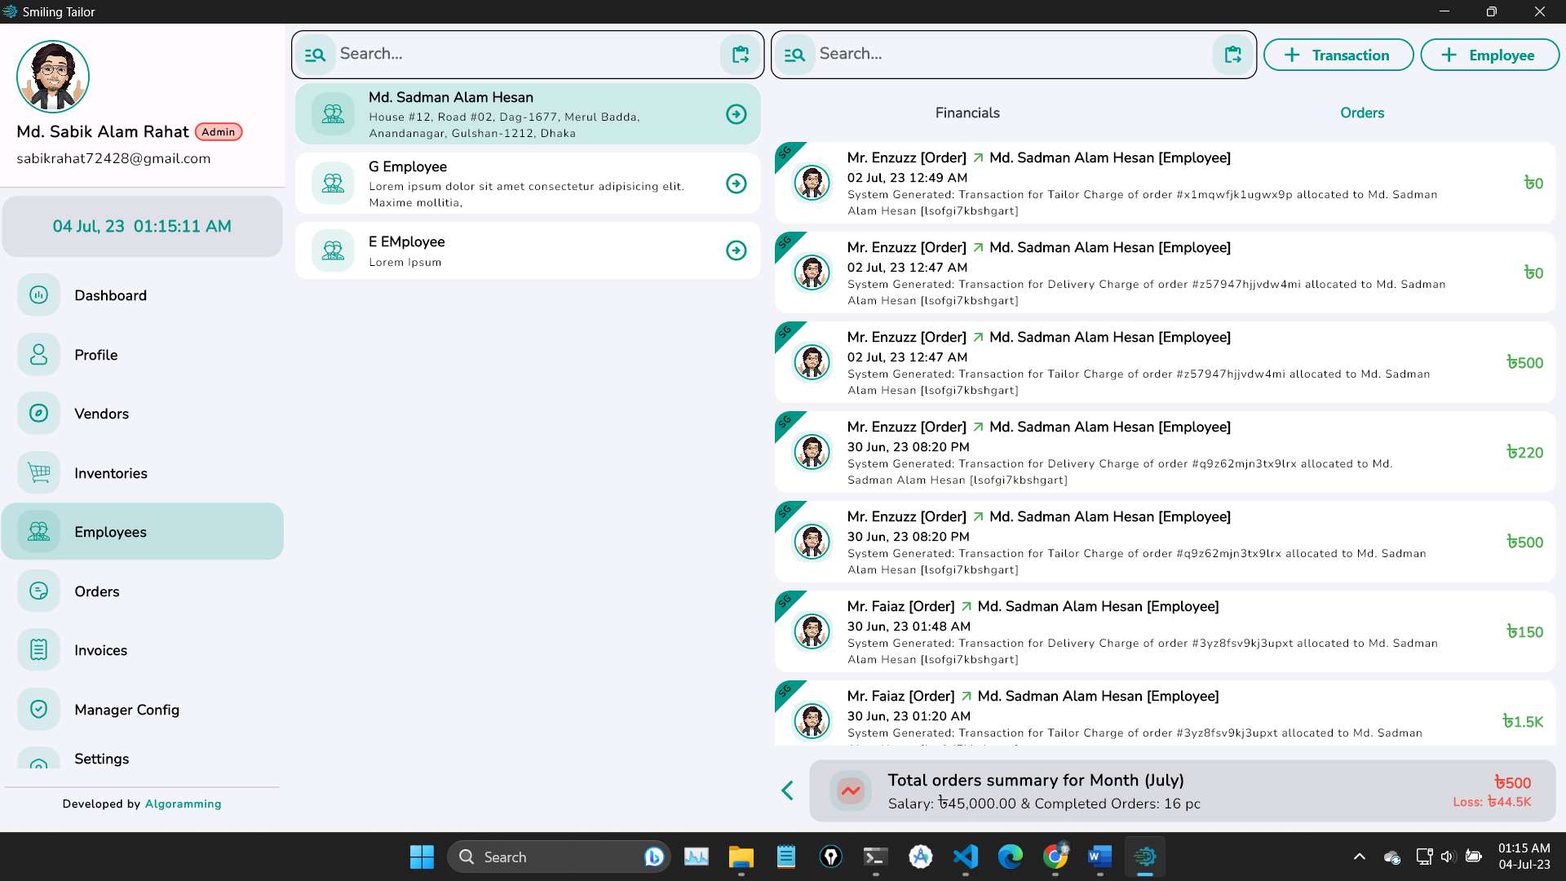

**Figure: Employee Management**

* **Order:** The Order Management feature allows users to efficiently handle orders from start to finish. Users can easily create new orders, make necessary edits, and generate downloadable slips such as the **cashier copy, tailor copy, and customer copy**, all formatted as **A5 size** pages. Additionally, users can assign a specific tailor to each order and set their respective charges. The system seamlessly integrates inventory details, enabling users to associate the inventory items used in the order and their corresponding prices if purchased from the store. Furthermore, users have the flexibility to allocate another employee if home delivery is required. With a comprehensive transaction history, users can track the financial aspects of each order, including payments and outstanding amounts. The system provides a clear overview of the remaining balance, allowing users to monitor outstanding payments in detail. The Order Management feature optimizes the order fulfillment process by providing essential functionalities, including order creation, slip generation on A5 size pages, tailor allocation, inventory tracking, employee assignment, and comprehensive transaction history. This streamlines operations, enhances efficiency, and ensures seamless order management for your tailoring business.

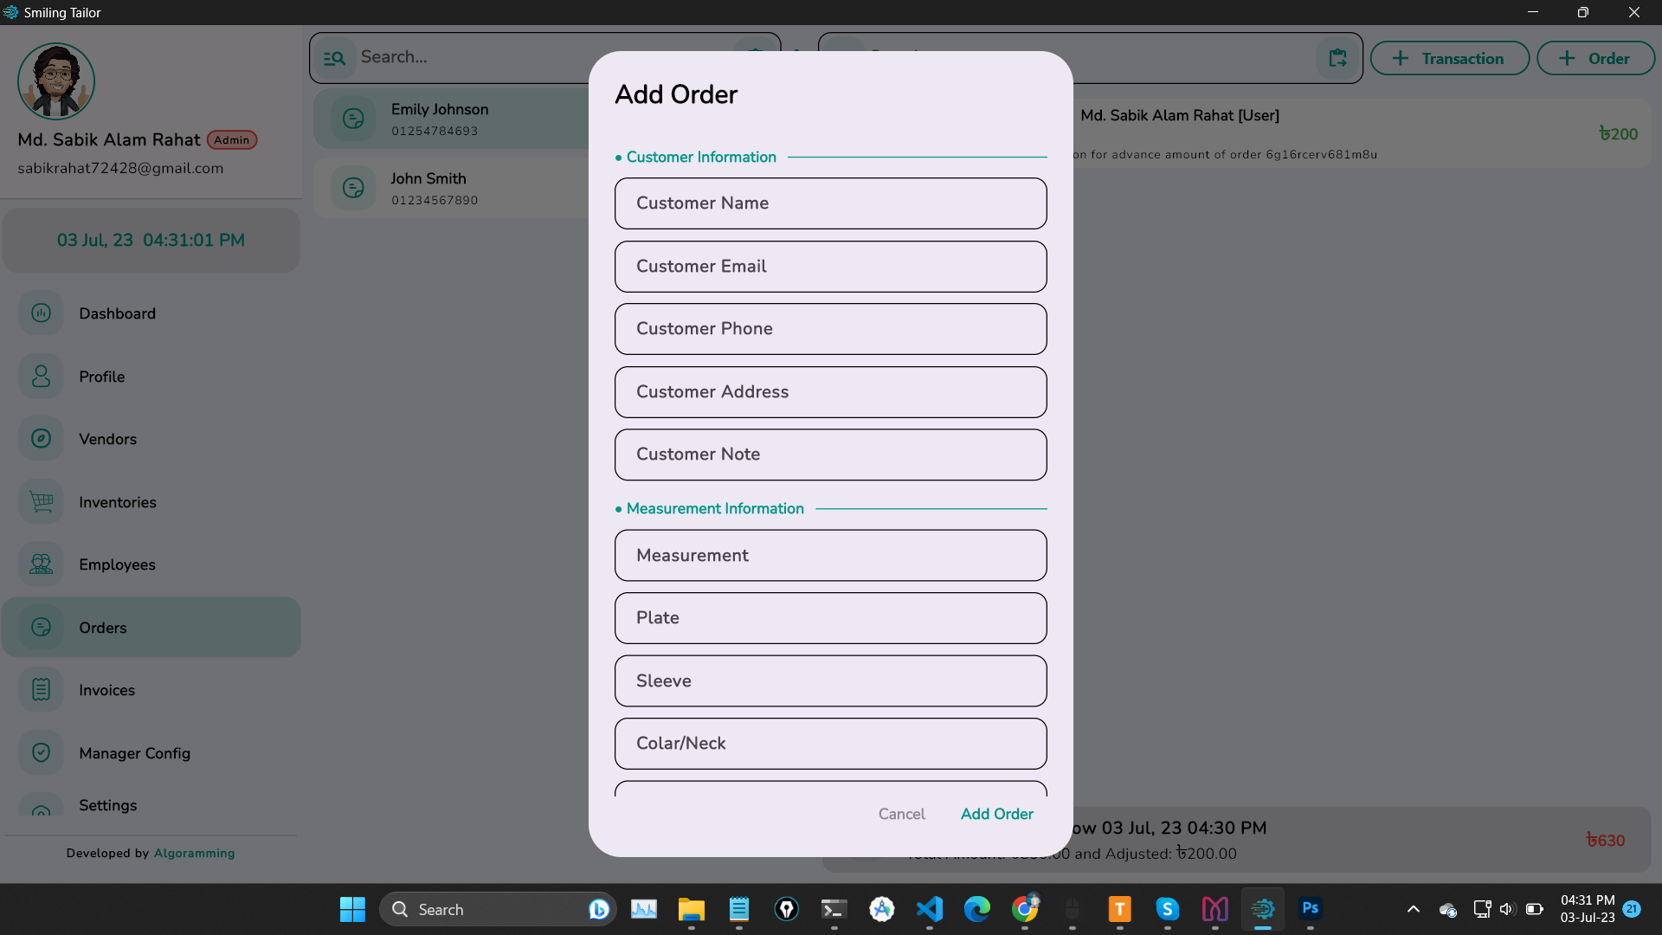

**Figure: Order Management**

**Figure: Slip Download Option**

* **Invoice:** The Invoice Management feature allows users to conveniently view and download invoices with ease. Users can access all invoices at a glance, perform searches, and print them as needed. Furthermore, users have the flexibility to select and send invoices via email or share them in their preferred format. Please note that the Invoice Management feature is not available on the web platform. However, it is fully functional on other platforms such as Android, iOS, macOS, and Windows. This ensures that users can leverage the benefits of invoice management across multiple devices, making it accessible and convenient for their business needs.

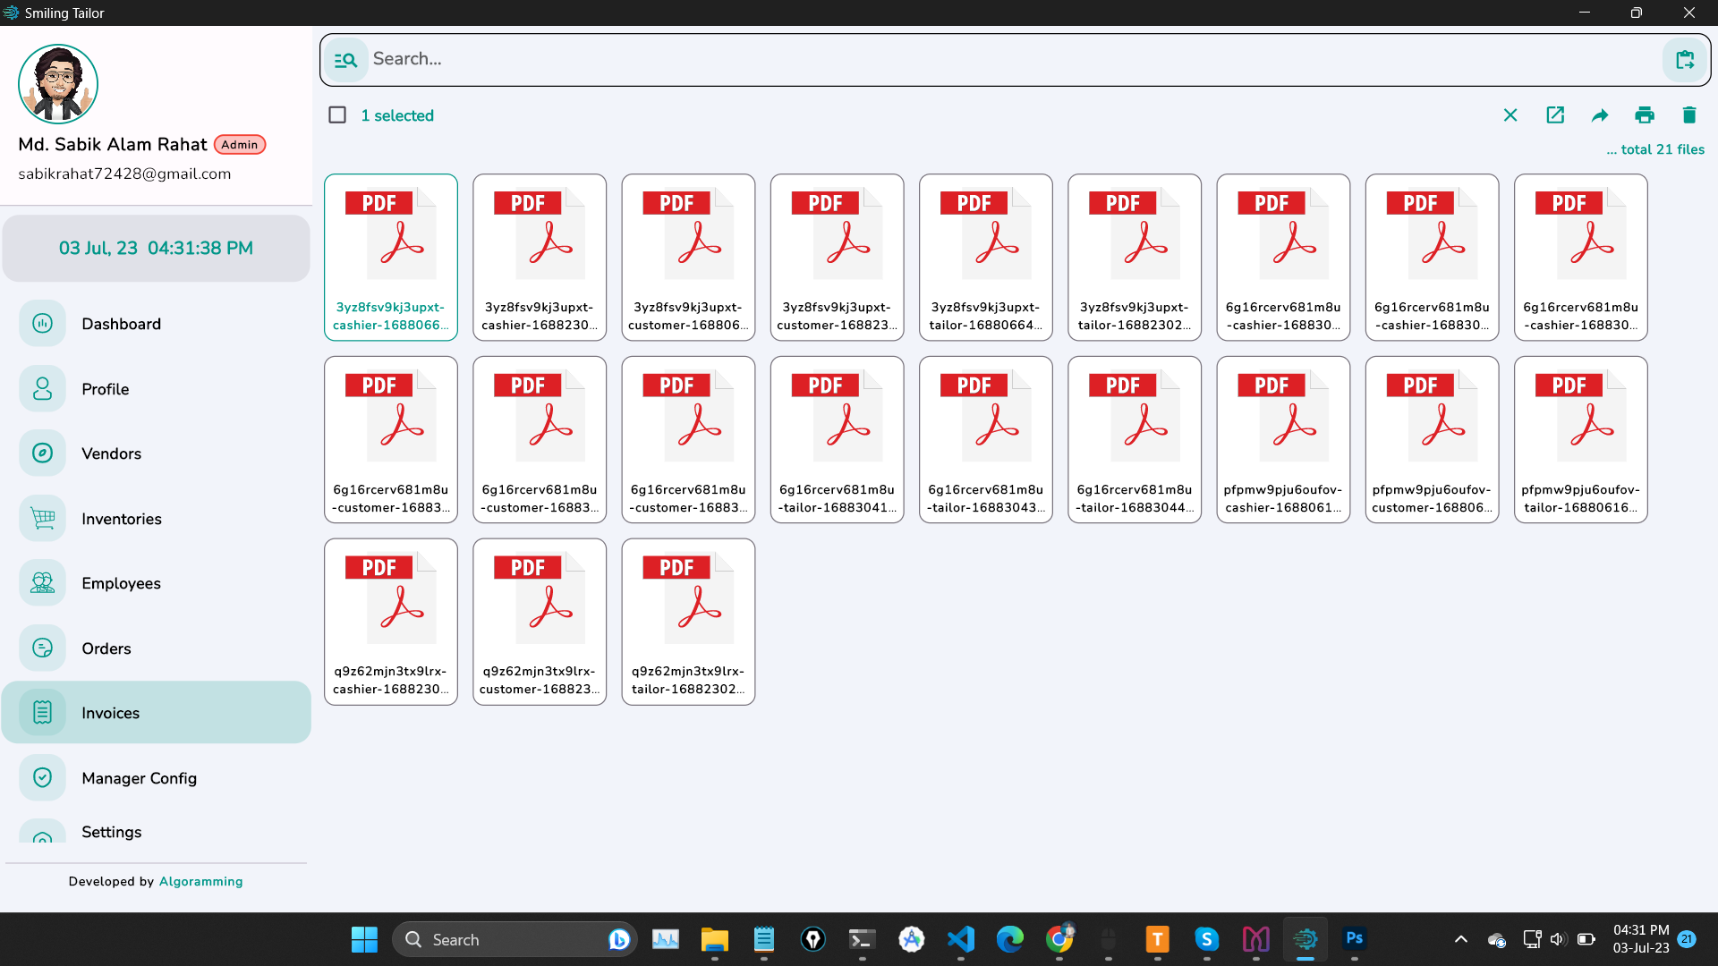

**Figure: Invoice Management**

* **Manager Config:** The Manager Configuration feature empowers users to manage user accounts and assign different roles within the system. Users have the capability to create new user accounts, allowing for the addition of managers or other authorized personnel. Additionally, users can modify user roles, granting or restricting access to specific features and functionalities based on individual responsibilities and requirements. This feature promotes effective user management, enhancing security and ensuring that the right level of access is granted to the appropriate individuals within the organization.

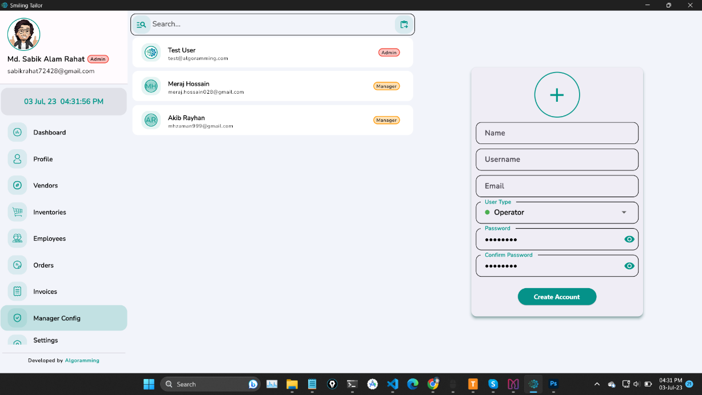

**Figure: Manager Configuration**

* **Settings:** The Settings feature offers a range of customization options for a personalized user experience. Users can effortlessly switch between dark and light mode themes, choose their preferred language, and customize the currency format. Additionally, they can select from various font styles to suit their visual preferences. Advanced settings provide access to licenses and agreements, as well as a convenient link to the main admin panel dashboard for more comprehensive control. With the Settings feature, users can tailor the application to their liking, enhancing usability and flexibility.

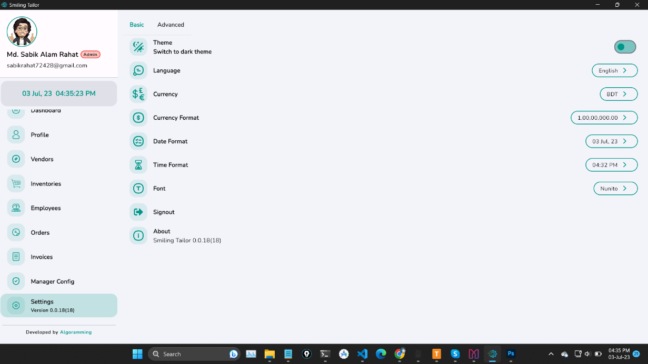

**Figure: Settings Part**

In conclusion, your tailor-focused Custom Business Management System is not only designed to streamline your operations but also prioritize the security of your data. We understand the importance of safeguarding sensitive business information and have implemented robust security measures to protect your data from unauthorized access or breaches. Our system utilizes industry-standard encryption protocols to ensure the confidentiality and integrity of your data during transmission and storage. Regular security audits and updates are conducted to identify and address any potential vulnerabilities, ensuring that your system remains secure and protected. Additionally, user access controls and role-based permissions are in place to limit access to sensitive features and data, ensuring that only authorized individuals can view and modify critical information. We are committed to maintaining the highest standards of security within our tailor-centric Custom Business Management System. Your trust and the security of your data are of utmost importance to us. If you have any security concerns or questions, please feel free to contact our support team or the system administrator. Thank you for choosing our solution, and we are dedicated to providing you with secure and reliable software experience.

**Note: If you have any questions or would like to discuss the project further, please don't hesitate to contact us. We would be happy to provide additional information and answer any of your questions. You can reach us by email at** [**algoramming@gmail.com**](mailto:algoramming@gmail.com) **or by visiting our website at** [**algoramming.com**](https://algoramming.com/)

***--***

***For any kind of queries or future updates you are always welcome.***

***Client satisfaction is our main motive.***