**Software Project Management Plan for thestateobserver.000webhostapp.com**

**Alex Gorinson**

**Revision record:**

1st Edition – 6/15/2020

2nd Edition – 6/25/2020

3rd Edition – 7/14/2020

**Preface:**

Scope and Purpose: The goal of this document is to outline the tools and other various topics that will be utilized when creating the product. Most off the time when a person wants to research a country’s political structure, it would require a lot of researching and “googling” on the person’s part in order to find the wanted information. To solve this problem creating a resource that already has all the information on a countries politics is of a paramount concern. The website will have sections for all countries recognized by the United Nations (UN) and a couple unorganized but widely known nations that people can visit in order to learn about the country’s political situation in that country. The website will have a section where someone can search up a country by typing it or by looking for it alphabetically using its commonly known name. The website will also have an interactable world map that a user can click on in order to learn about the wanted country.

**Table of Contents**

1: Title page

2: Revision Record

3: Preface

4: Table of Contents

5: Project overview, Project Deliverables, Evolution of SPMP, Reference Material, and Definitions and Acronyms

6: Process Model, Organizational Structure, Project Responsibilities, and Organizational Interfaces

7: Management Objectives and Priorities, Assumptions, Dependencies and Constraints, Risks Management, and Monitoring and Controlling Mechanisms.

8: Methods Tools and Techniques, Software Documentation, Project Support Functions

9: Work Breakdown Structure, Project schedule (Gantt Chart)

10-11: Use Cases

**Project Overview**

This project aims to create a centralized resource for political related information for every country in the world. The project itself is for the website called **thestateobserver.000webhostapp.com**. On this website it will be separated out into multiple sections, but the prevalent sections are the alphabetical country, about the website, social media, and world map section. Once on the website users will be able to either select through the country names to find their chosen country or enter it in through the search bar to find the name of the country. The main source of revenue for the website will be from donations and from ads served to everyone accessing the website.

**Project Deliverables**

SPMP: 06/26/2020

System test plan: 07/03/2020

Homepage, About the website, Social Media Section finished: 07/10/2020

Alphabetical country section finished: 07/14/2020

World map Section finished: 07/16/2020

Completed Website: 07/24/2020

**Evolution of the SPMP**

I anticipate that when actual construction of the website begins that changes will likely occur to either the design of certain functions of the website. In the case that changes are made then the SPMP will be updated and the revision record will then be updated to reflect the fact a change was made. When changes to the website are made, an announcement from the author will be posted on the about the website section.

**Reference Materials**

Agile development picture:

“Agile Model Software Engineering.” *Agile Method*, 2020, static.javatpoint.com/tutorial/software-engineering/images/software-engineering-agile-model.png.

**Definitions and Acronyms**

Tasks: Work items to be completed in order necessary to produce a certain product.

Schedules: The mapping of work items onto a timeline.

API: A set of functions and procedures allowing the creation of applications that access the features or data of an operating system, application, or other service.

**Process Model**

I plan on using the agile development process as it gives me the most power and opportunities to go back and change a part of the project should I find it lacking. It also allows for the greatest communication with the customer in the creation of the requirements for the project.

*(Graphic from javapoint.com)*

**Organizational Structure**

The organizational structure will feature only the main author which is Alex Gorinson who will serve as the client liaison, infrastructure, documentation, and developmental team lead.

**Organizational Interfaces**

The product will be developed on the website WordPress. Custom applets and software will also be developed using JavaScript and python.

**Project Responsibilities**

Due to the nature of the assignment (Individual) almost all creation, management, user contact, and payment will be the responsibility of the author Alex. The hosting for the website will be the responsibility of WordPress.

**Management Objectives and Priorities**

The management philosophy that will be practiced is that of incremental progress. Incremental goals with dates will be set for development and the developer will strive to meet those goals by the said date. Priority will be given to ensuring a stable API can be found that allows for information to be streamed and converted on the website to information that is useable by all users.

**Assumptions, Dependencies and Constraints**

The project depends on first, that WordPress allows for a higher level of development that is to be suited for what the developer is looking to do. Second, that an API can be found that allows for data to be transmitted and changed on the website. Finally, that the chosen language of JavaScript or Python allows for customization that would be needed for the site.

**Risk Management**

There are certain risks that come along with the project and the process on the project. For example, if WordPress is taken down, I plan to immediately migrate to either hosting my own server or godaddy.com. Next, if the API’s I try to use either break or don’t work I plan to have a way to manually enter in a country’s political information. Finally, if I find that the free version of WordPress is not useful, I plan to use the paid version of WordPress for the duration of classes.

**Monitoring and Controlling Mechanisms**

For the reporting on the website I plan to create a blog type area in the “About the website” section which will allow me to announce any changes and information about the website there.

**Methods, Tools and Techniques**

The main development tool that will be used for the website will be notepad++ and native html language. If API’s are found that can be used on the website they will be employed, but if not, the political information will be hard coded/manually entered in. One api will also be used from restcountries.eu which will help display all relevant information about the selected country. This section will likely be updated in the future to reflect and such changes to tools should they not be useable.

**Software Documentation**

At almost every stage of the building of the website documentation will be produced in order to ensure that nothing is lost during the building of the site. These documents will then be uploaded to the GitHub repository where a log of the changes and software documentation will be kept.

**Project Support Functions**

To ensure quality assurance I will be having at least three different people come to give constructive feedback onto the site. I will then add their feedback and change the site followed by three different people being asked to review the site then adding their changes into the site. Finally, I will ask the 30+ members of my fraternity to review the website and have them submit their thoughts on the website to a google response form.

**Work Breakdown Structure**

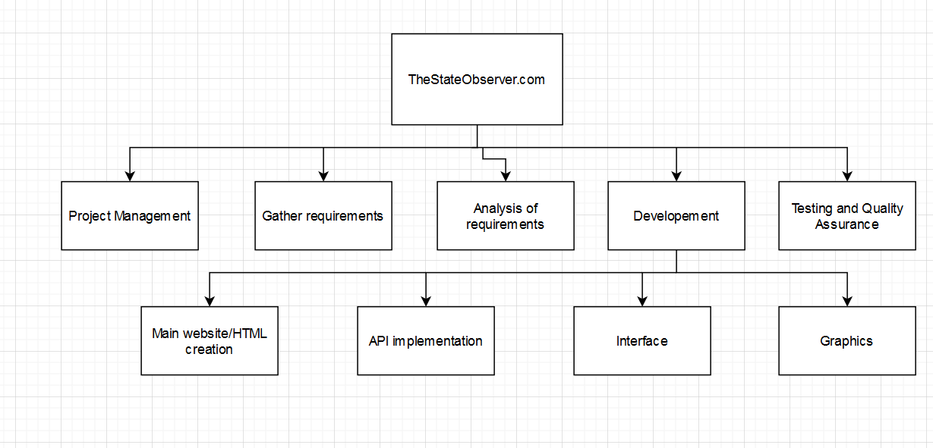

**Project Schedule**

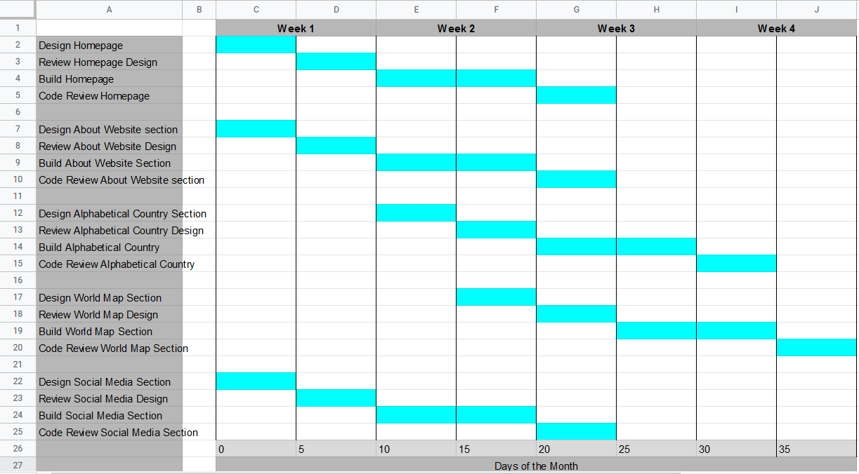

**Use Cases:**

User want to use the search bar for a particular country.

-The user wants to search for a particular country using the search bar since they know the spelling of the country. The user will click into the search bar on the top right of the screen in order to begin to type. The user will then type the name of the country into the search bar and hit enter when they are done typing. They will then click on the country to most closely matches what the user was typing. The user will then be brought to that countries page.

User wants to use the A-M list to find a particular country.

-The user wants to search for a particular country that starting with the letter A – M using the A – M country list. The user will click on the A-M country tab that will bring them to the list of countries with the first letter starting with A – M. The user will then search the list for the country and when they find it, click on it to be brought to the countries page.

User wants to use the N - Z list to find a particular country.

-The user wants to search for a particular country that starting with the letter N – Z using the N – Z country list. The user will click on the N – Z country tab that will bring them to the list of countries with the first letter starting with N – Z. The user will then search the list for the country and when they find it, click on it to be brought to the countries page.

User wants to use the world map to find a particular country.

-The user wants to search for a particular country on the website’s world map. The user will click on the world map tab which will bring them to a map of the world. The user will then be able to click on a particular country in the world map that will then take them to the page for the clicked country.

User wants to view a countries political information.

-The user wants to view a country’s political information. The user will navigate to a country using any of the methods mentioned above (search, A-M or N-Z list, or world map) and enter the countries page. Upon entering the page, the user will be able to view the country’s current executive leader, next election date, current legislature, current political parties in power, and ideology of those parties.

User wants to view the announcements for the website.

-The user wants to view what announcements have been posted about the website. The user on the main page will click on the “About the website” tab which will bring them to the About the website page. Here the user will be able to view all the announcements that have been posted from the author.

User wants to post to their social media from the social media section.

-The user wants to post on social media from the social media section. The user on the main page will click on the social media tab which will bring them to the social media page. Here the user will be able to click on the social media widget of the liking from all the social media websites.

User wants to post on social media from a countries page.

-The user wants to post on social media from a selected countries page. The user on a countries page will navigate down to the social media widget on the selected countries page. They will then click on the widget which will allow them to post on social media with a link to the countries page and information about the country.

User wants to message site owners regarding an issue or idea for the website.

-The user wants to message the website owners regarding an issue or idea for the website. The user on the homepage will navigate to the “About the Website” section. On this section they will see a “Contact Us” tab, clicking on it will allow the user to view an email address that the user can email to send their issue or idea.