**CST 336 Team Project: Jessica Vega, Laura McRae, Michael Fernandez**

**Database Schema:**

**general_info**

Name

animal_ID (primary key)

description

**detailed_info**

animal_ID (primary key)

gender

color

size

age

**animal_cost**

animal_ID (primary key)

adoption_fee

**Mock Up:**

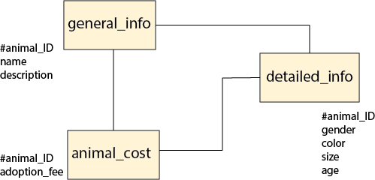

**User Story:**

Individuals from all over the galaxy will have access to an easy and convenient way to adopt all kinds of animals, from Humans to Whales. Users can sort the list of creatures available at the Human Society for the Adoption of Odd Animals by ascending or descending ID or Age. They may also wish to sort by a specific age, gender, or adoption fee amount and these are all possible at this site.

Once the user selects an animal, their species is displayed in the lower right-hand corner of the page. When the user wishes to adopt an animal (add them to their cart), they select the checkbox next to that animal’s name. Then, to view the cart, they click the appropriate button and are taken to a page that contains the contents of their cart.