Casey Carr

HW1 Comp 7745

2/19/2019

7. (a) From the graph below which shows avg. precision vs avg. recall (for 5-fold cross validation),

for varying values of the pruning confidence parameter (min_samples_leaf in sklearn), at some threshold level, say 40, as we increase the minimum number of samples on which we branch, precision and recall are optimized.

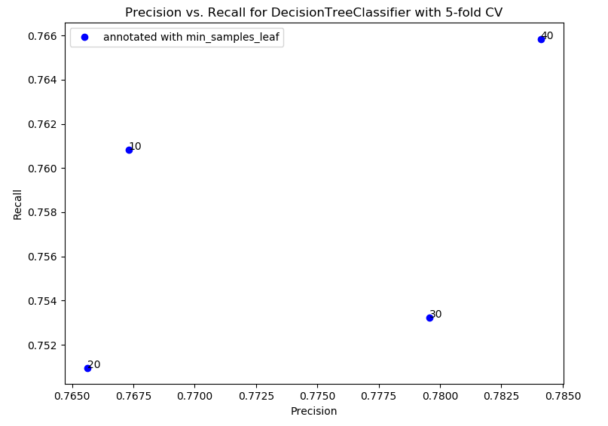

(b) The combination of learning rates and hidden layers with the best performance in terms of average F1-score is learning_rate = 0.01 and validation_fraction = 0.1. As we increase the validation_fraction, performance seems to deteriorate.

