Casey Carr

10/06/2018

Scientific Computing

Left Eigenvectors:

[[ 0.39923508 258.30673311 2.24948173]

[ 0.40434127 309.5371355 2.23421763]

[ 0.39700655 260.43284353 2.25415705]

...,

[ 0.60574005 -392.12927648 -1.13816255]

[ 0.60865836 -380.99087786 -1.13310509]

[ 0.61123511 -380.53821037 -1.1141282 ]]

Recovered Images via Span(U):

Image1

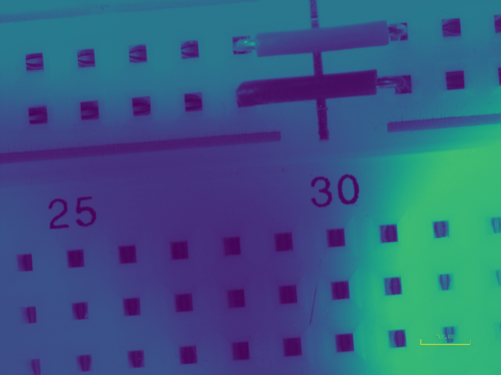

Image 2

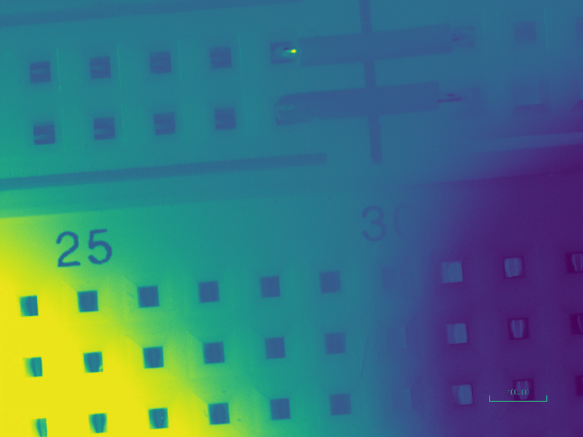

Image 3

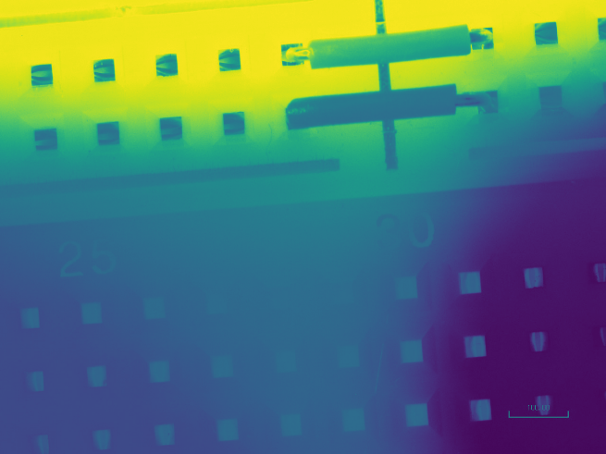

New Images:

