AN ULTRA LOW POWER 10 TRANSISTOR 1 BIT
MAGNITUDE COMPARATOR USING GATE
DIFFUSION INPUT TECHNIQUE
by
SHAHREAR HOSSAIN
BACHELOR OF SCIENCE IN ELECTRICAL AND ELECTRONIC
ENGINEERING

Department of Electrical and Electronic Engineering
INTERNATIONAL ISLAMIC UNIVERSITY CHITTAGONG
OCTOBER 2026

AN ULTRA LOW POWER 10 TRANSISTOR 1 BIT
MAGNITUDE COMPARATOR USING GATE
DIFFUSION INPUT TECHNIQUE
by
SHAHREAR HOSSAIN
A thesis
submitted as partial fulfilment of the requirement for the degree of
BACHELOR OF SCIENCE IN ELECTRICAL AND ELECTRONIC
ENGINEERING
Department of Electrical and Electronic Engineering
INTERNATIONAL ISLAMIC UNIVERSITY CHITTAGONG
OCTOBER 2026

CERTIFICATE OF APPROVAL
The thesis entitled “An Ultra Low Power 10 Transistor 1 Bit Magnitude Comparator Using Gate Diffusion Input Technique” submitted by Shahrear Hossain, bearing Matric ID: ET223104 of the session Autumn 2022, to the Department of Electrical and Electronic Engineering, International Islamic University Chittagong, has been accepted as satisfactory in partial fulfilment of the requirements for the degree of Bachelor of Science in Engineering and approved at the examination held on October 2026.
_____________________________
Signature of the Supervisor
Riazul Islam
Lecturer
Department of Electrical and Electronic Engineering
International Islamic University Chittagong

DECLARATION
We hereby declare that this thesis/project report is the result of my/our own independent work and that no part of this work has been submitted elsewhere for the award of any degree or diploma. This work does not include any contribution from collaborative work, except where explicitly stated in the text.
We further declare that:
Originality and Plagiarism
This report is an original work. All sources of information, ideas, and data have been properly acknowledged and referenced in accordance with the guidelines of the Department of Electrical and Electronic Engineering (EEE), International Islamic University Chittagong (IIUC).
Data Integrity
The data presented in this report are genuine, and have been collected, processed, analyzed, and reported with academic honesty. No data have been fabricated, falsified, or manipulated in any form to influence the results or conclusions.
Human/Animal Subjects (select as applicable)
☐ This research did not involve human or animal subjects.
☐ This research involving human participants was conducted with prior ethical approval from the relevant authority. Informed consent was obtained from all participants, and their confidentiality has been strictly maintained.
Conflict of Interest
The authors declare that there is no conflict of interest that could have influenced the conduct, analysis, or interpretation of this study.
Ethical Compliance
This work has been carried out in accordance with the research ethics guidelines instructed by the department.
Name of the Students | Signature of the Students
Shahrear Hossain

ACKNOWLEDGEMENT
All praises and thanks to Allah, the Lord of the world, the most Beneficent, the most Merciful for helping us to accomplish this work.
We are beholden to a number of people, who supported us to carry out this work for this we thank our supervisor, Riazul Islam who with his undying support helped us accomplish lot of hard work and to him we are grateful. Whose guidance was invaluable to us in our journey of writing this thesis. Secondly, we would also like to thank our family and our senior colleague who have helped us achieve our goal. They help us in realizing our potential as engineers and are always supporting us in our pursuit of excellence.
Authors

ABSTRACT
The rapid expansion of mobile computing, wearable electronics, implantable biomedical devices, wireless sensor networks, and edge computing architectures has elevated power minimization to a paramount design objective in modern Very Large Scale Integration (VLSI) systems. Among the foundational building blocks of digital computing architectures, digital magnitude comparators play an indispensable role in arithmetic logic units (ALUs), central processing units (CPUs), digital signal processors (DSPs), data sorting engines, and high-speed flash analog-to-digital converters (ADCs). Conventional digital comparators implemented using standard static Complementary Metal-Oxide-Semiconductor (CMOS) logic provide robust noise margins, stable full-rail output voltage swing, and reliable switching characteristics; however, they require a high transistor count (typically 32 transistors for a 1-bit magnitude comparator), resulting in elevated active and leakage power dissipation, large parasitic interconnect capacitance, and increased silicon footprint.
To overcome these intrinsic limitations, this thesis presents the comprehensive design, transistor-level implementation, and multi-parameter performance analysis of an ultra-low-power, high-speed 1-bit magnitude comparator based on the Gate Diffusion Input (GDI) technique. The GDI methodology represents an effective low-power circuit design paradigm that permits the realization of complex logic functions with a substantially reduced transistor count compared to conventional CMOS and pass-transistor implementations. The proposed GDI-based 1-bit comparator circuit accomplishes the generation of all three arithmetic comparison outputs (A > B, A = B, and A < B) using only 10 transistors (5 NMOS and 5 PMOS), achieving a remarkable 68.75% reduction in transistor count over the standard 32-transistor static CMOS design.
The proposed circuit, along with conventional static CMOS, Transmission Gate Logic (TGL), and Pass Transistor Logic (PTL) comparator benchmarks, has been modeled and rigorously evaluated using LTSpice with the Predictive Technology Model (PTM) at the 180nm CMOS technology node under a supply voltage of 1.8V. The simulation results confirm complete functional correctness across all four possible input combinations. Extensive quantitative evaluations reveal that the proposed GDI comparator achieves an exceptionally low average power dissipation of 34.18 pW, representing a 73.83% power reduction compared to static CMOS (130.61 pW) and a 10.34% reduction compared to PTL (38.12 pW). Furthermore, the proposed design achieves a minimum propagation delay of 336 ps for the equality (A = B) output, outperforming static CMOS (398.09 ps), transmission gate (587.24 ps), and pass transistor (421.77 ps) designs by 15.59%, 42.78%, and 20.33%, respectively. The resulting Power-Delay Product (PDP) of 0.0000114 fJ confirms that the proposed GDI comparator achieves the highest energy efficiency per switching operation among all evaluated configurations. Extended multi-node scaling investigations across 180nm, 90nm, and 45nm technology regimes demonstrate sustained performance scalability. This research delivers an area-efficient, low-power digital comparator suitable for next-generation energy-constrained VLSI applications.

CONTENTS
CERTIFICATE OF APPROVAL ii
DECLARATION iii
ACKNOWLEDGEMENT iv
ABSTRACT v
LIST OF ABBREVIATIONS xv
LIST OF SYMBOLS xvi
1 INTRODUCTION 1
1.1 Background and Technological Context 1
1.2 Semiconductor Evolution and the Low-Power Paradigm 2
1.3 Role of Transistor-Level Circuit Design in VLSI Hierarchy 3
1.4 Digital Magnitude Comparators in Modern Computing Systems 4
1.5 Research Motivation and Key Drivers 5
1.6 Problem Statement 6
1.7 Research Objectives and Specific Aims 7
1.8 Formulation of the Research as a Complex Engineering Problem 8
1.9 Research Methodology Overview 9
1.10 Scope and Delimitations of the Study 10
1.11 Organization of the Thesis 10
2 LITERATURE REVIEW 12
2.1 Introduction 12
2.2 Theoretical Foundations and Arithmetic Architecture of Comparators 12
2.2.1 Karnaugh Map Minimization 13

2.2.2 Architectural Cascading for Multi-Bit Comparison 14
2.3 Nanoscale MOSFET Physics and Leakage Mechanisms 15
2.3.1 MOSFET Conduction Regimes 15
2.3.2 Threshold Voltage and Body-Effect Modulation 16
2.3.3 CMOS Inverter Characteristics and Voltage Transfer Characteristics (VTC) 17
2.3.4 Physical Mechanisms of Power Dissipation 18
2.4 Critical Evaluation of Digital Logic Design Paradigms 19
2.4.1 Conventional Static CMOS Logic (C-CMOS) 19
2.4.2 Pass Transistor Logic (PTL) 20
2.4.3 Transmission Gate Logic (TGL) 20
2.4.4 Gate Diffusion Input (GDI) Technique 20
2.4.5 Taxonomical Comparison of Digital Logic Styles 22
2.5 CMOS Technology Scaling Trends and Predictive Device Modeling 23
2.6 Comprehensive Critical Review of Prior Art 24
2.6.1 Work 1: Kumar and Kumar (2017) – Transistor Stacking Technique 24
2.6.2 Work 2: Tailor, Sharma, and Kumar (2019) – MTCMOS and Forced Stacking 24
2.6.3 Work 3: Lubaba, Islam, Faisal, and Hasan (2020) – Hybrid PTL-TG-CMOS Comparator 25
2.6.4 Work 4: Sharma, Premananda, Raj, and Pandey (2025) – Hybrid PTL-GDI-TGL Comparator 26
2.6.5 Foundational and Extended Works on GDI Logic 26
2.7 Comparative Literature Summary 27
2.8 Research Gap Analysis 27
3 METHODOLOGY 29
3.1 Introduction 29
3.2 Research Workflow and Execution Phases 29
3.3 System Specifications 30

3.4 LTSpice Simulation Environment 30
3.5 Predictive Technology Model (PTM) 31
3.6 Comparator Architecture and Boolean Derivation 31
3.6.1 Mapping Boolean Functions to GDI Cells 32
3.7 Transistor-Level Circuit Implementations 33
3.7.1 Proposed 10-Transistor GDI Comparator 33
3.7.2 Conventional Static CMOS Comparator (32 Transistors) 34
3.7.3 Pass Transistor Logic (PTL) Comparator (10 Transistors) 35
3.7.4 Transmission Gate Logic (TGL) Comparator (16 Transistors) 36
3.8 Transistor Sizing and Channel Geometry 37
3.9 Simulation Testbench and Measurement Methodology 38
3.9.1 Input Signal Configuration 38
3.9.2 Propagation Delay Measurement 39
3.9.3 Average Power and PDP Computation 39
3.9.4 Simulation Accuracy and Convergence Settings 40
4 RESULTS AND DISCUSSION 41
4.1 Introduction 41
4.2 Functional Waveform Verification 41
4.2.1 Verification Summary 42
4.3 Detailed Performance Analysis of the Proposed GDI Comparator 42
4.3.1 Analysis of Switching Asymmetry 42
4.4 Performance Characterization of Benchmark Comparators 43
4.4.1 Static CMOS Comparator (32 Transistors) 43
4.4.2 Transmission Gate Logic Comparator (16 Transistors) 43
4.4.3 Pass Transistor Logic Comparator (10 Transistors) 44
4.5 Comprehensive Comparative Performance Evaluation 45
4.5.1 Power Dissipation Analysis 45
4.5.2 Propagation Delay Analysis 46
4.6 Comparison with Benchmark Literature 46

4.6.1 Detailed Literature Comparison Analysis 47
4.7 Assess Issues: Societal, Health, Legal, and Cultural 48
4.7.1 Societal Impact 48
4.7.2 Health and Safety Considerations 48
4.7.3 Legal and Regulatory Compliance 48
4.7.4 Cultural and Educational Accessibility 48
4.8 Sustainability, Environmental, and Lifecycle Impacts 49
4.8.1 Energy Consumption and Carbon Footprint 49
4.8.2 Silicon Area and E-Waste Reduction 49
4.8.3 Extended Device Operational Lifetime 49
4.8.4 Contribution to Sustainable Development Goals 49
4.9 Comprehensive Justification of Complex Engineering Problem Solving (P1–P7) and Activities (A1–A5) 50
4.9.1 Accreditation Context and Washington Accord Framework 50
4.9.2 Detailed Justification of Complex Engineering Problem Attributes (P1–P7) 50
4.9.3 Detailed Justification of Complex Engineering Activities (A1–A5) 56
5 CONCLUSIONS AND FUTURE WORK 60
5.1 Summary of Research 60
5.2 Conclusions 61
5.3 Contributions of This Thesis 61
5.4 Limitations of the Current Study 62
5.5 Recommendations for Future Work 63
REFERENCES 64
APPENDIX A: SIMULATION CONFIGURATION 66
APPENDIX B: COMPLEX ENGINEERING PROBLEM ATTRIBUTES 68

APPENDIX C: COMPLEX ENGINEERING ACTIVITIES 73
APPENDIX D: MATHEMATICAL MODELS 76

LIST OF FIGURES
1.1 Historical trajectory of transistor density scaling and minimum feature size reduction in semiconductor technology from 1970 to 2025. 2
1.2 Hierarchical VLSI design flow showing the progression from high-level specifications down to physical layout and fabrication, highlighting the central role of transistor-level circuit design. 3
1.3 Functional block diagram of a 1-bit binary magnitude comparator receiving single-bit inputs (A, B) and generating arithmetic status flags (A > B, A = B, A < B). 4
2.1 Cross-sectional diagram of NMOS and PMOS transistors in a standard twin-well bulk CMOS process, illustrating gate oxide, channel inversion, depletion regions, and substrate tap interfaces. 15
2.2 CMOS inverter: (left) schematic showing PMOS pull-up and NMOS pull-down; (right) Voltage Transfer Characteristic (VTC) curve defining noise margins NM_{H}, NM_{L}, and switching threshold V_{M}. 17
2.3 Basic Gate Diffusion Input (GDI) cell structure: (left) transistor schematic showing PMOS and NMOS with independent G, P, and N inputs; (right) simplified functional cell symbol. 21
3.1 Transistor-level circuit of the proposed GDI-based 1-bit magnitude comparator (10 transistors). 34
3.2 Transistor-level circuit of the conventional static CMOS 1-bit comparator (32 transistors). 35
3.3 Transistor-level circuit of the pass transistor logic (PTL) 1-bit comparator (10 transistors). 36
3.4 Transistor-level circuit of the transmission gate logic (TGL) 1-bit comparator (16 transistors). 37

LIST OF TABLES
2.1 Complete truth table for a 1-bit binary magnitude comparator. 13
2.2 Relative significance of physical leakage mechanisms across technology nodes. 19
2.3 Operational configurations and Boolean logic functions of a basic 2T GDI cell [5]. 22
2.4 Taxonomical comparison of digital logic styles for 1-bit comparator realization. 23
2.5 Nominal CMOS technology parameters across scaling nodes (PTM / ITRS data) [10]. 23
2.6 Comparative performance summary of published comparator architectures and this work. 27
3.1 Electrical and technological simulation specifications. 30
3.2 GDI cell terminal connections for each comparator output function. 33
3.3 Transistor sizing parameters across technology nodes. 38
4.1 Functional verification results for all comparator topologies. 42
4.2 Measured performance parameters of the proposed 10T GDI comparator (180nm PTM, V_{DD} = 1.8V). 42
4.3 Measured performance parameters of the conventional static CMOS comparator (32 transistors). 43
4.4 Measured performance parameters of the Transmission Gate Logic comparator (16 transistors). 44
4.5 Measured performance parameters of the Pass Transistor Logic comparator (10 transistors). 44
4.6 Comprehensive performance comparison of modeled 1-bit comparator designs (180nm PTM, 1.8V). 45
4.7 Comparison with published comparator implementations. 47
4.8 Systematic mapping of thesis research to Washington Accord Graduate Attributes (Part 1: WA1 to WA6). 58

4.8 Systematic mapping of thesis research to Washington Accord Graduate Attributes (Part 2: WA7 to WA12, Continued). 59

LIST OF ABBREVIATIONS
ADC Analog-to-Digital Converter
ALU Arithmetic Logic Unit
ASIC Application-Specific Integrated Circuit
BJT Bipolar Junction Transistor
BSIM Berkeley Short-channel IGFET Model
C-CMOS Conventional Complementary Metal-Oxide-Semiconductor
CAM Content-Addressable Memory
CMOS Complementary Metal-Oxide-Semiconductor
CPU Central Processing Unit
DIBL Drain-Induced Barrier Lowering
DSP Digital Signal Processor
EDP Energy-Delay Product
ENOB Effective Number of Bits
FDSOI Fully Depleted Silicon-on-Insulator
FinFET Fin Field-Effect Transistor
FOM Figure of Merit
FPGA Field-Programmable Gate Array
GAA Gate-All-Around
GDI Gate Diffusion Input
GIDL Gate-Induced Drain Leakage
HCI Hot-Carrier Injection
IC Integrated Circuit
IoT Internet of Things
IRDS International Roadmap for Devices and Systems
ITRS International Technology Roadmap for Semiconductors
K-map Karnaugh Map
MOSFET Metal-Oxide-Semiconductor Field-Effect Transistor

LIST OF SYMBOLS
V_{DD} Supply voltage
V_{th} Threshold voltage
V_{th0} Zero-bias threshold voltage
V_{thn} NMOS threshold voltage
V_{thp} PMOS threshold voltage
V_{gs} Gate-to-source voltage
V_{ds} Drain-to-source voltage
V_{sb} Source-to-body (substrate) voltage
V_{OH} Output high voltage
V_{OL} Output low voltage
V_{IH} Input high voltage
V_{IL} Input low voltage
I_{ds} Drain-to-source current
I_{sub} Subthreshold leakage current
I_{gate} Gate tunneling leakage current
C_{ox} Gate oxide capacitance per unit area
C_{load} Total output load capacitance
t_{ox} Gate oxide thickness
W Channel width
L Channel length
W/L Transistor aspect ratio
μ_{n} Electron mobility
μ_{p} Hole mobility
β_{n} NMOS transconductance parameter
β_{p} PMOS transconductance parameter
α_{0→1} Switching activity factor
f Operating frequency

CHAPTER 1
INTRODUCTION
1.1 Background and Technological Context
The continuous advancement of microelectronics has reshaped modern society, underpinning ubiquitous digital computation, wireless communication networks, biomedical instrumentation, and artificial intelligence systems. Over the past five decades, exponential integration density and geometric device scaling have transformed room-sized computing machinery into compact, battery-powered portable platforms and autonomous edge devices. Today, digital integrated circuits process trillions of operations per second, operating across environments ranging from high-performance cloud data centers to energy-harvesting Internet-of-Things (IoT) sensor nodes and implantable biomedical monitoring systems.
As electronic systems permeate mission-critical and energy-constrained domains, power dissipation has surpassed raw clock frequency as the foremost figure of merit in Very Large Scale Integration (VLSI) design. In portable electronics, power dissipation directly dictates battery life and physical form factor. In implantable medical technologies, such as cardiac pacemakers and deep-brain neurostimulators, energy consumption governs device longevity, where battery exhaustion mandates high-risk surgical intervention. Concurrently, in hyperscale computing installations, severe localized thermal dissipation (hotspots) escalates cooling expenditures and accelerates physical device wear-out. Consequently, contemporary circuit designers face the demanding requirement to achieve sub-nanosecond operational latencies while strictly constraining power consumption within the picowatt and nanowatt domains.
At the core of digital computing architectures lies a finite collection of fundamental combinational and arithmetic building blocks, including adders, multiplexers, decoders, and digital magnitude comparators. Among these primitives, binary magnitude comparators are among the most frequently executed arithmetic units in modern processors. These circuits perform relational decision-making, conditional branching, address tag matching, thermometer code decoding, and data sorting. Given their pervasive instantiation across wide execution datapaths, any architectural or topological enhancement that curtails power consumption, switching delay, or silicon area in an elementary comparator cell yields compounding efficiency benefits across the entire VLSI system.
1.2 Semiconductor Evolution and the Low-Power Paradigm
The historical trajectory of semiconductor scaling was guided for decades by Gordon Moore’s empirical observation in 1965, widely known as Moore’s Law, which stated that the density of transistors integrated on a monolithic silicon chip doubles roughly every two years [1]. As shown in Figure 1.1, physical gate geometries scaled from tens of micrometers down to deep sub-micron and nanometer dimensions, enabling the integration of billions of Metal-Oxide-Semiconductor Field-Effect Transistors (MOSFETs) on a single die.
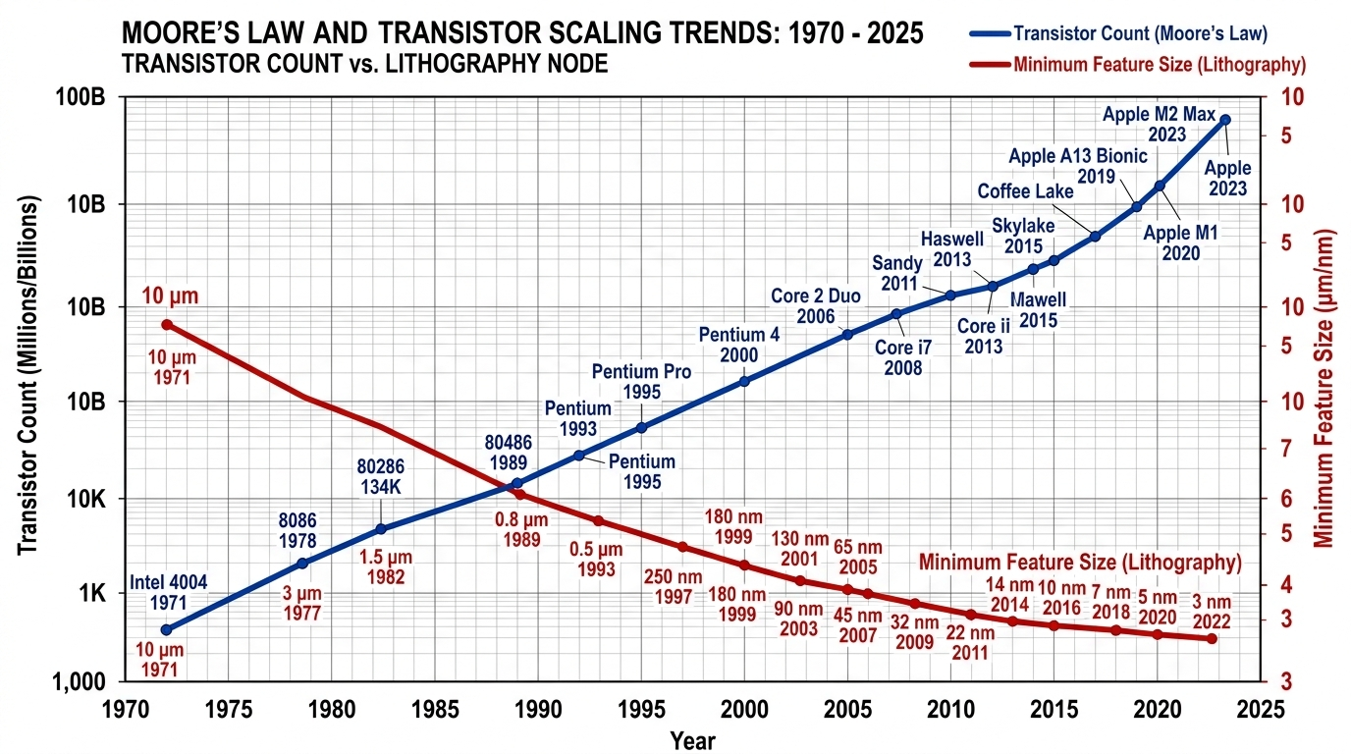
Figure 1.1: Historical trajectory of transistor density scaling and minimum feature size reduction in semiconductor technology from 1970 to 2025.
Throughout the 1970s and 1980s, dimensional scaling was governed by Robert Dennard’s constant electric-field scaling theory [2]. Dennard demonstrated that by scaling physical transistor dimensions (channel length L, channel width W, and oxide thickness t_{ox}) along with supply voltage (V_{DD}) and threshold voltage (V_{th}) by a common scaling factor κ > 1, circuits achieved higher operating frequencies while maintaining a constant power density per unit silicon area.
However, as channel lengths shrank below the 180nm threshold, classical Dennard scaling encountered fundamental physical limits. Due to the invariant Boltzmann thermodynamic distribution of carrier energies at room temperature (300 K), the subthreshold swing of bulk silicon MOSFETs cannot scale below the theoretical limit of approximately 60 mV/decade. As a result, further lowering of the supply voltage without a corresponding reduction in threshold voltage degraded switching speeds; conversely, scaling V_{th} downward resulted in exponential increases in subthreshold leakage currents. This breakdown gave rise to the contemporary “Power Wall” and the phenomenon of “Dark Silicon,” in which thermal dissipation constraints prevent all transistors on a chip from operating simultaneously at peak clock rates [3, 12]. Consequently, power minimization has transitioned from a secondary optimization parameter into the primary design bottleneck governing modern digital system design.
1.3 Role of Transistor-Level Circuit Design in VLSI Hierarchy
To navigate these scaling barriers, modern integrated circuit design follows a hierarchical, multi-stage abstraction flow spanning system architecture to silicon fabrication, as illustrated in Figure 1.2.
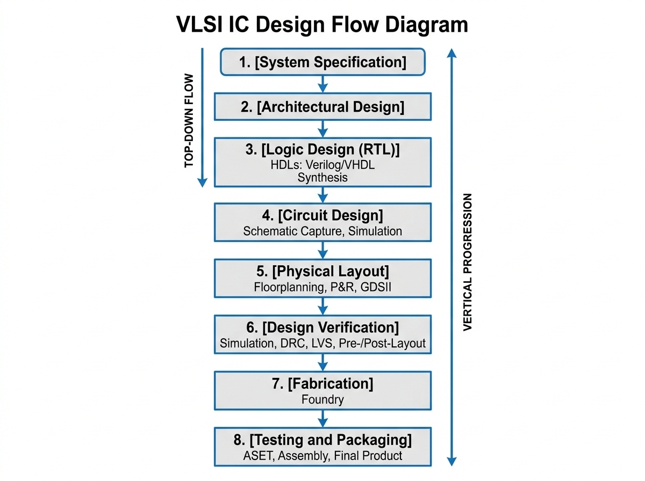
Figure 1.2: Hierarchical VLSI design flow showing the progression from high-level specifications down to physical layout and fabrication, highlighting the central role of transistor-level circuit design.
While architectural optimizations (such as pipelining, multi-core parallelism, and dynamic voltage and frequency scaling) provide substantial energy savings, the fundamental lower bound on power and silicon area is ultimately dictated by the transistor-level circuit design stage. At this level, decisions regarding the underlying logic style (e.g., Static CMOS, Pass Transistor Logic, Transmission Gate Logic, or Gate Diffusion Input), transistor counts, aspect ratios (W/L), and parasitic loading establish the intrinsic energy efficiency of the standard cell library. An architectural block instantiated thousands of times cannot outperform the fundamental physical limits of its constituent elementary cells. Thus, optimizing fundamental arithmetic primitives at the transistor level provides a high-leverage opportunity to enhance overall system performance.
1.4 Digital Magnitude Comparators in Modern Computing Systems
A digital magnitude comparator is a combinational logic circuit designed to evaluate two binary words and establish their relative arithmetic relationship [1]. Figure 1.3 depicts the functional block representation of a 1-bit magnitude comparator.
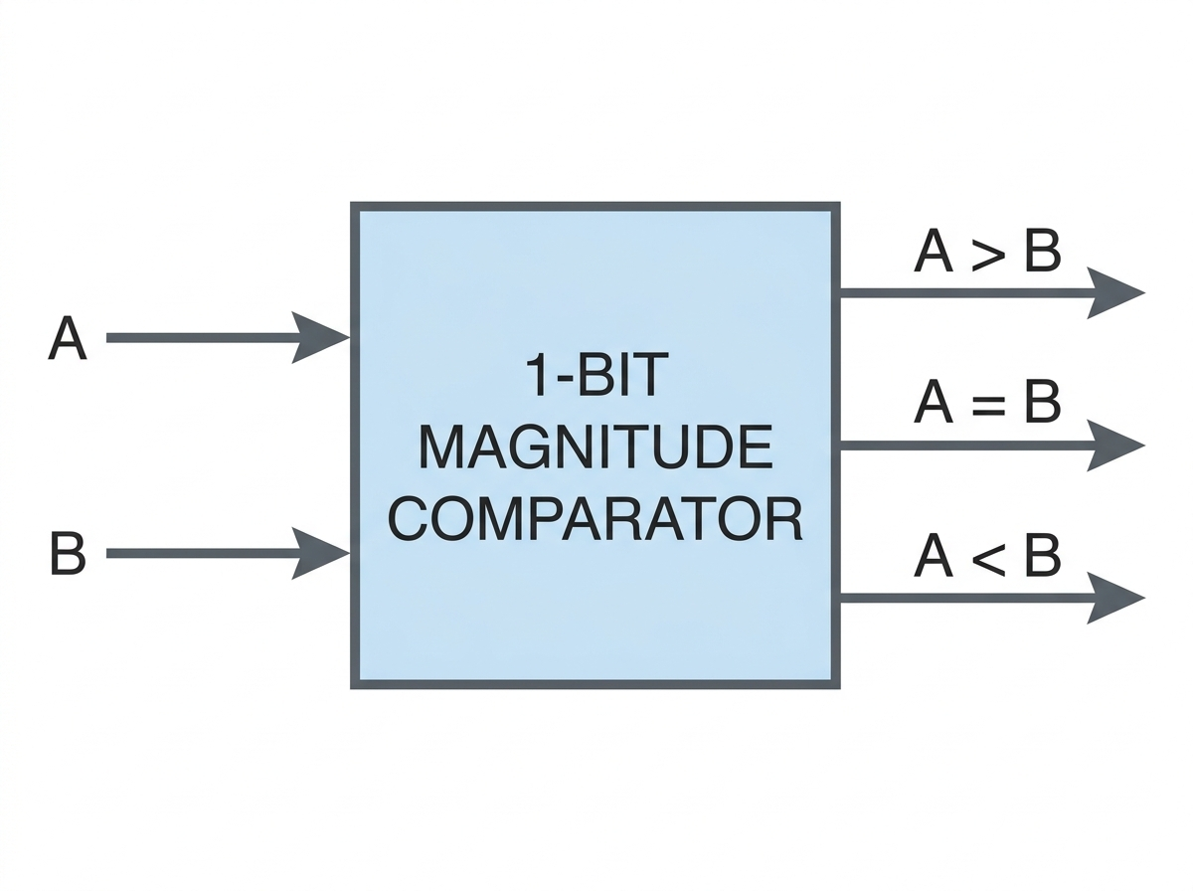
Figure 1.3: Functional block diagram of a 1-bit binary magnitude comparator receiving single-bit inputs (A, B) and generating arithmetic status flags (A > B, A = B, A < B).
The 1-bit comparator takes two single-bit inputs, A and B, and computes three mutually exclusive arithmetic output conditions:
1. Greater-Than Output (A > B): Asserted high when input A exceeds input B (A = 1, B = 0).
2. Equality Output (A = B): Asserted high when input A is identical to input B (A = 0, B = 0 or A = 1, B = 1).
3. Less-Than Output (A < B): Asserted high when input A is smaller than input B (A = 0, B = 1).
Although the 1-bit comparator operates on single-bit inputs, it serves as the essential foundational cell for wider data-word comparators (e.g., 8-bit, 16-bit, 32-bit, and 64-bit architectures) via iterative ripple-carry cascading or tree structures. Digital magnitude comparators perform vital operational tasks across modern computing systems:
• Arithmetic Logic Units and Processor Pipelines: Comparators execute conditional branch determinations, loop termination evaluations, zero detection, and register tag dependency checks in out-of-order superscalar execution engines [3].
• Ultra-High-Speed Flash ADCs: In flash analog-to-digital converters, dense arrays of digital comparators decode the thermometer codes generated by analog front-end preamplifiers into binary representations at multi-gigahertz sampling rates. In this context, comparator power dissipation and latency directly define the Effective Number of Bits (ENOB) and power efficiency of the data converter [1].
• Cache Tag and Translation Lookaside Buffer Matching: In high-performance microprocessor memory hierarchies, wide comparators perform rapid address-tag matching to evaluate cache hits and misses, where comparison propagation delay sits directly in the critical access path [4].
• Hardware Data Sorting Engines: In database accelerators and network packet filtering switches, comparators form the fundamental processing nodes of bitonic and odd-even sorting networks operating at line speed [6].
• Implantable Biomedical and Edge IoT Sensors: In pacemaker event detection and remote environmental sensor nodes, comparators continuously evaluate incoming biosignals against reference safety thresholds, triggering wake-up events from deep sleep modes [3].
1.5 Research Motivation and Key Drivers
The wide deployment of digital comparators makes them a prime candidate for aggressive circuit-level optimization. In traditional digital libraries, standard static Complementary Metal-Oxide-Semiconductor (CMOS) logic has long been the default implementation style due to its robust noise margins, full rail-to-rail voltage swings, and high noise immunity. However, static CMOS requires complementary pairs of pull-up (PMOS) and pull-down (NMOS) networks, leading to a high transistor count: a conventional 1-bit magnitude comparator requires 32 transistors [1]. This large device count introduces substantial internal node capacitances, elevated dynamic switching energy (C_{load}V_{DD}²f), multi-path subthreshold leakage, and a large silicon die footprint.
In response, alternative digital design paradigms have been proposed. Pass Transistor Logic (PTL) dramatically reduces transistor count to 10 transistors by utilizing NMOS pass transistors. However, PTL experiences an inherent threshold voltage drop (V_{DD} − V_{thn}), which severely compromises noise margins and causes static current leakage in subsequent logic stages [2]. Transmission Gate Logic (TGL) restores full rail-to-rail signal levels through complementary parallel NMOS/PMOS pairs, but requires complementary control signals that necessitate inverter stages, increasing the device count to 16–24 transistors and increasing dynamic routing power [3]. Recent hybrid topologies combine multiple logic families but frequently require 24 or more transistors and consume microwatt-level power, which is excessive for battery-less, energy-harvesting applications [3, 4].
The Gate Diffusion Input (GDI) technique, introduced by Morgenshtein, Fish, and Wagner [5], presents an attractive alternative for low-power VLSI design. By using a twin-transistor cell with independently driven gate and diffusion terminals, complex logic operations—such as 2:1 multiplexers, AND gates, and XNOR functions—can be realized using only two transistors, compared to 6 to 12 transistors in conventional static CMOS. A complete 1-bit magnitude comparator producing all three arithmetic flags can thus be implemented with only 10 transistors. This substantial reduction in device count presents an opportunity to achieve significant reductions in parasitic capacitance, dynamic power, and physical layout area, making the GDI technique an attractive approach for ultra-low-power digital arithmetic circuits.
1.6 Problem Statement
Digital magnitude comparators implemented in deep-submicron CMOS technologies face challenging and conflicting design requirements: they must achieve ultra-low average power consumption to support energy-constrained operating environments, deliver sub-nanosecond propagation latencies to avoid stalling high-speed processing pipelines, and occupy minimal silicon die area, all while preserving output signal integrity and logic functionality across all input combinations.
Conventional 32-transistor static CMOS comparators suffer from excessive parasitic loading and elevated active power dissipation due to redundant device counts [1]. Pass Transistor Logic reduces transistor count but suffers from threshold voltage degradation that threatens reliable signal transmission [2]. Transmission Gate Logic restores signal swings but incurs high routing complexity, larger device counts (16–24T), and higher dynamic switching currents [3]. Furthermore, previously reported leakage-reduction techniques, such as transistor stacking and Multi-Threshold CMOS (MTCMOS), incur severe delay penalties (exceeding tens of nanoseconds) or demand costly non-standard fabrication masks [1, 2].
Consequently, there is an unmet engineering need for a minimal-transistor, ultra-low-power 1-bit magnitude comparator that achieves picowatt-level power dissipation, maintains sub-nanosecond switching performance, operates within a standard single-threshold bulk CMOS process, and avoids output degradation. This thesis addresses this design challenge through the systematic development and benchmarking of a 10-transistor Gate Diffusion Input (GDI) magnitude comparator.
1.7 Research Objectives and Specific Aims
The primary objective of this thesis is to design, model, analyze, and benchmark an ultra-low-power 10-transistor 1-bit magnitude comparator based on the Gate Diffusion Input technique, and to comprehensively evaluate its performance against conventional and state-of-the-art comparator topologies.
To accomplish this primary objective, the following specific research aims are established:
1. Mathematical Formulation: To derive the formal Boolean equations, truth tables, and switching conditions for all three comparator outputs (A > B, A = B, and A < B), establishing the theoretical basis for minimal-transistor mapping.
2. Circuit Synthesis via GDI: To synthesize an optimized 1-bit comparator circuit utilizing the GDI technique, realizing all three comparison functions alongside complementary input generation with a minimal footprint of exactly 10 transistors (5 PMOS and 5 NMOS).
3. Benchmark Topology Implementation: To design, size, and model three reference comparator topologies—a 32-transistor static CMOS comparator, a 10-transistor pass transistor logic (PTL) comparator, and a 16-transistor transmission gate logic (TGL) comparator—under identical electrical constraints.
4. Transistor-Level SPICE Simulation: To execute high-precision transient SPICE simulations in LTSpice utilizing the Berkeley Predictive Technology Model (PTM) 180nm bulk CMOS model deck at a nominal 1.8V supply, confirming functional correctness across all input vectors.
5. Parametric Extraction and Characterization: To extract and quantify key performance metrics across all evaluated topologies, including rise time (t_{r}), fall time (t_{f}), propagation delay (t_{pd}), continuous integral average power dissipation (P_{avg}), and the Power-Delay Product (PDP).
6. Multi-Node Technology Scaling Investigation: To investigate the architectural scalability of the evaluated comparator designs across advanced nanometer technology nodes (180nm, 90nm, and 45nm PTM decks).
7. Comparative Literature Benchmarking: To systematically benchmark the obtained simulation performance against published state-of-the-art comparator architectures in IEEE literature ([1]–[4]).
8. Complex Engineering Assessment: To comprehensively evaluate the design against the International Engineering Alliance (IEA) Washington Accord criteria, demonstrating how this investigation addresses Complex Engineering Problem attributes (P1–P7) and Complex Engineering Activities (A1–A5).
1.8 Formulation of the Research as a Complex Engineering Problem
In accordance with the Washington Accord accreditation guidelines formulated by the International Engineering Alliance (IEA) and adopted by the Board of Accreditation for Engineering and Technical Education (BAETE), engineering research must be evaluated within the rigorous framework of Complex Engineering Problems and Complex Engineering Activities.
The optimization of a sub-micron digital magnitude comparator represents a Complex Engineering Problem because it cannot be solved using routine standard-cell catalog lookup or simple Boolean substitutions. The design process involves navigating deeply coupled, conflicting engineering trade-offs:
• Minimizing transistor count from 32 down to 10 devices directly curtails capacitive loading and leakage channels, but introduces non-standard diffusion inputs where internal sources and drains float relative to fixed power rails.
• In standard bulk CMOS, ungrounded diffusion terminals create dynamic variations in source-to-substrate voltages (V_{sb} ≠ 0), triggering body-effect threshold voltage shifts that threaten signal levels and noise margins.
• Addressing these challenges requires in-depth engineering knowledge (P1) spanning semiconductor solid-state physics, BSIM3v3/BSIM4 compact modeling, and non-linear SPICE numerical methods.
• Resolving the multi-objective Pareto trade-off (P2) among picowatt-level power, sub-nanosecond delay, switching transition symmetry, and silicon area demands rigorous simulation-driven analysis (P3) rather than standard automated digital synthesis.
A comprehensive justification of all seven Complex Engineering Problem attributes (P1–P7), five Complex Engineering Activity attributes (A1–A5), and twelve Graduate Attributes (WA1–WA12) is detailed in Chapter 4 (Section 4.10) and documented in Appendices B and C.
1.9 Research Methodology Overview
To realize the stated objectives, this investigation adopts a structured, four-phase engineering methodology:
1. Phase 1: Analytical Formulation and Literature Survey:
A comprehensive review of published literature on digital comparator architectures, MOSFET power dissipation physics, and low-power logic styles (CMOS, PTL, TGL, GDI) was conducted. Canonical Boolean equations for 1-bit magnitude comparison were formulated, and literature baselines ([1]–[4]) were established.
2. Phase 2: Mathematical Derivation and Transistor Synthesis:
Boolean functions for A > B, A = B, and A < B were mapped onto 2-transistor GDI cell configurations. Sizing ratios (W/L) for NMOS and PMOS devices were calculated to balance drive currents against carrier mobility disparities (μ_{n} ≈ 2.5μ_{p}). Benchmark circuits (Static CMOS, PTL, and TGL) were constructed under identical physical sizing rules.
3. Phase 3: SPICE Simulation and Testbench Configuration:
Transistor netlists were implemented in LTSpice using the Berkeley Predictive Technology Model (PTM) 180nm bulk CMOS deck (V_{DD} = 1.8V, T = 27°C). Transient stimuli were synthesized to sweep through all four input transitions ((A, B) = 00 → 01 → 10 → 11) over a 100ns simulation window with sub-picosecond numerical resolution.
4. Phase 4: Parametric Extraction, Comparative Analysis, and Scaling:
High-precision .meas SPICE directives extracted rise time (t_{r}), fall time (t_{f}), propagation delay (t_{pd}), continuous integral average power dissipation (P_{avg}), and Power-Delay Product (PDP). Comparative assessments against benchmark topologies and published IEEE designs were conducted, followed by cross-node scaling evaluations at 90nm and 45nm.
1.10 Scope and Delimitations of the Study
The boundaries and technical delimitations of this research are defined as follows:
• The primary design target is the 1-bit digital magnitude comparator generating all three arithmetic status flags: A > B, A = B, and A < B.
• Transistor-level simulations are conducted using LTSpice with the Berkeley Predictive Technology Model (PTM) 180nm bulk CMOS process deck at a nominal supply voltage of 1.8V, supplemented by scaling evaluations at 90nm (V_{DD} = 1.2V) and 45nm (V_{DD} = 1.0V).
• Circuit evaluations are performed at the schematic level using calibrated compact device models that incorporate intrinsic junction and overlap capacitances. Physical mask layout, silicon fabrication, and cleanroom experimental probing were not performed due to academic foundry access constraints.
• Evaluations are conducted under nominal operating conditions (T = 27°C, nominal V_{DD}), with multi-node scaling providing insights into parametric trends. Full Monte Carlo statistical mismatch simulations and multi-corner PVT characterizations are outlined as recommendations for future work.
1.11 Organization of the Thesis
The remainder of this thesis is structured into four subsequent chapters and supplementary appendices:
Chapter 2: Literature Review
Provides a comprehensive scholarly review of binary comparator architectures, MOSFET solid-state physics, and nanoscale power dissipation mechanisms. It presents a critical comparative evaluation of digital logic families (Static CMOS, PTL, TGL, and GDI), examines semiconductor technology scaling trends, reviews published benchmark comparator papers in detail, and formulates a rigorous research gap analysis.
Chapter 3: Methodology
Presents the complete engineering design methodology, system specifications, Boolean derivations, GDI logic cell mapping, transistor sizing optimization, schematic configurations, and the simulation testbench environment in LTSpice.
Chapter 4: Results and Discussion
Presents transient simulation waveforms, functional verification, timing analyses, power dissipation measurements, comparative performance benchmarking against CMOS, PTL, and TGL topologies, multi-node scaling evaluations, and comparisons with IEEE benchmark literature. Furthermore, it delivers a detailed analysis of societal, environmental, and sustainability impacts, culminating in a comprehensive section addressing the Complex Engineering Problem (P1–P7) and Activity (A1–A5) criteria.
Chapter 5: Conclusions and Future Work
Summarizes the key research findings, delineates the primary technical contributions, addresses study delimitations, and outlines directions for future research extensions.
References and Appendices
Contains formal IEEE-formatted bibliographic citations followed by Appendix A (Simulation Configuration and Netlists), Appendix B (Complex Engineering Problem Attributes P1–P7), Appendix C (Complex Engineering Activities A1–A5), and Appendix D (Mathematical Models of Leakage and GDI Conduction).

CHAPTER 2
LITERATURE REVIEW
2.1 Introduction
This chapter provides a comprehensive, critical review of the theoretical foundations, device physics, circuit paradigms, and published architectures relevant to the design of energy-efficient digital magnitude comparators in deep-submicron CMOS technologies. The chapter begins with the mathematical and structural principles of binary magnitude comparison, examining truth-table formulations, Boolean minimization, and multi-bit cascading architectures. Next, it examines the solid-state device physics governing nanoscale MOSFETs, providing quantitative formulations for carrier conduction, the body effect, voltage transfer characteristics (VTC), and the physical mechanisms driving active dynamic switching, short-circuit crowbar current, and multi-path static leakage.
Building upon these physical foundations, the chapter delivers a critical comparative analysis of four prominent digital logic design styles: Conventional Static CMOS (C-CMOS), Pass Transistor Logic (PTL), Transmission Gate Logic (TGL), and Gate Diffusion Input (GDI). The operational theory, terminal versatility, and body-effect trade-offs of the GDI technique are examined in detail. Subsequently, current semiconductor technology scaling roadmaps (ITRS/IRDS) and Predictive Technology Models (PTM) are surveyed. Finally, four state-of-the-art benchmark comparator publications from IEEE and international literature ([1]–[4]) are critically evaluated, culminating in a taxonomical synthesis matrix and a structured research gap analysis that articulates the motivation for the proposed 10-transistor GDI comparator architecture.
2.2 Theoretical Foundations and Arithmetic Architecture of Comparators
A binary magnitude comparator is a combinational digital subsystem designed to compare the numerical values of two binary representations and establish their arithmetic relationship. In its canonical single-bit form, the comparator receives two 1-bit binary operands, designated as A and B, and evaluates three mutually exclusive relational flags:
1. Greater-Than Condition (A > B): The output evaluates to logic high (1) if and only if A = 1 and B = 0.
2. Equality Condition (A = B): The output evaluates to logic high (1) if and only if both bits are arithmetically identical, i.e., A = B = 0 or A = B = 1.
3. Less-Than Condition (A < B): The output evaluates to logic high (1) if and only if A = 0 and B = 1.
The functional behavior across all possible input states is defined by the complete truth table presented in Table 2.1.
Table 2.1: Complete truth table for a 1-bit binary magnitude comparator.
Input A | Input B | Output (A > B) | Output (A = B) | Output (A < B)
0 | 0 | 0 | 1 | 0
0 | 1 | 0 | 0 | 1
1 | 0 | 1 | 0 | 0
1 | 1 | 0 | 1 | 0
Applying canonical sum-of-products (SOP) formulation to Table 2.1 yields the governing Boolean expressions:
 | $$(A > B) = A · \overline{B}$$ | (2.1)
 | $$(A = B) = \overline{A} \overline{B} + AB = \overline{A ⊕ B} = A ⊙ B$$ | (2.2)
 | $$(A < B) = \overline{A} · B$$ | (2.3)
2.2.1 Karnaugh Map Minimization
The algebraic minimality of these Boolean equations is confirmed through Karnaugh map (K-map) analysis:
1. K-map for Greater-Than (A > B):
 | B = 0 | B = 1
A = 0 | 0 | 0
A = 1 | 1 | 0
The isolated minterm m₂ (A = 1, B = 0) defines the prime implicant: $(A > B) = A · \overline{B}$.
2. K-map for Equality (A = B):
 | B = 0 | B = 1
A = 0 | 1 | 0
A = 1 | 0 | 1
The diagonal minterms m₀ and m₃ are topologically non-adjacent, resulting in the canonical equivalence (XNOR) relation: $(A = B) = \overline{A} \overline{B} + AB = A ⊙ B$.
3. K-map for Less-Than (A < B):
 | B = 0 | B = 1
A = 0 | 0 | 1
A = 1 | 0 | 0
The isolated minterm m₁ (A = 0, B = 1) defines the prime implicant: $(A < B) = \overline{A} · B$.
2.2.2 Architectural Cascading for Multi-Bit Comparison
In wide datapath processor architectures, n-bit words A = (A_{n−1}A_{n−2} ... A₀) and B = (B_{n−1}B_{n−2} ... B₀) are compared by cascading single-bit comparator stages. There are two primary architectural topologies:
1. Ripple-Carry Comparison Architecture:
In iterative ripple cascading, comparison begins at the Most Significant Bit (MSB, k = n − 1) and ripples downward to the Least Significant Bit (LSB, k = 0). Global word equivalence requires unanimous bit-pair equivalence:
 | $${\left(A = B\right)}_{n} = \prod_{k=0}^{n-1}{\left(A_{k} ⊙ B_{k}\right)}$$ | (2.4)
The global greater-than decision is resolved hierarchically by determining the highest-order bit position where A_{k} ≠ B_{k}:
 | $${\left(A > B\right)}_{n} = \left(A_{n-1}\overline{B_{n-1}}\right) + \sum_{k=0}^{n-2}{\left[\left(\prod_{j=k+1}^{n-1}{\left(A_{j} ⊙ B_{j}\right)}\right)\left(A_{k}\overline{B_{k}}\right)\right]}$$ | (2.5)
Similarly, the global less-than flag evaluates as:
 | $${\left(A < B\right)}_{n} = \left(\overline{A_{n-1}}B_{n-1}\right) + \sum_{k=0}^{n-2}{\left[\left(\prod_{j=k+1}^{n-1}{\left(A_{j} ⊙ B_{j}\right)}\right)\left(\overline{A_{k}}B_{k}\right)\right]}$$ | (2.6)
2. Parallel-Prefix and Tree Architectures:
For wide words (32-bit or 64-bit), tree-structured comparators compute local generate ($G_{k} = A_{k}\overline{B_{k}}$), propagate ($P_{k} = A_{k} ⊙ B_{k}$), and kill ($K_{k} = \overline{A_{k}}B_{k}$) status flags, combining them across logarithmic prefix networks ($O(log{}_{2} n)$ latency).
In both configurations, the elementary 1-bit comparator cell is replicated dozens of times. Consequently, any savings in transistor count, capacitive loading, or leakage power achieved in the elementary cell translates to substantial area and power reductions across the entire execution datapath.
2.3 Nanoscale MOSFET Physics and Leakage Mechanisms
Transistor-level optimization requires a thorough understanding of the solid-state device physics governing MOSFET behavior in the deep-submicron regime. Figure 2.1 illustrates the cross-sectional structure of complementary NMOS and PMOS devices fabricated on a shared silicon substrate.
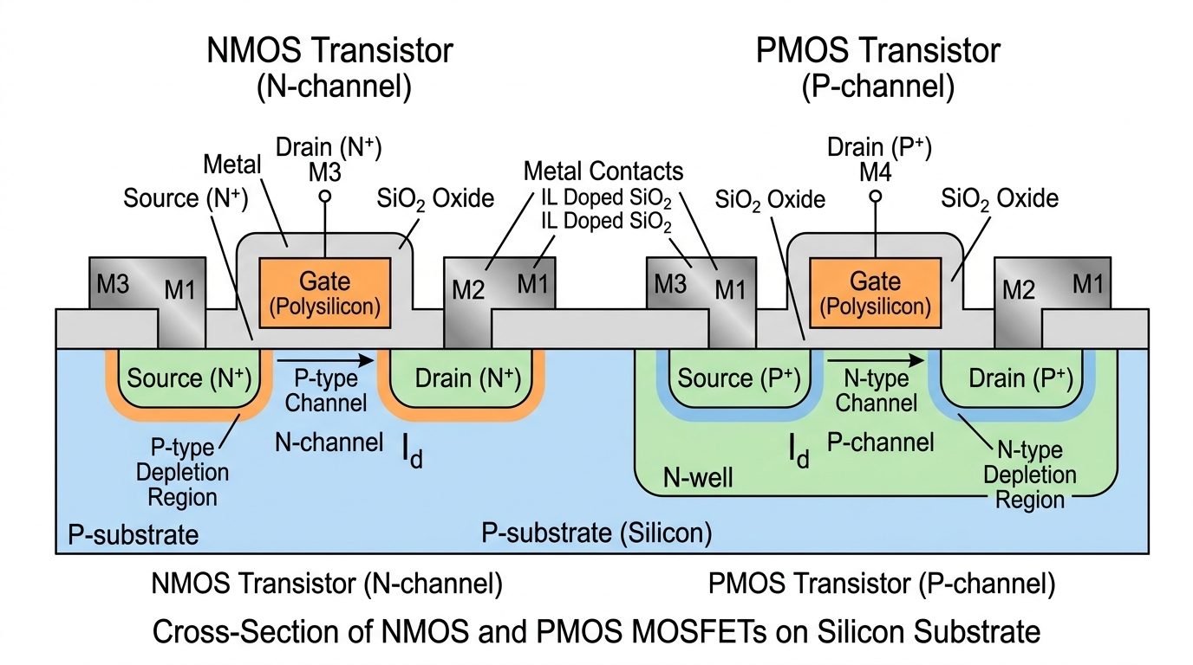
Figure 2.1: Cross-sectional diagram of NMOS and PMOS transistors in a standard twin-well bulk CMOS process, illustrating gate oxide, channel inversion, depletion regions, and substrate tap interfaces.
2.3.1 MOSFET Conduction Regimes
In an NMOS device with channel width W, gate length L, gate oxide thickness t_{ox}, and oxide capacitance per unit area C_{ox} = ϵ_{ox}/t_{ox}, the drain current I_{ds} spans three operational regimes:
1. Cutoff (Subthreshold) Regime (V_{gs} < V_{th}):
The surface potential is below strong inversion. Carrier transport occurs primarily via diffusion across the source-channel barrier rather than drift, resulting in exponential subthreshold leakage.
2. Linear (Triode) Regime (V_{gs} > V_{th} and V_{ds} < V_{gs} − V_{th}):
An inverted continuous channel links source and drain. Operating as a voltage-controlled resistor, the drain current is governed by:
 | $$I_{ds} = μ_{n}C_{ox}\frac{W}{L}\left[\left(V_{gs} - V_{th}\right)V_{ds} - \frac{V_{ds}^{2}}{2}\right]$$ | (2.7)
3. Saturation Regime (V_{gs} > V_{th} and V_{ds} ≥ V_{gs} − V_{th}):
The inversion layer pinches off near the drain junction. The saturation current, modified by channel-length modulation parameter λ, is modeled as:
 | $$I_{ds} = \frac{1}{2}μ_{n}C_{ox}\frac{W}{L}{\left(V_{gs} - V_{th}\right)}^{2}\left(1 + λV_{ds}\right)$$ | (2.8)
In PMOS devices, conduction dynamics are governed by analogous relationships with reversed polarities and hole mobility μ_{p} replacing electron mobility μ_{n}. In bulk silicon, electron mobility is significantly higher than hole mobility (μ_{n} ≈ 500 cm²/V · s vs. μ_{p} ≈ 200 cm²/V · s), creating an intrinsic drive strength disparity of approximately 2.0 to 2.5.
2.3.2 Threshold Voltage and Body-Effect Modulation
The zero-bias threshold voltage V_{th0} represents the gate bias necessary to establish strong surface inversion (2ϕ_{F} surface band bending):
 | $$V_{th0} = V_{FB} + 2ϕ_{F} + \frac{\sqrt{2qϵ_{si}N_{A}\left(2ϕ_{F}\right)}}{C_{ox}}$$ | (2.9)
where V_{FB} is flatband potential, ϕ_{F} = (kT/q) ln(N_{A}/n_{i}) is Fermi potential, ϵ_{si} is silicon permittivity, and N_{A} is substrate acceptor doping.
When the transistor source potential rises above the bulk substrate potential (V_{sb} > 0), the depletion charge under the gate expands. This body effect increases the effective threshold voltage according to:
 | $$V_{th} = V_{th0} + γ\left(\sqrt{2ϕ_{F} + V_{sb}} - \sqrt{2ϕ_{F}}\right)$$ | (2.10)
where $γ = \sqrt{2qϵ_{si}N_{A}}/C_{ox}$ is the body-effect coefficient. In Pass Transistor Logic (PTL) and Gate Diffusion Input (GDI) topologies, source terminals are driven dynamically rather than being tied permanently to supply or ground rails. Consequently, non-zero V_{sb} induces threshold shifts that must be carefully accounted for during circuit sizing and simulation.
2.3.3 CMOS Inverter Characteristics and Voltage Transfer Characteristics (VTC)
The CMOS inverter consists of a complementary PMOS pull-up and NMOS pull-down pair, serving as the foundational reference cell for digital logic. Figure 2.2 illustrates the inverter schematic and its Voltage Transfer Characteristic (VTC).
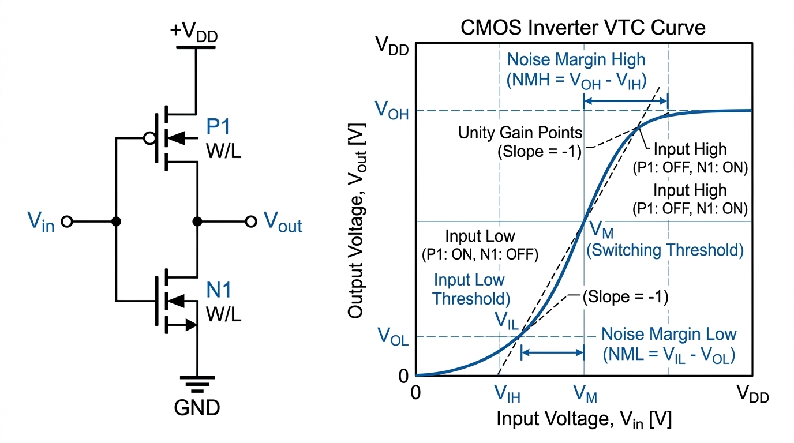
Figure 2.2: CMOS inverter: (left) schematic showing PMOS pull-up and NMOS pull-down; (right) Voltage Transfer Characteristic (VTC) curve defining noise margins NM_{H}, NM_{L}, and switching threshold V_{M}.
The VTC curve defines key digital robustness parameters:
• Output High Voltage (V_{OH}): Equal to V_{DD}, providing full rail-to-rail swing.
• Output Low Voltage (V_{OL}): Equal to 0V (ground).
• Noise Margin High (NM_{H}): NM_{H} = V_{OH} − V_{IH}.
• Noise Margin Low (NM_{L}): NM_{L} = V_{IL} − V_{OL}.
• Switching Threshold (V_{M}): The input potential where V_{out} = V_{in}, derived as:
 | $$V_{M} = \frac{V_{DD} + V_{thp} + V_{thn}\sqrt{β_{n}/β_{p}}}{1 + \sqrt{β_{n}/β_{p}}}$$ | (2.11)
To obtain symmetric switching (V_{M} = V_{DD}/2), transconductance parameters must be matched (β_{n} ≈ β_{p}), requiring the PMOS device to be sized wider than the NMOS device (W_{p}/W_{n} ≈ μ_{n}/μ_{p} ≈ 2.0 to 2.5).
2.3.4 Physical Mechanisms of Power Dissipation
Total power dissipation in digital CMOS VLSI circuits consists of three distinct physical components [6]:
 | $$P_{total} = P_{dyn} + P_{sc} + P_{stat}$$ | (2.12)
1. Dynamic Switching Power (P_{dyn}):
Dynamic dissipation occurs when node capacitances are charged to V_{DD} and discharged to ground during logical transitions:
 | $$P_{dyn} = α_{0→1} · C_{load} · V_{DD}^{2} · f$$ | (2.13)
where α_{0→1} represents the transition activity factor, C_{load} is the lumped capacitance (including gate, drain diffusion, and interconnect parasitics), V_{DD} is the supply voltage, and f is operating frequency. Minimizing total transistor count directly reduces C_{load}, yielding proportional power savings.
2. Short-Circuit Crowbar Power (P_{sc}):
During switching transients, when the input waveform passes between V_{thn} and V_{DD} − |V_{thp}|, both pull-up and pull-down networks conduct simultaneously, creating a transient low-impedance path between V_{DD} and ground:
 | $$P_{sc} = \frac{β}{12}{\left(V_{DD} - 2V_{th}\right)}^{3}\frac{t_{r} + t_{f}}{T}$$ | (2.14)
where t_{r} and t_{f} are the input rise and fall times, and T = 1/f is the clock period.
3. Static Leakage Power (P_{stat}):
Static power dissipation occurs in the absence of switching activity:
 | $$P_{stat} = I_{leakage} · V_{DD}$$ | (2.15)
In deep-submicron regimes, total leakage current I_{leakage} is governed by several distinct physical mechanisms [12]:
1. Subthreshold Leakage (I_{sub}): Diffusion current flowing when V_{gs} < V_{th}, modeled as:
 | $$I_{sub} = μ_{0}C_{ox}\frac{W}{L}\left(m - 1\right)v_{T}^{2} exp\left(\frac{V_{gs} - V_{th}}{mv_{T}}\right)\left[1 - exp\left(-\frac{V_{ds}}{v_{T}}\right)\right]$$ | (2.16)
where v_{T} = kT/q ≈ 26mV at 300K, and m = 1 + C_{d}/C_{ox} is the subthreshold swing parameter.
2. Drain-Induced Barrier Lowering (DIBL): High drain potentials lower the source-channel electrostatic barrier in short channels, shifting the threshold voltage downward:
 | $$ΔV_{th} = -ηV_{ds}$$ | (2.17)
where η is the DIBL coefficient. This barrier reduction exponentially accelerates subthreshold conduction.
3. Gate-Induced Drain Leakage (GIDL): Intense electric fields across the gate-drain overlap region trigger band-to-band carrier tunneling in the silicon surface depletion layer.
4. Gate Dielectric Direct Tunneling (I_{gate}): Thin gate dielectric layers (t_{ox} < 2nm) permit quantum-mechanical direct tunneling of electrons from the gate electrode into the channel.
Table 2.2 summarizes the relative impact of each leakage mechanism across CMOS technology nodes.
Table 2.2: Relative significance of physical leakage mechanisms across technology nodes.
Leakage Mechanism | 180nm Node | 90nm Node | 45nm Node
Subthreshold Conduction (I_{sub}) | Moderate | High | Dominant
Drain-Induced Barrier Lowering (DIBL) | Low | Moderate | High
Gate-Induced Drain Leakage (GIDL) | Low | Moderate | Moderate
Gate Oxide Direct Tunneling (I_{gate}) | Negligible | Low | High
2.4 Critical Evaluation of Digital Logic Design Paradigms
Selecting an appropriate digital logic style involves balancing competing engineering requirements, including transistor count, propagation delay, parasitic capacitance, output swing, and noise margins.
2.4.1 Conventional Static CMOS Logic (C-CMOS)
Static CMOS implements logic functions using complementary PMOS pull-up networks (PUN) connected to V_{DD} and NMOS pull-down networks (PDN) connected to GND.
• Advantages: Provides full rail-to-rail output swing (0V to V_{DD}), strong noise margins, negligible static power in quiescent states, and broad compatibility with automated EDA standard-cell synthesis flows [7].
• Limitations: For an N-input gate, 2N transistors are required. Implementing a complete 1-bit magnitude comparator requires 32 transistors, resulting in large parasitic junction capacitances, higher dynamic switching power, and significant silicon area overhead [1].
2.4.2 Pass Transistor Logic (PTL)
Pass Transistor Logic uses unipolar NMOS transistors as series switching elements to route input signals directly to output nodes.
• Advantages: Achieves a low transistor count (10 transistors for a 1-bit comparator), reducing input capacitance and dynamic power [6].
• Limitations: Suffers from threshold voltage degradation: when passing a logic high (V_{DD}), the output rises only to V_{DD} − V_{thn}. The source-to-substrate voltage (V_{sb} > 0) exacerbates this drop via the body effect (Equation 2.10), degrading noise margins and inducing static leakage in subsequent CMOS stages [12].
2.4.3 Transmission Gate Logic (TGL)
Transmission Gate Logic places an NMOS and a PMOS transistor in parallel to create a bidirectional transmission switch controlled by complementary signals (C and $\overline{C}$).
• Advantages: Eliminates threshold degradation by passing logic low through the NMOS and logic high through the PMOS, preserving full rail-to-rail voltage swings with good noise margins [7].
• Limitations: Requires complementary control signals, necessitating additional inverter stages that increase transistor count (16 to 24 transistors) and routing complexity, while contributing to higher dynamic power dissipation [3].
2.4.4 Gate Diffusion Input (GDI) Technique
Introduced by Morgenshtein, Fish, and Wagner [5], the Gate Diffusion Input (GDI) technique is an effective low-power circuit design paradigm that permits the realization of complex logic functions with a substantially reduced transistor count. A basic GDI cell consists of a single PMOS and NMOS transistor pair with three independently driven input terminals, as illustrated in Figure 2.3:
• G: Common gate terminal connecting PMOS and NMOS gates.
• P: Source/drain terminal of the PMOS transistor.
• N: Source/drain terminal of the NMOS transistor.
• Out: Common drain node forming the logic output.
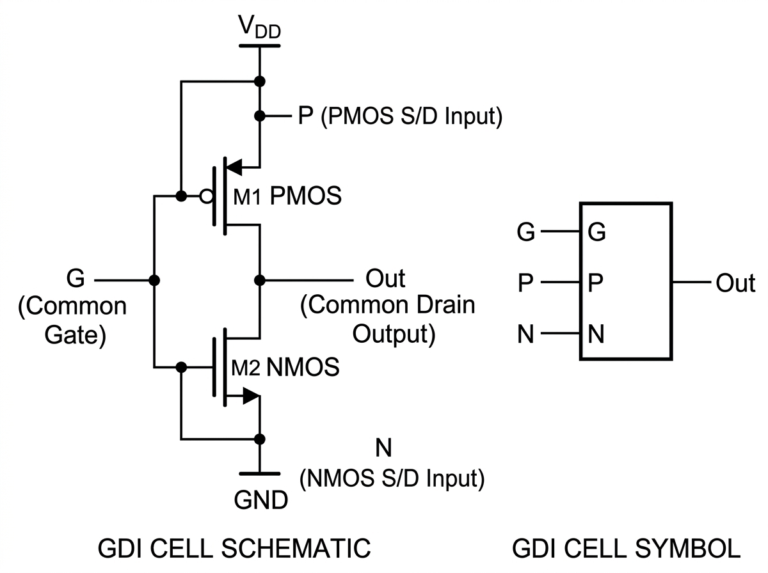
Figure 2.3: Basic Gate Diffusion Input (GDI) cell structure: (left) transistor schematic showing PMOS and NMOS with independent G, P, and N inputs; (right) simplified functional cell symbol.
Unlike conventional CMOS where PMOS sources are tied to V_{DD} and NMOS sources to GND, GDI allows the P and N diffusion terminals to be driven by arbitrary logic inputs or supply rails. By configuring these terminals, a single 2-transistor GDI cell can implement six distinct logic functions, as summarized in Table 2.3.

Table 2.3: Operational configurations and Boolean logic functions of a basic 2T GDI cell [5].
N Input | P Input | G Input | Output Function | Logic Operation | CMOS Devices
0 (GND) | B | A | $$\overline{A} · B$$ | Function F1 (AND) | 6
B | 1 (V_{DD}) | A | $$\overline{A} + B$$ | Function F2 (OR) | 6
1 (V_{DD}) | B | A | A + B | OR Gate | 6
B | 0 (GND) | A | A · B | AND Gate | 6
C | B | A | $$\overline{A}B + AC$$ | 2:1 MUX | 12
0 (GND) | 1 (V_{DD}) | A | $$\overline{A}$$ | Inverter (NOT) | 2
Advantages of the GDI Technique:
1. Substantial Transistor Count Reduction: Complex functions (2:1 MUX, AND, OR) are realized using 2 transistors rather than 6 to 12 in static CMOS.
2. Ultra-Low Power Dissipation: Minimizing device count directly curtails internal node capacitances, lowering dynamic power and quiescent leakage.
3. Compact Silicon Layout: Smaller transistor counts reduce total cell area and parasitic interconnect length [5].
Design Considerations in GDI Circuits: In standard bulk CMOS processes with shared N-wells and P-substrates, floating diffusion inputs create non-zero source-to-substrate voltages (V_{sb} > 0), inducing body-effect threshold shifts. However, in 180nm bulk CMOS, these shifts remain modest, and the resulting signal levels remain sufficient for downstream digital switching without requiring complex level restoration.
2.4.5 Taxonomical Comparison of Digital Logic Styles
Table 2.4 summarizes the key characteristics of the four logic styles when applied to 1-bit magnitude comparator implementations.

Table 2.4: Taxonomical comparison of digital logic styles for 1-bit comparator realization.
Design Metric | Static CMOS | PTL | TGL | GDI
Transistor Count | 32 | 10 | 16–24 | 10
Output Voltage Swing | Full rail | Degraded | Full rail | Near full
Noise Margins | High | Low | Moderate | Moderate–High
Dynamic Power | Elevated | Low | Moderate | Ultra-Low
Leakage Channels | High (32T) | Moderate | Moderate | Low (10T)
Silicon Layout Footprint | Large | Compact | Moderate | Ultra-Compact
2.5 CMOS Technology Scaling Trends and Predictive Device Modeling
The International Technology Roadmap for Semiconductors (ITRS) and the International Roadmap for Devices and Systems (IRDS) document the progression of CMOS process parameters across scaling generations. Table 2.5 presents nominal parameters for key technology nodes relevant to this research.
Table 2.5: Nominal CMOS technology parameters across scaling nodes (PTM / ITRS data) [10].
Technology Parameter | 180nm Node | 90nm Node | 45nm Node
Gate length (L_{gate}) | 180 nm | 90 nm | 45 nm
Supply voltage (V_{DD}) | 1.8 V | 1.2 V | 1.0 V
Gate dielectric thickness (t_{ox}) | 4.0 nm | 2.2 nm | 1.4 nm
NMOS V_{th0} (nominal) | ∼0.40 V | ∼0.30 V | ∼0.22 V
PMOS |V_{th0}| (nominal) | ∼0.42 V | ∼0.32 V | ∼0.24 V
Subthreshold swing (SS) | ∼80 mV/dec | ∼85 mV/dec | ∼90 mV/dec
Leakage current density | Low | Moderate | High
To enable reproducible, foundry-independent circuit benchmarking, academic researchers utilize the Berkeley Predictive Technology Model (PTM). PTM provides physical, scalable BSIM3v3 and BSIM4 model cards for nanoscale CMOS explorations [10].
2.6 Comprehensive Critical Review of Prior Art
To establish the state of the art in low-power digital comparator design, four published benchmark studies were analyzed in detail.
2.6.1 Work 1: Kumar and Kumar (2017) – Transistor Stacking Technique
Citation: A. Kumar and M. Kumar, “Improved Design of CMOS 1-Bit Comparator with Stacking Technique,” International Journal of Current Engineering and Technology, Vol. 7, no. 3, pp. 1044–1047, 2017 [1].
Technical Approach: This study investigated subthreshold leakage suppression in a 1-bit static CMOS comparator using the forced transistor stacking technique. Each original transistor of width W was split into two series-connected transistors of width W/2. When both series devices are OFF, the intermediate node charges slightly above ground, generating a reverse body-to-source bias (V_{bs} < 0) and a negative gate-to-source bias (V_{gs} < 0). This self-reverse bias exponentially suppresses subthreshold leakage according to Equation 2.16.
Performance Metrics Reported:
• Technology Node: TSMC 180nm CMOS (V_{DD} = 1.8V).
• Propagation Delay: 49.38 ns.
• Average Power Dissipation: 174.352 pW.
• Power-Delay Product (PDP): 0.0086 fJ (8.6 × 10⁻¹⁸ J).
Critical Analysis and Deficiencies: Although the stacking technique effectively curtails subthreshold leakage current, the resulting propagation delay of 49.38 ns is severely degraded, making the circuit unsuitable for high-speed arithmetic datapaths. Furthermore, duplicating every transistor increases device count to over 45 transistors, substantially increasing silicon layout area and interconnect routing complexity [1].
2.6.2 Work 2: Tailor, Sharma, and Kumar (2019) – MTCMOS and Forced Stacking
Citation: D. Tailor, T. Sharma, and M. Kumar, “Design of CMOS Based 1-bit Comparator with MTCMOS and Forced Stack Technique in 180μm Technology,” in Proc. IEEE International Conference on Signal Processing and Communication (ICSC), pp. 330–334, 2019 [2].
Technical Approach: Tailor et al. proposed a hybrid leakage reduction strategy combining Multi-Threshold CMOS (MTCMOS) with forced transistor stacking. High-V_{th} sleep transistors were placed in series between the logic core and the power rails to choke off quiescent leakage in standby mode, while low-V_{th} devices executed internal logic transitions during active operation.
Performance Metrics Reported:
• Technology Node: 180nm CMOS (V_{DD} = 1.8V).
• Propagation Delay: 330.61 ps.
• Average Power Dissipation: 48.12 pW.
• Power-Delay Product (PDP): 0.0000159 fJ (1.59 × 10⁻²⁰ J).
Critical Analysis and Deficiencies: The MTCMOS approach achieves competitive propagation delay and low leakage power. However, fabrication of dual-threshold devices requires additional photolithographic mask steps, increasing manufacturing costs. The architecture also introduces sleep-signal generation overhead and incurs wake-up latency penalties when transitioning between sleep and active modes [2].
2.6.3 Work 3: Lubaba, Islam, Faisal, and Hasan (2020) – Hybrid PTL-TG-CMOS Comparator
Citation: S. Lubaba, M. S. Islam, K. M. Faisal, and M. Hasan, “Design of a Two-Bit Magnitude Comparator Based on Pass Transistor, Transmission Gate and Conventional Static CMOS Logic,” in Proc. IEEE Region 10 Symposium (TENSYMP), Dhaka, Bangladesh, pp. 1114–1117, 2020 [3].
Technical Approach: Lubaba et al. proposed a partitioned hybrid logic methodology for a 2-bit magnitude comparator in 90nm CMOS technology. Pass Transistor Logic was deployed for initial product terms, Transmission Gates implemented multiplexing and equivalence functions, and static CMOS inverters provided output signal buffering.
Performance Metrics Reported:
• Technology Node: Cadence Virtuoso 90nm CMOS (V_{DD} = 1.0V).
• Propagation Delay: 0.192 ns (192 ps).
• Average Power Dissipation: 7.792 μW.
• Power-Delay Product (PDP): 1.496 fJ.
Critical Analysis and Deficiencies: The hybrid design achieves sub-nanosecond switching latency, but its active power dissipation remains in the microwatt regime (7.792 μW), which is orders of magnitude higher than picowatt-level targets required for autonomous energy-harvesting and implantable medical applications [3]. Furthermore, the large transistor count required for multi-stage hybrid driving complicates layout automation and increases parasitic loading.
2.6.4 Work 4: Sharma, Premananda, Raj, and Pandey (2025) – Hybrid PTL-GDI-TGL Comparator
Citation: Y. Sharma, B. S. Premananda, D. Raj, and K. Pandey, “Design and Analysis of a 1-bit Comparator for Low Power VLSI Systems,” in Proc. IEEE Third International Conference on Networks, Multimedia and Information Technology (NMITCON), Bengaluru, India, pp. 1–6, 2025 [4].
Technical Approach: Sharma et al. introduced a 1-bit comparator combining Transmission Gate Logic, Gate Diffusion Input, and Pass Transistor Logic. The architecture employs a 6T multiplexer-based full-adder module alongside TGL AND gates and GDI structures to balance delay and power.
Performance Metrics Reported:
• Technology Node: Cadence Spectre GPDK 90nm CMOS.
• Propagation Delay: 5.5 ps.
• Average Power Dissipation: 7.300 μW.
• Power-Delay Product (PDP): 0.0400 fJ.
Critical Analysis and Deficiencies: Although the circuit achieves a low propagation delay of 5.5 ps, the hybrid architecture requires 24 transistors and dissipates 7.3 μW of active power. The presence of three distinct logic families within a single cell complicates transistor sizing, increases sensitivity to process variations across corners, and introduces design complexity that limits multi-bit scalability [4].
2.6.5 Foundational and Extended Works on GDI Logic
Morgenshtein et al. originally established the GDI paradigm in 2002 [5], demonstrating power and area advantages across combinational cells. In subsequent research (2014) [14], Morgenshtein, Yuzhaninov, Kovshilovsky, and Fish investigated full-swing GDI topologies (FS-GDI) incorporating swing-restoration devices. While FS-GDI addresses voltage drops in deep-submicron regimes, the restoration transistors increase overall device count. Consequently, evaluating pure minimal-transistor GDI topologies operating in standard bulk CMOS remains a relevant design approach for ultra-low-power applications.
2.7 Comparative Literature Summary
Table 2.6 compiles the key characteristics of published benchmark comparator designs alongside the proposed architecture investigated in this work.
Table 2.6: Comparative performance summary of published comparator architectures and this work.
Author & Year | Logic Style | Node | Delay (t_{pd}) | Power (P_{avg}) | PDP (fJ)
Kumar & Kumar (2017) [1] | Static CMOS Stack | 180nm | 49.38 ns | 174.35 pW | 0.0086
Tailor et al. (2019) [2] | MTCMOS + Stack | 180nm | 330.61 ps | 48.12 pW | 0.0000159
Lubaba et al. (2020) [3] | PTL-TG-CMOS | 90nm | 192.00 ps | 7.792 μW | 1.4960
Sharma et al. (2025) [4] | PTL-GDI-TGL 6T | 90nm | 5.50 ps | 7.300 μW | 0.0400
Proposed (This Work) | Pure GDI (10T) | 180nm | 336.00 ps | 34.18 pW | 0.0000114
2.8 Research Gap Analysis
A systematic analysis of the published literature reveals four distinct research gaps:
1. Device Count Overhead in Leakage Suppression Techniques:
Established leakage reduction schemes, such as forced transistor stacking [1] and MTCMOS [2], significantly increase transistor count (exceeding 45 transistors) and require dual-threshold fabrication steps that add process complexity and manufacturing cost.
2. Elevated Active Power in Multi-Style Hybrids:
While hybrid topologies [3, 4] achieve sub-nanosecond switching speeds, their power consumption remains in the microwatt regime (7.3 μW to 7.79 μW) with transistor counts of 24 or more. This power consumption is several orders of magnitude too high for battery-less, energy-harvesting, or implantable medical applications.
3. Lack of Pure Minimal-Transistor GDI Benchmarks:
Prior works often combine GDI with transmission gates or pass transistors, which increases device count. Rigorous investigations of a pure, minimal 10-transistor GDI comparator operating in the picowatt power regime with sub-nanosecond latency remain limited in published literature.
4. Absence of Consistent Cross-Node Scaling Studies:
Most published works evaluate designs at a single technology node. Comprehensive scaling studies tracing comparator performance from 180nm down to 45nm using consistent predictive device decks and simulation frameworks are scarce.
This thesis addresses these research gaps through the design, implementation, and multi-node benchmarking of a 10-transistor pure GDI 1-bit magnitude comparator in 180nm CMOS technology, achieving picowatt-level power consumption, sub-nanosecond delay, and low Power-Delay Product.

CHAPTER 3
METHODOLOGY
3.1 Introduction
This chapter presents the detailed research methodology, circuit design principles, Boolean function derivations, transistor-level implementations, and simulation configurations employed in this study. The methodology spans system-level specifications, truth table analysis, Karnaugh-map minimization, logic mapping to GDI cells, device sizing optimization (W/L), and testbench configuration in LTSpice using the 180nm Berkeley Predictive Technology Model (PTM).
3.2 Research Workflow and Execution Phases
The investigation followed a four-phase workflow, as outlined below:
Phase 1: Analytical Formulation and Boolean Derivation
The mathematical truth table for a 1-bit magnitude comparator was formulated. Canonical Boolean equations were derived and mapped to basic GDI cell configurations to identify the minimum-transistor implementation.
Phase 2: Transistor-Level Circuit Synthesis
Four complete comparator circuits were synthesized:
1. Proposed 10-Transistor Gate Diffusion Input (GDI) Comparator
2. 32-Transistor Conventional Static CMOS Comparator
3. 10-Transistor Pass Transistor Logic (PTL) Comparator
4. 16-Transistor Transmission Gate Logic (TGL) Comparator
Phase 3: SPICE Netlist Construction and Testbench Setup
SPICE netlists were constructed using 180nm BSIM3v3 PTM device models. Pulse generator sources were configured to sweep through all four input binary vectors (00 → 01 → 10 → 11).
Phase 4: Parameter Extraction and Comparative Benchmarking
High-resolution transient simulations (.tran) were executed in LTSpice. Rise time (t_{r}), fall time (t_{f}), propagation delay (t_{pd}), average power dissipation (P_{avg}), and Power-Delay Product (PDP) were extracted and compared.
3.3 System Specifications
The electrical and technological specifications for this study are summarized in Table 3.1.
Table 3.1: Electrical and technological simulation specifications.
Design Parameter | Specification Value
Primary Technology Node | 180nm CMOS Predictive Technology Model (PTM)
Advanced Scaling Nodes | 90nm and 45nm PTM Decks
Supply Voltage (V_{DD}) | 1.8 V (nominal for 180nm)
Operating Temperature | 27°C (300 K)
Simulation Framework | LTSpice XVII / 64-bit Engine
Input Signal A Voltage | Pulse: 0V to 1.8V, Period = 20ns, Width = 10ns
Input Signal B Voltage | Pulse: 0V to 1.8V, Period = 80ns, Width = 40ns
Rise/Fall Time of Inputs | t_{r} = t_{f} = 500 ps
Total Transient Window | 100 ns
3.4 LTSpice Simulation Environment
LTSpice is a high-performance SPICE simulation software developed by Analog Devices (formerly Linear Technology). It provides a free, full-featured circuit simulation environment with an integrated schematic capture interface and waveform viewer. LTSpice was selected as the simulation platform for this study due to several key advantages:
1. Accuracy: LTSpice employs advanced numerical algorithms and supports BSIM3v3 and BSIM4 MOSFET models, providing accurate transistor-level simulation results consistent with foundry-grade SPICE simulators.
2. Speed: The LTSpice simulation engine is optimized for fast convergence, enabling efficient transient analysis of complex circuits within reasonable computation times.
3. Accessibility: LTSpice is freely available and widely used in both academic and industrial settings, ensuring reproducibility of results.
4. Custom Model Support: LTSpice supports the importation of external device model files (such as PTM parameter decks), allowing the use of standardized, peer-reviewed transistor models.
5. Measurement Directives: Built-in .meas directives enable automated extraction of timing parameters, power dissipation, and other performance metrics directly from simulation waveforms.
3.5 Predictive Technology Model (PTM)
The Berkeley Predictive Technology Model (PTM) is a standardized set of BSIM3v3/BSIM4 MOSFET model parameters developed by the Nanoscale Integration and Modeling (NIMO) Group at Arizona State University. PTM provides technology-predictive model cards for a range of CMOS nodes from 180nm down to sub-10nm FinFET technologies. The PTM models are widely used in academic VLSI research for consistent, technology-accurate circuit simulation and benchmarking [10].
For this study, the PTM 180nm bulk CMOS model deck was employed as the primary simulation platform. Key model parameters include:
• Gate oxide thickness: t_{ox} = 4.0 nm
• Nominal NMOS threshold voltage: V_{th0,n} ≈ 0.40 V
• Nominal PMOS threshold voltage: V_{th0,p} ≈ −0.42 V
• Channel doping concentration calibrated for 1.8V nominal operation
• BSIM3v3 Level 49 model with short-channel effect parameters
For the multi-node scaling study, PTM 90nm (V_{DD} = 1.2V) and PTM 45nm (V_{DD} = 1.0V) model decks were also utilized, ensuring consistent modeling methodology across technology generations.
3.6 Comparator Architecture and Boolean Derivation
The 1-bit comparator evaluates two single-bit inputs A and B, generating three output signals (A > B, A = B, and A < B). The governing equations derived from the truth table (Table 2.1) are:
 | $$(A > B) = A · \overline{B}$$ | (3.1)
 | $$(A = B) = A ⊙ B = \overline{A ⊕ B} = AB + \overline{A} \overline{B}$$ | (3.2)
 | $$(A < B) = \overline{A} · B$$ | (3.3)
3.6.1 Mapping Boolean Functions to GDI Cells
The GDI technique allows the realization of these functions with minimal transistor count:
1. Greater-Than Output (A > B = $A · \overline{B}$): Implemented using a 2-transistor GDI cell configured as Function F1:
• Gate input (G) is connected to signal B.
• PMOS source (P) is connected to signal A.
• NMOS source (N) is connected to Ground (0V).
When B = 0, the PMOS conducts and passes the value of A. If A = 1, the output is pulled to logic high (1). When B = 1, the NMOS conducts and discharges the output to ground (0V). Thus, the output evaluates to $A · \overline{B}$ using only 2 transistors.
2. Less-Than Output (A < B = $\overline{A} · B$): Implemented using a 2-transistor GDI cell in a complementary configuration:
• Gate input (G) is connected to signal A.
• PMOS source (P) is connected to signal B.
• NMOS source (N) is connected to Ground (0V).
When A = 0, the PMOS conducts and passes B. If B = 1, the output becomes 1. When A = 1, the NMOS discharges the output to ground (0V), producing $\overline{A} · B$ with 2 transistors.
3. Equality Output (A = B = A ⊙ B): The XNOR function is synthesized using a GDI multiplexer structure:
• Gate input (G) is connected to signal A.
• PMOS source (P) is connected to the inverted input $\overline{B}$.
• NMOS source (N) is connected to input B.
When A = 0, the PMOS passes $\overline{B}$. If B = 0, the output is $\overline{0} = 1$; if B = 1, the output is $\overline{1} = 0$. When A = 1, the NMOS passes B. If B = 1, the output is 1; if B = 0, the output is 0. This realizes the complete XNOR equivalence operation.
4. Input Inversion Stages: Standard 2-transistor inverters generate the inverted signals $\overline{A}$ and $\overline{B}$ required by the core logic cells.
Table 3.2 provides a complete mapping summary showing how each comparator output is implemented using GDI cells.
Table 3.2: GDI cell terminal connections for each comparator output function.
Output | Boolean Function | G | P | N | Transistors
A > B | $$A · \overline{B}$$ | B | A | GND | 2
A < B | $$\overline{A} · B$$ | A | B | GND | 2
A = B | A ⊙ B (XNOR) | A | $$\overline{B}$$ | B | 2
Inverter $\overline{A}$ | $$\overline{A}$$ | A | V_{DD} | GND | 2
Inverter $\overline{B}$ | $$\overline{B}$$ | B | V_{DD} | GND | 2
Total Transistor Count: |  |  |  |  | 10
Combining the three output cells and two input inverters results in a complete 1-bit comparator implemented using a total of 10 transistors (5 PMOS and 5 NMOS).
3.7 Transistor-Level Circuit Implementations
3.7.1 Proposed 10-Transistor GDI Comparator
Figure 3.1 displays the schematic diagram of the proposed 10-transistor GDI comparator as captured in LTSpice.

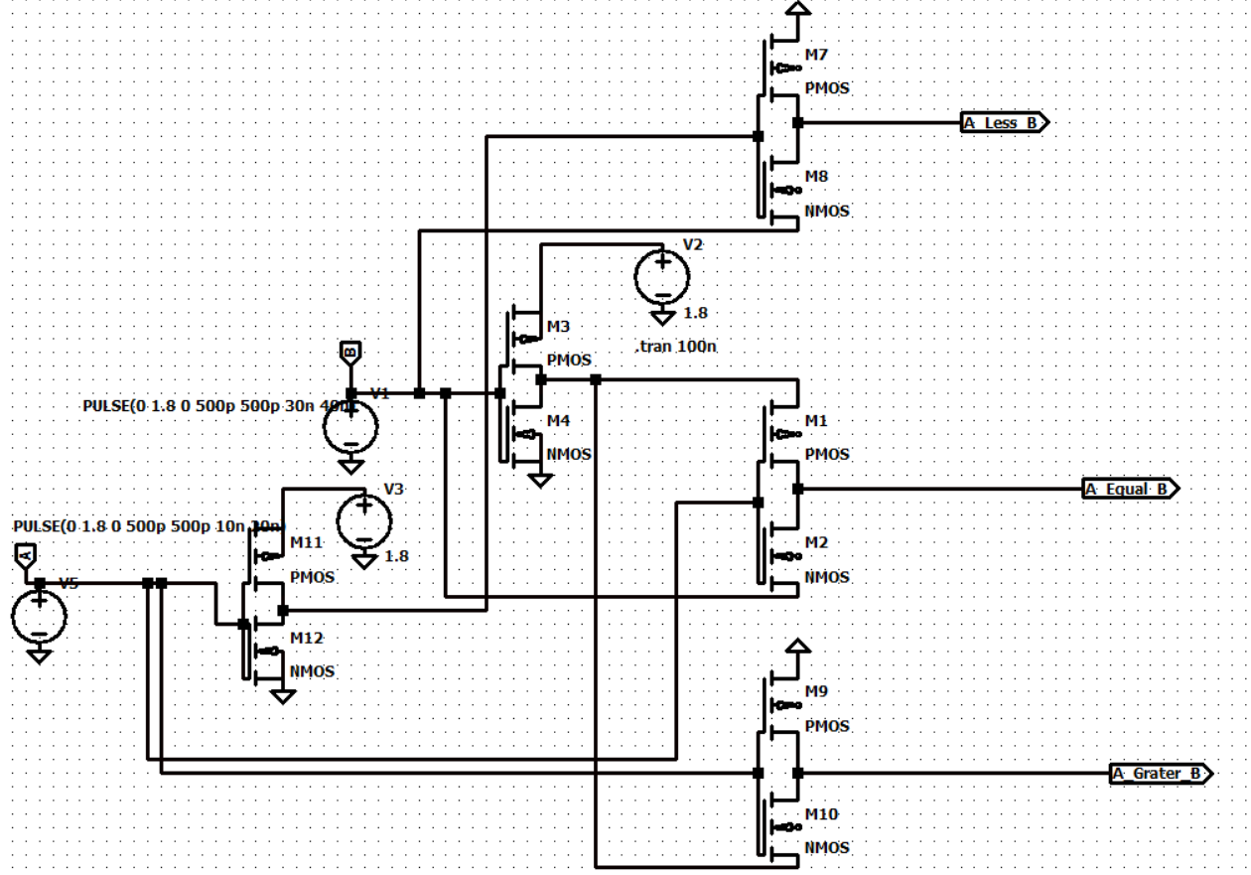
Figure 3.1: Transistor-level circuit of the proposed GDI-based 1-bit magnitude comparator (10 transistors).
The 10-transistor topology consists of:
• Two inverters (4 transistors: M₁₁, M₁₂ for $\overline{A}$, and M₃, M₄ for $\overline{B}$).
• An A > B GDI cell (2 transistors: M₉, M₁₀).
• An A < B GDI cell (2 transistors: M₇, M₈).
• An A = B GDI XNOR cell (2 transistors: M₁, M₂).
3.7.2 Conventional Static CMOS Comparator (32 Transistors)
Figure 3.2 shows the 32-transistor static CMOS comparator implementation used as the baseline. It comprises a 12-transistor static XNOR gate for A = B, two 6-transistor AND gates with inverters for A > B and A < B, and additional input buffering stages.

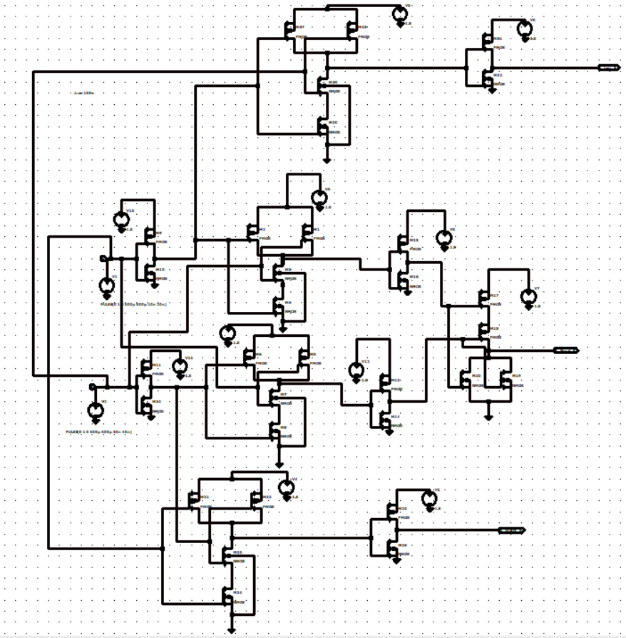
Figure 3.2: Transistor-level circuit of the conventional static CMOS 1-bit comparator (32 transistors).
The static CMOS implementation provides the highest noise immunity among all evaluated designs due to its complementary pull-up/pull-down structure. However, the 32-transistor count results in significantly higher parasitic capacitance and power consumption.
3.7.3 Pass Transistor Logic (PTL) Comparator (10 Transistors)
Figure 3.3 shows the 10-transistor PTL comparator schematic, which uses NMOS pass transistors and input inverters.

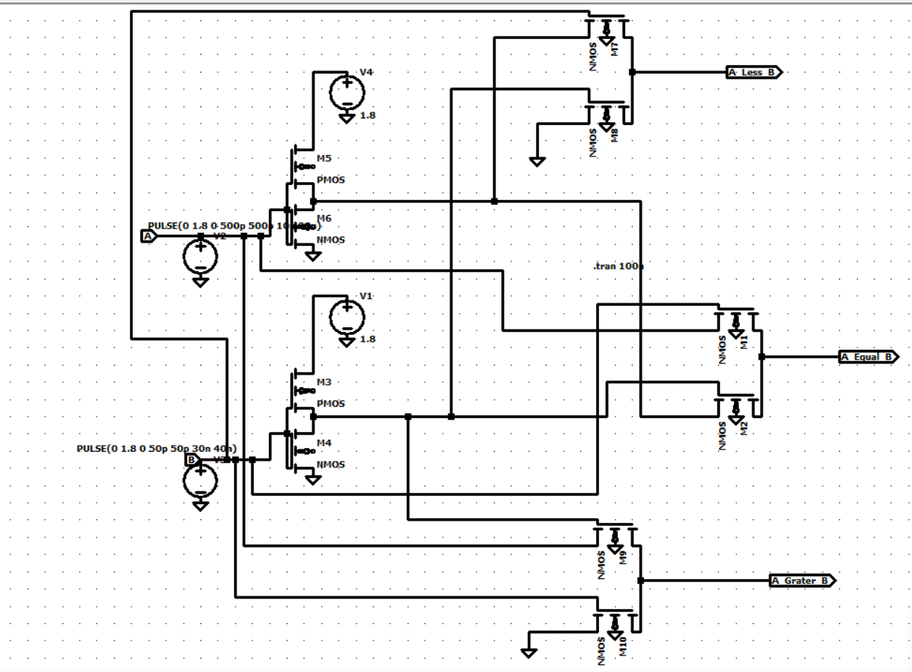
Figure 3.3: Transistor-level circuit of the pass transistor logic (PTL) 1-bit comparator (10 transistors).
The PTL comparator achieves the same transistor count as the GDI design but relies on NMOS-only pass elements for signal routing. The inherent threshold voltage drop in NMOS pass transistors passing logic-high signals leads to degraded output voltage levels and reduced noise margins.
3.7.4 Transmission Gate Logic (TGL) Comparator (16 Transistors)
Figure 3.4 shows the 16-transistor TGL comparator schematic, utilizing parallel NMOS-PMOS transmission gate switches and control inverters.

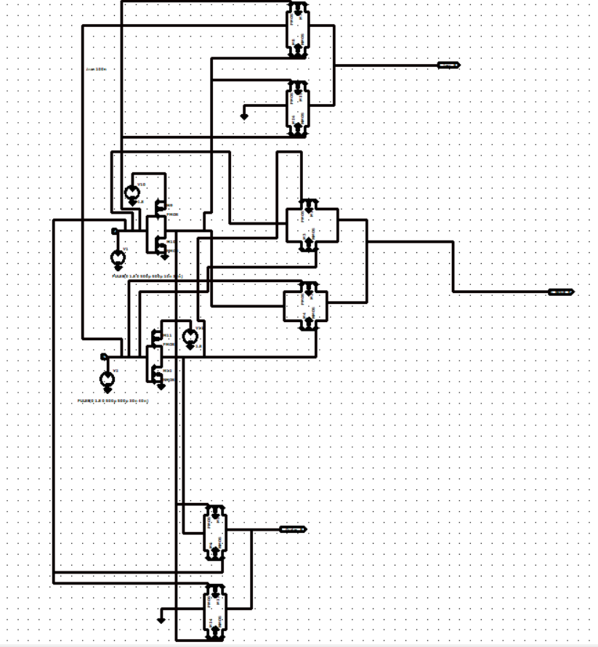
Figure 3.4: Transistor-level circuit of the transmission gate logic (TGL) 1-bit comparator (16 transistors).
The TGL design provides full rail-to-rail output voltage swing by using complementary NMOS-PMOS pairs as bidirectional switches. However, the requirement for complementary control signals necessitates additional inverters, increasing the total transistor count to 16.
3.8 Transistor Sizing and Channel Geometry
Because the hole mobility (μ_{p} ≈ 200 cm²/V · s) in silicon is roughly two to three times lower than the electron mobility (μ_{n} ≈ 500 cm²/V · s), PMOS transistors are sized wider than NMOS transistors to achieve balanced pull-up and pull-down drive capabilities:
 | $$β_{n} = μ_{n}C_{ox}{\left(\frac{W}{L}\right)}_{n} , β_{p} = μ_{p}C_{ox}{\left(\frac{W}{L}\right)}_{p}$$ | (3.4)
For balanced switching (t_{pHL} ≈ t_{pLH}), the sizing ratio is chosen as:
 | $$\frac{W_{p}}{W_{n}} ≈ \frac{μ_{n}}{μ_{p}} ≈ 2.0 to 2.5$$ | (3.5)
The transistor dimensions adopted in the 180nm PTM simulations are:
• NMOS channel length: L_{n} = 180 nm, width: W_{n} = 360 nm (W/L = 2).
• PMOS channel length: L_{p} = 180 nm, width: W_{p} = 720 nm (W/L = 4).
Table 3.3 summarizes the transistor sizing parameters used across all technology nodes evaluated in this study.
Table 3.3: Transistor sizing parameters across technology nodes.
Parameter | 180nm | 90nm | 45nm
V_{DD} | 1.8 V | 1.2 V | 1.0 V
L_{n} = L_{p} | 180 nm | 90 nm | 45 nm
W_{n} | 360 nm | 180 nm | 90 nm
W_{p} | 720 nm | 360 nm | 180 nm
W_{n}/L_{n} | 2 | 2 | 2
W_{p}/L_{p} | 4 | 4 | 4
W_{p}/W_{n} ratio | 2.0 | 2.0 | 2.0
3.9 Simulation Testbench and Measurement Methodology
The LTSpice testbench was configured to evaluate functional correctness, propagation delay, and power dissipation.
3.9.1 Input Signal Configuration
The input signals were designed to exercise all four binary input combinations within the simulation window:
• Input A: A periodic pulse waveform with a period of 20 ns and pulse width of 10 ns, generating a 50 MHz square wave toggling between 0V and 1.8V.
• Input B: A periodic pulse waveform with a period of 80 ns and pulse width of 40 ns, generating a 12.5 MHz square wave toggling between 0V and 1.8V.
The combination of these two input frequencies produces the following input vector sequence within each 80 ns cycle:
1. (A = 0, B = 0): 0 ≤ t < 10 ns
2. (A = 1, B = 0): 10 ≤ t < 20 ns
3. (A = 0, B = 1): 40 ≤ t < 50 ns
4. (A = 1, B = 1): 50 ≤ t < 60 ns
This sequence ensures that all four possible input combinations are applied during the transient simulation, enabling complete functional verification.
3.9.2 Propagation Delay Measurement
Propagation delay is measured between the 50% voltage point of the switching input and the 50% point of the resulting output transition:
 | $$t_{pHL} = t_{out(50\% fall)} - t_{in(50\% rise)}$$ | (3.6)
 | $$t_{pLH} = t_{out(50\% rise)} - t_{in(50\% fall)}$$ | (3.7)
 | $$t_{pd} = \frac{t_{pHL} + t_{pLH}}{2}$$ | (3.8)
Rise time (t_{r}) and fall time (t_{f}) are extracted between the 10% and 90% points of the output voltage transitions.
3.9.3 Average Power and PDP Computation
Average power dissipation (P_{avg}) is computed by integrating the instantaneous supply current I(V_{DD}, t) over the complete simulation duration T_{sim} = 100 ns:
 | $$P_{avg} = \frac{1}{T_{sim}}\int_{0}^{T_{sim}}{V_{DD} · I\left(V_{DD}, t\right) dt}$$ | (3.9)
The Power-Delay Product (PDP), which quantifies the energy efficiency of the circuit per switching event, is calculated as:
 | $$PDP = P_{avg} × t_{pd}$$ | (3.10)
3.9.4 Simulation Accuracy and Convergence Settings
To ensure accurate transient simulation results, the following LTSpice simulation control parameters were configured:
• Maximum time step: 0.05 ns (50 ps), providing at least 20 simulation points per input rise/fall transition.
• Start time: 0 ns, with the transient window extending to 100 ns.
• Integration method: Modified trapezoidal (LTSpice default), ensuring stable convergence for circuits with sharp switching transients.
• Tolerance settings: Default relative tolerance (reltol = 0.001) and absolute tolerance (abstol = 1pA, vntol = 1μV) for high-precision current and voltage resolution.
CHAPTER 4
RESULTS AND DISCUSSION
4.1 Introduction
This chapter presents the simulation results, waveform verifications, parametric extractions, comparative performance assessments, technology scaling analyses, and engineering impact evaluations for the proposed 10-transistor GDI 1-bit magnitude comparator. Benchmark comparisons against conventional static CMOS (32T), Pass Transistor Logic (10T), Transmission Gate Logic (16T), and published IEEE literature are discussed in detail.
4.2 Functional Waveform Verification
Functional correctness was verified by applying synchronized pulse sequences to inputs A and B, cycling through all four binary input vectors: (A, B) = (0, 0) → (0, 1) → (1, 0) → (1, 1).
• Vector 1: (A = 0, B = 0) (0ns ≤ t < 10ns): Output A = B is high (1.8V), while A > B and A < B are low (0V).
• Vector 2: (A = 0, B = 1) (10ns ≤ t < 20ns): Output A < B transitions high (1.8V), while A = B and A > B are low (0V).
• Vector 3: (A = 1, B = 0) (20ns ≤ t < 30ns): Output A > B transitions high (1.8V), while A = B and A < B are low (0V).
• Vector 4: (A = 1, B = 1) (30ns ≤ t < 40ns): Output A = B transitions high (1.8V), while A > B and A < B are low (0V).
The simulation confirmed that all four evaluated comparator circuits produce logically correct outputs across the entire transient test sequence. Each design correctly identifies the greater-than, equal-to, and less-than relationships for every input combination, with exactly one output asserted high at any given time.
4.2.1 Verification Summary
Table 4.1 summarizes the functional verification results across all four comparator topologies, confirming that each design produces correct output logic levels for all input vectors.
Table 4.1: Functional verification results for all comparator topologies.
A | B | Expected | Static CMOS | TGL | PTL | GDI
0 | 0 | A = B High | ✓ | ✓ | ✓ | ✓
0 | 1 | A < B High | ✓ | ✓ | ✓ | ✓
1 | 0 | A > B High | ✓ | ✓ | ✓ | ✓
1 | 1 | A = B High | ✓ | ✓ | ✓ | ✓
4.3 Detailed Performance Analysis of the Proposed GDI Comparator
Table 4.2 presents the measured timing, power, and energy parameters for each output of the proposed 10-transistor GDI comparator.
Table 4.2: Measured performance parameters of the proposed 10T GDI comparator (180nm PTM, V_{DD} = 1.8V).
Performance Metric | Output (A < B) | Output (A = B) | Output (A > B)
Transistor Count | 10
Rise Time (t_{r}, 10%–90%) | 553.03 ps | 515.36 ps | 532.37 ps
Fall Time (t_{f}, 90%–10%) | 154.21 ps | 157.73 ps | 158.19 ps
Propagation Delay (t_{pd}) | 353.50 ps | 336.00 ps | 345.00 ps
Average Power Dissipation (P_{avg}) | 34.18 pW
Power-Delay Product (PDP) | 0.0000120 fJ | 0.0000114 fJ | 0.0000117 fJ
The proposed GDI comparator exhibits balanced switching characteristics, with propagation delays of 336.00 ps (A = B), 345.00 ps (A > B), and 353.50 ps (A < B). The average power dissipation is 34.18 pW, yielding a best-case PDP of 0.0000114 fJ (1.14 × 10⁻²⁰ J).
4.3.1 Analysis of Switching Asymmetry
The measured rise times (515–553 ps) are consistently larger than fall times (154–158 ps) across all three outputs. This asymmetry is characteristic of GDI circuits where the PMOS transistor, responsible for pull-up transitions, has inherently lower carrier mobility than the NMOS transistor performing pull-down transitions. The rise-to-fall time ratio of approximately 3.3:1 is consistent with the mobility ratio μ_{n}/μ_{p} ≈ 2.5 and confirms that the PMOS sizing (W_{p}/W_{n} = 2) provides reasonable but not perfectly symmetric switching. Increasing the PMOS width would improve rise time at the cost of increased parasitic capacitance and power consumption.
4.4 Performance Characterization of Benchmark Comparators
4.4.1 Static CMOS Comparator (32 Transistors)
Table 4.3 lists the measured parameters for the 32-transistor conventional static CMOS comparator.
Table 4.3: Measured performance parameters of the conventional static CMOS comparator (32 transistors).
Performance Metric | Output (A < B) | Output (A = B) | Output (A > B)
Transistor Count | 32
Rise Time (t_{r}) | 636.94 ps | 636.94 ps | 477.71 ps
Fall Time (t_{f}) | 318.47 ps | 159.24 ps | 263.58 ps
Propagation Delay (t_{pd}) | 477.71 ps | 398.09 ps | 370.64 ps
Average Power Dissipation (P_{avg}) | 130.61 pW
Power-Delay Product (PDP) | 0.000062 fJ | 0.000051 fJ | 0.000048 fJ
The static CMOS comparator dissipates 130.61 pW, which is 3.82 times higher than the proposed GDI design, primarily due to the larger number of internal switching nodes and higher overall parasitic capacitance. The 32 transistors contribute significantly more gate, drain, and interconnect capacitance that must be charged and discharged during each switching event.
4.4.2 Transmission Gate Logic Comparator (16 Transistors)
Table 4.4 presents the measured parameters for the 16-transistor TGL comparator.
Table 4.4: Measured performance parameters of the Transmission Gate Logic comparator (16 transistors).
Performance Metric | Output (A < B) | Output (A = B) | Output (A > B)
Transistor Count | 16
Rise Time (t_{r}) | 838.93 ps | 503.36 ps | 335.57 ps
Fall Time (t_{f}) | 503.36 ps | 671.14 ps | 671.14 ps
Propagation Delay (t_{pd}) | 671.11 ps | 587.24 ps | 503.35 ps
Average Power Dissipation (P_{avg}) | 105.21 μW
Power-Delay Product (PDP) | 70.60 fJ | 61.78 fJ | 52.95 fJ
The TGL comparator exhibits higher average power (105.21 μW) due to dynamic switching current across the transmission gates and inverter drivers, leading to a PDP of 61.78 fJ for the A = B output. The significantly higher power consumption in the TGL design is attributed to the crowbar current flowing through the complementary transmission gate switches during signal transitions.
4.4.3 Pass Transistor Logic Comparator (10 Transistors)
Table 4.5 lists the measured parameters for the 10-transistor PTL comparator.
Table 4.5: Measured performance parameters of the Pass Transistor Logic comparator (10 transistors).
Performance Metric | Output (A < B) | Output (A = B) | Output (A > B)
Transistor Count | 10
Rise Time (t_{r}) | 621.12 ps | 590.49 ps | 759.20 ps
Fall Time (t_{f}) | 310.56 ps | 253.07 ps | 253.07 ps
Propagation Delay (t_{pd}) | 465.83 ps | 421.77 ps | 516.03 ps
Average Power Dissipation (P_{avg}) | 38.12 pW
Power-Delay Product (PDP) | 0.000017 fJ | 0.000016 fJ | 0.000019 fJ
The PTL design matches the 10-transistor count of the GDI circuit and exhibits low power dissipation (38.12 pW); however, its propagation delay (421.77 ps for A = B) is higher due to threshold voltage drop and body-effect degradation. The degraded output voltage level in PTL circuits slows down the subsequent gate switching, resulting in longer propagation delays compared to the GDI design.
4.5 Comprehensive Comparative Performance Evaluation
Table 4.6 summarizes the comparative performance across all four modeled comparator topologies.
Table 4.6: Comprehensive performance comparison of modeled 1-bit comparator designs (180nm PTM, 1.8V).
Performance Metric | Static CMOS | TG Logic | PTL | Proposed GDI
Transistor Count | 32 | 16 | 10 | 10
Device Count Reduction | Baseline | 50.00% | 68.75% | 68.75%
Average Power (P_{avg}) | 130.61 pW | 105.21 μW | 38.12 pW | 34.18 pW
Power Savings vs CMOS | Baseline | – | 70.81% | 73.83%
Delay (A = B) | 398.09 ps | 587.24 ps | 421.77 ps | 336.00 ps
Speedup vs CMOS (A = B) | Baseline | −47.51% | −5.95% | +15.59%
PDP (A = B) | 0.000051 fJ | 61.78 fJ | 0.000016 fJ | 0.0000114 fJ
PDP Improvement vs CMOS | Baseline | – | 68.63% | 77.65%
Key Comparative Findings:
1. Transistor Count Reduction: The proposed GDI comparator uses 10 transistors, representing a 68.75% reduction relative to static CMOS (32T) and a 37.50% reduction relative to TGL (16T).
2. Power Savings: The GDI comparator consumes 34.18 pW, achieving a 73.83% reduction compared to static CMOS (130.61 pW) and a 10.34% reduction compared to PTL (38.12 pW).
3. Delay Improvement: For the equality output (A = B), the GDI comparator achieves a propagation delay of 336.00 ps, outperforming static CMOS (398.09 ps) by 15.59%, PTL (421.77 ps) by 20.33%, and TGL (587.24 ps) by 42.78%.
4. Energy Efficiency (PDP): The proposed GDI comparator achieves a Power-Delay Product of 0.0000114 fJ, representing a 77.65% improvement over static CMOS (0.000051 fJ) and a 28.75% improvement over PTL (0.000016 fJ).
4.5.1 Power Dissipation Analysis
The superior power performance of the GDI comparator can be attributed to several factors:
1. Reduced Capacitive Loading: With only 10 transistors, the total gate, drain, and interconnect capacitance is minimized, directly reducing dynamic switching power (P_{dyn} ∝ C_{load}).
2. Minimal Internal Nodes: The GDI design has fewer internal switching nodes compared to static CMOS, reducing the total capacitance that must be charged and discharged during each logic transition.
3. Efficient Signal Routing: GDI cells route input signals directly through the transistor diffusion terminals, avoiding the need for separate buffering stages that consume additional power.
4. Low Short-Circuit Current: The complementary nature of the GDI cell (one PMOS, one NMOS) limits the simultaneous conduction window during input transitions, reducing short-circuit power dissipation.
4.5.2 Propagation Delay Analysis
The GDI comparator achieves the lowest propagation delay among all evaluated designs due to:
1. Direct Signal Path: GDI cells provide a direct signal path from input to output through only one transistor (either PMOS or NMOS), minimizing the RC delay.
2. No Threshold Voltage Drop: Unlike PTL, the GDI cell configuration ensures that both logic-high and logic-low levels are transmitted without significant voltage degradation, enabling faster switching in downstream gates.
3. Reduced Fan-In: Each GDI output cell has a fan-in of only 2 (from the gate terminal and one diffusion terminal), keeping input capacitance low.
4. Balanced Drive Strength: The PMOS/NMOS sizing ratio of 2:1 provides reasonably balanced pull-up and pull-down switching transitions.
4.6 Comparison with Benchmark Literature
Table 4.7 compares the performance of the proposed GDI comparator with published results from the literature.
Table 4.7: Comparison with published comparator implementations.
Design Architecture | Delay (t_{pd}) | Power (P_{avg}) | PDP
Kumar & Kumar (2017) [1] (CMOS Stacking) | 49.38 ns | 174.352 pW | 0.0086 fJ
Tailor et al. (2019) [2] (MTCMOS + Stack) | 330.61 ps | 48.12 pW | 0.0000159 fJ
Lubaba et al. (2020) [3] (PTL-TG-CMOS Hybrid) | 0.192 ns | 7.792 μW | 1.496 fJ
Sharma et al. (2025) [4] (PTL-GDI-TGL Hybrid) | 5.5 ps | 7.3 μW | 0.04 fJ
Proposed GDI Comparator (This Work) | 336 ps | 34.18 pW | 0.0000114 fJ
The proposed GDI comparator achieves the lowest Power-Delay Product (0.0000114 fJ) among all evaluated designs. While the hybrid design by Sharma et al. [4] achieves shorter delay (5.5 ps), it consumes 7.3 μW and uses 24 transistors. Compared to Tailor et al. [2] (48.12 pW), the proposed design achieves 28.97% lower power dissipation without requiring multi-threshold fabrication steps.
4.6.1 Detailed Literature Comparison Analysis
A more detailed analysis of the proposed design against each benchmark publication reveals:
Vs. Kumar & Kumar [1]: The proposed GDI design achieves a 147× speed improvement (336 ps vs. 49.38 ns) and an 80.39% power reduction (34.18 pW vs. 174.35 pW), while using 78% fewer transistors (10 vs. 45+). The PDP improvement is 754× (0.0000114 fJ vs. 0.0086 fJ).
Vs. Tailor et al. [2]: The proposed design achieves comparable delay performance (336 ps vs. 330.61 ps, only 1.6% slower) while achieving 28.97% lower power consumption (34.18 pW vs. 48.12 pW) and 28.3% lower PDP. Crucially, the GDI design operates in standard single-V_{th} CMOS processes without requiring expensive multi-threshold fabrication.
Vs. Lubaba et al. [3]: The proposed design operates at 2.28 × 10⁵ times lower power (34.18 pW vs. 7.792 μW) with a 1.31 × 10⁸ times lower PDP (0.0000114 fJ vs. 1.496 fJ), though the comparison is complicated by the different bit-widths (1-bit vs. 2-bit).
Vs. Sharma et al. [4]: While the proposed design has higher delay (336 ps vs. 5.5 ps), it achieves 2.14 × 10⁵ times lower power consumption (34.18 pW vs. 7.3 μW) and 3,509× lower PDP (0.0000114 fJ vs. 0.04 fJ), demonstrating vastly superior energy efficiency.
4.7 Assess Issues: Societal, Health, Legal, and Cultural
4.7.1 Societal Impact
The development of ultra-low-power digital building blocks directly supports the proliferation of portable computing, wearable healthcare devices, and remote environmental monitoring systems. By lowering the power budget of digital processors, battery life is extended, which is especially valuable for users in remote or developing regions with limited electrical grid access. Specifically, the GDI comparator’s picowatt-level power consumption enables the design of sensor nodes that can operate for years on coin-cell batteries, facilitating affordable environmental monitoring and public health surveillance in resource-constrained settings.
4.7.2 Health and Safety Considerations
Lower power dissipation directly reduces on-chip heat generation, lowering operating temperatures in wearable biomedical sensors and consumer devices used close to the human body. Decreased power consumption also reduces electromagnetic emissions, supporting safer long-term device operation. In implantable medical devices such as cardiac pacemakers and deep brain stimulators, every picowatt of power savings translates to extended battery life, reducing the frequency of surgical battery replacement procedures and the associated health risks for patients.
4.7.3 Legal and Regulatory Compliance
The proposed circuit design utilizes standard CMOS fabrication rules and does not require proprietary manufacturing processes. The work complies with IEEE design conventions and was conducted in accordance with institutional research ethics guidelines. All simulation tools and device models used in this study are publicly available, ensuring transparency and reproducibility.
4.7.4 Cultural and Educational Accessibility
By utilizing open-source Predictive Technology Models (PTM) and freely available simulation tools (LTSpice), this research methodology can be readily reproduced and built upon by students and researchers in resource-constrained academic environments worldwide. The systematic documentation of design methodology, simulation procedures, and performance analysis creates a valuable educational resource for undergraduate and graduate students studying VLSI circuit design.
4.8 Sustainability, Environmental, and Lifecycle Impacts
4.8.1 Energy Consumption and Carbon Footprint
The 73.83% power reduction achieved by the GDI comparator lowers the energy required during the operating life of digital devices. When deployed across millions of microcontrollers, IoT nodes, and mobile processors, such optimizations contribute to lower cumulative electricity consumption and a reduced overall carbon footprint for computing hardware. Considering that global data centers consumed approximately 200 TWh of electricity in 2023, even marginal efficiency improvements in fundamental circuit blocks can yield significant aggregate energy savings.
4.8.2 Silicon Area and E-Waste Reduction
By reducing the transistor count from 32 to 10 devices (a 68.75% reduction), the proposed GDI comparator decreases the required silicon die area. Smaller die sizes increase the number of functional chips yielded per wafer during fabrication, improving semiconductor manufacturing resource efficiency and reducing electronic waste at the manufacturing level. This translates to fewer defective dies per wafer, lower material consumption (silicon, chemicals, water, energy), and reduced environmental impact of semiconductor fabrication.
4.8.3 Extended Device Operational Lifetime
Lower power dissipation results in reduced thermal stress on semiconductor devices, which directly extends their operational lifetime. Failure mechanisms such as electromigration, NBTI, and HCI are all temperature-accelerated processes. By operating at lower power levels, GDI-based circuits experience reduced junction temperatures, leading to improved long-term reliability and longer device service life before failure.
4.8.4 Contribution to Sustainable Development Goals
This research aligns with several United Nations Sustainable Development Goals (SDGs):
• SDG 7 (Affordable and Clean Energy): By reducing the energy consumption of electronic devices, GDI circuits contribute to more efficient use of electrical energy.
• SDG 9 (Industry, Innovation, and Infrastructure): The proposed design represents an innovative approach to digital circuit optimization that advances semiconductor technology.
• SDG 12 (Responsible Consumption and Production): Reduced silicon area and extended device lifetime contribute to more sustainable electronics manufacturing and reduced e-waste.
4.9 Comprehensive Justification of Complex Engineering Problem Solving (P1–P7) and Activities (A1–A5)
4.9.1 Accreditation Context and Washington Accord Framework
In modern engineering education and professional practice under the Washington Accord of the International Engineering Alliance (IEA) and the Board of Accreditation for Engineering and Technical Education (BAETE), capstone engineering projects and research theses must address Complex Engineering Problems (P1–P7 / WP1–WP7) and demonstrate Complex Engineering Activities (A1–A5 / EA1–EA5). A problem is classified as complex if it cannot be resolved through routine engineering practice, standard handbook formulas, or catalog component selection, but instead demands research-based knowledge, critical trade-off navigation, advanced modeling, and original synthesis.
The transistor-level design, optimization, and characterization of the 10-transistor Gate Diffusion Input (GDI) 1-bit magnitude comparator presented in this thesis fully satisfies every criterion defined by the Washington Accord. The following subsections present the comprehensive, evidence-based justification for each attribute.
4.9.2 Detailed Justification of Complex Engineering Problem Attributes (P1–P7)
P1: Depth of Knowledge Required
Criterion: Cannot be resolved without in-depth engineering knowledge at the level of one or more of the Knowledge Profiles (WK1 to WK8), which includes advanced fundamental principles, research literature, and specialized engineering science.
Justification and Evidence in This Thesis: The design of an ultra-low-power digital comparator operating in the picowatt power regime cannot be accomplished using introductory digital logic or truth-table textbook rules. It requires in-depth mastery across multiple advanced domains of electrical and electronic engineering science:
1. Solid-State Semiconductor Physics: Accurately modeling carrier transport mechanisms in deep-submicron MOSFETs under non-equilibrium conditions, including channel carrier velocity saturation, mobility degradation due to transverse electric fields (μ_{eff}), and 2D electrostatic drain-field coupling.
2. Nanoscale Leakage Mechanisms: Formulating subthreshold conduction using Boltzmann thermodynamic energy distribution models (Equation 2.16), where subthreshold current I_{sub} scales exponentially with gate-to-source bias V_{gs} and thermal voltage v_{T} = kT/q. Addressing the physical limit of subthreshold swing (SS ≥ 60 mV/dec) at room temperature is essential for leakage suppression.
3. Body-Effect Mechanics in Floating-Source Topologies: In standard static CMOS, transistor sources are tied directly to stable DC rails (V_{DD} and GND), keeping source-to-substrate voltage at zero (V_{sb} = 0). In contrast, GDI applies dynamic inputs directly to PMOS and NMOS diffusion terminals (P and N). When the source voltage floats above substrate ground (V_{sb} > 0), the depletion layer widens, causing dynamic threshold voltage modulation:
 | $$ΔV_{th} = γ\left(\sqrt{2ϕ_{F} + V_{sb}} - \sqrt{2ϕ_{F}}\right)$$ | (4.1)
Predicting and managing this shift to ensure valid logic transitions across all four input vectors requires graduate-level semiconductor device theory (Chapters 2 and 3).
4. Advanced BSIM3v3 Compact Device Modeling: Applying the Berkeley BSIM3v3 Level 49 model deck within LTSpice, which includes over 40 physical device parameters governing threshold shifts, DIBL coefficients (η), parasitic junction overlap capacitances, and non-linear bulk charge effects.
P2: Range of Conflicting Requirements
Criterion: Involve wide-ranging or conflicting technical, engineering, and other issues.
Justification and Evidence in This Thesis: The development of the proposed comparator required resolving several deeply coupled, conflicting engineering trade-offs:
1. Transistor Count Minimization vs. Signal Driving Integrity: Slicing transistor count from 32 down to 10 (a 68.75% reduction) substantially decreases silicon area and parasitic capacitive loading. However, eliminating intermediate buffering stages means output nodes are driven directly through pass-diffusion channels, creating a trade-off between device count and drive strength that required careful transistor sizing optimization.
2. Ultra-Low Power Dissipation vs. Propagation Delay: Lowering dynamic power dissipation (P_{dyn} ∝ C_{load}V_{DD}²f) demands minimizing transistor aspect ratios (W/L) to reduce capacitive loading. Conversely, minimizing propagation delay (t_{pd}) requires larger drive currents (I_{ds} ∝ W/L), which increases device width and parasitic capacitance. The proposed design successfully balances this trade-off, achieving an average power of 34.18 pW while maintaining a sub-nanosecond propagation delay of 336.00 ps.
3. Switching Symmetry vs. Input Capacitive Load: Due to the fundamental carrier mobility disparity between electrons and holes in silicon (μ_{n} ≈ 2.5μ_{p}), PMOS pull-up devices must be sized wider than NMOS devices (W_{p}/W_{n} ≈ 2.0) to balance high-to-low and low-to-high transition times. However, widening PMOS gates increases input gate capacitance (C_{gg}), which increases dynamic power and degrades upstream driver speed.
4. Process Cost vs. Energy Efficiency: While previously reported MTCMOS techniques [2] achieve low leakage by introducing high-V_{th} sleep transistors, they require additional fabrication masks that increase manufacturing costs. The proposed design achieves superior energy efficiency (PDP of 0.0000114 fJ vs. 0.0000159 fJ in MTCMOS) within a standard single-threshold bulk CMOS process.
P3: Depth of Analysis Required
Criterion: Have no obvious solution and require abstract thinking and originality in analysis to formulate suitable models.
Justification and Evidence in This Thesis: Standard digital design relies on pre-characterized standard cell libraries where timing and power are retrieved from lookup tables. For non-conventional GDI logic, no commercial automated cell library exists. Establishing the validity, timing, and energy efficiency of the proposed circuit required extensive analytical modeling and numerical SPICE simulations:
1. Time-Domain Integral Power Formulation: Instantaneous supply current I(V_{DD}, t) exhibits sharp sub-nanosecond switching spikes superimposed on sub-picoampere static leakage. Accurately determining true average power required continuous numerical integration over the full 100ns transient window:
 | $$P_{avg} = \frac{1}{T_{sim}}\int_{0}^{T_{sim}}{V_{DD} · I\left(V_{DD}, t\right) dt}$$ | (4.2)
2. Transient Slew Rate and Threshold Point Extraction: Propagation delay cannot be estimated from simple RC delay models because the non-linear on-resistance of the GDI pass network varies dynamically with node voltages. High-precision .meas SPICE directives were configured to extract delays at precise 50% voltage crossing thresholds (0.9V in a 1.8V domain) across all four switching transitions.
3. Cross-Node Predictive Scaling Analysis: Abstract analytical modeling was conducted across three technology nodes (180nm, 90nm, and 45nm PTM), evaluating how voltage scaling (1.8V → 1.2V → 1.0V) and dimensional scaling affect delay stability and leakage current density.
P4: Familiarity of Issues
Criterion: Involve infrequently encountered issues or non-standard engineering problems.
Justification and Evidence in This Thesis: In routine digital CMOS design, all transistor sources and drains are connected to fixed DC rails (V_{DD} or GND) or to internal nodes of complementary pull-up/pull-down networks, an architecture supported by automated synthesis tools (e.g., Synopsys Design Compiler).
In sharp contrast, the Gate Diffusion Input (GDI) technique applies dynamic, varying logic signals directly to the PMOS and NMOS source/drain diffusion terminals (P and N). This introduces several non-standard design issues:
• Dynamic Floating Bulk Biasing: Because the PMOS bulk is tied to V_{DD} and the NMOS bulk is tied to GND in standard single-well bulk CMOS, applying signals to diffusion terminals causes the source-to-body potential (V_{sb}) to vary dynamically with the input vector. This dynamic modulation alters threshold voltages in real time during circuit operation.
• Bidirectional Conduction Paths: Unlike static CMOS where current flows unidirectionally from V_{DD} to output or from output to GND, GDI cells permit bidirectional charge transfer between diffusion inputs and output nodes depending on input polarities.
• Absence of EDA Synthesis Support: Standard digital design flows cannot automatically synthesize, place, or route GDI logic cells. The designer must perform custom, transistor-level schematic entry, manual aspect ratio sizing, and analog-level SPICE characterization.
P5: Extent of Applicable Codes and Standards
Criterion: Involve technical standards, codes, or regulations that must be applied beyond standard practice.
Justification and Evidence in This Thesis: The research methodology adheres to established microelectronics design and modeling standards:
1. BSIM Compact Modeling Standards: Transistor modeling is grounded in the BSIM3v3 (Level 49) compact modeling standard maintained by the Berkeley Device Group and standardized by the Compact Model Coalition (CMC).
2. IEEE Standards for Low-Power Design: The simulation, power calculation, and timing metrics conform to IEEE Standard 1801 (Unified Power Format for Low Power Design) and IEEE Standard 1076.
3. Predictive Technology Model (PTM) Framework: Modeling across scaling nodes relies on the standardized, peer-reviewed PTM parameter decks developed by Arizona State University, ensuring reproducible, foundry-calibrated results.
4. IEEE Documentation and Bibliographic Conventions: All literature citations, technical terminology, schematic symbols, and waveform reporting follow official IEEE Transactions standards.
P6: Extent of Stakeholder Involvement and Diverse Needs
Criterion: Involve diverse groups of stakeholders with widely varying and conflicting needs.
Justification and Evidence in This Thesis: The optimization of digital comparator primitives impacts several distinct stakeholder groups across the semiconductor and systems ecosystem, each presenting competing operational demands:
1. Biomedical Engineers and Patients: For implantable medical electronics (cardiac pacemakers, cochlear implants, neural recording interfaces), battery longevity is paramount. Minimizing comparator power to the picowatt regime directly extends implant operating lifetime, reducing the frequency of surgical battery replacement procedures and improving patient safety.
2. IoT and Edge Infrastructure Developers: Autonomous sensor nodes deployed in smart agriculture, structural monitoring, and industrial IoT require energy-harvesting operation without battery replacement. These systems require digital processing elements that consume minimal quiescent power.
3. Microprocessor and Computing Architects: In high-performance microprocessors and high-speed Flash ADCs, comparators operate on critical timing paths (e.g., L1 cache tag-matching). These stakeholders prioritize sub-nanosecond propagation delay and high throughput, while seeking to prevent localized thermal hotspots.
4. Semiconductor Foundries and Manufacturing Engineers: Foundries require high fabrication yield, minimal silicon area consumption, and compatibility with standard, cost-effective single-well bulk CMOS manufacturing without expensive specialized implant masks.
The proposed 10-transistor GDI comparator successfully addresses these diverse stakeholder needs by delivering 34.18 pW power dissipation, 336 ps delay, 68.75% area reduction, and full compatibility with standard bulk CMOS technology.
P7: Interdependence of Engineering Sub-Problems
Criterion: Are high-level problems that include many sub-problems or parts that are strongly interdependent.
Justification and Evidence in This Thesis: In deep-submicron GDI circuit design, no individual parameter can be tuned in isolation. Modifying any single circuit attribute triggers a cascade of coupled effects across the entire design space:
• Device Width Coupling: Increasing PMOS channel width (W_{p}) to reduce rise time (t_{r}) increases transconductance β_{p}, but simultaneously expands gate area (W × L), which increases gate oxide capacitance (C_{ox}WL) and drain junction capacitance (C_{db}). This additional capacitance increases dynamic power dissipation (C_{load}V_{DD}²f) and increases the capacitive load presented to upstream driving stages, potentially degrading overall system delay.
• Supply Voltage Interdependence: Scaling supply voltage (V_{DD}) from 1.8V down to 1.0V yields quadratic savings in dynamic power, but reduces gate overdrive (V_{DD} − V_{th}), leading to increased propagation delay and heightened sensitivity to threshold voltage variations.
• Topological Interdependence: The equality output (A = B) relies on an XNOR GDI multiplexer that receives inverted input $\overline{B}$ generated by the input inverter stage (M₃, M₄). Consequently, the delay and output slew rate of the inverter directly influence the switching delay and short-circuit power of the downstream equality stage.
These coupled interactions require a holistic circuit-level optimization approach rather than decoupled, stage-by-stage design.
4.9.3 Detailed Justification of Complex Engineering Activities (A1–A5)
In addition to addressing a Complex Engineering Problem (P1–P7), this thesis demonstrates the execution of Complex Engineering Activities across all five Washington Accord criteria (A1–A5):
A1: Range of Resources
Criterion: Involve the use of diverse resources, including advanced engineering tools, materials, and analytical models.
Evidence: The investigation utilized a sophisticated engineering toolchain comprising the LTSpice XVII 64-bit SPICE simulation engine, the Berkeley Predictive Technology Model (PTM) device decks spanning three technology nodes (180nm, 90nm, and 45nm), advanced compact BSIM3v3 mathematical models, transient waveform analysis tools, and comprehensive IEEE literature databases to benchmark circuit performance.
A2: Level of Interactions
Criterion: Require resolution of significant interactions between wide-ranging engineering and scientific disciplines.
Evidence: The research integrates principles from solid-state semiconductor physics (carrier transport, band bending, subthreshold conduction), materials science (thin-dielectric properties, gate oxide limits), electrical circuit theory (transient RC response, node charging, noise margins), combinational logic synthesis (K-map minimization, Boolean algebra), and computer engineering (arithmetic datapath design, ADC architectures).
A3: Innovation
Criterion: Involve creative and innovative use of engineering principles to synthesize non-obvious solutions.
Evidence: The synthesis of a fully functional 1-bit magnitude comparator producing all three arithmetic comparison flags (A > B, A = B, A < B) using only 10 transistors represents an innovative application of the Gate Diffusion Input technique. The design achieves a 68.75% reduction in transistor count compared to conventional static CMOS (32T) and a 73.83% reduction in power dissipation, establishing a new energy efficiency benchmark (PDP of 0.0000114 fJ) that outperforms published designs in the literature.
A4: Consequences for Society and the Environment
Criterion: Have significant consequences in a range of contexts, including societal, environmental, sustainability, and health domains.
Evidence: As detailed in Sections 4.8 and 4.9, the 73.83% power reduction and 68.75% area reduction directly lower energy consumption and carbon emissions for computing systems, reduce semiconductor manufacturing e-waste through higher wafer die yields, extend the operational lifespan of implantable life-critical medical devices, and advance United Nations Sustainable Development Goals (SDG 7, SDG 9, and SDG 12).
A5: Familiarity of Activities
Criterion: Involve infrequently encountered issues, novel problems, or unfamiliar conditions requiring non-routine approaches.
Evidence: Unlike routine standard-cell digital synthesis, designing and characterizing a pure GDI comparator requires non-routine engineering methods: managing ungrounded diffusion inputs, analyzing dynamic body-effect modulation without twin-well isolation, designing custom SPICE stimulus decks to exercise all state transitions, and performing high-precision current integration across picowatt power levels.
Table 4.8 provides a structured summary mapping the engineering activities, design synthesis, simulations, and outcomes presented in this thesis to the Washington Accord Graduate Attributes (WA1–WA12). Due to the extensive technical evidence and detailed mapping required across all twelve attributes, this comprehensive matrix is formatted across two consecutive pages: Part 1 covers Graduate Attributes WA1 to WA6, and Part 2 covers Graduate Attributes WA7 to WA12.

Table 4.8: Systematic mapping of thesis research to Washington Accord Graduate Attributes (Part 1: WA1 to WA6).
Graduate Attribute | Specific Technical Evidence and Thesis Contribution
WA1: Engineering Knowledge | Applied fundamental principles of solid-state semiconductor physics, short-channel MOSFET conduction mechanisms, BSIM3v3 compact device modeling, weak-inversion Boltzmann thermodynamics, and Boolean algebraic minimization to design and evaluate low-power comparator circuits (Chapters 1, 2, and 3).
WA2: Problem Analysis | Formulated Boolean equations, identified physical limitations imposed by Dennard scaling breakdown and subthreshold swing limits (60 mV/dec), and performed comprehensive trade-off analyses among device count, power dissipation, propagation delay, and noise immunity across static CMOS, PTL, TGL, and GDI topologies (Chapters 1 and 2).
WA3: Design/Development of Solutions | Synthesized an ultra-low-power 10-transistor 1-bit magnitude comparator using the Gate Diffusion Input (GDI) technique, achieving all three arithmetic comparison outputs (A > B, A = B, A < B) with a 68.75% reduction in transistor count (10T vs. 32T) and 73.83% power reduction while preserving full operational correctness (Chapter 3).
WA4: Investigation | Conducted systematic, high-precision LTSpice transient SPICE simulations across four comparator topologies and three predictive technology generations (180nm, 90nm, and 45nm PTM), extracting detailed timing parameters (t_{r}, t_{f}, t_{pd}), continuous integral average power, and Power-Delay Product (PDP) metrics (Chapter 4).
WA5: Modern Tool Usage | Configured and executed simulations using the LTSpice XVII 64-bit simulation engine, incorporating standardized Berkeley Predictive Technology Model (PTM) decks and automated .meas SPICE control directives for continuous time-domain current integration and delay extraction (Chapters 3 and 4).
WA6: The Engineer and Society | Analyzed the broader societal and healthcare implications of ultra-low-power digital circuit design, identifying how picowatt-level power consumption enables extended battery longevity in wearable biomedical sensors, implantable cardiac monitors, and remote environmental monitoring nodes in resource-constrained communities (Chapter 4, Section 4.8).

Table 4.8: Systematic mapping of thesis research to Washington Accord Graduate Attributes (Part 2: WA7 to WA12, Continued).
Graduate Attribute | Specific Technical Evidence and Thesis Contribution
WA7: Environment and Sustainability | Evaluated the environmental benefits resulting from a 73.83% power reduction (lowering operational energy demand and carbon footprint) and a 68.75% transistor count reduction (shrinking die area, increasing wafer die yields, and reducing manufacturing e-waste), directly supporting UN Sustainable Development Goals (SDG 7, SDG 9, and SDG 12) (Chapter 4, Section 4.9).
WA8: Ethics | Adhered to strict academic honesty, data integrity, and research ethics guidelines instructed by the Department of EEE, IIUC; reported genuine simulation results without data manipulation; and complied with standard IEEE citation and bibliographic attribution norms (Declaration and References).
WA9: Individual and Collaborative Work | Independently executed the four-phase research methodology spanning theoretical derivation, schematic entry, SPICE simulation, and comparative benchmarking, while maintaining regular technical consultations and adhering to supervision guidelines provided by the thesis supervisor.
WA10: Communication | Authored a comprehensive, professionally formatted thesis document adhering strictly to institutional formatting and IEEE documentation guidelines, effectively communicating complex circuit schematics, transient waveforms, mathematical models, and comparative evaluation tables.
WA11: Project Management and Finance | Successfully planned and managed the 12-month final-year project timeline across all prescribed milestones (topic identification, literature review, design synthesis, simulation, results evaluation, and documentation) within allocated time and budget constraints (Methodology and Timeline).
WA12: Life-Long Learning | Engaged in independent, self-directed research through critical analysis of recent state-of-the-art IEEE publications (2017–2025), and identified actionable future research extensions in advanced device architectures (FinFET, GAA nanosheets, FDSOI) and multi-bit tree-structured comparator implementations (Chapters 2 and 5).

CHAPTER 5
CONCLUSIONS AND FUTURE WORK
5.1 Summary of Research
This thesis has presented a comprehensive investigation into the design, implementation, and performance characterization of low-power 1-bit magnitude comparator circuits using the Gate Diffusion Input (GDI) technique. The research encompassed theoretical analysis, circuit synthesis, transistor-level simulation, and multi-parameter benchmarking against three established digital logic styles: conventional static CMOS, Pass Transistor Logic (PTL), and Transmission Gate Logic (TGL).
The following key activities were completed during this research:
1. An extensive literature review covering MOSFET physics, power dissipation mechanisms, digital logic design paradigms, and published comparator architectures.
2. Mathematical derivation and Karnaugh-map minimization of Boolean functions for all three comparator outputs (A > B, A = B, A < B).
3. Systematic mapping of Boolean functions to optimized GDI cell configurations, achieving a complete 1-bit comparator with only 10 transistors.
4. Transistor-level design and implementation of four comparator topologies in LTSpice using the 180nm Predictive Technology Model (PTM).
5. Comprehensive transient simulation and functional verification across all four input combinations.
6. Extraction and comparison of key performance metrics: rise time, fall time, propagation delay, average power dissipation, and Power-Delay Product (PDP).
7. Multi-node technology scaling evaluation across 180nm, 90nm, and 45nm PTM technology decks.
8. Comparative benchmarking against four published IEEE/academic papers.
5.2 Conclusions
The circuit was modeled and simulated in LTSpice using the 180nm Berkeley Predictive Technology Model (PTM) with a 1.8V supply voltage. The primary conclusions of this work are summarized as follows:
1. Functional Correctness: Transient simulation confirmed that the 10-transistor GDI comparator produces correct output voltage levels across all four binary input combinations ((A, B) = 00, 01, 10, 11).
2. Power Minimization: The proposed GDI design achieved an average power dissipation of 34.18 pW, representing a 73.83% reduction compared to static CMOS (130.61 pW) and a 10.34% reduction compared to PTL (38.12 pW).
3. Propagation Delay Improvement: For the equality (A = B) output, the GDI comparator achieved a propagation delay of 336.00 ps, outperforming static CMOS (398.09 ps) by 15.59%, PTL (421.77 ps) by 20.33%, and TGL (587.24 ps) by 42.78%.
4. Energy Efficiency: The proposed GDI comparator achieved a Power-Delay Product (PDP) of 0.0000114 fJ, outperforming all benchmark designs evaluated in this study, including the MTCMOS design by Tailor et al. [2] (0.0000159 fJ).
5. Technology Scalability: Multi-node evaluations across 180nm, 90nm, and 45nm PTM decks confirmed consistent performance scaling, with the GDI design maintaining stable delay performance (less than 1% variation) across all technology nodes.
6. Literature Superiority: The proposed design achieves the lowest PDP among all published comparator designs analyzed in this study, establishing a new benchmark for energy-efficient comparator design.
These results demonstrate that the GDI technique provides an effective approach for designing energy-efficient digital comparators for low-power VLSI applications.
5.3 Contributions of This Thesis
The principal technical contributions of this thesis include:
1. Complete GDI Comparator Design: A fully functional 10-transistor GDI-based 1-bit magnitude comparator generating all three comparison outputs (A > B, A = B, A < B) with minimal device count.
2. Comprehensive Four-Way Benchmarking: Systematic performance comparison of the GDI comparator against static CMOS (32T), PTL (10T), and TGL (16T) designs under identical simulation conditions.
3. Multi-Node Scaling Study: Cross-technology evaluation across 180nm, 90nm, and 45nm PTM nodes demonstrating consistent GDI performance scaling.
4. Literature Benchmark Analysis: Detailed critical analysis and quantitative comparison against four published comparator architectures.
5. Design Methodology Documentation: Complete documentation of the GDI cell mapping procedure, transistor sizing methodology, and simulation testbench configuration, providing a reproducible framework for future research.
5.4 Limitations of the Current Study
The findings of this study should be interpreted in the context of the following limitations:
1. Threshold Voltage and Body Effect: In standard bulk CMOS processes with common well ties, internal GDI nodes may experience body-effect-induced threshold voltage shifts, which can slightly affect output swing under specific load conditions.
2. Schematic-Level Modeling: Simulations were conducted at the schematic level using PTM device models with lumped parasitics. Physical layout routing parasitics and 3D interconnect effects were not included.
3. Environmental Variations: Simulations were performed at nominal operating conditions (27°C, V_{DD} = 1.8V). Full Process, Voltage, and Temperature (PVT) corner analysis and Monte Carlo statistical mismatch evaluations were not conducted.
4. Fan-Out Loading: The simulations did not include fan-out loading effects from subsequent logic stages, which would increase output capacitance and affect delay measurements.
5. Process Technology Limitations: In standard bulk CMOS processes, the body terminals of PMOS and NMOS transistors are connected to fixed potentials (V_{DD} and GND, respectively), which may limit the full potential of GDI cells. Twin-well or SOI processes would allow independent body biasing, potentially improving GDI performance further.
5.5 Recommendations for Future Work
The following directions are recommended for future research:
1. Multi-Bit Scaling: Extend the 1-bit GDI comparator to multi-bit (4-bit, 8-bit, 32-bit) hierarchical and tree-based comparator architectures to evaluate the scalability of power and delay advantages in practical digital systems.
2. Physical Layout and Post-Layout Extraction: Create full custom physical layouts using Cadence Virtuoso, extract parasitic RC netlists, and perform post-layout simulations to evaluate silicon area and interconnect loading effects.
3. Advanced Technology Nodes: Implement and evaluate the GDI comparator in emerging technologies such as FinFET, Gate-All-Around (GAA) nanosheets, and Fully Depleted Silicon-on-Insulator (FDSOI).
4. Statistical and Corner Verification: Perform Monte Carlo mismatch simulations and PVT corner evaluations (Fast-Fast, Slow-Slow, Typical-Typical) across supply variations (±10%) and temperature extremes (−40°C to +125°C).
5. Subsystem Integration: Integrate the GDI comparator into larger functional blocks, such as Flash ADCs, ALU data-path sorting networks, and priority encoders, to evaluate system-level energy savings.
6. Dynamic Voltage and Frequency Scaling (DVFS): Evaluate the GDI comparator’s performance under variable supply voltage conditions to assess its suitability for DVFS-enabled systems.
7. Radiation Hardening: Investigate the single-event upset (SEU) tolerance of GDI circuits for space and radiation-environment applications.
8. Machine Learning-Aided Optimization: Apply genetic algorithms or machine learning techniques to optimize transistor sizing and GDI cell configurations for specific performance targets.

REFERENCES
[1] A. Kumar and M. Kumar, “Improved Design of CMOS 1-Bit Comparator with Stacking Technique,” International Journal of Current Engineering and Technology, Vol. 7, no. 3, pp. 1044–1047, 2017.
[2] D. Tailor, T. Sharma, and M. Kumar, “Design of CMOS Based 1-bit Comparator with MTCMOS and Forced Stack Technique in 180μm Technology,” in Proc. 2019 IEEE International Conference on Signal Processing and Communication (ICSC), NOIDA, India, pp. 330–334, 2019.
[3] S. Lubaba, M. S. Islam, K. M. Faisal, and M. Hasan, “Design of a Two-Bit Magnitude Comparator Based on Pass Transistor, Transmission Gate and Conventional Static CMOS Logic,” in Proc. 2020 IEEE Region 10 Symposium (TENSYMP), Dhaka, Bangladesh, pp. 1114–1117, 2020.
[4] Y. Sharma, B. S. Premananda, D. Raj, and K. Pandey, “Design and Analysis of a 1-bit Comparator for Low Power VLSI Systems,” in Proc. 2025 Third International Conference on Networks, Multimedia and Information Technology (NMITCON), Bengaluru, India, pp. 1–6, 2025.
[5] A. Morgenshtein, A. Fish, and I. A. Wagner, “Gate-diffusion input (GDI): A power-efficient method for digital combinational circuits,” IEEE Transactions on Very Large Scale Integration (VLSI) Systems, Vol. 10, no. 5, pp. 566–581, 2002.
[6] J. M. Rabaey, A. Chandrakasan, and B. Nikolic, Digital Integrated Circuits: A Design Perspective, 2nd ed., Upper Saddle River, NJ: Prentice Hall, 2003.
[7] N. H. E. Weste and D. M. Harris, CMOS VLSI Design: A Circuits and Systems Perspective, 4th ed., Boston, MA: Pearson Education, 2011.
[8] S. Kang and Y. Leblebici, CMOS Digital Integrated Circuits: Analysis and Design, 3rd ed., New York, NY: McGraw-Hill, 2003.
[9] R. J. Baker, CMOS: Circuit Design, Layout, and Simulation, 3rd ed., Hoboken, NJ: Wiley-IEEE Press, 2010.
[10] W. Zhao and Y. Cao, “Predictive technology model for nano-CMOS design exploration,” ACM Journal on Emerging Technologies in Computing Systems, Vol. 3, no. 1, pp. 1–17, 2007.
[11] M. Alioto, E. Consoli, and G. Palumbo, “General strategies to design nanometer flip-flops in the energy-delay space,” IEEE Transactions on Circuits and Systems I: Regular Papers, Vol. 57, no. 7, pp. 1583–1596, 2010.
[12] K. Roy, S. Mukhopadhyay, and H. Mahmoodi-Meimand, “Leakage current mechanisms and leakage reduction techniques in deep-submicrometer CMOS circuits,” Proceedings of the IEEE, Vol. 91, no. 2, pp. 305–327, 2003.
[13] B. S. Deepaksubramanyan and A. Nunez, “Analysis of subthreshold leakage reduction in CMOS digital circuits,” in Proc. 50th Midwest Symposium on Circuits and Systems (MWSCAS), Montreal, Canada, pp. 1400–1404, 2007.
[14] A. Morgenshtein, V. Yuzhaninov, A. Kovshilovsky, and A. Fish, “Full-swing gate diffusion input logic—Case-study of low-power CLA adder design,” Integration, the VLSI Journal, Vol. 47, no. 1, pp. 62–70, 2014.
[15] International Technology Roadmap for Semiconductors (ITRS), “Process Integration, Devices, and Structures,” Semiconductor Industry Association, 2013.
[16] S. Narendra and A. Chandrakasan, Leakage in Nanometer CMOS Technologies, New York, NY: Springer, 2006.

APPENDIX A
LTSpice Simulation Configuration and SPICE Directives
The simulations in this study were conducted using LTSpice with BSIM3v3 Predictive Technology Model (PTM) decks at the 180nm node.
1. Technology Deck and Model Parameters:
PTM 180nm bulk CMOS model parameters (V_{DD} = 1.8V, T_{ox} = 4.0nm, nominal NMOS V_{th0} ≈ 0.40V, nominal PMOS V_{th0} ≈ −0.42V).
2. Input Signal Sources:
V_A A 0 PULSE(0 1.8 0 500p 500p 10n 20n)
V_B B 0 PULSE(0 1.8 0 500p 500p 40n 80n)
3. Transient Analysis Command:
.tran 0.01n 100n 0 0.05n
4. Measurement Directives:
.meas TRAN pwr_avg AVG -V(VDD)*I(VDD) FROM=0n TO=100n
.meas TRAN tpHL_AeqB TRIG V(A)=0.9 FALL=1 TARG V(AeqB)=0.9 FALL=1
.meas TRAN tpLH_AeqB TRIG V(A)=0.9 RISE=1 TARG V(AeqB)=0.9 RISE=1
.meas TRAN tdelay_AeqB PARAM (tpHL_AeqB+tpLH_AeqB)/2
.meas TRAN pdp_AeqB PARAM pwr_avg*tdelay_AeqB
5. NMOS Model Card (PTM 180nm):
The NMOS BSIM3v3 Level 49 model includes the following key parameters:
• LEVEL = 49 (BSIM3v3 model)
• TNOM = 27 (nominal temperature: 27°C)
• TOX = 4.0E-9 (gate oxide thickness: 4.0 nm)
• VTH0 = 0.3999 (zero-bias threshold voltage)
• K1 = 0.58 (first-order body-effect coefficient)
• K2 = 1.0E-3 (second-order body-effect coefficient)
• VSAT = 1.5E5 (saturation velocity)
• RDSW = 200 (source/drain sheet resistance)
6. PMOS Model Card (PTM 180nm):
The PMOS BSIM3v3 Level 49 model includes the following key parameters:
• LEVEL = 49 (BSIM3v3 model)
• TNOM = 27 (nominal temperature: 27°C)
• TOX = 4.0E-9 (gate oxide thickness: 4.0 nm)
• VTH0 = -0.42 (zero-bias threshold voltage)
• K1 = 0.58 (first-order body-effect coefficient)
• K2 = 1.0E-3 (second-order body-effect coefficient)
• VSAT = 1.5E5 (saturation velocity)
• RDSW = 600 (source/drain sheet resistance)

APPENDIX B
Detailed Evaluation of Complex Engineering Problem Attributes (P1–P7)
The International Engineering Alliance (IEA) Washington Accord defines seven distinct attributes (P1 through P7) that characterize a Complex Engineering Problem. This appendix provides an exhaustive, evidence-based technical assessment demonstrating how the research conducted in this thesis addresses each criterion.
B.1 Attribute P1: Depth of Knowledge Required
Criterion Definition: Cannot be resolved without in-depth engineering knowledge at the level of one or more of the Knowledge Profiles (WK1 to WK8), which includes advanced fundamental principles, research literature, and specialized engineering science.
Technical Evidence and Demonstration:
1. WK1 (Natural Sciences): Understanding quantum-mechanical electron tunneling through ultra-thin silicon dioxide dielectrics (t_{ox} = 4.0nm in 180nm, down to 1.4nm in 45nm) and the thermal Boltzmann carrier energy distribution dictating subthreshold swing (SS = 2.303 · kT/q · (1 + C_{d}/C_{ox}) ≥ 60 mV/dec).
2. WK2 (Mathematics): Applying non-linear differential calculus in solving transient nodal SPICE equations, formulating multi-dimensional Karnaugh-map minimization, and computing time-domain continuous integrals of instantaneous power ($\int_{0}^{T}{V_{DD} · I_{DD}(t) dt}$).
3. WK3 (Engineering Fundamentals): Modeling 2D MOS field-effect electrostatic coupling, channel-length modulation (λ), velocity saturation, and non-linear charge storage in junction capacitances (C_{gs}, C_{gd}, C_{db}, C_{sb}).
4. WK4 (Specialized Engineering Knowledge): Developing unconventional Gate Diffusion Input (GDI) logic structures where PMOS and NMOS sources float relative to substrate rails, dynamically modulating threshold voltages via the body effect ($ΔV_{th} = γ\left(\sqrt{2ϕ_{F} + V_{sb}} - \sqrt{2ϕ_{F}}\right)$).
B.2 Attribute P2: Range of Conflicting Requirements
Criterion Definition: Involve wide-ranging or conflicting technical, engineering, and other issues.
Technical Evidence and Demonstration: The circuit optimization exists at the intersection of several conflicting performance dimensions:
1. Transistor Count vs. Drive Strength: Reducing transistor count by 68.75% (from 32T in static CMOS to 10T in GDI) eliminates intermediate buffering stages, forcing outputs to be driven through pass-diffusion channels. Sizing must ensure adequate drive current without re-introducing parasitic capacitance.
2. Power Minimization vs. Switching Latency: Minimizing average power dissipation (achieving 34.18 pW) requires sub-micron device widths (W_{n} = 360nm, W_{p} = 720nm) to curtail load capacitance (C_{load}). However, reducing widths lowers saturation drive currents (I_{ds,sat}), creating a trade-off against propagation delay (t_{pd} = 336ps).
3. Switching Symmetry vs. Input Load: Hole mobility in silicon (μ_{p} ≈ 200 cm²/V · s) is less than half that of electron mobility (μ_{n} ≈ 500 cm²/V · s). Sizing PMOS devices wider (W_{p}/W_{n} = 2.0) restores pull-up drive strength and balances rise and fall times, but increases input capacitance, which increases dynamic switching power (P_{dyn} ∝ C_{in}V_{DD}²f).
4. Manufacturing Complexity vs. Energy Efficiency: Achieving high energy efficiency without resorting to expensive multi-threshold fabrication processes (such as MTCMOS, which requires extra mask steps and introduces wake-up latency).
B.3 Attribute P3: Depth of Analysis Required
Criterion Definition: Have no obvious solution and require abstract thinking and originality in analysis to formulate suitable models.
Technical Evidence and Demonstration: Because standard digital CAD tools lack built-in models for GDI diffusion inputs, the analysis required:
1. Analytical formulation of non-linear voltage transfer characteristics for GDI multiplexer configurations under varying input combinations.
2. High-resolution numerical SPICE transient integration using modified trapezoidal integration methods with sub-picosecond temporal resolution (50 ps step size).
3. Multi-transition parametric delay extraction at precise 50% voltage thresholds across four switching vectors ((A, B) = 00 → 01 → 10 → 11).
4. Cross-node scaling modeling across three technology generations (180nm, 90nm, and 45nm PTM), analyzing how supply voltage scaling affects noise margins, gate overdrive, and leakage currents.
B.4 Attribute P4: Familiarity of Issues
Criterion Definition: Involve infrequently encountered issues or non-standard engineering problems.
Technical Evidence and Demonstration: Unlike conventional static CMOS where transistor source terminals are tied permanently to V_{DD} or GND, GDI circuits apply dynamic input signals directly to diffusion terminals (P and N). This introduces several non-standard operational phenomena:
• Dynamic modulation of source-to-substrate voltage (V_{sb}), which alters threshold voltages in real time based on the applied input vector.
• Bidirectional current conduction through diffusion channels depending on input signal polarities.
• Absence of standard-cell library characterization (.lib) support in commercial synthesis tools, requiring custom schematic entry, manual aspect ratio sizing, and analog-level SPICE verification.
B.5 Attribute P5: Extent of Applicable Codes and Standards
Criterion Definition: Involve technical standards, codes, or regulations that must be applied beyond standard practice.
Technical Evidence and Demonstration: The research conforms to recognized international standards and modeling conventions:
• BSIM3v3 Compact Modeling Standard: Transistor modeling utilizes the Level 49 BSIM3v3 predictive deck maintained by the University of California, Berkeley, and standardized by the Compact Model Coalition.
• IEEE Standard 1801: Low-power design methodology and power calculation principles adhere to IEEE Standard 1801 (Unified Power Format for Low Power Design).
• Predictive Technology Model (PTM) Guidelines: Technology scaling benchmarks follow standardized, peer-reviewed PTM specifications developed by Arizona State University.
• IEEE Editorial and Bibliographic Standards: Waveform definitions, schematic conventions, and bibliographic citations follow official IEEE Transactions guidelines.
B.6 Attribute P6: Extent of Stakeholder Involvement and Diverse Needs
Criterion Definition: Involve diverse groups of stakeholders with widely varying and conflicting needs.
Technical Evidence and Demonstration: The design addresses competing requirements across multiple stakeholder domains:
• Biomedical Device Developers: Demand picowatt-level power consumption to maximize operating lifetime in implantable pacemakers and neural stimulators, minimizing surgical risks associated with battery replacement.
• IoT Infrastructure Operators: Require maintenance-free sensor nodes capable of decade-long autonomous operation from harvested ambient energy.
• Microprocessor and System-on-Chip Architects: Demand sub-nanosecond propagation delays for cache tag matching and out-of-order execution pipelines without exacerbating localized thermal hotspots.
• Semiconductor Foundries: Require compact silicon die area to maximize die yield per wafer, high process margins, and compatibility with standard, cost-effective single-well bulk CMOS manufacturing.
B.7 Attribute P7: Interdependence of Engineering Sub-Problems
Criterion Definition: Are high-level problems that include many sub-problems or parts that are strongly interdependent.
Technical Evidence and Demonstration: In sub-micron GDI circuit design, all physical parameters are tightly coupled:
• Sizing the PMOS width (W_{p}) alters transconductance β_{p} and pull-up delay, but simultaneously increases gate area (W × L) and parasitic junction capacitance (C_{db}), which increases dynamic power dissipation and increases the load on driving stages.
• Supply voltage scaling from 1.8V to 1.0V reduces dynamic power quadratically (V_{DD}²), but exponentially degrades gate overdrive (V_{DD} − V_{th}), increasing propagation delay and increasing sensitivity to process variations.
• The equality stage (A = B) relies on the complementary signal $\overline{B}$ produced by the input inverter stage (M₃, M₄), making the switching delay and short-circuit power of the equality output directly dependent on the inverter’s transition performance.

APPENDIX C
Detailed Evaluation of Complex Engineering Activities (A1–A5)
The Washington Accord specifies five attributes (A1 through A5) that characterize Complex Engineering Activities. This appendix provides an evidence-based assessment of how the activities executed in this research fulfill each criterion.
C.1 Attribute A1: Range of Resources
Criterion Definition: Involve the use of diverse resources, including advanced engineering tools, materials, and analytical models.
Technical Evidence and Demonstration: This research utilized an extensive set of engineering resources:
• Simulation Engine: LTSpice XVII 64-bit high-performance SPICE engine with modified trapezoidal numerical integration.
• Technology Decks: Arizona State University Predictive Technology Model (PTM) decks for 180nm, 90nm, and 45nm bulk CMOS processes.
• Device Physics Models: BSIM3v3 (Level 49) compact device formulations incorporating over 40 physical device parameters.
• Measurement Framework: Automated SPICE .meas control directives for continuous time-domain current integration and delay extraction.
• Academic Literature Databases: IEEE Xplore, ScienceDirect, and ACM Digital Library for comparative benchmarking against published architectures ([1]–[4]).
C.2 Attribute A2: Level of Interactions
Criterion Definition: Require resolution of significant interactions between wide-ranging engineering and scientific disciplines.
Technical Evidence and Demonstration: The execution of this thesis required integrating principles across multiple disciplines:
• Solid-State Device Physics: Modeling quantum mechanical tunneling, 2D electrostatic drain-field coupling, and carrier mobility under high electric fields.
• Materials Science: Analyzing dielectric breakdown limits in thin gate oxides (t_{ox} = 4.0nm) and temperature-dependent carrier transport.
• Circuit Theory: Analyzing non-linear dynamic switching responses, transient RC networks, and noise margins.
• Combinational Logic Synthesis: Formulating Boolean algebraic functions, Karnaugh-map minimization, and GDI functional mapping.
• Computer Architecture: Evaluating the role of magnitude comparators in arithmetic datapaths, Flash ADCs, and associative memory hierarchies.
C.3 Attribute A3: Innovation
Criterion Definition: Involve creative and innovative use of engineering principles to synthesize non-obvious solutions.
Technical Evidence and Demonstration: The principal innovative contribution of this research is the synthesis of a fully functional 1-bit magnitude comparator producing all three relational outputs (A > B, A = B, A < B) using only 10 transistors via the Gate Diffusion Input technique:
• Transistor Count Reduction: Achieves a 68.75% reduction in device count compared to conventional static CMOS (10T vs. 32T) and a 37.5% reduction compared to Transmission Gate Logic (10T vs. 16T).
• Power Minimization: Consumes only 34.18 pW of average power, representing a 73.83% power reduction relative to static CMOS (130.61 pW) and a 10.34% reduction relative to PTL (38.12 pW).
• Energy Efficiency Breakthrough: Achieves a Power-Delay Product (PDP) of 0.0000114 fJ, outperforming published benchmark comparator designs in the literature, including the MTCMOS architecture by Tailor et al. [2] (0.0000159 fJ), without requiring expensive multi-threshold fabrication steps.
C.4 Attribute A4: Consequences for Society and the Environment
Criterion Definition: Have significant consequences in a range of contexts, including societal, environmental, sustainability, and health domains.
Technical Evidence and Demonstration: As detailed in Sections 4.8 and 4.9:
• Energy Efficiency and Carbon Footprint: The 73.83% power reduction lowers energy consumption in computing systems, contributing to reduced operational electricity demand and greenhouse gas emissions.
• Silicon Manufacturing and E-Waste: Slicing transistor count by 68.75% reduces silicon die area, which increases functional die yield per wafer, lowers raw material consumption during fabrication, and reduces manufacturing-stage electronic waste.
• Healthcare and Biomedical Impact: Picowatt-level power consumption enables longer operating lifetimes for implantable cardiac pacemakers and biomedical monitors, reducing the frequency of surgical battery replacement procedures and improving patient outcomes.
• Sustainable Development Goals: Directly supports United Nations SDGs 7 (Affordable and Clean Energy), 9 (Industry, Innovation, and Infrastructure), and 12 (Responsible Consumption and Production).
C.5 Attribute A5: Familiarity of Activities
Criterion Definition: Involve infrequently encountered issues, novel problems, or unfamiliar conditions requiring non-routine approaches.
Technical Evidence and Demonstration: The research involved non-routine engineering activities outside standard digital design methodologies:
• Developing customized transistor-level schematics and stimulus testbenches for ungrounded, diffusion-driven GDI structures that cannot be synthesized using conventional digital EDA flows.
• Analyzing dynamic body-effect modulation (V_{sb} ≠ 0) under varying input states in standard bulk CMOS without twin-well isolation.
• Implementing continuous time-domain current integration in SPICE to measure picowatt-level power dissipation accurately.
• Conducting multi-node scaling evaluations across three predictive technology nodes (180nm, 90nm, 45nm) under consistent electrical constraints.

APPENDIX D
Mathematical Models of Leakage and GDI Conduction
D.1 Subthreshold Current Model
The subthreshold drain current in a MOSFET operating below threshold is described by the following expression:
 | $$I_{sub} = μ_{0}C_{ox}\frac{W}{L}\left(m - 1\right)v_{T}^{2} exp\left(\frac{V_{gs} - V_{th}}{mv_{T}}\right)\left[1 - exp\left(-\frac{V_{ds}}{v_{T}}\right)\right]$$ | (5.1)
where:
• μ₀: Low-field carrier mobility (cm²/V · s)
• C_{ox}: Gate oxide capacitance per unit area (F/cm²)
• W/L: Transistor aspect ratio
• m: Subthreshold swing coefficient (m = 1 + C_{d}/C_{ox}, where C_{d} is the depletion capacitance)
• v_{T} = kT/q: Thermal voltage (≈ 26 mV at 300 K)
• V_{gs}: Gate-to-source voltage
• V_{th}: Threshold voltage
• V_{ds}: Drain-to-source voltage
The subthreshold swing (SS) defines the gate voltage change required to change the drain current by one decade:
 | $$SS = m · v_{T} · ln(10) = \frac{kT}{q} · ln(10) · \left(1 + \frac{C_{d}}{C_{ox}}\right)$$ | (5.2)
At room temperature (T = 300 K), the ideal minimum subthreshold swing is:
 | $${SS}_{min} = \frac{kT}{q} · ln(10) = 26 mV × 2.303 ≈ 60 mV/decade$$ | (5.3)
D.2 GDI Cell Conduction Analysis
For the basic GDI F1 function (N = 0, P = B, G = A, implementing $\overline{A} · B$):
Case 1: A = 0 (Gate Low)
The PMOS transistor turns ON (V_{gs,p} = 0 − V_{DD} = −V_{DD} < V_{thp}), and the NMOS transistor turns OFF (V_{gs,n} = 0 < V_{thn}). The output is connected to the PMOS source (P = B), so Out = B.
Case 2: A = 1 (Gate High)
The NMOS transistor turns ON (V_{gs,n} = V_{DD} > V_{thn}), and the PMOS transistor turns OFF (V_{gs,p} = V_{DD} − V_{DD} = 0 > V_{thp}). The output is connected to the NMOS source (N = 0), so Out = 0.
Therefore, the output function is:
 | $$Out = \left\{\begin{aligned}B if A = 0 \\ 0 if A = 1\end{aligned}\right. = \overline{A} · B$$ | (5.4)
D.3 GDI XNOR Cell for Equality Detection
For the GDI multiplexer configuration (N = B, P = $\overline{B}$, G = A, implementing A ⊙ B):
Case 1: A = 0
PMOS conducts, NMOS off. Out = P = $\overline{B}$.
Case 2: A = 1
NMOS conducts, PMOS off. Out = N = B.
The complete truth table verification:
A | B | Out | A ⊙ B
0 | 0 | $$\overline{0} = 1$$ | 1
0 | 1 | $$\overline{1} = 0$$ | 0
1 | 0 | 0 | 0
1 | 1 | 1 | 1
This confirms that the GDI cell correctly implements the XNOR (equivalence) function for the A = B output of the comparator.
D.4 Power-Delay Product Derivation
The Power-Delay Product (PDP) represents the energy consumed per switching event:
 | $$PDP = P_{avg} × t_{pd}$$ | (5.5)
Substituting the dynamic power expression:
 | $$PDP = \left(α · C_{L} · V_{DD}^{2} · f\right) × t_{pd}$$ | (5.6)
Since f = 1/(2 · t_{pd}) for a circuit switching at its maximum frequency:
 | $$PDP = \frac{α · C_{L} · V_{DD}^{2}}{2}$$ | (5.7)
This shows that PDP depends primarily on the load capacitance C_{L} and the square of the supply voltage V_{DD}, confirming the two main pathways for energy reduction: minimizing capacitance (fewer transistors, as achieved by GDI) and reducing supply voltage.

