Curriculum vitae

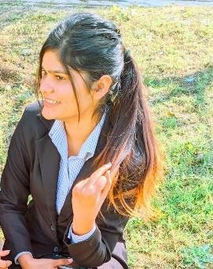**TAVASSUM KHAN**

**MBA ( Human Resources and Marketing )**

**Contact No.:** 9792208927

# E-Mail: [tavassum1999@gmail.com](mailto:tavassum1999@gmail.com)

**Address:** Maa girls pg near by Maharana Pratap Engineering college Kanpur.

**PROFILE SUMMARY**

Seeking an entry-level opportunity in an organization where I can utilize my skills and enhance my capabilities and knowledge.

**SUMMER INTERNSHIP**

* **Company Name :** Regency Healthcare

# Project Title : Recuitment and selection process

* **Duration : 2 month’s**

**ACADEMICS QUALIFICATIONS**

|  |  |  |  |
| --- | --- | --- | --- |
| **Qualification** | **Board/University** | **Year** | **Percentage** |
| MBA | AKTU | 2020-  22 | 70% |
| BBA | Rama University | 2017-  20 | 71.2% |
| Intermediate | UP Board | 2016 | 69.8% |
| Highschool | UP Board | 2014 | 79% |

**CERTIFICATIONS**

* Course on Computer Concept Certified by NIELIT
* Basic Computer Course Certified by NIELIT

**AWARDS & ACHIEVEMENTS**

* Got First Position in Ad Mad Show at Maharana Pratap Engineering College, Kanpur.

**CO-CURRICULAR & EXTRACURRICULAR ACTIVITIES**

* Coordinator of HR Club in my college.
* Decoration volunteer of Maharana Pratap Premium League at MPGI.

**TECHNICAL SKILLS**

* Microsoft Office (Word, PowerPoint, Excel)
* Google Drive (Docs, Sheets, Slides, Forms)
* Photo Editing, Video Creation, Designing in Canva, Adobe Photoshop.

**HOBBIES**

* + Photography
  + Travelling
  + Learning new skills

**PERSONAL DETAILS**

* + **Father’s Name :** Irfan Ali
  + **Permanent Address :** Nagla Kabar gola bazar Mainpuri
  + **Date of Birth :** 12th july 1999
  + **Language Known :** English & Hindi
  + **Marital Status :** Unmarried
  + **Nationality/Religion :** Indian/Muslim
  + **Gender :** Female

**DECLARATION**

I do hereby declare that the above information is true to the best of my knowledge**.**