B-Pulse Digital Workers
Admin User Guide
Worker Administration for Team Leads
April 2026
Audience: Team Administrators

Welcome
As a Team Administrator on B-Pulse Digital Workers, you manage the day-to-day configuration of your Digital Worker — keeping data fresh, managing workflows, and supporting your team members. This guide shows you exactly what you can do and how. You have admin access scoped to your assigned worker only. For platform-wide changes (creating new workers, connector credentials, adding admins), contact your Super Admin.

Your account is linked to one worker. Everything you see in the Admin Console relates to that worker only.

1. Signing In
Open your browser and navigate to the Admin Console URL (e.g. http://localhost:8000/admin.html). Enter your username and password and click Sign In.

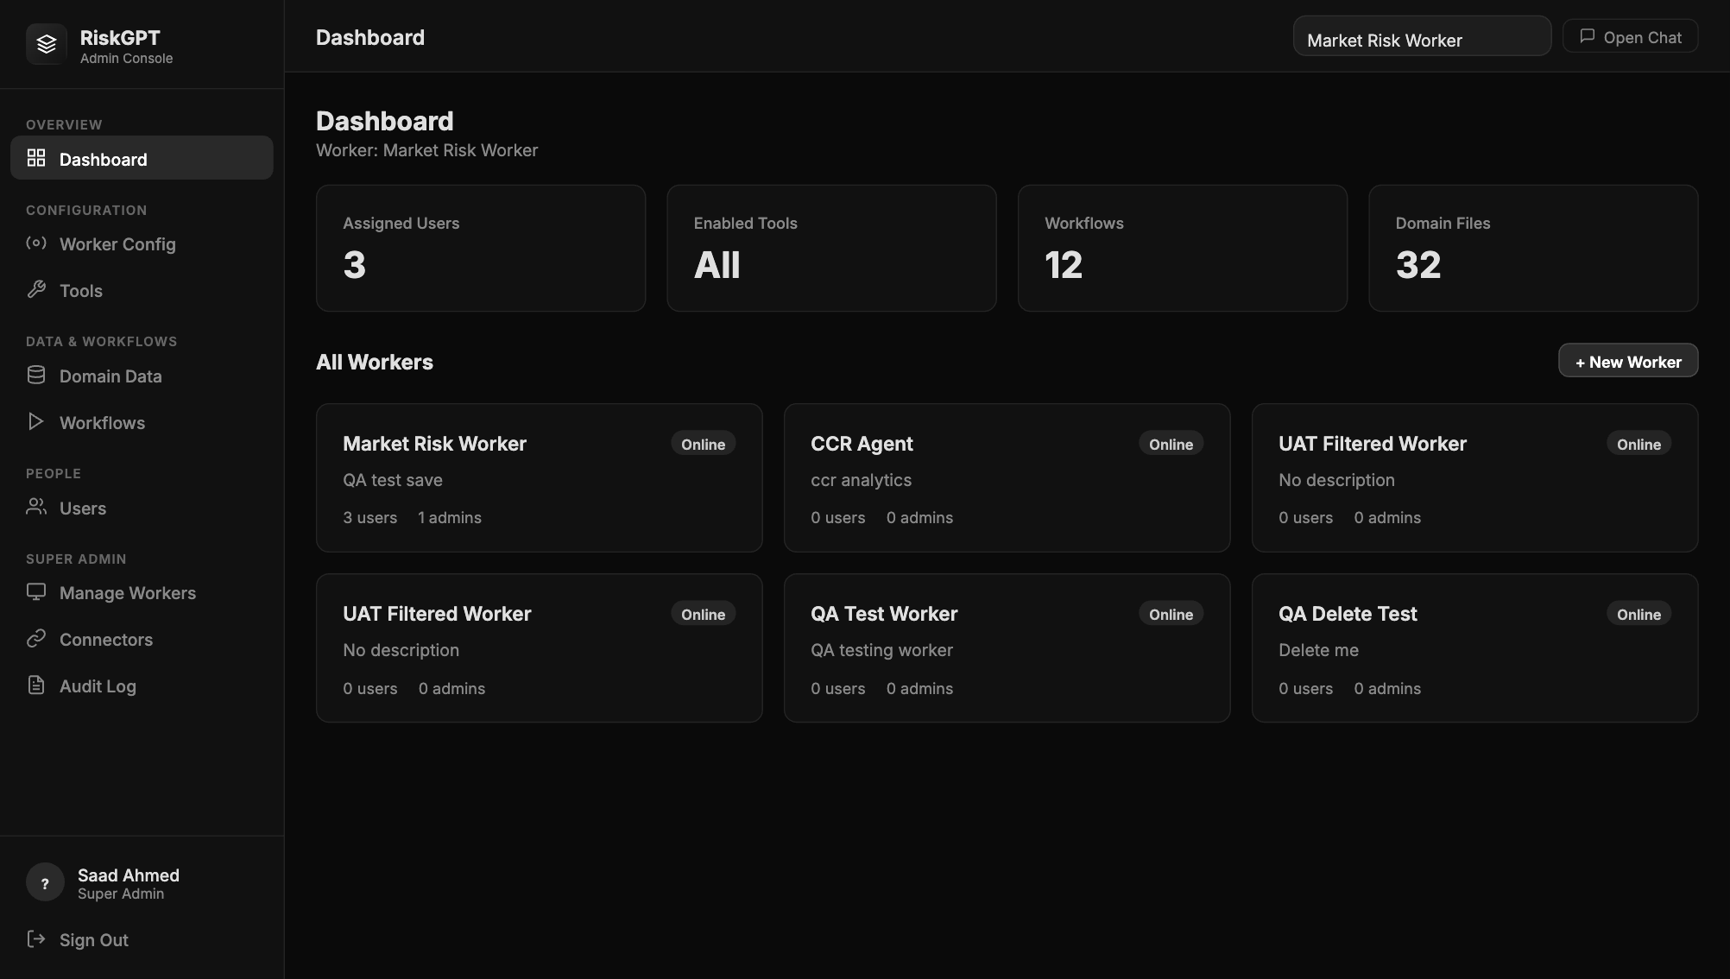
Sign in with your admin credentials

After signing in, you will see the Dashboard for your worker.


Dashboard — your worker's overview at a glance

The four stat cards show: how many users are on your team (Assigned Users), how many AI capabilities are turned on (Enabled Tools), how many saved analysis sequences exist (Workflows), and how many data files your worker can read (Domain Files).

2. Worker Settings
Click Worker Config in the left sidebar to view and update your worker's name and description.

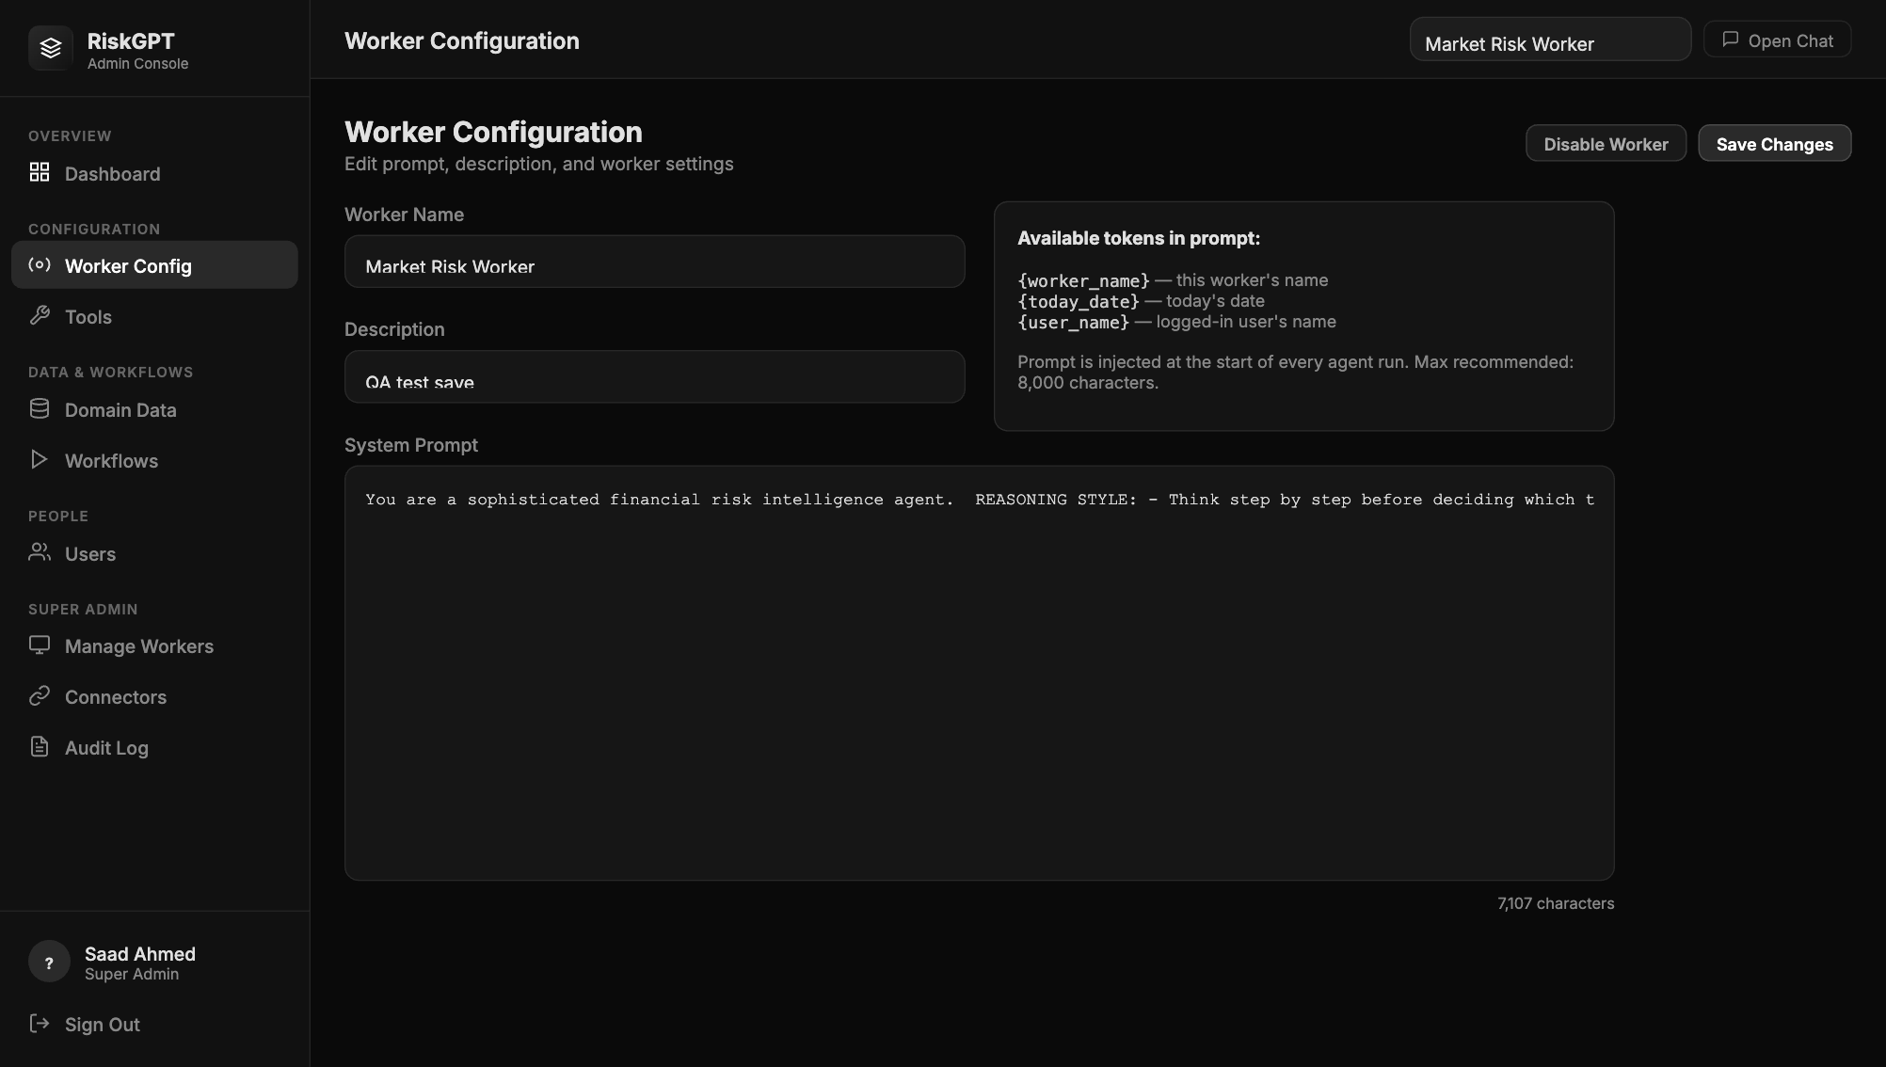
Worker Config — basic settings for your Digital Worker

- Edit the worker name or description to reflect the team's current focus
- Click Save Changes to apply
- The Worker ID, connector scope, and tool assignments at the platform level can only be changed by a Super Admin

3. Managing AI Tools
Click Tools in the sidebar to see the full list of AI capabilities available to your worker. As an admin, you can enable or disable individual tools depending on what your team needs.

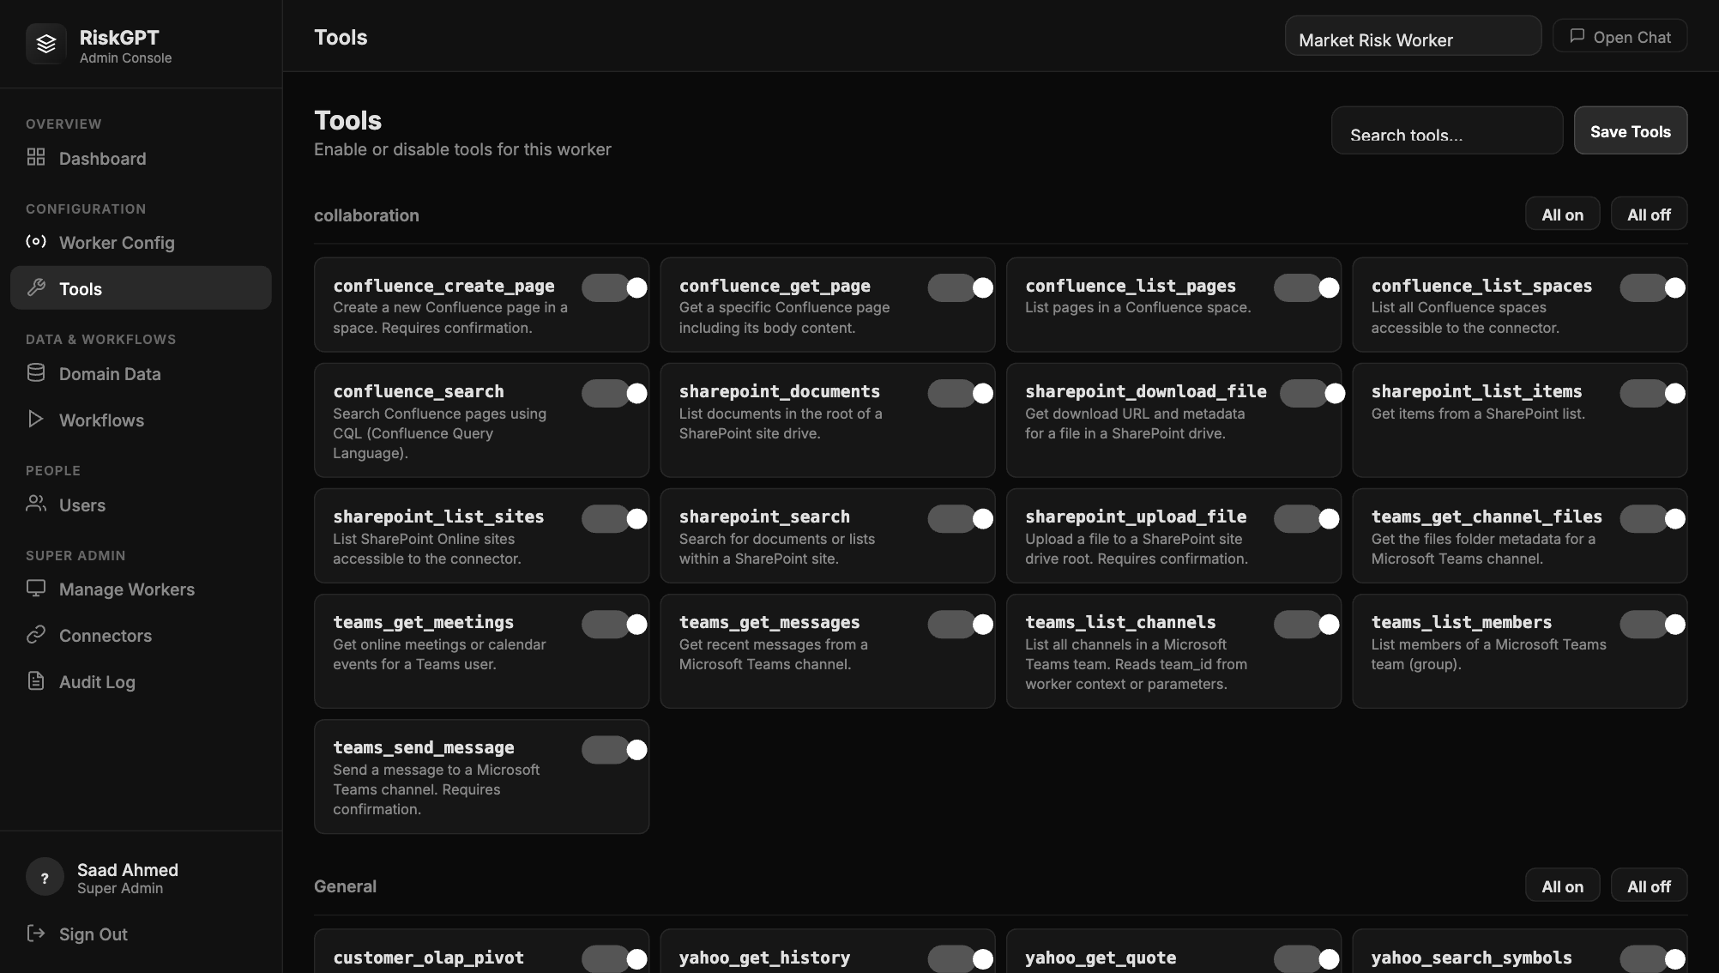
Tools library — toggle capabilities on or off for your worker

What each tool category does:
Tool Category | What it enables the AI to do
Microsoft Teams | Read channel messages, post updates, check meeting schedules
Microsoft Outlook | Read the team inbox, reply to emails, send new messages on your behalf
Atlassian Confluence | Search and read your space, create and update pages
Atlassian Jira | Create tickets, update issues, add comments, check sprint boards
Market Data | Fetch live stock quotes, indices, rates from exchanges and central banks
CCR / Counterparty | Query counterparty exposure, credit limits, VaR contribution
OSFI Regulatory | Search and read OSFI regulatory guidance documents
SEC / EDGAR | Retrieve earnings reports, MD&A, risk factors for public companies
Domain Data | Read uploaded files (your CSV, Excel, PDF data files)
Workflows | Run saved analysis sequences

- Toggle each tool on or off with the switch
- Click Save Tools after making any changes
- Changes take effect immediately — no restart or re-login needed

If a team member says the AI "cannot" do something it should be able to do, check the Tools page — the relevant tool may be switched off.

4. Domain Data — Your Knowledge Base
The Domain Data section is where you manage the files your Digital Worker reads from. Think of it as the AI's library. The more current and relevant the files you upload, the better the AI's answers will be.

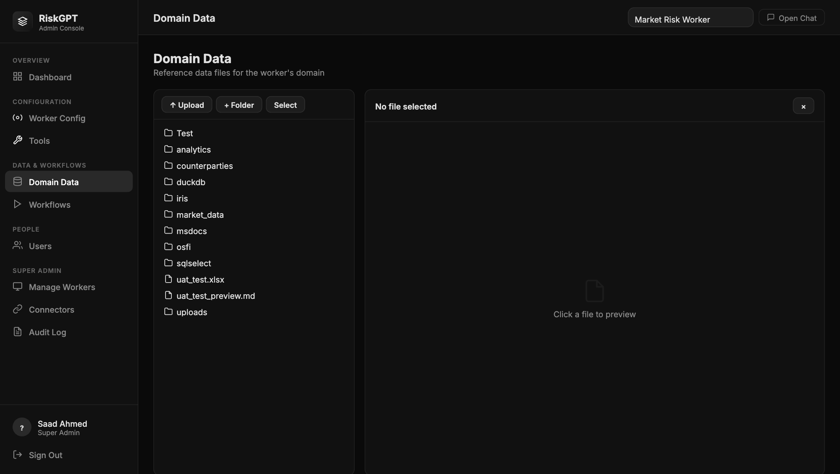
Domain Data — file tree with upload and folder management

4.1 Uploading Files
- 1. In the file tree, navigate to the correct subfolder (e.g. reports/ or counterparties/)
- 2. Click the Upload button in the toolbar
- 3. Select one or more files from your computer
- 4. Wait for the confirmation message — the file is immediately available

Supported formats: CSV, Excel (.xlsx), PDF, Word (.docx), plain text (.txt), Markdown (.md)

4.2 Organising with Folders
- Click + Folder to create a new subfolder
- Drag files between folders (or use the Move option in the context menu)

4.3 Recommended Folder Structure
Folder | What to Store Here
counterparties/ | Counterparty exposure files, credit limit sheets, trade inventories
reports/ | Daily / weekly risk reports for the AI to reference
regulatory/ | OSFI guidance, internal policy documents, Basel requirements
templates/ | Standard report templates the AI should use when drafting outputs
archive/ | Older versions of files kept for historical reference

5. Workflows
Workflows are pre-written AI instruction sequences for repeatable analyses. Examples: "Daily CCR Report", "Counterparty Limit Breach Summary", "Weekly VaR Attribution". End users can run these with a single click from the chat interface.

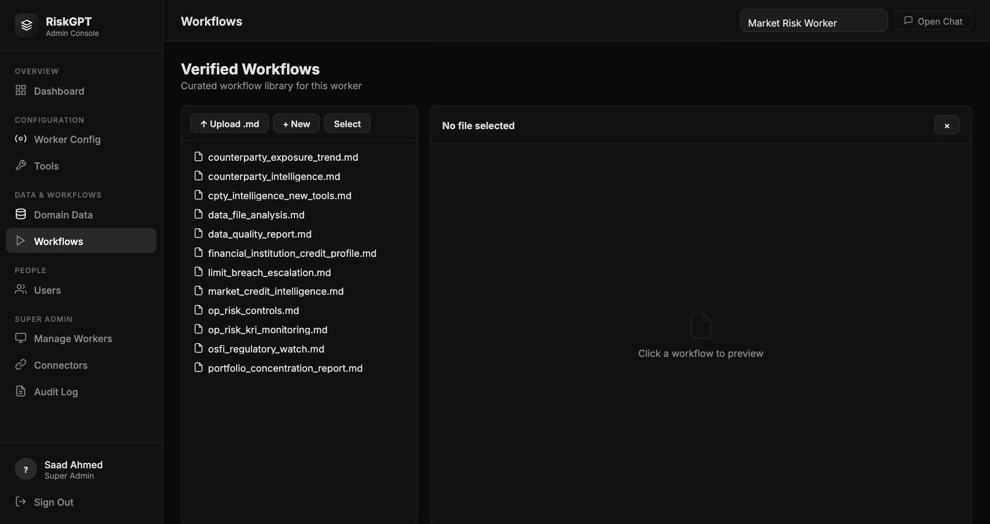
Workflows — verified analysis sequences your team can run on demand

- Click a workflow to preview its steps and purpose
- Verified workflows (marked with a tick) are available to all users on your worker
- To create new workflows: use the chat interface and save a successful analysis as a workflow — contact your Super Admin for help with this process

6. Your Team Members
Click Users in the sidebar to see who is assigned to your worker.

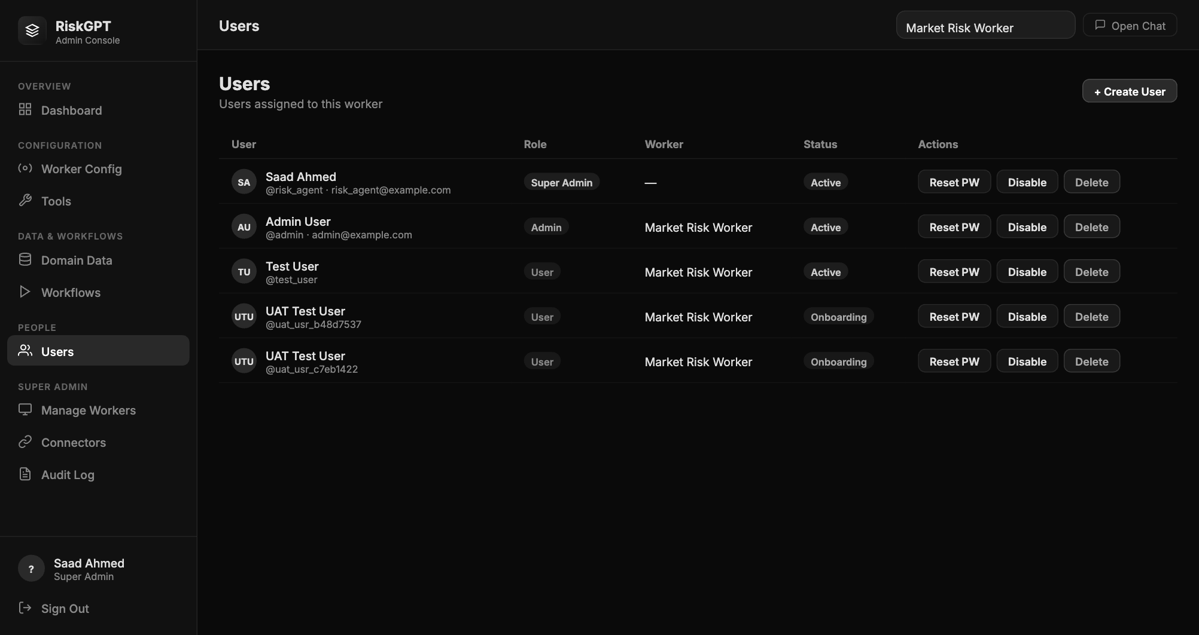
Users — team members assigned to your worker

- You can see each user's display name, role, and last login time
- To add a new team member: contact your Super Admin — they will create the account and assign it to your worker
- If a user is locked out: use the Reset Password option next to their name (if available for your role)

7. Quick Reference
Task | Where
Update worker name / description | Worker Config → Save Changes
Enable or disable a tool | Tools → toggle switch → Save Tools
Upload a new data file | Domain Data → navigate to folder → Upload
Create a subfolder for data files | Domain Data → + Folder
View available workflows | Workflows
See who is on your team | Users
Add a new team member | Contact your Super Admin
Configure connector credentials | Contact your Super Admin (Connectors section)
View audit / tool call log | Contact your Super Admin (Audit Log section)

