B-Pulse Digital Workers
Connectors Guide
Configuration & Credentials by Digital Worker
April 2026
Audience: Administrators & IT Teams

1. Overview
B-Pulse Digital Workers integrates with Microsoft 365 (Teams, Outlook) and Atlassian (Confluence, Jira) to enable AI-driven communication and documentation workflows. This guide covers the connector credentials required and the step-by-step setup in the Admin Console.

Connector credentials grant the AI agent the ability to read and write on behalf of your organisation. Ensure all credentials have the minimum permissions described below and are stored securely.

2. Microsoft 365 Connector

2.1 Credential Requirements
The Microsoft 365 connector uses OAuth2 Client Credentials Flow (app-level permissions). An Azure AD App Registration is required.
Credential | Where to Find | Notes
Tenant ID | Azure Portal → Azure Active Directory → Overview → Tenant ID | A GUID (xxxxxxxx-xxxx-xxxx-xxxx-xxxxxxxxxxxx)
Application (Client) ID | Azure Portal → App registrations → your app → Overview | A GUID
Client Secret | Azure Portal → App registrations → your app → Certificates & secrets | Create a new secret; copy the value immediately — it is only shown once

2.2 Required API Permissions (Application)
In Azure Portal → App registrations → your app → API permissions, add the following as Application permissions and grant Admin consent:
Permission | Required For
Mail.Read | Reading emails (Outlook read tools)
Mail.Send | Sending emails (Outlook send tool)
Mail.ReadWrite | Replying to emails, managing folders
Calendars.Read | Reading meeting schedules (teams_get_meetings)
Team.ReadBasic.All | Listing teams and channels
ChannelMessage.Read.All | Reading Teams channel messages
ChannelMessage.Send | Posting messages to Teams channels
Files.Read.All | Reading files shared in channels

All permissions must be Application (not Delegated) permissions. Admin consent must be granted by an Azure Global Administrator before any tools will function.

2.3 Worker Scope Values
After the connector is configured, each Digital Worker needs a scope that limits which Teams channel and Outlook mailbox it can access:
Field | Description | How to Find
Teams Team ID | GUID of the Microsoft Team for this worker | Teams → right-click team → Get link to team → extract object ID from URL
Outlook User Email | Email address of the mailbox this worker reads/sends from | The shared mailbox address, e.g. mrrisk@company.com
SharePoint Site URL | Optional: SharePoint site for file access | Navigate to the site; copy URL up to /sites/{name}

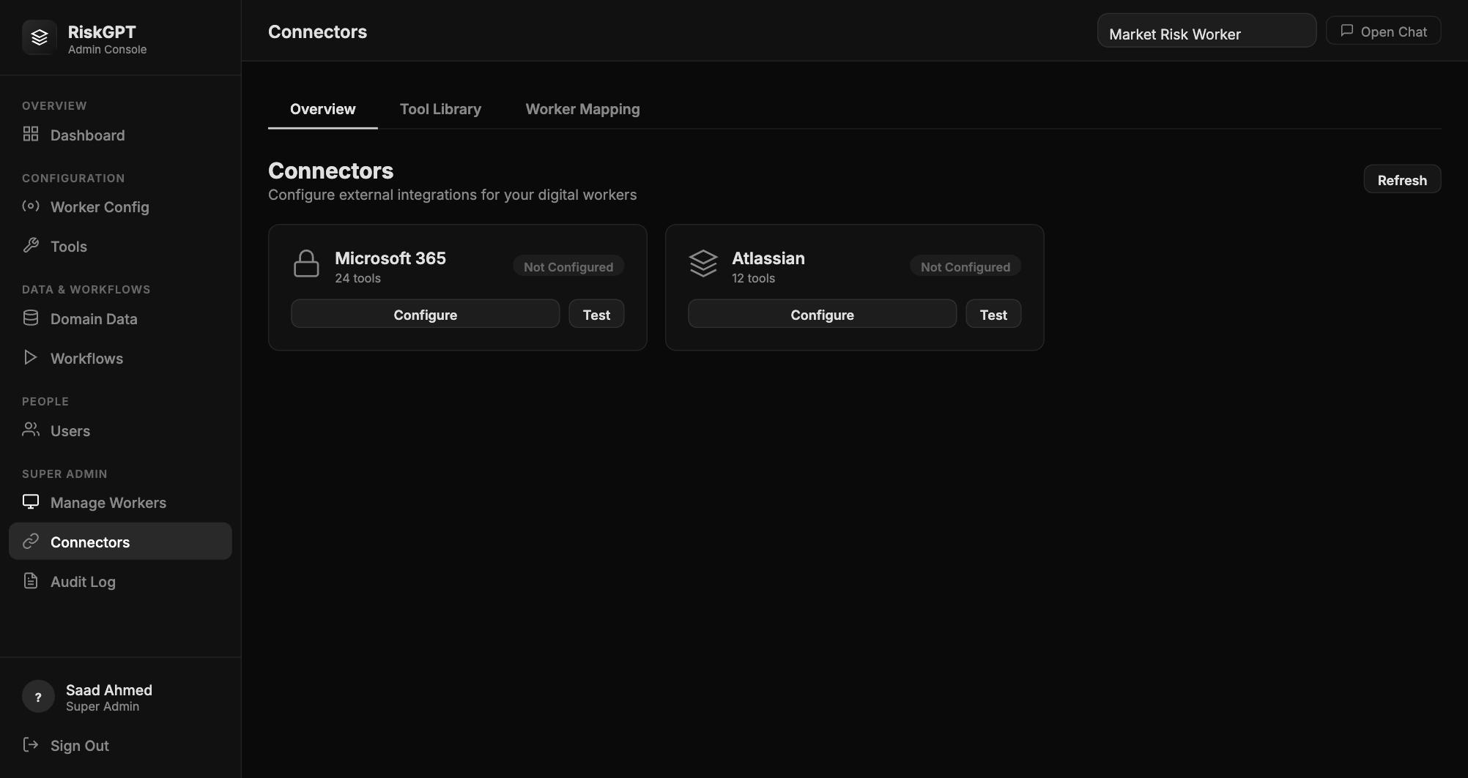
Connectors page — Admin Console

3. Atlassian Connector

3.1 Credential Requirements
The Atlassian connector uses HTTP Basic authentication with a personal API token. A dedicated service account (not a personal user account) is strongly recommended for production.
Credential | Where to Find | Notes
Atlassian Email | Email of the Atlassian account used for API auth | Recommend a service account: bpulse-agent@company.com
API Token | https://id.atlassian.com → Security → Create and manage API tokens | Label it "B-Pulse MCP Server"; copy value immediately
Confluence Base URL | Your Confluence site | https://yourcompany.atlassian.net (no /wiki suffix)
Jira Base URL | Your Jira site | https://yourcompany.atlassian.net

3.2 Required Atlassian Permissions
- Confluence: Can View space, Add Page, Edit Page for the target space
- Jira: Browse Projects, Create Issues, Edit Issues, Add Comments for the target project
- Jira: View Board, Manage Sprints (required if sprint management tools are enabled)

3.3 Worker Scope Values
Field | Description | How to Find
Confluence Space Key | Key identifying the target Confluence space | Go to the space; URL shows /wiki/spaces/{SPACE_KEY}/
Jira Project Key | Key identifying the target Jira project | Visible in issue IDs: MRISK-123 → key is MRISK
Jira Board ID | Numeric board ID for sprint queries | Navigate to board → URL shows /boards/{BOARD_ID}
Confluence Parent Page ID | Numeric ID of parent page for new pages created by the agent | Navigate to the page → URL shows /pages/{PAGE_ID}

4. Connector Configuration in Admin Console

4.1 Step-by-Step: Microsoft 365
- 1. Log into Admin Console as a super_admin user
- 2. Click Connectors in the left sidebar
- 3. On the Overview tab, click Configure on the Microsoft 365 card
- 4. Enter: Display Name, Tenant ID, Application (Client) ID, and Client Secret
- 5. Click Test Connection — wait for the green success confirmation
- 6. Click Save — the card will now show status: Connected

4.2 Step-by-Step: Atlassian
- 1. In Connectors → Overview, click Configure on the Atlassian card
- 2. Enter: Display Name, Email, API Token, Confluence URL, Jira URL
- 3. Click Test Connection → green success
- 4. Click Save

4.3 Assigning Scope to a Worker
- 1. Click the Worker Mapping tab in the Connectors section
- 2. Select the target worker from the dropdown (e.g. Market Risk Worker)
- 3. Enter Microsoft 365 scope: Teams Team ID, Outlook email, optional SharePoint URL
- 4. Click Save Microsoft 365 Scope
- 5. Enter Atlassian scope: Space Key, Project Key, Board ID, Parent Page ID
- 6. Click Save Atlassian Scope
- 7. Verify the worker's connector_scope in Admin Console → Worker Config — it should now show real values, not the placeholder qa-team / RISK / CCR defaults

5. Connector Requirements by Digital Worker
Digital Worker | Teams | Outlook | Confluence | Jira | Notes
Market Risk Worker | Required | Required | Required | Required | Full connector suite; primary production worker
CCR Agent | Optional | Optional | Required | Optional | Primarily Confluence for regulatory documentation

6. Security Notes
- Store credentials in the Admin Console only — never in .env files or source control
- Rotate Microsoft 365 Client Secrets every 90 days (Azure enforces this by default)
- Rotate Atlassian API tokens every 180 days
- Use a dedicated Atlassian service account, not a personal user account
- BUG-CONN-001: Credentials are currently stored plaintext in config/connectors.json — do not commit this file to git; AES-256-GCM encryption is planned in REQ-07
- The agent only acts within the connector_scope defined for each worker — it cannot access Teams channels or Confluence spaces outside its assigned scope

