B-Pulse Digital Workers
Super Admin Guide
Full Platform Administration
April 2026
Audience: Super Administrators

Welcome to the Admin Console
As a Super Admin, you have full control over the B-Pulse Digital Workers platform. This guide walks you through everything: creating and managing Digital Workers, adding users, uploading data, configuring connectors, and monitoring the audit trail. You access everything from the Admin Console — a web interface that opens in your browser.

Super Admin is the highest role on the platform. You can see and do everything. Guard your credentials carefully.

1. Signing In
Open your browser and go to the Admin Console URL (e.g. http://localhost:8000/admin.html). You will see the login screen.

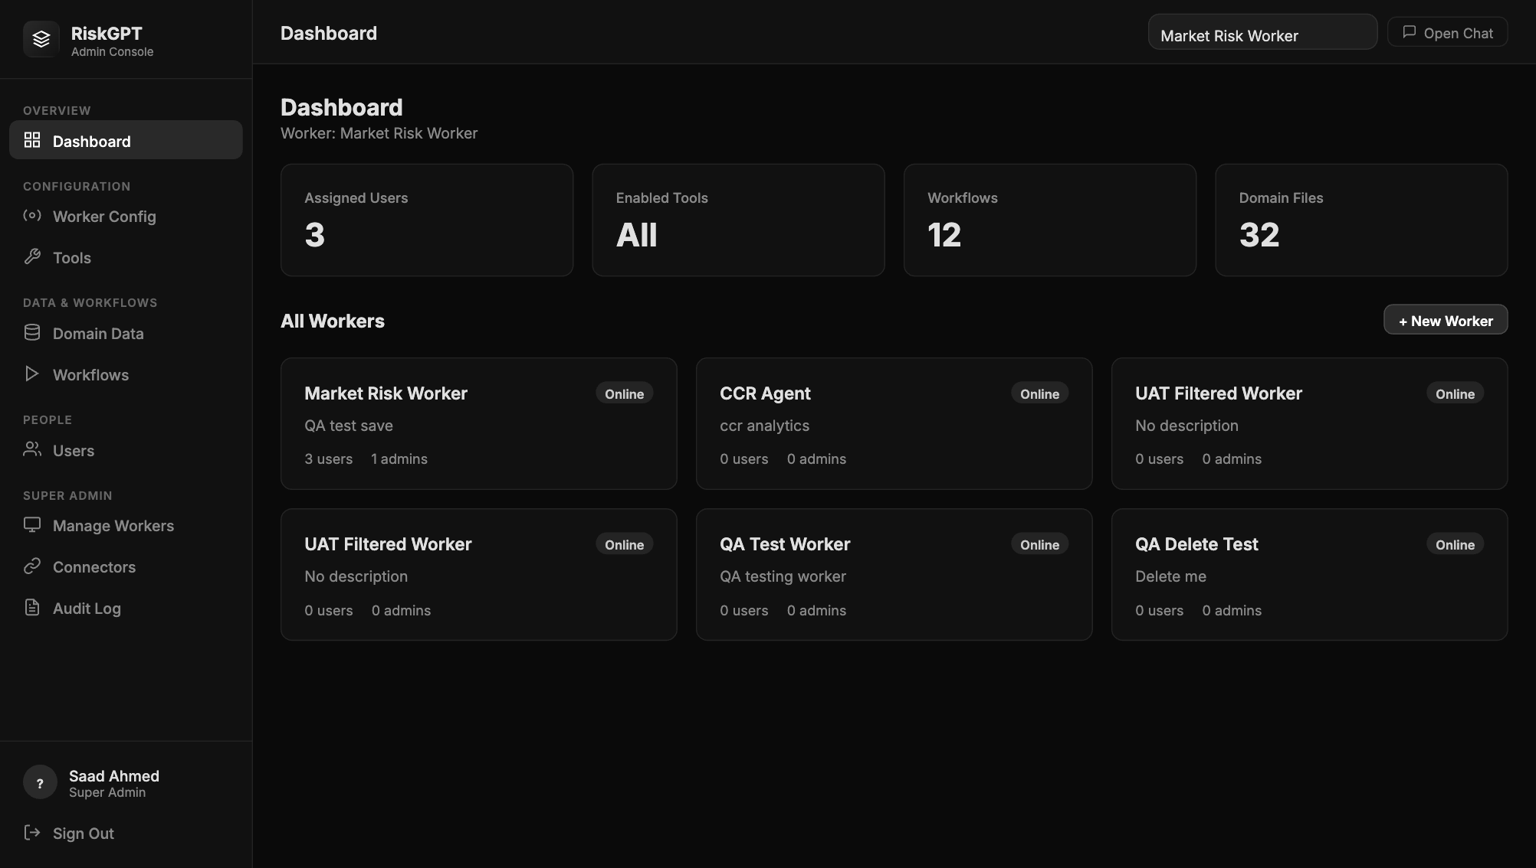
The B-Pulse login screen

- Enter your Username (e.g. risk_agent)
- Enter your Password
- Click Sign In
- You land on the Admin Console Dashboard


Admin Console Dashboard — showing worker statistics and all active Digital Workers

The Dashboard shows statistics for the currently selected worker (top-right dropdown): Assigned Users, Enabled Tools, Workflows, and Domain Files. Scroll down to see cards for every Digital Worker on the platform.

2. Managing Digital Workers

2.1 What Is a Digital Worker?
A Digital Worker is a specialist AI agent built for a specific team or function. Each worker has its own tools, data files, connector scope (which Teams channel, Confluence space, and Jira project it can access), and assigned users. Examples: Market Risk Worker, CCR Agent.

2.2 Viewing All Workers
The Dashboard shows a card for every worker. The card displays the worker name, status (Online/Offline), number of assigned users and admins. Use the + New Worker button to create a new one.

2.3 Creating a New Worker
- 1. On the Dashboard, click + New Worker (top right)
- 2. Fill in: Worker Name (e.g. "Credit Risk Worker"), Description, Worker ID (lowercase + hyphens only, e.g. w-credit-risk)
- 3. Click Create Worker
- 4. A new card appears on the Dashboard with status Online

2.4 Worker Config — Settings
Select a worker from the top-right dropdown then click Worker Config in the sidebar to update its name, description, and settings.

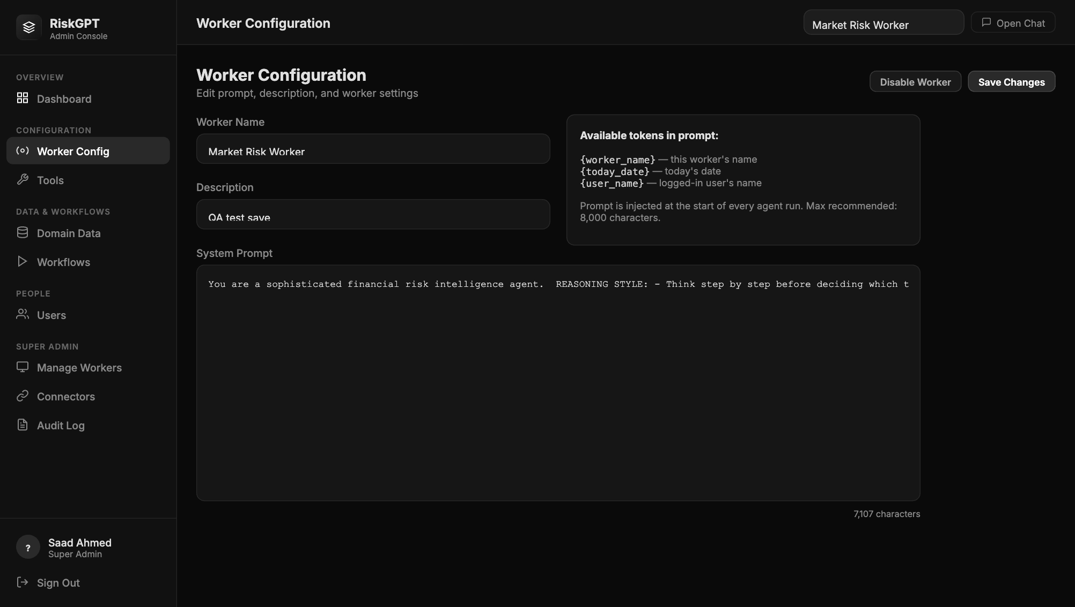
Worker Config — name, description, and settings for the selected worker

- Edit the name or description and click Save Changes
- You can also disable a worker here (Disable Worker button) — it stays in the system but cannot be used by team members

2.5 Managing Worker Tools
Click Tools in the sidebar to see all 74+ available tools. Toggle individual tools on or off for the current worker — for example, disable Teams tools if a worker should not be able to post messages.

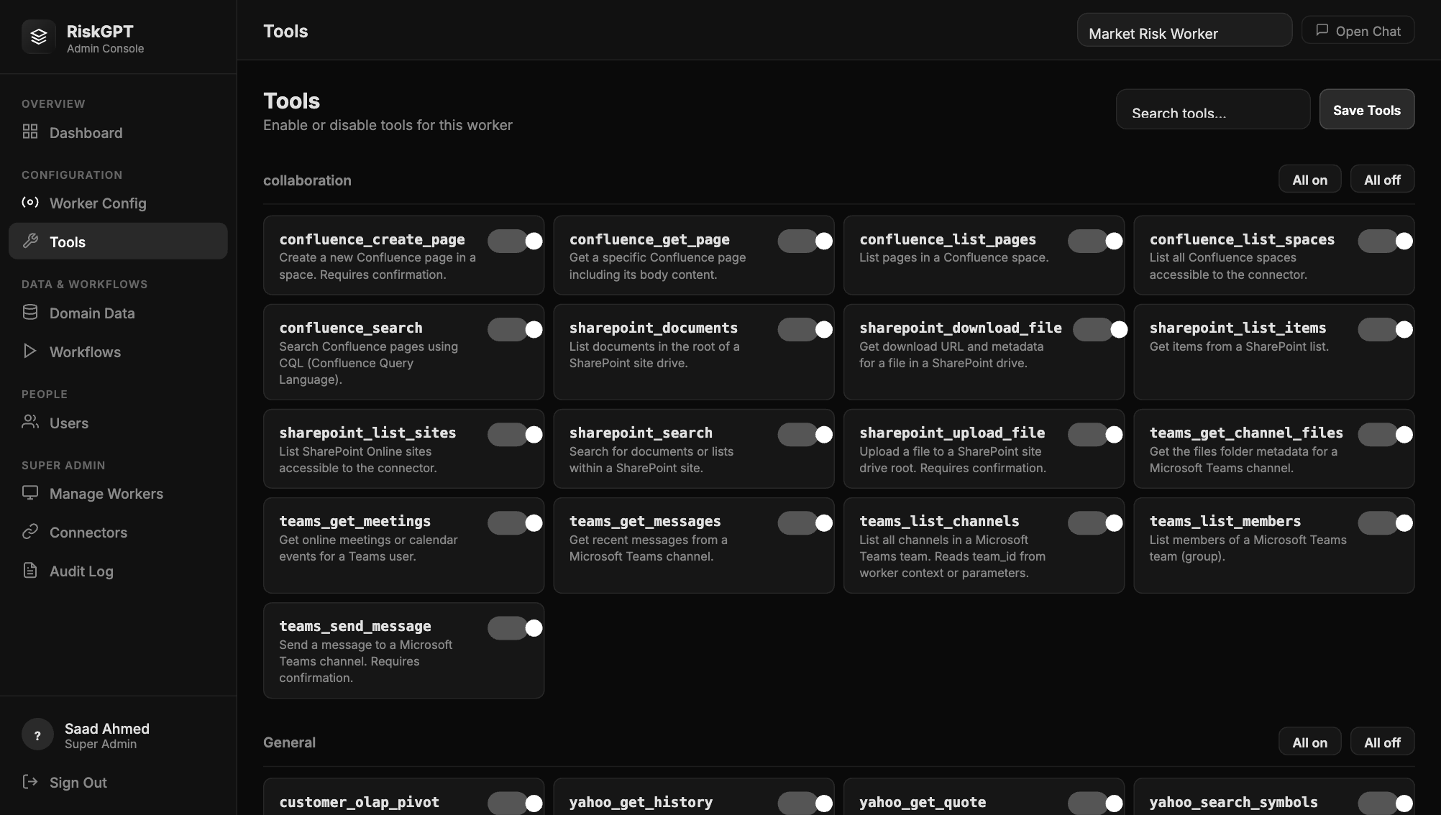
Tools page — toggle individual AI capabilities on or off per worker

- Use the toggle switches to enable or disable individual tools
- Bulk controls let you enable or disable all tools at once
- Click Save Tools — changes take effect immediately, no restart needed

3. User Management
Click Users in the sidebar to see all platform users, their roles, assigned workers, and last login time.

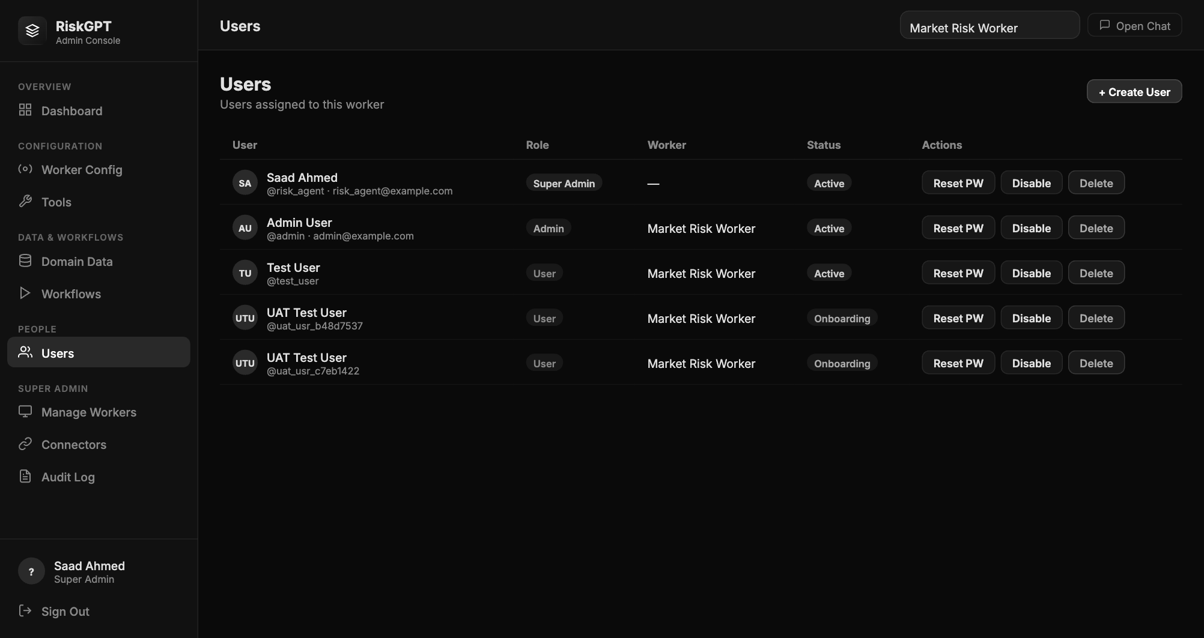
Users page — all platform users with role and worker assignment

3.1 Adding a New User
- 1. Click + Add User
- 2. Enter: Username, Display Name, Email, Role, and initial Password
- 3. If the role is admin or user, assign them to a Worker
- 4. Click Create User
- 5. Share the credentials with the user — they should change their password on first login

3.2 Roles Explained
Role | Capabilities
Super Admin | Full access: create workers, manage all users, configure connectors, view all audit logs, manage domain data for any worker
Admin | Worker-scoped: manage tools, domain data, and workflows for their assigned worker; manage users within that worker; cannot create new workers or connectors
User | End-user access only: use the chat interface, view workflows, upload personal files; no admin console access

4. Domain Data & Workflows

4.1 Domain Data
Domain Data is the knowledge base the AI reads from — CSV files, Excel reports, PDFs, regulatory documents, and any other files your team needs. Click Domain Data in the sidebar to manage it.

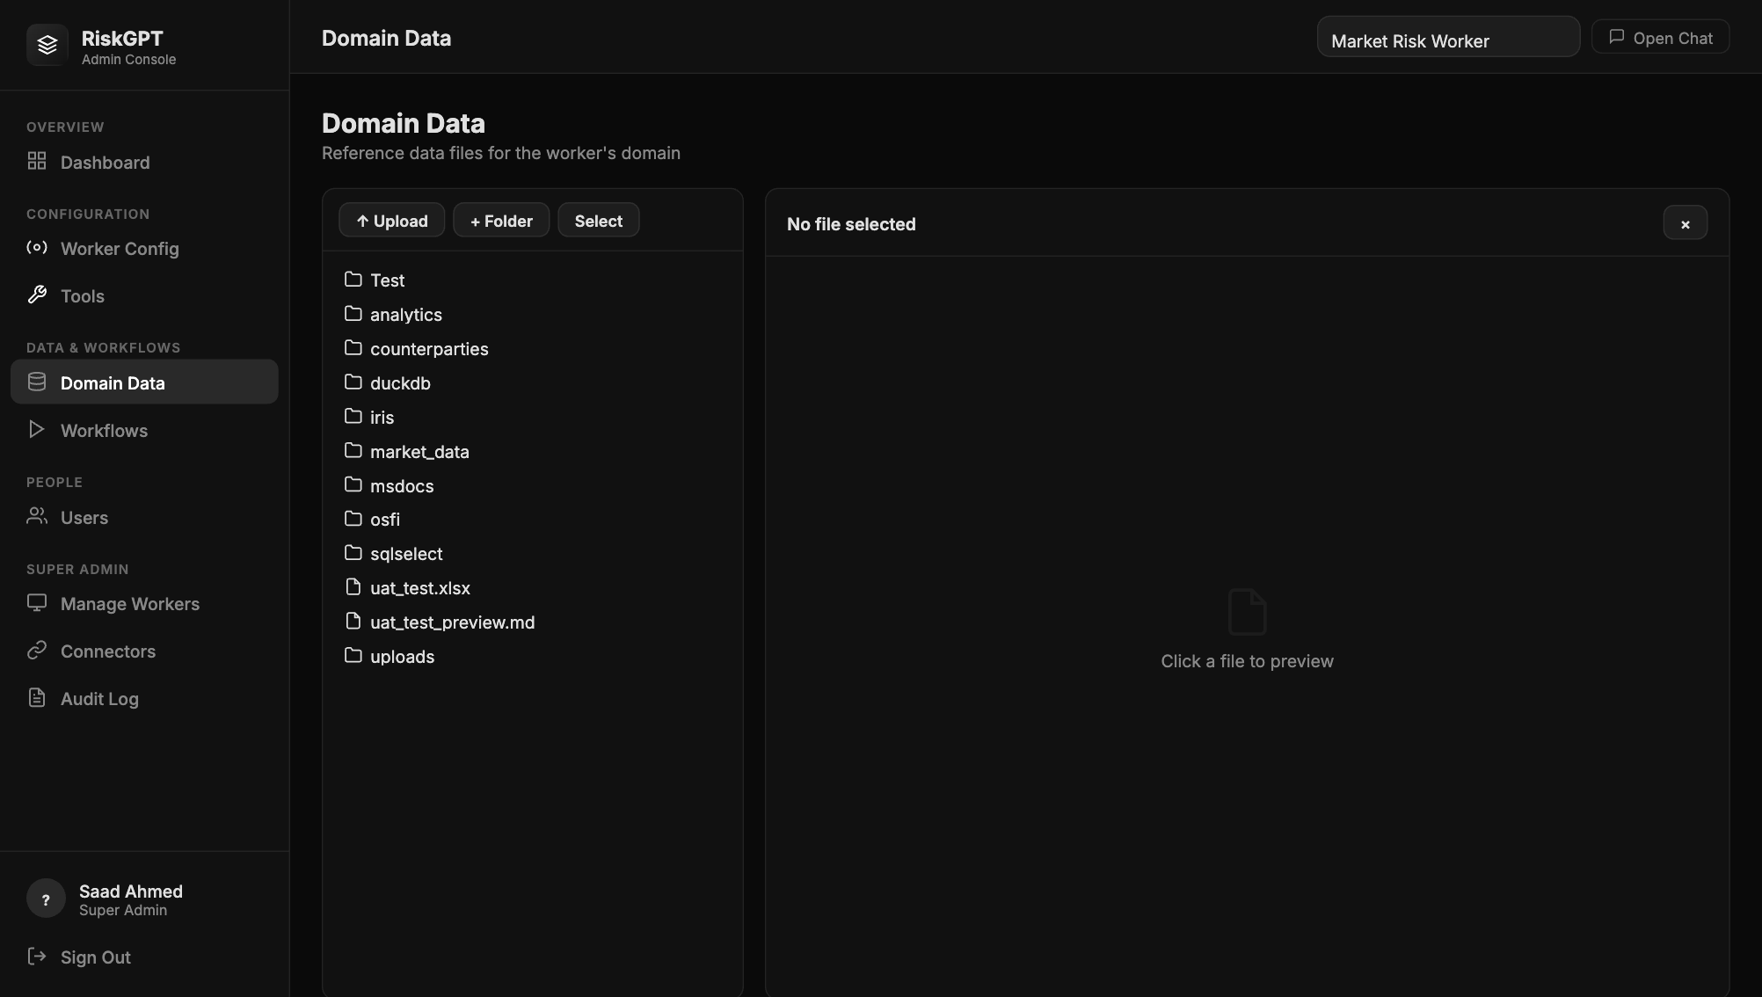
Domain Data — file tree showing all documents available to the worker

- Navigate folders using the tree on the left
- Click a file to preview its contents on the right
- Click Upload to add new files (CSV, Excel, PDF, Word, text)
- Click + Folder to create a new subfolder for organisation
- Files are available to the AI immediately after upload

4.2 Workflows
Workflows are saved AI instruction sequences for repeatable analyses — like "Daily CCR Summary" or "Counterparty Limit Breach Report". Click Workflows to manage them.

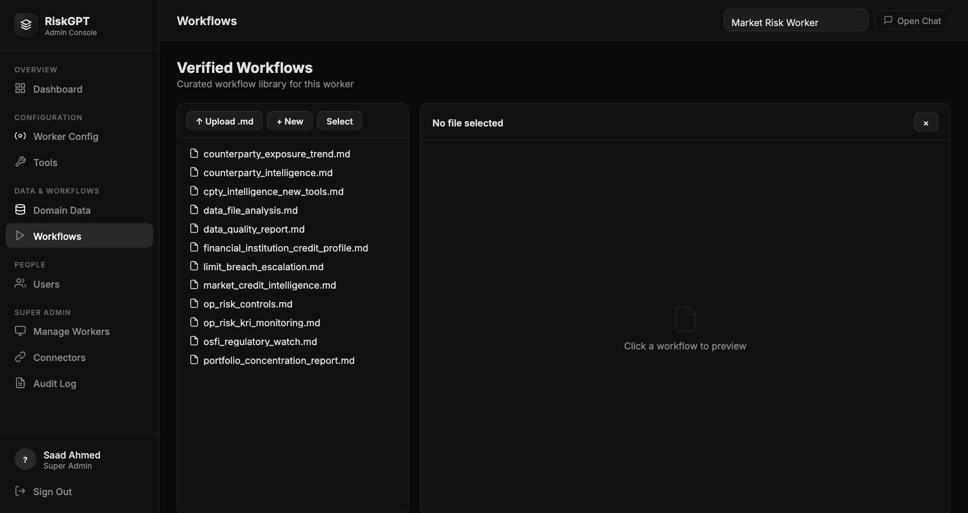
Workflows — verified analysis sequences available to end users

5. Connectors
Click Connectors in the sidebar to manage Microsoft 365 and Atlassian integrations. See the Connectors Guide for full setup instructions.

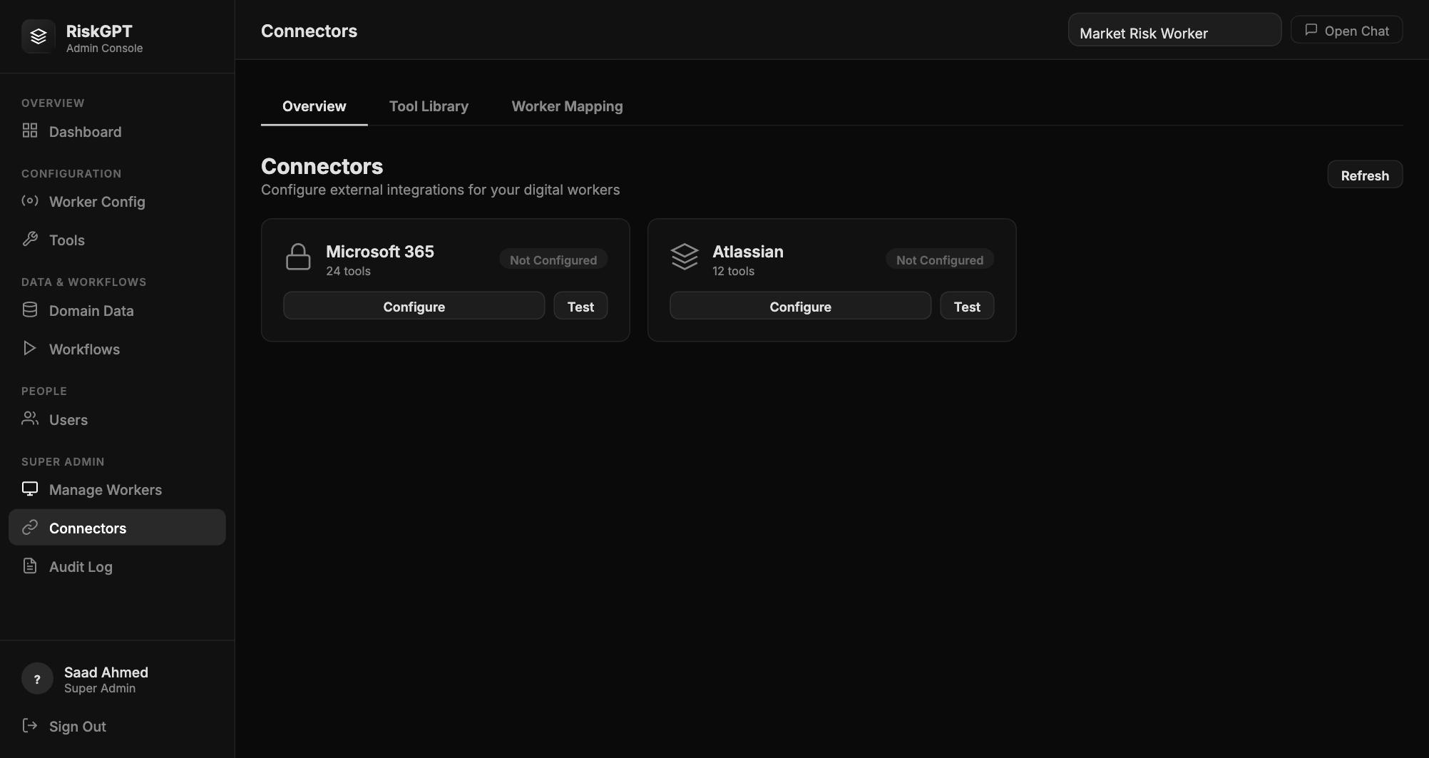
Connectors — Overview tab showing Microsoft 365 and Atlassian configuration status

- Overview tab: Configure connector credentials and test the connection
- Worker Mapping tab: Assign specific Teams channels, Confluence spaces, and Jira projects to each worker
- A green Connected badge confirms the integration is live

6. Audit Log
The Audit Log is your compliance record. Every tool call made by every user across all workers is logged here. Click Audit Log in the sidebar.

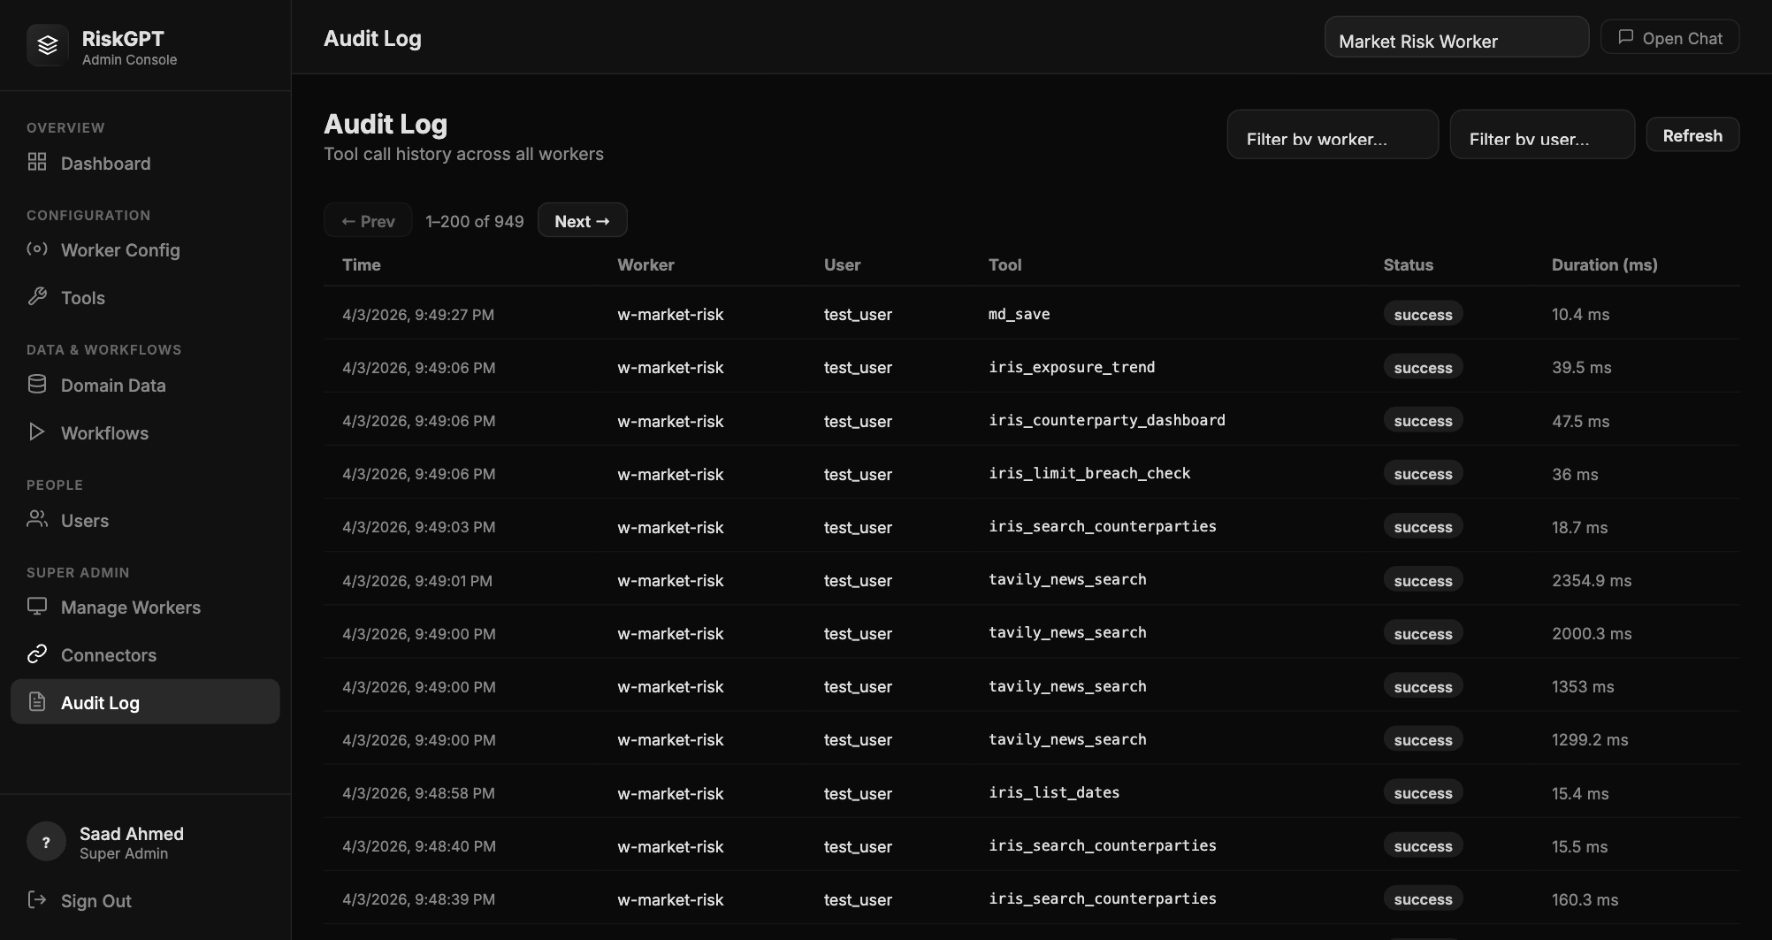
Audit Log — complete record of all tool calls, approvals, and write operations

- Filter by user, worker, tool name, or date range
- Write operations (sending Teams messages, emails, creating Jira tickets) show confirmation_required: true — confirming a human approved the action
- Export the log for compliance reporting
- The log is stored as an append-only file — it cannot be edited or deleted from the UI

7. Quick Reference
Task | Where to Go | Action
Create a new Digital Worker | Dashboard | Click + New Worker; fill in name & ID
Add a user to the platform | Users | Click + Add User; set role & worker
Enable / disable tools | Tools (select worker) | Toggle switches; click Save Tools
Upload a domain data file | Domain Data | Navigate to folder; click Upload
Configure Microsoft 365 | Connectors → Overview | Click Configure on MS365 card; enter Tenant ID, Client ID, Secret
Configure Atlassian | Connectors → Overview | Click Configure on Atlassian card; enter email, API token
Assign connector scope to worker | Connectors → Worker Mapping | Select worker; enter IDs/keys; click Save
Review the compliance audit trail | Audit Log | Filter by date, user, or tool; export as needed
Change worker description | Worker Config | Edit fields; click Save Changes
Disable a worker temporarily | Worker Config | Click Disable Worker button

