Poročilo N04 – Aleksander Grobelnik

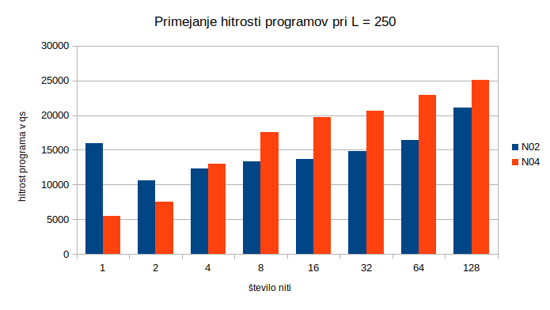

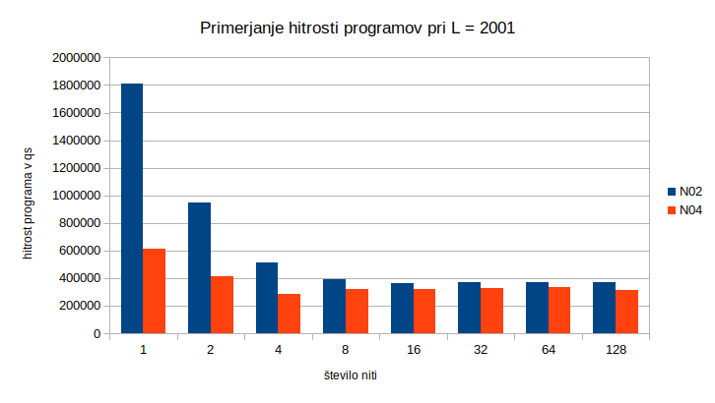

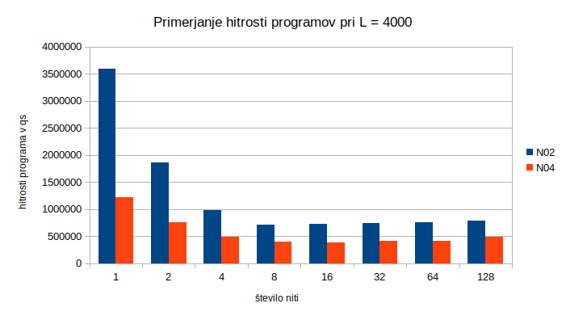

Maksimalna pohititej je okoli 5x, vendar je ta dosežena pri velikih L-jih in ne pri L = 250. Pri L = 250 se pri dveh niti skoraj 2x pohitri, vendar se nato hitro obrne nazaj. Če opazujemo naprej od 8 niti opazimo, da se vrednost pri velikih L-jih ustavi in doseže svoj maksimalni limit pri cca 20%.
Neverjetno je pri majhnih L-ji veliko število niti v bistvu upočasnitev programa, saj se niti dlje časa ukvarjajo z zaklepanjem/odklepanjem mutexa, ki hrani maksimalno število nfes ponovitev. Če bi to ohranili, bi se stvar dosti-krat hitreje obnašala.
Koda programa:
#include <algorithm>
#include <array>
#include <climits>
#include <cmath>
#include <iostream>
#include <mutex>
#include <omp.h>
#include <random>
#include <sstream>
#include <thread>
#include <vector>

#define NUM_THREADS 8
unsigned int nfes = 0;
std::vector<double> mfs;
std::vector<unsigned int> psls;
std::mutex mtx;

void printWrongUsage() {
std::cout
<< "Usage: main.x -L=<unsign int> -type=[PSL|MF] -seed=<unsigned int> "
"-nfesLmt=<unsigned int>"
<< std::endl;
}

int *generateSequence(unsigned int size, unsigned int seed) {
int *arr = new int[size];
int values[2] = {-1, 1};
std::mt19937 mt(seed);
std::uniform_int_distribution<int> dist(0,
(sizeof(values) / sizeof(int)) - 1);
for (unsigned int i = 0; i < size; i++) {
arr[i] = values[dist(mt)];
}
return arr;
}

std::string convertBinaryToHexadecimal(int *arr, unsigned int size) {
int n = ceil((size - 1) / 4) + 1;
std::string res = "0x";
for (unsigned int i = n; i > 0; i--) {
int sum = (*(arr + size - i * 4 + 3) != 1 ? 0 : 1) +
(*(arr + size - i * 4 + 2) != 1 ? 0 : 1) * 2 +
(*(arr + size - i * 4 + 1) != 1 ? 0 : 1) * 4 +
(*(arr + size - i * 4) != 1 ? 0 : 1) * 8;
res += (sum > 9 ? (char)(sum + 65 - 10) : std::to_string(sum)[0]);
// std::cout << *(arr + i * 4) << " " << *(arr + i * 4 + 1) << " "
// << *(arr + i * 4 + 2) << " " << *(arr + i * 4 + 3) << " " <<
// std::endl;
}
return res;
}

int C(int *sequence, unsigned int k, unsigned int L) {
int sum = 0;
for (unsigned int i = 0; i <= L - k - 1; i++) {
sum += sequence[i] * sequence[i + k];
}
return sum;
}

unsigned int PSL(int *sequence, unsigned int L, unsigned int nfesLmt) {
int mVal = INT_MIN;
for (unsigned int k = 1; k < L; k++) {
if (nfes > nfesLmt) {
return INT_MIN;
}
mVal = std::max(std::abs(C(sequence, k, L)), mVal);
mtx.lock();
nfes++;
mtx.unlock();
}
return mVal;
}

double MF(int *sequence, unsigned int L, unsigned int nfesLmt) {
int energy = 0;
for (unsigned int k = 1; k < L; k++) {
if (nfes > nfesLmt) {
return 0;
}
int ck = C(sequence, k, L);
energy += ck * ck;
mtx.lock();
nfes++;
mtx.unlock();
}
return (L * L) / (2.0 * energy);
}

int split(int *arr, std::string type, int a, int b) {
double pivot = arr[a];
int li = a;
int ri = b;
while (li < ri) {
while (arr[li] <= pivot && li < b) {
li++;
}
while (arr[ri] >= pivot && ri > a) {
ri--;
}
if (li < ri) {
std::swap(arr[li], arr[ri]);
}
}
std::swap(arr[a], arr[ri]);
return ri;
}

void quicksort(int *arr, std::string type, int a, int b) {
if (a < b) {
int splitter = split(arr, type, a, b);
quicksort(arr, type, a, splitter - 1);
quicksort(arr, type, splitter + 1, b);
}
}

void computeSequence(int *sequence, std::string type, unsigned int size,
unsigned int start, unsigned int end,
unsigned int nfesLmt) {
for (unsigned int i = start; i <= end; i++) {
int *seq = new int[size];
for (unsigned int i = 0; i < size; i++) {
seq[i] = sequence[i];
}
seq[i] *= -1;
if (type == "PSL") {
int psl = PSL(seq, size, nfesLmt);
psls[i] = psl;
} else if (type == "MF") {
double mf = MF(seq, size, nfesLmt);
mfs[i] = mf;
}
}

if (end == size - 1) {
if (type == "PSL") {
int psl = PSL(sequence, size, nfesLmt);
psls[size] = psl;
} else if (type == "MF") {
double mf = MF(sequence, size, nfesLmt);
mfs[size] = mf;
}
}
}

int main(int argc, char **argv) {
if (argc == 1) {
std::cout << "Wrong number of given arguments" << std::endl;
printWrongUsage();
return 1;
}
unsigned int seed = 0;
unsigned int L = 0;
std::string type = "";
unsigned int nfesLmt = 0;
for (int i = 1; i < argc; i++) {
std::string arg(argv[i]);
int pos = arg.find("=");
if (pos == -1 || arg == "-h" || arg == "-?") {
printWrongUsage();
return 1;
}
if (arg.substr(0, pos) == "-L" || arg.substr(0, pos) == "L") {
L = stoi(arg.substr(pos + 1));
} else if (arg.substr(0, pos) == "-type" || arg.substr(0, pos) == "type") {
type = arg.substr(pos + 1);
} else if (arg.substr(0, pos) == "-seed" || arg.substr(0, pos) == "seed") {
seed = stoi(arg.substr(pos + 1));
} else if (arg.substr(0, pos) == "-nfesLmt" ||
arg.substr(0, pos) == "nfesLmt") {
nfesLmt = stoi(arg.substr(pos + 1));
}
}
if (seed == 0 || L == 0 || type == "" || nfesLmt == 0) {
std::cout << (seed != 0 ? "FOUND: seed" : "NOT FOUND: seed") << std::endl
<< (L != 0 ? "FOUND: L" : "NOT FOUND: L") << std::endl
<< ((type == "MF" || type == "PSL") ? "FOUND: type"
: "NOT FOUND: type")
<< std::endl
<< (nfesLmt != 0 ? "FOUND: nfesLmt" : "NOT FOUND: nfesLmt")
<< std::endl;
printWrongUsage();
return -1;
}
std::chrono::time_point<std::chrono::system_clock> start, end;

// int arr[] = {1, 1, 1, -1, -1, -1, 1, -1, -1, 1, -1, -1};
int *sequence = generateSequence(L, seed);
psls.resize(L + 1);
mfs.resize(L + 1);
// std::array<std::thread, NUM_THREADS> threads;
// int thr_i = 0;
start = std::chrono::system_clock::now();
// for (auto &thr : threads) {
// unsigned int start = thr_i * (L / NUM_THREADS);
// unsigned int end =
// thr_i == (NUM_THREADS - 1) ? L - 1 : (thr_i + 1) * (L / NUM_THREADS);
// thr = std::thread([sequence, type, L, start, end, nfesLmt] {
// computeSequence(sequence, type, L, start, end, nfesLmt);
// });
// thr_i++;
// }
// for (auto &thr : threads) {
// thr.join();
// }
omp_set_num_threads(NUM_THREADS);
#pragma omp parallel
{
int id = omp_get_thread_num();
unsigned int start = id * (L / NUM_THREADS);
unsigned int end =
id == (NUM_THREADS - 1) ? L - 1 : (id + 1) * (L / NUM_THREADS);
computeSequence(sequence, type, L, start, end, nfesLmt);
}
end = std::chrono::system_clock::now();
std::chrono::duration<double> elapsed_seconds;
elapsed_seconds = end - start;
unsigned int index;
if (type == "MF") {
index = std::distance(std::begin(mfs),
std::max_element(std::begin(mfs), std::end(mfs)));
} else {
index = std::distance(std::begin(psls),
std::min_element(std::begin(psls), std::end(psls)));
}
sequence[index] *= -1;
std::cout << "L: " << L << std::endl
<< "nfesLmt: " << nfesLmt << std::endl
<< "seed: " << seed << std::endl
<< "nfes: " << nfes << std::endl
<< // Število ovrednotenj
"runtime: " << elapsed_seconds.count() * 1000 * 1000 << "qs" << std::endl
<< //Čas izvajanja algoritma
"speed: " << nfes / elapsed_seconds.count() * 1000 * 1000 << std::endl
<< // Število ovrednotenj na sekundo
"sequence: " << convertBinaryToHexadecimal(sequence, L) << std::endl
<< "MF: " << mfs[index] << std::endl
<< "PSL: " << psls[index] << std::endl;
/*std::cout << "Operations per second: "
<< size * (method != 2 ? 1 : size) / elapsed_seconds.count() <<
std::endl; std::cout << "Number of operations: " << size * (method != 2 ? 1 :
size) << std::endl;*/
// delete[] sequence;
return 0;
}
V spodni preglednici tudi dodajam neobdelane podatke iz katerih sem naredil zgornja dva grafa.
count of threads | L | N02 250 | N02 2001 | N02 4000 | N04 250 | N04 2001 | N04 4001
1 | 15932 | 1808540 | 3593480 | 5513 | 613213 | 1219020
2 | 10618 | 944317 | 1862100 | 7491 | 411468 | 751766
4 | 12304 | 511725 | 982662 | 13005 | 285222 | 494269
8 | 13341 | 391873 | 709298 | 17592 | 317444 | 394189
16 | 13736 | 365541 | 720870 | 19678 | 321954 | 383543
32 | 14824 | 373789 | 735301 | 20663 | 330224 | 407582
64 | 16466 | 368336 | 750876 | 22892 | 331530 | 411897
128 | 21075 | 367354 | 785694 | 25075 | 313578 | 487111

